Supplementary Figures
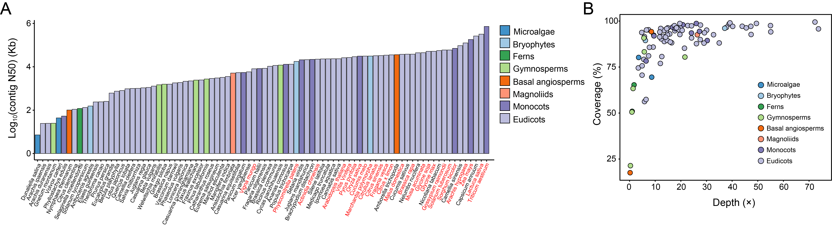
Supplementary Fig. 1 Quality assessment of reference genomes and methylome data.
A Bar plot of contig N50 values (log₁₀-transformed) for the reference genomes. Species names in red indicate telomere-to-telomere (T2T) or near gap-free assemblies. Bars are colored according to taxonomic clade. B Scatter plot of genome coverage (%) versus sequencing depth (×) for the methylome data. Each dot represents a single species, colored according to its taxonomic clade.

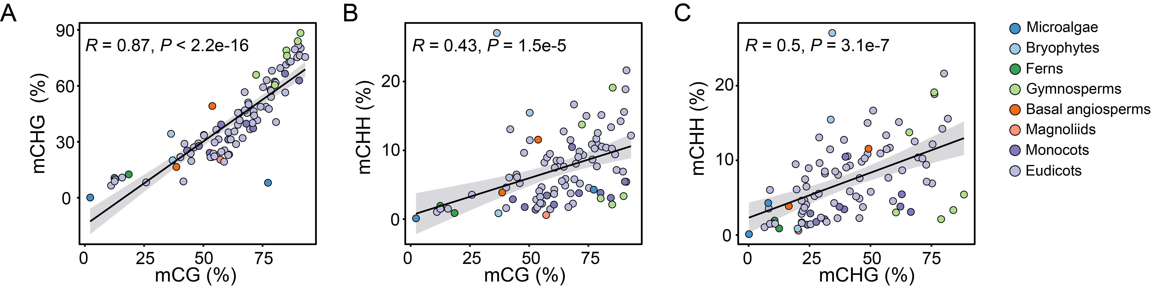
Supplementary Fig. 2 Coordinated variation of methylation levels across contexts.
Scatter plots showing pairwise correlations of global average methylation levels: (A) mCHG vs. mCG, (B) mCHH vs. mCG, and (C) mCHH vs. mCHG. Each dot represents a single species (n = 94). Pearson correlation coefficients (R) and P-values are indicated. The solid line represents the linear regression fit, with the shaded area indicating the 95% confidence interval.

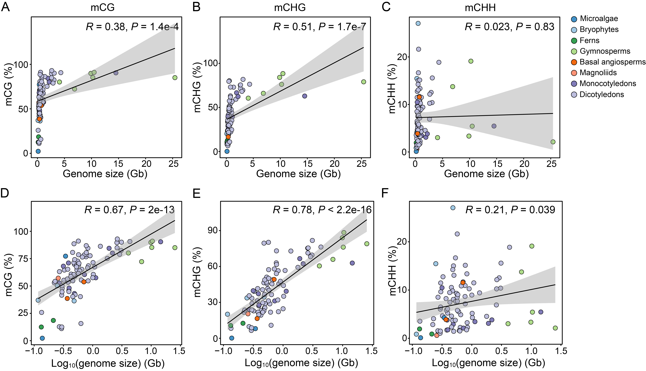
Supplementary Fig. 3 Relationship between genome size and methylation levels.
Scatter plots showing global methylation levels plotted against (A–C) raw and (D–F) log₁₀-transformed genome sizes. The specific contexts are (A, D) CG, (B, E) CHG, and (C, F) CHH. Pearson correlation coefficients (R) and P-values are provided.

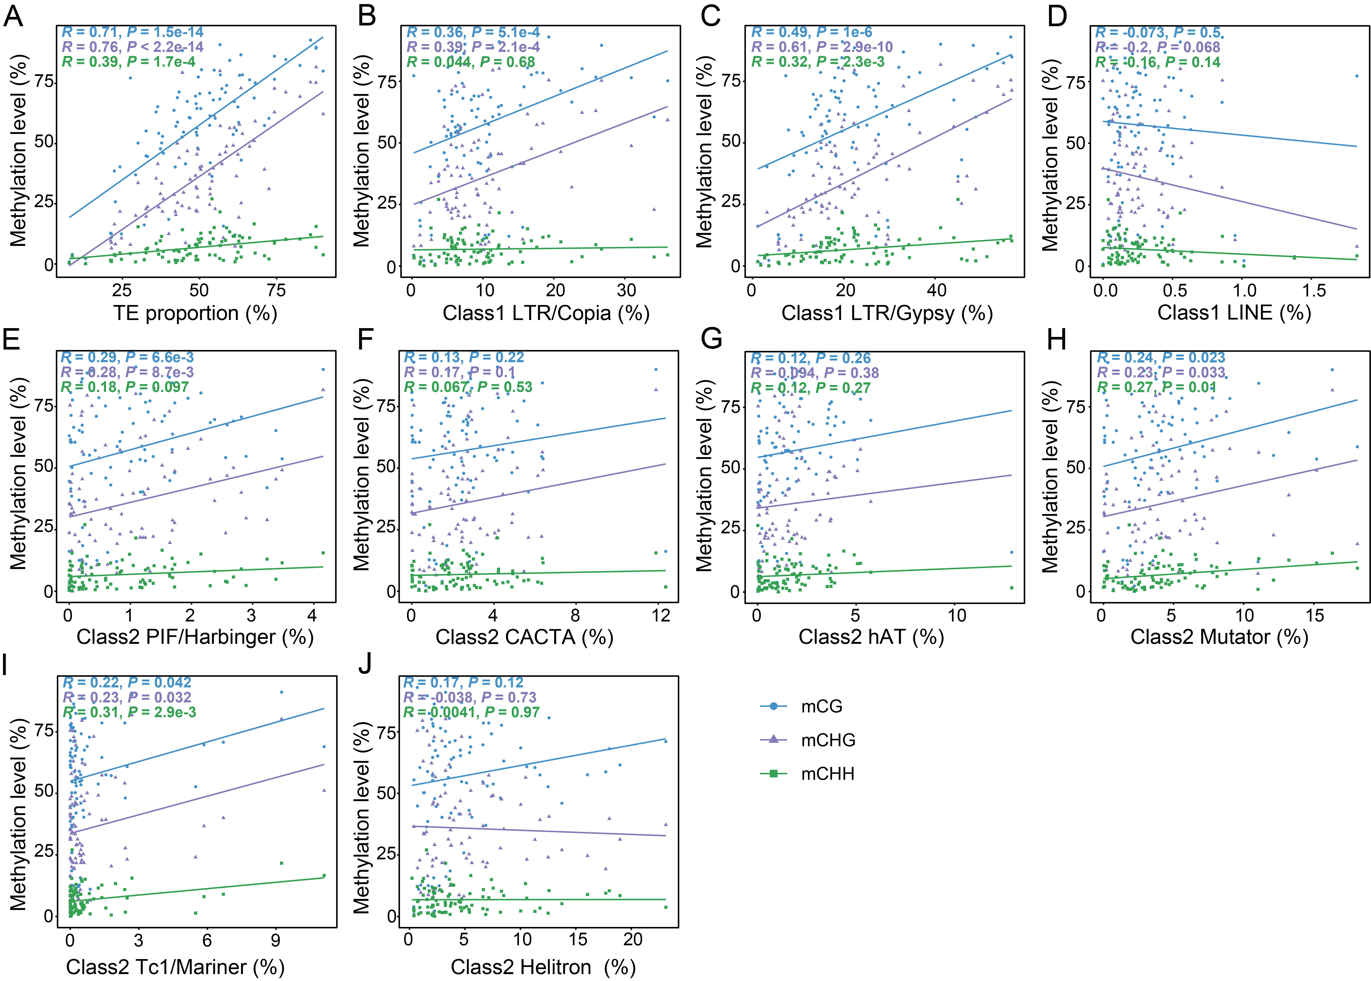
Supplementary Fig. 4 Associations between genomic proportions of transposable element (TE) superfamilies and methylation levels.
Scatter plots of global methylation levels (y-axis) versus the genomic proportions of specific TE types (x-axis) for the CG (blue), CHG (purple), and CHH (green) contexts. Panels show data for (A) total TE content; (B–D) Class I retrotransposons, including (B) long terminal repeat (LTR)/Copia, (C) LTR/Gypsy, and (D) LINE; and (E–J) Class II DNA transposons, including (E) PIF/Harbinger, (F) CACTA, (G) hAT, (H) Mutator, (I) Tc1/Mariner, and (J) Helitron. Pearson correlation coefficients (R) and P-values are color-coded according to methylation context. Solid lines indicate significant regression fits.

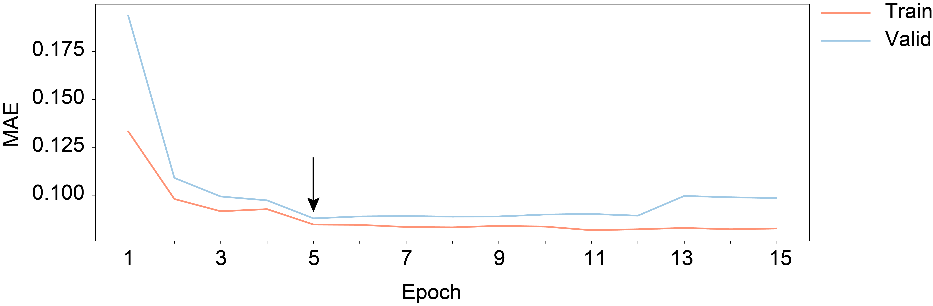
Supplementary Fig. 5 Learning curves of EvoPlantMeth. Mean absolute error (MAE) on the training (orange) and validation (blue) sets over 15 epochs. The arrow indicates the optimal model checkpoint at epoch 5 (MAE = 0.0879), selected via early stopping.

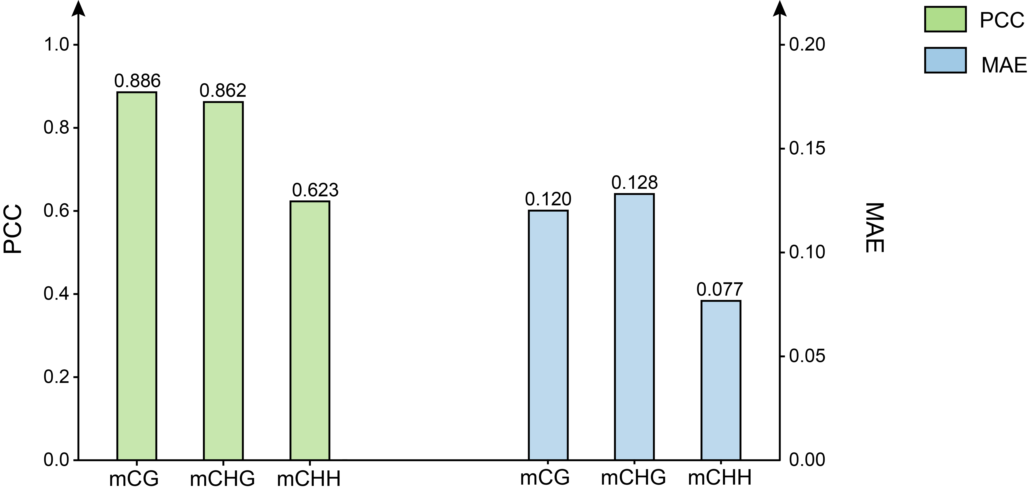
Supplementary Fig. 6 Model performance across different methylation contexts. Bar plots of Pearson correlation coefficient (PCC; green, left axis) and mean absolute error (MAE; blue, right axis) on the validation set for the methylation level of CG, CHG, and CHH contexts. Exact values are annotated above the bars.

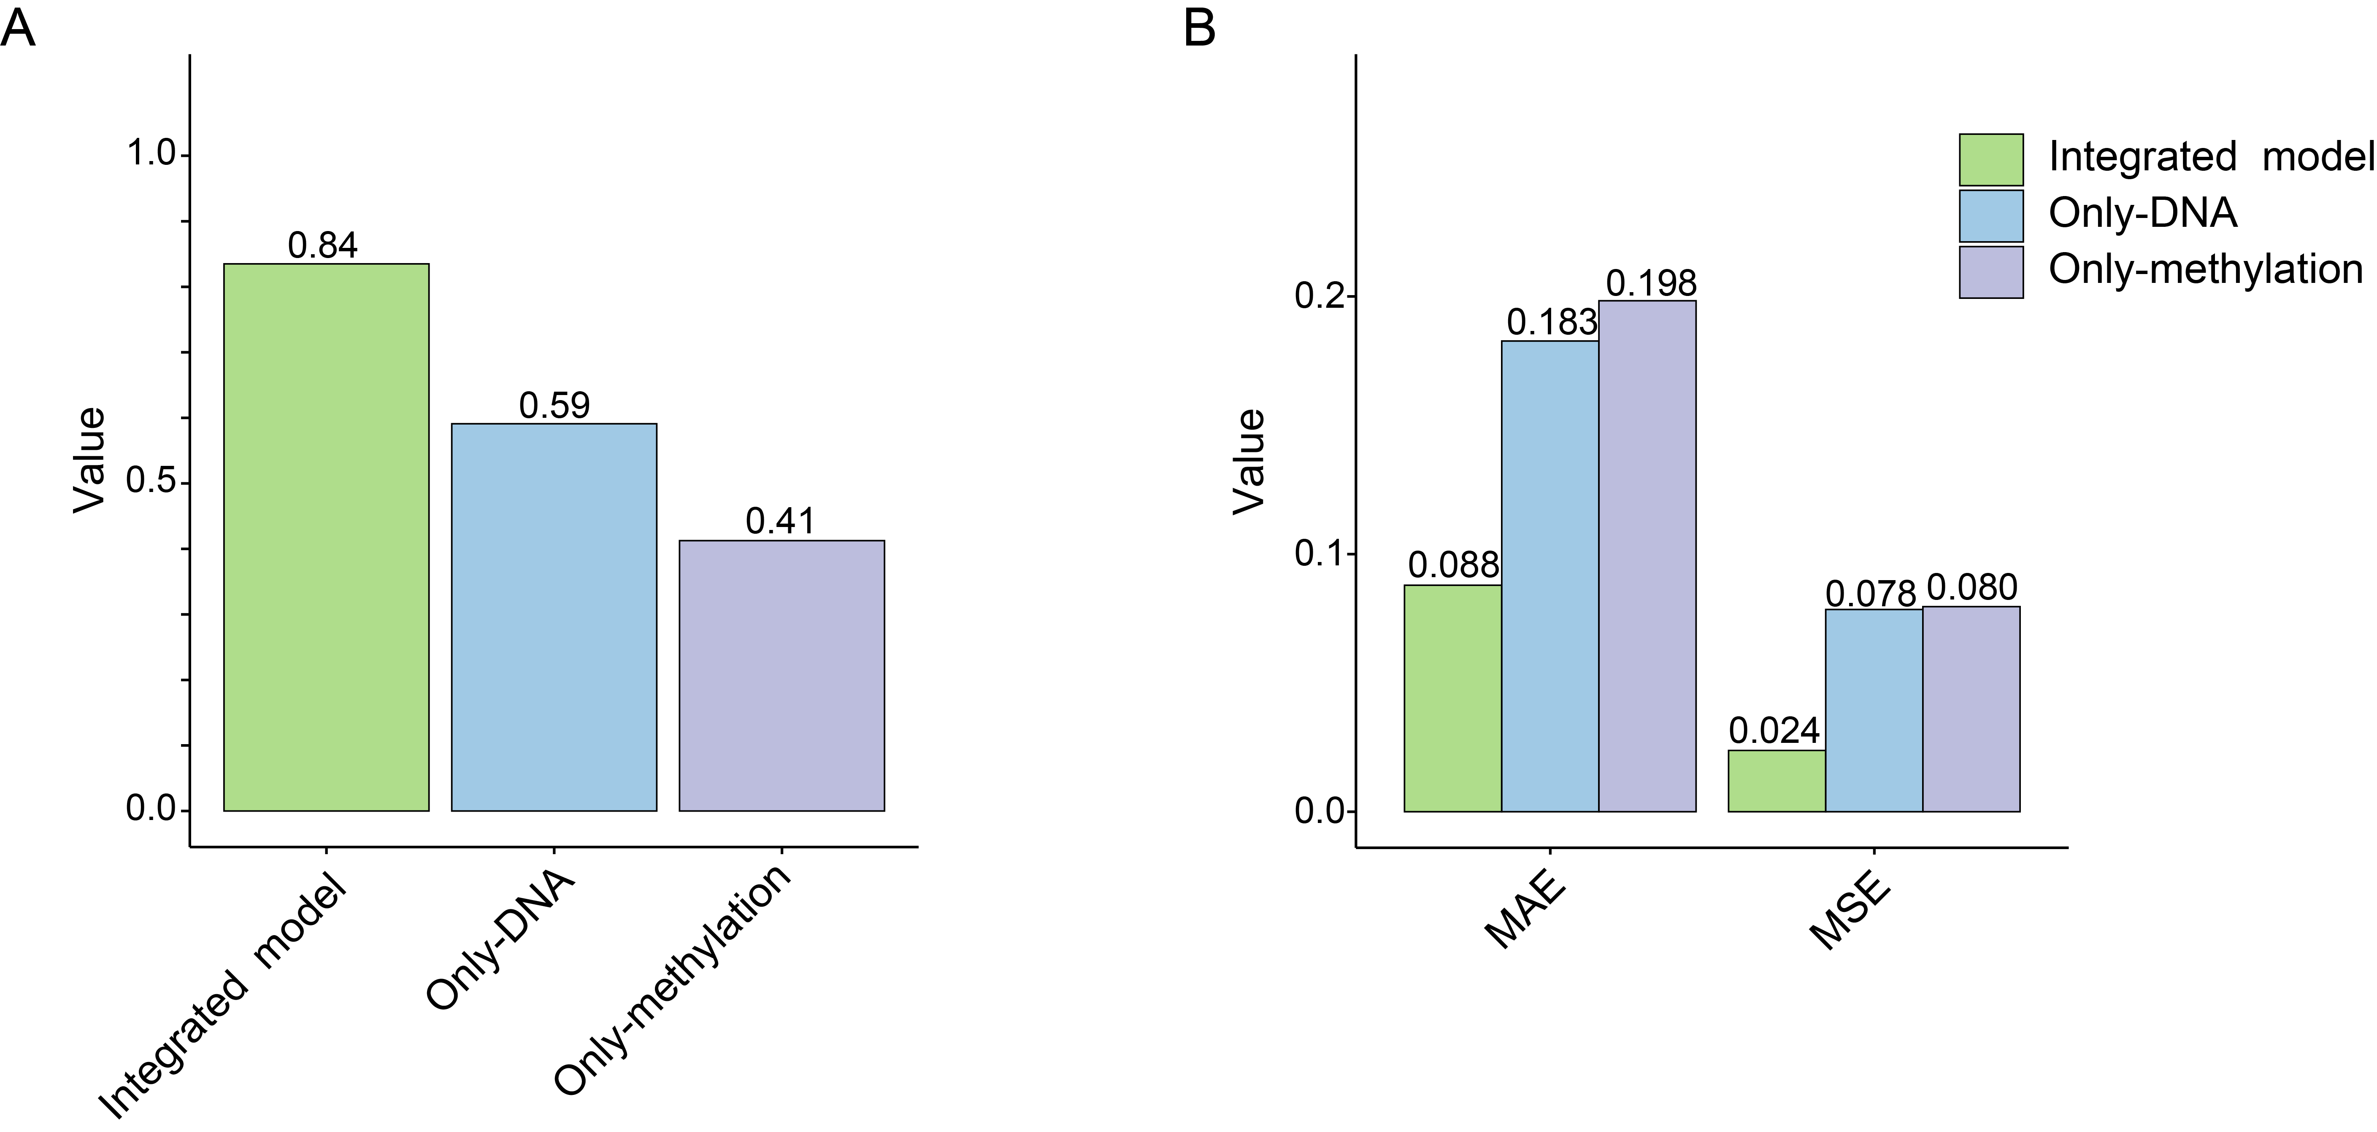
Supplementary Fig. 7 Ablation study of model components.
Performance comparison between the integrated EvoPlantMeth model and single-input variants (DNA-only and methylation-only) in terms of (A) the Pearson correlation coefficient (PCC) and (B) mean absolute error (MAE) and mean squared error (MSE).

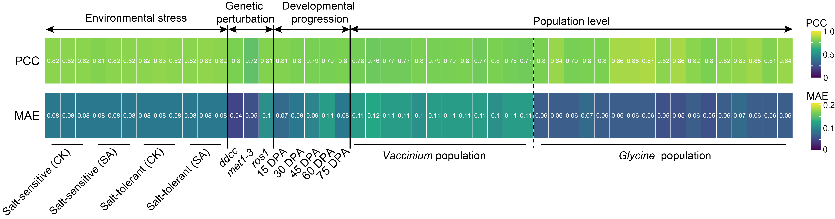
Supplementary Fig. 8 Predictive performance across diverse biological scenarios. Heatmap summarizing EvoPlantMeth performance, showing the Pearson correlation coefficient (PCC; top row) and mean absolute error (MAE; bottom row), with specific values annotated inside each cell. From left to right, the columns are categorized into four major biological contexts: (1) environmental stress, featuring salt-sensitive and salt-tolerant alfalfa (Medicago sativa) varieties under control (CK) and salt-stress (SA) conditions; (2) genetic perturbation, assessing Arabidopsis thaliana epigenetic mutants, specifically the ddcc quadruple mutant (drm1/2 and cmt2/3) along with met1-3 and ros1 lines; (3) developmental progression, tracking a fruit ripening time-series in blueberry (Vaccinium corymbosum) spanning 15, 30, 45, 60, and 75 days post-anthesis (DPA); and (4) population level, evaluating natural populations encompassing 12 Vaccinium (blueberry) and 17 Glycine (soybean) accessions, including cultivars, landraces, and wild varieties. Color scales on the right indicate the value ranges for PCC and MAE.

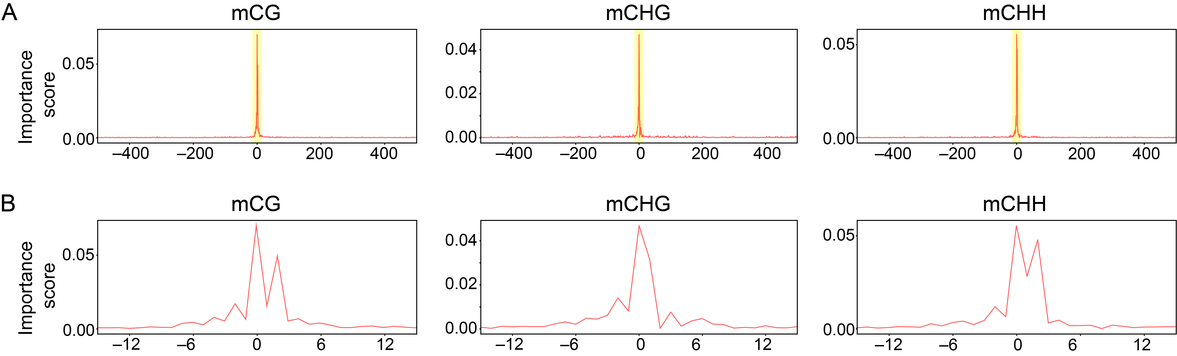
Supplementary Fig. 9 Multiscale distribution of EvoPlantMeth importance scores around methylated cytosines (mCs).
Line plots illustrating the gradient-based importance scores derived from EvoPlantMeth, centered on target mCs (position 0) across the CG, CHG, and CHH contexts. Importance scores reflect the normalized contribution of each nucleotide position to the model’s prediction. A Large-scale distribution of importance scores across a broad flanking genomic window (± 500 bp). High importance scores are observed at the target cytosine (position 0) and the immediately surrounding region, highlighted by the light orange-shaded region. B Magnified views of the orange-shaded regions in (A), showing importance scores within a ± 15 bp window around the target cytosine.

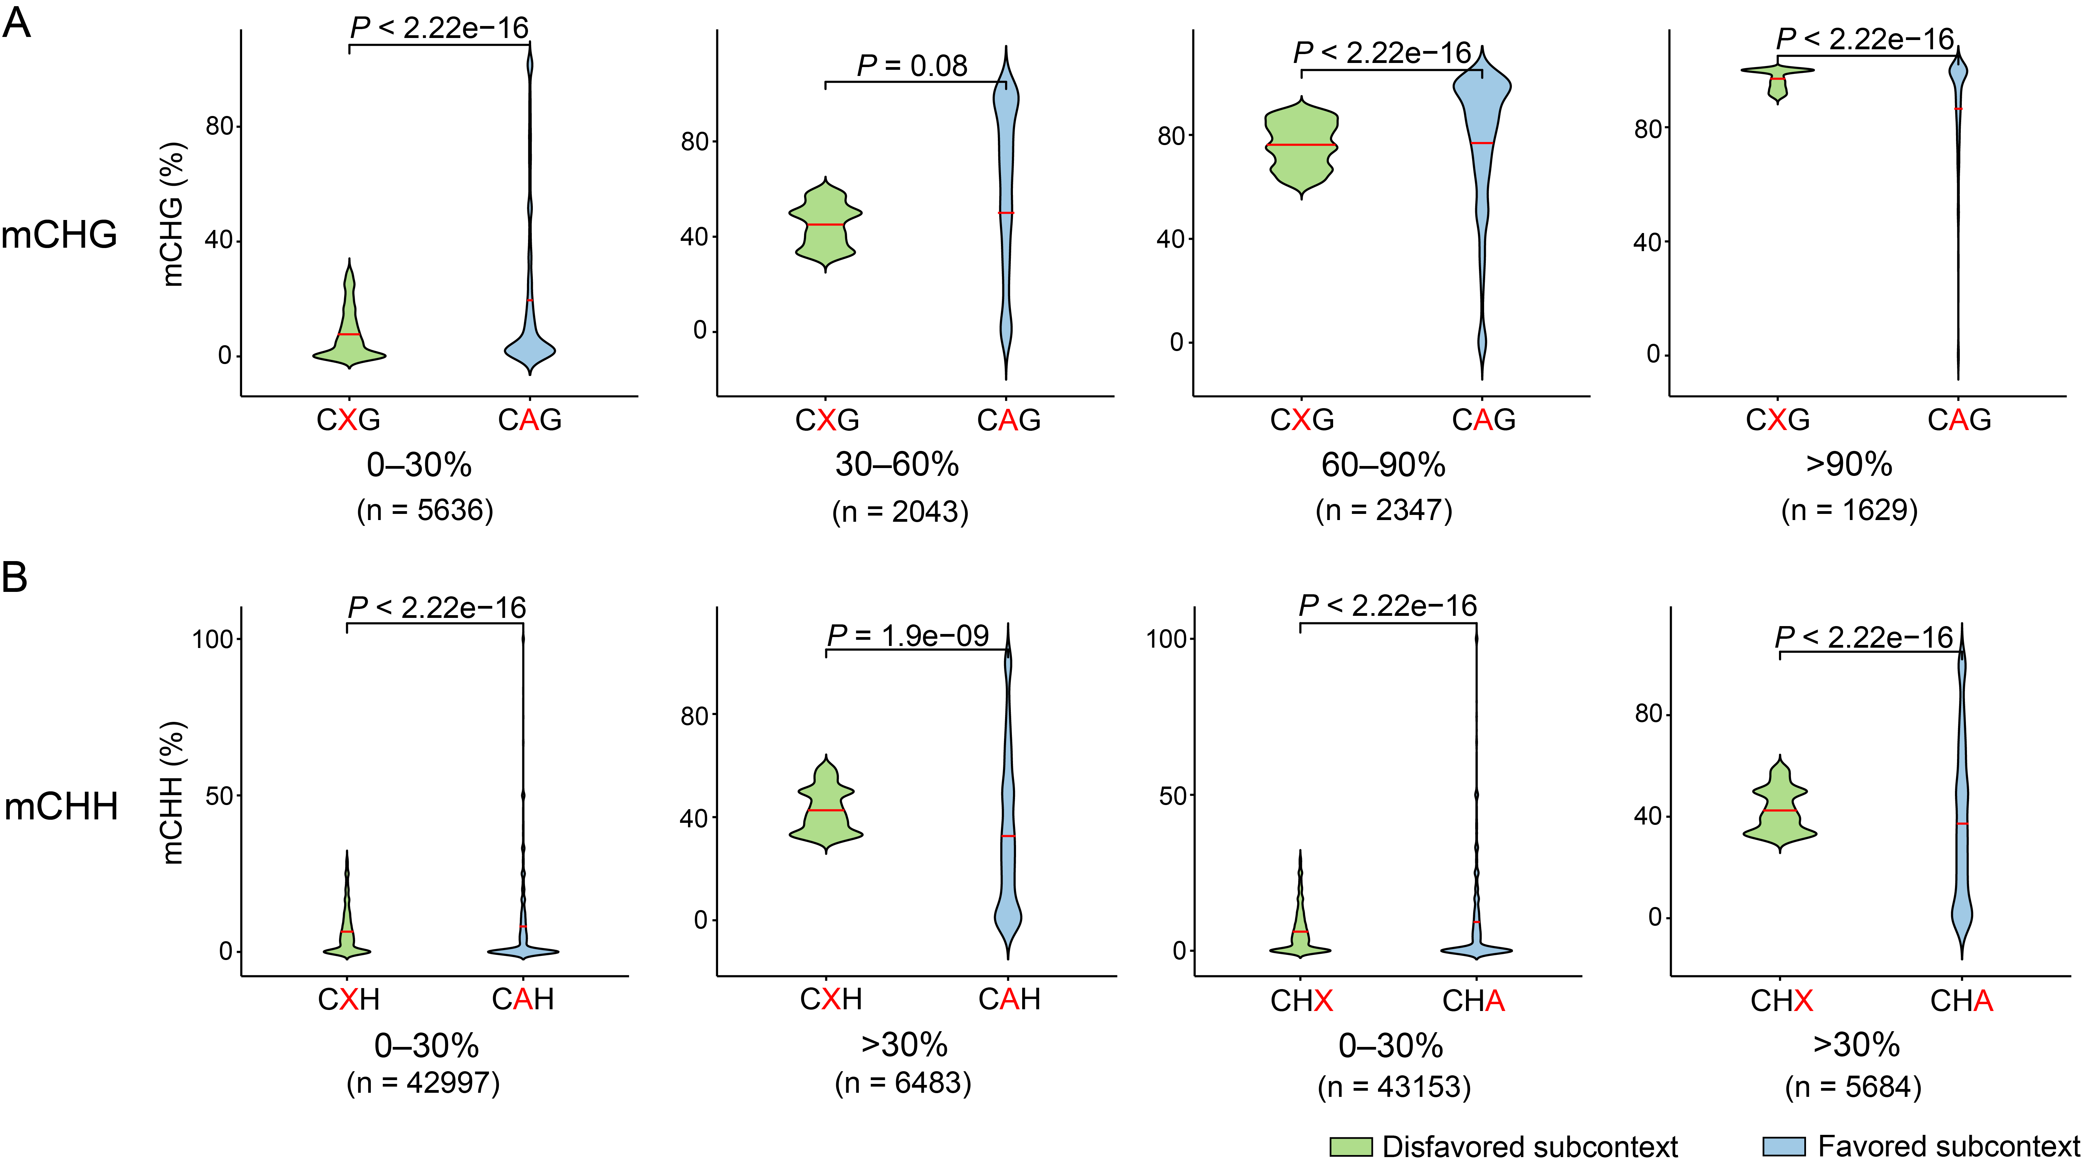
Supplementary Fig. 10 Genetic validation of sequence subcontexts for mCHG and mCHH.
Validation using naturally occurring single nucleotide polymorphisms (SNPs) in the blueberry population. Violin plots compare methylation levels between genotypes carrying the favored allele (blue, favored subcontext) versus alternative alleles (green, disfavored subcontext) at identical genomic loci for the (A) CHG and (B) CHH contexts. For the CHG context, the favored CAG allele is compared against alternative CXG alleles (where X = C or T) across four methylation strata (0–30%, 30–60%, 60–90%, and > 90%). For the CHH context, the favored CAH and CHA alleles are compared against alternative CXH and CHX alleles, respectively, across two bins (0–30% and > 30%). The number of analyzed loci (n) is indicated below each comparison. Red horizontal lines within the violins denote the mean methylation levels. P-values were calculated using the two-sided Wilcoxon signed-rank test.

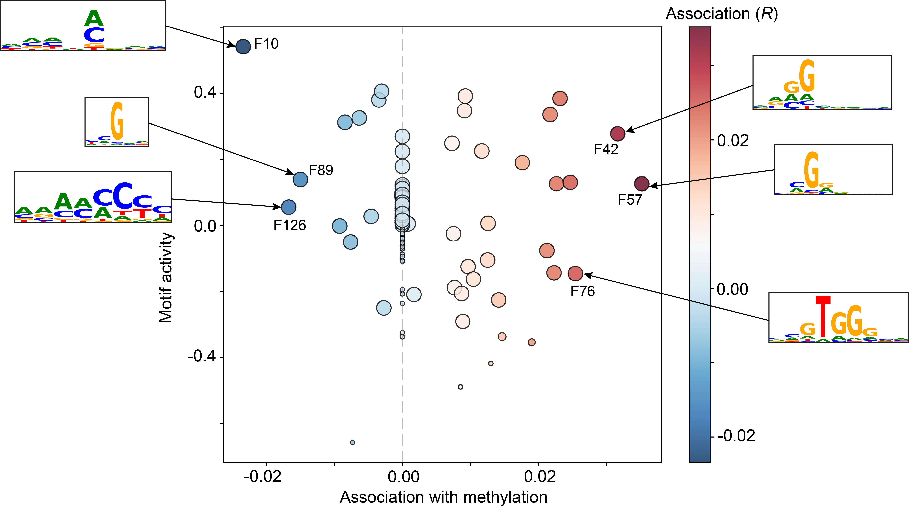
Supplementary Fig. 11 Identification of learned sequence motifs from convolutional filters. Scatter plot of 128 convolutional filters based on their association with methylation levels (x-axis, R) and overall motif activity (y-axis). Each circle represents an individual filter, with its size proportional to the number of genomic sites matching the corresponding motif. The color gradient reflects the direction and magnitude of the association, ranging from blue (negative correlation, indicating penalized contexts) to red (positive correlation, indicating favored contexts). Representative sequence logos for select filters (e.g., F10, F89, and F42) show the specific sequence patterns captured by the model.

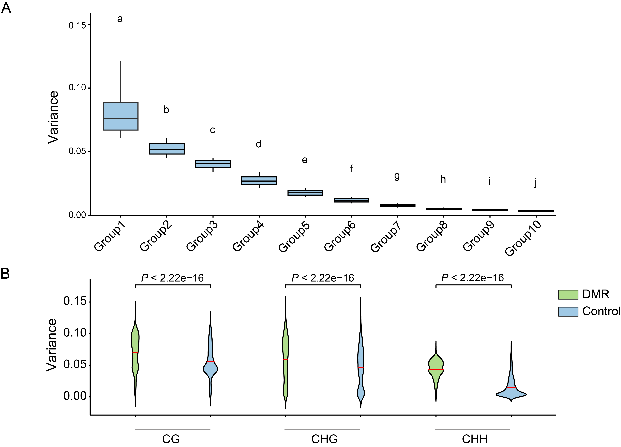
Supplementary Fig. 12 Validation of computationally inferred epigenetic plasticity using population-level methylation diversity.
A Correlation between actual methylation variation and model prediction variance. Genomic sites were ranked by their Shannon index—where higher values indicate greater natural methylation diversity—and divided into 10 groups, from highest (Group 1) to lowest (Group 10) actual diversity. Boxplots show that prediction variance steadily decreases as natural methylation diversity declines. Different letters above the boxes indicate significant differences (P < 0.05, Bonferroni correction) in multiple comparisons. B Comparison of prediction variance between differentially methylated regions (DMRs) and non-DMR controls. Violin plots demonstrate that biologically defined DMRs (green) consistently exhibit significantly higher prediction variance than control regions (blue) across all sequence contexts (two-sided Mann–Whitney–Wilcoxon test).

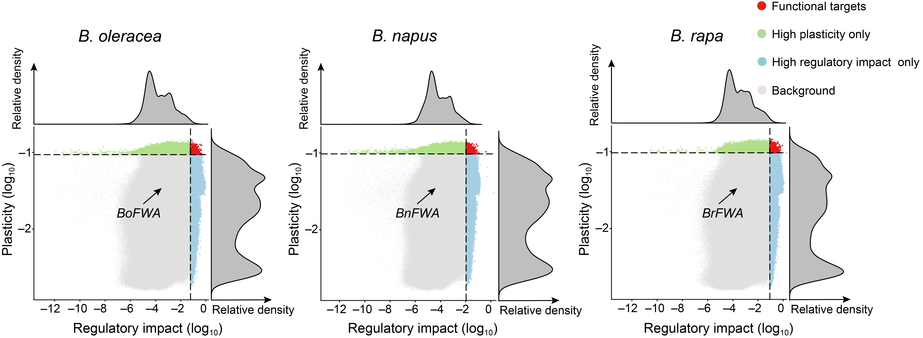
Supplementary Fig. 13 The “plasticity-impact” dual-dimensional framework in Brassica oleracea (left), B. napus (middle), and B. rapa (right). Scatter plots classify genomic sites based on their regulatory impact (x-axis) and epigenetic plasticity (y-axis). Top and right marginal density curves display the overall distributions of impact and plasticity, respectively. Putative functional regulatory elements (red quadrant) are defined by the intersection of the top 1% thresholds (dashed lines) for both parameters.

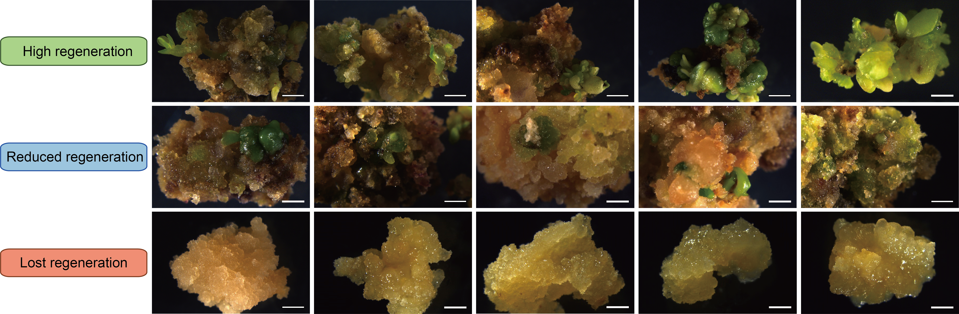
Supplementary Fig. 14 Representative images of alfalfa calli after shoot induction culture. The first, second, and third rows display the phenotypes of 35d, 63d, and 1-yr calli, representing high, reduced, and completely lost regeneration capacities, respectively. Five calli are shown for each group. Scale bars, 2 mm.

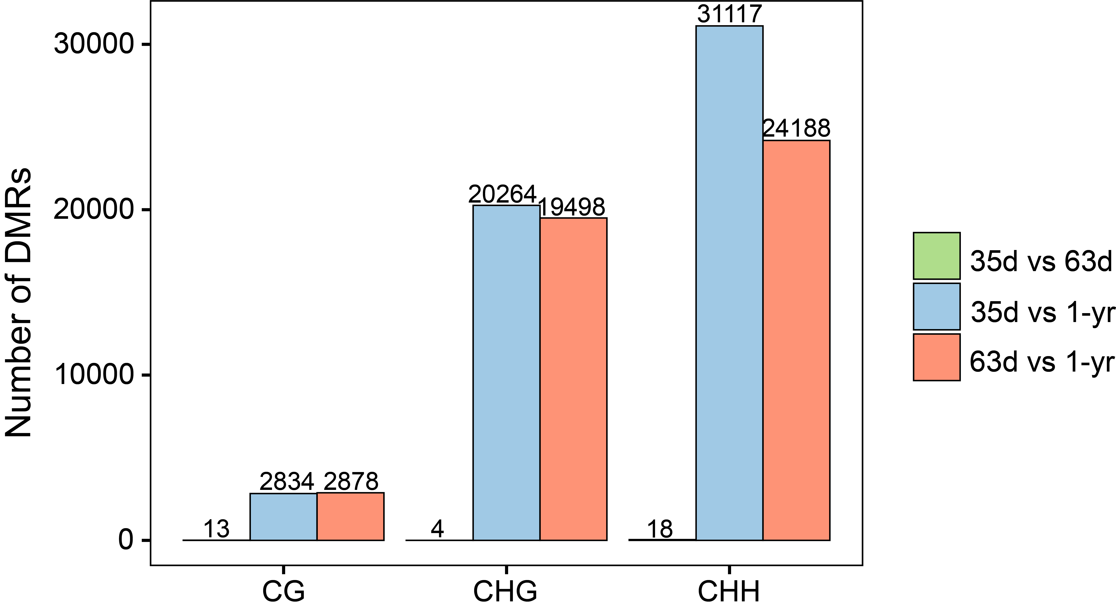
Supplementary Fig. 15 Quantification of differentially methylated regions (DMRs) across callus subculture stages. Bar plots illustrate the number of DMRs identified in CG, CHG, and CHH contexts for three pairwise comparisons: 35d vs. 63d (green), 35d vs. 1-yr (blue), and 63d vs. 1-yr (orange).

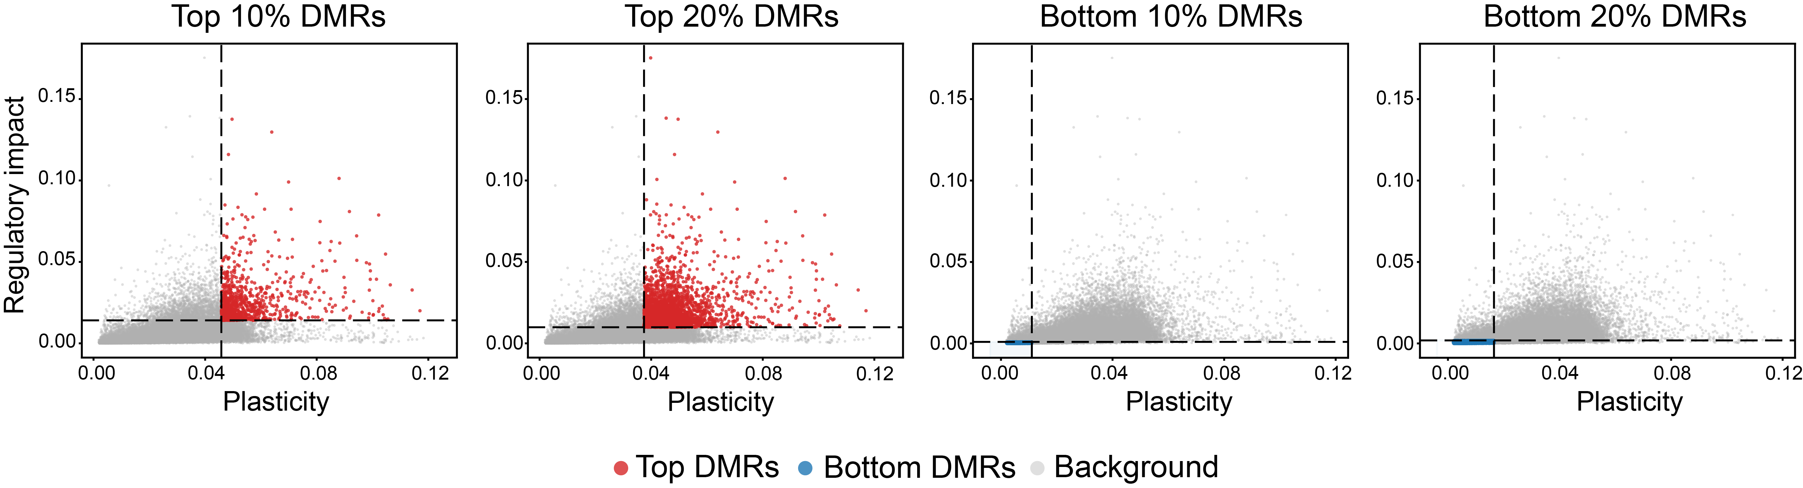
Supplementary Fig. 16 Identification of top and bottom differentially methylated regions (DMRs) in alfalfa through dual-dimensional framework. Scatter plots illustrate the classification of DMRs based on their epigenetic plasticity (x-axis) and regulatory impact (y-axis). From left to right, the panels display the selection of DMRs ranking in the top 10%, top 20%, bottom 10%, and bottom 20% for both parameters. Dashed lines indicate the corresponding percentile thresholds. Top DMRs (red dots) are defined by the intersection of the upper thresholds (top-right quadrant), whereas bottom DMRs (blue dots) are defined by the intersection of the lower thresholds (bottom-left quadrant). All other sites are designated as background (gray dots).

Supplementary Tables
Supplementary Table 1. Comprehensive profiling of the 94 plant species analyzed in this study, detailing taxonomic information, reference genome quality, and WGBS data statistics.
Species | Taxonomy | Reference | Coverage (%) | Depth (×)
Dunaliella salina | microalgea | Dunsal1 v. 2 | 69.50 | 8.64
Volvox carteri | microalgea | v1.0 | 80.21 | 3.55
Anthoceros agrestis | bryophytes | Anthoceros agrestis [Bonn] | 96.09 | 37.13
Marchantia polymorpha | bryophytes | MpTak1_v7.1 | 96.59 | 19.19
Physcomitrella patens | bryophytes | V6 | 89.46 | 6.18
Selaginella moellendorffii | fern | v1.0 | 65.31 | 1.76
Selaginella kraussiana | fern | Selaginella_kraussiana_v2 | 50.93 | 1.03
Taxus wallichiana | gymnosperm | Ta-2021 | 21.38 | 0.34
Pinus tabuliformis | gymnosperm | CPIR1 | 83.28 | 5.75
Cycas panzhihuaensis | gymnosperm | Cycas_panzhihuaensis | 63.34 | 1.38
Welwitschia mirabilis | gymnosperm | W.mirabilis.final.new | 80.44 | 21.59
Ginkgo biloba | gymnosperm | Gbi_Chr | 50.54 | 0.92
Gnetum montanum | gymnosperm | Gmm | 90.82 | 5.59
Nymphaea thermarum | basal angiosperms | ASM1179976v1 | 94.25 | 8.52
Amborella trichopoda | basal angiosperms | SantaCruz_75 HAP1 v2.1 | 17.55 | 0.22
Aristolochia fimbriata | magnoliids | ASM1984555v1 | 92.54 | 26.43
Musa acuminata | monocotyledons | Cavendish_Baxijiao_AAA | 93.78 | 4.76
Setaria viridis | monocotyledons | Setaria_viridis_v2.0 | 96.70 | 16.75
Brachypodium distachyon | monocotyledons | Brachypodium_distachyon_v3.0 | 98.70 | 26.03
Panicum hallii | monocotyledons | PhalliiHAL_v2.1 | 90.11 | 13.30
Elaeis guineensis | monocotyledons | EG11 | 85.72 | 7.75
Ananas comosus | monocotyledons | F153 | 89.41 | 30.29
Phyllostachys edulis | monocotyledons | Bamboo genome | 93.52 | 24.13
Zea mays | monocotyledons | Zm-Mo17-REFERENCE-CAU-2.0 | 97.97 | 20.77
Triticum aestivum | monocotyledons | CS-IAAS | 95.89 | 17.88
Sorghum bicolor | monocotyledons | Hongyingzi | 78.29 | 6.45
Oryza sativa | monocotyledons | AGIS-1.0 | 94.41 | 27.28
Panicum virgatum | monocotyledons | Genome assembly P.virgatum_v5 | 91.95 | 9.51
Manihot esculenta | dicotyledons | M.esculenta_v8 | 85.85 | 9.22
Medicago truncatula | dicotyledons | MtrunA17r5.0_ANR | 80.70 | 12.59
Cucumis sativus | dicotyledons | CLv4.0 | 88.09 | 34.97
Betula platyphylla | dicotyledons | Bplatyphylla_679_v1.0 | 85.25 | 21.42
Theobroma cacao | dicotyledons | ASM3589663v1 | 88.88 | 13.56
Avicennia marina | dicotyledons | Amar | 88.01 | 29.03
Casuarina cunninghamiana | dicotyledons | Casuarina cunninghamiana | 91.36 | 11.74
Casuarina equisetifolia | dicotyledons | Casuarina equisetifolia | 97.42 | 24.18
Casuarina glauca | dicotyledons | Casuarina glauca | 90.84 | 24.18
Vitis Vinifera | dicotyledons | ASM3070453v1 | 92.51 | 14.79
Mangifera indica | dicotyledons | CATAS_Mindica_2.1 | 97.15 | 47.30
Fragaria vesca | dicotyledons | F._vesca_v6.0 | 96.23 | 17.65
Prunus persica | dicotyledons | Prunus_persica_NCBIv2 | 95.07 | 30.06
Fragaria x ananassa | dicotyledons | Fana_Yuexin | 97.17 | 43.93
Eutrema salsugineum | dicotyledons | Eutrema salsugineum | 94.74 | 17.64
Arabidopsis thaliana | dicotyledons | Col-PEK | 91.73 | 13.12
Diospyros lotus | dicotyledons | ASM1463336v1 | 97.11 | 40.22
Eucalyptus grandis | dicotyledons | ASM1654582v1 | 74.52 | 3.42
Populus trichocarpa | dicotyledons | Pop_tri_v4 | 97.55 | 22.70
Citrus clementina | dicotyledons | Citrus_clementina_v1.0 | 95.06 | 13.55
Citrus x limon | dicotyledons | lemon | 87.71 | 26.09
Ricinus communis | dicotyledons | Rc039 | 92.27 | 9.45
Glycine soja | dicotyledons | Gso | 94.97 | 13.49
Phaseolus vulgaris | dicotyledons | P. vulgaris v2.0 | 95.99 | 12.15
Lotus japonicus | dicotyledons | LjGifu_v1.2 | 81.08 | 7.42
Juglans mandshurica | dicotyledons | Jman | 94.96 | 20.53
Juglans regia | dicotyledons | Walnut 2.0 | 75.67 | 4.92
Cucumis melo | dicotyledons | MPI assembly | 92.68 | 19.62
Citrullus lanatus | dicotyledons | G42 | 95.16 | 6.61
Quercus lobata | dicotyledons | ValleyOak3.0 | 95.90 | 19.53
Nelumbo nucifera | dicotyledons | CA3.0 | 98.69 | 19.60
Actinidia chinensis | dicotyledons | DH hap1 | 99.47 | 72.30
Fragaria nilgerrensis | dicotyledons | Yunnan | 96.30 | 45.51
Malus domestica | dicotyledons | GDT2T_hap1 | 93.00 | 15.66
Pyrus pyrifolia | dicotyledons | Yunhong No. 1 | 94.05 | 11.79
Brassica rapa | dicotyledons | B. rapa Chiifu v4.0 | 97.54 | 54.95
Salvia miltiorrhiza | dicotyledons | IMPLAD_Smil_shh | 88.20 | 16.42
Cannabis sativa | dicotyledons | ASM2916894v1 | 79.18 | 5.57
Vigna mungo | dicotyledons | ASM3688567v1 | 57.38 | 6.44
Arachis hypogaea | dicotyledons | YZ9102 T2T | 95.25 | 7.40
Arachis duranensis | dicotyledons | aradu.V14167.gnm2.J7QH | 76.97 | 12.01
Glycine max | dicotyledons | Gma | 96.32 | 14.94
Arachis ipaensis | dicotyledons | Araip1.1 | 91.25 | 14.04
Vaccinium darrowii | dicotyledons | USDA_Vadar_1.0_pri | 94.14 | 55.06
Vaccinium corymbosum | dicotyledons | draper v1 | 97.83 | 27.66
Catharanthus roseus | dicotyledons | ASM2450571v1 | 95.75 | 73.66
Gossypium raimondii | dicotyledons | T2T | 88.63 | 15.88
Lactuca sativa | dicotyledons | L. sativa cv. PKU06 T2T | 91.53 | 5.81
Fagopyrum tataricum | dicotyledons | Pinku1 | 98.41 | 38.82
Fraxinus excelsior | dicotyledons | F35 | 70.60 | 4.89
Solanum lycopersicum | dicotyledons | SL3.0 | 89.93 | 27.57
Solanum tuberosum | dicotyledons | SolTub_3.0 | 89.47 | 14.72
Capsicum annuum | dicotyledons | Capsicum annuum T2T | 96.61 | 37.78
Nicotiana tabacum | dicotyledons | ASM71507v2 | 98.72 | 49.48
Lonicera japonica | dicotyledons | jyh | 95.29 | 19.22
Camellia sinensis | dicotyledons | Camellia_sinensis_Zijuan | 90.33 | 12.36
Camellia oleifera | dicotyledons | CON_genome_data | 93.63 | 29.20
Brassica oleracea | dicotyledons | BobV2 | 92.70 | 47.40
Brassica napus | dicotyledons | Da-Ae | 92.57 | 32.75
Silene latifolia | dicotyledons | S. latifolia | 95.91 | 14.52
Acer palmatum | dicotyledons | Acer_palmatum | 94.79 | 14.34
Acer rubrum | dicotyledons | Acer_rubrum | 97.51 | 17.50
Acer yangbiense | dicotyledons | AYv1.1 | 96.10 | 19.92
Beta vulgaris | dicotyledons | EL10.2 | 56.23 | 5.83
Ipomoea aquatica | dicotyledons | Ipomoea_aquatica_TC01 | 96.32 | 18.32
Citrus sinensis | dicotyledons | DVS_A1.0 | 99.01 | 39.16

Supplementary Table 2. Evaluation datasets and comprehensive predictive performance metrics of EvoPlantMeth across diverse biological conditions.
Species | WGBS data | Description of WGBS data
Arabidopsis thaliana | SRR1970650 | ros1, seedlings
Arabidopsis thaliana | SRR15859982 | ddcc, mature leaves
Arabidopsis thaliana | SRR15859983 | met1-3, mature leaves
Medicago sativa | SRR32030060 | salt-tolerant, salt stress
Medicago sativa | SRR32030061 | salt-tolerant, CK
Medicago sativa | SRR32030062 | salt-tolerant, CK
Medicago sativa | SRR32030063 | salt-tolerant, CK
Medicago sativa | SRR32030064 | salt-sensitive, salt stress
Medicago sativa | SRR32030065 | salt-sensitive, salt stress
Medicago sativa | SRR32030066 | salt-sensitive, salt stress
Medicago sativa | SRR32030067 | salt-sensitive, CK
Medicago sativa | SRR32030068 | salt-tolerant, salt stress
Medicago sativa | SRR32030069 | salt-tolerant, salt stress
Medicago sativa | SRR32030070 | salt-sensitive, CK
Medicago sativa | SRR32030071 | salt-sensitive, CK

Supplementary Table 3. Metadata and regeneration capacity groupings for the independent cohort of 40 alfalfa individuals.
Sample | Regeneration efficiency | Group
D8 | 1.00 | High regeneration efficiency
D104 | 0.97 | High regeneration efficiency
B6 | 0.97 | High regeneration efficiency
B199 | 0.94 | High regeneration efficiency
D156 | 0.94 | High regeneration efficiency
B36 | 0.90 | High regeneration efficiency
D86 | 0.90 | High regeneration efficiency
D171 | 0.88 | High regeneration efficiency
D157 | 0.85 | High regeneration efficiency
D20 | 0.83 | High regeneration efficiency
B188 | 0.74 | High regeneration efficiency
B198 | 0.74 | High regeneration efficiency
B197 | 0.72 | High regeneration efficiency
D150 | 0.69 | High regeneration efficiency
D27 | 0.68 | High regeneration efficiency
B161 | 0.68 | High regeneration efficiency
B180 | 0.68 | High regeneration efficiency
B19 | 0.66 | High regeneration efficiency
D96 | 0.64 | High regeneration efficiency
B5 | 0.64 | High regeneration efficiency
B135 | 0.15 | Low regeneration efficiency
D181 | 0.04 | Low regeneration efficiency
D4 | 0.04 | Low regeneration efficiency
D13 | 0.03 | Low regeneration efficiency
D15 | 0.03 | Low regeneration efficiency
B125 | 0.03 | Low regeneration efficiency
D160 | 0.02 | Low regeneration efficiency
B182 | 0.01 | Low regeneration efficiency
B191 | 0.01 | Low regeneration efficiency
D187 | 0.01 | Low regeneration efficiency
D184 | 0.01 | Low regeneration efficiency
B59 | 0.00 | Low regeneration efficiency
C6 | 0.00 | Low regeneration efficiency
B39 | 0.00 | Low regeneration efficiency
B84 | 0.00 | Low regeneration efficiency
D25 | 0.00 | Low regeneration efficiency
D40 | 0.00 | Low regeneration efficiency
D87 | 0.00 | Low regeneration efficiency
D159 | 0.00 | Low regeneration efficiency
D189 | 0.00 | Low regeneration efficiency
D189 | 0.00 | Low regeneration efficiency

