Supplement
Efficacy and Safety of Mazdutide in Adults with Obesity or Overweight, With or Without Diabetes: A Bayesian Network Meta-Analysis
Adili Tuersun^{1,2}, Xinyi Hu¹, Shan Wang¹, Liyuan Pang¹, Qiuxia Yu¹, Yu Zhong¹, Haiyang Liu¹, Yulin Wu¹, Lixin Hua*³, Guo Ma*^{1,2}

Table of contents
Appendix 1. PRISMA 2020 Checklist of Items to Include. 2
eTable 1: Search Strategy. 5
eTable 2: Publication Bias Assessment Using Eggger's and Begg's Tests. 6
eTable 3: Results of Heterogeneity and Inconsistency Detection. 7
eTable 4: Detailed Results of Consistency Model Fit and Inconsistency Assessment for All Outcomes. 12
eTable 5: Results of Subgroup Analysis by Diabetes Status. 13
eTable 6: Results of Network Meta-regression by Diabetes Status. 17
eTable 7: Node-Splitting Analysis for Assessment of Local Inconsistency Across All Outcomes. 21
eFigure 1: Risk of bias assessment. 24
eFigure 2: Funnel plots for Different Interventions. 25
eFigure 3: Trace and density plots for the network meta-analysis of Different outcomes. 27
eFigure 4: Gelman–Rubin convergence diagnostics for all outcomes. 36
A 36
eFigure 5: Leverage-versus-Deviance Scatter Plot for Assessment of Model Fit. 45

Appendix 1. PRISMA 2020 Checklist of Items to Include.
Section and Topic | Item # | Checklist item | Location where item is reported
TITLE
Title | 1 | Identify the report as a systematic review. | 1
ABSTRACT
Abstract | 2 | See the PRISMA 2020 for Abstracts checklist. | 3-4
INTRODUCTION
Rationale | 3 | Describe the rationale for the review in the context of existing knowledge. | 5-7
Objectives | 4 | Provide an explicit statement of the objective(s) or question(s) the review addresses. | 5-7
METHODS
Eligibility criteria | 5 | Specify the inclusion and exclusion criteria for the review and how studies were grouped for the syntheses. | 7-8
Information sources | 6 | Specify all databases, registers, websites, organisations, reference lists and other sources searched or consulted to identify studies. Specify the date when each source was last searched or consulted. | 7
Search strategy | 7 | Present the full search strategies for all databases, registers and websites, including any filters and limits used. | eTable 1
Selection process | 8 | Specify the methods used to decide whether a study met the inclusion criteria of the review, including how many reviewers screened each record and each report retrieved, whether they worked independently, and if applicable, details of automation tools used in the process. | 7
Data collection process | 9 | Specify the methods used to collect data from reports, including how many reviewers collected data from each report, whether they worked independently, any processes for obtaining or confirming data from study investigators, and if applicable, details of automation tools used in the process. | 7-8
Data items | 10a | List and define all outcomes for which data were sought. Specify whether all results that were compatible with each outcome domain in each study were sought (e.g. for all measures, time points, analyses), and if not, the methods used to decide which results to collect. | 8
Data items | 10b | List and define all other variables for which data were sought (e.g. participant and intervention characteristics, funding sources). Describe any assumptions made about any missing or unclear information. | 8
Study risk of bias assessment | 11 | Specify the methods used to assess risk of bias in the included studies, including details of the tool(s) used, how many reviewers assessed each study and whether they worked independently, and if applicable, details of automation tools used in the process. | 8
Effect measures | 12 | Specify for each outcome the effect measure(s) (e.g. risk ratio, mean difference) used in the synthesis or presentation of results. | 9-10
Synthesis methods | 13a | Describe the processes used to decide which studies were eligible for each synthesis (e.g. tabulating the study intervention characteristics and comparing against the planned groups for each synthesis (item #5)). | 9-10
Synthesis methods | 13b | Describe any methods required to prepare the data for presentation or synthesis, such as handling of missing summary statistics, or data conversions. | 9-10
Synthesis methods | 13c | Describe any methods used to tabulate or visually display results of individual studies and syntheses. | 9-10
Synthesis methods | 13d | Describe any methods used to synthesize results and provide a rationale for the choice(s). If meta-analysis was performed, describe the model(s), method(s) to identify the presence and extent of statistical heterogeneity, and software package(s) used. | 10
Synthesis methods | 13e | Describe any methods used to explore possible causes of heterogeneity among study results (e.g. subgroup analysis, meta-regression). | 9
Synthesis methods | 13f | Describe any sensitivity analyses conducted to assess robustness of the synthesized results. | eTable 5
Reporting bias assessment | 14 | Describe any methods used to assess risk of bias due to missing results in a synthesis (arising from reporting biases). | 8
Certainty assessment | 15 | Describe any methods used to assess certainty (or confidence) in the body of evidence for an outcome. | 9-10
RESULTS
Study selection | 16a | Describe the results of the search and selection process, from the number of records identified in the search to the number of studies included in the review, ideally using a flow diagram. | 10, Figure 1
Study selection | 16b | Cite studies that might appear to meet the inclusion criteria, but which were excluded, and explain why they were excluded. | Figure 1
Study characteristics | 17 | Cite each included study and present its characteristics. | Table 1
Risk of bias in studies | 18 | Present assessments of risk of bias for each included study. | eFigure 1
Results of individual studies | 19 | For all outcomes, present, for each study: (a) summary statistics for each group (where appropriate) and (b) an effect estimate and its precision (e.g. confidence/credible interval), ideally using structured tables or plots. | Figure 3, Figure 4
Results of syntheses | 20a | For each synthesis, briefly summarise the characteristics and risk of bias among contributing studies. | eFigure 2
Results of syntheses | 20b | Present results of all statistical syntheses conducted. If meta-analysis was done, present for each the summary estimate and its precision (e.g. confidence/credible interval) and measures of statistical heterogeneity. If comparing groups, describe the direction of the effect. | Figure 3
Results of syntheses | 20c | Present results of all investigations of possible causes of heterogeneity among study results. | eTable 3, eTable 4
Results of syntheses | 20d | Present results of all sensitivity analyses conducted to assess the robustness of the synthesized results. | eTable 6
Reporting biases | 21 | Present assessments of risk of bias due to missing results (arising from reporting biases) for each synthesis assessed. | eTable 2
Certainty of evidence | 22 | Present assessments of certainty (or confidence) in the body of evidence for each outcome assessed. | Figure 3
DISCUSSION
Discussion | 23a | Provide a general interpretation of the results in the context of other evidence. | 21
Discussion | 23b | Discuss any limitations of the evidence included in the review. | 24
Discussion | 23c | Discuss any limitations of the review processes used. | 24
Discussion | 23d | Discuss implications of the results for practice, policy, and future research. | 24-25
OTHER INFORMATION
Registration and protocol | 24a | Provide registration information for the review, including register name and registration number, or state that the review was not registered. | 7
Registration and protocol | 24b | Indicate where the review protocol can be accessed, or state that a protocol was not prepared. | None
Registration and protocol | 24c | Describe and explain any amendments to information provided at registration or in the protocol. | None
Support | 25 | Describe sources of financial or non-financial support for the review, and the role of the funders or sponsors in the review. | 27
Competing interests | 26 | Declare any competing interests of review authors. | 26
Availability of data, code and other materials | 27 | Report which of the following are publicly available and where they can be found: template data collection forms; data extracted from included studies; data used for all analyses; analytic code; any other materials used in the review. | 26

eTable 1: Search Strategy.
Database | Search strategy
PubMed | #1 (((Mazdutide[Title/Abstract]) OR (IBI362[Title/Abstract])) OR (LY3305677[Title/Abstract])) AND (Randomized Controlled Trial[Publication Type])
Web of Science | #1 Mazdutide (Topic)  #2 IBI362 (Topic)  #3 LY3305677 (Topic)  #4 #1 OR #2 OR #3  #5 Randomized Controlled Trial (Topic)  #6 #4 AND #5
EMBASE | #1 mazdutide/  #2 (IBI362 or LY3305677).ab,ti,kw.  #3 1 or 2  #4 randomized controlled trial/  #5 3 and 4
Cochrane Library | #1 (Mazdutide or IBI362 or LY3305677):ti,ab,kw
ClinicalTrail. gov | #1 Mazdutide OR IBI362 OR LY3305677

eTable 2: Publication Bias Assessment Using Eggger's and Begg's Tests.
Outcome Measure | Egger's Test |  | Begg's Test
Outcome Measure | Coefficient (b) | P-value | Z-value | P-value
WC | -0.370 | 0.942 | -0.010 | 1.000
BW | -3.043 | 0.480 | 0.810 | 0.417
BMI | 3.799 | 0.137 | 0.480 | 0.634
SBP | 0.193 | 0.813 | 0.370 | 0.711
DBP | 0.500 | 0.455 | 0.020 | 0.982
HbA1c | 1.301 | 0.228 | 0.300 | 0.761
FPG | 0.827 | 0.311 | 0.300 | 0.761
LDL | 0.098 | 0.268 | 0.070 | 0.948
HDL | 0.768 | 0.491 | 0.900 | 0.366
TC | 0.678 | 0.476 | 0.660 | 0.509
TG | 29.6 | 0.161 | 0.110 | 0.914
ALT | 2.542 | 0.065 | 1.44 | 0.149
AE | 0.4976 | 0.265 | 0.25 | 0.799
SAE | 0.056 | 0.808 | 0.440 | 0.660
Gastrointestinal Disorders | 0.965 | 0.167 | 0.100 | 0.922
Hypoglycemia | 0.259 | 0.449 | 0.550 | 0.584
Decreased Appetite | 0.835 | 0.156 | 0.071 | 0.475
Note: Egger's test: Linear regression of standardized effect vs. precision (1/SE). Begg's test: Rank correlation test between standardized effect and variance. Significant correlation (P < 0.05) indicates potential publication bias.
Abbreviations: P-value, Probability Value; WC, Waist circumference; BW, body weight; BMI, Body Mass Index; SBP, Systolic Blood Pressure; DBP, Diastolic Blood Pressure; HbA1c, Glycated hemoglobin; FPG, Fasting Plasma glucose; LDL, Low-density lipoprotein cholesterol; HDL, High-density lipoprotein cholesterol; TC, Total Cholesterol; TG, Triglyceride; ALT, Alanine Aminotransferase; AE, Adverse Event; SAE, Serious Adverse Event.

eTable 3: Results of Heterogeneity and Inconsistency Detection.
WC |  |  |  |  | BW |  |  |  |  | BMI
t1 | t2 | i2. pair | i2. cons | incons.  p | t1 | t2 | i2. pair | i2.cons | incons.  p | t1 | t2 | i2. pair | i2.cons | incons.  p
Dulaglutide1.5mg | Mazdutide3mg | 0.00000 | 0.00000 | 0.853280 | Dulaglutide1.5mg | Mazdutide3mg | 0.00000 | 0.00000 | 0.702241 | Dulaglutide1.5mg | Mazdutide3mg | NA | NA | NA
Dulaglutide1.5mg | Mazdutide4.5mg | 0.00000 | 0.00000 | 0.458228 | Dulaglutide1.5mg | Mazdutide4.5mg | 0.00000 | 27.19262 | 0.447905 | Dulaglutide1.5mg | Mazdutide4.5mg | NA | NA | NA
Dulaglutide1.5mg | Mazdutide4mg | NA | 0.00000 | 0.906750 | Dulaglutide1.5mg | Mazdutide4mg | NA | 0.00000 | 0.926205 | Dulaglutide1.5mg | Mazdutide4mg | NA | NA | NA
Dulaglutide1.5mg | Mazdutide6mg | 0.00000 | 0.00000 | NA | Dulaglutide1.5mg | Mazdutide6mg | 0.00000 | 0.00000 | NA | Dulaglutide1.5mg | Mazdutide6mg | NA | NA | NA
Dulaglutide1.5mg | Placebo | 0.00000 | 0.00000 | 0.294080 | Dulaglutide1.5mg | Placebo | 0.00000 | 57.27187 | 0.141551 | Dulaglutide1.5mg | Placebo | NA | NA | NA
Mazdutide10mg | Mazdutide9mg | NA | NA | NA | Mazdutide10mg | Mazdutide9mg | NA | NA | NA | Mazdutide10mg | Mazdutide9mg | NA | NA | NA
Mazdutide10mg | Placebo | NA | NA | NA | Mazdutide10mg | Placebo | NA | NA | NA | Mazdutide10mg | Placebo | NA | NA | NA
Mazdutide16mg | Placebo | NA | NA | NA | Mazdutide16mg | Placebo | NA | NA | NA | Mazdutide16mg | Placebo | NA | NA | NA
Mazdutide3mg | Mazdutide4.5mg | 0.00000 | 0.00000 | NA | Mazdutide3mg | Mazdutide4.5mg | 0.00000 | 0.00000 | NA | Mazdutide3mg | Mazdutide4.5mg | NA | NA | NA
Mazdutide3mg | Mazdutide6mg | 0.00000 | 0.00000 | NA | Mazdutide3mg | Mazdutide6mg | 0.00000 | 0.00000 | NA | Mazdutide3mg | Mazdutide6mg | NA | NA | NA
Mazdutide3mg | Placebo | 15.78373 | 17.45110 | NA | Mazdutide3mg | Placebo | 79.89959 | 79.63208 | NA | Mazdutide3mg | Placebo | NA | NA | NA
Mazdutide4.5mg | Mazdutide6mg | 0.00000 | 0.00000 | NA | Mazdutide4.5mg | Mazdutide6mg | 0.00000 | 0.00000 | NA | Mazdutide4.5mg | Mazdutide6mg | NA | NA | NA
Mazdutide4.5mg | Placebo | 70.81518 | 72.23828 | NA | Mazdutide4.5mg | Placebo | 86.23390 | 86.28553 | NA | Mazdutide4.5mg | Placebo | NA | NA | NA
Mazdutide4mg | Mazdutide6mg | 0.00000 | 0.00000 | NA | Mazdutide4mg | Mazdutide6mg | 0.00000 | 0.00000 | NA | Mazdutide4mg | Mazdutide6mg | NA | NA | NA
Mazdutide4mg | Placebo | 95.56746 | 91.43152 | 0.365403 | Mazdutide4mg | Placebo | 97.06113 | 93.45454 | 0.454246 | Mazdutide4mg | Placebo | NA | NA | NA
Mazdutide6mg | Placebo | 85.45373 | 85.63111 | NA | Mazdutide6mg | Placebo | 92.12448 | 92.07231 | NA | Mazdutide6mg | Placebo | NA | NA | NA
Mazdutide9mg | Placebo | NA | NA | NA | Mazdutide9mg | Placebo | NA | NA | NA | Mazdutide9mg | Placebo | NA | NA | NA
SBP |  |  |  |  | DBP |  |  |  |  | HbA1c
t1 | t2 | i2. pair | i2. cons | incons.  p | t1 | t2 | i2. pair | i2. cons | incons.  p | t1 | t2 | i2. pair | i2.cons | incons.  p
Dulaglutide1.5mg | Mazdutide3mg | NA | NA | NA | Dulaglutide1.5mg | Mazdutide3mg | NA | NA | NA | Dulaglutide1.5mg | Mazdutide3mg | 0.00000 | 0.00000 | 0.948581
Dulaglutide1.5mg | Mazdutide4.5mg | NA | NA | NA | Dulaglutide1.5mg | Mazdutide4.5mg | NA | NA | NA | Dulaglutide1.5mg | Mazdutide4.5mg | 0.00000 | 0.00000 | 0.647057
Dulaglutide1.5mg | Mazdutide4mg | NA | NA | NA | Dulaglutide1.5mg | Mazdutide4mg | NA | NA | NA | Dulaglutide1.5mg | Mazdutide4mg | NA | 80.83481 | 0.496867
Dulaglutide1.5mg | Mazdutide6mg | NA | NA | NA | Dulaglutide1.5mg | Mazdutide6mg | NA | NA | NA | Dulaglutide1.5mg | Mazdutide6mg | 0.00000 | 47.16004 | NA
Dulaglutide1.5mg | Placebo | NA | NA | NA | Dulaglutide1.5mg | Placebo | NA | NA | NA | Dulaglutide1.5mg | Placebo | 0.00000 | 65.74350 | 0.111514
Mazdutide16mg | Placebo | NA | NA | NA | Mazdutide16mg | Placebo | NA | NA | NA | Mazdutide16mg | Placebo | NA | NA | NA
Mazdutide3mg | Mazdutide4.5mg | NA | NA | NA | Mazdutide3mg | Mazdutide4.5mg | NA | NA | NA | Mazdutide3mg | Mazdutide4.5mg | 45.95093 | 64.76524 | NA
Mazdutide3mg | Mazdutide6mg | NA | NA | NA | Mazdutide3mg | Mazdutide6mg | NA | NA | NA | Mazdutide3mg | Mazdutide6mg | 10.85304 | 58.48775 | NA
Mazdutide3mg | Placebo | NA | NA | NA | Mazdutide3mg | Placebo | NA | NA | NA | Mazdutide3mg | Placebo | 92.20567 | 95.17739 | NA
Mazdutide4.5mg | Mazdutide6mg | NA | NA | NA | Mazdutide4.5mg | Mazdutide6mg | NA | NA | NA | Mazdutide4.5mg | Mazdutide6mg | 0.00000 | 0.00000 | NA
Mazdutide4.5mg | Placebo | NA | NA | NA | Mazdutide4.5mg | Placebo | NA | NA | NA | Mazdutide4.5mg | Placebo | 95.64689 | 97.23322 | NA
Mazdutide4mg | Mazdutide6mg | NA | NA | NA | Mazdutide4mg | Mazdutide6mg | NA | NA | NA | Mazdutide4mg | Mazdutide6mg | 75.15457 | 62.67211 | NA
Mazdutide4mg | Placebo | NA | NA | NA | Mazdutide4mg | Placebo | NA | NA | NA | Mazdutide4mg | Placebo | 98.69018 | 97.25373 | 0.915488
Mazdutide6mg | Placebo | NA | NA | NA | Mazdutide6mg | Placebo | NA | NA | NA | Mazdutide6mg | Placebo | 98.34822 | 98.55162 | NA
FPG |  |  |  |  | LDL |  |  |  |  | HDL
t1 | t2 | i2. pair | i2.cons | incons.  p | t1 | t2 | i2. pair | i2.cons | incons.  p | t1 | t2 | i2. pair | i2.cons | incons.  p
Dulaglutide1.5mg | Mazdutide3mg | 0.00000 | 0.00000 | 0.681727 | Dulaglutide1.5mg | Mazdutide3mg | 0.00000 | 0.00000 | 0.42966 | Dulaglutide1.5mg | Mazdutide3mg | NA | 67.42323 | 0.092677
Dulaglutide1.5mg | Mazdutide4.5mg | 0.00000 | 0.00000 | 0.643957 | Dulaglutide1.5mg | Mazdutide4.5mg | 52.16507 | 56.87614 | 0.11303 | Dulaglutide1.5mg | Mazdutide4.5mg | NA | 0.00000 | 0.827736
Dulaglutide1.5mg | Mazdutide4mg | NA | 62.94736 | 0.553912 | Dulaglutide1.5mg | Mazdutide4mg | NA | 98.81731 | 0.00000 | Dulaglutide1.5mg | Mazdutide4mg | NA | 96.33624 | 0.002
Dulaglutide1.5mg | Mazdutide6mg | 0.00000 | 0.00000 | NA | Dulaglutide1.5mg | Mazdutide6mg | 53.95037 | 60.41341 | NA | Dulaglutide1.5mg | Mazdutide6mg | 51.90794 | 52.45025 | NA
Dulaglutide1.5mg | Placebo | 0.00000 | 36.13118 | 0.226327 | Dulaglutide1.5mg | Placebo | 0.00000 | 0.00000 | 0.75404 | Dulaglutide1.5mg | Placebo | NA | 0.00000 | 0.93828
Mazdutide16mg | Placebo | NA | NA | NA | Mazdutide16mg | Placebo | NA | NA | NA | Mazdutide16mg | Placebo | NA | NA | NA
Mazdutide3mg | Mazdutide4.5mg | 35.66983 | 47.12766 | NA | Mazdutide3mg | Mazdutide4.5mg | 0.00000 | 0.00000 | NA | Mazdutide3mg | Mazdutide4.5mg | 21.12451 | 36.24296 | NA
Mazdutide3mg | Mazdutide6mg | 49.65160 | 70.68448 | NA | Mazdutide3mg | Mazdutide6mg | 0.00000 | 0.00000 | NA | Mazdutide3mg | Mazdutide6mg | 40.71223 | 55.71875 | NA
Mazdutide3mg | Placebo | 45.50549 | 67.44055 | NA | Mazdutide3mg | Placebo | 0.00000 | 0.00000 | NA | Mazdutide3mg | Placebo | 12.10420 | 16.85330 | NA
Mazdutide4.5mg | Mazdutide6mg | 0.00000 | 0.00000 | NA | Mazdutide4.5mg | Mazdutide6mg | 0.00000 | 0.00000 | NA | Mazdutide4.5mg | Mazdutide6mg | 0.00000 | 0.00000 | NA
Mazdutide4.5mg | Placebo | 84.85010 | 89.58590 | NA | Mazdutide4.5mg | Placebo | 12.08508 | 12.12258 | NA | Mazdutide4.5mg | Placebo | 0.00000 | 0.00000 | NA
Mazdutide4mg | Mazdutide6mg | 77.95293 | 67.42382 | NA | Mazdutide4mg | Mazdutide6mg | 0.00000 | 0.00000 | NA | Mazdutide4mg | Mazdutide6mg | 0.00000 | 0.00000 | NA
Mazdutide4mg | Placebo | 99.17504 | 98.41601 | 0.940558 | Mazdutide4mg | Placebo | 0.00000 | 0.00000 | 0.83865 | Mazdutide4mg | Placebo | 59.77141 | 60.74981 | NA
Mazdutide6mg | Placebo | 97.45053 | 97.74988 | NA | Mazdutide6mg | Placebo | 0.00000 | 0.00000 | NA | Mazdutide6mg | Placebo | 0.00000 | 0.00000 | NA
TC |  |  |  |  | TG |  |  |  |  | ALT
t1 | t2 | i2. pair | i2.cons | incons.  p | t1 | t2 | i2. pair | i2. cons | incons.  p | t1 | t2 | i2. pair | i2. cons | incons.  p
Dulaglutide1.5mg | Mazdutide3mg | 0.00000 | 0.000000 | 0.59600 | Dulaglutide1.5mg | Mazdutide3mg | 0.00000 | 0.00000 | 0.41017 | Dulaglutide1.5mg | Mazdutide3mg | NA | NA | NA
Dulaglutide1.5mg | Mazdutide4.5mg | 0.00000 | 0.000000 | 0.47067 | Dulaglutide1.5mg | Mazdutide4.5mg | 0.00000 | 0.00000 | 0.75302 | Dulaglutide1.5mg | Mazdutide4.5mg | NA | NA | NA
Dulaglutide1.5mg | Mazdutide4mg | NA | 44.6758 | 0.19896 | Dulaglutide1.5mg | Mazdutide4mg | NA | 81.63757 | 0.02409 | Dulaglutide1.5mg | Mazdutide4mg | NA | NA | NA
Dulaglutide1.5mg | Mazdutide6mg | 22.30678 | 27.3768 | NA | Dulaglutide1.5mg | Mazdutide6mg | 0.00000 | 0.00000 | NA | Dulaglutide1.5mg | Mazdutide6mg | NA | NA | NA
Dulaglutide1.5mg | Placebo | 0.00000 | 0.000000 | 0.98918 | Dulaglutide1.5mg | Placebo | 0.00000 | 12.87699 | 0.14193 | Dulaglutide1.5mg | Placebo | NA | NA | NA
Mazdutide16mg | Placebo | NA | NA | NA | Mazdutide16mg | Placebo | NA | NA | NA | Mazdutide16mg | Placebo | NA | NA | NA
Mazdutide3mg | Mazdutide4.5mg | 0.00000 | 0.000000 | NA | Mazdutide3mg | Mazdutide4.5mg | 0.00000 | 0.00000 | NA | Mazdutide3mg | Mazdutide4.5mg | NA | NA | NA
Mazdutide3mg | Mazdutide6mg | 0.00000 | 0.000000 | NA | Mazdutide3mg | Mazdutide6mg | 0.00000 | 0.00000 | NA | Mazdutide3mg | Mazdutide6mg | NA | NA | NA
Mazdutide3mg | Placebo | 0.00000 | 0.000000 | NA | Mazdutide3mg | Placebo | 0.00000 | 0.00000 | NA | Mazdutide3mg | Placebo | NA | NA | NA
Mazdutide4.5mg | Mazdutide6mg | 0.00000 | 0.000000 | NA | Mazdutide4.5mg | Mazdutide6mg | 0.00000 | 0.00000 | NA | Mazdutide4.5mg | Mazdutide6mg | NA | NA | NA
Mazdutide4.5mg | Placebo | 44.12161 | 45.0016 | NA | Mazdutide4.5mg | Placebo | 0.00000 | 0.00000 | NA | Mazdutide4.5mg | Placebo | NA | NA | NA
Mazdutide4mg | Mazdutide6mg | 0.00000 | 0.000000 | NA | Mazdutide4mg | Mazdutide6mg | 19.07005 | 22.42530 | NA | Mazdutide4mg | Mazdutide6mg | NA | NA | NA
Mazdutide4mg | Placebo | 0.00000 | 3.266555 | 0.28871 | Mazdutide4mg | Placebo | 0.00000 | 33.59732 | 0.11940 | Mazdutide4mg | Placebo | NA | NA | NA
Mazdutide6mg | Placebo | 0.00000 | 0.000000 | NA | Mazdutide6mg | Placebo | 0.00000 | 0.00000 | NA | Mazdutide6mg | Placebo | NA | NA | NA
AE |  |  |  |  | SAE |  |  |  |  | Gastrointestinal Disorders
t1 | t2 | i2. pair | i2.cons | incons.  p | t1 | t2 | i2. pair | i2. cons | incons.  p | t1 | t2 | i2. pair | i2.cons | incons.  p
Dulaglutide1.5mg | Mazdutide3mg | 0.000000 | 0.000000 | 0.883951 | Dulaglutide1.5mg | Mazdutide3mg | 0.00000 | 0.00000 | 0.739062 | Dulaglutide1.5mg | Mazdutide3mg | 0.00000 | 0.000000 | 0.379391
Dulaglutide1.5mg | Mazdutide4.5mg | 0.000000 | 14.23118 | 0.272482 | Dulaglutide1.5mg | Mazdutide4.5mg | 0.00000 | 0.00000 | 0.540504 | Dulaglutide1.5mg | Mazdutide4.5mg | 0.00000 | 0.000000 | 0.551042
Dulaglutide1.5mg | Mazdutide4mg | NA | 24.70507 | 0.314699 | Dulaglutide1.5mg | Mazdutide4mg | NA | NA | NA | Dulaglutide1.5mg | Mazdutide4mg | NA | 0.000000 | 0.692970
Dulaglutide1.5mg | Mazdutide6mg | 0.000000 | 0.000000 | NA | Dulaglutide1.5mg | Mazdutide6mg | 0.00000 | 0.00000 | NA | Dulaglutide1.5mg | Mazdutide6mg | 0.00000 | 0.000000 | NA
Dulaglutide1.5mg | Placebo | 0.000000 | 0.000000 | 0.812399 | Dulaglutide1.5mg | Placebo | 0.00000 | 67.01571 | 0.016876 | Dulaglutide1.5mg | Placebo | 0.00000 | 0.000000 | 0.918023
Mazdutide10mg | Mazdutide9mg | NA | NA | NA | Mazdutide10mg | Mazdutide9mg | NA | NA | NA | Mazdutide10mg | Mazdutide9mg | NA | NA | NA
Mazdutide10mg | Placebo | NA | NA | NA | Mazdutide10mg | Placebo | NA | NA | NA | Mazdutide10mg | Placebo | NA | NA | NA
Mazdutide16mg | Placebo | NA | NA | NA | Mazdutide16mg | Placebo | NA | NA | NA | Mazdutide16mg | Placebo | NA | NA | NA
Mazdutide3mg | Mazdutide4.5mg | 0.000000 | 0.000000 | NA | Mazdutide3mg | Mazdutide4.5mg | 0.00000 | 0.00000 | NA | Mazdutide3mg | Mazdutide4.5mg | 0.00000 | 0.000000 | NA
Mazdutide3mg | Mazdutide6mg | 0.000000 | 0.000000 | NA | Mazdutide3mg | Mazdutide6mg | 0.00000 | 0.00000 | NA | Mazdutide3mg | Mazdutide6mg | 0.00000 | 0.000000 | NA
Mazdutide3mg | Placebo | 0.000000 | 0.000000 | NA | Mazdutide3mg | Placebo | 0.00000 | 0.00000 | NA | Mazdutide3mg | Placebo | 0.00000 | 0.000000 | NA
Mazdutide4.5mg | Mazdutide6mg | 0.000000 | 0.000000 | NA | Mazdutide4.5mg | Mazdutide6mg | 0.00000 | 0.00000 | NA | Mazdutide4.5mg | Mazdutide6mg | 0.00000 | 0.000000 | NA
Mazdutide4.5mg | Placebo | 4.134069 | 5.985767 | NA | Mazdutide4.5mg | Placebo | 0.00000 | 0.00000 | NA | Mazdutide4.5mg | Placebo | 0.00000 | 0.000000 | NA
Mazdutide4mg | Mazdutide6mg | 0.000000 | 0.000000 | NA | Mazdutide4mg | Mazdutide6mg | 0.00000 | 0.00000 | NA | Mazdutide4mg | Mazdutide6mg | 65.97214 | 66.77746 | NA
Mazdutide4mg | Placebo | 17.806272 | 29.28152 | 0.245723 | Mazdutide4mg | Placebo | 51.87894 | 71.29626 | NA | Mazdutide4mg | Placebo | 42.59157 | 7.016907 | 0.574959
Mazdutide6mg | Placebo | 0.000000 | 0.000000 | NA | Mazdutide6mg | Placebo | 0.00000 | 0.00000 | NA | Mazdutide6mg | Placebo | 0.00000 | 3.025429 | NA
Mazdutide9mg | Placebo | NA | NA | NA | Mazdutide9mg | Placebo | NA | NA | NA | Mazdutide9mg | Placebo | NA | NA | NA
Hypoglycemia |  |  |  |  | Decreased Appetite
t1 | t2 | i2. pair | i2. cons | incons.  p | t1 | t2 | i2. pair | i2.cons | incons.  p
Dulaglutide1.5mg | Mazdutide3mg | NA | NA | NA | Dulaglutide1.5mg | Mazdutide3mg | 0.00000 | 22.75623 | 0.228348
Dulaglutide1.5mg | Mazdutide4.5mg | NA | NA | NA | Dulaglutide1.5mg | Mazdutide4.5mg | 0.00000 | 0.00000 | 0.879418
Dulaglutide1.5mg | Mazdutide4mg | NA | NA | NA | Dulaglutide1.5mg | Mazdutide4mg | NA | NA | NA
Dulaglutide1.5mg | Mazdutide6mg | NA | NA | NA | Dulaglutide1.5mg | Mazdutide6mg | 0.00000 | 0.00000 | NA
Dulaglutide1.5mg | Placebo | NA | NA | NA | Dulaglutide1.5mg | Placebo | 0.00000 | 0.00000 | 0.936820
Mazdutide10mg | Mazdutide9mg | NA | NA | NA | Mazdutide10mg | Mazdutide9mg | NA | NA | NA
Mazdutide10mg | Placebo | NA | NA | NA | Mazdutide10mg | Placebo | NA | NA | NA
Mazdutide16mg | Placebo | NA | NA | NA | Mazdutide16mg | Placebo | NA | NA | NA
Mazdutide3mg | Mazdutide4.5mg | NA | NA | NA | Mazdutide3mg | Mazdutide4.5mg | 0.00000 | 19.85485 | NA
Mazdutide3mg | Mazdutide6mg | NA | NA | NA | Mazdutide3mg | Mazdutide6mg | 0.00000 | 0.00000 | NA
Mazdutide3mg | Placebo | NA | NA | NA | Mazdutide3mg | Placebo | 0.00000 | 0.00000 | NA
Mazdutide4.5mg | Mazdutide6mg | NA | NA | NA | Mazdutide4.5mg | Mazdutide6mg | 40.61484 | 42.30107 | NA
Mazdutide4.5mg | Placebo | NA | NA | NA | Mazdutide4.5mg | Placebo | 0.00000 | 0.00000 | NA
Mazdutide4mg | Mazdutide6mg | NA | NA | NA | Mazdutide4mg | Mazdutide6mg | 71.88476 | 71.46701 | NA
Mazdutide4mg | Placebo | NA | NA | NA | Mazdutide4mg | Placebo | 0.00000 | 18.72965 | 0.1460494
Mazdutide6mg | Placebo | NA | NA | NA | Mazdutide6mg | Placebo | 0.00000 | 0.00000 | NA
Mazdutide9mg | Placebo | NA | NA | NA | Mazdutide9mg | Placebo | NA | NA | NA
Note: Cells with light grey background indicate statistically significant results (p < 0.05); i2. pair, I² of pairwise meta-analysis; i2. cons, I² of network meta-analysis; incons. Both i2. pair and i2. cons were results of heterogeneity detection; p, p-value of inconsistency detection.
Abbreviations: WC, Waist circumference; BW, body weight; BMI, Body Mass Index; SBP, Systolic Blood Pressure; DBP, Diastolic Blood Pressure; HbA1c, Glycated hemoglobin; FPG, Fasting Plasma glucose; LDL, Low-density lipoprotein cholesterol; HDL, High-density lipoprotein cholesterol; TC, Total Cholesterol; TG, Triglyceride; ALT, Alanine Aminotransferase; AE, Adverse Event; SAE, Serious Adverse Event; NA, not available.

eTable 4: Detailed Results of Consistency Model Fit and Inconsistency Assessment for All Outcomes.

Outcome Measure | No. of Data Points | Inconsistency model |  | Consistency model |  | ∆ DIC
Outcome Measure | No. of Data Points | DIC | pD | DIC | pD | ∆ DIC
WC | 32 | 64.04 | 32.02 | 59.21 | 28.19 | 4.83
BW | 32 | 63.96 | 31.98 | 62.05 | 30.17 | 1.91
BMI | 30 | 60.09 | 30.04 | 58.43 | 28.67 | 1.66
SBP | 27 | 54.06 | 27.03 | 47.61 | 19.58 | 6.45
DBP | 27 | 54.05 | 27.02 | 51.19 | 20.94 | 2.86
HbA1c | 29 | 57.96 | 28.98 | 54.43 | 26.57 | 3.53
FPG | 29 | 57.99 | 28.99 | 54.75 | 26.66 | 3.24
LDL | 29 | 57.98 | 28.99 | 49.56 | 18.14 | 8.42
HDL | 20 | 40.03 | 20.01 | 38.60 | 17.30 | 1.43
TC | 29 | 58.01 | 29.00 | 50.23 | 18.42 | 7.78
TG | 29 | 57.95 | 28.97 | 44.80 | 17.34 | 13.15
ALT | 19 | 37.99 | 18.99 | 30.66 | 12.67 | 7.33
AE | 32 | 58.73 | 29.30 | 46.67 | 17.87 | 12.06
SAE | 32 | 33.81 | 16.75 | 36.32 | 14.25 | 2.51
Gastrointestinal Disorders | 32 | 66.94 | 33.47 | 53.89 | 24.23 | 13.05
Hypoglycemia | 30 | 46.34 | 23.05 | 40.60 | 17.02 | 5.74
Decreased Appetite | 32 | 63.30 | 31.61 | 60.57 | 24.52 | 2.73
Note: ∆DIC, Delta (Change in) Deviation Information Criterion; pD, Effective Number of Parameters; Model selection was based on a pre-specified ∆DIC threshold of <5, favoring the consistency model. Cells with light grey background indicate ∆DIC threshold was＞5.
Abbreviations: WC, Waist circumference; BW, body weight; BMI, Body Mass Index; SBP, Systolic Blood Pressure; DBP, Diastolic Blood Pressure; HbA1c, Glycated hemoglobin; FPG, Fasting Plasma glucose; LDL, Low-density lipoprotein cholesterol; HDL, High-density lipoprotein cholesterol; TC, Total Cholesterol; TG, Triglyceride; ALT, Alanine Aminotransferase; AE, Adverse Event; SAE, Serious Adverse Event.

eTable 5: Results of Subgroup Analysis by Diabetes Status.
Intervention (vs placebo) | Main analysis | Only include RCTs with T2DM Patients | Only include RCTs with Non-T2DM Patients
WC
Dulaglutide 1.5mg | -2.2 (-4.4, 0.13) | -0.56 (-1.78, 0.62) | -4.96 (-7.73, -1.79)
Mazdutide 10mg | -2.7 (-8.4, 3.0) | 1.76 (-3.73, 7.17) | -2.64 (-7.06, 1.83)
Mazdutide 16mg | -14.0 (-21.0, -8.1) | -10.19 (-16.63, -4.28) | -14.56 (-19.99, -9.4)
Mazdutide 3mg | -2.5 (-4.6, -0.40) | -0.83 (-2.21, 0.61) | -5.05 (-6.5, -3.41)
Mazdutide 4.5mg | -4.5 (-6.5, -2.4) | -2.56 (-3.81, -1.25) | -7.13 (-8.64, -5.55)
Mazdutide 4mg | -5.0 (-7.2, -2.8) | -3.14 (-4.27, -1.98) | -7.54 (-8.82, -6.1)
Mazdutide 6mg | -5.8 (-7.5, -4.1) | -4.08 (-5.08, -2.99) | -8.5 (-9.6, -7.18)
Mazdutide 9mg | -5.1 (-11.0, 0.45) | -0.68 (-6.36, 4.65) | -5.07 (-9.46, -0.73)
BW
Dulaglutide 1.5mg | -2.5 (-5.6, 0.57) | -0.41 (-2.7, 1.9) | -5.5 (-10.0, -0.20)
Mazdutide 10mg | -6.1 (-12.0, 0.41) | -0.94 (-7.7, 5.9) | -6.0 (-11.0, -1.2)
Mazdutide 16mg | -19.0 (-31.0, -6.9) | -14.0 (-26.0, -1.6) | -19.0 (-30.0, -7.7)
Mazdutide 3mg | -3.9 (-6.6, -1.2) | -1.3 (-3.7, 1.0) | -6.4 (-8.6, -4.2)
Mazdutide 4.5mg | -6.2 (-8.8, -3.5) | -3.4 (-5.7, -1.0) | -8.6 (-11.0, -6.4)
Mazdutide 4mg | -5.6 (-8.6, -2.5) | -3.1 (-5.5, -0.81) | -8.2 (-11.0, -5.5)
Mazdutide 6mg | -7.0 (-9.3, -4.8) | -4.5 (-6.4, -2.6) | -9.6 (-12.0, -7.6)
Mazdutide 9mg | -7.7 (-14.0, -1.4) | -2.5 (-9.2, 4.2) | -7.6 (-12.0, -2.9)
BMI
Dulaglutide 1.5mg | -0.93 (-2.1, 0.20) | -0.15 (-0.98, 0.67) | -2.0 (-3.6, -0.29)
Mazdutide 10mg | -2.4 (-4.9, 0.035) | -0.55 (-3.2, 2.0) | -2.4 (-4.3, -0.52)
Mazdutide 3mg | -1.4 (-2.4, -0.46) | -0.47 (-1.3, 0.33) | -2.3 (-3.2, -1.5)
Mazdutide 4.5mg | -2.1 (-3.1, -1.1) | -1.1 (-2.0, -0.25) | -3.0 (-3.9, -2.2)
Mazdutide 4mg | -2.0 (-3.1, -0.86) | -1.1 (-2.0, -0.22) | -3.0 (-3.9, -2.0)
Mazdutide 6mg | -2.5 (-3.3, -1.7) | -1.5 (-2.3, -0.84) | -3.4 (-4.2, -2.7)
Mazdutide 9mg | -3.0 (-5.4, -0.59) | -1.1 (-3.6, 1.4) | -3.0 (-4.8, -1.2)
SBP
Dulaglutide 1.5mg | -1.1 (-4.4, 3.0) | -0.44 (-3.4, 3.4) | -2.1 (-15, 9.6)
Mazdutide 3mg | -5.3 (-9.0, -2.0) | -4.7 (-8.7, -0.84) | -5.4 (-9.5, -2.0)
Mazdutide 4.5mg | -5.9 (-9.4, -2.5) | -6.0 (-10.0, -1.9) | -5.8 (-9.6, -2.3)
Mazdutide 4mg | -5.1 (-8.3, -1.7) | -4.1 (-7.2, -0.76) | -5.5 (-9.1, -2.1)
Mazdutide 6mg | -6.1 (-8.6, -3.4) | -4.0 (-7.0, -1.0) | -8.2 (-11, -5.1)
DBP
Dulaglutide 1.5mg | -0.87 (-3.5, 2.3) | -0.23 (-2.8, 3.3) | -1.6 (-8.4, 6.5)
Mazdutide 3mg | -3.6 (-6.5, -1.1) | -3.0 (-6.3, 0.40) | -4.7 (-7.8, -1.3)
Mazdutide 4.5mg | -4.0 (-6.8, -1.5) | -3.6 (-6.9, -0.25) | -4.3 (-7.9, -1.5)
Mazdutide 4mg | -2.2 (-4.7, 0.59) | -1.4 (-4.1, 2.1) | -2.7 (-6.1, 0.50)
Mazdutide 6mg | -2.8 (-4.7, -0.56) | -1.5 (-3.9, 1.5) | -4.2 (-6.7, -1.5)
HbA1c
Dulaglutide 1.5mg | -0.72 (-1.4, -0.070) | -1.3 (-1.6, -1.0) | -0.044 (-0.72, 0.52)
Mazdutide 16mg | -0.38 (-1.5, 0.70) | -1.6 (-2.3, -0.88) | -0.38 (-0.67, -0.10)
Mazdutide 3mg | -0.70 (-1.3, -0.15) | -1.5 (-1.8, -1.1) | -0.31 (-0.48, -0.12)
Mazdutide 4.5mg | -0.85 (-1.4, -0.31) | -1.6 (-1.9, -1.3) | -0.33 (-0.51, -0.15)
Mazdutide 4mg | -0.74 (-1.4, -0.13) | -1.4 (-1.7, -1.2) | -0.22 (-0.43, -0.0017)
Mazdutide 6mg | -0.82 (-1.3, -0.38) | -1.6 (-1.8, -1.3) | -0.31 (-0.46, -0.15)
FPG
Dulaglutide 1.5mg | -1.1 (-2.1, -0.16) | -2.0 (-2.5, -1.5) | -0.31 (-2.2, 1.5)
Mazdutide 16mg | -1.0 (-2.7, 0.66) | -2.7 (-4.6, -0.14) | -1.0 (-1.6, -0.41)
Mazdutide 3mg | -0.78 (-1.6, 0.042) | -1.6 (-2.3, -0.83) | -0.33 (-0.70, 0.085)
Mazdutide 4.5mg | -1.1 (-2.0, -0.27) | -2.2 (-2.8, -1.5) | -0.40 (-0.78, -0.030)
Mazdutide 4mg | -1.2 (-2.2, -0.27) | -2.2 (-2.7, -1.7) | -0.39 (-0.85, 0.041)
Mazdutide 6mg | -1.3 (-2.0, -0.62) | -2.4 (-2.8, -1.9) | -0.44 (-0.78, -0.14)
LDL
Dulaglutide 1.5mg | -0.20 (-0.35, -0.010) | -0.24 (-0.43, -0.0046) | -0.15 (-0.56, 0.32)
Mazdutide 16mg | -0.80 (-1.3, -0.33) | -0.90 (-1.6, -0.25) | -0.81 (-1.3, -0.31)
Mazdutide 3mg | -0.20 (-0.37, -0.040) | -0.26 (-0.50, -0.022) | -0.17 (-0.37, 0.047)
Mazdutide 4.5mg | -0.42 (-0.59, -0.27) | -0.51 (-0.76, -0.29) | -0.37 (-0.58, -0.16)
Mazdutide 4mg | -0.29 (-0.42, -0.16) | -0.33 (-0.54, -0.14) | -0.26 (-0.45, -0.046)
Mazdutide 6mg | -0.40 (-0.52, -0.29) | -0.44 (-0.64, -0.28) | -0.38 (-0.54, -0.21)
HDL
Dulaglutide 1.5mg | -0.024 (-0.085, 0.042) | -0.039 (-0.11, 0.040) | -0.0062 (-0.16, 0.15)
Mazdutide 16mg | -0.14 (-0.39, 0.11) | -0.17 (-0.46, 0.11) | -0.14 (-0.39, 0.11)
Mazdutide 3mg | -0.059 (-0.13, 0.0026) | -0.096 (-0.19, -0.0074) | -0.036 (-0.12, 0.040)
Mazdutide 4.5mg | -0.054 (-0.12, 0.012) | -0.066 (-0.15, 0.023) | -0.045 (-0.12, 0.034)
Mazdutide 4mg | -0.041 (-0.094, 0.012) | -0.056 (-0.12, 0.012) | -0.024 (-0.099, 0.048)
Mazdutide 6mg | -0.054 (-0.10, -0.011) | -0.066 (-0.13, -0.0054) | -0.044 (-0.11, 0.017)
TC
Dulaglutide 1.5mg | -0.34 (-0.55, -0.12) | -0.43 (-0.69, -0.14) | -0.26 (-1.0, 0.33)
Mazdutide 16mg | -1.6 (-2.0, -1.1) | -1.7 (-2.5, -0.87) | -1.6 (-2.1, -1.0)
Mazdutide 3mg | -0.45 (-0.68, -0.24) | -0.55 (-0.87, -0.25) | -0.40 (-0.67, -0.15)
Mazdutide 4.5mg | -0.67 (-0.90, -0.48) | -0.81 (-1.2, -0.53) | -0.59 (-0.85, -0.33)
Mazdutide 4mg | -0.45 (-0.64, -0.29) | -0.54 (-0.81, -0.31) | -0.38 (-0.65, -0.14)
Mazdutide 6mg | -0.62 (-0.80, -0.50) | -0.71 (-0.97, -0.51) | -0.57 (-0.79, -0.38)
TG
Dulaglutide 1.5mg | -0.23 (-0.48, -0.033) | -0.31 (-0.61, -0.058) | -0.20 (-0.78, 0.34)
Mazdutide 16mg | -0.40 (-0.89, 0.080) | -0.52 (-1.3, 0.22) | -0.41 (-0.91, 0.089)
Mazdutide 3mg | -0.46 (-0.66, -0.26) | -0.51 (-0.82, -0.19) | -0.43 (-0.66, -0.20)
Mazdutide 4.5mg | -0.54 (-0.72, -0.36) | -0.60 (-0.88, -0.31) | -0.50 (-0.72, -0.29)
Mazdutide 4mg | -0.49 (-0.67, -0.32) | -0.57 (-0.82, -0.32) | -0.46 (-0.70, -0.23)
Mazdutide 6mg | -0.70 (-0.86, -0.57) | -0.80 (-1.0, -0.58) | -0.65 (-0.85, -0.47)
ALT
Dulaglutide 1.5mg | -0.39 (-3.9, 2.9) | 0.056 (-3.9, 3.8) | -2.1 (-15, 10)
Mazdutide 3mg | -2.4 (-6.4, 1.6) | -2.1 (-6.5, 2.2) | -4.2 (-17, 8.9)
Mazdutide 4.5mg | -5.5 (-10.0, -1.3) | -5.3 (-10.0, -0.66) | -7.4 (-20, 6.0)
Mazdutide 4mg | -7.7 (-11.0, -4.4) | -7.2 (-11.0, -3.0) | -8.9 (-15, -3.1)
Mazdutide 6mg | -7.6 (-10.0, -4.6) | -6.9 (-10.0, -3.2) | -9.6 (-15, -4.4)
AE
Dulaglutide 1.5mg | 1.7 (0.85, 3.5) | 1.4 (0.63, 3.0) | 2.5 (0.38, 22)
Mazdutide 10mg | 1.2e+12 (1.6, 2.0e+30) | 2.6e+06 (0.45, 1.6e+26) | 4.9e+06 (0.97, 3.0e+26)
Mazdutide 16mg | 5.5e+16 (110, 3.3e+36) | 2.8e+14 (170, 1.4e+30) | 5.0e+14 (330, 2.7e+30)
Mazdutide 3mg | 2.6 (1.2, 5.5) | 2.2 (0.84, 5.4) | 3.2 (1.2, 8.4)
Mazdutide 4.5mg | 3.5 (1.7, 8.4) | 2.4 (1.0, 6.7) | 5.7 (2.1, 20)
Mazdutide 4mg | 2.5 (1.3, 4.8) | 2.0 (0.92, 4.2) | 3.4 (1.4, 9.0)
Mazdutide 6mg | 3.3 (2.0, 5.9) | 2.5 (1.3, 5.1) | 4.8 (2.2, 11)
Mazdutide 9mg | 1.7e+08 (0.72, 8.0e+37) | 6.1e+15 (17.0, 4.0e+36) | 1.1e+16 (28, 7.5e+36)
SAE
Dulaglutide 1.5mg | 2.4 (0.49, 21.0) | 2.2 (0.24, 27.0) | 4.2 (0.098, 280)
Mazdutide 10mg | 3.1e+04 (2.3e-20, 6.1e+33) | 6.7e+07 (7.3e-22, 1.1e+34) | 1.2e+08 (1.4e-21, 2.1e+34)
Mazdutide 16mg | 4.0e+04 (2.5e-19, 1.0e+30) | 2100 (1.0e-21, 2.5e+33) | 3900 (2.3e-21, 6.9e+33)
Mazdutide 3mg | 0.26 (0.019, 2.5) | 0.13 (0.0022, 2.7) | 0.42 (0.022, 9.9)
Mazdutide 4.5mg | 0.79 (0.12, 6.6) | 0.50 (0.028, 8.1) | 1.3 (0.11, 28)
Mazdutide 4mg | 2.0 (0.54, 13.0) | 1.9 (0.22, 20.0) | 2.3 (0.32, 39.0)
Mazdutide 6mg | 1.5 (0.48, 7.9) | 1.4 (0.20, 11.0) | 1.9 (0.36, 24.0)
Mazdutide 9mg | 0.03 (1.9e-36, 1.1e+23) | 4.4e-06 (7.0e-39, 9.2e+24) | 9.1e-06 (1.7e-38, 1.1e+25)
Gastrointestinal Disorders
Dulaglutide 1.5mg | 2.6 (1.1, 5.6) | 2.4 (0.98, 6.0) | 2.5 (0.24, 15.0)
Mazdutide 10mg | 0.17 (0.0052, 3.0) | 0.17 (0.0020, 6.0) | 0.18 (0.0038, 2.6)
Mazdutide 16mg | 170 (8.1, 15000) | 170 (3.8, 28000) | 160 (8.3, 17000)
Mazdutide 3mg | 3.6 (1.6, 7.6) | 4.1 (1.5, 11.0) | 3.2 (1.2, 8.1)
Mazdutide 4.5mg | 6.1 (2.9, 13.0) | 6.7 (2.6, 19.0) | 5.6 (2.2, 14.0)
Mazdutide 4mg | 4.8 (2.4, 9.3) | 4.4 (1.9, 10.0) | 5.2 (2.0, 12.0)
Mazdutide 6mg | 6.3 (3.5, 11.0) | 5.3 (2.5, 12.0) | 7.9 (3.4, 16.0)
Mazdutide 9mg | 0.95 (0.021, 42.0) | 1.0 (0.0096, 110) | 1.1 (0.018, 53.0)
Hypoglycemia
Dulaglutide 1.5mg | 0.98 (0.18, 5.48) | 1.1 (0.17, 7.7) | 0.63 (0.022, 15.0)
Mazdutide 10mg | 1.13 (0.02, 86.53) | 1.8 (0.0100, 330) | 1.0 (0.014, 69.0)
Mazdutide 3mg | 1.71 (0.25, 10.15) | 1.9 (0.23, 15.0) | 1.0 (0.073, 14.0)
Mazdutide 4.5mg | 3.68 (0.69, 21.54) | 4.8 (0.73, 39.0) | 1.7 (0.13, 25.0)
Mazdutide 4mg | 1.67 (0.39, 8.01) | 1.9 (0.33, 12.0) | 1.5 (0.18, 15.0)
Mazdutide 6mg | 0.58 (0.12, 2.45) | 0.66 (0.11, 3.6) | 0.36 (0.038, 3.3)
Mazdutide 9mg | 0 (0, 0.56) | 7.7e-09 (2.3e-26, 1.8) | 4.6e-09 (1.4e-26, 0.69)
Decreased Appetite
Dulaglutide 1.5mg | 3.4 (1.2, 9.5) | 4.7 (1.3, 19.0) | 2.51 (0.21, 38.39)
Mazdutide 10mg | 0.33 (0.0065, 7.4) | 0.64 (0.0066, 37.0) | 0.34 (0.01, 8.52)
Mazdutide 16mg | 6.9 (0.46, 310) | 14.0 (0.33, 1300) | 7.03 (0.44, 333.28)
Mazdutide 3mg | 3.1 (1.0, 8.1) | 4.9 (1.1, 20.0) | 1.97 (0.45, 6.89)
Mazdutide 4.5mg | 6.8 (2.8, 20.0) | 10.2 (2.9, 50.0) | 5.05 (1.51, 19.73)
Mazdutide 4mg | 7.2 (2.8, 18.0) | 9.3 (2.7, 37.0) | 6.47 (1.56, 21.93)
Mazdutide 6mg | 7.4 (3.4, 16.0) | 11.3 (3.5, 36.0) | 5.51 (1.7, 14.72)
Mazdutide 9mg | 6.3 (0.49, 110) | 12.0 (0.34, 600) | 6.31 (0.47, 120.93)
Note: Cells with light grey background indicate that results were statistically significantly changed compared to main analysis.
Abbreviations: vs, Versus; RCTs, Randomized Controlled Trials; T2DM, Type 2 Diabetes Mellitus; WC, Waist circumference; BW, body weight; BMI, Body Mass Index; SBP, Systolic Blood Pressure; DBP, Diastolic Blood Pressure; HbA1c, Glycated hemoglobin; FPG, Fasting Plasma glucose; LDL, Low-density lipoprotein cholesterol; HDL, High-density lipoprotein cholesterol; TC, Total Cholesterol; TG, Triglyceride; ALT, Alanine Aminotransferase; AE, Adverse Event; SAE, Serious Adverse Event.

eTable 6: Results of Network Meta-regression by Diabetes Status.
Intervention | Adjusted Mean Difference or OR (95% CrI) | T2DM Status Coefficient (β, 95% CrI)
WC
Placebo vs Dulaglutide 1.5mg | -2.97 (-4.70, -1.05) | 4.34 (1.20, 7.23)
Placebo vs Mazdutide 10mg | -0.69 (-5.35, 4.03) | 4.37 (1.19, 7.39)
Placebo vs Mazdutide 16mg | -12.69 (-18.29, -7.30) | 4.33 (1.00, 7.35)
Placebo vs Mazdutide 3mg | -3.16 (-4.32, -1.92) | 4.21 (2.31, 5.93)
Placebo vs Mazdutide 4.5mg | -5.09 (-6.18, -3.94) | 4.57 (2.79, 6.39)
Placebo vs Mazdutide 4mg | -5.57 (-6.50, -4.55) | 4.38 (2.70, 5.98)
Placebo vs Mazdutide 6mg | -6.52 (-7.30, -5.60) | 4.40 (2.80, 5.89)
Placebo vs Mazdutide 9mg | -3.15 (-7.91, 1.48) | 4.33 (1.08, 7.40)
BW
Placebo vs Dulaglutide 1.5mg | -3.23 (-6.34, 0.07) | 5.08 (-0.21, 9.88)
Placebo vs Mazdutide 10mg | -3.76 (-9.13, 1.58) | 5.10 (0.28, 10.00)
Placebo vs Mazdutide 16mg | -16.61 (-27.94, -5.27) | 5.07 (0.15, 9.94)
Placebo vs Mazdutide 3mg | -4.15 (-5.91, -2.35) | 5.07 (2.21, 7.97)
Placebo vs Mazdutide 4.5mg | -6.28 (-8.08, -4.53) | 5.25 (2.38, 8.16)
Placebo vs Mazdutide 4mg | -5.94 (-7.93, -3.92) | 5.06 (2.01, 8.00)
Placebo vs Mazdutide 6mg | -7.31 (-8.76, -5.86) | 5.05 (2.37, 7.69)
Placebo vs Mazdutide 9mg | -5.36 (-10.57, -0.15) | 5.11 (0.32, 10.04)
BMI
Placebo vs Dulaglutide 1.5mg | -1.08 (-2.09, -0.05) | 1.87 (0.14, 3.47)
Placebo vs Mazdutide 10mg | -1.49 (-3.63, 0.60) | 1.85 (0.09, 3.47)
Placebo vs Mazdutide 3mg | -1.40 (-2.04, -0.78) | 1.85 (0.78, 2.91)
Placebo vs Mazdutide 4.5mg | -2.08 (-2.75, -1.42) | 1.93 (0.87, 3.00)
Placebo vs Mazdutide 4mg | -2.02 (-2.75, -1.28) | 1.86 (0.71, 2.95)
Placebo vs Mazdutide 6mg | -2.50 (-3.03, -1.97) | 1.90 (0.91, 2.88)
Placebo vs Mazdutide 9mg | -2.02 (-4.04, -0.02) | 1.88 (0.16, 3.59)
SBP
Dulaglutide 1.5mg vs Mazdutide 3mg | -3.91 (-10.15, 2.34) | 1.81 (-9.75, 14.60)
Dulaglutide 1.5mg vs Mazdutide 4.5mg | -4.80 (-10.94, 1.15) | 0.80 (-4.18, 5.77)
Dulaglutide 1.5mg vs Mazdutide 4mg | -3.58 (-9.22, 2.45) | -0.19 (-5.40, 5.05)
Dulaglutide 1.5mg vs Mazdutide 6mg | -4.64 (-10.21, 1.26) | 1.48 (-2.82, 5.95)
Dulaglutide 1.5mg vs Placebo | 1.12 (-4.52, 7.22) | 4.12 (-0.13, 8.12)
DBP
Dulaglutide 1.5mg vs Mazdutide 3mg | -3.91 (-10.15, 2.34) | 1.81 (-9.75, 14.60)
Dulaglutide 1.5mg vs Mazdutide 4.5mg | -4.80 (-10.94, 1.15) | 0.80 (-4.18, 5.77)
Dulaglutide 1.5mg vs Mazdutide 4mg | -3.58 (-9.22, 2.45) | -0.19 (-5.40, 5.05)
Dulaglutide 1.5mg vs Mazdutide 6mg | -4.64 (-10.21, 1.26) | 1.48 (-2.82, 5.95)
Dulaglutide 1.5mg vs Placebo | 1.12 (-4.52, 7.22) | 4.12 (-0.13, 8.12)
HbA1c
Placebo vs Dulaglutide 1.5mg | -0.67 (-1.05, -0.32) | -1.22 (-1.80, -0.57)
Placebo vs Mazdutide 16mg | -0.99 (-1.41, -0.55) | -1.22 (-1.85, -0.54)
Placebo vs Mazdutide 3mg | -0.88 (-1.07, -0.67) | -1.15 (-1.48, -0.76)
Placebo vs Mazdutide 4.5mg | -0.97 (-1.17, -0.78) | -1.28 (-1.63, -0.96)
Placebo vs Mazdutide 4mg | -0.83 (-1.00, -0.64) | -1.21 (-1.50, -0.90)
Placebo vs Mazdutide 6mg | -0.95 (-1.08, -0.80) | -1.28 (-1.54, -1.00)
FPG
Placebo vs Dulaglutide 1.5mg | -1.17 (-2.19, -0.17) | -1.68 (-3.56, 0.21)
Placebo vs Mazdutide 16mg | -1.81 (-2.92, -0.48) | -1.62 (-3.55, 0.81)
Placebo vs Mazdutide 3mg | -0.94 (-1.34, -0.53) | -1.23 (-2.03, -0.41)
Placebo vs Mazdutide 4.5mg | -1.29 (-1.67, -0.90) | -1.78 (-2.47, -1.07)
Placebo vs Mazdutide 4mg | -1.31 (-1.66, -0.94) | -1.84 (-2.45, -1.16)
Placebo vs Mazdutide 6mg | -1.41 (-1.70, -1.12) | -1.94 (-2.48, -1.36)
LDL
Placebo vs Dulaglutide 1.5mg | -0.18 (-0.44, 0.10) | -0.09 (-0.55, 0.33)
Placebo vs Mazdutide 16mg | -0.85 (-1.38, -0.31) | -0.09 (-0.56, 0.34)
Placebo vs Mazdutide 3mg | -0.21 (-0.39, -0.03) | -0.09 (-0.38, 0.17)
Placebo vs Mazdutide 4.5mg | -0.44 (-0.62, -0.27) | -0.14 (-0.46, 0.11)
Placebo vs Mazdutide 4mg | -0.29 (-0.45, -0.14) | -0.08 (-0.35, 0.16)
Placebo vs Mazdutide 6mg | -0.41 (-0.54, -0.29) | -0.07 (-0.31, 0.15)
HDL
Placebo vs Dulaglutide 1.5mg | -0.02 (-0.11, 0.07) | -0.03 (-0.18, 0.12)
Placebo vs Mazdutide 16mg | -0.16 (-0.41, 0.10) | -0.03 (-0.18, 0.12)
Placebo vs Mazdutide 3mg | -0.07 (-0.14, -0.001) | -0.06 (-0.17, 0.04)
Placebo vs Mazdutide 4.5mg | -0.06 (-0.12, 0.01) | -0.02 (-0.12, 0.08)
Placebo vs Mazdutide 4mg | -0.04 (-0.10, 0.01) | -0.03 (-0.12, 0.06)
Placebo vs Mazdutide 6mg | -0.06 (-0.10, -0.01) | -0.02 (-0.10, 0.06)
TC
Placebo vs Dulaglutide 1.5mg | -0.35 (-0.76, 0.02) | -0.14 (-0.74, 0.62)
Placebo vs Mazdutide 16mg | -1.63 (-2.23, -1.00) | -0.16 (-0.79, 0.52)
Placebo vs Mazdutide 3mg | -0.48 (-0.71, -0.26) | -0.15 (-0.50, 0.21)
Placebo vs Mazdutide 4.5mg | -0.70 (-0.94, -0.49) | -0.23 (-0.63, 0.10)
Placebo vs Mazdutide 4mg | -0.47 (-0.67, -0.28) | -0.16 (-0.49, 0.17)
Placebo vs Mazdutide 6mg | -0.65 (-0.83, -0.50) | -0.15 (-0.45, 0.14)
TG
Placebo vs Dulaglutide 1.5mg | -0.26 (-0.61, 0.07) | -0.11 (-0.66, 0.44)
Placebo vs Mazdutide 16mg | -0.46 (-1.04, 0.11) | -0.11 (-0.67, 0.45)
Placebo vs Mazdutide 3mg | -0.47 (-0.69, -0.26) | -0.07 (-0.40, 0.28)
Placebo vs Mazdutide 4.5mg | -0.55 (-0.75, -0.35) | -0.09 (-0.41, 0.24)
Placebo vs Mazdutide 4mg | -0.52 (-0.70, -0.33) | -0.11 (-0.41, 0.20)
Placebo vs Mazdutide 6mg | -0.73 (-0.89, -0.58) | -0.15 (-0.44, 0.13)
ALT
Dulaglutide 1.5mg vs Mazdutide 3mg | -2.09 (-7.28, 3.19) | 2.14 (-10.47, 14.86)
Dulaglutide 1.5mg vs Mazdutide 4.5mg | -5.29 (-10.68, 0.15) | 2.07 (-10.69, 14.67)
Dulaglutide 1.5mg vs Mazdutide 4mg | -7.11 (-11.31, -2.58) | 2.06 (-10.84, 14.77)
Dulaglutide 1.5mg vs Mazdutide 6mg | -7.01 (-10.76, -2.76) | 1.76 (-4.84, 8.48)
Dulaglutide 1.5mg vs Placebo | 0.39 (-3.75, 4.73) | 2.78 (-3.43, 9.32)
AE
Placebo vs Dulaglutide 1.5mg | 1.95 (0.59, 7.05) | -0.64 (-2.78, 1.27)
Placebo vs Mazdutide 10mg | 2.41e+08 (0.73, 2.21e+26) | -0.60 (-2.75, 1.46)
Placebo vs Mazdutide 16mg | 7.66e+14 (254.33, 2.44e+30) | -0.60 (-2.70, 1.48)
Placebo vs Mazdutide 3mg | 2.66 (1.23, 5.66) | -0.38 (-1.52, 0.86)
Placebo vs Mazdutide 4.5mg | 4.01 (1.86, 9.66) | -0.86 (-2.27, 0.30)
Placebo vs Mazdutide 4mg | 2.70 (1.38, 5.31) | -0.54 (-1.64, 0.52)
Placebo vs Mazdutide 6mg | 3.64 (2.12, 6.57) | -0.64 (-1.64, 0.33)
Placebo vs Mazdutide 9mg | 8.94e+16 (22.78, 6.01e+36) | -0.61 (-2.76, 1.47)
Lixisenatide 20μg SC | -0.73 (-4.99, 3.47) | 0.55 (-4.11, 5.26)
Semaglutide 2.4mg SC | 0.02 (-3.73, 3.72) | 0.53 (-4.13, 5.35)
SAE
Placebo vs Dulaglutide 1.5mg | 3.43 (0.25, 60.25) | -0.71 (-4.66, 3.01)
Placebo vs Mazdutide 10mg | 6.58e+07 (3.01e-21, 2.14e+34) | -0.74 (-4.88, 2.87)
Placebo vs Mazdutide 16mg | 1.84e+04 (1.62e-21, 1.93e+33) | -0.75 (-4.90, 2.87)
Placebo vs Mazdutide 3mg | 0.24 (0.01, 3.56) | -1.34 (-5.44, 1.67)
Placebo vs Mazdutide 4.5mg | 0.89 (0.10, 10.23) | -1.07 (-4.51, 1.74)
Placebo vs Mazdutide 4mg | 2.32 (0.43, 19.24) | -0.29 (-3.24, 2.30)
Placebo vs Mazdutide 6mg | 1.79 (0.43, 11.15) | -0.45 (-3.28, 1.95)
Placebo vs Mazdutide 9mg | 5.25e-06 (1.10e-38, 2.68e+25) | -0.73 (-4.87, 2.87)
Gastrointestinal Disorders
Placebo vs Dulaglutide 1.5mg | 2.38 (0.60, 7.71) | 0.02 (-1.87, 2.33)
Placebo vs Mazdutide 10mg | 0.15 (0.003, 3.24) | -0.01 (-2.24, 2.42)
Placebo vs Mazdutide 16mg | 198.65 (6.74, 19288.54) | -0.02 (-2.27, 2.35)
Placebo vs Mazdutide 3mg | 3.57 (1.64, 7.37) | 0.27 (-0.96, 1.66)
Placebo vs Mazdutide 4.5mg | 6.09 (2.95, 12.82) | 0.20 (-1.00, 1.53)
Placebo vs Mazdutide 4mg | 4.79 (2.42, 9.18) | -0.14 (-1.25, 1.02)
Placebo vs Mazdutide 6mg | 6.55 (3.62, 11.17) | -0.37 (-1.39, 0.78)
Placebo vs Mazdutide 9mg | 1.02 (0.02, 62.00) | -0.01 (-2.24, 2.41)
Hypoglycemia
Placebo vs Dulaglutide 1.5mg | 0.84 (0.10, 6.84) | 0.59 (-2.53, 3.81)
Placebo vs Mazdutide 10mg | 1.33 (0.01, 118.94) | 0.58 (-2.52, 3.77)
Placebo vs Mazdutide 3mg | 1.39 (0.20, 9.91) | 0.65 (-1.97, 3.36)
Placebo vs Mazdutide 4.5mg | 2.94 (0.49, 20.88) | 1.04 (-1.55, 3.91)
Placebo vs Mazdutide 4mg | 1.72 (0.35, 8.84) | 0.21 (-2.31, 2.65)
Placebo vs Mazdutide 6mg | 0.49 (0.10, 2.30) | 0.59 (-1.88, 3.07)
Placebo vs Mazdutide 9mg | 3.23e-10 (1.48e-26, 0.99) | 0.60 (-2.50, 3.82)
Decreased Appetite
Placebo vs Dulaglutide 1.5mg | 3.34 (0.65, 18.65) | 0.64 (-2.11, 3.17)
Placebo vs Mazdutide 10mg | 0.42 (0.01, 13.44) | 0.65 (-1.90, 3.18)
Placebo vs Mazdutide 16mg | 10.85 (0.49, 512.94) | 0.66 (-1.91, 3.22)
Placebo vs Mazdutide 3mg | 2.89 (0.88, 8.21) | 0.94 (-0.69, 2.76)
Placebo vs Mazdutide 4.5mg | 7.13 (2.67, 22.60) | 0.73 (-0.84, 2.47)
Placebo vs Mazdutide 4mg | 7.55 (2.62, 20.40) | 0.41 (-1.18, 2.19)
Placebo vs Mazdutide 6mg | 7.34 (3.09, 16.44) | 0.70 (-0.72, 2.29)
Placebo vs Mazdutide 9mg | 8.90 (0.51, 198.89) | 0.67 (-1.88, 3.27)
Note: Cells with light grey background indicate that results were statistically significantly changed compared to main analysis.
Abbreviations: T2DM, Type 2 Diabetes Mellitus; OR, Odds Ratio; 95% CrI, 95% Credible Interval; vs, Versus; WC, Waist circumference; BW, body weight; BMI, Body Mass Index; SBP, Systolic Blood Pressure; DBP, Diastolic Blood Pressure; HbA1c, Glycated hemoglobin; FPG, Fasting Plasma glucose; LDL, Low-density lipoprotein cholesterol; HDL, High-density lipoprotein cholesterol; TC, Total Cholesterol; TG, Triglyceride; ALT, Alanine Aminotransferase; AE, Adverse Event; SAE, Serious Adverse Event.

eTable 7: Node-Splitting Analysis for Assessment of Local Inconsistency Across All Outcomes.
Outcome | Comparison | P-value | Direct Estimate (95% CrI) | Indirect Estimate (95% CrI) | Network Estimate (95% CrI)
AE (log OR) | Dulaglutide1.5mg vs Mazdutide3mg | 0.747 | 0.53 (-0.68, 1.8) | 0.25 (-1.3, 1.7) | 0.42 (-0.48, 1.3)
AE (log OR) | Dulaglutide1.5mg vs Mazdutide4.5mg | 0.202 | 0.31 (-0.78, 1.6) | 1.5 (0.029, 3.3) | 0.71 (-0.12, 1.7)
AE (log OR) | Dulaglutide1.5mg vs Mazdutide4mg | 0.386 | 0.66 (-0.43, 1.8) | 0.036 (-1.2, 1.3) | 0.40 (-0.35, 1.1)
AE (log OR) | Dulaglutide1.5mg vs Placebo | 0.794 | -0.36 (-1.5, 0.87) | -0.55 (-1.8, 0.60) | -0.53 (-1.3, 0.16)
AE (log OR) | Mazdutide4mg vs Placebo | 0.386 | -0.73 (-1.7, 0.16) | -1.3 (-2.7, -0.021) | -0.93 (-1.6, -0.29)
ALT (U/L) | Dulaglutide1.5mg vs Mazdutide4mg | 0.639 | -7.8 (-14.0, -1.9) | -6.1 (-12.0, 0.38) | -7.4 (-11.0, -3.8)
ALT (U/L) | Dulaglutide1.5mg vs Placebo | 0.635 | 0.02 (-4.5, 4.6) | 1.4 (-3.2, 6.1) | 0.43 (-2.9, 3.9)
ALT (U/L) | Mazdutide4mg vs Placebo | 0.294 | 8.9 (4.3, 14.0) | 5.3 (-1.1, 12.0) | 7.8 (4.4, 11.0)
BMI (kg/m²) | Dulaglutide1.5mg vs Mazdutide3mg | 0.711 | -0.30 (-1.9, 1.3) | -0.81 (-3.3, 1.7) | -0.50 (-1.7, 0.70)
BMI (kg/m²) | Dulaglutide1.5mg vs Mazdutide4.5mg | 0.594 | -0.86 (-2.6, 0.81) | -1.6 (-4.1, 0.84) | -1.2 (-2.4, 0.026)
BMI (kg/m²) | Dulaglutide1.5mg vs Mazdutide4mg | 0.994 | -1.1 (-3.3, 1.1) | -1.1 (-3.0, 0.88) | -1.1 (-2.4, 0.25)
BMI (kg/m²) | Dulaglutide1.5mg vs Placebo | 0.247 | 0.16 (-1.1, 1.4) | 1.3 (-0.36, 3.0) | 0.93 (-0.19, 2.1)
BMI (kg/m²) | Mazdutide4mg vs Placebo | 0.620 | 2.3 (0.84, 3.8) | 1.7 (-0.30, 3.7) | 2.0 (0.85, 3.1)
Body Weight (kg) | Dulaglutide1.5mg vs Mazdutide3mg | 0.696 | -0.72 (-5.2, 3.8) | -2.2 (-8.7, 4.3) | -1.4 (-4.7, 2.0)
Body Weight (kg) | Dulaglutide1.5mg vs Mazdutide4.5mg | 0.654 | -2.9 (-7.4, 1.7) | -4.5 (-11.0, 2.0) | -3.6 (-7.0, -0.33)
Body Weight (kg) | Dulaglutide1.5mg vs Mazdutide4mg | 0.938 | -2.9 (-8.8, 3.0) | -3.2 (-8.4, 2.0) | -3.0 (-6.6, 0.47)
Body Weight (kg) | Dulaglutide1.5mg vs Placebo | 0.272 | 0.44 (-3.4, 4.2) | 3.7 (-1.2, 8.5) | 2.5 (-0.56, 5.6)
Body Weight (kg) | Mazdutide4mg vs Placebo | 0.650 | 6.3 (2.3, 10.0) | 4.8 (-0.72, 10.0) | 5.6 (2.5, 8.6)
DBP (mm Hg) | Dulaglutide1.5mg vs Mazdutide3mg | 0.635 | -3.1 (-7.6, 0.99) | -1.6 (-7.8, 3.1) | -2.8 (-6.5, 0.13)
DBP (mm Hg) | Dulaglutide1.5mg vs Mazdutide4.5mg | 0.415 | -4.3 (-9.3, -0.16) | -1.6 (-7.9, 4.0) | -3.2 (-6.8, -0.30)
DBP (mm Hg) | Dulaglutide1.5mg vs Mazdutide4mg | 0.713 | -0.90 (-6.2, 4.4) | -2.0 (-7.3, 2.8) | -1.3 (-4.6, 1.6)
DBP (mm Hg) | Dulaglutide1.5mg vs Placebo | 0.278 | -1.1 (-6.0, 3.1) | 2.2 (-3.0, 7.4) | 0.88 (-2.3, 3.5)
DBP (mm Hg) | Mazdutide4mg vs Placebo | 0.829 | 2.4 (-1.8, 6.6) | 1.8 (-4.5, 7.5) | 2.2 (-0.57, 4.7)
Decreased Appetite (log OR) | Dulaglutide1.5mg vs Mazdutide3mg | 0.382 | 0.33 (-1.6, 1.8) | -0.69 (-2.7, 1.3) | -0.088 (-1.3, 0.98)
Decreased Appetite (log OR) | Dulaglutide1.5mg vs Mazdutide4.5mg | 0.796 | 0.82 (-0.66, 2.5) | 0.53 (-1.4, 2.7) | 0.68 (-0.30, 2.0)
Decreased Appetite (log OR) | Dulaglutide1.5mg vs Mazdutide4mg | 0.853 | 0.67 (-1.3, 2.6) | 0.87 (-1.2, 2.8) | 0.74 (-0.29, 1.8)
Decreased Appetite (log OR) | Dulaglutide1.5mg vs Placebo | 0.915 | -1.4 (-3.7, 0.52) | -1.3 (-3.1, 0.81) | -1.2 (-2.3, -0.14)
Decreased Appetite (log OR) | Mazdutide4mg vs Placebo | 0.385 | -2.3 (-3.6, -1.0) | -1.5 (-3.3, 0.23) | -2.0 (-3.0, -0.98)
FPG (mmol/L) | Dulaglutide1.5mg vs Mazdutide3mg | 0.642 | 0.59 (-0.94, 2.1) | 0.03 (-2.0, 2.1) | 0.35 (-0.71, 1.4)
FPG (mmol/L) | Dulaglutide1.5mg vs Mazdutide4.5mg | 0.778 | -0.19 (-1.7, 1.3) | 0.13 (-1.8, 2.1) | 0.04 (-1.0, 1.1)
FPG (mmol/L) | Dulaglutide1.5mg vs Mazdutide4mg | 0.628 | -0.36 (-2.2, 1.4) | 0.20 (-1.5, 1.8) | -0.06 (-1.2, 1.1)
FPG (mmol/L) | Dulaglutide1.5mg vs Placebo | 0.290 | 1.8 (0.43, 3.1) | 0.72 (-0.89, 2.3) | 1.1 (0.15, 2.1)
FPG (mmol/L) | Mazdutide4mg vs Placebo | 0.845 | 1.2 (0.06, 2.4) | 1.4 (-0.23, 3.1) | 1.2 (0.27, 2.2)
Gastrointestinal Disorders (log OR) | Dulaglutide1.5mg vs Mazdutide3mg | 0.316 | 0.74 (-0.52, 1.9) | -0.16 (-1.6, 1.3) | 0.34 (-0.55, 1.2)
Gastrointestinal Disorders (log OR) | Dulaglutide1.5mg vs Mazdutide4.5mg | 0.434 | 1.2 (-0.03, 2.5) | 0.49 (-0.96, 2.0) | 0.87 (0.03, 1.8)
Gastrointestinal Disorders (log OR) | Dulaglutide1.5mg vs Mazdutide4mg | 0.962 | 0.70 (-0.45, 1.8) | 0.67 (-0.61, 2.0) | 0.63 (-0.15, 1.4)
Gastrointestinal Disorders (log OR) | Dulaglutide1.5mg vs Placebo | 0.975 | -0.98 (-2.5, 0.43) | -1.0 (-2.2, 0.31) | -0.94 (-1.7, -0.10)
Gastrointestinal Disorders (log OR) | Mazdutide4mg vs Placebo | 0.701 | -1.7 (-2.5, -0.85) | -1.5 (-2.7, -0.28) | -1.6 (-2.2, -0.85)
HbA1c (%) | Dulaglutide1.5mg vs Mazdutide3mg | 0.669 | 0.13 (-0.88, 1.2) | -0.21 (-1.5, 1.1) | 0.02 (-0.68, 0.75)
HbA1c (%) | Dulaglutide1.5mg vs Mazdutide4.5mg | 0.823 | -0.30 (-1.3, 0.67) | -0.14 (-1.4, 1.1) | -0.13 (-0.85, 0.58)
HbA1c (%) | Dulaglutide1.5mg vs Mazdutide4mg | 0.552 | -0.25 (-1.4, 0.94) | 0.20 (-0.89, 1.3) | -0.02 (-0.75, 0.73)
HbA1c (%) | Dulaglutide1.5mg vs Placebo | 0.124 | 1.3 (0.43, 2.1) | 0.32 (-0.65, 1.3) | 0.72 (0.07, 1.4)
HbA1c (%) | Mazdutide4mg vs Placebo | 0.947 | 0.77 (-0.03, 1.6) | 0.81 (-0.31, 2.0) | 0.74 (0.13, 1.4)
HDL (mmol/L) | Dulaglutide1.5mg vs Mazdutide3mg | 0.642 | 0.59 (-0.94, 2.1) | 0.03 (-2.0, 2.1) | 0.35 (-0.71, 1.4)
HDL (mmol/L) | Dulaglutide1.5mg vs Mazdutide4.5mg | 0.778 | -0.19 (-1.7, 1.3) | 0.13 (-1.8, 2.1) | 0.04 (-1.0, 1.1)
HDL (mmol/L) | Dulaglutide1.5mg vs Mazdutide4mg | 0.628 | -0.36 (-2.2, 1.4) | 0.20 (-1.5, 1.8) | -0.06 (-1.2, 1.1)
HDL (mmol/L) | Dulaglutide1.5mg vs Placebo | 0.290 | 1.8 (0.43, 3.1) | 0.72 (-0.89, 2.3) | 1.1 (0.15, 2.1)
HDL (mmol/L) | Mazdutide4mg vs Placebo | 0.845 | 1.2 (0.06, 2.4) | 1.4 (-0.23, 3.1) | 1.2 (0.27, 2.2)
Hypoglycaemia (log OR) | Dulaglutide1.5mg vs Mazdutide3mg | 0.530 | 0.04 (-2.5, 2.5) | 1.3 (-2.4, 4.7) | 0.56 (-1.4, 2.3)
Hypoglycaemia (log OR) | Dulaglutide1.5mg vs Mazdutide4.5mg | 0.850 | 1.2 (-0.67, 3.6) | 0.87 (-2.7, 4.1) | 1.3 (-0.38, 3.1)
Hypoglycaemia (log OR) | Dulaglutide1.5mg vs Mazdutide4mg | 0.617 | 0.79 (-1.5, 3.1) | 0.03 (-2.5, 2.9) | 0.57 (-0.98, 2.2)
Hypoglycaemia (log OR) | Dulaglutide1.5mg vs Placebo | 0.072 | -2.0 (-5.7, 0.76) | 1.2 (-1.1, 3.7) | 0.02 (-1.7, 1.7)
Hypoglycaemia (log OR) | Mazdutide4mg vs Placebo | 0.718 | -0.34 (-2.5, 1.5) | -0.95 (-3.9, 2.3) | -0.54 (-2.1, 0.94)
LDL (mmol/L) | Dulaglutide1.5mg vs Mazdutide3mg | 0.134 | -0.13 (-0.40, 0.12) | 0.13 (-0.10, 0.37) | -0.002 (-0.22, 0.18)
LDL (mmol/L) | Dulaglutide1.5mg vs Mazdutide4.5mg | 0.019 | -0.43 (-0.68, -0.19) | -0.02 (-0.25, 0.22) | -0.22 (-0.45, -0.05)
LDL (mmol/L) | Dulaglutide1.5mg vs Mazdutide4mg | 0.054 | -1.9e-05 (-0.18, 0.18) | -0.30 (-0.54, -0.06) | -0.08 (-0.28, 0.06)
LDL (mmol/L) | Dulaglutide1.5mg vs Placebo | 0.260 | 0.14 (-0.10, 0.37) | 0.30 (0.14, 0.45) | 0.21 (0.02, 0.35)
LDL (mmol/L) | Mazdutide4mg vs Placebo | 0.916 | 0.29 (0.06, 0.52) | 0.27 (-0.07, 0.60) | 0.29 (0.16, 0.42)
SAE (log OR) | Dulaglutide1.5mg vs Mazdutide3mg | 0.025 | -28.0 (-84.0, -3.1) | -1.4 (-5.2, 2.5) | -2.2 (-5.2, 0.02)
SAE (log OR) | Dulaglutide1.5mg vs Mazdutide4.5mg | 0.505 | -2.1 (-6.4, 1.4) | -0.61 (-4.5, 3.3) | -1.1 (-3.5, 0.94)
SAE (log OR) | Dulaglutide1.5mg vs Mazdutide4mg | 0.882 | -0.33 (-3.7, 3.1) | -0.05 (-3.8, 3.5) | -0.21 (-2.0, 1.6)
SAE (log OR) | Dulaglutide1.5mg vs Placebo | 0.432 | -0.06 (-3.4, 3.2) | -1.5 (-5.3, 1.3) | -0.87 (-3.0, 0.68)
SAE (log OR) | Mazdutide4mg vs Placebo | 0.833 | -0.74 (-3.6, 1.8) | -1.2 (-5.6, 2.7) | -0.67 (-2.6, 0.63)
SBP (mm Hg) | Dulaglutide1.5mg vs Mazdutide3mg | 0.332 | -5.7 (-12.0, -0.42) | -1.7 (-9.0, 4.6) | -4.2 (-9.2, -0.41)
SBP (mm Hg) | Dulaglutide1.5mg vs Mazdutide4.5mg | 0.137 | -6.8 (-12.0, -2.0) | -1.3 (-7.3, 4.1) | -4.8 (-9.6, -0.99)
SBP (mm Hg) | Dulaglutide1.5mg vs Mazdutide4mg | 0.419 | -2.9 (-9.1, 3.3) | -5.9 (-12.0, -0.14) | -4.0 (-8.3, -0.39)
SBP (mm Hg) | Dulaglutide1.5mg vs Placebo | 0.207 | -1.4 (-7.2, 3.8) | 3.3 (-2.8, 9.4) | 1.1 (-3.1, 4.4)
SBP (mm Hg) | Mazdutide4mg vs Placebo | 0.996 | 5.0 (0.14, 9.9) | 5.0 (-2.4, 12.0) | 5.1 (1.7, 8.3)
TC (mmol/L) | Dulaglutide1.5mg vs Mazdutide3mg | 0.399 | -0.24 (-0.64, 0.15) | -0.02 (-0.40, 0.35) | -0.11 (-0.40, 0.13)
TC (mmol/L) | Dulaglutide1.5mg vs Mazdutide4.5mg | 0.094 | -0.51 (-0.87, -0.17) | -0.13 (-0.43, 0.20) | -0.33 (-0.62, -0.09)
TC (mmol/L) | Dulaglutide1.5mg vs Mazdutide4mg | 0.264 | -0.05 (-0.36, 0.26) | -0.30 (-0.68, 0.08) | -0.11 (-0.35, 0.08)
TC (mmol/L) | Dulaglutide1.5mg vs Placebo | 0.749 | 0.32 (-0.02, 0.67) | 0.39 (0.18, 0.61) | 0.34 (0.12, 0.55)
TC (mmol/L) | Mazdutide4mg vs Placebo | 0.625 | 0.42 (0.14, 0.72) | 0.53 (0.09, 0.95) | 0.45 (0.29, 0.64)
TG (mmol/L) | Dulaglutide1.5mg vs Mazdutide3mg | 0.199 | -0.002 (-0.41, 0.42) | -0.34 (-0.65, -0.02) | -0.23 (-0.46, 0.05)
TG (mmol/L) | Dulaglutide1.5mg vs Mazdutide4.5mg | 0.380 | -0.17 (-0.57, 0.25) | -0.39 (-0.72, -0.06) | -0.31 (-0.53, -0.04)
TG (mmol/L) | Dulaglutide1.5mg vs Mazdutide4mg | 0.100 | -0.37 (-0.63, -0.11) | 0.007 (-0.37, 0.40) | -0.27 (-0.45, -0.02)
TG (mmol/L) | Dulaglutide1.5mg vs Placebo | 0.028 | 0.63 (0.24, 1.0) | 0.11 (-0.13, 0.36) | 0.23 (0.03, 0.48)
TG (mmol/L) | Mazdutide4mg vs Placebo | 0.073 | 0.39 (0.17, 0.60) | 0.71 (0.42, 1.0) | 0.49 (0.32, 0.67)
Waist Circumference (cm) | Dulaglutide1.5mg vs Mazdutide3mg | 0.701 | 0.08 (-3.3, 3.5) | -1.0 (-6.1, 4.0) | -0.36 (-2.9, 2.1)
Waist Circumference (cm) | Dulaglutide1.5mg vs Mazdutide4.5mg | 0.522 | -1.7 (-4.9, 1.6) | -3.4 (-8.4, 1.6) | -2.3 (-4.7, 0.16)
Waist Circumference (cm) | Dulaglutide1.5mg vs Mazdutide4mg | 0.925 | -2.7 (-7.0, 1.7) | -2.9 (-6.8, 0.95) | -2.8 (-5.4, -0.22)
Waist Circumference (cm) | Dulaglutide1.5mg vs Placebo | 0.307 | 0.68 (-2.2, 3.5) | 2.9 (-0.69, 6.5) | 2.2 (-0.14, 4.4)
Waist Circumference (cm) | Mazdutide4mg vs Placebo | 0.549 | 5.6 (2.7, 8.5) | 4.2 (0.07, 8.3) | 5.0 (2.8, 7.2)
Note: Estimates are presented as mean differences with 95% credible intervals (CrI). P-values < 0.05 indicate significant local inconsistency between direct and indirect evidence. Cells with light grey background indicate that results were statistically significantly changed compared to main analysis.
Abbreviations: T2DM, Type 2 Diabetes Mellitus; OR, Odds Ratio; 95% CrI, 95% Credible Interval; vs, Versus; WC, Waist circumference; BMI, Body Mass Index; SBP, Systolic Blood Pressure; DBP, Diastolic Blood Pressure; HbA1c, Glycated hemoglobin; FPG, Fasting Plasma glucose; LDL, Low-density lipoprotein cholesterol; HDL, High-density lipoprotein cholesterol; TC, Total Cholesterol; TG, Triglyceride; ALT, Alanine Aminotransferase; AE, Adverse Event; SAE, Serious Adverse Event.

eFigure 1: Risk of bias assessment.

eFigure 2: Funnel plots for Different Interventions.
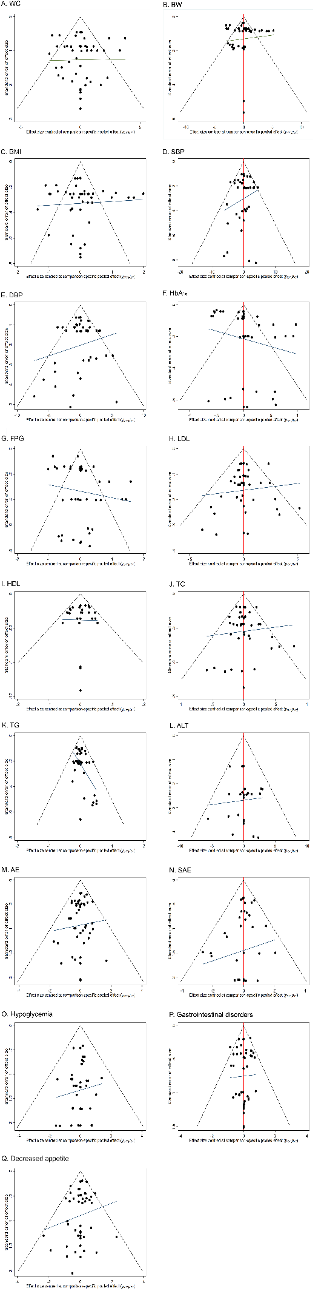
A, WC; B, BW; C, BMI; D, SBP; E, DBP; F, HbA1c; G, FPG; H, LDL; I, HDL; J, TC; K, TG; L, ALT; M, AE; N, SAE; O, Hypoglycemia; P, Gastrointestinal Disorders; Q, Decreased Appetite.
Abbreviations: WC, Waist circumference; BW, Body Weight; BMI, Body Mass Index; SBP; Systolic Blood Pressure; DBP, Diastolic Blood Pressure; HbA1c, Glycated hemoglobin; FPG, Fasting Plasma glucose; LDL, Low-density lipoprotein cholesterol; HDL, High-density lipoprotein cholesterol; TC, Total Cholesterol; TG, Triglyceride; ALT, Alanine Aminotransferase; AE, Adverse Event; SAE, Serious Adverse Event.

eFigure 3: Trace and density plots for the network meta-analysis of Different outcomes.
A
B
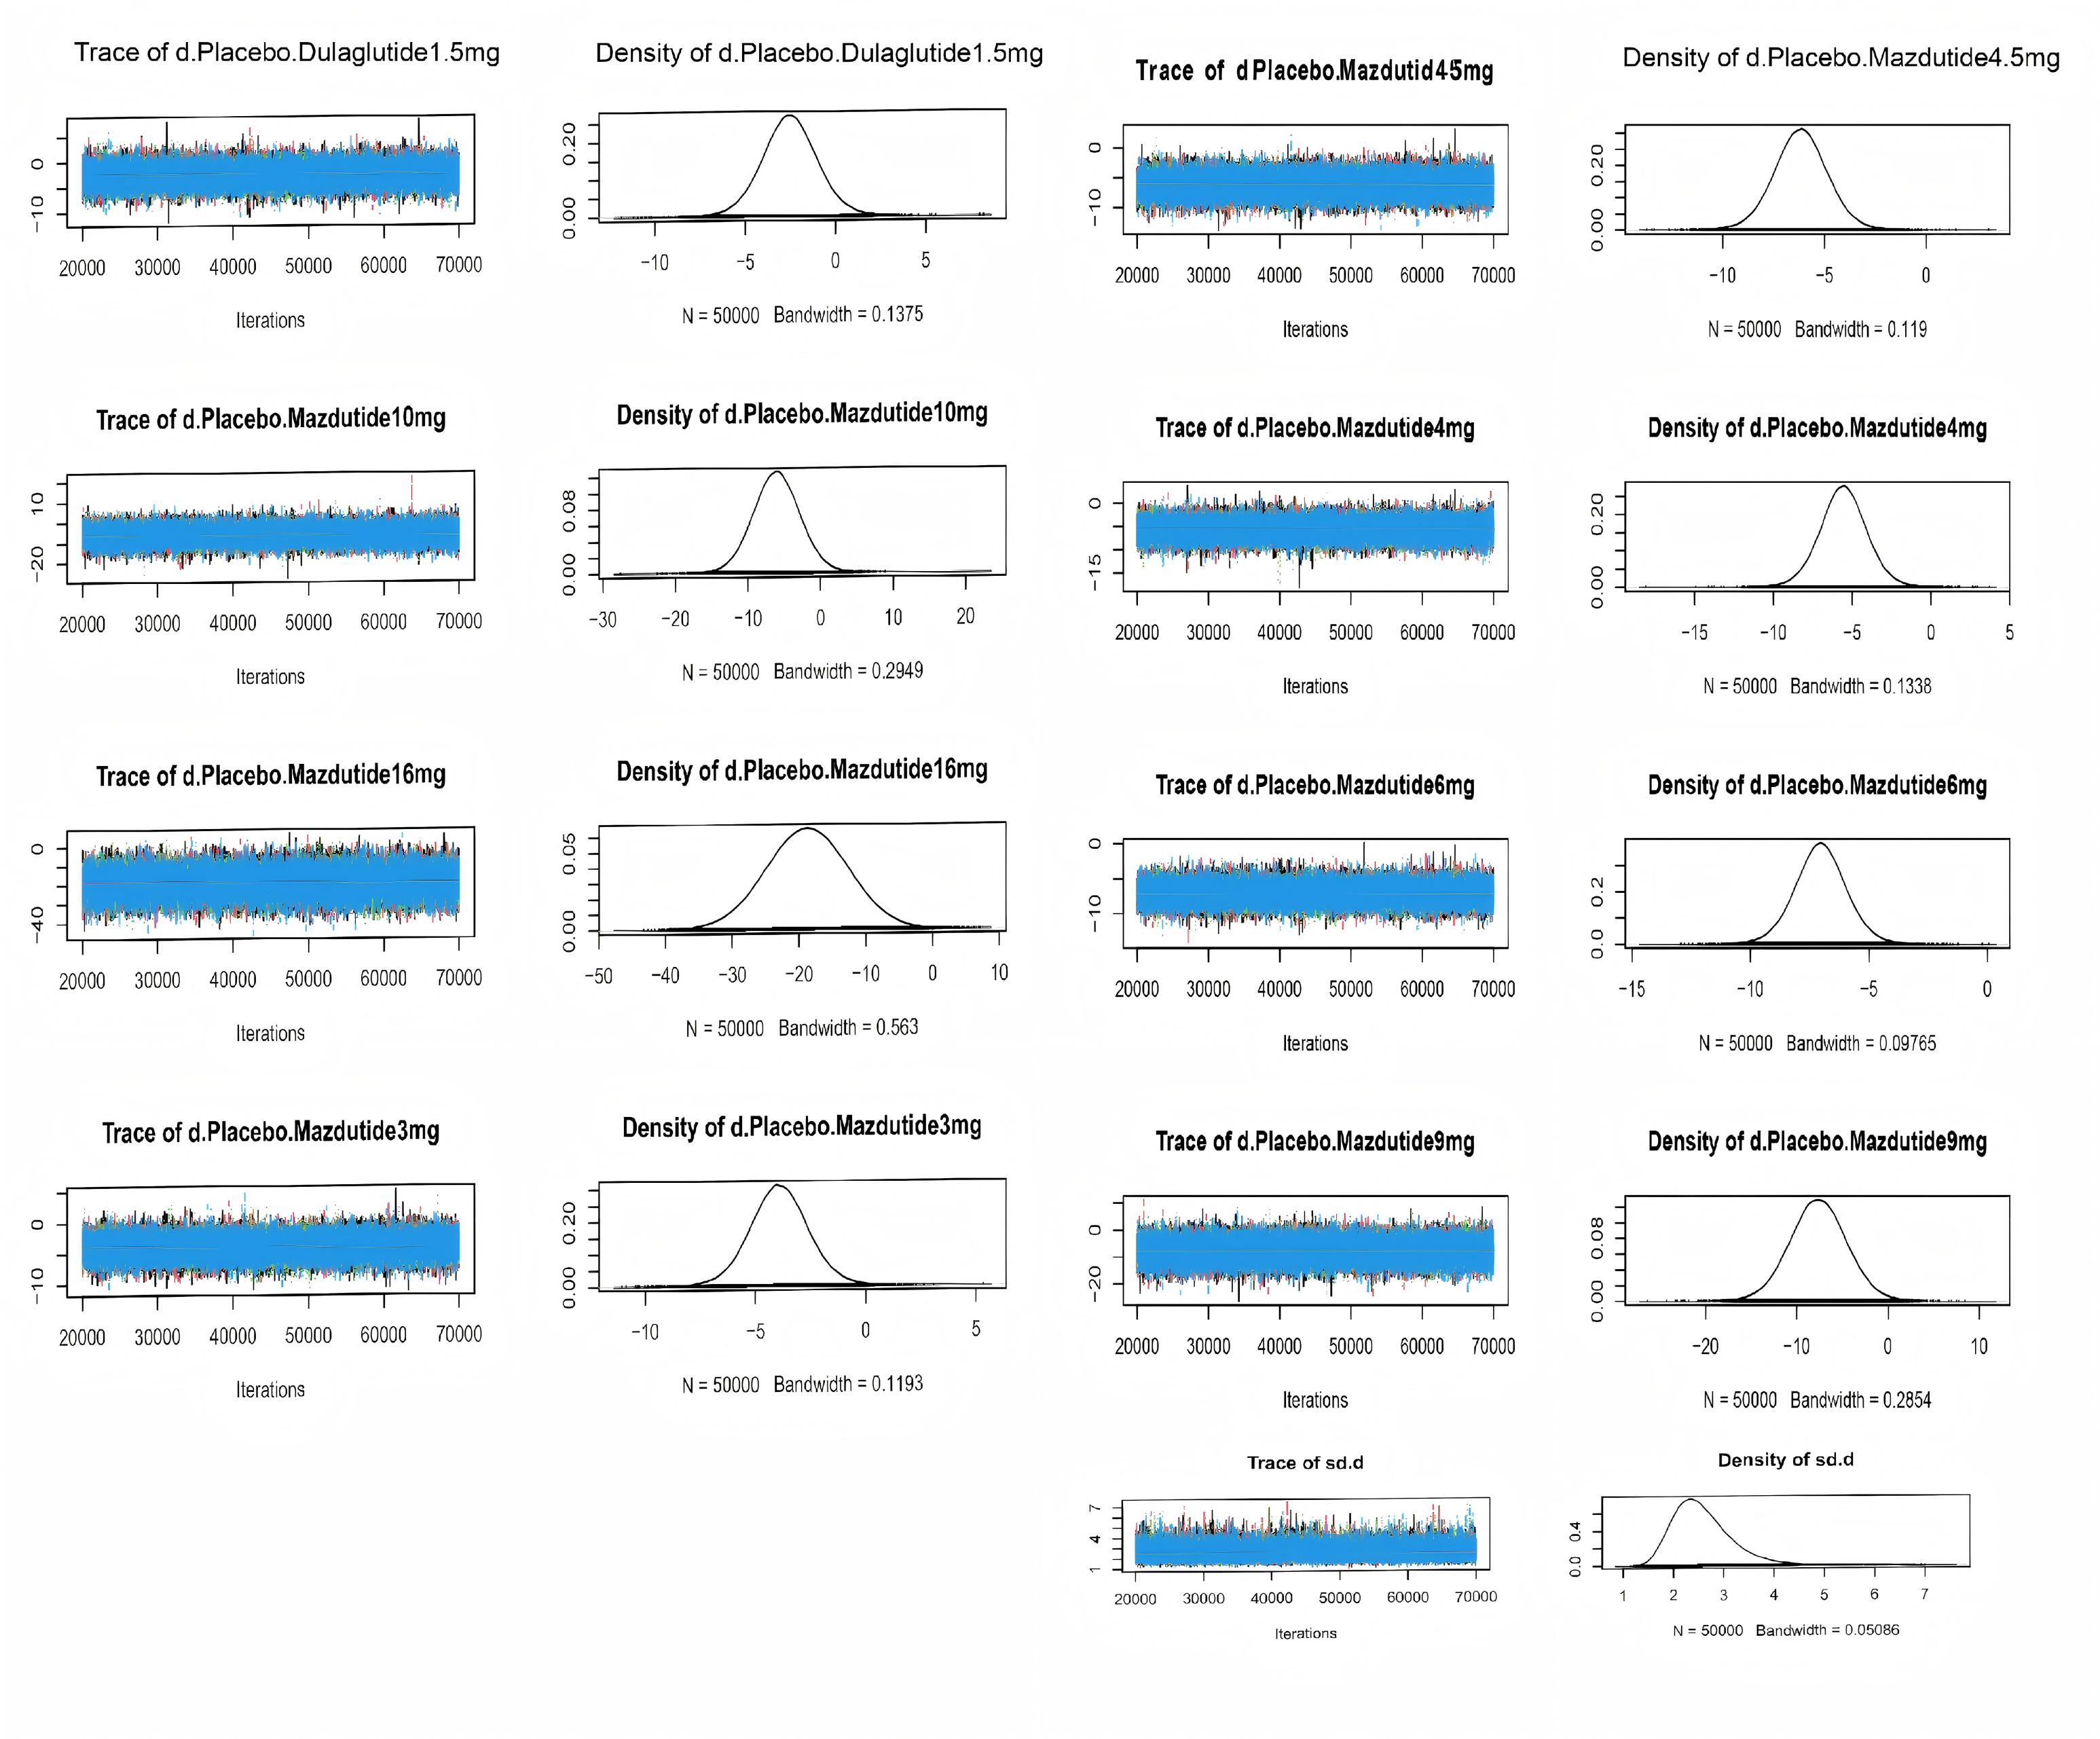

C 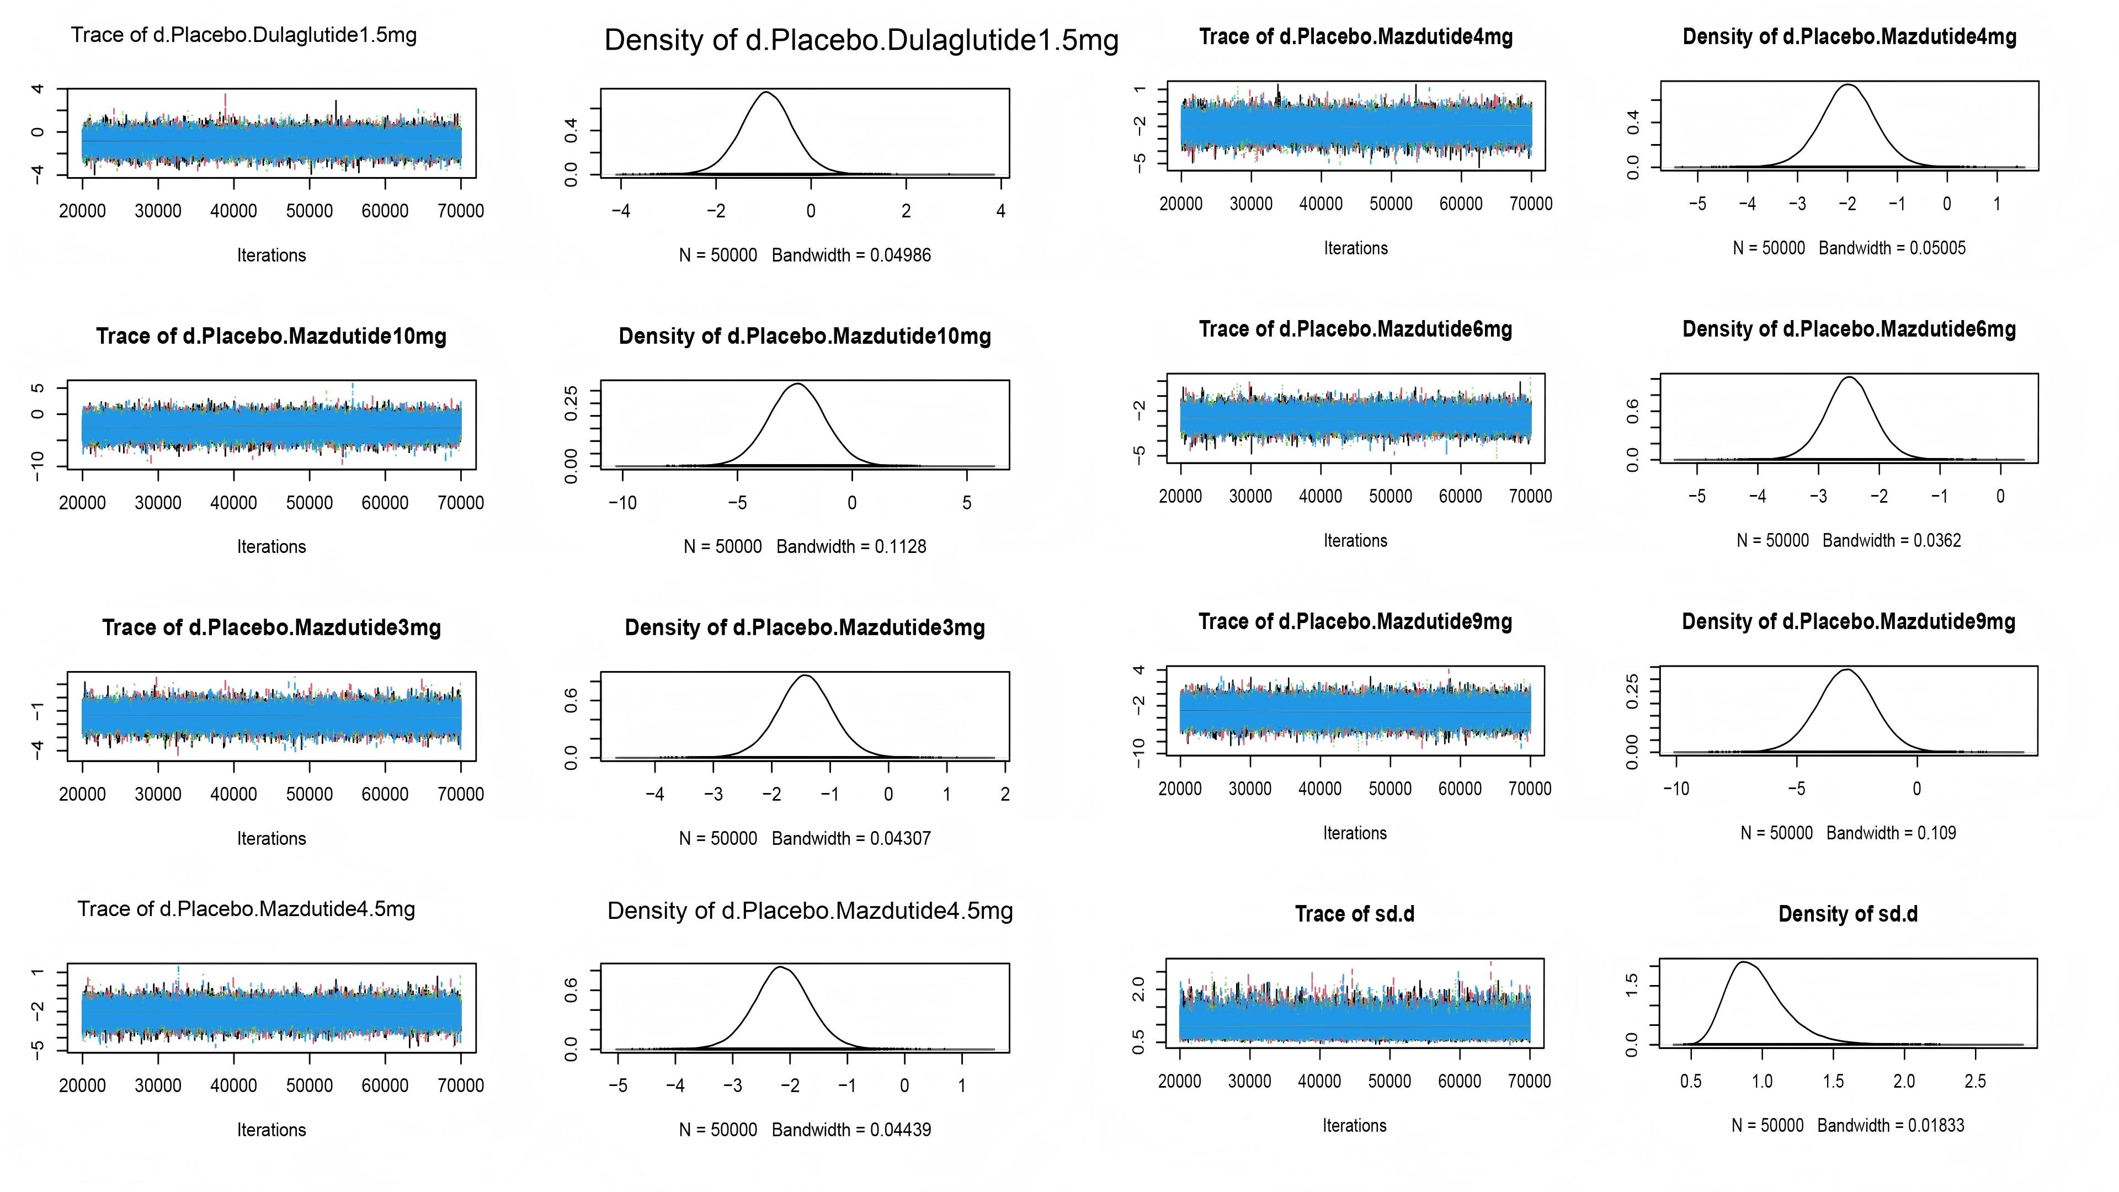
D

E
F

G
H

I
J

K
L

M
N

O
P

Q
A, WC; B, BW; C, BMI; D, SBP; E, DBP; F, HbA1c; G, FPG; H, LDL; I, HDL; J, TC; K, TG; L, ALT; M, AE; N, SAE; O, Hypoglycemia; P, Gastrointestinal Disorders; Q, Decreased Appetite.
Abbreviations: WC, Waist circumference; BW, Body Weight; BMI, Body Mass Index; SBP; Systolic Blood Pressure; DBP, Diastolic Blood Pressure; HbA1c, Glycated hemoglobin; FPG, Fasting Plasma glucose; LDL, Low-density lipoprotein cholesterol; HDL, High-density lipoprotein cholesterol; TC, Total Cholesterol; TG, Triglyceride; ALT, Alanine Aminotransferase; AE, Adverse Event; SAE, Serious Adverse Event.

eFigure 4: Gelman–Rubin convergence diagnostics for all outcomes.

A
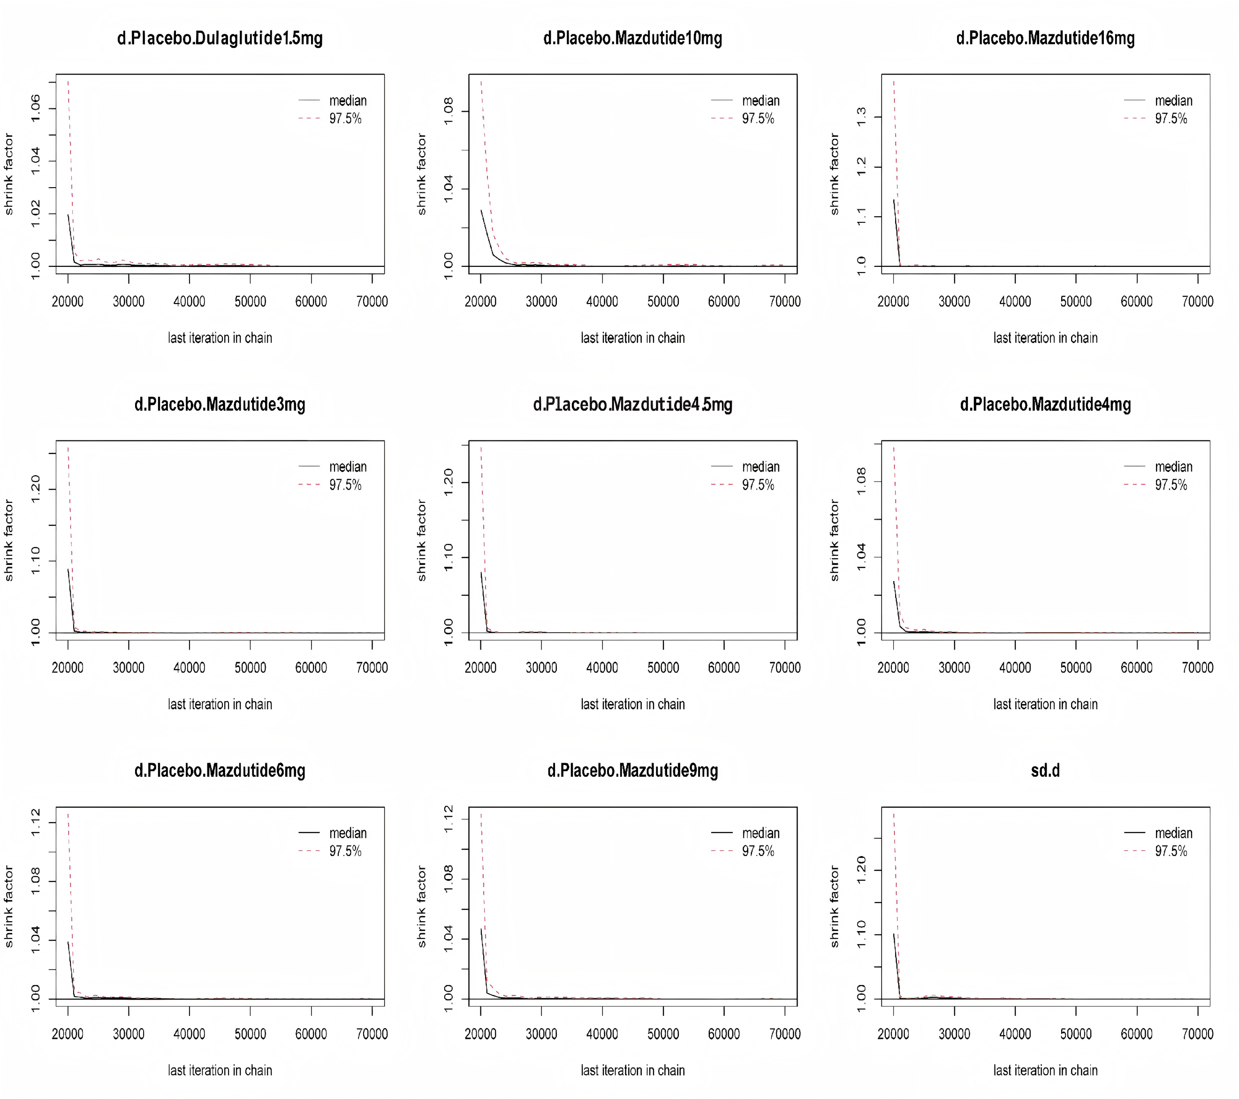
B
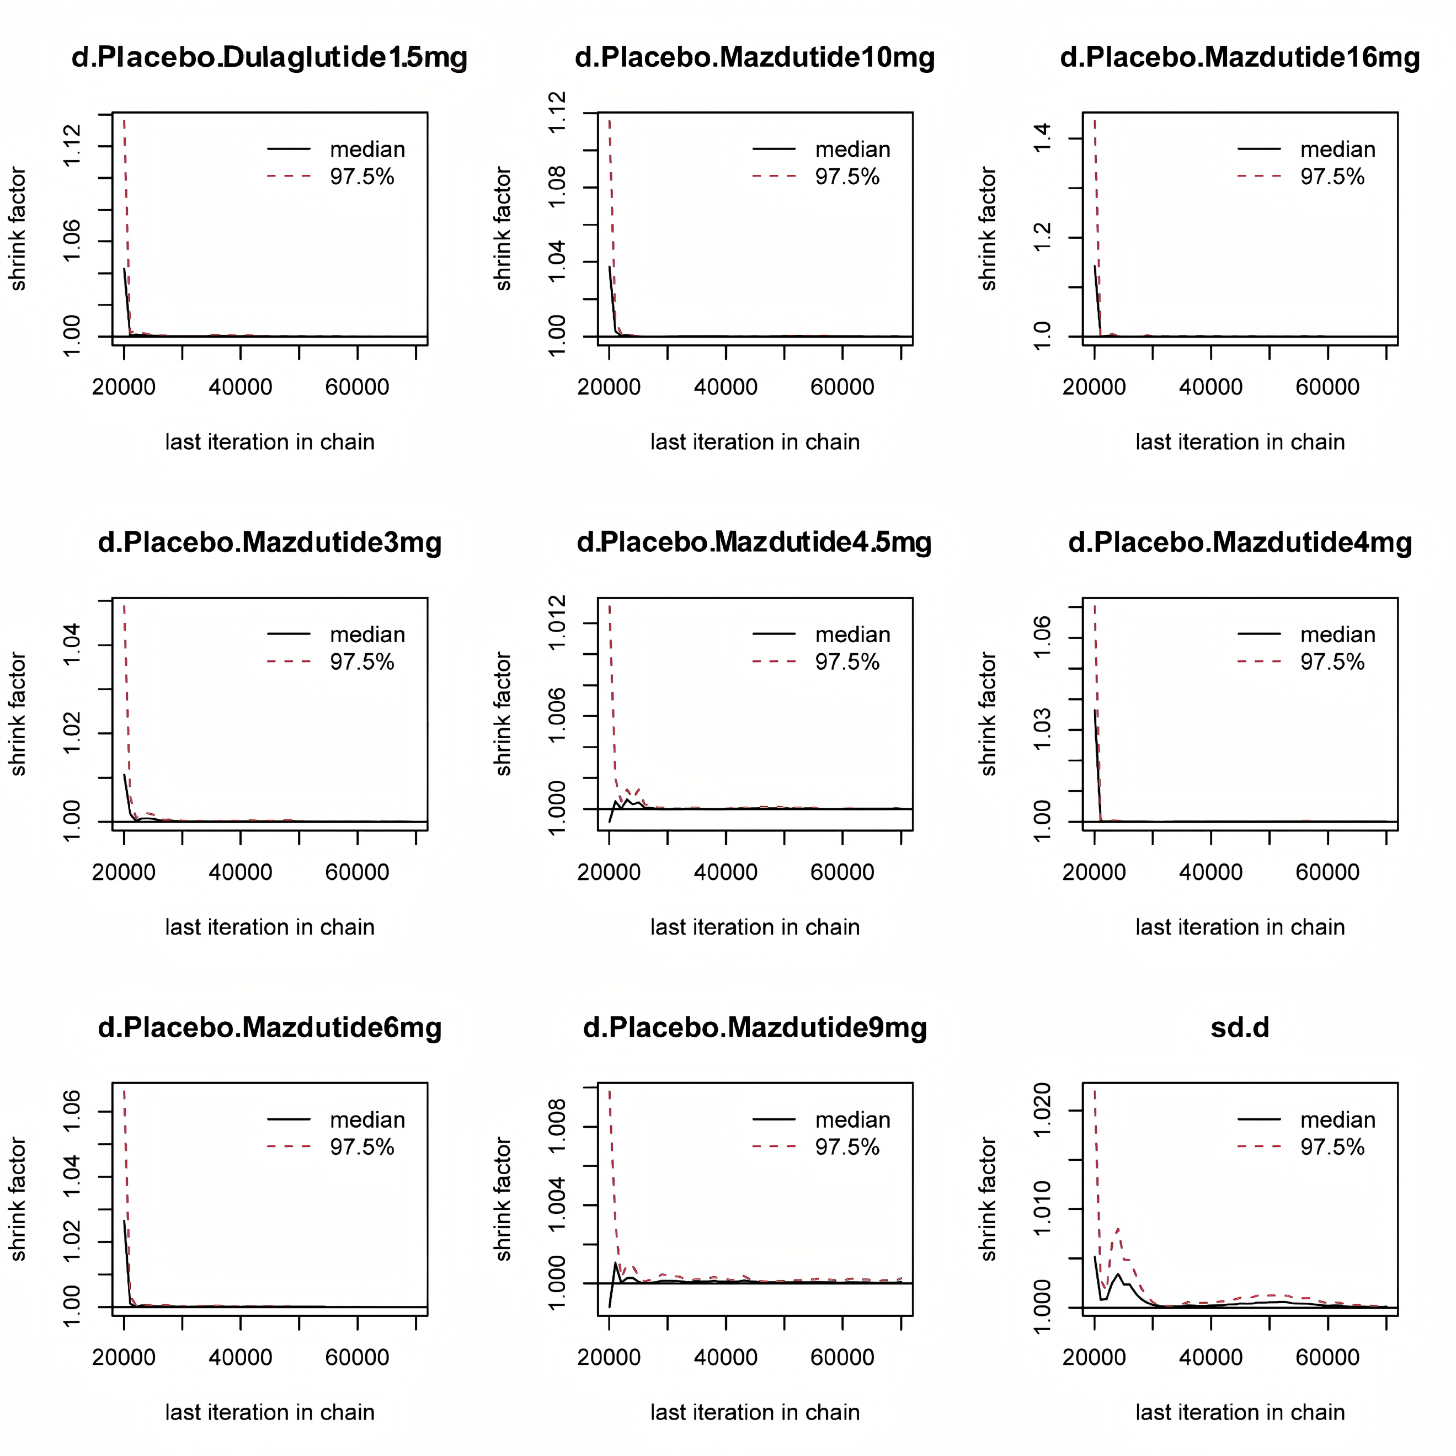

C
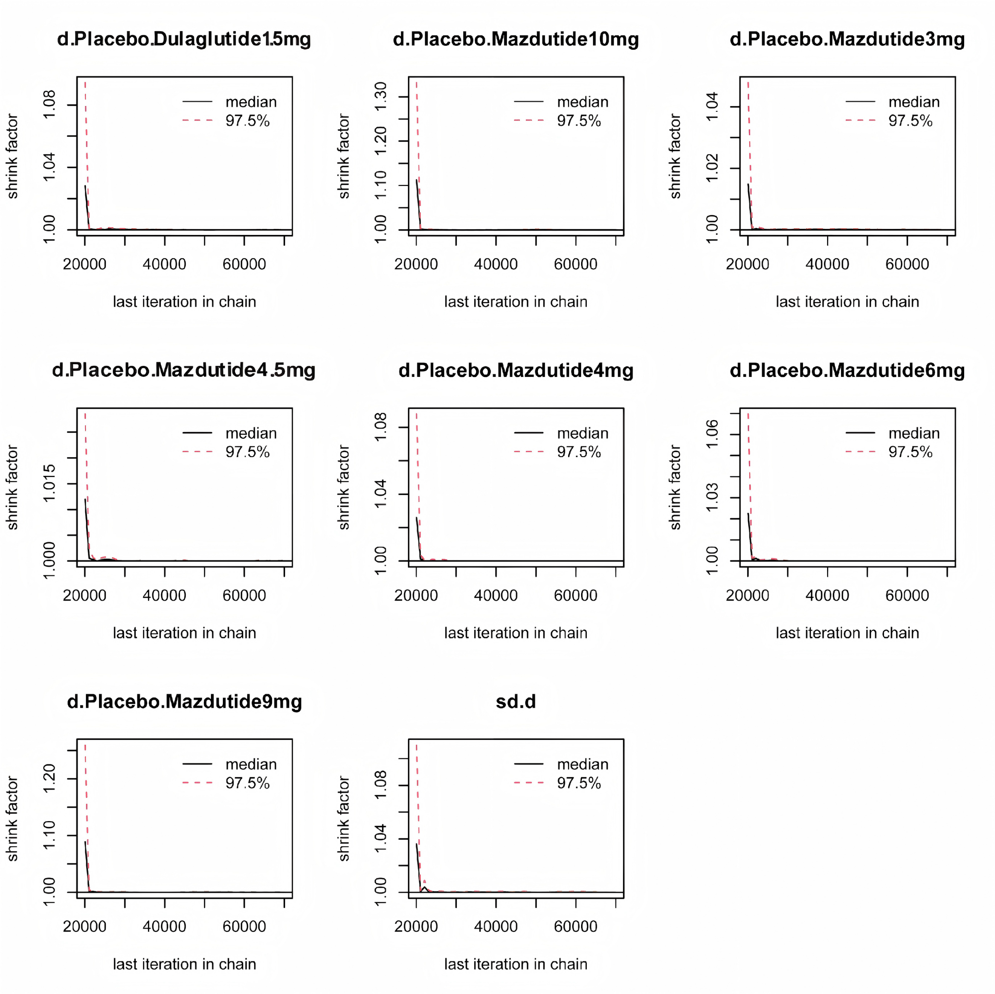
D

E
F
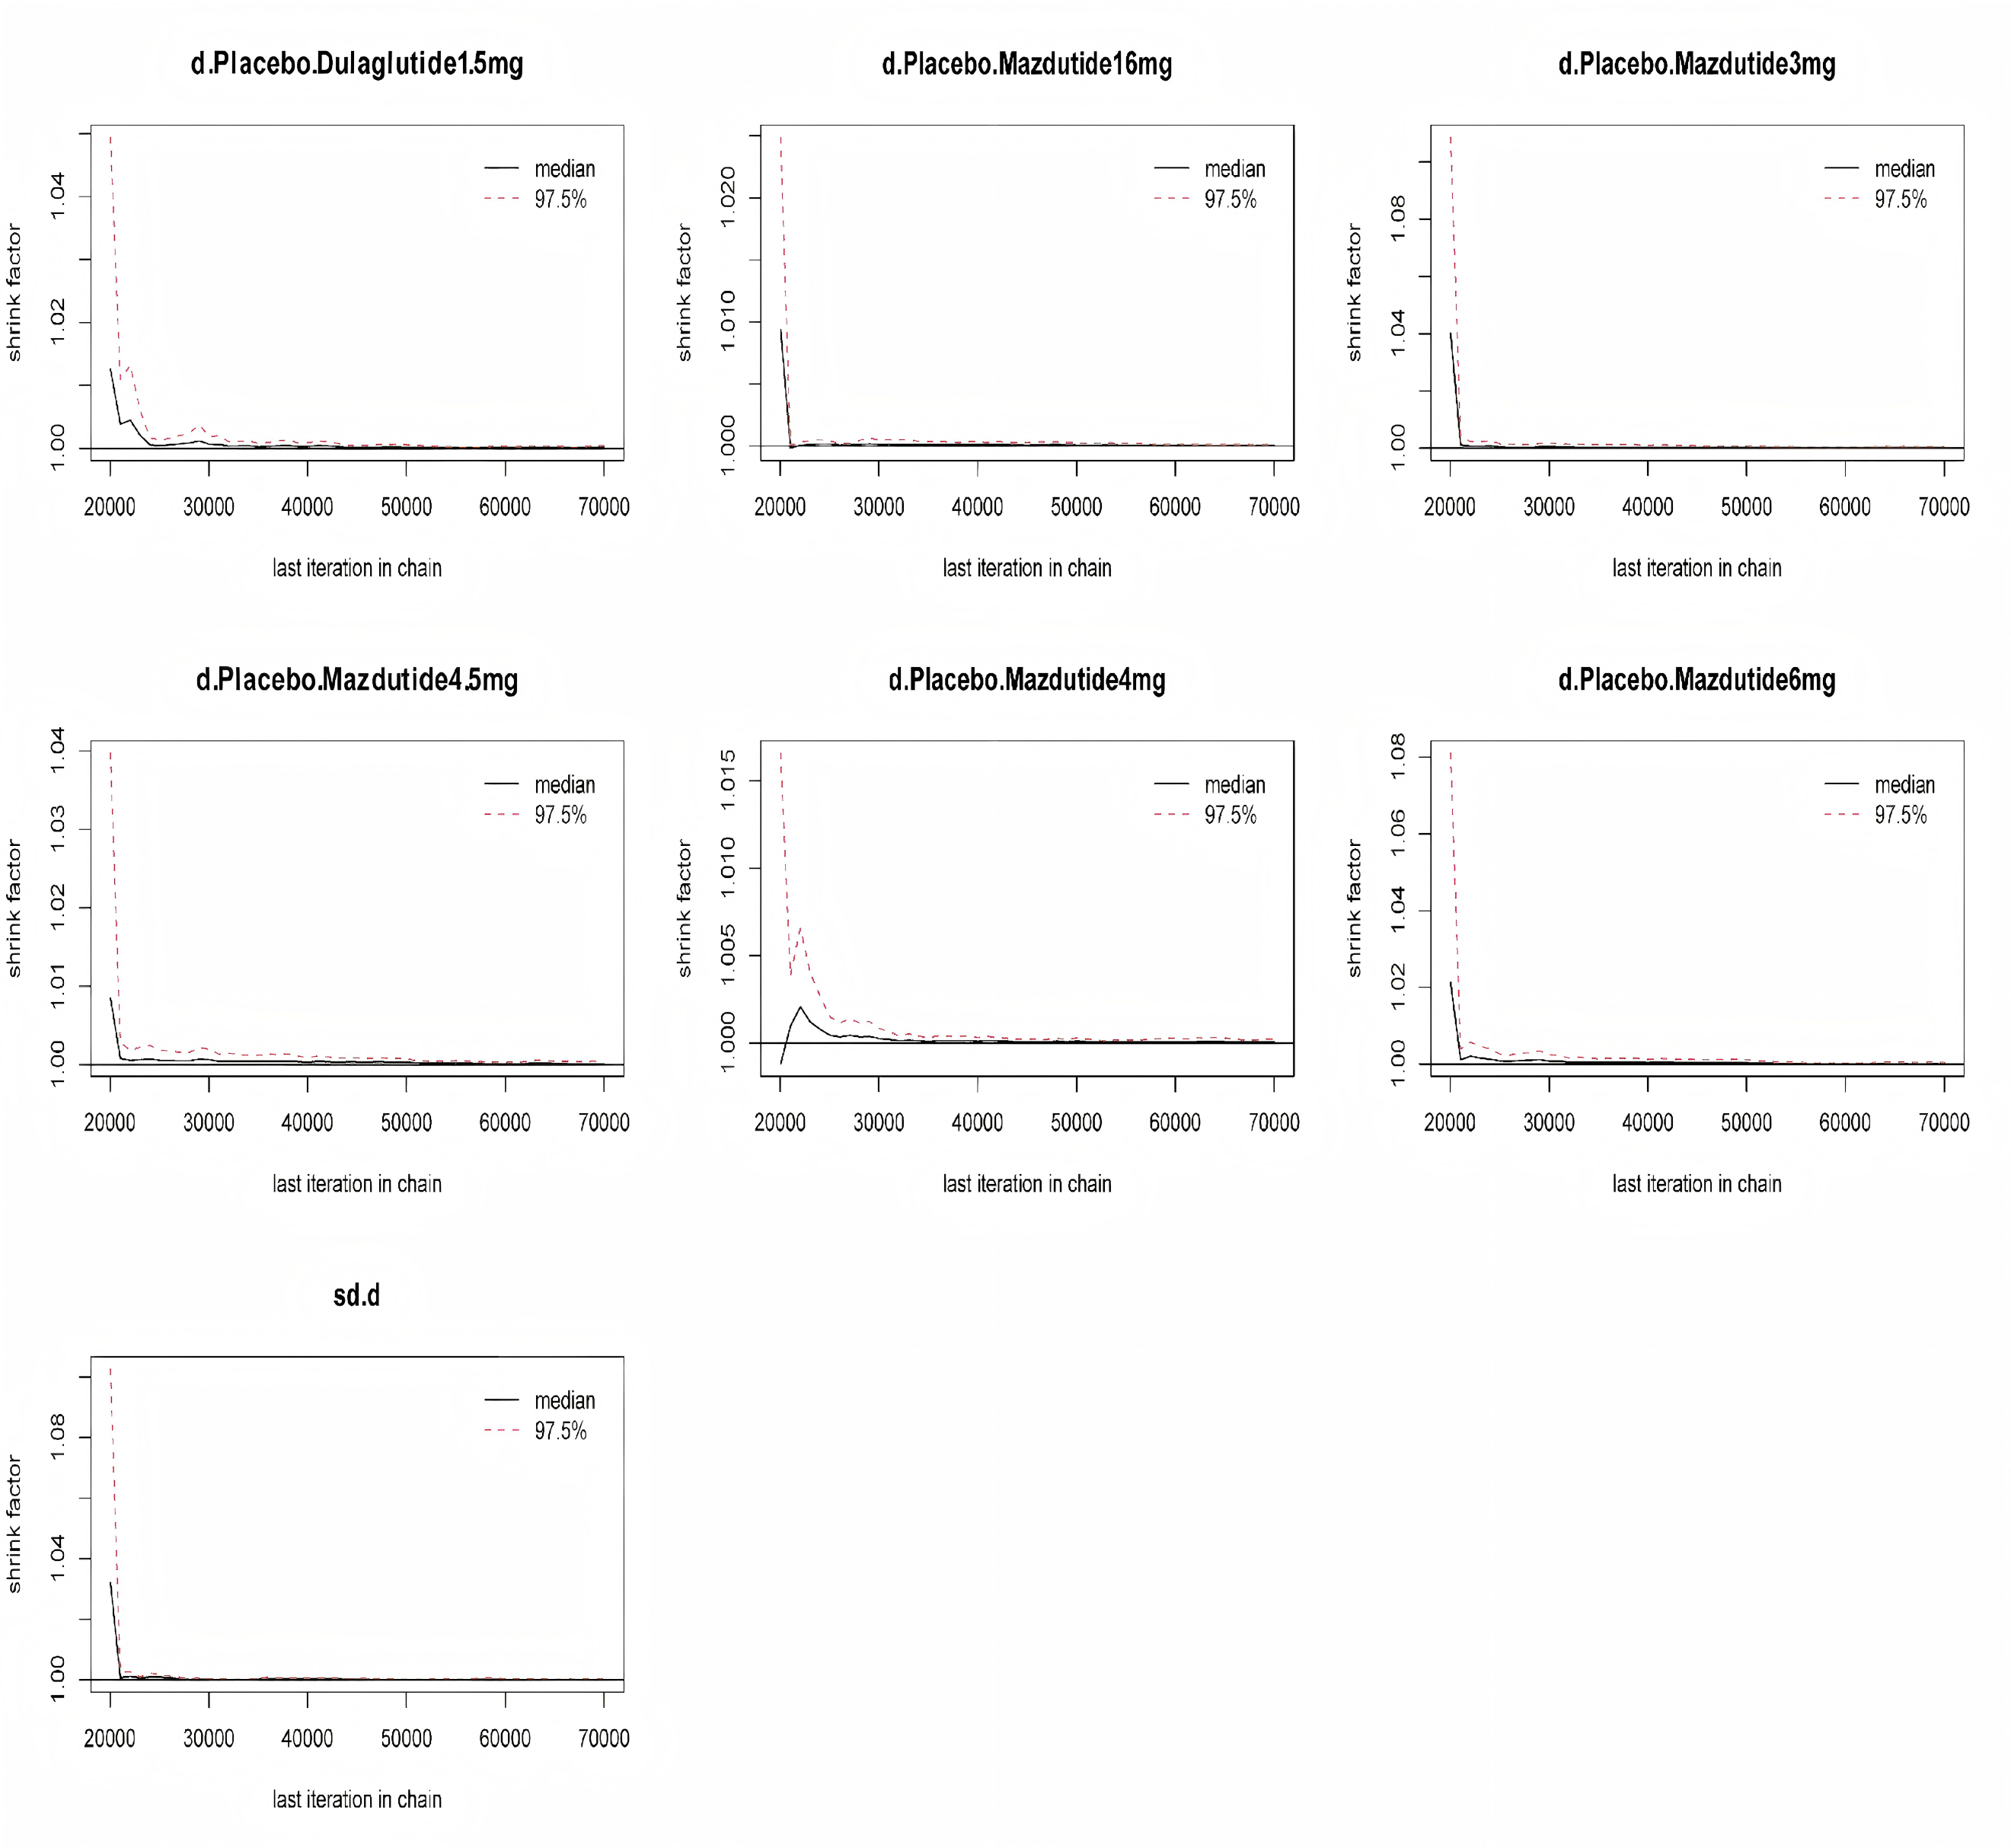

G

H

I 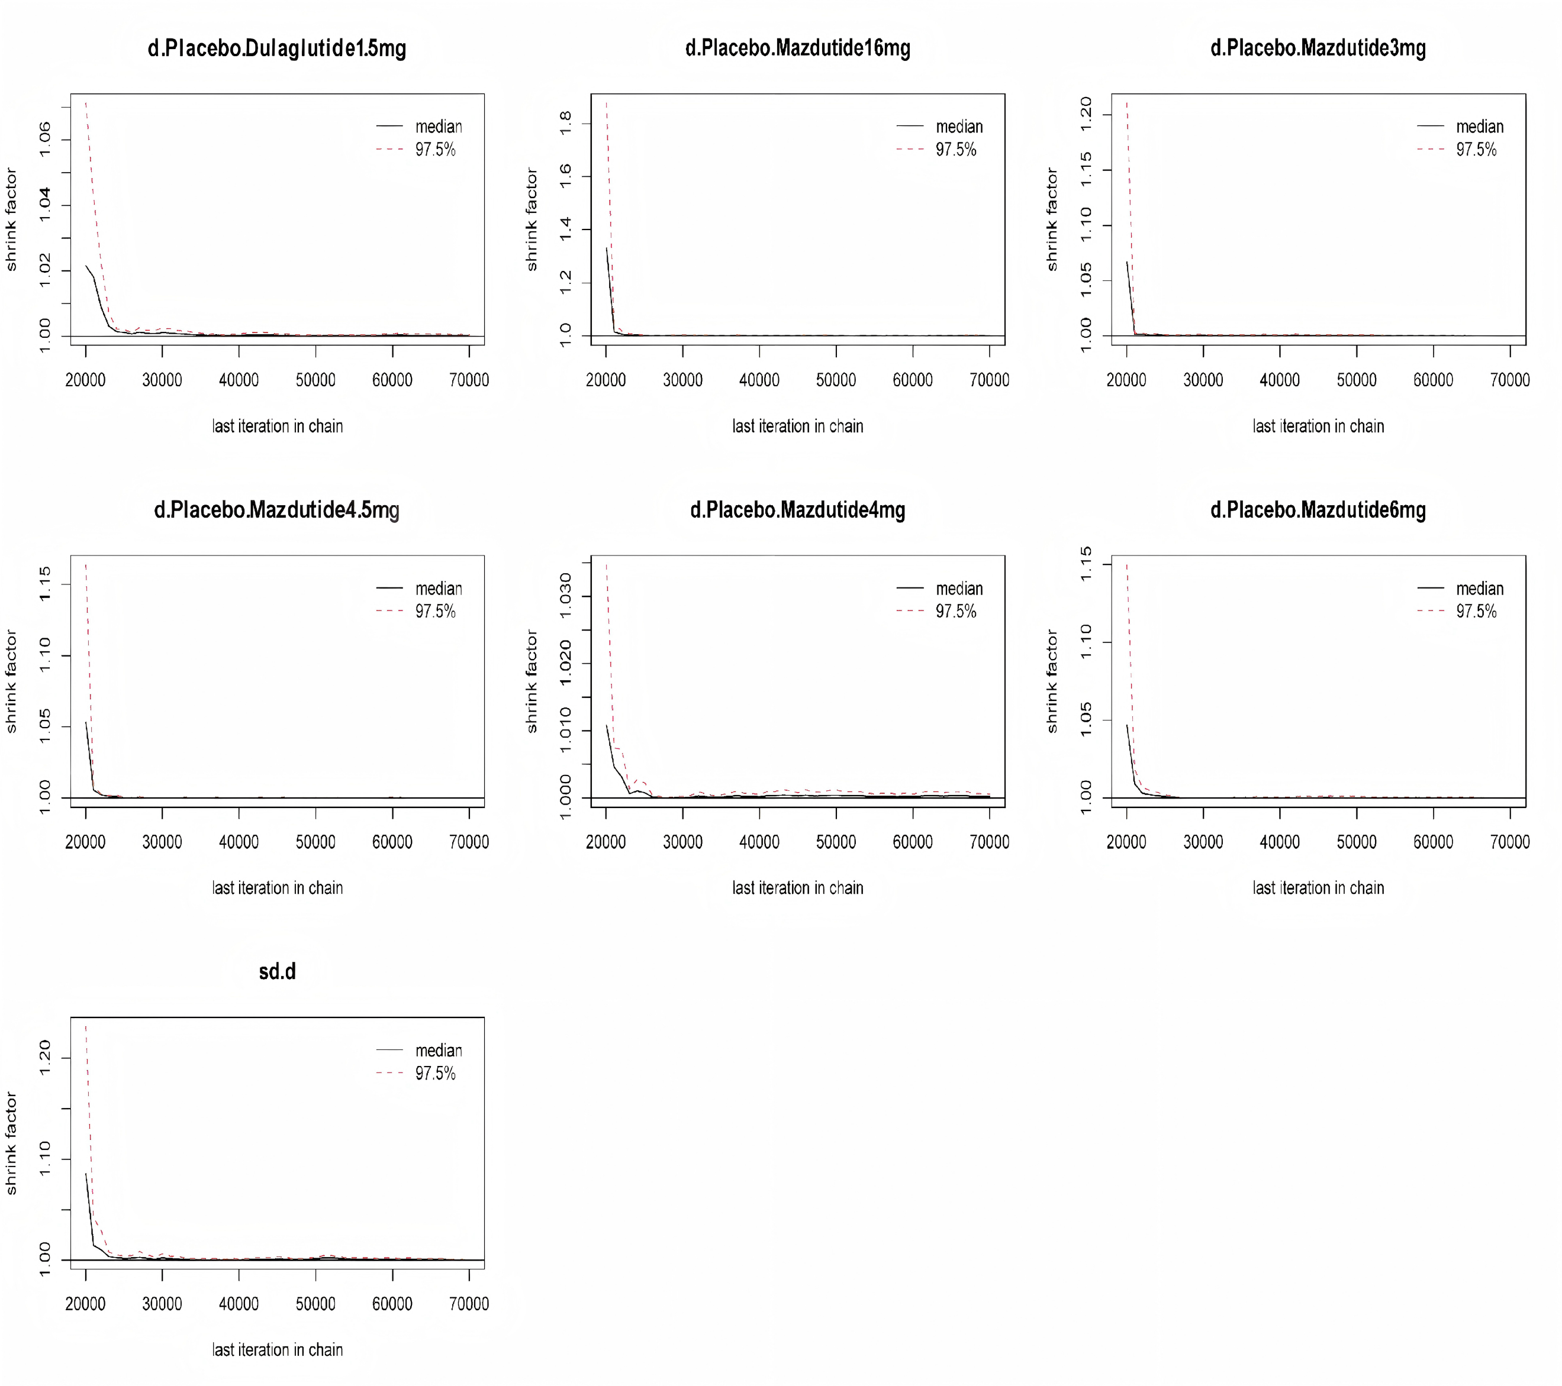
J 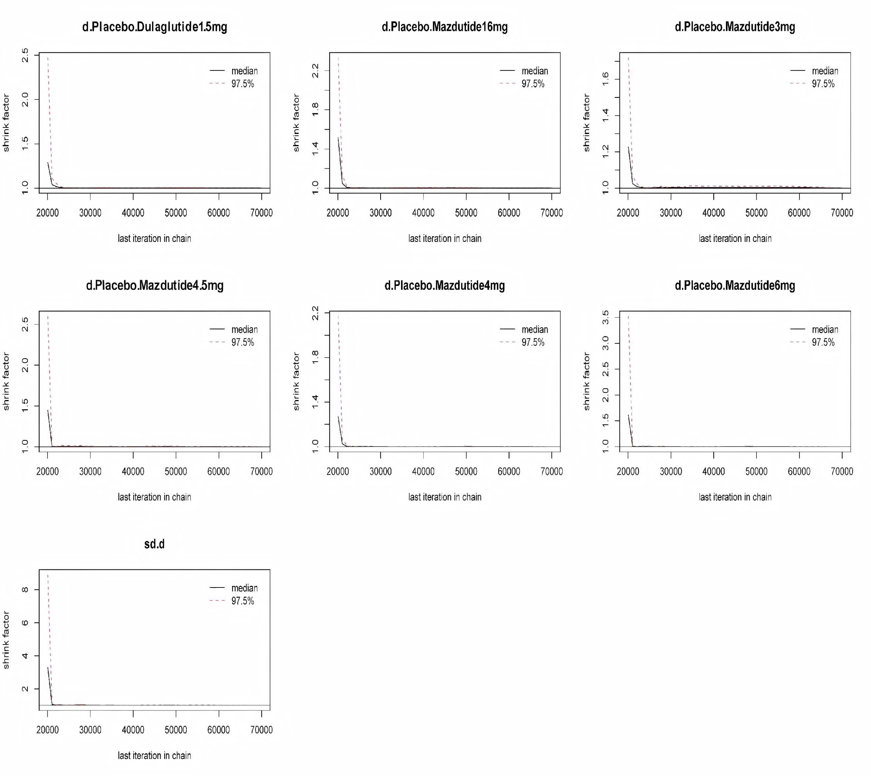

K
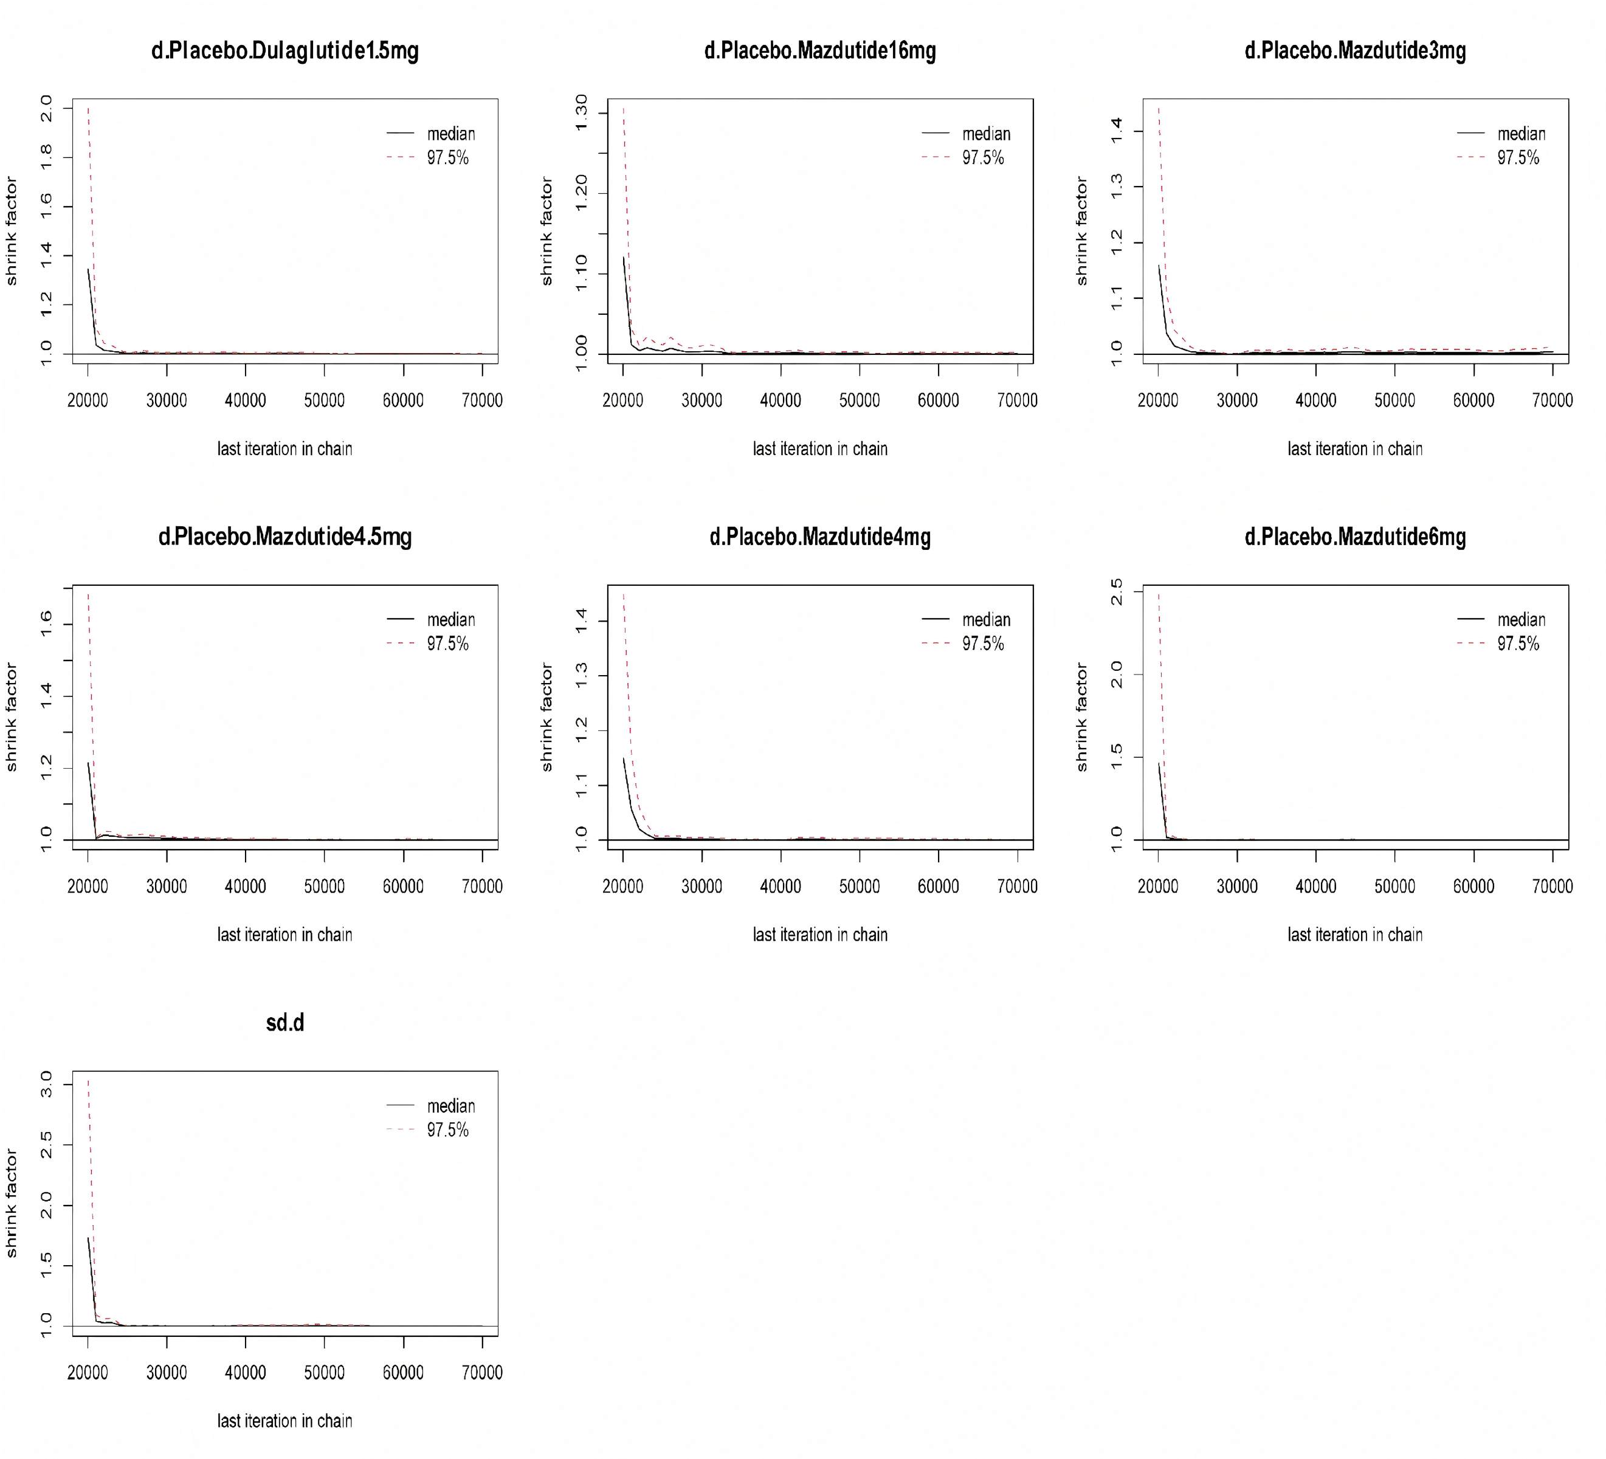
L
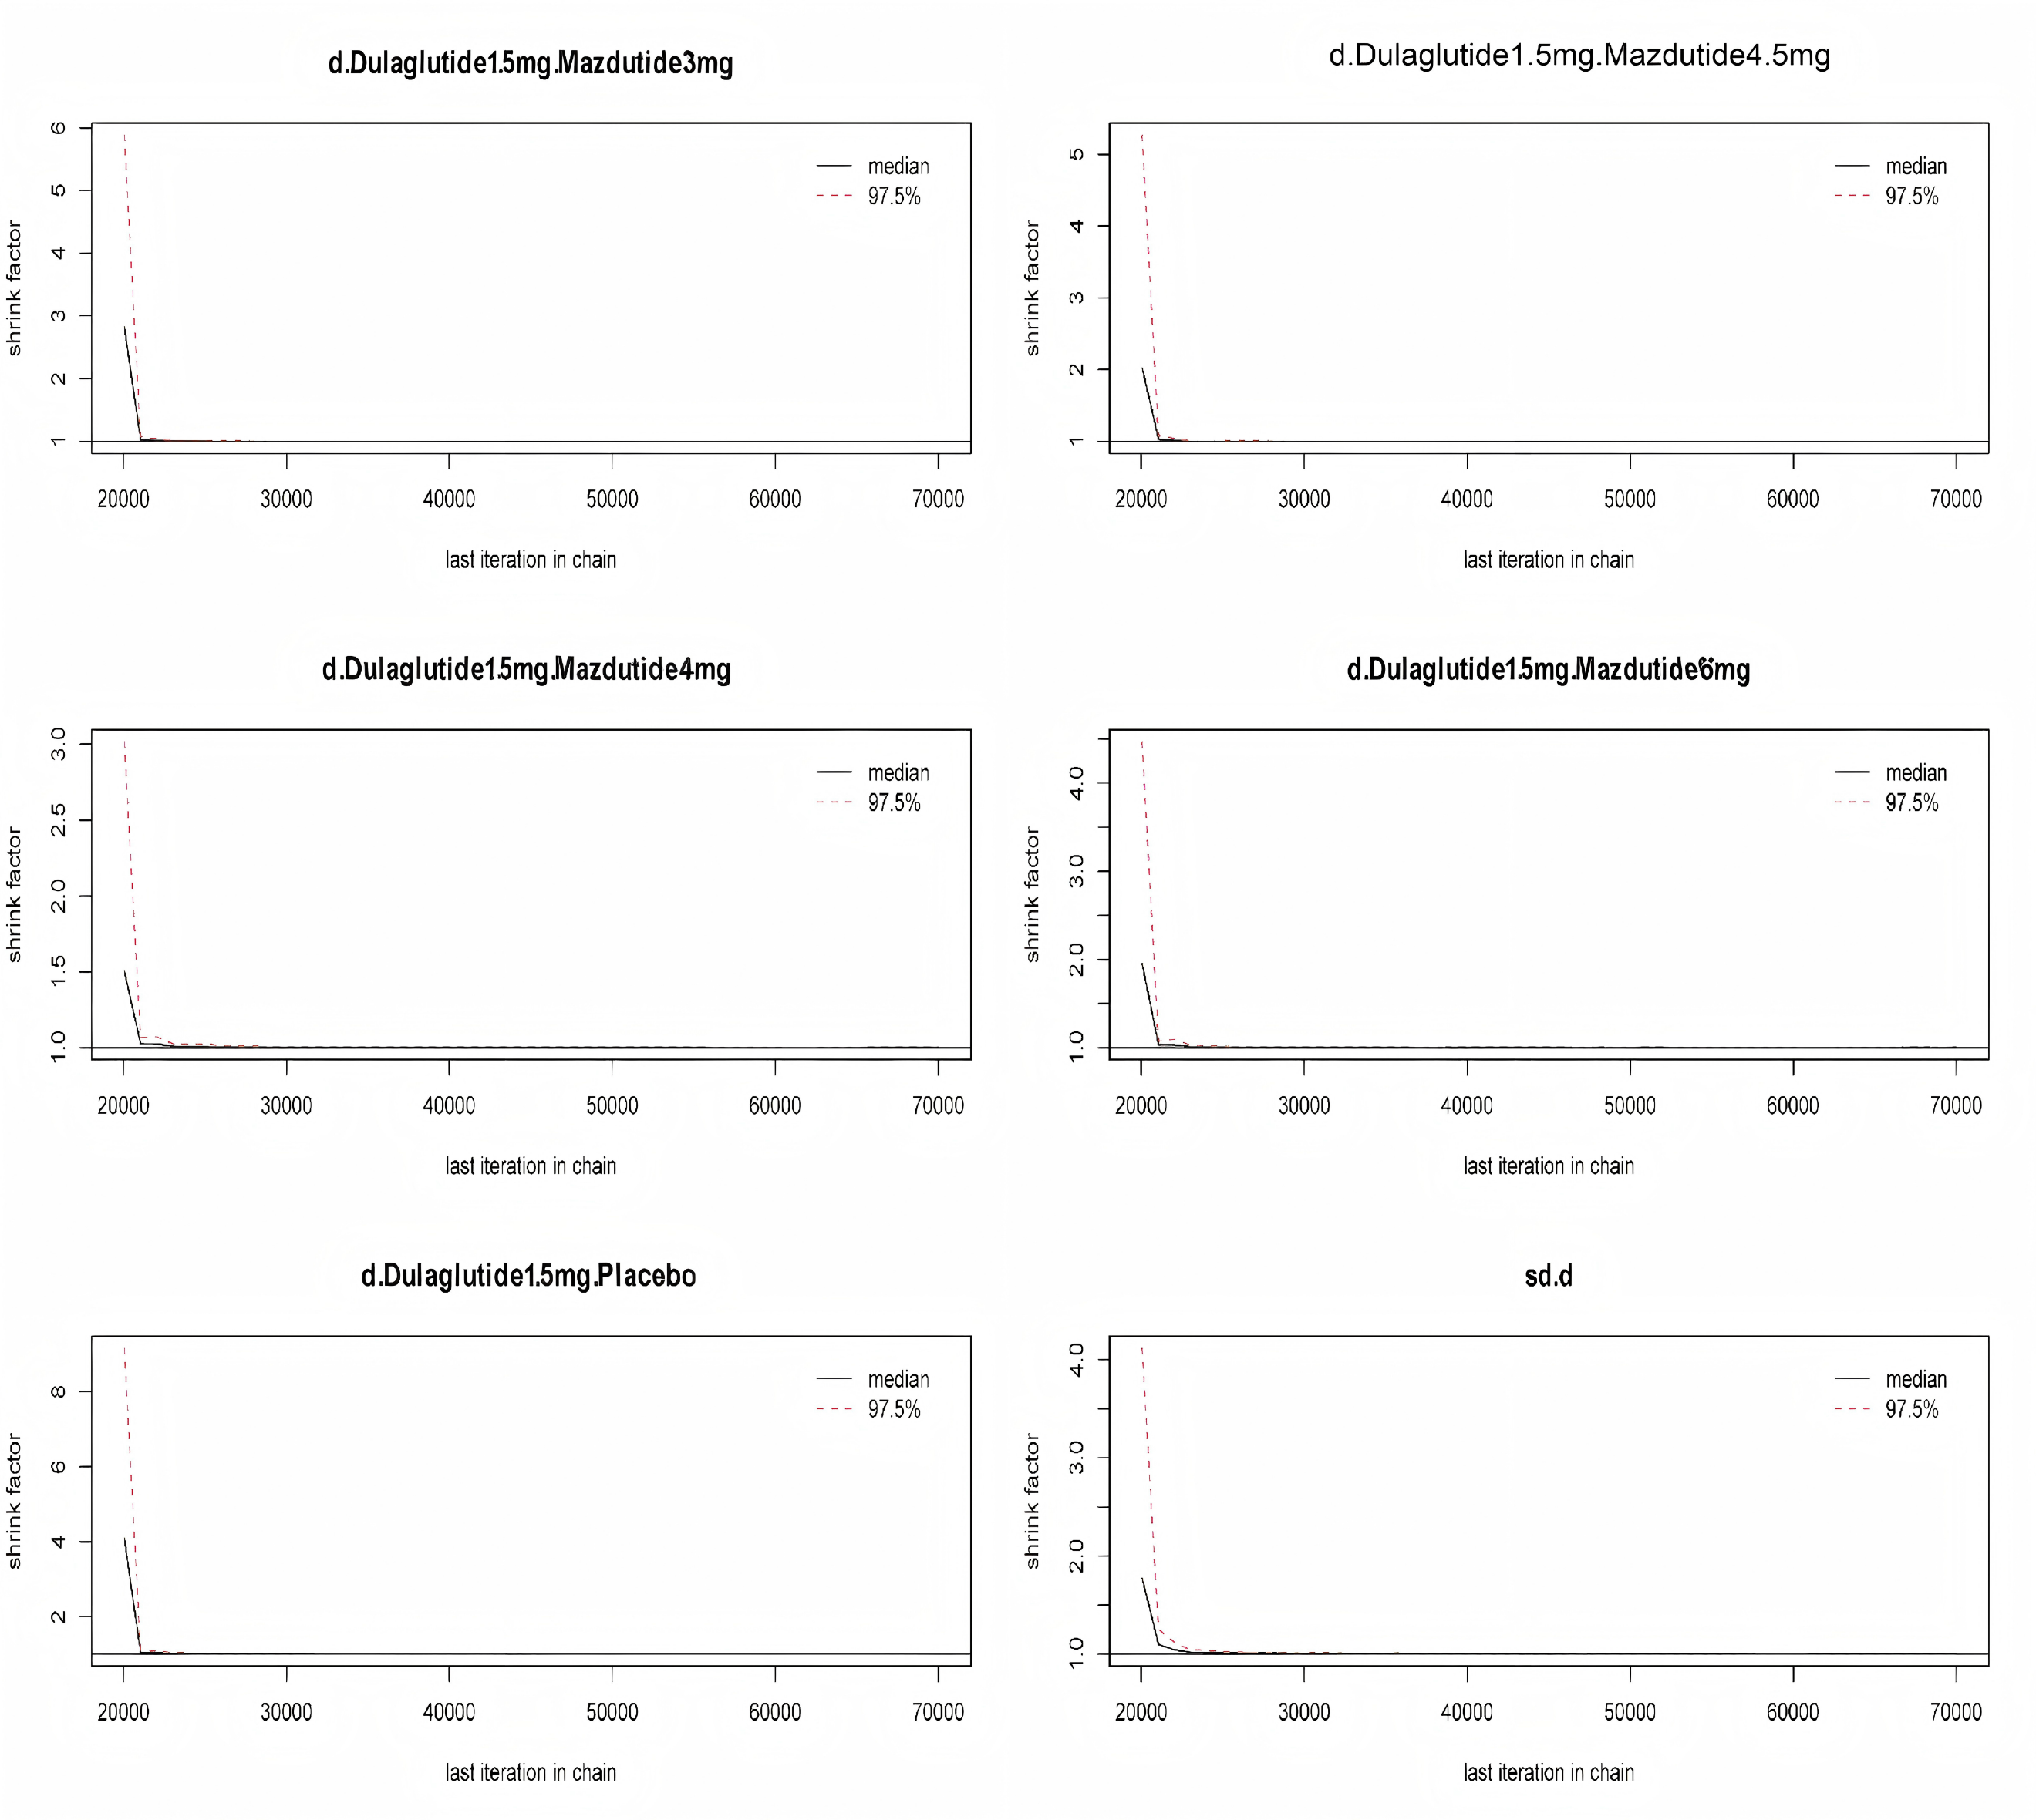

M
N

O

P
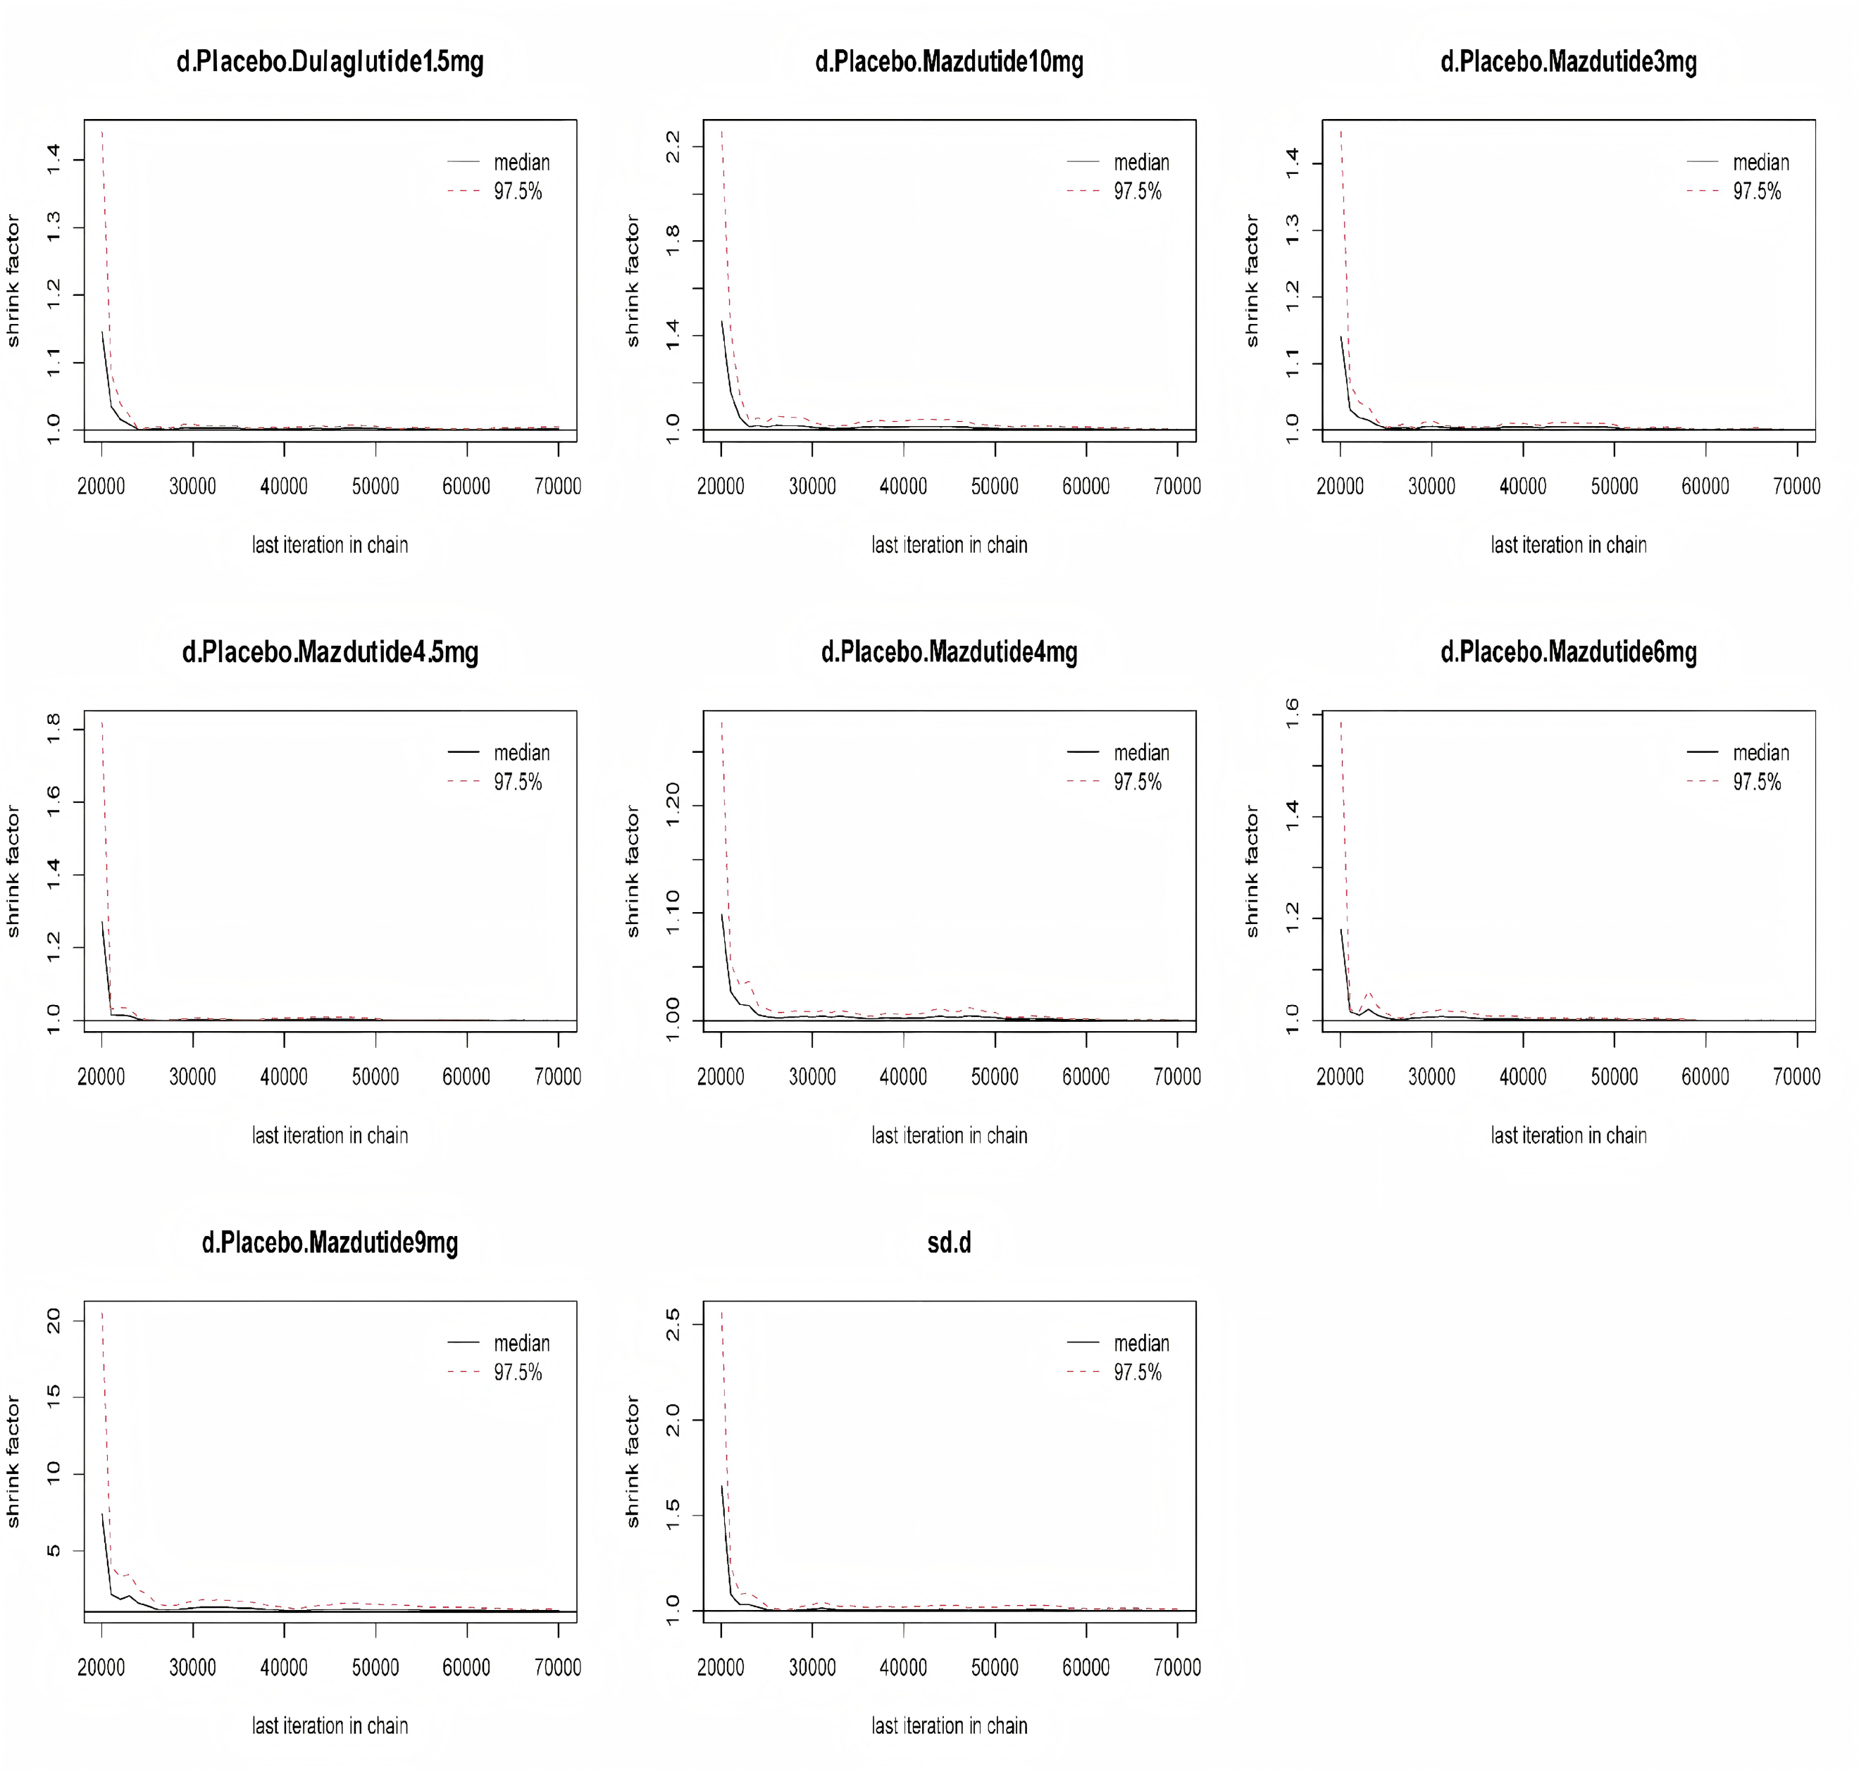
Q
A, WC; B, BW; C, BMI; D, SBP; E, DBP; F, HbA1c; G, FPG; H, LDL; I, HDL; J, TC; K, TG; L, ALT; M, AE; N, SAE; O, Hypoglycemia; P, Gastrointestinal Disorders; Q, Decreased Appetite.
Abbreviations: WC, Waist circumference; BW, Body Weight; BMI, Body Mass Index; SBP; Systolic Blood Pressure; DBP, Diastolic Blood Pressure; HbA1c, Glycated hemoglobin; FPG, Fasting Plasma glucose; LDL, Low-density lipoprotein cholesterol; HDL, High-density lipoprotein cholesterol; TC, Total Cholesterol; TG, Triglyceride; ALT, Alanine Aminotransferase; AE, Adverse Event; SAE, Serious Adverse Event.

eFigure 5: Leverage-versus-Deviance Scatter Plot for Assessment of Model Fit.

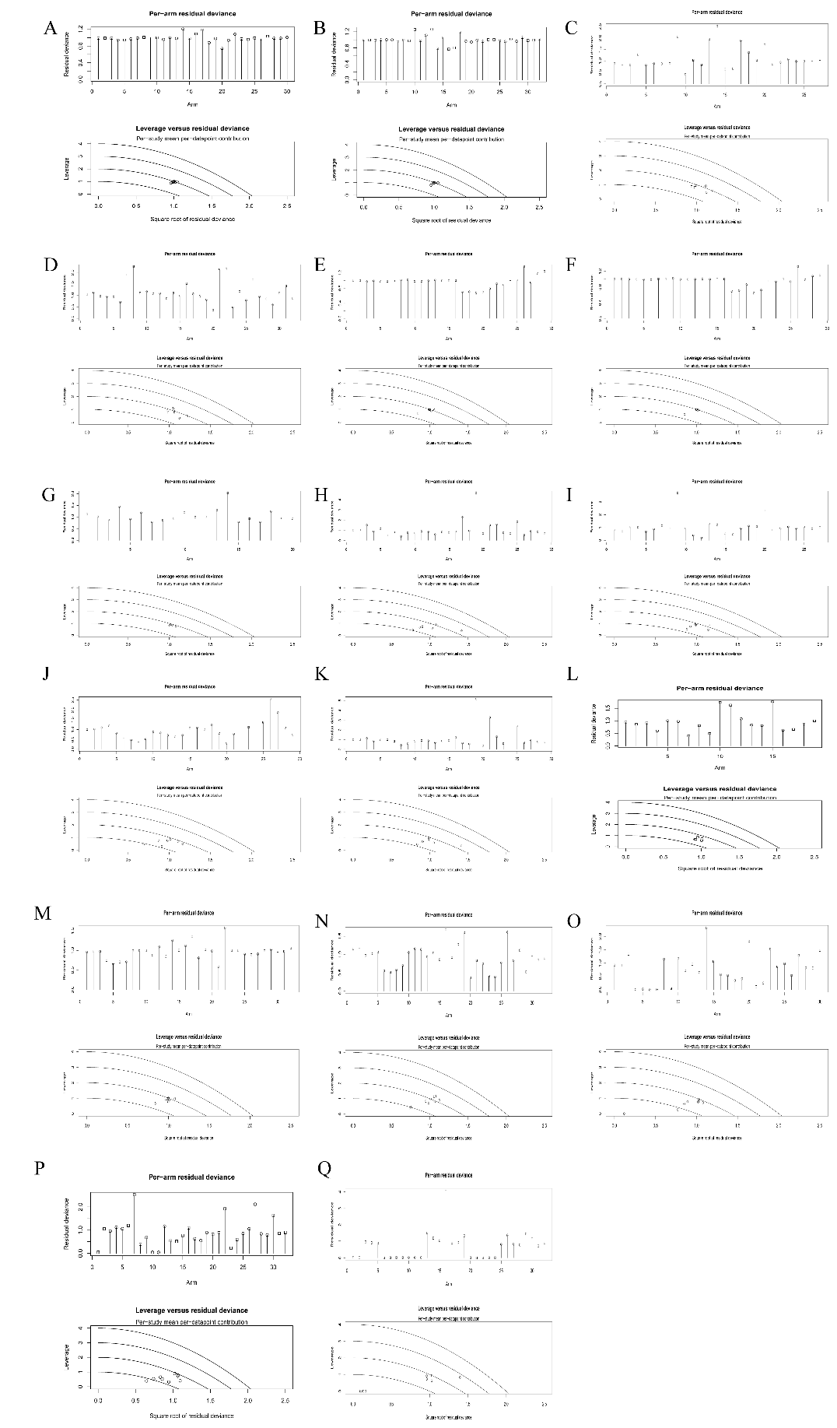
A, BMI; B, BW; C, DBP; D, Decreased Appetite; E, FPG; F, HbA1c; G, HDL; H, LDL; I, SBP; J, TG; K, TC; L, ALT; M, WC; N, Gastrointestinal Disorders; O, Hypoglycemia; P, AE; Q, SAE.
Abbreviations: BMI, Body Mass Index; BW, Body Weight; DBP, Diastolic Blood Pressure; FPG, Fasting Plasma glucose; HbA1c, Glycated hemoglobin; HDL, High-density lipoprotein cholesterol; LDL, Low-density lipoprotein cholesterol; SBP, Systolic Blood Pressure; TG, Triglyceride; TC, Total Cholesterol; ALT, Alanine Aminotransferase; WC, Waist circumference; AE, Adverse Event; SAE, Serious Adverse Event.

