Supplementary information
Divergent anaerobic fates of biodegradable plastics in landfill leachate

Shinhyeong Choe ^{1†}, Hyungmin Choi ^{2a†}, Hosung Moon ³, Woohyuk Shin ², Sunho Park ¹, Huiju Park ⁴, Ju Yong Lee ¹, Sukhwan Yoon ¹, Konstantinos T. Konstantinidis ⁵, Changsoo Lee ^{2,4*}, and Jaewook Myung ^{1,3*}
¹ Department of Civil and Environmental Engineering, Korea Advanced Institute of Science and Technology (KAIST), Daejeon, Republic of Korea
² Department of Civil, Urban, Earth, and Environmental Engineering, Ulsan National Institute of Science and Technology (UNIST), Ulsan, Republic of Korea
³ Graduate School of Green Growth and Sustainability, Korea Advanced Institute of Science and Technology (KAIST), Daejeon, Republic of Korea
⁴ Graduate School of Carbon Neutrality, Ulsan National Institute of Science and Technology (UNIST), Ulsan, Republic of Korea
⁵ School of Civil and Environmental Engineering, and School of Biological Sciences, Georgia Institute of Technology, Atlanta, GA, USA
* Corresponding authors: jjaimyung@kaist.ac.kr (J. Myung), cslee@unist.ac.kr (C. Lee)
† These authors have contributed equally to this work and share the first authorship
ª Current affiliation: Division of Environmental Engineering, Faculty of Engineering, Hokkaido University, North 13, West 8, Sapporo, Hokkaido, Japan

Table of Contents:
Supplementary Notes (Pages S2–S6)
Supplementary Figures (Figures S1–S16, Pages S7–S23)
Supplementary Notes
Sample processing and amplicon library preparation
One milliliter of mixed liquor was centrifuged at 10,000 × g for 3 min to pellet the microbial biomass at varying incubation time points. After discarding the supernatant, the resulting pellet was resuspended in an equal volume of DNA/RNA Shield solution (Zymo Research, USA) and stored at –20 °C until nucleic acid extraction. PBS-washed plastic samples were cut into small pieces (< 1 mm × 1 mm) using autoclaved scissors and immediately subjected to nucleic acid extraction.
The primers were tagged with Illumina overhang adapter sequences at the 5’ ends (Table S15). The resulting amplicons were purified, indexed, and pooled in equimolar proportions following the Illumina Metagenomic Sequencing Library Preparation instructions (Illumina, USA).

16S rRNA amplicon read processing
Amplicon sequence processing was performed using the QIIME2 platform (v.2024.10) ¹. Raw paired-end reads were first demultiplexed, and quality profiles were inspected to determine trimming and truncation parameters based on median Phred quality scores (≥ 30). Subsequently, paired-end reads were quality-filtered and processed with the DADA2 plugin to denoise sequences, infer ASVs, merge paired reads, and remove chimeras ². Singletons were excluded to reduce sequencing noise. Taxonomic assignment was performed using a multinomial naïve Bayes classifier trained on the Greengenes2 reference database (release 2024.09) trimmed to the V4 region (515F/806R primers) ³. Phylogenetic relationships were inferred by fragment insertion into the Greengenes2 reference tree using the SATé-enabled phylogenetic placement (SEPP) approach for downstream phylogenetic diversity analyses.

Community composition, diversity, and statistical analyses
All community composition, diversity, and statistical analyses were conducted in R (v.4.2.2). 16S rRNA amplicon count tables were normalized using Scaling with Ranked Subsampling (SRS) to account for variable sequencing depth ⁴. A target library size of 14,490 reads was determined based on SRS curve-derived richness curves, and two cDNA libraries (BR_LDPE_5 and BR_LDPE_60) that fell below this cut-off were excluded from downstream 16S analyses (Fig. S14). Taxonomic aggregation and relative-abundance profiling were performed across multiple taxonomic ranks for DNA- and RNA-derived (cDNA) libraries and microbial lifestyles (biofilm and free-living). At each rank, low-abundance taxa (<1% relative abundance) were collapsed into an “<1% [rank]” category. To provide a comparable taxonomic context for the DNA libraries, shotgun metagenomic DNA reads were taxonomically profiled using Kraken2 ⁵, and MAG relative abundances were estimated using CoverM ⁶. These outputs were summarized at corresponding taxonomic ranks using the same aggregation and low-abundance collapsing rules. Differential taxonomic patterns between lifestyles were assessed separately within DNA and RNA libraries using metacoder, and contrasts were visualized as differential heat trees based on DESeq2-modeled differential abundance (log₂ fold changes with FDR-adjusted p-values) ⁷.
Alpha and beta diversity analyses were performed to evaluate taxonomic and phylogenetic community structure. To enable direct comparisons between DNA- and RNA-derived libraries from the same extracts (i.e., matched DNA–RNA sample sets with consistent sample sizes), diversity analyses were restricted to 16S rRNA (gene) amplicon ASV data. Alpha-diversity indices, including Richness, Shannon, and Gini–Simpson (taxonomic) and Faith’s phylogenetic diversity (PD), standardized effect size of PD (ses.PD), and nearest taxon index (NTI) (phylogenetic), were calculated using the vegan and picante packages ⁸. Standardized effect sizes were derived from 999 randomized null models to assess deviations from random community assembly.
Beta-diversity analyses were conducted to compare community dissimilarities across substrates (PHB, PLA, PBAT, and LDPE), microbial lifestyles (biofilm and free-living), and nucleic acid types (DNA and RNA). Taxonomic dissimilarity was quantified using the Bray–Curtis and Jaccard indices, and phylogenetic dissimilarity was evaluated with weighted and unweighted UniFrac distances computed in phyloseq ⁹. Ordination patterns were visualized using principal coordinate analysis (PCoA) implemented in ape ¹⁰ and ggplot2 ¹¹ packages.
Differences in alpha-diversity indices among substrates, microbial lifestyles, and nucleic acid types were evaluated using non-parametric tests. The Kruskal–Wallis test was applied for multiple-group comparisons across substrates, followed by Dunn’s post-hoc tests when significant, whereas pairwise contrasts for nucleic acid type and lifestyle were assessed using the Wilcoxon rank-sum test. Effects on beta diversity were tested by permutational multivariate analysis of variance (PERMANOVA, 999 permutations) implemented in vegan ⁸, based on Bray–Curtis, Jaccard, weighted and unweighted UniFrac distance matrices. Homogeneity of group dispersion was verified using permutational analysis of multivariate dispersions (PERMDISP) using the vegan and betapart packages. Statistical significance was considered at P < 0.05.

Gene-centric workflow for depolymerase annotation and transcript quantification
Total DNA quantity and integrity (DIN) for metagenomic sequencing and total RNA quality and integrity (DV200) for metatranscriptomic sequencing were assessed using the QuantiFluor dsDNA System (Promega, USA), the Quant-iT RiboGreen RNA assay (Invitrogen, USA), and the 4200 TapeStation system (Agilent, USA), as appropriate.
Raw paired-end metagenomic reads were quality-filtered using fastp (v0.24.0) with adapter trimming, a quality threshold of Q25, and a minimum read length of 50 bp 39. Filtered reads were de novo assembled into contigs using MetaSPAdes (v4.0.0) in metagenomic mode with default parameters ¹², after which contigs shorter than 300 bp were discarded. Open reading frames (ORFs) were predicted from assembled contigs using Prodigal (v2.6.3) ¹³. The unified ORF catalog was clustered into a non-redundant (NR) representative set using MMseqs2 (95% identity, 80% coverage) to collapse highly similar ORFs arising from co-assemblies across samples into a unified reference catalog for gene-centric annotation and transcript quantification ¹⁴.
A curated reference database of depolymerases involved in PHB and PLA biodegradation was constructed by filtering PHB- and PLA-depolymerase families from PlasticDB. Experimentally validated enzyme sequences implicated in PHB and PLA biodegradation were additionally retrieved from PAZy ¹⁵ and merged with the PlasticDB ¹⁶ subset. The merged reference was standardized to ensure consistent enzyme-family and substrate labels across databases and deduplicated to remove identical sequences, resulting in NR protein sequences (n = 77, Table S6). Protein sequences translated from NR representative ORFs were annotated against the curated reference database using DIAMOND blastp (v2.1.11) ¹⁷. Matches with ≥ 30% amino acid identity, ≥ 50% query coverage, and ≤ 1e^{–5} e-value were retained. For each ORF, the best match ranked by bitscore was retained to assign an enzyme label. Hit-quality distributions, filtering thresholds, and reference-database structure were systematically evaluated (Figs. S11 and S12).
Paired-end metatranscriptomic reads were quality-filtered with fastp (v0.24.0) based on adapter detection, a quality threshold of Q30, and a minimum post-trimming read length of 36 bp ¹⁸. Remaining rRNA reads after rRNA depletion were removed using SortMeRNA (v4.3.6). Non-rRNA reads were quantified against the unified NR representative nucleotide catalog using Salmon (v1.10.3) with GC- and sequence-bias correction enabled, using a single index built from this catalog and shared across samples ¹⁹. Enzyme labels assigned to NR representatives were used to aggregate transcript abundance at both the representative and enzyme levels, and representatives assigned conflicting labels were flagged. Transcripts per million (TPM) and NumReads were summarized as a representative-level matrix and a label-summed matrix using custom R and Python scripts (Tables S7 and S8). Non-rRNA read retention and transcript mapping rates were estimated (Fig. S13).

MAG reconstruction, dereplication, and taxonomic classification
Quality-filtered raw metagenomic reads were aligned to assembled contigs using Bowtie2 (v2.3.5.1) in --very-sensitive mode ²⁰. The resulting sequence alignment (SAM) files were sorted with SAMtools (v1.17), and coverage profiles were generated using jgi_summarize_bam_contig_depths ²¹. Contigs ≥ 2,000 bp were retained for binning, which was performed using three algorithms: MetaBAT2 (v2.15) ²², MaxBin2 (v2.2.7) ²³, and CONCOCT (v1.1.0) ²⁴. Binning results were integrated, and consensus bins were selected with DAS Tool (v1.1.7) ²⁵. The quality of metagenome-assembled genomes (MAGs) was assessed with CheckM2 (v1.0.2) ²⁶ using a UniRef100 reference ²⁷. Dereplication at 95% average nucleotide identity (ANI) was performed using dRep (v3.5.0) across 1,207 preliminary bins 54.
Taxonomic classification of 238 dereplicated MAGs, comprising 113 medium-quality (completeness ≥ 50%, contamination ≤ 10%) and 125 high-quality (completeness ≥ 90%, contamination ≤ 5%) genomes, was performed with GTDB-Tk (v2.4.0) based on the Genome Taxonomy Database (GTDB) Release R226 ^{28, 29}. Relative abundance and coverage of MAGs across samples were estimated using CoverM (v0.7.0) in genome mode with --min-read-percent-identity 95 and --min-read-aligned-percent ⁶.

MAG-level depolymerase profiling, comparative phylogenomics, and targeted genome mining
Coding sequences (CDSs) within each MAG were predicted using Prodigal in metagenomic mode. The predicted proteins were annotated using DIAMOND blastp against the curated PlasticDB–PAZy reference database described above, using the same identity, query-coverage, and e-value thresholds applied in the gene-centric analysis. To assess gene expression, quality-filtered metatranscriptomic reads were quantified in paired-end mode against the MAG-derived CDSs using Salmon. Gene expression was quantified as TPM per CDS and aggregated to the MAG level using custom Python scripts. MAGs were designated as transcriptionally supported if genome-wide depolymerase-associated TPM was ≥ 1.
To contextualize MAGs encoding PHB- and PLA-depolymerase homologs within a broader phylogenomic framework, we combined the MAG set with reference genome assemblies of source organisms encoding experimentally validated depolymerases curated in the PlasticDB–PAZy reference set. For each validated enzyme, the corresponding source-organism genome assembly was retrieved, added to the phylogenomic dataset, and the combined marker-gene phylogeny was inferred. Analyses focused on transcriptionally supported MAGs. The combined genome collection was processed through a single GTDB-Tk (Release R226) workflow to generate a consistent marker-gene alignment. A maximum-likelihood tree was reconstructed using IQ-TREE2 (v2.4.0), with automatic model selection via ModelFinder and 1,000 ultrafast bootstrap replicates ³⁰, and the resulting topology was visualized in iTOL (v7) with MAG metadata, including completeness, sample origin, genome taxonomy, and gene expression status ³¹.
To extend the phylogenomic and ecological context, genomes with PHB- or PLA-depolymerase potential were expanded through targeted genome mining anchored to the MAGs recovered in this study. Query MAGs were defined as MAGs encoding PHB- and/or PLA-depolymerase homologs, as determined by DIAMOND blastp matches against the curated PlasticDB–PAZy reference database; where available, query MAG assignments were further supported by metatranscriptomic detection of depolymerase transcripts. For query MAGs unresolved to species level by GTDB-Tk, we expanded each query by retrieving GTDB reference genomes classified at the lowest resolved taxonomic rank of the query (e.g., genus or family) and downloading the corresponding assemblies using NCBI Datasets. All aggregated genomes were processed through the same ORF prediction and DIAMOND annotation workflow described above, using the same identity, query-coverage, and e-value thresholds applied to MAG-centric annotation (≥ 30% amino acid identity, ≥ 50% query coverage, and ≤ 1e^{–5} e-value). This procedure resulted in a consolidated genome set encoding PHB- and/or PLA-depolymerase homologs (n = 1,781 unique genomes; represented as 2,024 polymer-specific records for mapping, with genomes carrying both markers counted). Ecological and geographic metadata were compiled by integrating GTDB with NCBI Assembly/BioSample records and, when needed, curated from source publications. Ecosystem categories were inferred from isolation-source descriptors, and coordinates were standardized to decimal format for mapping. Global distributions were visualized in R. The entire bioinformatic workflow is visually summarized (Figs. S15 and S16).

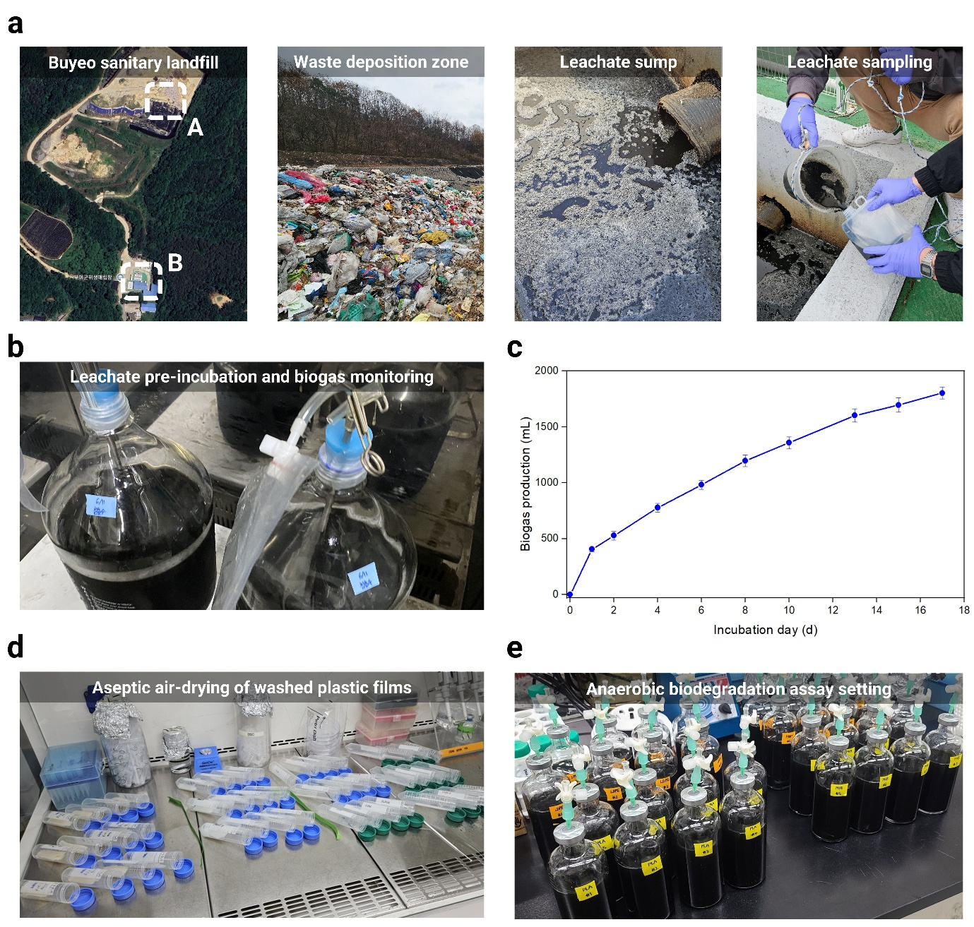
Supplementary Fig. S1. Workflow of the anaerobic plastic biodegradation assay using landfill leachate. a, Sampling scheme of the Buyeo sanitary landfill (Chungcheongnam-do, Republic of Korea), showing the (A) waste deposition zone and (B) the leachate collection sump. Leachate samples used in this study were directly collected from the sump. b, Leachate pre-incubation prior to biodegradation assay initiation. c, Cumulative biogas production during the pre-incubation period for 17 d. Error bars indicate standard deviation (n = 2). d, Preparation of plastic substrates: plastic films (1 cm × 4.5 cm, 1.2 g per bottle) were aseptically cut, washed with 70% ethanol, and air-dried under sterile conditions. e, Anaerobic biodegradation assay setup with eight replicates per plastic treatment and triplicated blanks.
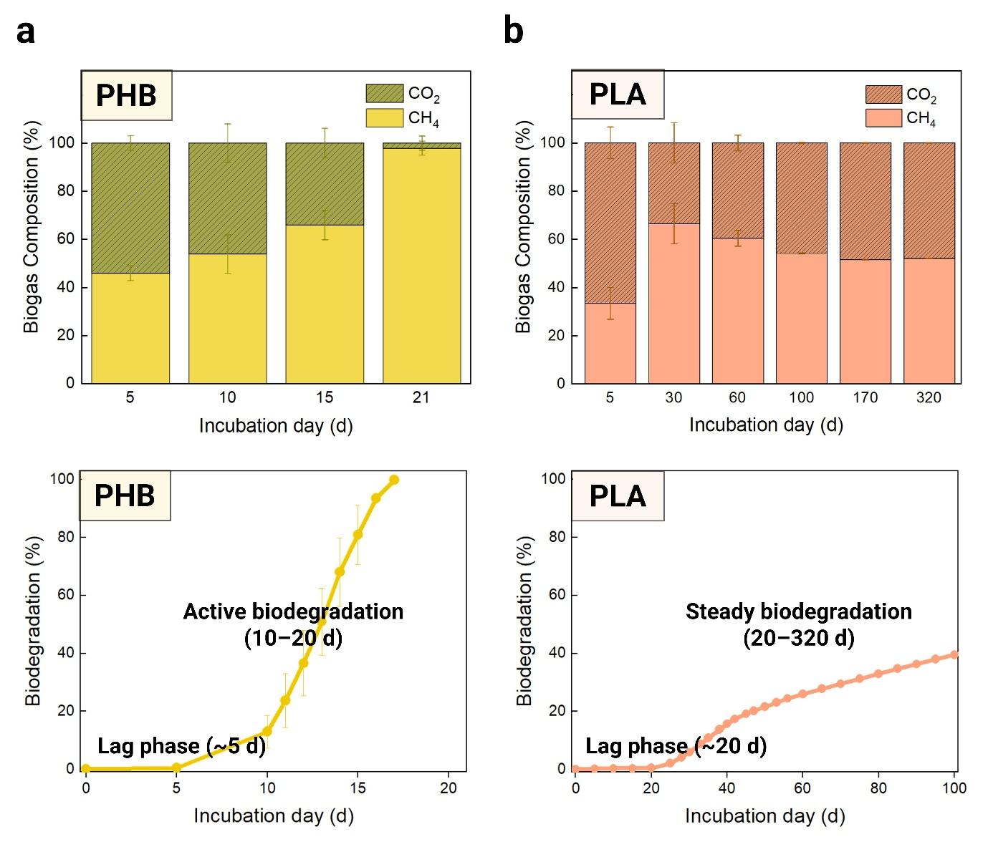
Supplementary Fig. S2. Early-phase biogas composition and biodegradation dynamics for PHB and PLA. a, PHB and b, PLA incubations. Top panels present the relative composition of biogas (CO₂ and CH₄) at the indicated incubation days. Bottom panels show cumulative biodegradation (%), with the lag and active biodegradation phases indicated.
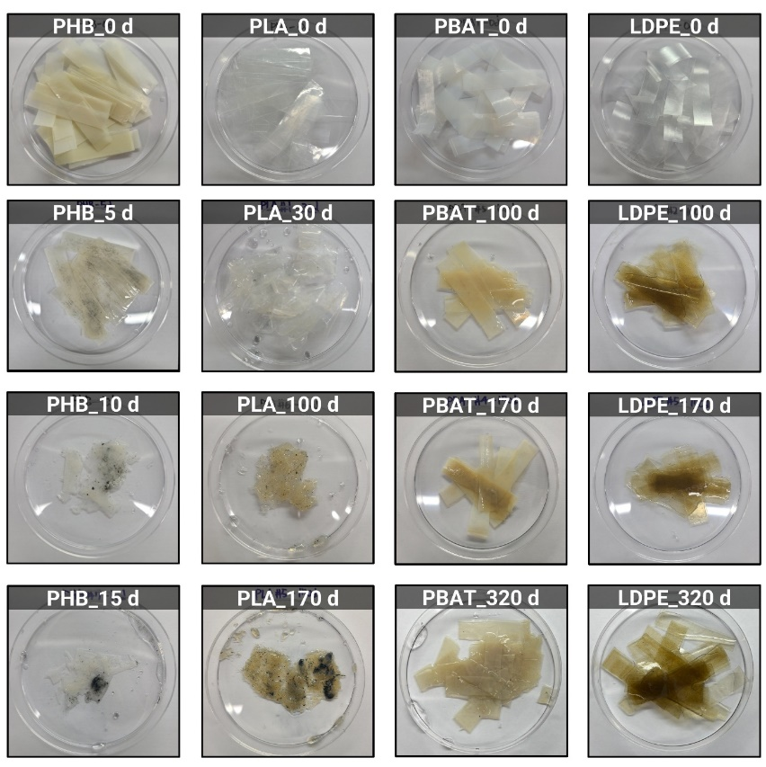
Supplementary Fig. S3. Time-course disintegration of biodegradable plastics (PHB, PLA, and PBAT) and LDPE during anaerobic landfill leachate incubation. Representative images of residual films sacrificially collected from a single replicate (n = 8) at the indicated time points. PHB exhibited rapid disintegration and was not recovered after 15 d, while PLA showed progressive fragmentation over 320 d. In contrast, PBAT and LDPE exhibited limited macroscopic changes.
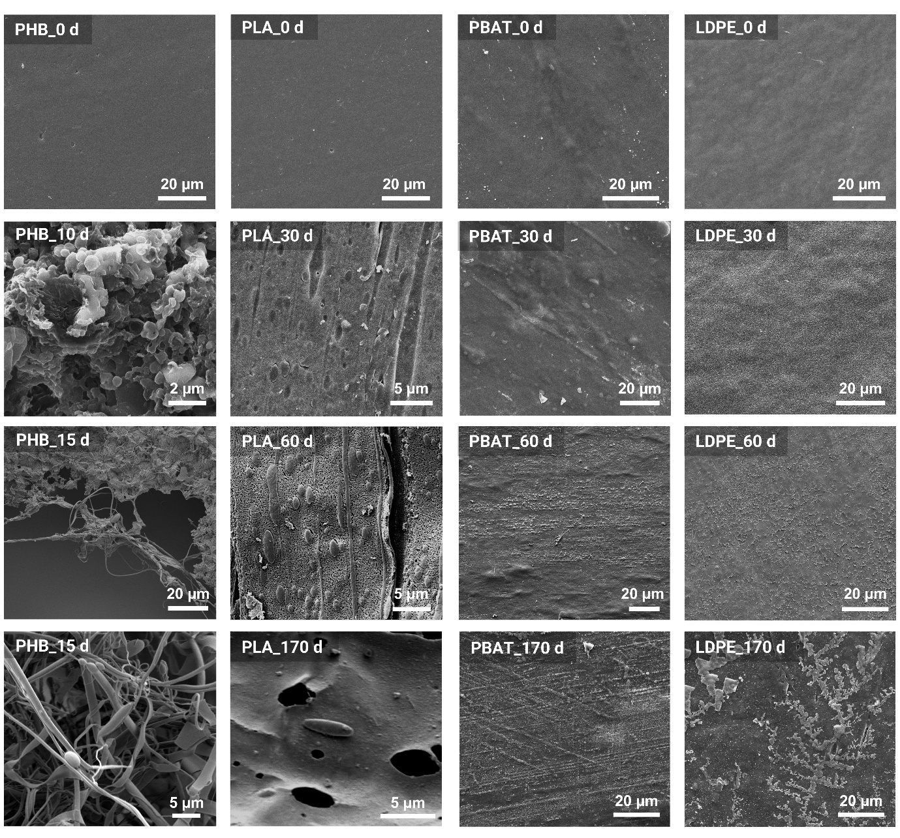
Supplementary Fig. S4. Surface morphology of biodegradable plastics (PHB, PLA, and PBAT) and LDPE films during anaerobic landfill leachate incubation. PHB exhibited rapid surface erosion and dense microbial colonization by 10–15 d, followed by complete disintegration. PLA showed progressive surface cracking, void formation, and lamellar peeling, with pronounced deterioration by 170 d. In contrast, PBAT retained its initial surface morphology with only minor scratches, and LDPE showed no structural breakdown during the 170 d incubation. Scale bars are shown in the bottom right of each image.
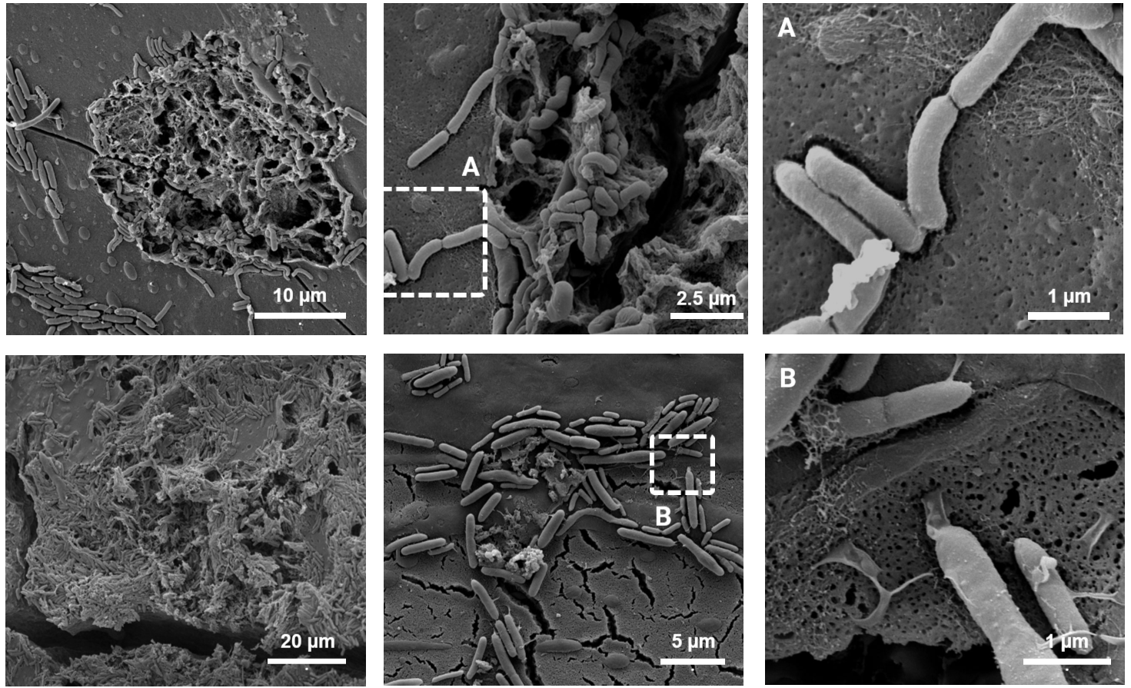
Supplementary Fig. S5. Biofilm formation on PLA films after 90 d of incubation under mesophilic (35 °C) anaerobic landfill leachate conditions in a preliminary microcosm test (separate from the main biodegradation experiment). Dense microbial aggregates and extracellular matrix structures were observed in scanning electron micrographs, consistent with biofilm development. Panels A and B correspond to the magnified views of the boxed regions in the adjacent images, highlighting cell morphology and extracellular network structures. Scale bars are shown in the bottom right of each image.

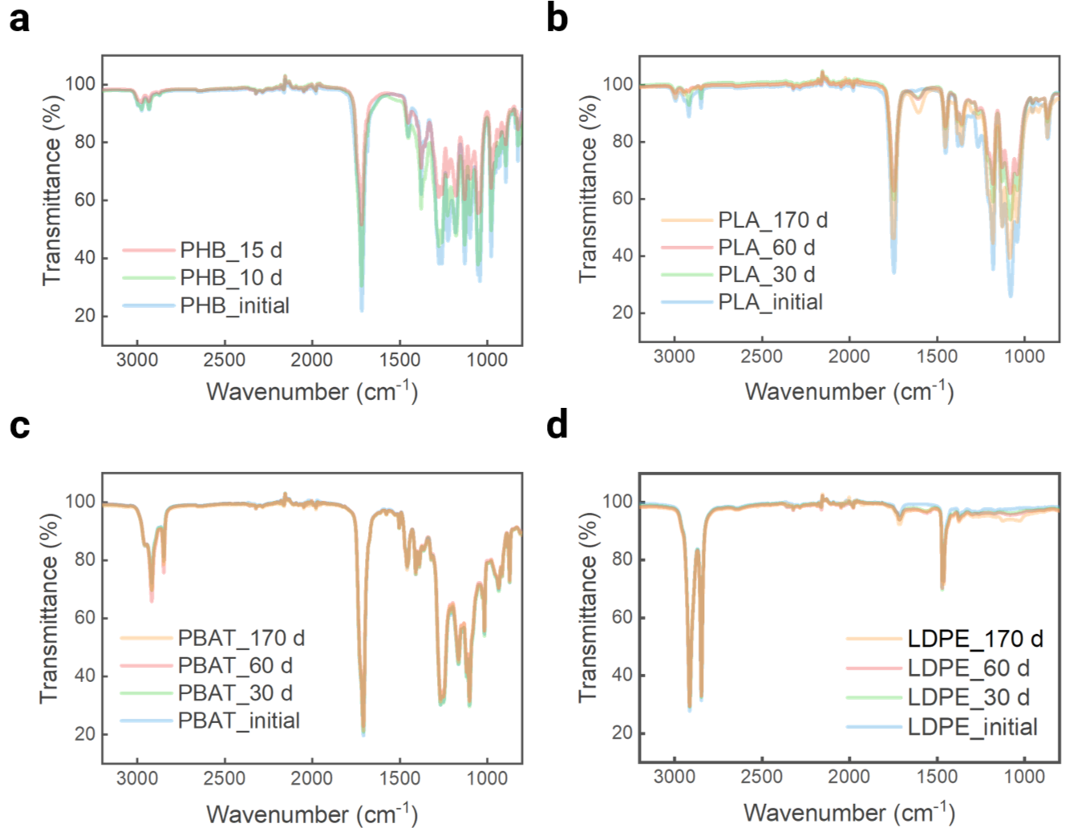
Supplementary Fig. S6. FT-IR spectra of plastic films during anaerobic landfill leachate incubation. a, PHB. b, PLA. c, PBAT. d, LDPE. Spectra are shown for the initial films and for residual films recovered at the indicated incubation time points. PHB and PLA exhibited progressive spectral changes during incubation, consistent with temporal alteration of their chemical bonding structures during anaerobic degradation, whereas PBAT and LDPE showed little to no observable spectral variation.

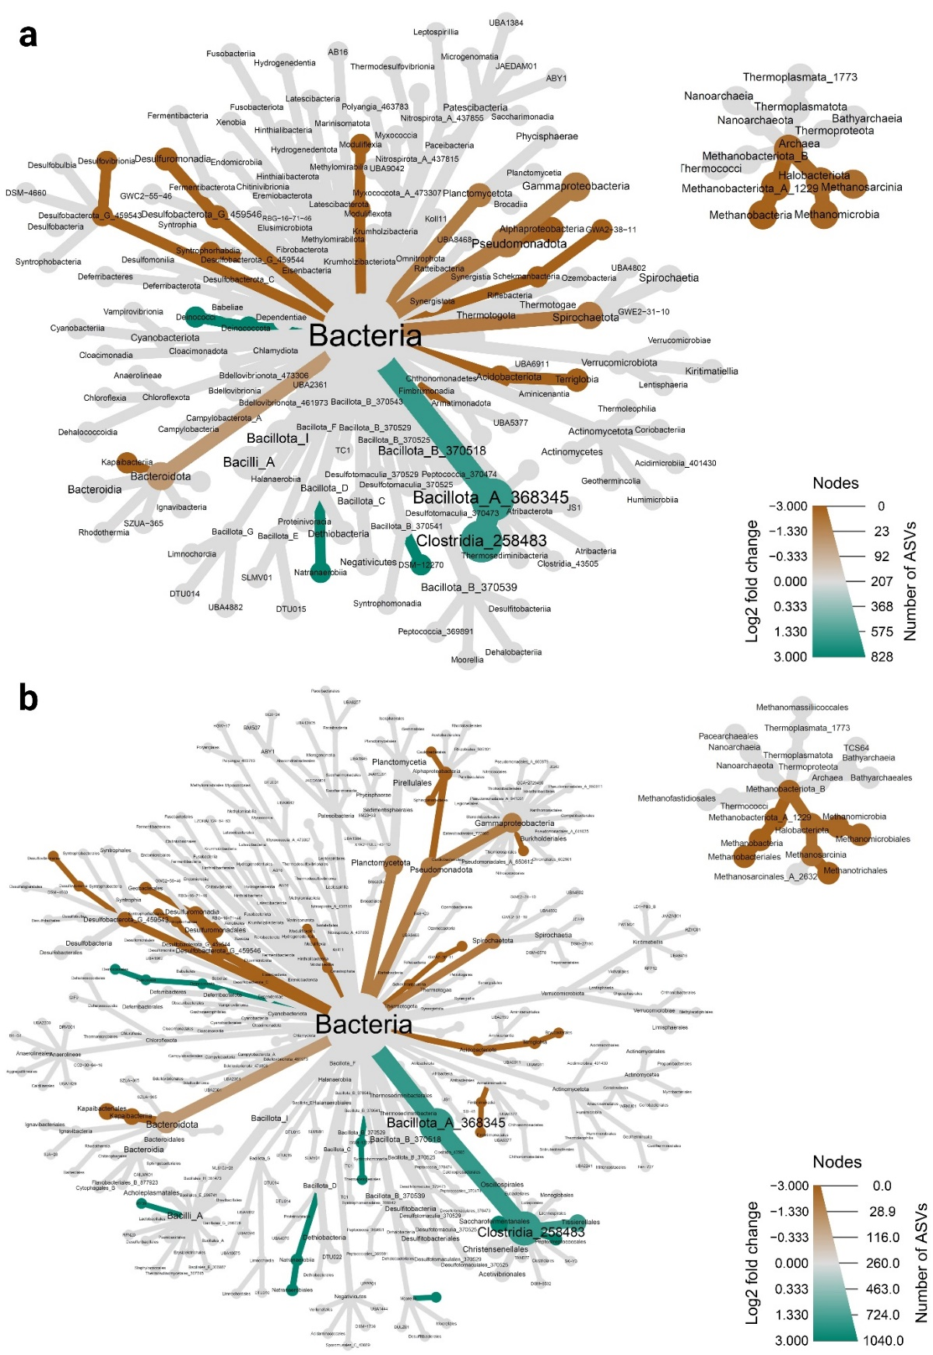
Supplementary Fig. S7. Differential abundance of bacterial and archaeal lineages between 16S rRNA (gene) amplicon profiles. Heat trees summarize DESeq2-based differential abundance testing comparing communities profiled from genomic DNA and RNA-derived cDNA, shown at the a, class and b, order levels. Node colour indicates the DESeq2 log₂-fold change (DNA vs RNA), with teal indicating enrichment in DNA-derived profiles and brown indicating enrichment in RNA-derived profiles. Node size reflects the number of ASVs assigned to each lineage. Grey nodes denote taxa that did not meet the significance threshold (Benjamini–Hochberg-adjusted, P ≥ 0.05). Taxonomy was assigned using Greengenes2 (v2024.09).

Supplementary Fig. S8. Unclassified and unmapped fractions across shotgun metagenomic profiling approaches. Boxplots show the proportion of reads that were unclassified in read-based taxonomic profiling (Kraken2 v2.0.8-beta, standard database; MetaPhlAn4 v4.2.2, marker database mpa_vJan25_CHOCOPhlAnSGB_202503) and unmapped in genome-resolved profiling (CoverM mapping to dereplicated MAGs; MAG taxonomy assigned with GTDB R226) across samples. Median values and ranges are annotated above each method.
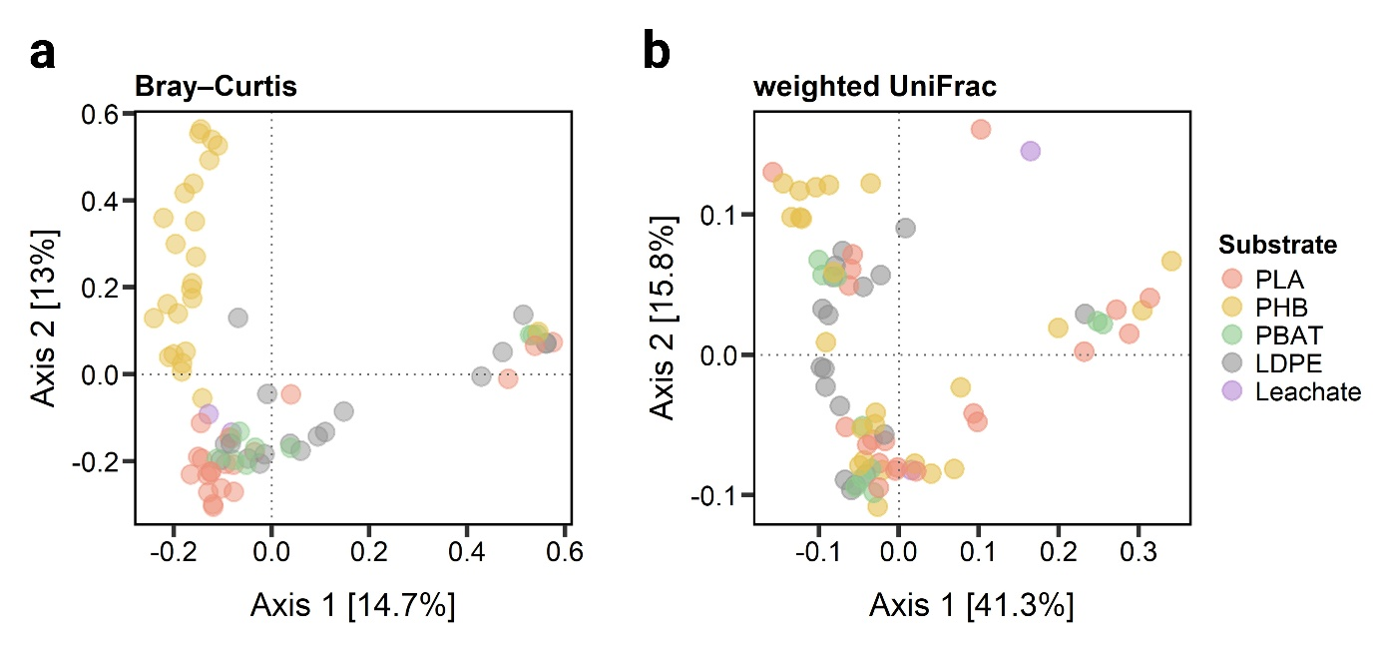
Supplementary Fig. S9. Beta-diversity patterns of 16S rRNA (gene) amplicon communities across substrates during anaerobic landfill leachate incubation. Principal coordinates analysis (PCoA) of community dissimilarities based on a, Bray–Curtis and b, weighted UniFrac distances. Points represent individual samples and are colored by substrate (PLA, PHB, PBAT, LDPE, and leachate inoculum).

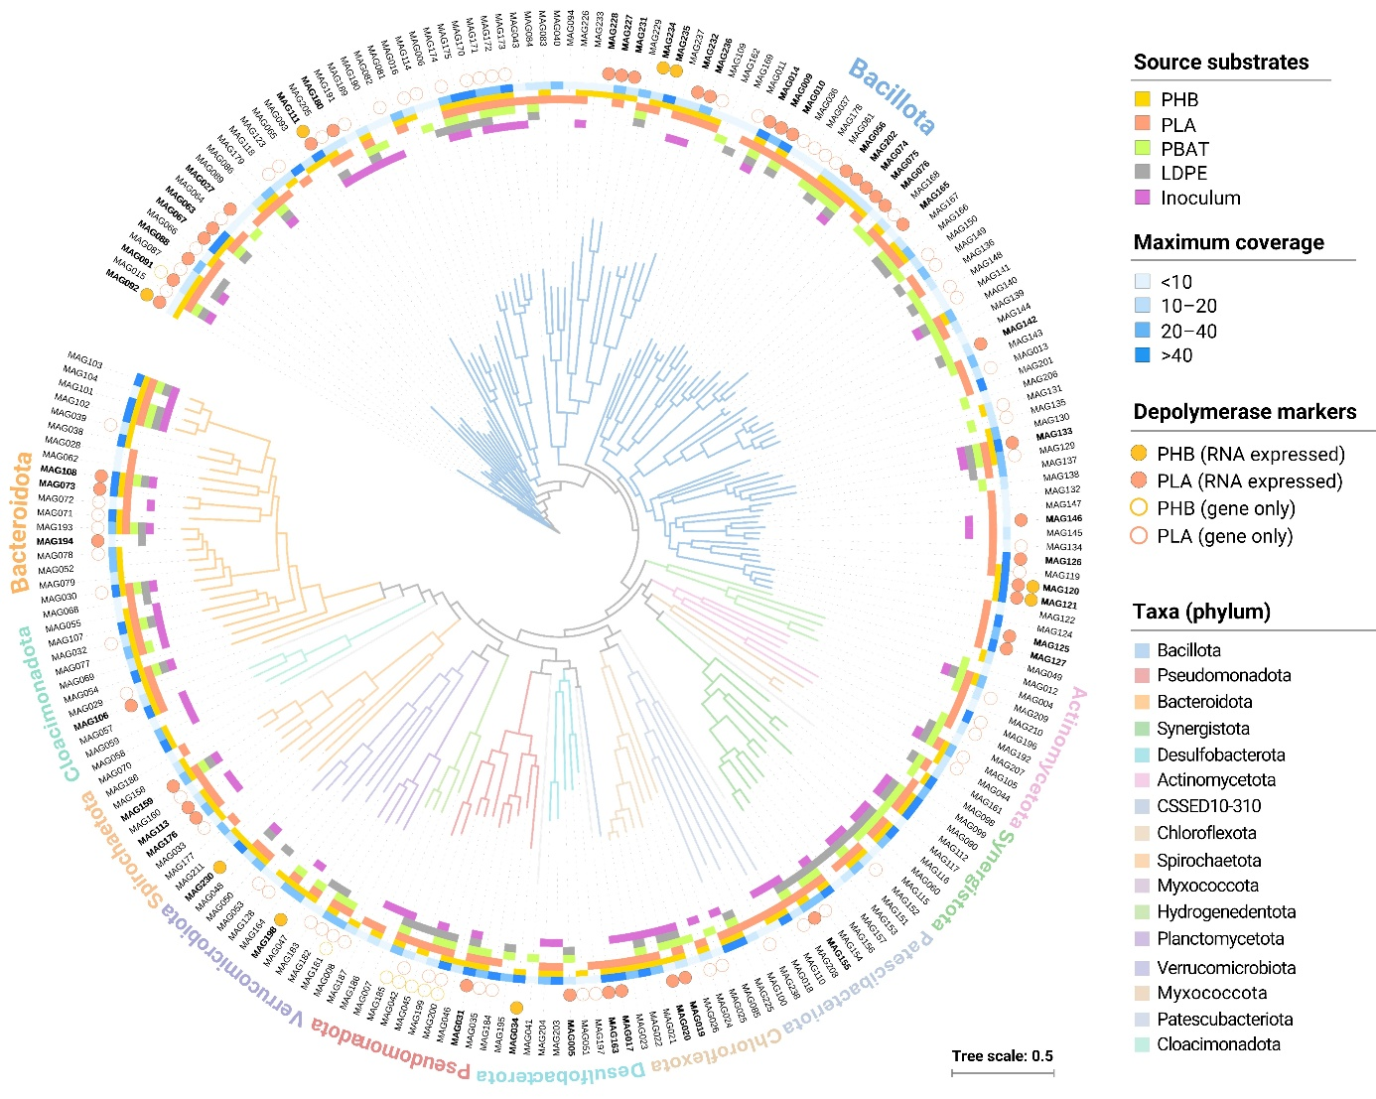
Supplementary Fig. S10. Phylogenomic diversity and global distribution of PHB and PLA depolymerase–encoding lineages. Phylogenomic tree of 218 dereplicated medium- to high-quality bacterial MAGs recovered from anaerobic incubations with plastic substrates. Branch colors indicate phylum-level taxonomy. Outer color strips denote source substrates, maximum coverage across source samples, and depolymerase status. MAG identifiers are shown in bold for genomes with putative PHB or PLA depolymerase gene expression. Solid circles indicate metatranscriptomic support (TPM ≥ 1), whereas hollow circles indicate putative genes without detectable expression.

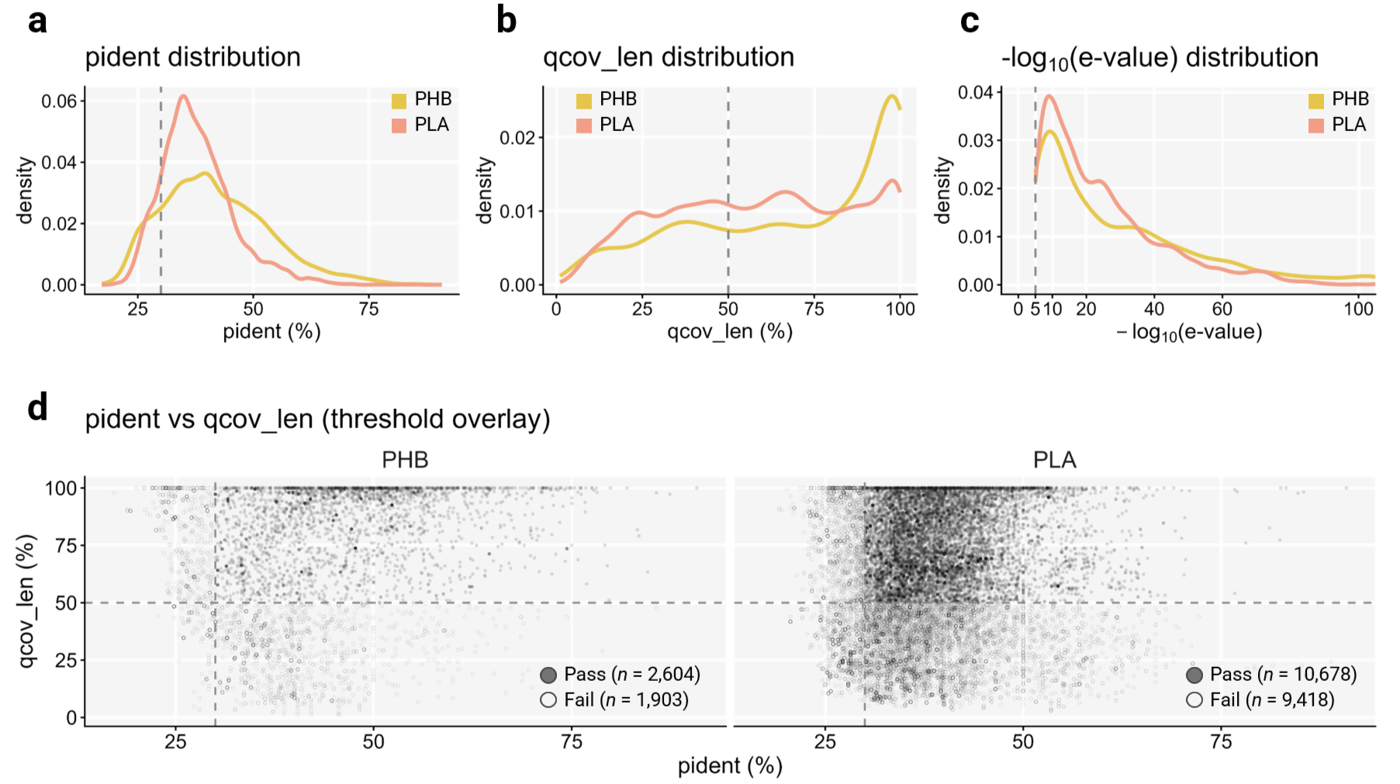
Supplementary Fig. S11. Gene-centric DIAMOND hit-quality distributions and filtering thresholds for depolymerase homolog assignment. a, Kernel density distribution of percent amino-acid identity (pident, %) for DIAMOND blastp hits, shown for PHB (gold) and PLA (salmon); the vertical dashed line indicates the applied threshold (pident ≥ 30%). b, Kernel density distribution of query coverage based on aligned length (qcov_len, %; 100 × alignment length/query length) for DIAMOND blastp hits, shown for PHB (gold) and PLA (salmon); the vertical dashed line indicates the applied threshold (qcov_len ≥ 50%). c, Kernel density distribution of −log₁₀(e-value) for DIAMOND blastp hits, shown for PHB (gold) and PLA (salmon); the x-axis is truncated at 100 for visualization, and the vertical dashed line indicates the applied threshold (e-value ≤ 1e⁻⁵; corresponding to −log₁₀(e-value) ≥ 5). d, Joint distribution of pident and qcov_len for individual hits (one point per DIAMOND hit), shown separately for PHB and PLA; dashed lines indicate the applied thresholds. Filled points denote retained hits (PASS), whereas open points denote excluded hits (FAIL). Counts of retained and excluded hits are annotated within each facet.
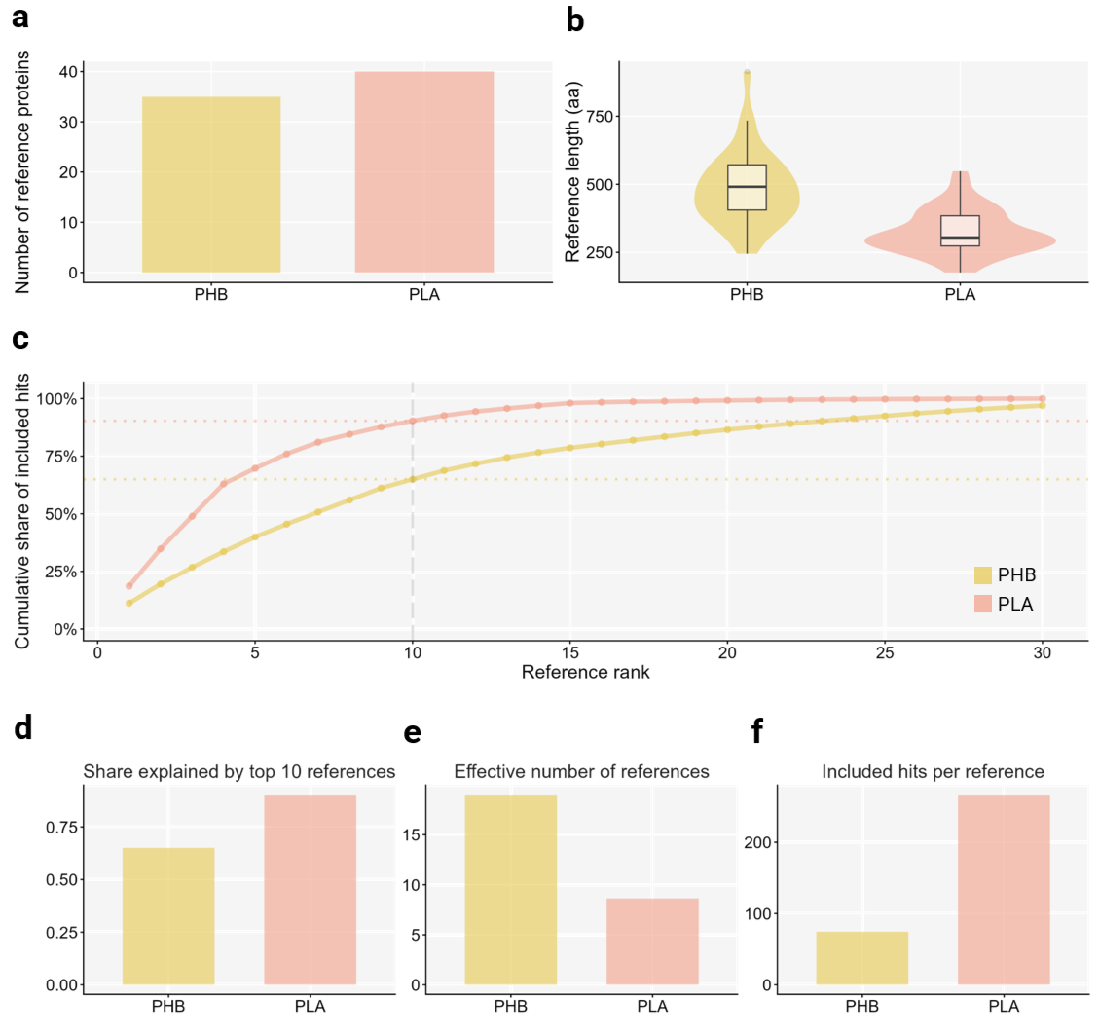
Supplementary Fig. S12. Reference database structure and hit concentration for PHB and PLA depolymerase annotations. a, Curated reference database composition after curation and dereplication with the number of reference proteins for PHB and PLA. b, Amino-acid length distributions of reference proteins. c, Cumulative share of included hits explained by the top-ranked reference proteins. Reference proteins were ranked by their included-hit counts within each substrate (x-axis), and the cumulative fraction of included hits was plotted (y-axis). The vertical dashed line indicates the top 10 references, and horizontal dotted lines indicate the fraction of included hits explained by the top 10 references for each substrate (top-10 share). d, Share explained by the top 10 references. e, Effective number of references (middle; 1/Σp_{i}², where p_{i} is the fraction of included hits assigned to reference i). f, Included hits per reference.

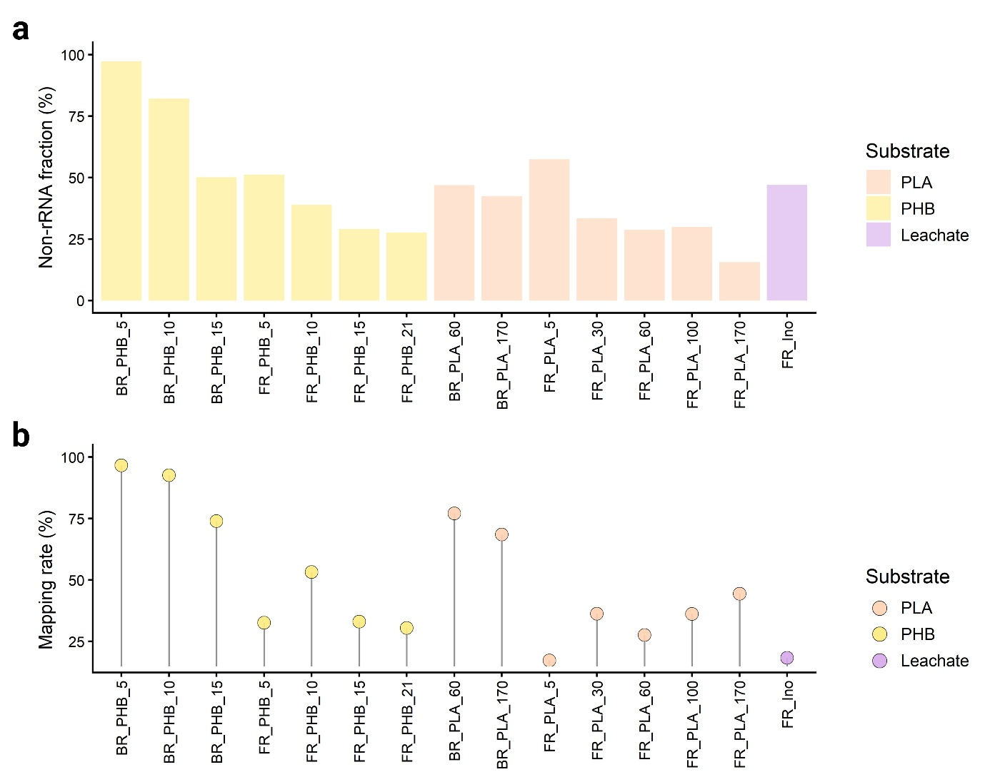
Supplementary Fig. S13. Non-rRNA read fraction and transcript mapping rate in metatranscriptomic libraries from anaerobic landfill leachate incubations. a, Fraction of reads retained after rRNA removal using SortMeRNA (non-rRNA, %). b, Mapping rate (%) of the rRNA-filtered reads to the assembly-derived coding sequences (CDSs) (Prodigal-predicted ORFs from metagenomic assemblies). Colors indicate substrate amendment (PHB or PLA) or the leachate-only control.
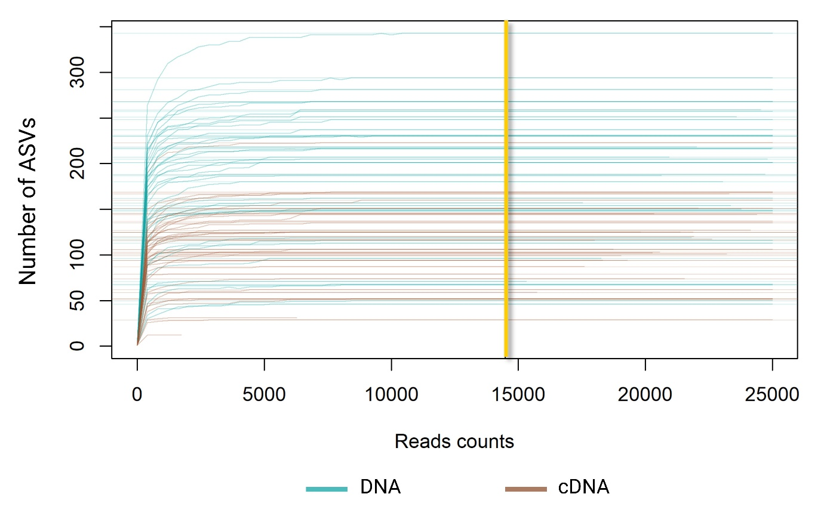
Supplementary Fig. S14. Rarefaction curves of 16S rRNA (gene) amplicon libraries from DNA (teal) and cDNA (brown). Normalization was performed using Scaling with Ranked Subsampling (SRS) to 14,490 reads per sample (yellow line). Two cDNA libraries (BR_LDPE_5 and BR_LDPE_60) with lower sequencing depth than the cutoff were excluded from downstream analyses.
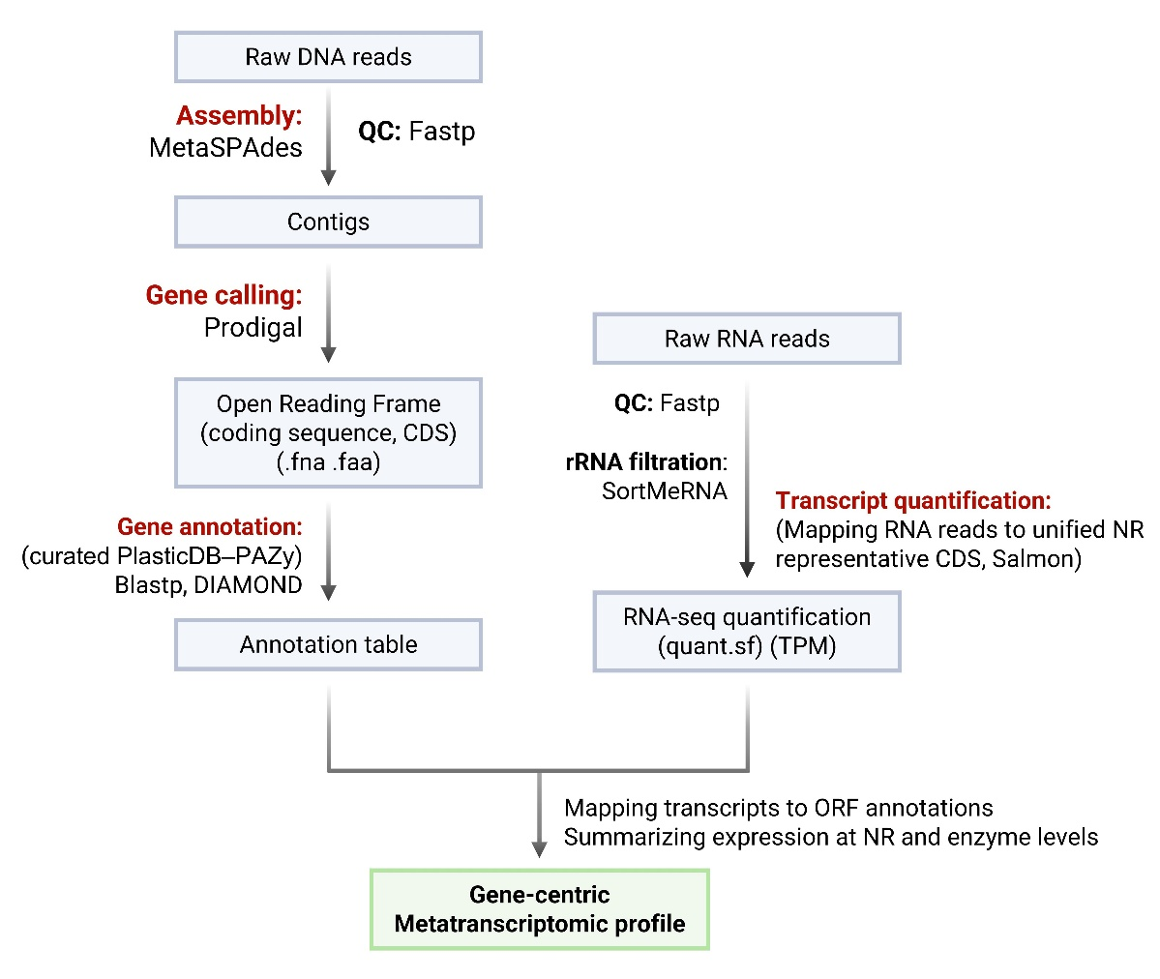
Supplementary Fig. S15. Gene-centric metatranscriptomic workflow for identifying depolymerase homologs and quantifying their transcriptional activity. Raw metagenomic reads were quality-filtered (fastp), assembled with MetaSPAdes, and used for ORF prediction with Prodigal. Predicted ORFs were clustered into a unified non-redundant (NR) representative CDS catalog and annotated against a curated depolymerase reference database (PlasticDB–PAZy) using DIAMOND blastp. In parallel, metatranscriptomic reads were quality-filtered (fastp), depleted of rRNA (SortMeRNA), and quantified with Salmon by mapping non-rRNA reads to the same NR catalog to estimate transcript abundances (TPM). Transcript abundances were merged with ORF annotations and summarized at both the NR-representative and enzyme-label levels to generate gene-centric metatranscriptomic profiles across samples.

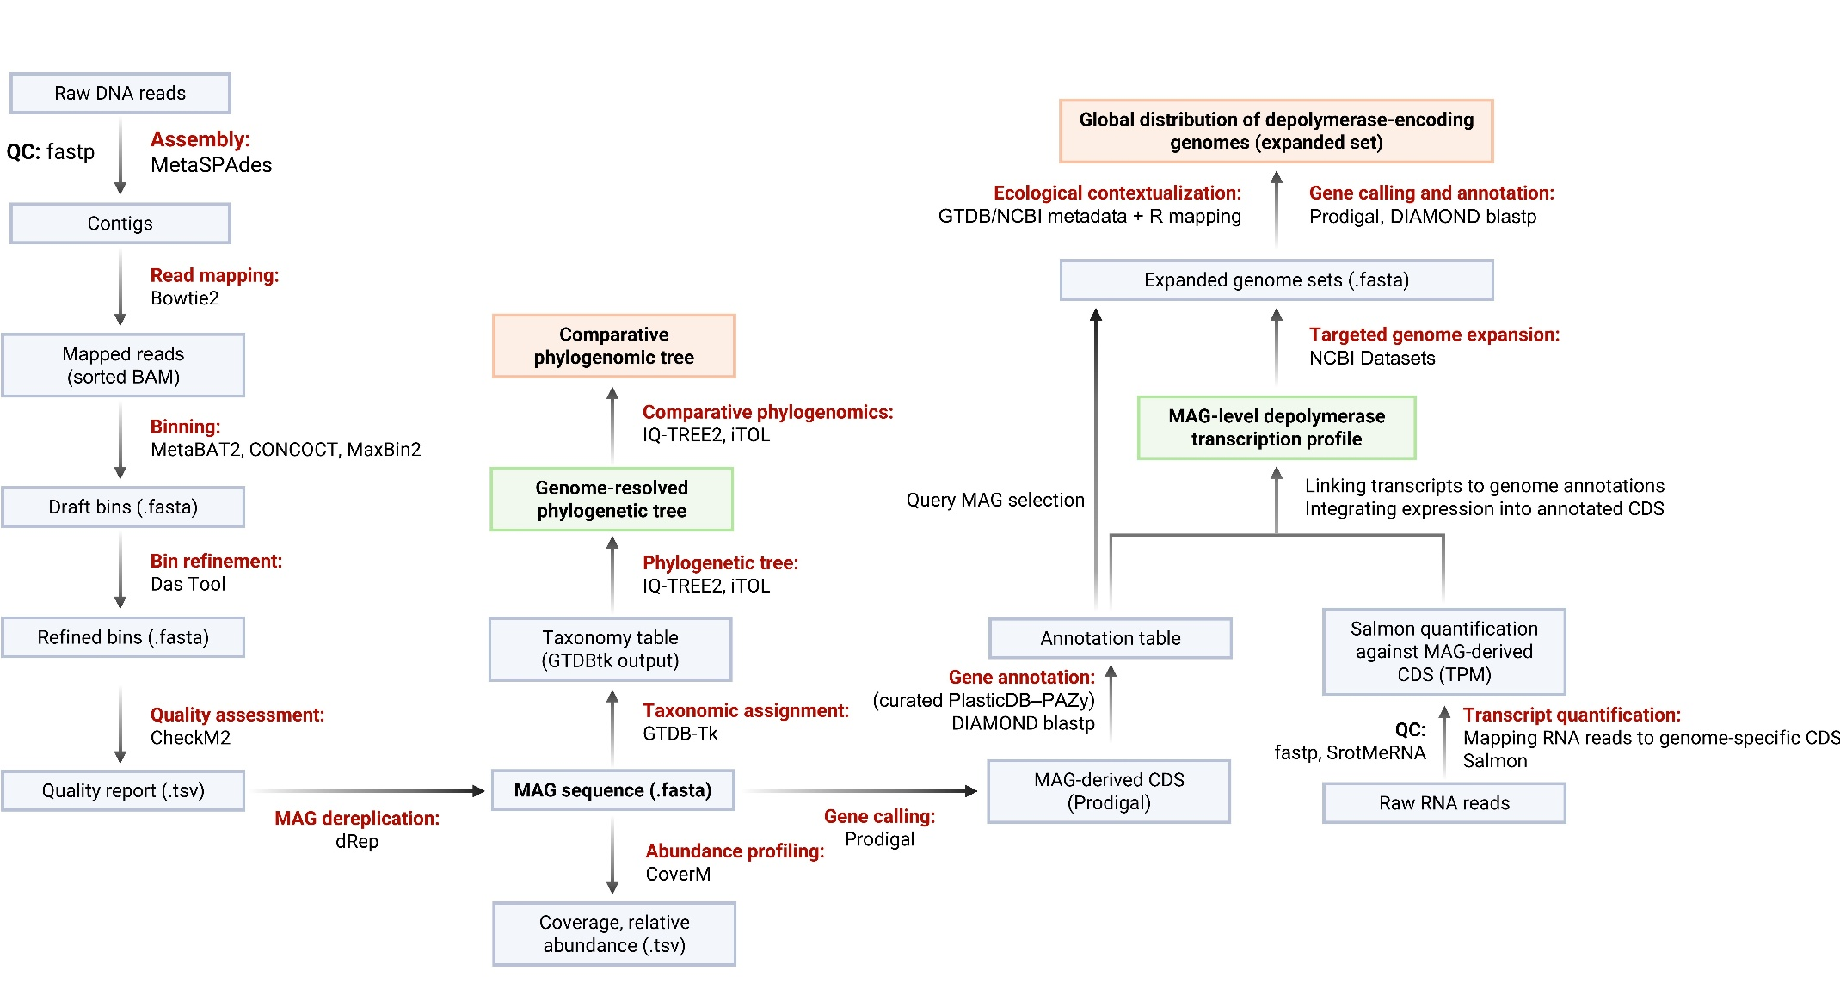
Supplementary Fig. S16. Genome-centric workflow for reconstructing depolymerase-associated MAGs and integrating metatranscriptomic support, followed by comparative phylogenomics and biogeographic contextualization. Quality-filtered metagenomic reads were assembled and binned to generate quality-controlled, dereplicated, and taxonomically assigned MAGs with sample-wise abundance/coverage estimates. MAG CDSs were annotated against a curated PlasticDB–PAZy depolymerase reference, and metatranscriptomic reads were quantified by mapping to MAG-derived CDSs to generate MAG-level depolymerase transcription profiles. Depolymerase-positive MAGs seeded targeted genome expansion using GTDB/NCBI reference genomes, enabling global distribution mapping and comparative phylogenetic analyses.

References
1. Bolyen, E., et al. Reproducible, interactive, scalable and extensible microbiome data science using QIIME 2. Nat. Biotechnol. 37, 852–857 (2019).
2. Callahan, B.J., et al. DADA2: high-resolution sample inference from Illumina amplicon data. Nat. Methods 13, 581–583 (2016).
3. McDonald, D., et al. Greengenes2 unifies microbial data in a single reference tree. Nat. Biotechnol. 42, 715–718 (2024).
4. Beule, L. & Karlovsky, P. Improved normalization of species count data in ecology by scaling with ranked subsampling (SRS): application to microbial communities. PeerJ 8, e9593 (2020).
5. Wood, D.E., Lu, J. & Langmead, B. Improved metagenomic analysis with Kraken 2. Genome Biol. 20, 257 (2019).
6. Aroney, S.T., et al. CoverM: read alignment statistics for metagenomics. Bioinformatics 41, btaf147 (2025).
7. Foster, Z.S., Sharpton, T.J. & Grünwald, N.J. Metacoder: aAn R package for visualization and manipulation of community taxonomic diversity data. PLoS Comput. Biolo. 13, e1005404 (2017).
8. Oksanen J, et al. Package ‘vegan’: Community ecology package, version 2, 1–295 (2013).
9. McMurdie, P.J. & Holmes, S. phyloseq: an R package for reproducible interactive analysis and graphics of microbiome census data. PloS one 8, e61217 (2013).
10. Paradis, E. & Schliep, K. ape 5.0: an environment for modern phylogenetics and evolutionary analyses in R. Bioinformatics 35, 526–528 (2019).
11. Wickham, H. ggplot2. Wiley Interdiscip. Rev. Comput. Stat. 3, 180–185 (2011).
12. Prjibelski, A., Antipov, D., Meleshko, D., Lapidus, A. & Korobeynikov, A. Using SPAdes de novo assembler. Curr. Protoc. Bioinformatics 70, e102 (2020).
13. Hyatt, D., et al. Prodigal: prokaryotic gene recognition and translation initiation site identification. BMC Bioinformatics 11, 119 (2010).
14. Steinegger, M. & Söding, J. MMseqs2 enables sensitive protein sequence searching for the analysis of massive data sets. Nat. Biotechnol. 35, 1026–1028 (2017).
15. Buchholz, P.C., et al. Plastics degradation by hydrolytic enzymes: the plastics‐active enzymes database—PAZy. Proteins: Struct. Func. Bioinf. 90, 1443–1456 (2022).
16. Gambarini, V., et al. PlasticDB: a database of microorganisms and proteins linked to plastic biodegradation. Database 2022, baac008 (2022).
17. Buchfink, B., Reuter, K., Drost, H.G. Sensitive protein alignments at tree-of-life scale using DIAMOND. Nat. Methods 18, 366–368 (2021).
18. Chen, S., Zhou, Y., Chen, Y. & Gu, J. fastp: an ultra-fast all-in-one FASTQ preprocessor. Bioinformatics 34, i884–i890 (2018).
19. Patro, R., Duggal, G., Love, M.I., Irizarry, R.A. & Kingsford, C. Salmon provides fast and bias-aware quantification of transcript expression. Nat. Methods 14, 417–419 (2017).
20. Langmead, B. & Salzberg, S.L. Fast gapped-read alignment with Bowtie 2. Nat. Methods 9, 357–359 (2012).
21. Li, H., et al. The sequence alignment/map format and SAMtools. Bioinformatics 25, 2078–2079 (2009).
22. Kang, D.D., et al. MetaBAT 2: an adaptive binning algorithm for robust and efficient genome reconstruction from metagenome assemblies. PeerJ 7, e7359 (2019).
23. Wu, Y.W., Simmons, B.A. & Singer, S.W. MaxBin 2.0: an automated binning algorithm to recover genomes from multiple metagenomic datasets. Bioinformatics 32, 605–607 (2016).
24. Alneberg, J., et al. CONCOCT: clustering contigs on coverage and composition. Preprint at https://arxiv.org/abs/1312.4038 (2013).
25. Sieber, C.M., et al. Recovery of genomes from metagenomes via a dereplication, aggregation and scoring strategy. Nat. Microbiol. 3, 836–843 (2018).
26. Chklovski, A., Parks, D.H., Woodcroft, B.J. & Tyson, G.W. CheckM2: a rapid, scalable and accurate tool for assessing microbial genome quality using machine learning. Nat. Methods 20, 1203–1212 (2023).
27. Suzek, B.E., Huang, H., McGarvey, P., Mazumder, R. & Wu, C.H. UniRef: comprehensive and non-redundant UniProt reference clusters. Bioinformatics 23, 1282–1288 (2007).
28. Chaumeil, P.A., Mussig, A.J., Hugenholtz, P. & Parks, D.H.. GTDB-Tk: a toolkit to classify genomes with the Genome Taxonomy Database. Bioinformatics 36, 1282–1288 (2020).
29. Chaumeil, P.A., Mussig, A.J., Hugenholtz, P. & Parks, D.H.. GTDB-Tk v2: memory friendly classification with the genome taxonomy database. Bioinformatics 38, 5315–5316 (2022).
30. Minh, B.Q., et al. IQ-TREE 2: new models and efficient methods for phylogenetic inference in the genomic era. Mol. Biol. Evol. 37, 1530–1534 (2020).
31. Letunic, I. & Bork, P. Interactive Tree of Life (iTOL) v6: recent updates to the phylogenetic tree display and annotation tool. Nucleic Acids Res. 52, W78–W82 (2024).

