Supplementary Material
Potential impacts of climate change and water resource management on fish catch in the Lower Mekong River

Text S1. Modelling water level and water temperature
Precipitation of all upstream sub-basins and air temperature of the Upper Lancang (see Figure 1) were utilised to create a generalised additive model (GAM) for predicting the water level (monthly average) at Stung Treng in the Lower Mekong. Cross-correlation analysis between the precipitation in the upstream sub-basins and the water level in Stung Treng was conducted to identify the time lag in the response of the water level to the upstream precipitation and the identified lag was included in GAM. The temperature of sub-basins other than the Upper Lancang was omitted in this model because they did not show major improvement in the model accuracy. The model was calibrated using the data from 1950 to 1992, which corresponds to natural hydrological conditions with no major interventions by dams or land use changes (Lu & Chua, 2021).
Then, the water level at Stung Treng and the precipitation of the 3S, Tonle Sap, and Southern Lower Mekong basins were used to model water levels (monthly average) at Kratie (1950–1992), Phnom Penh (1960–1992), and Prek Kdam (1960–1992) with the framework of a MLR. Based on cross-correlation analysis, these models also integrated time lags between precipitation and downstream water levels as well as between the water level in Stung Treng and downstream water levels. Lastly, the water level at Kampong Luong was modelled based on the water level at Prek Kdam and the precipitation in the Tonle Sap Basin considering the local hydrological process and the data limitation (i.e., available only from 1997 to 2022). After the calibration, all models were validated based on 50-times 5-fold cross-validation with coefficient of determination (R²), normalised root mean square error (NRMSE), and Nash-Sutcliffe efficiency (NSE) as indicators for model fitness.
Water temperatures (monthly average) at the five sites (Figure 1) were modelled using GAMs with explanatory variables chosen based on the energy balance concept (Eq. 1), following Laanaya, et al. (2017). The key energy fluxes determining water temperature are shortwave radiation flux, longwave radiation flux, sensible heat flux, latent heat flux, and the heat flux from inflows (Wade et al., 2024). The models were calibrated with the data from 1950 to 1992, to exclude potential effects of water resource management. Shortwave (r_{sw,t}) and longwave (r_{lw,t}) radiation fluxes were obtained directly from ERA5-Land and projection data sets. The sensible heat flux was approximated by the difference of air temperature (T_{a, t-1}) and water temperature in a preceding month (T_{w, t-1}). The latent heat flux was estimated using wind speed of a concerned month (u_{t}) as a proxy for the evaporation rate because wind acts as a driver of evaporation by removing the saturated air layer directly above the water surface (McVicar et al., 2012). To capture heat fluxes from inflow (i.e., inputs from subsurface flow and precipitation), a term combining precipitation (P_{t}) with air temperature (T_{a,t}) in a concerned month was included in the models because the correlation of water temperature with air temperature was the strongest among all predictor variables. These estimates for energy fluxes alongside the water temperature in a previous month were incorporated as predictor variables in the GAM framework, where β₀ is the intercept of the model.
$T_{w, t}= β_{0}+ f_{1}\left(r_{sw, t}\right)+ f_{2}\left(r_{ lw, t}\right)+ f_{3}\left(T_{a, t-1}, T_{w, t-1}\right)+ f_{4}\left(u_{ t}\right)+ f_{5}\left(P_{ t}, T_{a, t}\right)+ T_{w, t-1}$ (1)
The models were then validated by 50-times 5-fold cross-validation on the historical data using R², NRMSE, and NSE.

Text S2. Modelling fish catch
This study employed the lifecycle approach to model annual catch of migratory fish as well as annual catches of two dominant cyprinid species of Henicorhynchus lobatus, and Labiobarbus lineatus. These species accounted for 20.7% and 12.4% of the total catch of migratory fish in average for the period from 2001 to 2015 and are among the most abundant and productive carps in the Lower Mekong, highly relying on its floodplain systems (Ngor et al., 2018). Due to their productiveness and size, these small cyprinids contribute substantially to food security in the Lower Mekong, being used in the production of prahok, an important fish paste in Cambodian cuisine (McKenney & Tola, 2004).
The lifecycle approach considers life stages of migratory fish, including refugee, spawning, migration, and feeding, to determine habitat conditions as explanatory variables, which are water temperatures, water level, rate of flood rise, and rate of drawdown at relevant sites to their life stages (Ly et al., 2024). The applied explanatory variables are detailed in Table S2. The data of these habitat conditions were extracted from the hydrological data or models. Generalised linear models (GLMs) and MLRs were applied with a maximum of five of these variables. To prevent multicollinearity, variance inflation factor (VIF) was calculated for all possible variable combinations and the maximum allowable VIF was set to five across all combinations (Akinwande et al., 2015).
The models were calibrated with fish catch and hydrological data from the hydrological year 2000/2001 to 2014/2015. The three best models of each model structure were selected based on Akaike information criterion (AICc) corrected for our small sample sizes (Hurvich & Tsai, 1989), and then they were used for identifying significant variables for fish catch. The reason for creating three models of each model type was to ensure that the ecologically significant hydrological variables were reflected in the following projection, under the limited data availability. The identified models were validated based on the NRMSE and 50-times 5-fold cross-validation.
Then, sensitivity analysis was conducted for the model of the total fish catch to investigate to which extents input variables affect fishery in Tonle Sap, and the model which showed the highest cross-validated R² among the developed models was used in the scenario analysis.

Table S1. Hydrological variables used in this study. MSL: gauge basis in meters above sea level.
Variable | Source | Site | Data period
Water Level (m)  (river gauge height) | Mekong River Commission | Stung Treng  (36.8 m MSL) | 1950–2022
Water Level (m)  (river gauge height) | Mekong River Commission | Kratie  (-0.1 m MSL) | 1950–2022
Water Level (m)  (river gauge height) | Mekong River Commission | Phnom Penh  (0.0 m MSL) | 1960–2022
Water Level (m)  (river gauge height) | Mekong River Commission | Prek Kdam  (0.08 m MSL) | 1960–2022
Water Level (m)  (river gauge height) | Mekong River Commission | Kampong Luong  (0.64 MSL) | 1997–2022
Water Temperature (°C) | ERA5-Land | Stung Treng | 1950–2025
Water Temperature (°C) | ERA5-Land | Kratie | 1950–2025
Water Temperature (°C) | ERA5-Land | Phnom Penh | 1950–2025
Water Temperature (°C) | ERA5-Land | Prek Kdam | 1950–2025
Water Temperature (°C) | ERA5-Land | Kampong Luong | 1950–2025

Table S2. Hydrological data used in this study for modelling fish catch (from Ly et al., 2024).
Life stage | Variable name | Definition
Refugee  Mekong River/Kratie  February – April | 1WL | Mean Water Level during Refugee Season (m)
Refugee  Mekong River/Kratie  February – April | 1WT | Mean Water Temperature during Refugee Season (°C)
Spawning  Upstream Mekong River/Stung Treng  May – July | 2WL | Mean Water Level during Spawning Season (m)
Spawning  Upstream Mekong River/Stung Treng  May – July | 2WT | Mean Water Temperature during Spawning Season (°C)
Migration  Mekong River/Kratie  May – July | 3WL | Mean Water Level during Migration Season (m)
Migration  Mekong River/Kratie  May – July | 3WT | Mean Water Temperature during Migration Season (°C)
Feeding  Tonle Sap/Kampong Luong  July – November | 4WL | Mean Water Level during Feeding Season (m)
Feeding  Tonle Sap/Kampong Luong  July – November | 4WT | Mean Water Temperature during Feeding Season (°C)
Feeding  Tonle Sap/Kampong Luong  July – November | 4WLmax | Maximum Water Level during Feeding Season (m)
Feeding  Tonle Sap/Kampong Luong  July – November | 4FS | Start date of flood – first day when the water level in Kampong Luong is above 2m (d)
Feeding  Tonle Sap/Kampong Luong  July – November | 4FE | End date of flood – last day when the water level in Kampong Luong is above 2m (d)
Feeding  Tonle Sap/Kampong Luong  July – November | 4DF | Duration of flood – duration between start and end date of flood (d)
Feeding  Tonle Sap/Kampong Luong  July – November | 4RFR | Rate of flood rise – ratio of the water level amplitude during flood (4WLmax – 2m) to the duration of rising water levels (t(4WLmax) – 4FS) (m/d)
Feeding  Tonle Sap/Kampong Luong  July – November | 4RDD | Rate of drawdown – ratio of the water level amplitude during flood (4WLmax – 2m) to the duration of falling water levels (4FE – t(4WLmax)) (m/d)
Migration  Tonle Sap River/Prek Kdam  December – February | 5WL | Mean Water Level during Migration Season (m)
Migration  Tonle Sap River/Prek Kdam  December – February | 5WT | Mean Water Temperature during Migration Season (°C)
Migration  Tonle Sap River/Prek Kdam  December – February | 5BP | Fish biomass caught in the previous year (kg)

Table S3. Performance of the models for water levels and temperatures, created and validated during the periods shown in Table S1 for the period up to 1992.
Site | Water Level |  |  | Water Temperature
Site | Cross-validated R² | NRMSE | NSE | Cross-validated R² | NRMSE | NSE
Stung Treng | 0.96 | 0.054 | 0.97 | 0.98 | 0.026 | 0.99
Kratie | 0.99 | 0.033 | 0.99 | 0.99 | 0.023 | 0.99
Phnom Penh | 0.97 | 0.052 | 0.97 | 0.96 | 0.036 | 0.97
Prek Kdam | 0.96 | 0.054 | 0.96 | 0.97 | 0.033 | 0.98
Kampong Luong | 0.99 | 0.025 | 0.99 | 0.98 | 0.028 | 0.99

Table S4. Performance of GAM model for the water level in Stung Treng.
Model | Unstandardised Coefficients |  | t | Sign. | 95% Confidence Interval for β
Model | β | Std. Error | t | Sign. | Lower Bound | Upper Bound
Intercept | 2.69 | 0.125 | 21.51 | *** | 2.447 | 2.938
$${WL}_{ST, t-1}$$ | 0.38 | 0.028 | 13.34 | *** | 0.324 | 0.436
 | Estimated Degrees of Freedom |  | F |  | Sign.
$$s(p_{CLM, t})$$ | 7.523 |  | 4.182 |  | ***
$$s(p_{ NLM, t})$$ | 7.620 |  | 13.401 |  | ***
$$s(p_{ CMB, t})$$ | 3.496 |  | 3.718 |  | **
$$s(p_{ NOB, t-1})$$ | 3.713 |  | 3.319 |  | **
$$s(p_{ LL, t-1})$$ | 1.897 |  | 19.309 |  | ***
$$s(T_{ UL, t-1})$$ | 3.856 |  | 10.587 |  | ***
$$te(T_{UL, t-1}, p_{ UL, t-1})$$ | 2.0 |  | 8.176 |  | ***
$$te(T_{UL, t-2}, p_{UL, t-2})$$ | 3.0 |  | 5.813 |  | ***

With:
${WL}_{ST, i}$ = Monthly mean water level in Stung Treng in month i,
$p_{Basin, i}$ = Monthly total precipitation in a specific upstream basin in month i,
$T_{Basin, i}$ = Monthly mean temperature in a specific upstream basin in month i,
CLM = Central Lower Mekong,
NLM = Northern Lower Mekong,
CMB = Chi Mun River Basin,
NMB = Nam Ou River Basin,
LL = Lower Lancang,
UL = Upper Lancang

Table S5. Model performance for estimating fish catch.
Model | AICc | Cross-validated R² | NRMSE
MLR1 | 3.95 | 0.87 | 0.12
MLR2 | 8.09 | 0.83 | 0.14
MLR3 | 9.02 | 0.86 | 0.13
GLM1 | 4.91×10⁶ | 0.81 | 0.15
GLM2 | 4,93×10⁶ | 0.85 | 0.13
GLM3 | 5,0×10⁶ | 0.84 | 0.14

Table S6. Selected variables for modelling fish catch. Significance levels: *p < 0.05, **p < 0.01, ***p < 0.005.
Variable | MLR1 | MLR2 | MLR3 | GLM1 | GLM2 | GLM3
1WT | −** | −* | −* | −*** | −*** | −***
2WT | −** | −** | −** | −*** | −*** | −***
2WL |  |  |  | +***
3WL |  |  |  |  | +***
4DF |  |  |  |  |  | +***
4RFR | +*** | +*** | +*** | +*** | +*** | +***
4RDD |  |  | −
5WT |  | − |  | −*** | −*** | −***

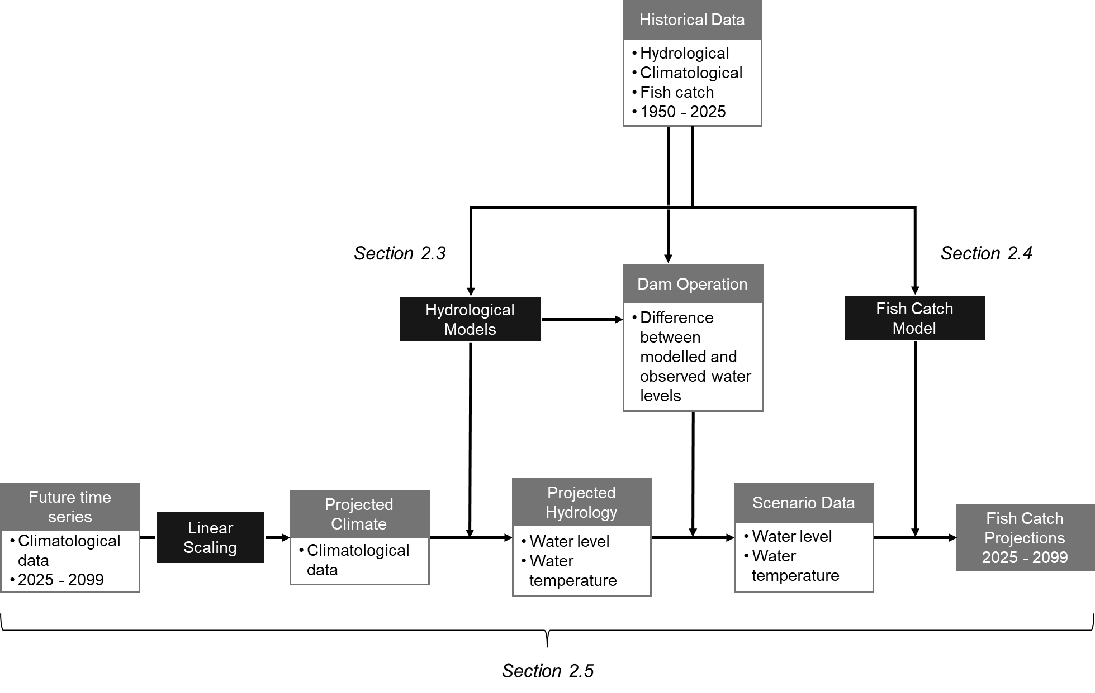
Figure S1. Flowchart of the data processing, modelling, and scenario analysis.
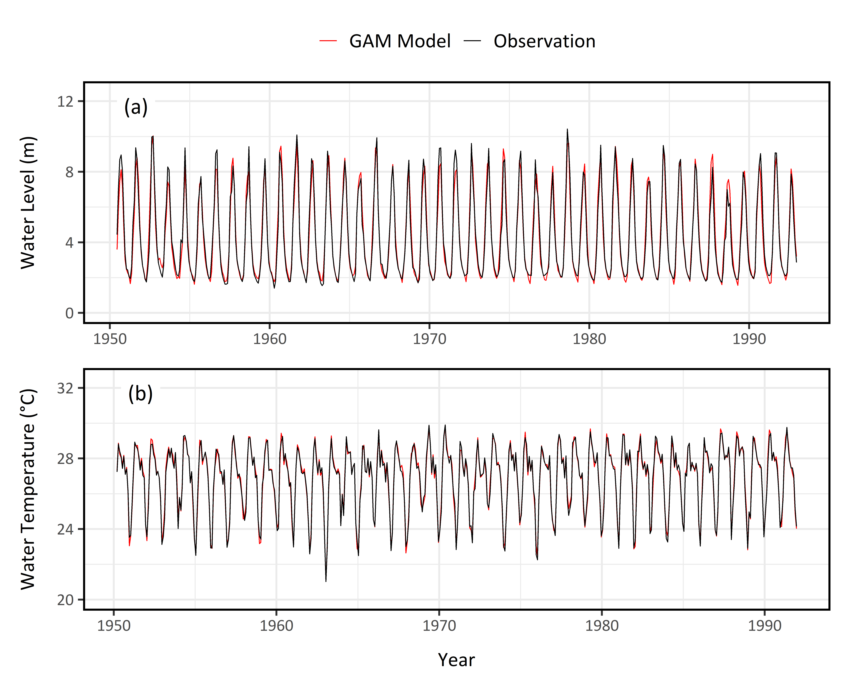
Figure S2. The observed and modelled monthly water levels (a) and temperatures (b) at Stung Treng for the pre-dam period (from 1950 to 1992).

Figure S3. Comparison of modelled and observed water temperatures at Stung Treng during (a) the pre-dam and (b, c) the post-dam periods.

Figure S4. Cross-validation results of the six best fitting models for all migratory fish.
Figure S5. Performance of the models for fish catch, showing the performance comparison (Perf.) of all models (a, c, e) and the cross-validation (CV) results of the best models (b, d, f) for all species and the two individual species. As for the black dots, overlaps of grey dots make them appear darker.

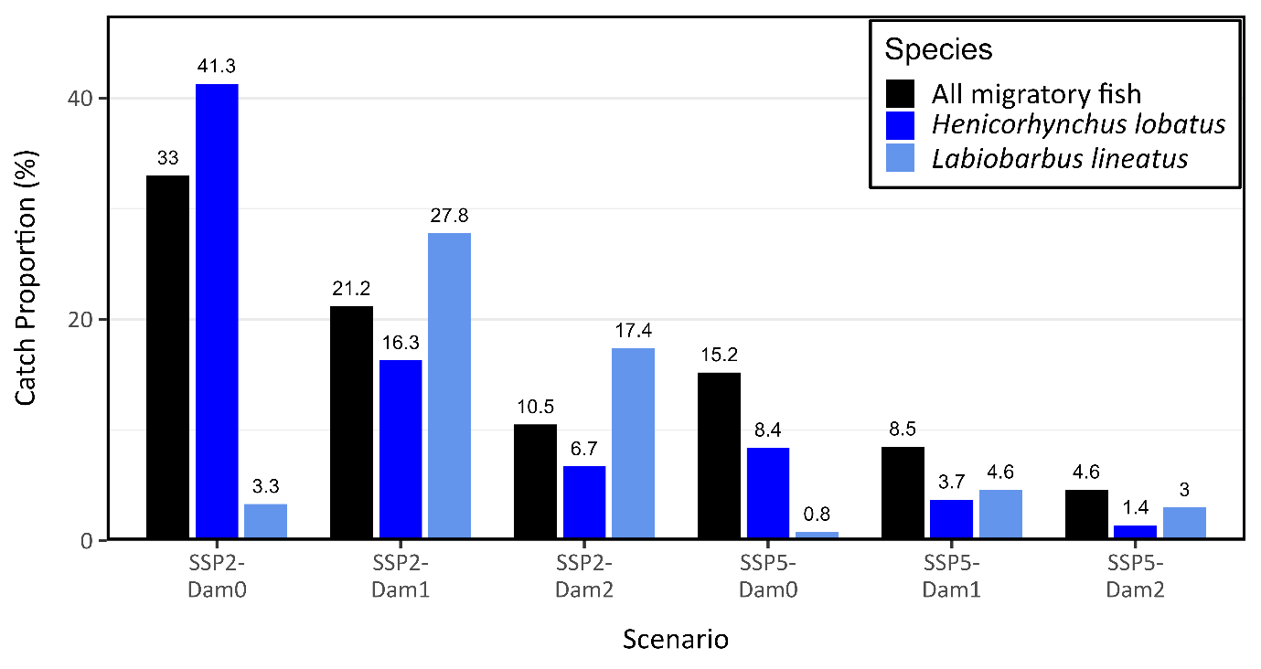
Figure S6. Catch proportion during the final decade of the projections (2090–2099) relative to the baseline period (2001–2015), across all six scenarios, for all migratory fish and the two individual species.

Figure S7. Sensitivity analysis for variables applied in the selected models for all migratory fish.

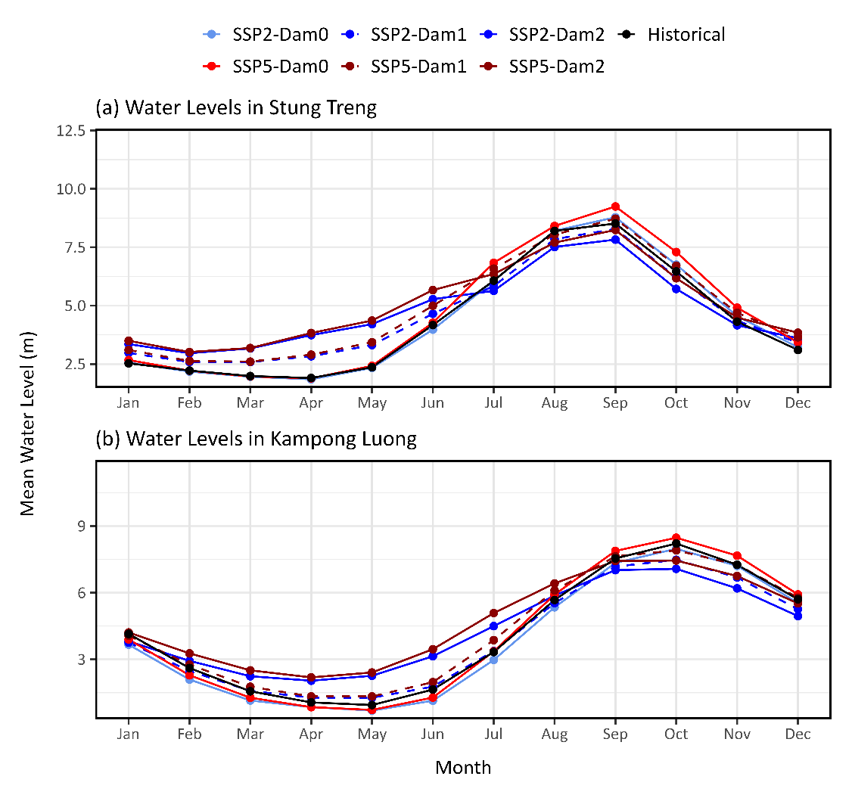
Figure S8. Comparison of the average monthly water level in Stung Treng (a) and Kampong Luong (b) before the dam construction (1950 – 1992) with the projections for the last decade of the 21st century (2090–2099) under models that do not consider temperatures. For the water level in Kampong Luong, historical data from 1997 to 2010 were used due to limited availability.

