Western blots (full blots)
Important point: For ATM and ATM proteins, we used high molecular weight ladder,
For all other proteins we used normal ladder of 250KDa start band size
- OVCAR-5 (pATR)
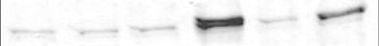
pATR (Ser428)
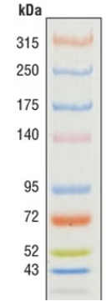
300kDa

- OVCAR-5 (tATR)
tATR
300kDa

- OVCAR-5 (pATM)
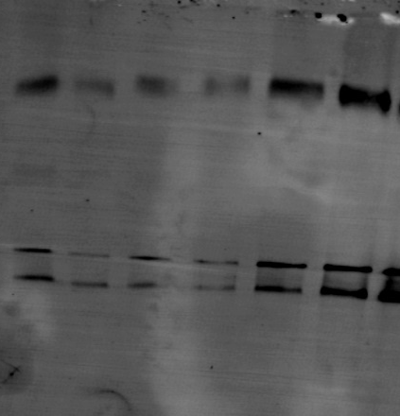
pATM (Ser1981)
350kDa

- OVCAR-5 (tATM)
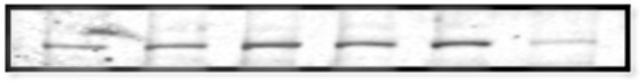
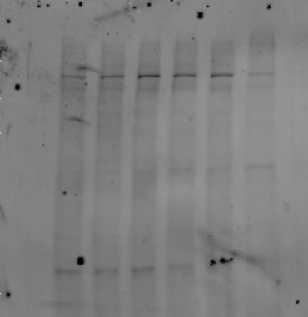
350kDa
tATM

- OVCAR-5 pChk1
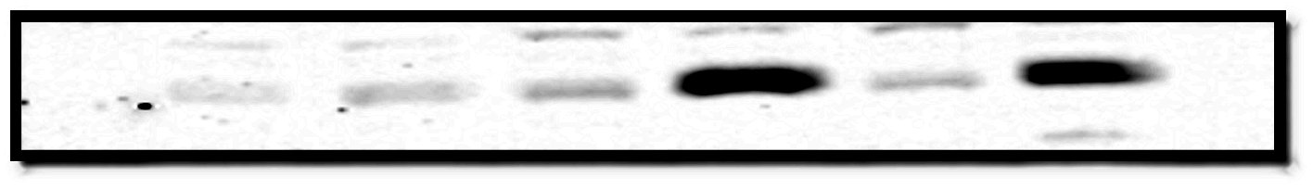

pChk1 (Ser345)
56KDa

- OVCAR-5 tChk1
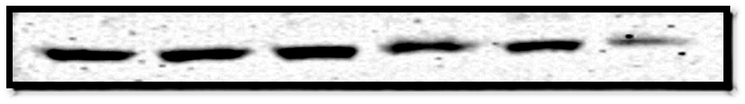
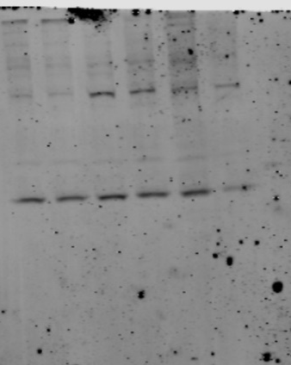
tChk1
56kDa

- OVCAR-5 pChk2 (Thr68)
62kDa

pChk2 (Thr68)

- OVCAR-5 tChk2
62kDa
tChk2

- OVCAR5- α Tubulin
55kDa
α-Tubulin

- OVCAR5- β Actin
42kDa
β- actin

- ID8- pChk1
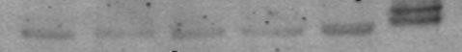
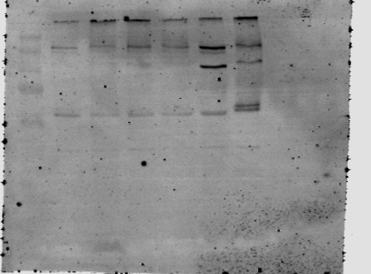
56 kDa
pChk1 (Ser345)

- ID8-tChk1
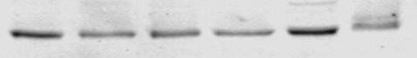
tChk1
56 kDa

- ID8-β- actin

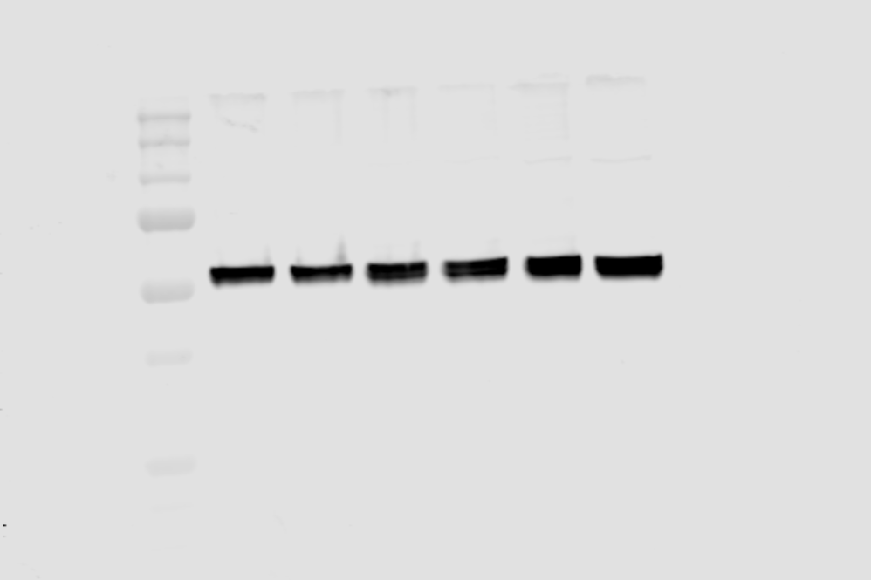
42 kDa
β- actin

- IRF1knockdown western blot-OVCAR-5

45-48 kDa
55 kDa
α-Tubulin
IRF1

- IRF1knockdown western blot-OVCAR-5 -only tubulin
45-48 kDa
IRF1
55 kDa
α-Tubulin

- cGAS blot with all cell lines
42kDa
Nonspecific
β- actin
cGAS
62 kDa

- tSTING blot with all cell lines
42kDa
β- actin
35 kDa
tSTING
30 KDa

- β Actin band for cGAS and STING blots
42kDa
β- actin

- tSTING blot OVCAR-5

tSTING
35 kDa

- pSTING blot-OVCAR5

42 kDa
pSTING

- tSTAT1 blot -OVCAR-5
84 and 91 kDa
tSTAT1

- cGAS blot OVCAR-5
β- actin
42 kDa
62 kDa
cGAS

- pSTAT3 tyr705-OVCAR5
β- actin
42 kDa
79 and 86 kDa
pSTAT3 (tyr705)

- tSTAT3 blot-OVCAR5
42kDa
β- actin
86 kDa
tSTAT3

- beta actin for STAT1 signaling (OVCAR5)

42kDa
β- actin

- pSTAT1 ser 727 (OVCAR-5)

91 KDa
pSTAT1 (ser 727)
42KDa
β- actin

- ID8-pChk2
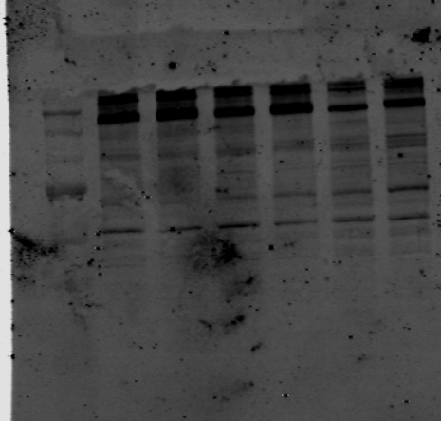
pChk2 (Thr68)
62kDa

- ID8-tChk2
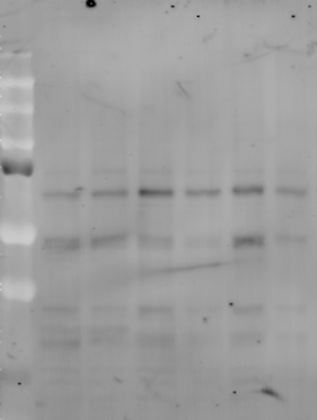
tChk2
62kDa

