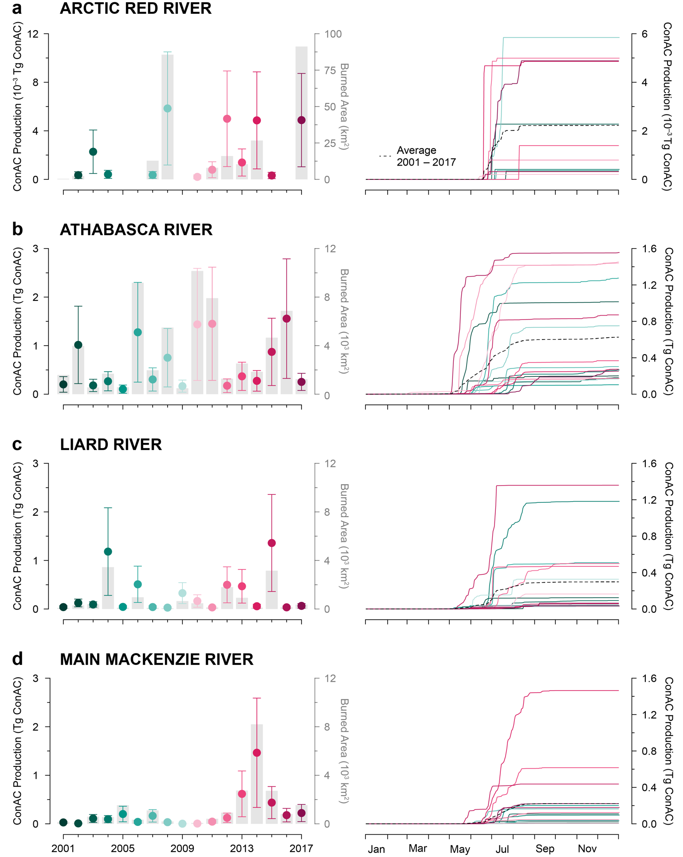
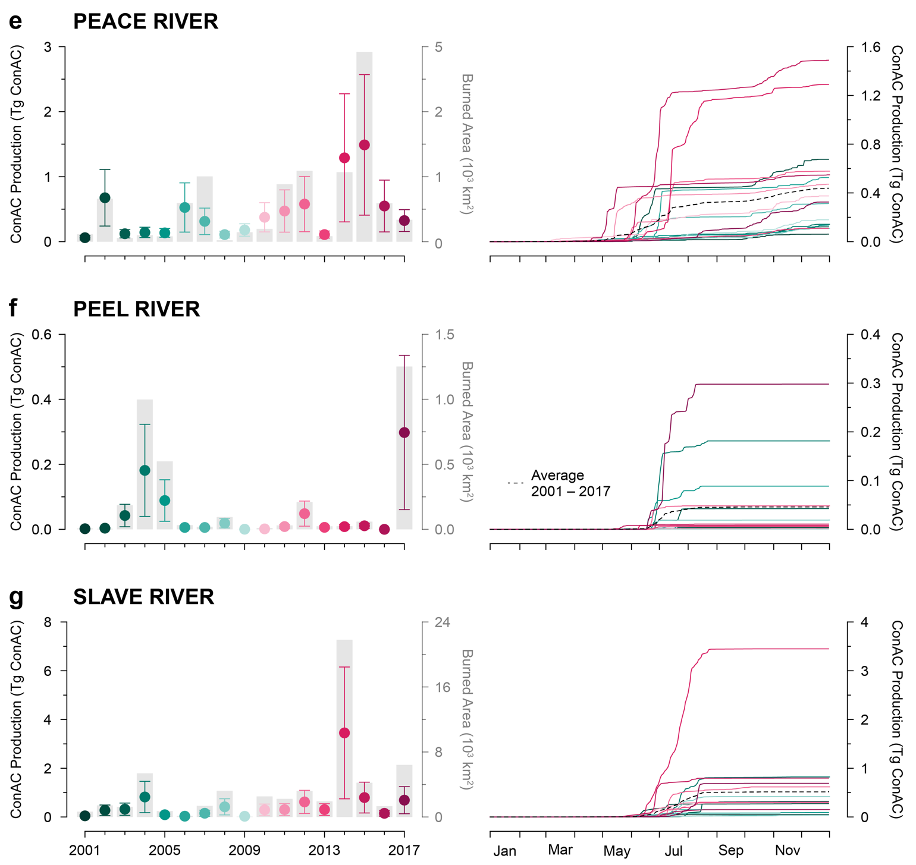
Extended Data Fig. 1 | Temporal dynamics of condensed aromatic carbon (ConAC) production across major sub-basins of the Mackenzie River Basin. Each sub-basin is represented by two panels: the left shows annual ConAC production rates (± 1 SD) from 2001 to 2017, with burned area (km²) overlaid on a secondary y-axis; the right shows the cumulative ConAC production over the same period. The dashed line in each cumulative panel represents the mean cumulative production for that sub-basin, averaged across all years. Sub-basins shown include: (a) Arctic Red River, (b) Athabasca River, (c) Liard River, (d) Main Mackenzie River, (e) Peace River, (f) Peel River, and (g) Slave River.
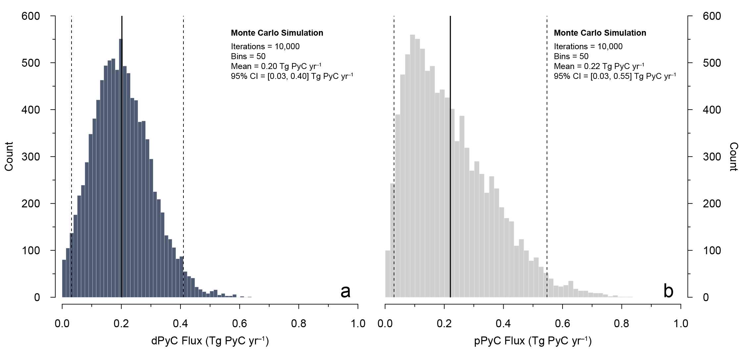
Extended Data Fig. 2 | Estimated fluxes of dissolved and particulate condensed aromatic carbon (ConAC) exported to the Arctic Ocean via the Mackenzie River system. (a) Monte Carlo simulation of dissolved ConAC (dConAC) flux (Tg ConAC yr^{–1}), based on flow-weighted dConAC/OC ratios (n = 7) from sub-basins and a uniform distribution of modeled DOC fluxes^{50,51,125,127,129–132}. (b) Monte Carlo simulation of particulate ConAC (pConAC) flux (Tg ConAC yr^{–1}), using flow-weighted pConAC/OC ratios (n = 27) and a uniform distribution of modeled POC fluxes^{72,96,125–128}. In both panels, black lines show the mean flux estimate, and black dashed lines represent the 95% confidence interval from 10,000 simulations.
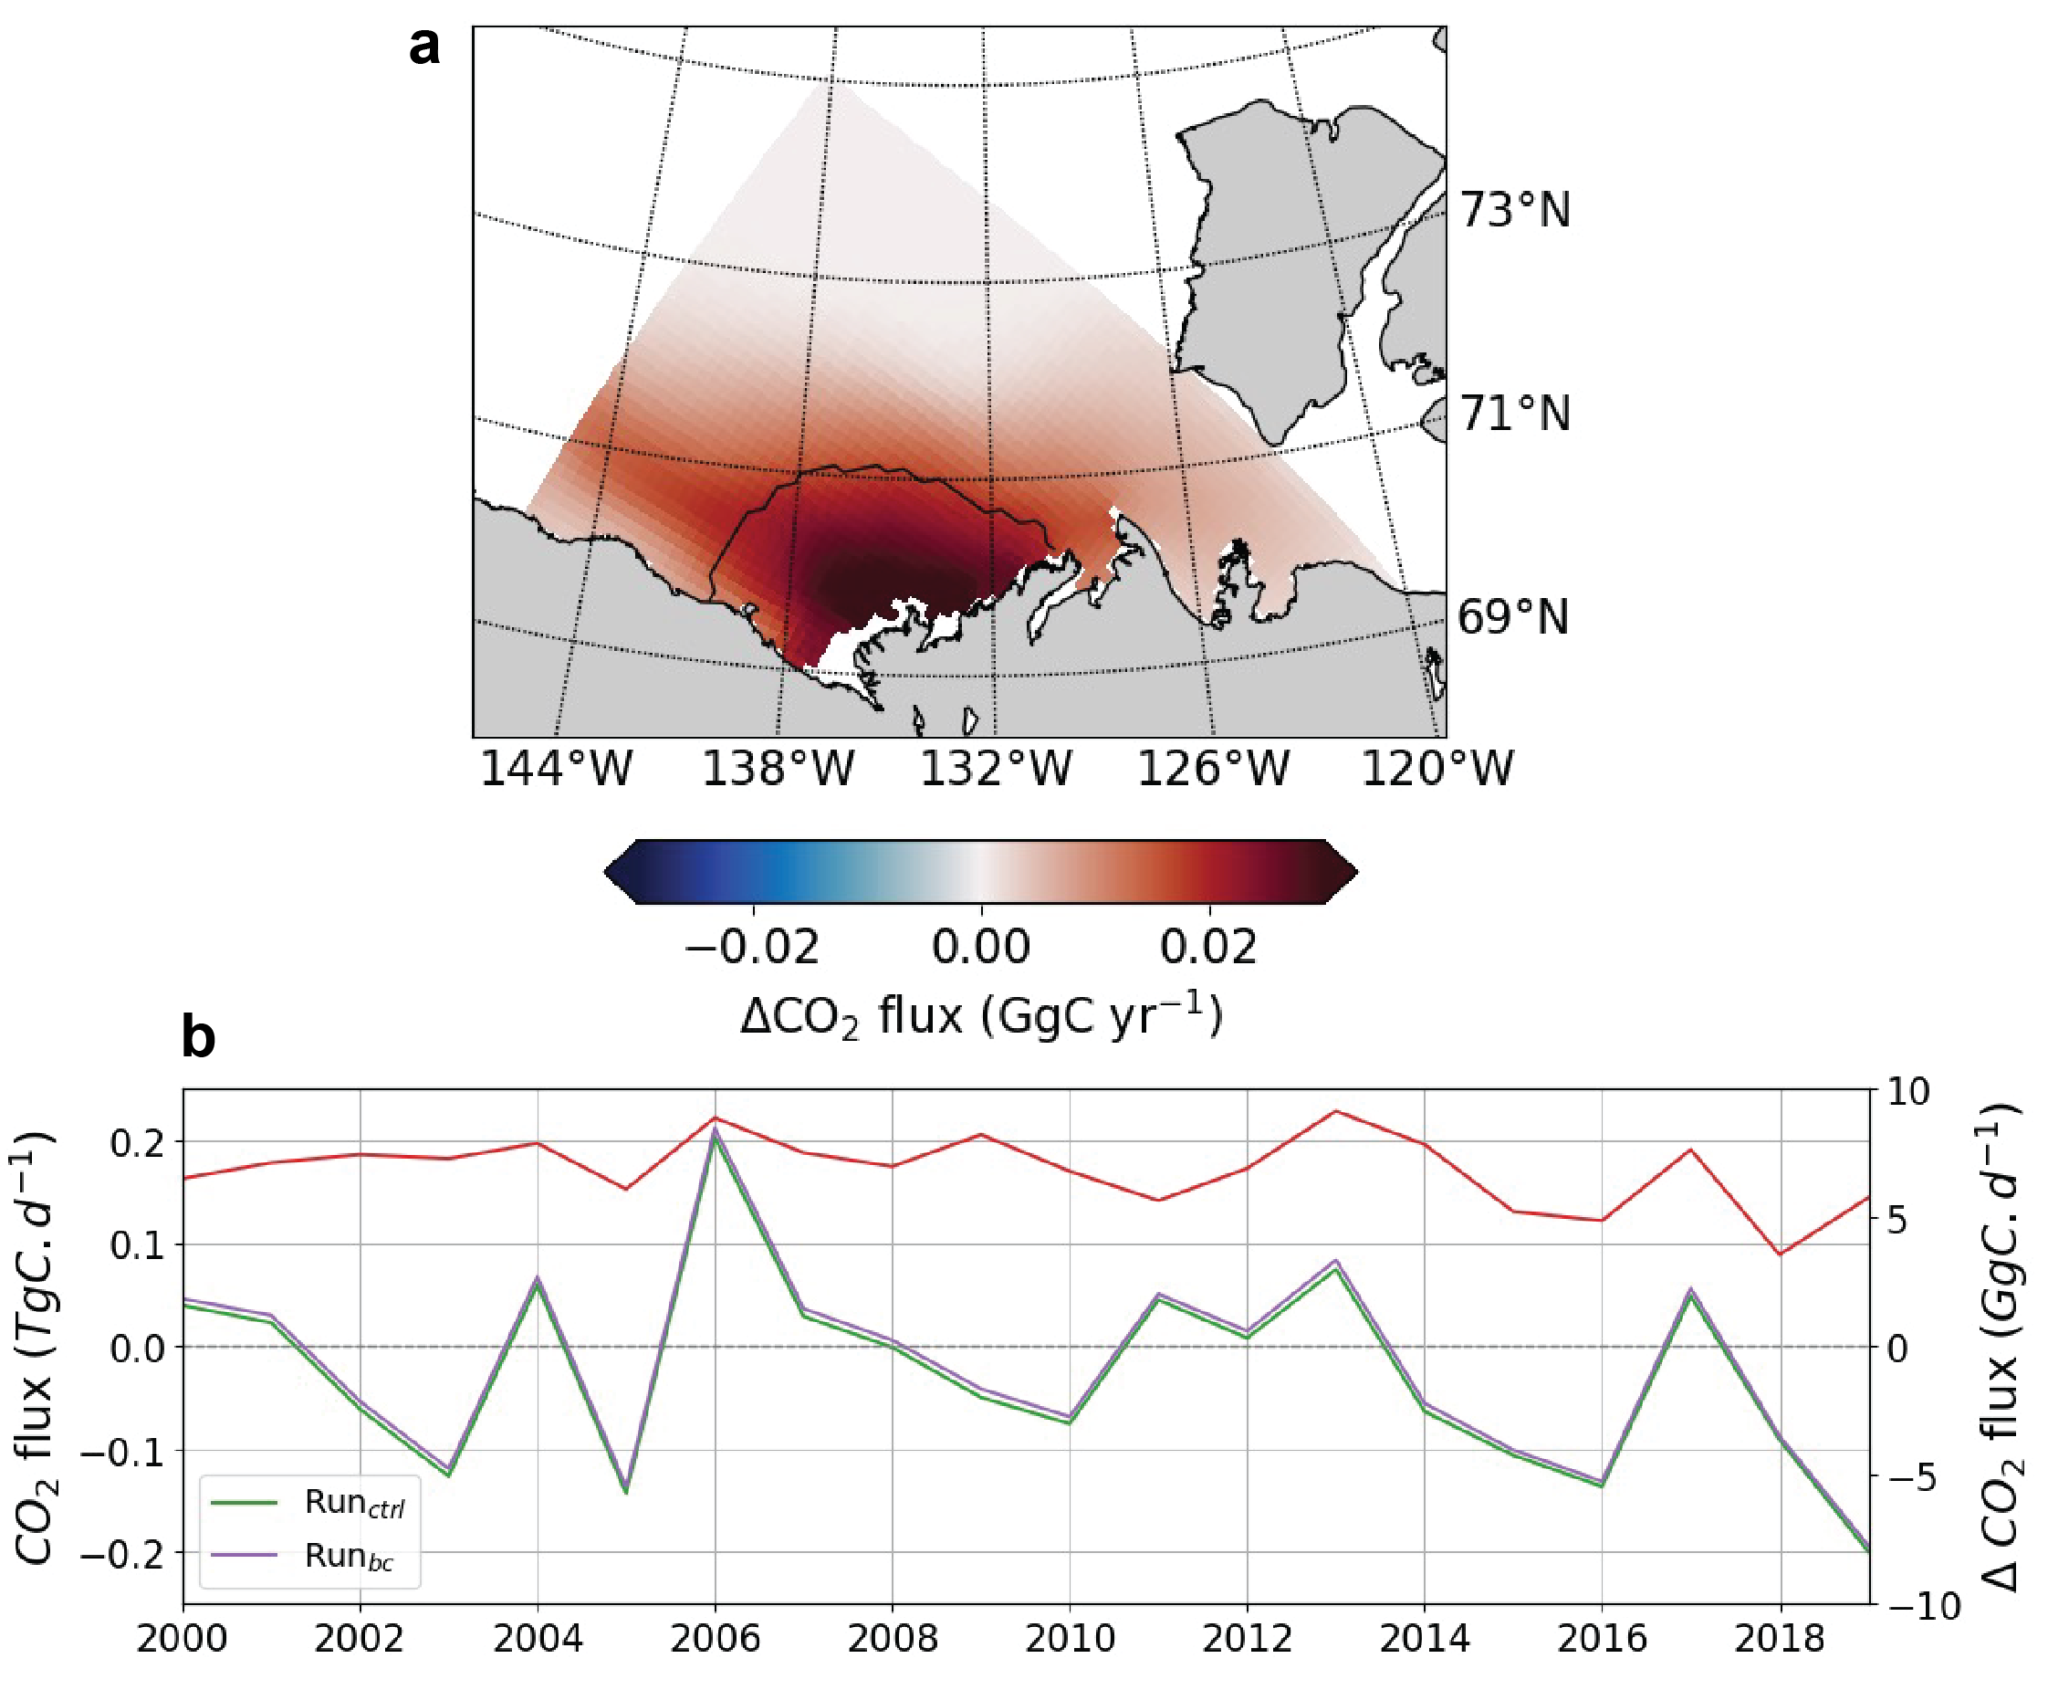
Extended Data Fig. 3 | Modeled air–sea CO₂ fluxes influenced by semi-refractory condensed aromatic carbon (ConAC) in the Beaufort Sea. a) Net air–sea ConAC-CO₂ fluxes simulated using a regional configuration of ECCO-Darwin^{55,94}. Positive values represent CO₂ outgassing, while negative values represent oceanic uptake. The black contour outlines the freshwater-influenced plume region (S < 27). b) Time series of modeled CO₂ fluxes from 2000 to 2019 for a simulation including ConAC (purple) and a control run without pyrogenic carbon (green). Red line indicates the change in air–sea CO₂ (Run_{bc} − Run_{ctrl}), with units given on the right axis.
Extended Data Table 1 | Characteristics of wildfire activity and condensed aromatic carbon (ConAC) emissions across major sub-basins of the Mackenzie River Basin from 2001 to 2017. Sub-basin-scale burned area statistics are derived from the National Burned Area Composite (NBAC). ConAC/OC emission ratios reflect the mean proportion of pyrogenic carbon relative to total organic carbon emissions from fire-affected areas. ConAC production rates are reported as total and area-normalized annual medians and interquartile ranges (IQR). Total carbon emissions are cumulative values over 17 years. All ConAC values are derived from the Arctic Boreal Vulnerability Experiment Fire Emissions Database (ABoVE-FED).
River Basin | Basin Area | Total Burned Areaª | Burned Area Percentageª | ConAC Production Rate | Area-normalized ConAC Production Rate | ConAC/OC Emitted Ratio | Total C Emission
 | km² | km² | % | Tg ConAC yr^{–1} | t ConAC km^{–2} yr^{–1} | %OC emitted | Tg C yr^{–1}
Arctic Red River | 21,818 | 253 | 1.2 | 0.0004 (0.0000, 0.0023) | 0.017 (0.000, 0.104) | 2.7 (0.0, 5.4) | 0.02 (0.00, 0.03)
Athabasca River | 272,343 | 61,997 | 22.8 | 0.30 (0.20, 1.02) | 1.11 (0.74, 3.73) | 4.6 (4.0, 5.9) | 7.0 (4.4, 20.3)
Liard River | 274,165 | 13,243 | 4.8 | 0.09 (0.04, 0.47) | 0.34 (0.15, 1.71) | 7.5 (6.9, 8.7) | 1.8 (0.5, 4.6)
Main Mackenzie River | 447,654 | 21,933 | 4.9 | 0.11 (0.03, 0.20) | 0.24 (0.08, 0.45) | 3.6 (3.2, 4.9) | 3.2 (0.8, 6.5)
Peace River | 322,986 | 16,576 | 5.1 | 0.33 (0.14, 0.55) | 1.01 (0.42, 1.70) | 10.7 (10.1, 11.9) | 2.9 (1.3, 5.1)
Peel River | 80,667 | 3,475 | 4.3 | 0.01 (0.00, 0.04) | 0.10 (0.04, 0.53) | 4.7 (4.2, 5.5) | 0.1 (0.1, 0.9)
Slave River | 378,907 | 57,868 | 15.3 | 0.30 (0.15, 0.62) | 0.79 (0.40, 1.63) | 3.8 (3.4, 4.8) | 6.9 (4.6, 13.0)
Total Basin | 1,798,539 | 175,345 | 9.7 | 2.05 (0.98, 2.39) | 1.14 (0.55, 1.33) | 5.0 (4.4, 6.7) | 35.2 (22.6, 45.1)
ªNatural Resources Canada and Canadian Forest Service. National Burned Area Composite (NBAC). Fire Monitoring, Accounting and Reporting System (FireMARS). Retrieved from https://cwfis.cfs.nrcan.gc.ca/datamart

Extended Data Table 2 | Burned area within buffer zones around streams (Strahler order 1–3) and rivers (Strahler order 4–9) across major watersheds in the Mackenzie River Basin. Buffer distances extend 0–5 km from streams and 0–50 km from rivers. Stream and river data are from the HydroRIVERS (HydroSHEDS)¹³³ dataset, and burned area data are from the National Burned Area Composite (NBAC) and Fire Monitoring, Accounting and Reporting System (FireMARS), Natural Resources Canada, Canadian Forest Service.
Watershed | STREAMS (Strahler order 1 – 3)ª |  |  |  |  |  | RIVERS (Strahler order 4 – 9)ª
Watershed | Buffer | Buffer Area | Fire Area^{b} | Burned Area | Fire Density |  | Buffer | Buffer Area | Fire Area^{b} | Burned Area | Fire Density
Watershed | km | km² | km² | % of Total Fire in Sub-basin | % of Buffer Burned |  | km | km² | km² | % of Total Fire in Sub-basin | % of Buffer Burned
Arctic Red River | 0 – 1 | 7465.6 | 105.6 | 41.7 | 1.4 |  | 0 – 10 | 11408.9 | 156.1 | 61.6 | 1.4
Arctic Red River | 1 – 2 | 6626.1 | 92.8 | 36.6 | 1.4 |  | 10 – 20 | 7255.3 | 97.4 | 38.4 | 1.3
Arctic Red River | 2 – 3 | 4831.9 | 48.1 | 19.0 | 1.0 |  | 20 – 30 | 2658.0 | 0.0 | 0.0 | 0.0
Arctic Red River | 3 – 4 | 2300.1 | 6.0 | 2.4 | 0.3 |  | 30 – 40 | 494.1 | 0.0 | 0.0 | 0.0
Arctic Red River | 4 – 5 | 529.7 | 0.9 | 0.4 | 0.2 |  | 40 – 50 | 1.4 | 0.0 | 0.0 | 0.0
Arctic Red River | > 5 | 64.3 | 0.0 | 0.0 | 0.0 |  | > 50 | 0.0 | 0.0 | 0.0 | -
Arctic Red River | Total | 21817.7 | 253.5 | 100.0 | 1.2 |  | Total | 21817.7 | 253.5 | 100.0 | 1.2
Athabasca River | 0 – 1 | 109282.2 | 24406.3 | 39.4 | 22.3 |  | 0 – 10 | 125905.1 | 32367.5 | 52.2 | 25.7
Athabasca River | 1 – 2 | 86236.3 | 21308.1 | 34.4 | 24.7 |  | 10 – 20 | 84817.3 | 19636.6 | 31.7 | 23.2
Athabasca River | 2 – 3 | 49351.8 | 11989.1 | 19.3 | 24.3 |  | 20 – 30 | 43386.1 | 7206.2 | 11.6 | 16.6
Athabasca River | 3 – 4 | 15837.8 | 3454.0 | 5.6 | 21.8 |  | 30 – 40 | 13767.4 | 1544.2 | 2.5 | 11.2
Athabasca River | 4 – 5 | 3393.2 | 560.1 | 0.9 | 16.5 |  | 40 – 50 | 3787.4 | 835.7 | 1.3 | 22.1
Athabasca River | > 5 | 8241.2 | 279.7 | 0.5 | 3.4 |  | > 50 | 679.2 | 407.0 | 0.7 | 59.9
Athabasca River | Total | 272342.5 | 61997.3 | 100.0 | 22.8 |  | Total | 272342.5 | 61997.3 | 100.0 | 22.8
Liard River | 0 – 1 | 106190.3 | 5484.3 | 41.4 | 5.2 |  | 0 – 10 | 125649.2 | 7114.7 | 53.7 | 5.7
Liard River | 1 – 2 | 86933.2 | 4283.4 | 32.3 | 4.9 |  | 10 – 20 | 85805.2 | 3784.8 | 28.6 | 4.4
Liard River | 2 – 3 | 54928.3 | 2423.7 | 18.3 | 4.4 |  | 20 – 30 | 44562.8 | 2022.7 | 15.3 | 4.5
Liard River | 3 – 4 | 20690.4 | 864.4 | 6.5 | 4.2 |  | 30 – 40 | 16493.7 | 303.3 | 2.3 | 1.8
Liard River | 4 – 5 | 4585.3 | 172.5 | 1.3 | 3.8 |  | 40 – 50 | 1639.9 | 17.2 | 0.1 | 1.0
Liard River | > 5 | 837.1 | 14.3 | 0.1 | 1.7 |  | > 50 | 14.0 | 0.0 | 0.0 | 0.0
Liard River | Total | 274164.7 | 13242.6 | 100.0 | 4.8 |  | Total | 274164.7 | 13242.6 | 100.0 | 4.8
Main Mackenzie River | 0 – 1 | 145034.0 | 7725.8 | 35.2 | 5.3 |  | 0 – 10 | 165381.2 | 8919.9 | 40.7 | 5.4
Main Mackenzie River | 1 – 2 | 120522.4 | 6454.6 | 29.4 | 5.4 |  | 10 – 20 | 129817.7 | 6522.9 | 29.7 | 5.0
Main Mackenzie River | 2 – 3 | 85673.3 | 4454.3 | 20.3 | 5.2 |  | 20 – 30 | 81275.2 | 4185.8 | 19.1 | 5.2
Main Mackenzie River | 3 – 4 | 45808.4 | 2217.8 | 10.1 | 4.8 |  | 30 – 40 | 38431.4 | 1725.9 | 7.9 | 4.5
Main Mackenzie River | 4 – 5 | 17840.3 | 757.3 | 3.5 | 4.2 |  | 40 – 50 | 14198.1 | 578.2 | 2.6 | 4.1
Main Mackenzie River | > 5 | 32775.7 | 323.0 | 1.5 | 1.0 |  | > 50 | 18550.6 | 0.0 | 0.0 | 0.0
 | Total | 447654.1 | 21932.7 | 100.0 | 4.9 |  | Total | 447654.1 | 21932.7 | 100.0 | 4.9
Peace River | 0 – 1 | 134588.4 | 7228.1 | 43.6 | 5.4 |  | 0 – 10 | 159596.2 | 6502.2 | 39.2 | 4.1
Peace River | 1 – 2 | 104926.1 | 5327.2 | 32.1 | 5.1 |  | 10 – 20 | 105271.4 | 6526.5 | 39.4 | 6.2
Peace River | 2 – 3 | 59754.9 | 2955.2 | 17.8 | 4.9 |  | 20 – 30 | 45629.3 | 3004.8 | 18.1 | 6.6
Peace River | 3 – 4 | 19660.7 | 922.3 | 5.6 | 4.7 |  | 30 – 40 | 11722.1 | 501.1 | 3.0 | 4.3
Peace River | 4 – 5 | 3519.4 | 134.1 | 0.8 | 3.8 |  | 40 – 50 | 731.2 | 41.3 | 0.2 | 5.7
Peace River | > 5 | 536.6 | 9.0 | 0.1 | 1.7 |  | > 50 | 35.8 | 0.0 | 0.0 | 0.0
Peace River | Total | 322986.1 | 16575.9 | 100.0 | 5.1 |  | Total | 322986.1 | 16575.9 | 100.0 | 5.1
Peel River | 0 – 1 | 28085.6 | 1222.6 | 35.2 | 4.4 |  | 0 – 10 | 38637.5 | 2436.3 | 70.1 | 6.3
Peel River | 1 – 2 | 24743.1 | 1106.7 | 31.8 | 4.5 |  | 10 – 20 | 25941.4 | 802.2 | 23.1 | 3.1
Peel River | 2 – 3 | 17798.9 | 726.0 | 20.9 | 4.1 |  | 20 – 30 | 10730.6 | 207.7 | 6.0 | 1.9
Peel River | 3 – 4 | 7879.0 | 300.4 | 8.6 | 3.8 |  | 30 – 40 | 4163.0 | 27.7 | 0.8 | 0.7
Peel River | 4 – 5 | 1848.0 | 93.0 | 2.7 | 5.0 |  | 40 – 50 | 1166.9 | 0.9 | 0.0 | 0.1
Peel River | > 5 | 312.1 | 26.0 | 0.7 | 8.3 |  | > 50 | 27.5 | 0.0 | 0.0 | 0.0
Peel River | Total | 80666.7 | 3474.7 | 100.0 | 4.3 |  | Total | 80666.7 | 3474.7 | 100.0 | 4.3
Slave River | 0 – 1 | 136216.4 | 20684.2 | 35.7 | 15.2 |  | 0 – 10 | 168855.5 | 27490.0 | 47.5 | 16.3
Slave River | 1 – 2 | 104651.8 | 17788.8 | 30.7 | 17.0 |  | 10 – 20 | 111919.9 | 16351.7 | 28.3 | 14.6
Slave River | 2 – 3 | 67189.2 | 11561.7 | 20.0 | 17.2 |  | 20 – 30 | 56947.1 | 7022.1 | 12.1 | 12.3
Slave River | 3 – 4 | 30888.2 | 5202.6 | 9.0 | 16.8 |  | 30 – 40 | 22019.9 | 3513.7 | 6.1 | 16.0
Slave River | 4 – 5 | 10276.9 | 1526.5 | 2.6 | 14.9 |  | 40 – 50 | 9826.1 | 3488.5 | 6.0 | 35.5
Slave River | > 5 | 29684.6 | 1104.4 | 1.9 | 3.7 |  | > 50 | 9338.4 | 2.3 | 0.0 | 0.0
Slave River | Total | 378907.0 | 57868.3 | 100.0 | 15.3 |  | Total | 378907.0 | 57868.3 | 100.0 | 15.3
Total Basin | 0 – 1 | 666862.4 | 66857.0 | 38.1 | 10.0 |  | 0 – 10 | 795433.6 | 84986.6 | 48.5 | 10.7
Total Basin | 1 – 2 | 534639.0 | 56361.6 | 32.1 | 10.5 |  | 10 – 20 | 550828.1 | 53722.1 | 30.6 | 9.8
Total Basin | 2 – 3 | 339528.2 | 34158.1 | 19.5 | 10.1 |  | 20 – 30 | 285189.1 | 23649.2 | 13.5 | 8.3
Total Basin | 3 – 4 | 143064.7 | 12967.3 | 7.4 | 9.1 |  | 30 – 40 | 107091.7 | 7615.9 | 4.3 | 7.1
Total Basin | 4 – 5 | 41992.9 | 3244.5 | 1.9 | 7.7 |  | 40 – 50 | 31351.0 | 4961.7 | 2.8 | 15.8
Total Basin | > 5 | 72451.6 | 1756.4 | 1.0 | 2.4 |  | > 50 | 28645.3 | 409.3 | 0.2 | 1.4
Total Basin | Total | 1798538.8 | 175344.9 | 100.0 | 9.7 |  | Total | 1798538.8 | 175344.9 | 100.0 | 9.7
ª HydroSHEDS. HydroRIVERS. Retrieved from https://www.hydrosheds.org/products/hydrorivers
^{b} Natural Resources Canada and Canadian Forest Service. National Burned Area Composite (NBAC). Fire Monitoring, Accounting and Reporting System (FireMARS). Retrieved from https://cwfis.cfs.nrcan.gc.ca/datamart

Extended Data Table 3 | Carbon and pyrogenic carbon stocks and fluxes across the Mackenzie River–Beaufort Sea system. Estimates of major carbon and condensed aromatic carbon reservoirs and annual fluxes spanning terrestrial, fluvial, and marine domains. Stocks represent standing pools in vegetation, soil, river plume waters, and marine sediments. Fluxes include fire emissions, riverine transport, gas exchange, and sediment burial. Values reflect mean ± 1 SD, median (Interquartile Range), or reported ranges; uncertainties are propagated or compiled from literature where available. See Methods for full derivations and data sources.
Component | Estimate | Unit | Description | Reference(s)
STOCKS
Plant Biomass | 4,356 ± 107 | Tg C | Aboveground and belowground biomass, and detritus carbon in the Mackenzie River Basin | ^{48,49}
Soil Organic Carbon | 58,491 ± 3,606 | Tg C | SOC stock in the upper 100 cm of basin soils | ^{48,49}
Soil Condensed Aromatic Carbon | 4,032 ± 385 | Tg ConAC | ConAC content in the upper 100 cm of basin soils | ¹⁸
Marine Dissolved Organic Carbon | 23.6 ± 0.6 | Tg C | DOC pool integrated over the full water column of the Mackenzie River plume | ^{85,86}
Marine Dissolved Condensed Aromatic Carbon | 1.2 ± 0.5 | Tg ConAC | DOC pool integrated over the full water column of the Mackenzie River plume | ^{16,84}
Marine Sediment Organic Carbon | 500 ± 73 | Tg C | Dissolved ConAC stock in the upper 100 cm of sediments in the Mackenzie River plume area | ¹⁰¹
Marine Sediment Condensed Aromatic Carbon | 89 ± 22 | Tg ConAC | ConAC stock in the upper 100 cm of sediments in the Mackenzie River plume area | ¹⁰⁰; this study
FLUXES
Fire-Derived Carbon Emission | 35.2 (22.6, 45.1) | Tg C yr^{–1} | Annual carbon emissions from biomass burning in the basin | This study
Fire-Derived Condensed Aromatic Carbon | 2.05 (0.98, 2.39) | Tg ConAC yr^{–1} | Annual ConAC production from fires across the basin | This study
Freshwater CO₂ | 0.25 | Tg C yr^{–1} | Riverine CO₂ evasion to the atmosphere across the basin | ^{145,146}
Ocean-Atmosphere Gas Exchange | –1.77–0.13 | Tg C yr^{–1} | Net CO₂ flux across the air-sea interface in the Mackenzie plume region | ^{55,94,96,147–152}
Condensed Aromatic CO₂ | 0.007 ± 0.001 | Tg ConAC yr^{–1} | CO₂ flux from ConAC oxidation in the Mackenzie River plume area | This study
Particulate Organic Carbon | 0.30–2.60 | Tg C yr^{–1} | POC flux from the basin to the Mackenzie River Delta (Tsiigehtshik) | ^{17,72,96,125–128,153}
Particulate Condensed Aromatic Carbon | 0.22 ± 0.14 | Tg ConAC yr^{–1} | Particulate ConAC flux from the basin to the Mackenzie River Delta (Tsiigehtshik) | ¹⁷; this study
Dissolved Organic Carbon | 1.04–1.76 | Tg C yr^{–1} | DOC flux from the basin to the Mackenzie River Delta (Tsiigehtshik) | ^{50,51,125,127,132}
Dissolved Condensed Aromatic Carbon | 0.20 ± 0.10 | Tg ConAC yr^{–1} | Dissolved ConAC flux from the basin to the Mackenzie River Delta (Tsiigehtshik) | ⁴⁵; this study
Organic Carbon Sedimentation Rate | 0.22–0.52 | Tg C yr^{–1} | Sedimentation rate of OC in shelf sediments for the Mackenzie plume area | ^{96–99}
Condensed Aromatic Carbon Sedimentation Rate | 0.14 ± 0.01 | Tg ConAC yr^{–1} | Sedimentation rate of ConAC in shelf sediments for the Mackenzie plume area | ¹⁰⁰

