Supplementary Material
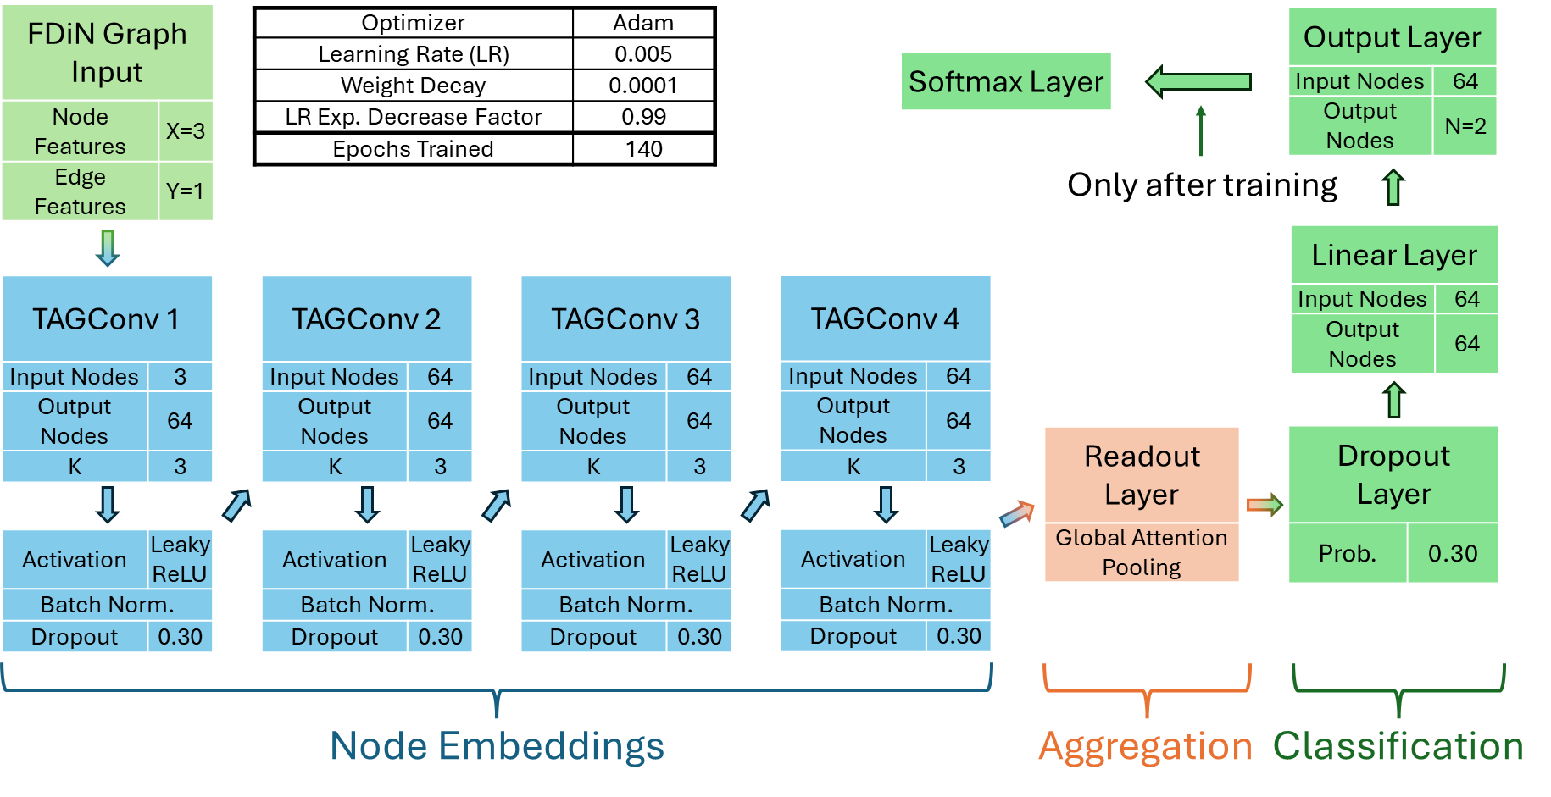
Supplementary Figure 1: Diagram of the FDiGNN architecture used for LGD. X and Y represent the number of node and edge features of the input while N is the number of dataset classes. Abbreviations: ReLU: Rectified Linear Unit; Exp.: Exponential.

Supplementary Table 1: General characteristics of the benchmark datasets after pre-processing and treatment. Abbreviations: P.vivax+Prior – Patients infected with P. vivax that had been infected in the past, P.vivax+NoPrior – Patients infected with P. vivax that had not been infected in the past (Control are not infected samples). * – The MD dataset illustrates what to expect when formulas are assigned in a much less accurate way and is here deployed to show what our approach can still do with mainstream, less performing mass spectrometers when benchmarking for molecular formula assignment from spectral data alone.
Dataset | Samples | Features | Features/ Sample (Range) | Classes | Samples/Class | FDiN nodes | FDiN edges
LGD | 72 | 1159 | 1066  (530 – 1141) | 2 | 36 | 350 | 799
LID | 354 | 5700 | 2117  (1782 – 2720) | 2 | 177 | 871 | 1676
MD* | 627 | 17087 | 5168  (2334 – 6649) | 3 | 237 ‘P.vivax+Prior’,  213 ‘P.vivax+NoPrior’,  177 ‘Control’ | 2264 | 5404

Supplementary Table 2: List of chemical elemental transformations used to build the FDiNs.
Elemental Transformations | Reaction Type Examples
O (-NH) | Deamination
NH₃ (-O) | Transamination
H₂ | Hydrogenation / Dehydrogenation
CH₂ | Methylation
O | Oxygenation / Hydroxylation
H₂O | Condensation / Dehydration / Cyclization
NCH | Transfer of a formidoyl group
CO | Formylation
CHOH | Hydroxymethylation
S | Transfer of a –SH group
C₂H₂O | Acetylation
CONH | Transfer of a carbamoyl group
CO₂ | Carboxylation / Decarboxylation
SO₃ | Sulphation
PO₃H | Phosphorylation

Supplementary Table 3: Characteristics of the FDiGNN models for the different datasets. Other details not shown are identical among all datasets and shown in Sup. Figure 2.
Datasets | LGD | LID | MD
Number of Parameters in FDiGNN | 55 043 | 30 083 | 55 108
TAG layers
Number | 4 | 4 | 4
Hidden Channels | 64 | 64 | 64
K | 3 | 1 | 3
Other layers
Dropout Probability | 0.30 | 0.15 | 0.30
Leaky ReLU Activation between classifier layers | No | No | Yes
Training Parameters
Optimizer | Adam | Adam | Adam
Learning Rate (LR) | 0.005 | 0.005 | 0.001
Weight Decay | 0.0001 | 0.0001 | 0.0001
LR Exp. Decrease Factor | 0.99 | 0.99 | 0.99
Epochs Trained | 140 | 160 | 500

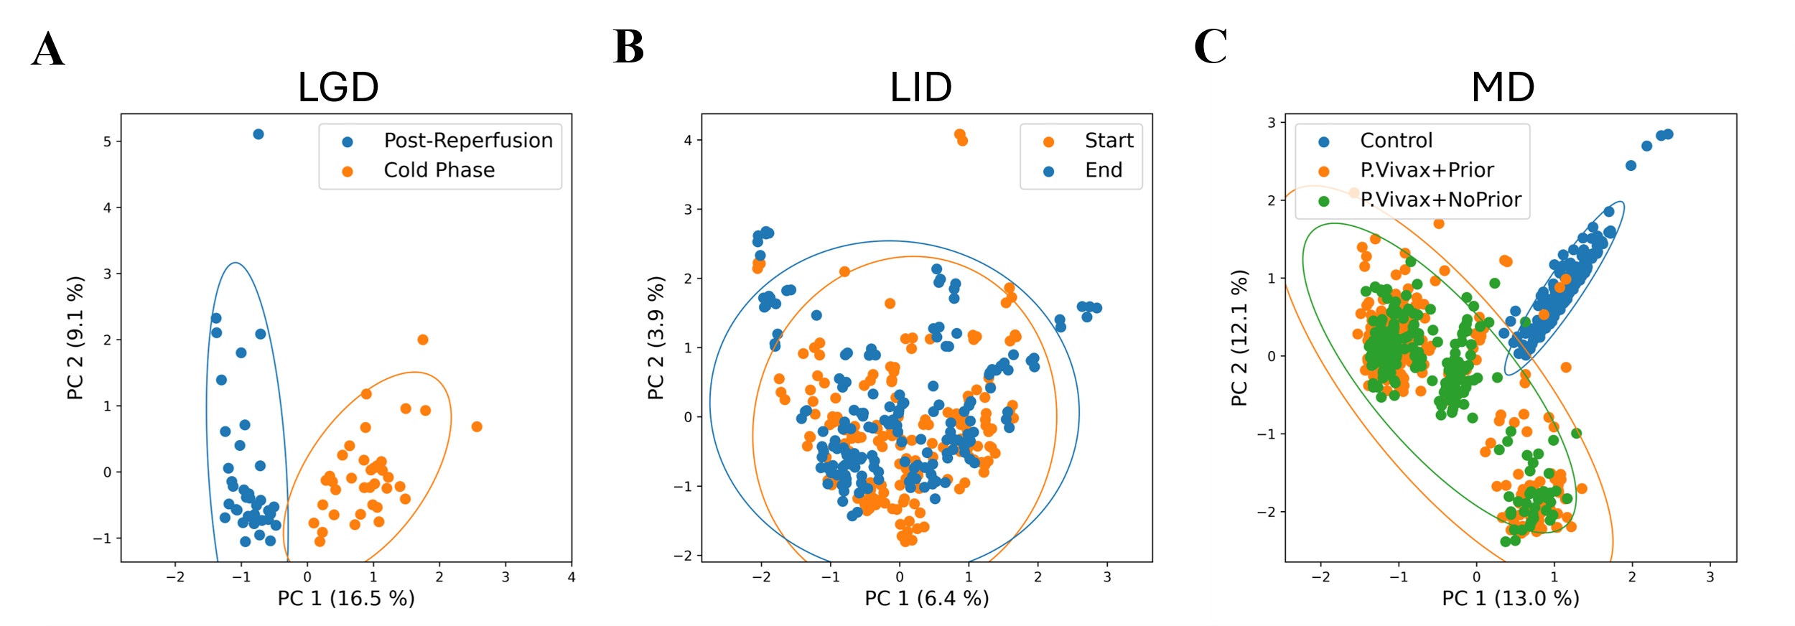
Supplementary Figure 2: Sample projection of the first two components of Principal Component Analysis. PCA of A) LGD, B) LID and C) MD. Ellipses drawn for each class in each PCA correspond to the confidence interval at 95%. Number in parenthesis in the axis titles represent the percentage of variance explained by the corresponding component. PC – Principal Components.
Supplementary Table 4: Spearman Correlation between FDiGNN ranks of the 16 or 20 simulations to the closeness centrality of the corresponding nodes in the dataset’s FDiN considering all nodes, only the pathway nodes or the single nodes for each set within each simulation. Original is the original model with no modification. E.g. for the 5-Graphlet Simulation on the LGD, 20 sets of graphlets were used. Therefore, all 20 sets of ranks were used to calculate the correlation. Lowest correlation (closer to 0) is in bold for each case.
Dataset | Simulation | Changes | All Nodes | Pathway Nodes | Single Nodes
LGD | Original |  | -0.807 | - | -
LGD | 5-Graphlet | Non-Randomized | -0.637 | -0.192 | -0.538
LGD | 5-Graphlet | Randomized | -0.464 | -0.224 | -0.524
LGD | 6-Graphlet | Non-Randomized | -0.617 | -0.287 | -0.498
LGD | 6-Graphlet | Randomized | -0.463 | -0.306 | -0.509
LGD | 4-Graphlet | Non-Randomized | -0.634 | -0.250 | -0.327
LGD | 4-Graphlet | Randomized | -0.435 | -0.206 | -0.168
LGD | 5-Graphlet with a neutral gap | Non-Randomized | -0.705 | -0.334 | -0.679
LGD | 5-Graphlet with a neutral gap | Randomized | -0.426 | -0.010 | -0.420
LGD | 6-Graphlet with a neutral gap | Non-Randomized | -0.624 | -0.125 | -0.500
LGD | 6-Graphlet with a neutral gap | Randomized | -0.452 | -0.255 | -0.471
LGD | 5-Graphlet with an opposite gap | Non-Randomized | -0.653 | -0.145 | -0.489
LGD | 5-Graphlet with an opposite gap | Randomized | -0.494 | -0.195 | -0.485
LGD | 6-Graphlet with an opposite gap | Non-Randomized | -0.611 | -0.210 | -0.493
LGD | 6-Graphlet with an opposite gap | Randomized | -0.495 | -0.302 | -0.548
LID | Original |  | -0.451 | - | -
LID | 5-Graphlet | Non-Randomized | -0.356 | -0.095 | -0.426
LID | 5-Graphlet | Randomized | -0.390 | -0.111 | -0.408
LID | 6-Graphlet | Non-Randomized | -0.360 | -0.107 | -0.414
LID | 6-Graphlet | Randomized | -0.371 | -0.109 | -0.347
LID | 4-Graphlet | Non-Randomized | -0.327 | -0.310 | -0.323
LID | 4-Graphlet | Randomized | -0.265 | -0.064 | -0.251
LID | 5-Graphlet with a neutral gap | Non-Randomized | -0.403 | -0.058 | -0.383
LID | 5-Graphlet with a neutral gap | Randomized | -0.325 | 0.030 | -0.334
LID | 6-Graphlet with a neutral gap | Non-Randomized | -0.321 | -0.034 | -0.400
LID | 6-Graphlet with a neutral gap | Randomized | -0.383 | -0.013 | -0.413
LID | 5-Graphlet with an opposite gap | Non-Randomized | -0.372 | -0.112 | -0.303
LID | 5-Graphlet with an opposite gap | Randomized | -0.345 | -0.007 | -0.373
LID | 6-Graphlet with an opposite gap | Non-Randomized | -0.357 | -0.115 | -0.484
LID | 6-Graphlet with an opposite gap | Randomized | -0.347 | -0.002 | -0.361
MD | Original |  | 0.032 | - | -
MD | 5-Graphlet | Non-Randomized | -0.148 | 0.213 | -0.047
MD | 5-Graphlet | Randomized | -0.208 | -0.053 | -0.201
MD | 6-Graphlet | Non-Randomized | -0.165 | -0.090 | -0.142
MD | 6-Graphlet | Randomized | -0.165 | -0.073 | -0.226
MD | 4-Graphlet | Non-Randomized | -0.163 | 0.128 | -0.133
MD | 4-Graphlet | Randomized | -0.172 | 0.024 | -0.163
MD | 5-Graphlet with a neutral gap | Non-Randomized | -0.194 | -0.009 | -0.157
MD | 5-Graphlet with a neutral gap | Randomized | -0.211 | -0.096 | -0.159
MD | 6-Graphlet with a neutral gap | Non-Randomized | -0.188 | -0.126 | -0.033
MD | 6-Graphlet with a neutral gap | Randomized | -0.186 | -0.126 | -0.111
MD | 5-Graphlet with an opposite gap | Non-Randomized | -0.173 | -0.164 | -0.132
MD | 5-Graphlet with an opposite gap | Randomized | -0.230 | -0.172 | -0.256
MD | 6-Graphlet with an opposite gap | Non-Randomized | -0.154 | -0.034 | -0.227
MD | 6-Graphlet with an opposite gap | Randomized | -0.151 | 0.027 | -0.056

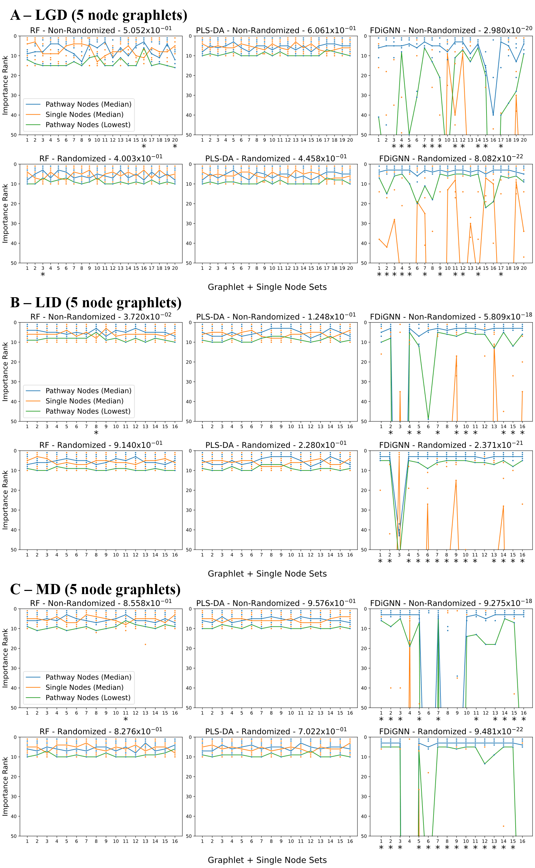
Supplementary Figure 3: Node Importance ranks of pathway and single nodes from Gini Importance of RF, VIP scores of PLS-DA and PINNI score from FDiGNN models in 5-node graphlet simulations. Results are shown for the A) LGD, B) LID and C) MD benchmarks. In each 5-node graphlet simulation, a random 5-length graphlet is randomly selected, representing pathway nodes, and 5 nodes with no connection to each other or the graphlet are also selected as single nodes. Chart titles include the Mann-Whitney test p-value considering all ranks of the pathway nodes and of the single nodes across all simulations in that chart. Dots show the individual ranks of the selected nodes in each simulation with the blue line connecting the medians of the pathway node ranks in each simulation, the orange line the medians of the single nodes and the green line the worst-case ranked pathway node. Simulations have a * symbol below them if there is a significant difference (p-value below 0.05) between the ranks of pathway and single nodes (Mann-Whitney test). Only the top 50 ranks in each case are shown.
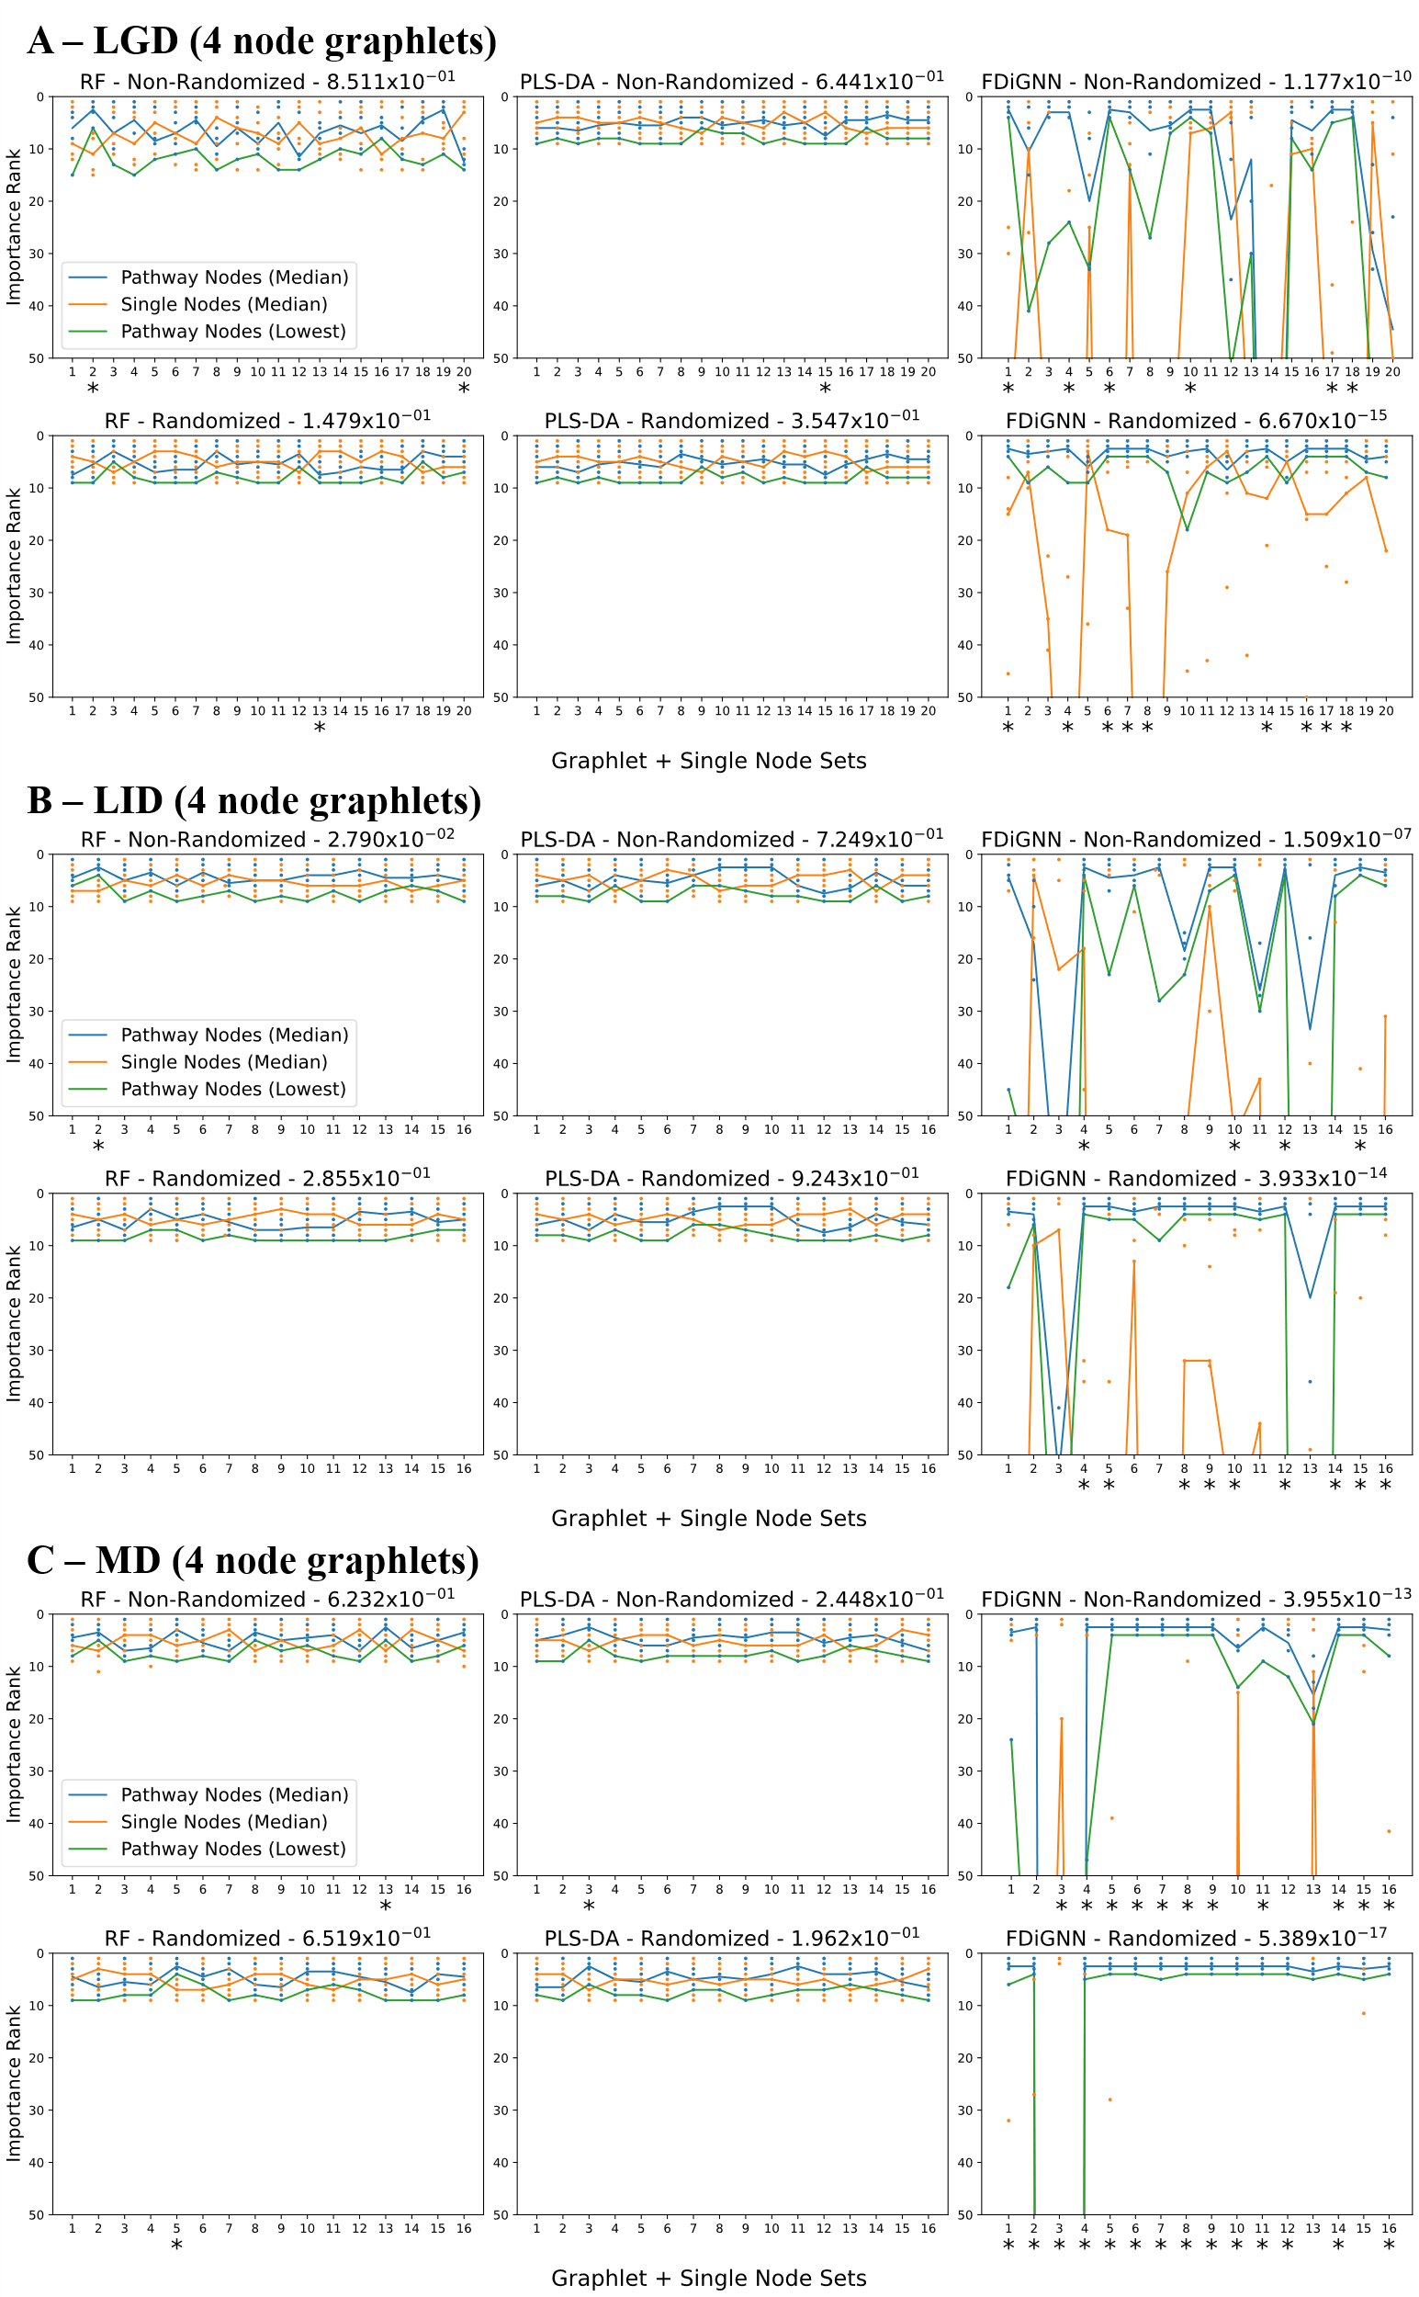
Supplementary Figure 4: Node Importance ranks of pathway and single nodes from Gini Importance of RF, VIP scores of PLS-DA and PINNI score from FDiGNN models in 4-node graphlet simulations. Results are shown for the A) LGD, B) LID and C) MD benchmarks. In each 4-node graphlet simulation, a random 4-length graphlet is randomly selected, representing pathway nodes, and 5 nodes with no connection to each other or the graphlet are also selected as single nodes. Chart titles include the Mann-Whitney test p-value considering all ranks of the pathway nodes and of the single nodes across all simulations in that chart. Dots show the individual ranks of the selected nodes in each simulation with the blue line connecting the medians of the pathway node ranks in each simulation, the orange line the medians of the single nodes and the green line the worst-case ranked pathway node. Simulations have a * symbol below them if there is a significant difference (p-value below 0.05) between the ranks of pathway and single nodes (Mann-Whitney test). Only the top 50 ranks in each case are shown.

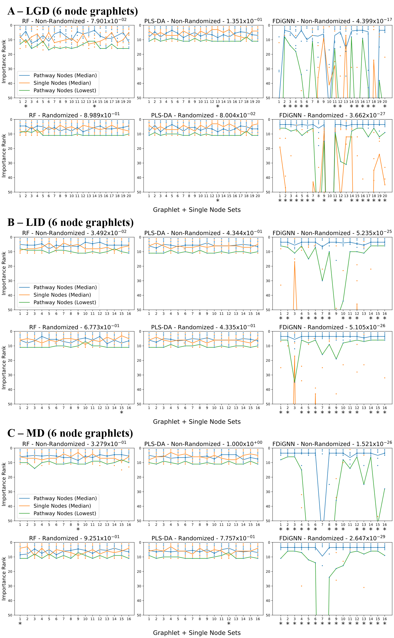
Supplementary Figure 5: Node Importance ranks of pathway and single nodes from Gini Importance of RF, VIP scores of PLS-DA and PINNI score from FDiGNN models in 6-node graphlet simulations. Results are shown for the A) LGD, B) LID and C) MD benchmarks. In each 6-node graphlet simulation, a random 6-length graphlet is randomly selected, representing pathway nodes, and 5 nodes with no connection to each other or the graphlet are also selected as single nodes. Chart titles include the Mann-Whitney test p-value considering all ranks of the pathway nodes and of the single nodes across all simulations in that chart. Dots show the individual ranks of the selected nodes in each simulation with the blue line connecting the medians of the pathway node ranks in each simulation, the orange line the medians of the single nodes and the green line the worst-case ranked pathway node. Simulations have a * symbol below them if there is a significant difference (p-value below 0.05) between the ranks of pathway and single nodes (Mann-Whitney test). Only the top 50 ranks in each case are shown.
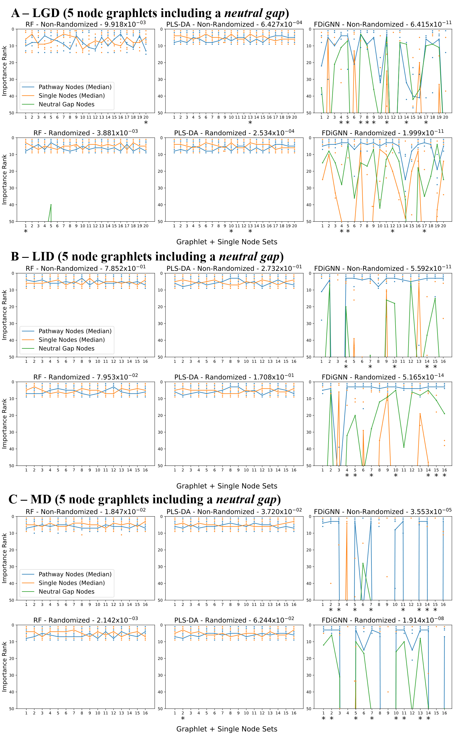
Supplementary Figure 6: Node Importance ranks of pathway, and single, and neutral gap nodes from Gini Importance of RF, VIP scores of PLS-DA and PINNI score from FDiGNN models in 5-node graphlet including a neutral gap simulations. Results are shown for the A) LGD, B) LID and C) MD benchmarks. In each 5-node graphlet including a neutral gap simulation, a random 5-length graphlet is randomly selected, representing pathway nodes, and 5 nodes with no connection to each other or the graphlet are also selected as single nodes. The neutral gap is a graphlet node with the highest degree assigned with intensities with intermediate random values between all samples. Chart titles include the Mann-Whitney test p-value considering all ranks of the pathway nodes (including the neutral gap) and of the single nodes across all simulations in that chart. Dots show the individual ranks of the selected nodes in each simulation performed with the blue line connecting each simulation medians of the pathway node ranks, the orange line the medians of the single nodes and the green line the ranks of the neutral gaps. Simulations have a * symbol below them if there is a significant difference (p-value below 0.05) between the ranks of pathway (including the neutral gap) and single nodes (Mann-Whitney test). Only the top 50 ranks in each case are shown.
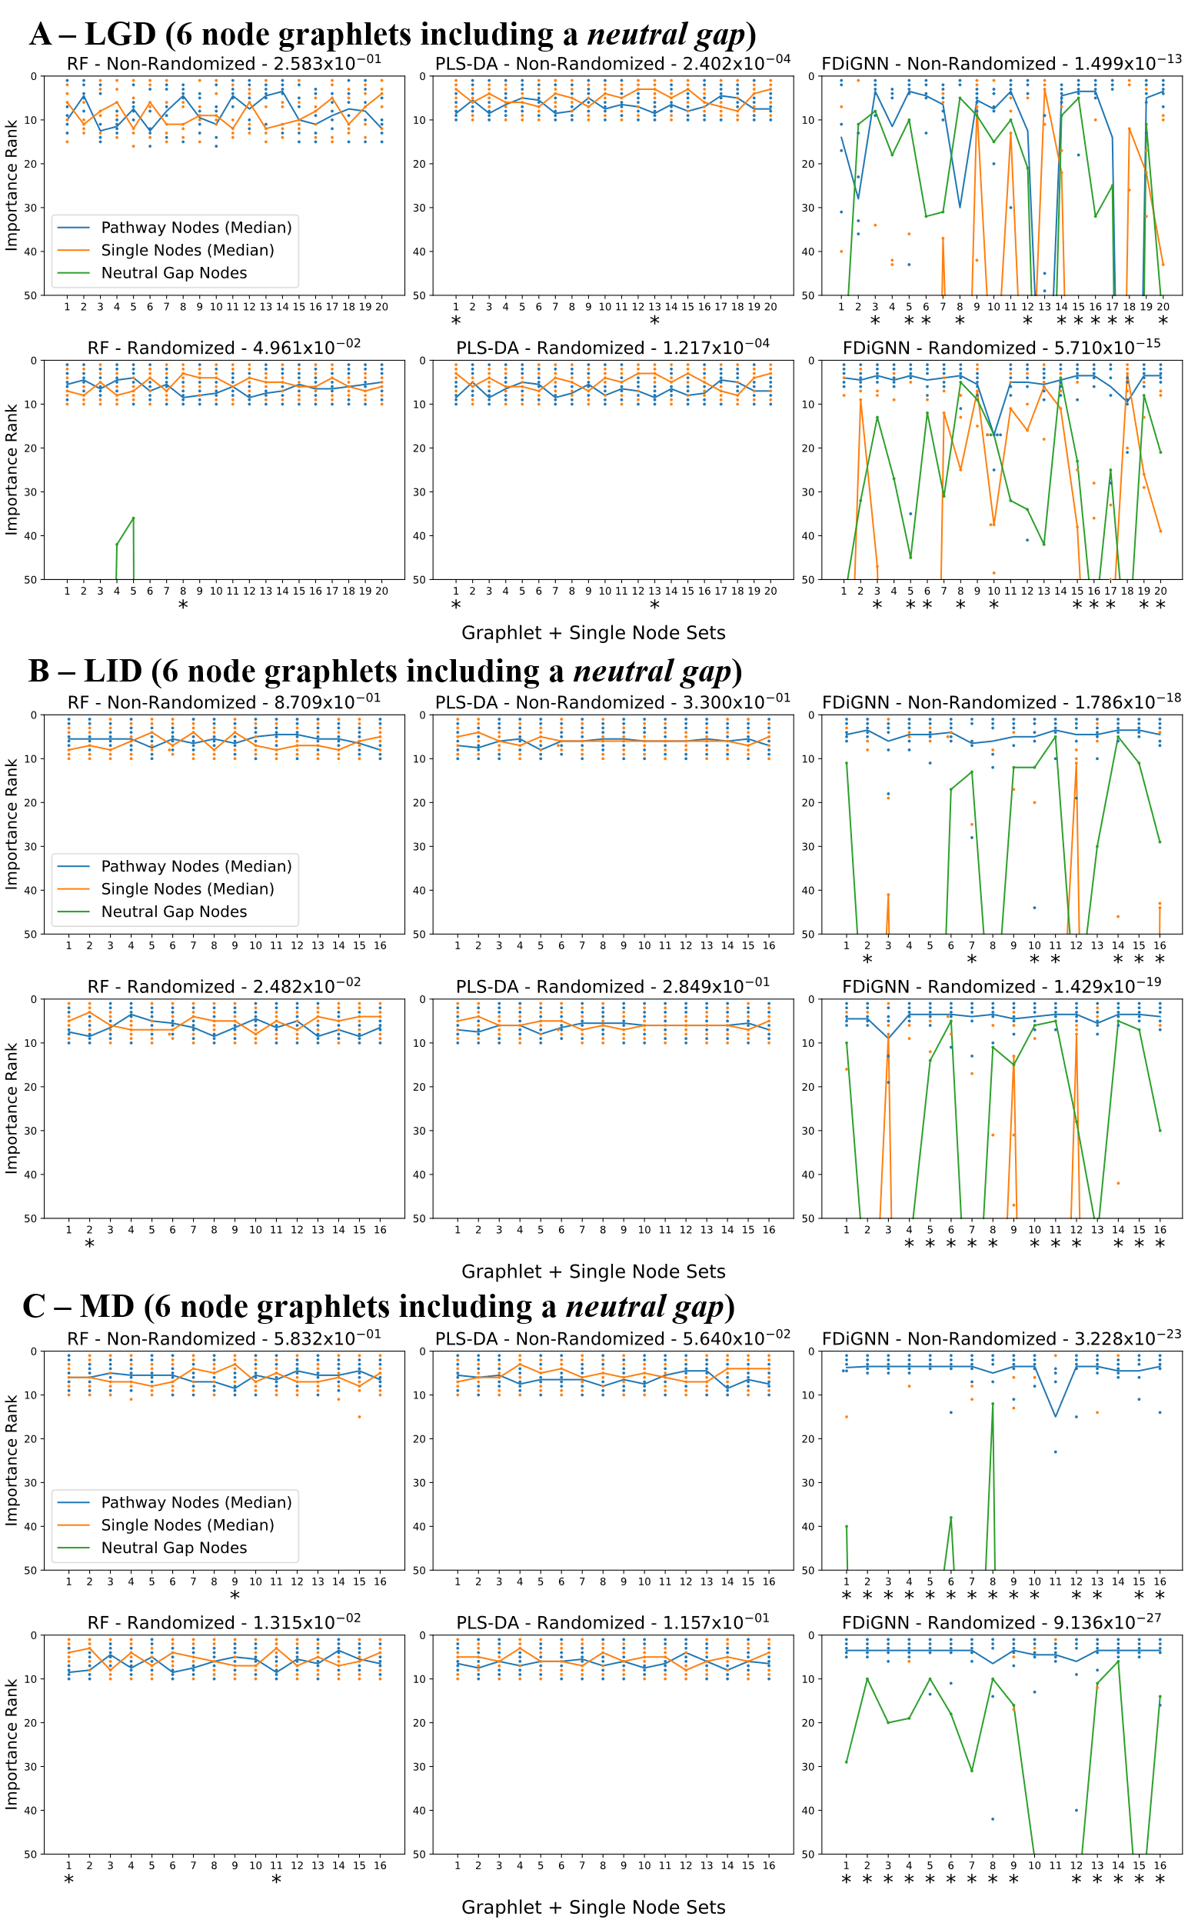
Supplementary Figure 7: Node Importance ranks of pathway, and single, and neutral gap nodes from Gini Importance of RF, VIP scores of PLS-DA and PINNI score from FDiGNN models in 6-node graphlet including a neutral gap simulations. Results are shown for the A) LGD, B) LID and C) MD benchmarks. In each 6-node graphlet including a neutral gap simulation, a random 6-length graphlet is randomly selected, representing pathway nodes, and 5 nodes with no connection to each other or the graphlet are also selected as single nodes. The neutral gap is a graphlet node with the highest degree assigned with intensities with intermediate random values between all samples. Chart titles include the Mann-Whitney test p-value considering all ranks of the pathway nodes (including the neutral gap) and of the single nodes across all simulations in that chart. Dots show the individual ranks of the selected nodes in each simulation performed with the blue line connecting each simulation medians of the pathway node ranks, the orange line the medians of the single nodes and the green line the ranks of the neutral gaps. Simulations have a * symbol below them if there is a significant difference (p-value below 0.05) between the ranks of pathway (including the neutral gap) and single nodes (Mann-Whitney test). Only the top 50 ranks in each case are shown.
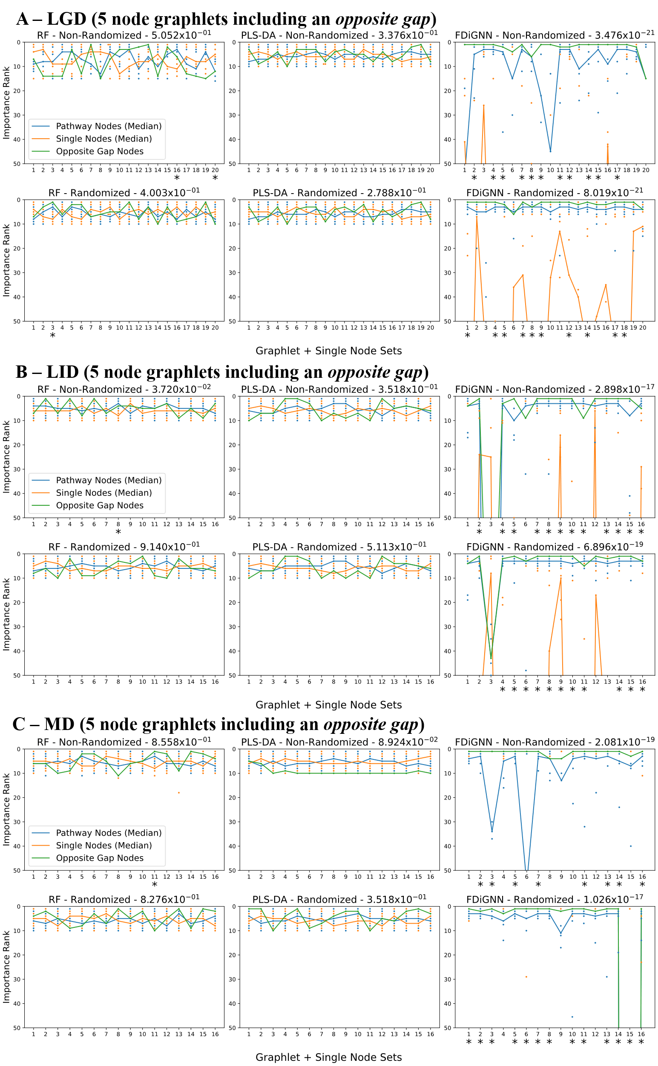
Supplementary Figure 8: Node Importance ranks of pathway, and single, and opposite gap nodes from Gini Importance of RF, VIP scores of PLS-DA and PINNI score from FDiGNN models in 5-node graphlet including an opposite gap simulations. Results are shown for the A) LGD, B) LID and C) MD benchmarks. In each 5-node graphlet including an opposite gap simulation, a random 5-length graphlet is randomly selected, representing pathway nodes, and 5 nodes with no connection to each other or the graphlet are also selected as single nodes. The opposite gap is a graphlet node with the highest degree assigned with either high or low intensities across the samples to have an opposite relationship of intensities to the remaining pathway nodes. Chart titles include the Mann-Whitney test p-value considering all ranks of the pathway nodes (including the opposite gap) and of the single nodes across all simulations in that chart. Dots show the individual ranks of the selected nodes in each simulation performed with the blue line connecting each simulation medians of the pathway node ranks, the orange line the medians of the single nodes and the green line the ranks of the opposite gaps. Simulations have a * symbol below them if there is a significant difference (p-value below 0.05) between the ranks of pathway (including the opposite gap) and single nodes (Mann-Whitney test). Only the top 50 ranks in each case are shown.
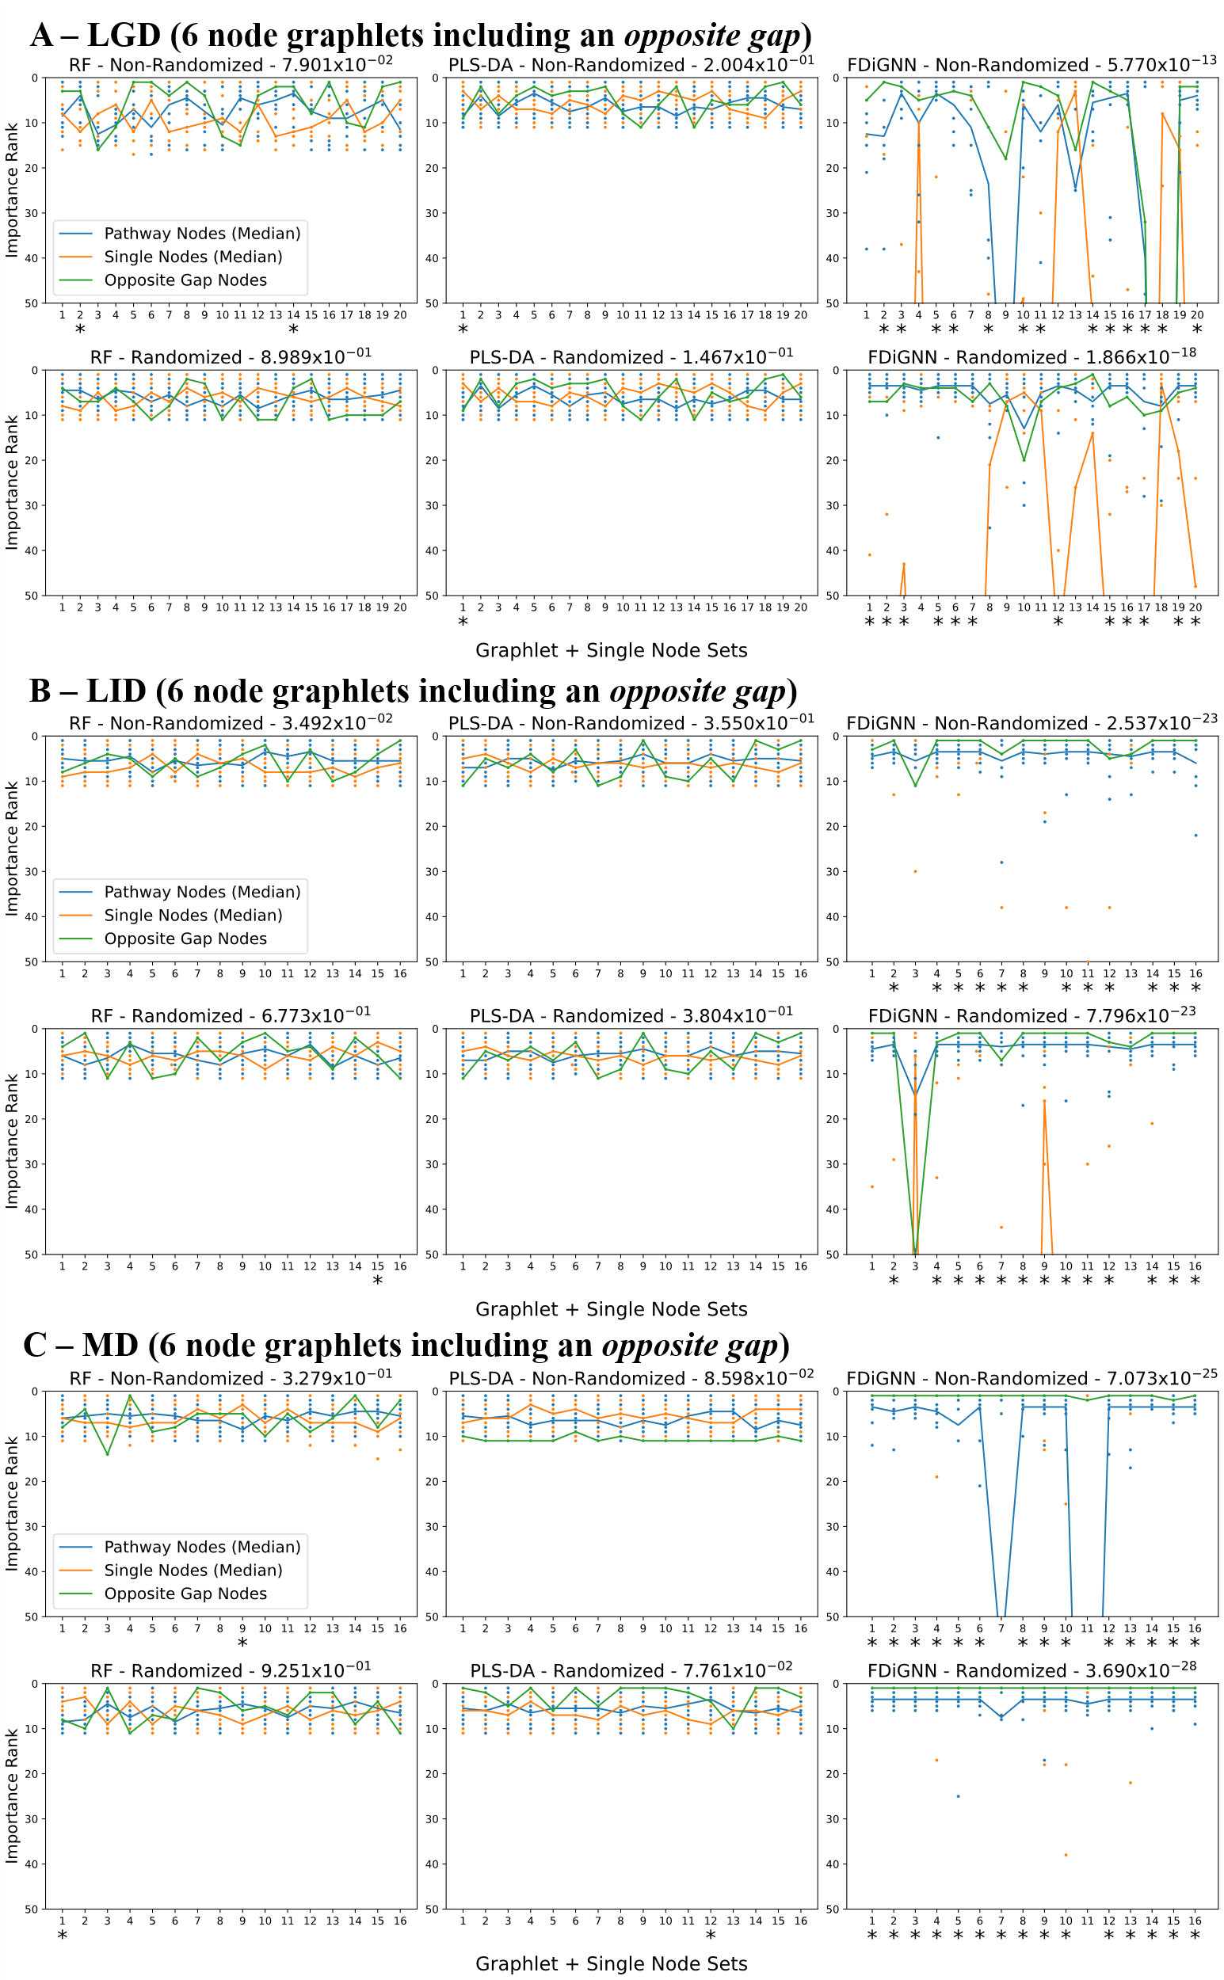
Supplementary Figure 9: Node Importance ranks of pathway, and single, and opposite gap nodes from Gini Importance of RF, VIP scores of PLS-DA and PINNI score from FDiGNN models in 6-node graphlet including an opposite gap simulations. Results are shown for the A) LGD, B) LID and C) MD benchmarks. In each 6-node graphlet including an opposite gap simulation, a random 6-length graphlet is randomly selected, representing pathway nodes, and 5 nodes with no connection to each other or the graphlet are also selected as single nodes. The opposite gap is a graphlet node with the highest degree assigned with either high or low intensities across the samples to have an opposite relationship of intensities to the remaining pathway nodes. Chart titles include the Mann-Whitney test p-value considering all ranks of the pathway nodes (including the opposite gap) and of the single nodes across all simulations in that chart. Dots show the individual ranks of the selected nodes in each simulation performed with the blue line connecting each simulation medians of the pathway node ranks, the orange line the medians of the single nodes and the green line the ranks of the opposite gaps. Simulations have a * symbol below them if there is a significant difference (p-value below 0.05) between the ranks of pathway (including the opposite gap) and single nodes (Mann-Whitney test). Only the top 50 ranks in each case are shown.
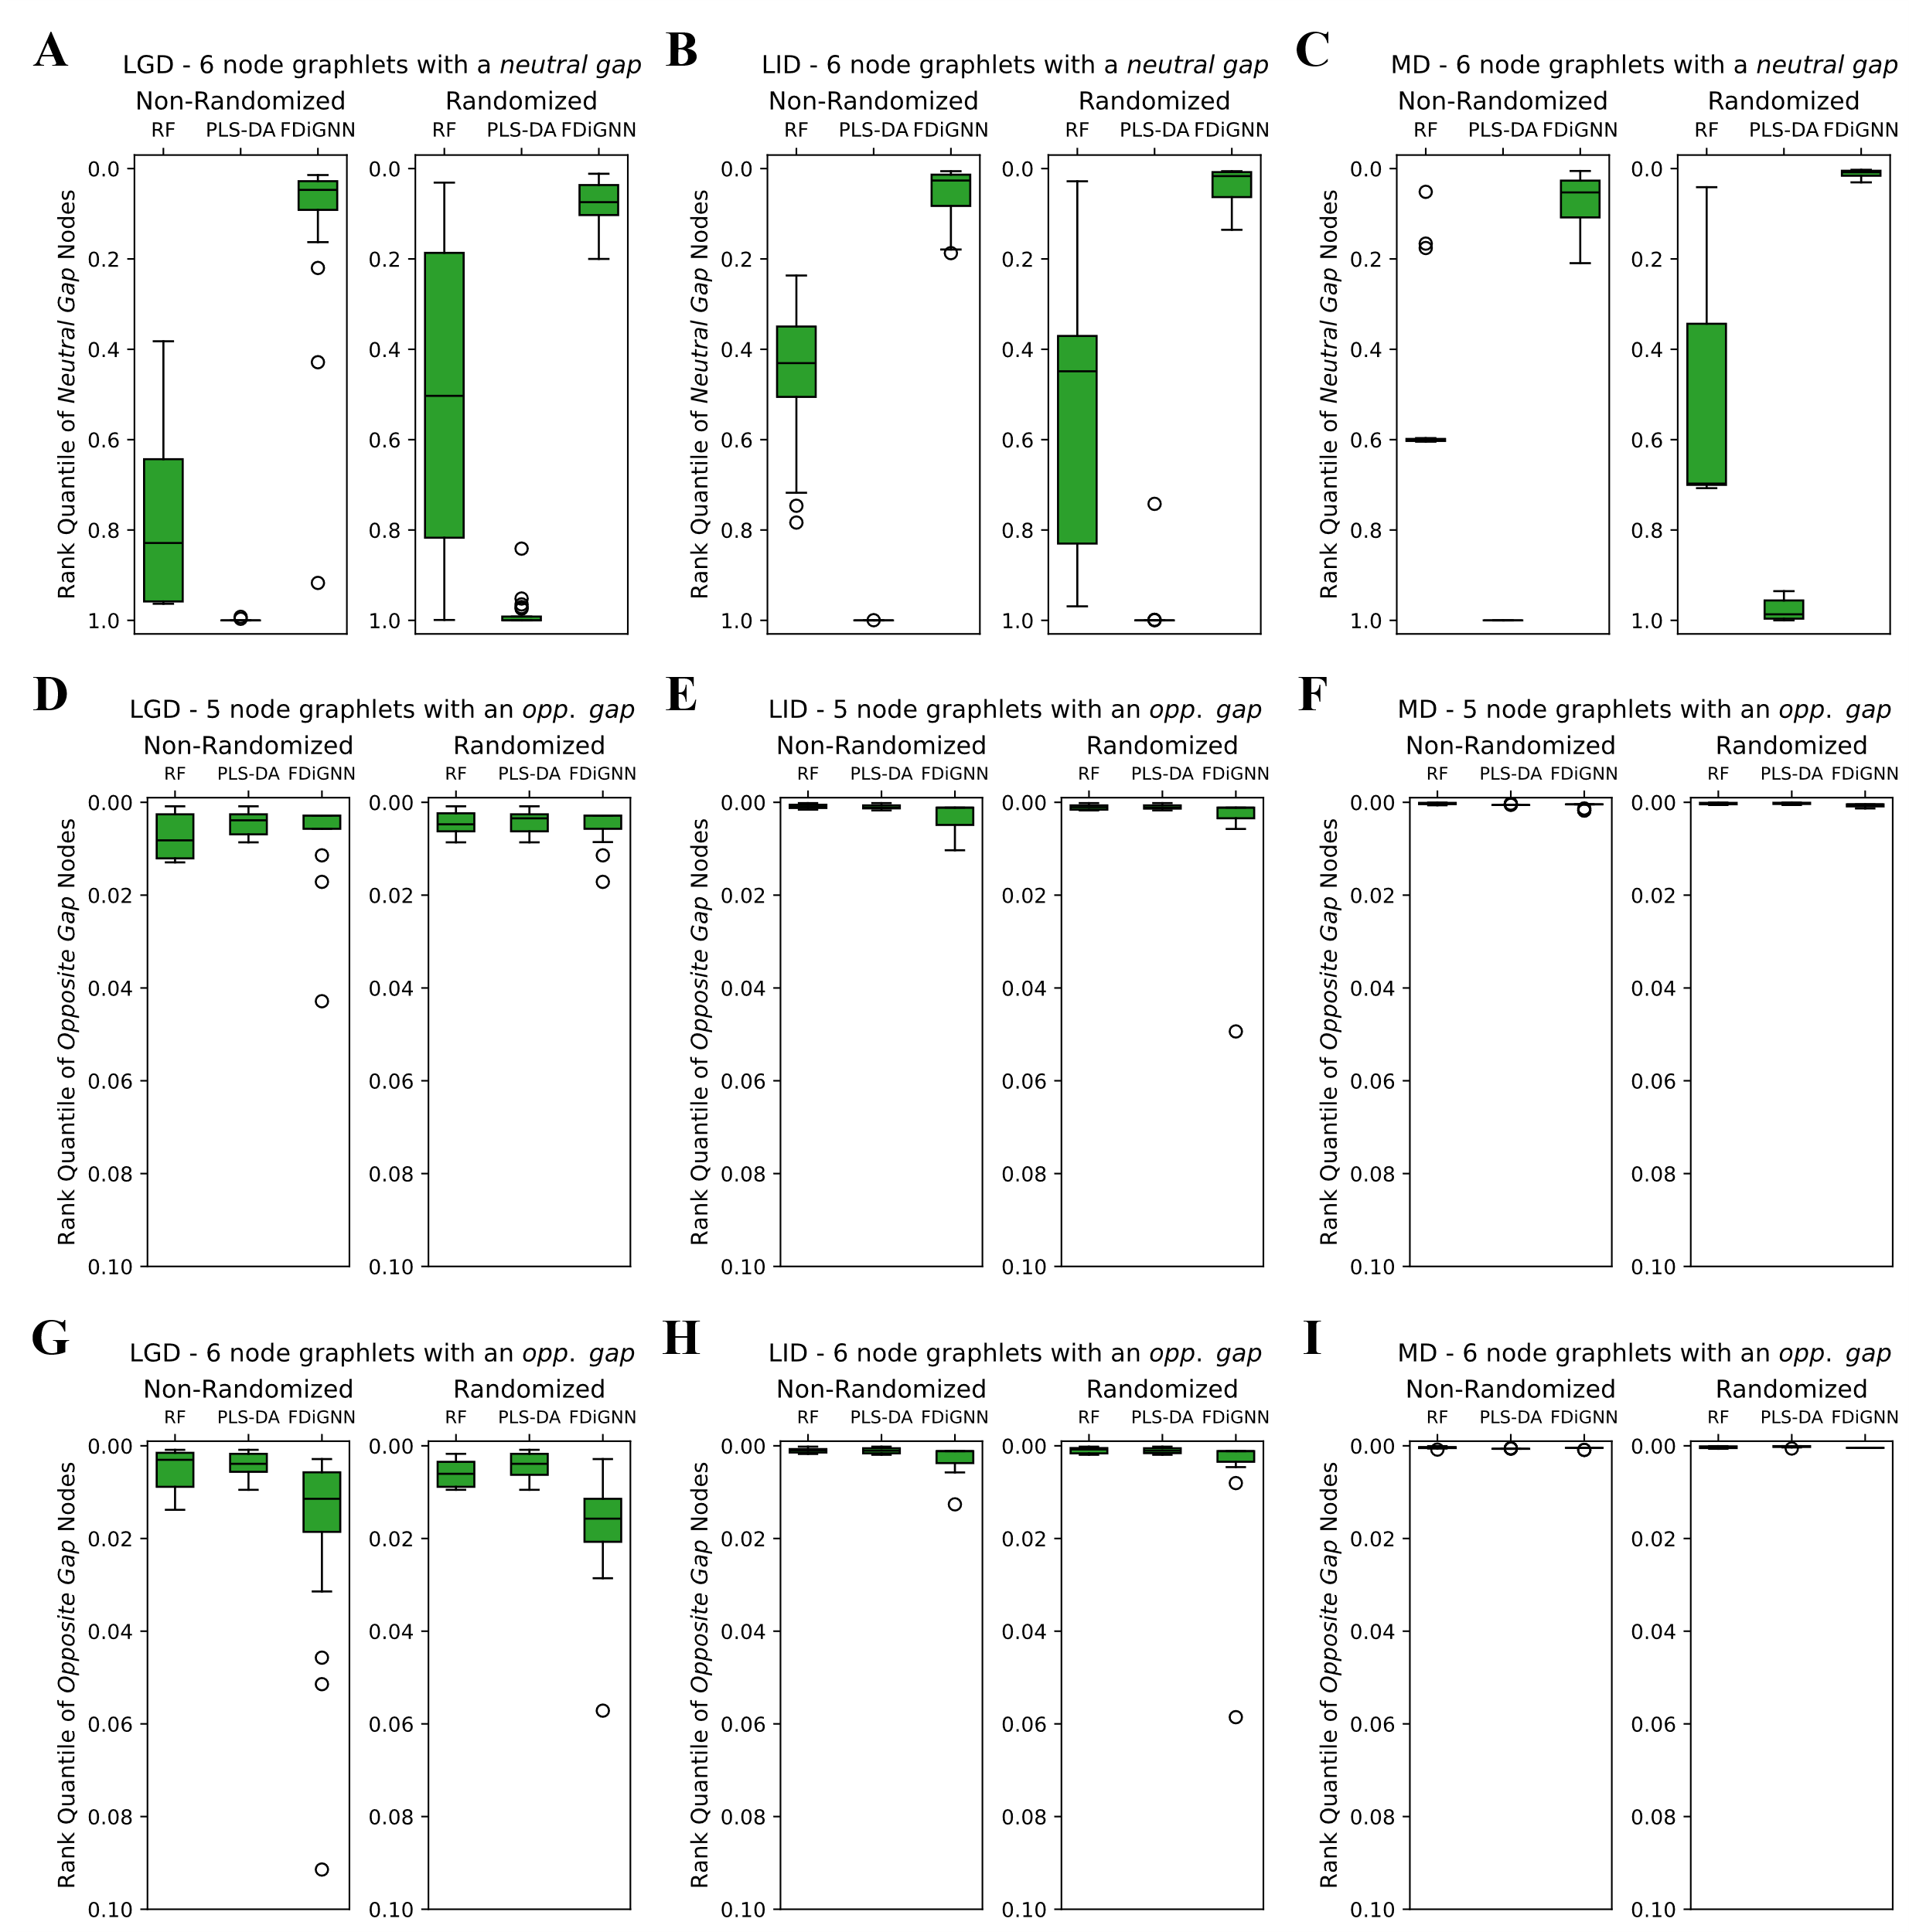
Supplementary Figure 10: Distribution of the rank quantiles of the neutral or opposite gap nodes in each simulation, according to the three importance rankings. 6-node graphlets with a neutral gap results are shown for A) LGD, B) LID and C) MD benchmarks. 5-node graphlets with an opposite gap results are shown for D) LGD, E) LID and F) MD benchmarks. 6-node graphlets with an opposite gap results are shown for G) LGD, H) LID and I) MD benchmarks. The neutral gap or opposite gap (Opp. Gap) select one of the highest degree nodes in the selected 5- or 6-node graphlets to have intermediate values between all samples – the neutral gap – or to have the opposite relationship of intensities to the remaining pathway nodes – the opposite gap.
Supplementary Table 5: Top 11 most significant pathways from Pathway Enrichment Analysis on LID considering the top 5% of FDiGNN ranked nodes as significant. Methodology explained in the Methods. Pathway database used was SMPDB. Abbreviations: Met. – Metabolites, BH – Benjamini-Hochberg multiple test correction.
Rank | Pathway | Nr. Metabolites Ranks | Nr. Metabolites Dataset | % of Metabolites In Top Ranks | Probability | Adjusted (BH) Probability
1 | Arginine and Proline Metabolism | 8 | 8 | 100.00 | 0.000011 | 0.000339
2 | Purine Metabolism | 7 | 7 | 100.00 | 0.000052 | 0.000786
3 | Histidine Metabolism | 6 | 6 | 100.00 | 0.000235 | 0.002346
4 | Tryptophan Metabolism | 4 | 4 | 100.00 | 0.004269 | 0.013435
5 | Urea Cycle | 4 | 4 | 100.00 | 0.004269 | 0.013435
6 | Nicotinate and Nicotinamide Metabolism | 4 | 4 | 100.00 | 0.004269 | 0.013435
7 | Aspartate Metabolism | 4 | 4 | 100.00 | 0.004269 | 0.013435
8 | Glutathione Metabolism | 4 | 4 | 100.00 | 0.004269 | 0.013435
9 | Ammonia Recycling | 4 | 4 | 100.00 | 0.004269 | 0.013435
10 | Glycine and Serine Metabolism | 5 | 6 | 83.33 | 0.004926 | 0.013435
11 | Glutamate Metabolism | 5 | 6 | 83.33 | 0.004926 | 0.013435

Supplementary Table 6: Top 5 most significant pathways from Pathway Enrichment Analysis on MD considering the top 25% of FDiGNN ranked nodes as significant. Methodology explained in the Methods. Pathway database used was SMPDB. Abbreviations: Met. – Metabolites, BH – Benjamini-Hochberg multiple test correction.
Rank | Pathway | Nr. Metabolites Ranks | Nr. Metabolites Dataset | % of Metabolites In Top Ranks | Probability | Adjusted (BH) Probability
1 | Histidine Metabolism | 4 | 5 | 80.00 | 0.0031 | 0.0769
2 | Fructose and Mannose Degradation | 3 | 3 | 100.00 | 0.0045 | 0.0769
3 | Tyrosine Metabolism | 4 | 6 | 66.67 | 0.0083 | 0.0937
4 | Estrone Metabolism | 3 | 4 | 75.00 | 0.0159 | 0.1354
5 | Alpha Linolenic Acid and Linoleic Acid Metabolism | 4 | 10 | 40.00 | 0.0684 | 0.2536

