Supplementary material

Isolation of the New Cytotoxic Polyketide (−)-R-Talaropinophiloic Acid Guided by an Integrated Metabolomics-Dereplication Approach

Marcus Vinicius Almeida Marques,ª Andresa Hiromi Sakai,^{b} Lucas Haidar Martorano,^{c} Viviani N. Takahashi,^{d} Juliana Mara Serpeloni,^{b} Fernando Martins dos Santos Júnior,^{c} Jorge M. David,ª and Eliane O. Silva^{a,*}

ª Department of Organic Chemistry, Institute of Chemistry, Universidade Federal da Bahia, Salvador 40170-115, Bahia, Brazil
^{b} Department of General Biology, Center for Biological Sciences, Universidade Estadual de Londrina, Londrina 86057-970, Paraná, Brazil
^{c} Departamento of Organic Chemistry, Chemistry Institute, Federal Fluminense
University – UFF, Niterói 24.020-141, Rio de Janeiro, Brazil
^{d} Department of Chemistry, Faculty of Philosophy, Sciences and Letters of Ribeirão Preto, Universidade de São Paulo, Ribeirão Preto 14040900, São Paulo, Brazil

*Corresponding author:

elianeos@ufba.br (E.O. Silva)
Institute of Chemistry, Organic Chemistry Department, Federal University of Bahia (UFBA), Barão de Jeremoabo 147, 40170-115 Salvador, Bahia, Brazil

A

B

C

D

E

F

Fig. S1 Base peak chromatogram (100–1000 Da) from the extract of J1, J5, J6, J7, J9, and J13 strains (A-F, respectively) growth in PDA medium. Data acquired at electrospray ionization in positive mode.

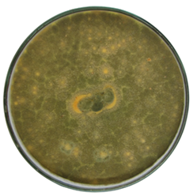
Fig. S2 Macroscopic morphology of 7-day culture of Talaromyces pinophilus J6 grown on potato dextrose agar

Table S1. Complete list of features exclusively detected in Talaromyces pinophilus J6 grown on PDA_AS. The seven annotated natural products (a-g), due to their lower mass error, common adducts for positive ionization mode (under the employed analytical method), and a match score with compounds from our in-house library greater than 0.5, are gray-highlighted. The isolated compounds are green-highlighted.
row identity  data bank ID:adduct:score | m/z | retention time | J6_PDA Feature status | J6_PDA_ST Feature status | J6_PDA_AS Feature status | J6_PDA_AS Peak area
864: [M+NH4]+: 0.617 | 136.06235 | 6.2624 | UNKNOWN | UNKNOWN | DETECTED | 2137533.5
711: [M+NH4]+: 0.812 | 215.10357 | 12.398 | UNKNOWN | UNKNOWN | DETECTED | 2579876.5
697: [M+NH4]+: 0.861 | 126.05565 | 12.702 | UNKNOWN | UNKNOWN | DETECTED | 5250707.5
646: [M+H]+: 0.867 | 152.07127 | 12.702 | UNKNOWN | UNKNOWN | DETECTED | 3569922.5
645: [M+H]+: 0.697 | 190.04835 | 12.702 | UNKNOWN | UNKNOWN | DETECTED | 7203956.5
820: [M+H]+: 0.445 | 239.06749 | 14.508 | UNKNOWN | UNKNOWN | DETECTED | 3510277.5
120: [M+NH4]+: 0.762 | 216.12422 | 15.554 | UNKNOWN | UNKNOWN | DETECTED | 3348312.8
705: [M+NH4]+: 0.787 | 190.10849 | 15.639 | UNKNOWN | UNKNOWN | DETECTED | 4433511.5
880: [M+NH4]+: 0.761 | 224.09293 | 15.767 | UNKNOWN | UNKNOWN | DETECTED | 875192.2
756: [M+H]+: 0.813 | 157.05051 | 16.018 | UNKNOWN | UNKNOWN | DETECTED | 4531233.5
208: [M+H]+: 0.706 | 169.04807 | 16.560 | UNKNOWN | UNKNOWN | DETECTED | 8055467
166: [M+NH4]+: 0.668 | 318.09888 | 16.812 | UNKNOWN | UNKNOWN | DETECTED | 1825431
576: [M+NH4]+: 0.746 | 241.15593 | 17.149 | UNKNOWN | UNKNOWN | DETECTED | 1013323.3
849: [M+H]+: 0.762 | 193.05077 | 18.134 | UNKNOWN | UNKNOWN | DETECTED | 6705788.5
847: [M+H]+: 0.770 | 207.02763 | 18.134 | UNKNOWN | UNKNOWN | DETECTED | 5029270
669: [M+K]+: 0.447 | 265.11728 | 18.497 | UNKNOWN | UNKNOWN | DETECTED | 4950071
109: [M+H]+: 0.809 | 181.05053 | 18.537 | UNKNOWN | UNKNOWN | DETECTED | 18381566
278: [M+NH4]+: 0.729 | 388.14107 | 18.697 | UNKNOWN | UNKNOWN | DETECTED | 1210966.5
a 675: [M+Na]+: 0.776 | 205.0460 | 18.737 | UNKNOWN | UNKNOWN | DETECTED | 1801531.1
874: [M+NH4]+: 0.750 | 204.12428 | 18.777 | UNKNOWN | UNKNOWN | DETECTED | 6991657.5
749: [M+H]+: 0.738 | 246.0774 | 18.897 | UNKNOWN | UNKNOWN | DETECTED | 34431060
723: [M+H]+: 0.782 | 239.09029 | 18.937 | UNKNOWN | UNKNOWN | DETECTED | 3620280.2
750: [M+H]+: 0.755 | 202.08503 | 18.976 | UNKNOWN | UNKNOWN | DETECTED | 2186877.8
117: [M+H]+: 0.806 | 211.06107 | 18.976 | UNKNOWN | UNKNOWN | DETECTED | 6133644
428: [M+H]+: 0.669 | 321.09853 | 18.976 | UNKNOWN | UNKNOWN | DETECTED | 3847950.5
714: [M+H]+: 0.878 | 343.08062 | 18.976 | UNKNOWN | UNKNOWN | DETECTED | 1507671.5
798: [M+NH4]+: 0.676 | 302.10394 | 19.055 | UNKNOWN | UNKNOWN | DETECTED | 5636771.5
763: [M+K]+: 0.939 | 277.11974 | 19.214 | UNKNOWN | UNKNOWN | DETECTED | 6906535
824: [M+NH4]+: 0.880 | 354.09661 | 19.214 | UNKNOWN | UNKNOWN | DETECTED | 8593076
722: [M+H]+: 0.757 | 211.09526 | 19.373 | UNKNOWN | UNKNOWN | DETECTED | 15109078
839: [M+Na]+: 0.668 | 329.06488 | 19.574 | UNKNOWN | UNKNOWN | DETECTED | 1238988.4
3: [M+K]+: 0.858 | 432.16765 | 19.967 | UNKNOWN | UNKNOWN | DETECTED | 5636684.5
826: [M+H]+: 0.865 | 341.0649 | 20.006 | UNKNOWN | UNKNOWN | DETECTED | 1491232.8
244: [M+NH4]+: 0.559 | 400.14133 | 20.006 | UNKNOWN | UNKNOWN | DETECTED | 3326324.5
827: [M+H]+: 0.909 | 369.09642 | 20.564 | UNKNOWN | UNKNOWN | DETECTED | 7441919.5
279: [M+NH4]+: 0.712 | 374.12535 | 20.564 | UNKNOWN | UNKNOWN | DETECTED | 10174723
529: [M+H]+: 0.753 | 195.10033 | 20.603 | UNKNOWN | UNKNOWN | DETECTED | 9675234
139: [M+H]+: 0.767 | 265.10824 | 20.603 | UNKNOWN | UNKNOWN | DETECTED | 2201312.5
91: [M+H]+: 0.819 | 251.0923 | 20.683 | UNKNOWN | UNKNOWN | DETECTED | 2133682.2
798: [M+NH4]+: 0.676 | 302.10394 | 19.055 | UNKNOWN | UNKNOWN | DETECTED | 5636771.5
302: [M+NH4]+: 0.778 | 266.13757 | 20.683 | UNKNOWN | UNKNOWN | DETECTED | 1390973.5
b 90: [M+H]+: 0.756 | 237.07699 | 20.722 | UNKNOWN | UNKNOWN | DETECTED | 1985499.2
265: [M+NH4]+: 0.648 | 360.14593 | 20.762 | UNKNOWN | UNKNOWN | DETECTED | 6682047
156: [M+H]+: 0.620 | 389.16137 | 20.762 | UNKNOWN | UNKNOWN | DETECTED | 1221826
880: [M+H]+: 0.769 | 207.06634 | 20.842 | UNKNOWN | UNKNOWN | DETECTED | 2982268.2
185: [M+H]+: 0.918 | 429.15397 | 20.842 | UNKNOWN | UNKNOWN | DETECTED | 2888913
647: [M+H]+: 0.695 | 195.06671 | 20.961 | UNKNOWN | UNKNOWN | DETECTED | 1848509
592: [M+K]+: 0.863 | 391.15964 | 21.435 | UNKNOWN | UNKNOWN | DETECTED | 2148652.2
575: [M+H]+: 0.791 | 183.09993 | 21.474 | UNKNOWN | UNKNOWN | DETECTED | 774721.6
774: [M+NH4]+: 0.657 | 390.15644 | 21.474 | UNKNOWN | UNKNOWN | DETECTED | 9727725
c 114: [M+H]+: 0.717 | 363.10889 | 21.513 | UNKNOWN | UNKNOWN | DETECTED | 6734015
549: [M+H]+: 0.869 | 385.09112 | 21.513 | UNKNOWN | UNKNOWN | DETECTED | 6783180
771: [M+NH4]+: 0.871 | 192.06617 | 21.709 | UNKNOWN | UNKNOWN | DETECTED | 5632537.5
870: [M+K]+: 0.883 | 390.14598 | 21.709 | UNKNOWN | UNKNOWN | DETECTED | 27118170
207: [M+H]+: 0.742 | 291.0876 | 21.749 | UNKNOWN | UNKNOWN | DETECTED | 1698877
297: [M+H]+: 0.711 | 317.06702 | 21.749 | UNKNOWN | UNKNOWN | DETECTED | 7723254.5
611: [M+NH4]+: 0.692 | 332.1144 | 21.866 | UNKNOWN | UNKNOWN | DETECTED | 4373645
154: [M+H]+: 0.701 | 403.14027 | 21.866 | UNKNOWN | UNKNOWN | DETECTED | 3469163
198: [M+H]+: 0.845 | 155.10745 | 21.943 | UNKNOWN | UNKNOWN | DETECTED | 6951705.5
d 136: [M+H]+: 0.637 | 419.13549 | 22.021 | UNKNOWN | UNKNOWN | DETECTED | 3001251.2
e 368: [M+H]+: 0.785 | 267.1216 | 22.138 | UNKNOWN | UNKNOWN | DETECTED | 3553592.5
323: [M+Na]+: 0.155 | 405.15624 | 22.295 | UNKNOWN | UNKNOWN | DETECTED | 2666925
734: [M+H]+: 0.790 | 185.04553 | 22.373 | UNKNOWN | UNKNOWN | DETECTED | 1501829.2
351: [M+H]+: 0.762 | 249.07697 | 22.373 | UNKNOWN | UNKNOWN | DETECTED | 21168118
15: [M+K]+: 0.730 | 349.09351 | 22.373 | UNKNOWN | UNKNOWN | DETECTED | 34388988
214: [M+H]+: 0.737 | 223.09516 | 22.491 | UNKNOWN | UNKNOWN | DETECTED | 7368954
416: [M+Na]+: 0.609 | 443.1332 | 22.610 | UNKNOWN | UNKNOWN | DETECTED | 707472.1
387: [M+H]+: 0.783 | 283.11649 | 22.887 | UNKNOWN | UNKNOWN | DETECTED | 4211945
f 133: [M+H]+: 0.666 | 375.10914 | 22.887 | UNKNOWN | UNKNOWN | DETECTED | 14816281
146: [M+]+: 0.753 | 397.09124 | 22.887 | UNKNOWN | UNKNOWN | DETECTED | 9575312
162: [M+H]+: 0.266 | 825.16985 | 23.043 | UNKNOWN | UNKNOWN | DETECTED | 26036162
111: [2M+H]+: 0.434 | 657.19951 | 23.082 | UNKNOWN | UNKNOWN | DETECTED | 1300383.2
903: [M+K]+: 0.403 | 404.14397 | 23.278 | UNKNOWN | UNKNOWN | DETECTED | 1516457.9
413: [M+H]+: 0.997 | 401.12306 | 23.437 | UNKNOWN | UNKNOWN | DETECTED | 1654892.6
253: [M+H]+: 0.926 | 413.15911 | 23.558 | UNKNOWN | UNKNOWN | DETECTED | 5950916.5
119: [M+H]+: 0.784 | 183.10266 | 23.761 | UNKNOWN | UNKNOWN | DETECTED | 2755833.8
418: [M+H]+: 0.782 | 417.11909 | 23.964 | UNKNOWN | UNKNOWN | DETECTED | 1339851.9
415: [M+Na]+: 0.782 | 427.10104 | 24.044 | UNKNOWN | UNKNOWN | DETECTED | 723205.5
209: [M+H]+: 0.863 | 109.06547 | 24.163 | UNKNOWN | UNKNOWN | DETECTED | 2451827.2
276: [M+H]+: 0.589 | 389.17277 | 24.163 | UNKNOWN | UNKNOWN | DETECTED | 3321278.2
164: [2M+NH4]+: 0.418 | 590.13222 | 24.403 | UNKNOWN | UNKNOWN | DETECTED | 2763903
375: [M+H]+: 0.404 | 239.0580 | 24.442 | UNKNOWN | UNKNOWN | DETECTED | 6511078
2 411: [M+Na]+: 0.732 | 411.10538 | 24.442 | UNKNOWN | UNKNOWN | DETECTED | 836990140
1 113: [M+Na]+: 0.726 | 379.07885 | 24.482 | UNKNOWN | UNKNOWN | DETECTED | 1064326.5
770: [M+H]+: 0.345 | 401.08998 | 24.521 | UNKNOWN | UNKNOWN | DETECTED | 8832310
219: [M+H]+: 0.805 | 197.04545 | 24.600 | UNKNOWN | UNKNOWN | DETECTED | 3958610.5
181: [M+Na]+: 0.963 | 375.0841 | 24.600 | UNKNOWN | UNKNOWN | DETECTED | 3517727.5
g 135: [M+H]+: 0.091 | 211.0610 | 24.679 | UNKNOWN | UNKNOWN | DETECTED | 2687240.2
129: [M+Na]+: 0.315 | 187.07637 | 25.608 | UNKNOWN | UNKNOWN | DETECTED | 1672651.9
137: [M]+: 0.906 | 190.06347 | 25.608 | UNKNOWN | UNKNOWN | DETECTED | 2710075
772: [M+H]+: 0.772 | 233.08201 | 25.608 | UNKNOWN | UNKNOWN | DETECTED | 30356360
400: [M+Na]+: 0.558 | 407.11233 | 26.057 | UNKNOWN | UNKNOWN | DETECTED | 3658270.2
420: [M+Na]+: 0.606 | 409.12779 | 26.841 | UNKNOWN | UNKNOWN | DETECTED | 2167998.5
623: [M+Na]+: 0.643 | 413.26801 | 33.942 | UNKNOWN | UNKNOWN | DETECTED | 4542658.5
625: [M+H]+: 0.749 | 285.24367 | 34.835 | UNKNOWN | UNKNOWN | DETECTED | 1644876.1

Fig. S3 500 MHz ¹H NMR spectrum of (-)-R-talaropinophiloic acid (1) registered in CD₃OD

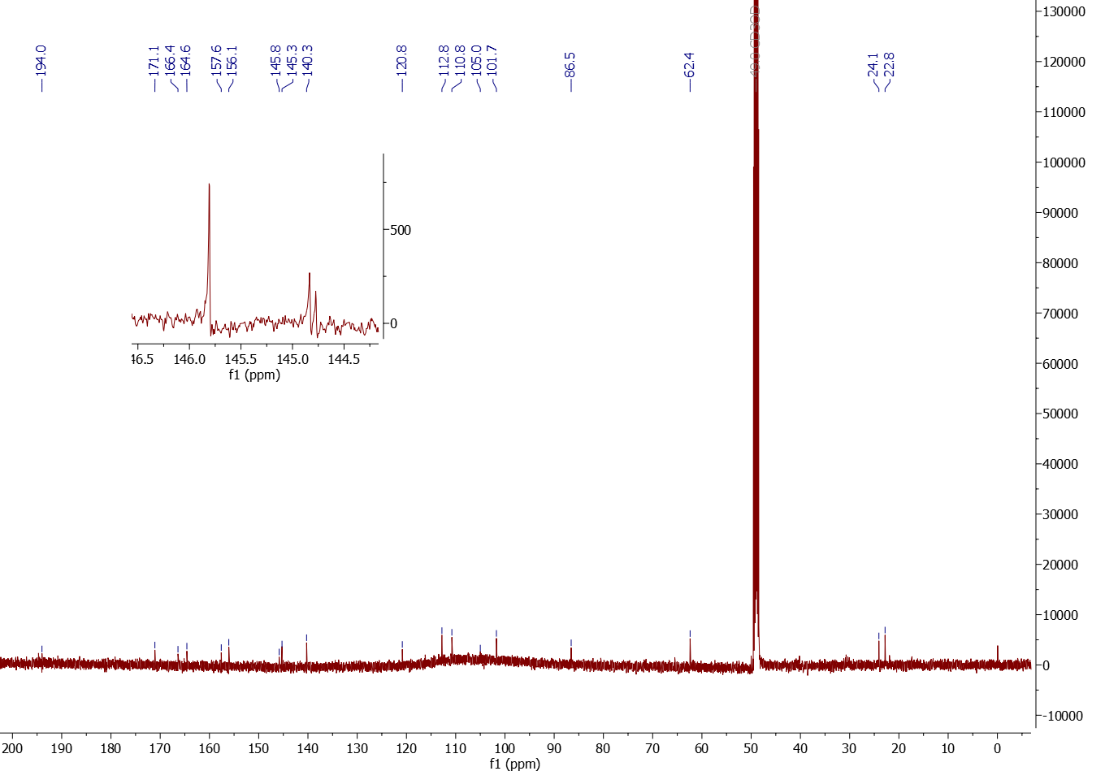
Fig. S4 125 MHz ¹³C spectrum of (-)-R-talaropinophiloic acid (1) registered in CD₃OD

Fig. S5 Heteronuclear HSQC (500 MHz for ¹H; 125 MHz for ¹³C) contour map of (-)-R-talaropinophiloic acid (1) registered in CD₃OD
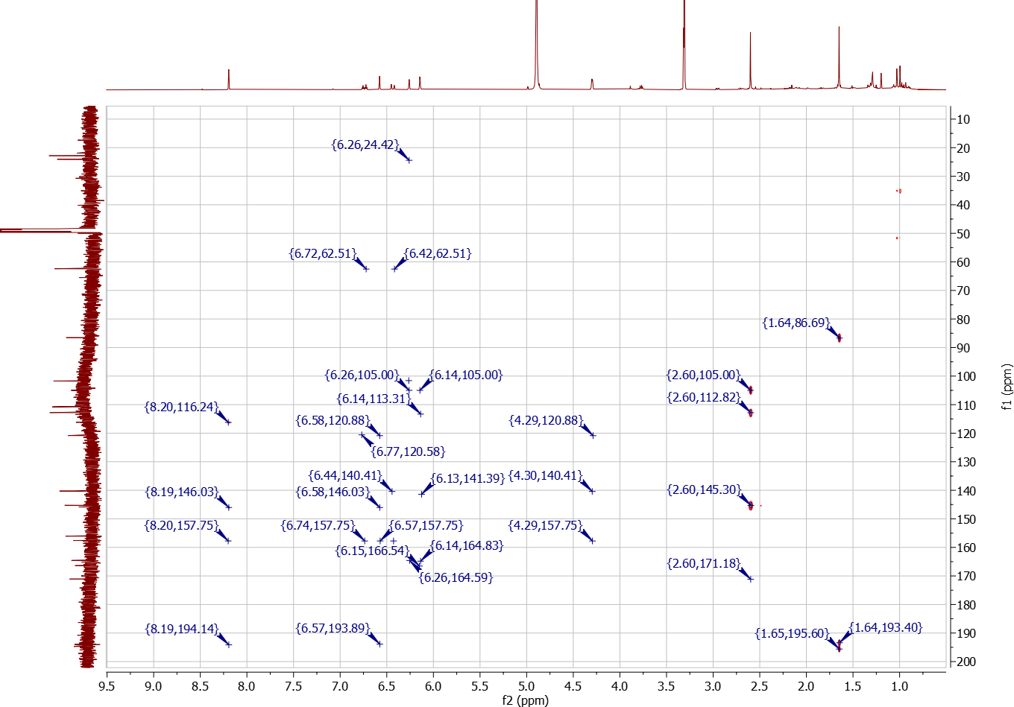
Fig. S6 Heteronuclear HMBC (500 MHz for ¹H; 125 MHz for ¹³C) contour map of (-)-R-talaropinophiloic acid (1) registered in CD₃OD
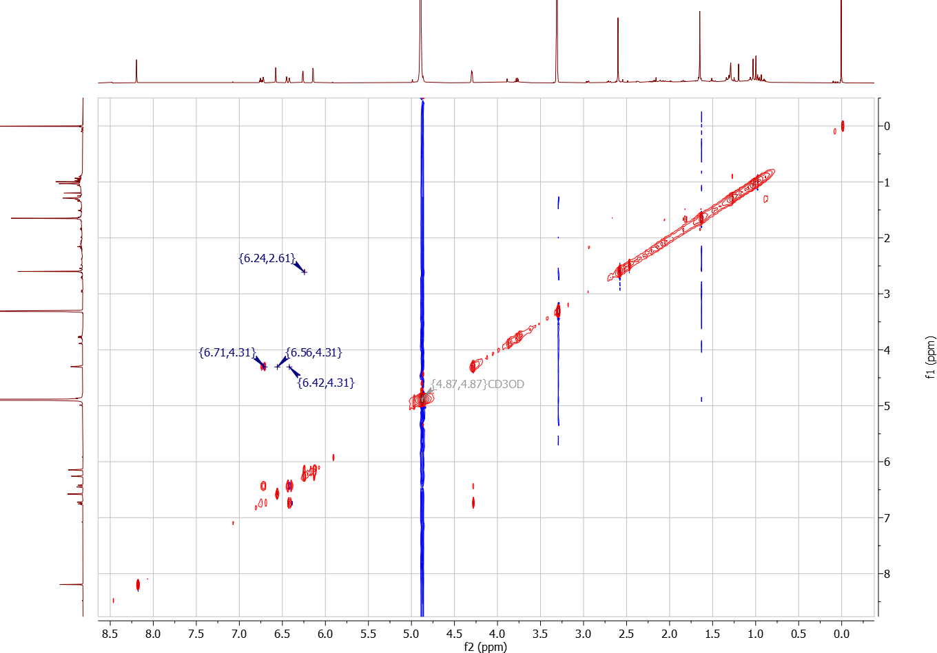
Fig. S7 Homonuclear TOCSY (500 MHz) contour map of (-)-R-talaropinophiloic acid (1) registered in CD₃OD

Fig. S8 HRESIMS spectrum of (-)-R-talaropinophiloic acid (1) (positive ion mode)
Fig. S9 500 MHz ¹H NMR spectrum of 3-O-methylfunicone registered in CD₃OD
Fig. S10 125 MHz ¹³C spectrum of 3-O-methylfunicone registered in CD₃OD
Fig. S11 Heteronuclear HSQC (500 MHz for ¹H; 125 MHz for ¹³C) contour map of 3-O-methylfunicone registered in CD₃OD
Fig. S12 Heteronuclear HMBC (500 MHz for ¹H; 125 MHz for ¹³C) contour map of 3-O-methylfunicone registered in CD₃OD

Fig. S13 HRESIMS spectrum of 3-O-methylfunicone (positive ion mode)

