Supporting Information
Table S1. Examples of occupations classified as clerical, sales, professional, craft, or service roles per the Department of Labor’s Dictionary of Occupational Titles.[18]

Clerical or Sales | Unemployed | Professional, Technical, or Managerial | Crafts or Operative | Service Work or Labor
(n=19, 8.6%)  Mail Handler  Claims Adjuster  Salesman  Stock Clerk  Clerkteller – Bank  Airport Control  Computer Operator | (n=1, 0.45%)  -- | (n=102, 46.4%)  Student  Teacher  Lab Technician  Dentist  Biochemist/Chemist  Engineer  Grocer | (n=65, 29.5%)  Carpenter  Cement Mason  Electrician  Machinist  Plumber  Warehouseman  Welder | (n=33, 15.0%)  Cook  Cement Laborer  Janitor  Hairdresser  Longshoreman  Maintenance  Police Officer

Table S2. Characteristics of endogenous and exogenous metabolites identified across all models, including HMDB and KEGG identifiers, when available.
Annotation | m/z | RT, sec | Adduct | HMDB ID | KEGG | Chromatography
Desmosterol | 385.3455 | 27.8 | M+H | HMDB0002719 | C01802 | HILIC
5β-cholestan-3-one | 409.3458 | 33.3 | M+Na | HMDB59604 | C03091 | HILIC
Leukotriene E4 | 466.1923 | 66.8 | M-H | HMDB0002200 | C05952 | C18
Tetrahydrocorticosterone | 349.2362 | 281.8 | M-H | HMDB0000268 | C05476 | C18
Androsterone glucuronide | 465.2488 | 40.3 | M-H | HMDB0002829 | C11135 | C18
17α-hydroxypregnalone-sulfate | 410.1797 | 65.8 | M-H | HMDB0000416 | -- | C18
Testosterone | 307.2254 | 26.3 | M+H₂O | HMDB0000234 | C00535 | HILIC
Aldosterone | 361.2003 | 28.6 | M+H | HMDB0000037 | C01780 | HILIC
Progesterone | 315.2328 | 18.8 | M+H | HMDB0001830 | C00410 | HILIC
5α-Dihydrotestosterone | 289.2173 | 236.3 | M-H | HMDB0002961 | C03917 | C18
Androstenedione | 309.1799 | 67.4 | M+Na | HMDB0000053 | C00280 | HILIC
7α,27-dihydroxy cholesterol | 419.352 | 26.3 | M+H | HMDB0006281 | C06341 | HILIC
Prostaglandin E3 | 349.2017 | 92.3 | M-H | HMDB0002664 | C06439 | C18
11-dehydrocorticosterone | 345.208 | 27.3 | M+H | HMDB0004029 | C05490 | HILIC
Palmitoylcarnitine | 400.3387 | 26.5 | M+H | HMDB0000222 | C02990 | HILIC
Octadecanoylcarnitine | 426.3572 | 25.8 | M+H | HMDB0094687 | -- | HILIC
Heptadecanoylcarnitine | 414.3577 | 26.6 | M+H | HMDB0006210 | -- | HILIC
Stearoylcarnitine | 428.3733 | 26.4 | M+H |  | -- | HILIC
  HMDB0000848
Tetradecanoylcarnitine | 372.3107 | 27.2 | M+H | HMDB0005066 | -- | HILIC

Table S3. Significantly different metabolites identified in the BMI stratified analysis associated with pathways including C21-steroid hormone biosynthesis, androgen and estrogen metabolism, squalene and cholesterol metabolism, and glycerophospholipid metabolism. For each metabolite, data are included for the adduct, m/z, retention time, p-value, log₂ fold change, and pathway enrichment.

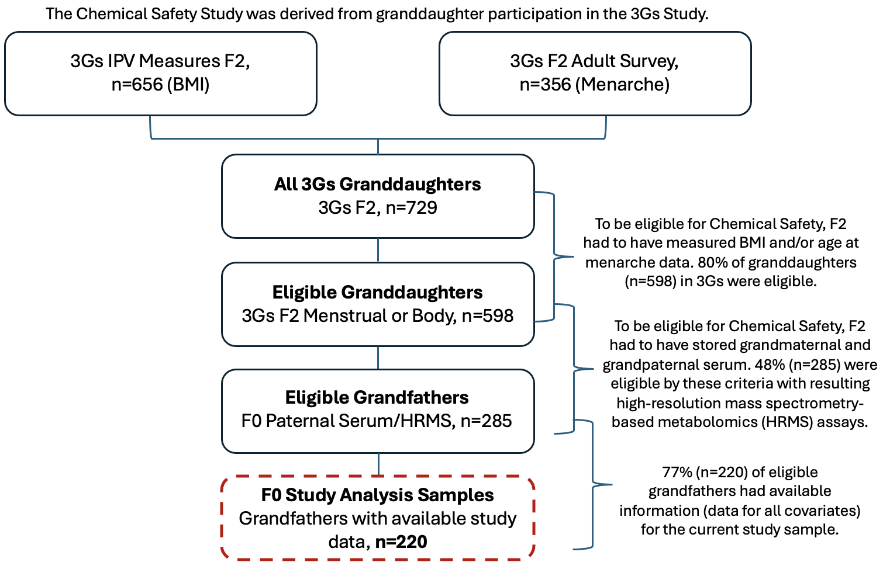
Figure S1. A flowchart depicting the current sample of 220 men in relation to the larger Child Health and Development Studies cohort. Grandfathers (F0) of granddaughters (F2) enrolled in the 3 Generations (3Gs) study were eligible for inclusion if their serum was available for HRMS analysis and they had available data for all covariates of interest in the current study, including occupation, age, race/ethnicity, and highest level of completed education.

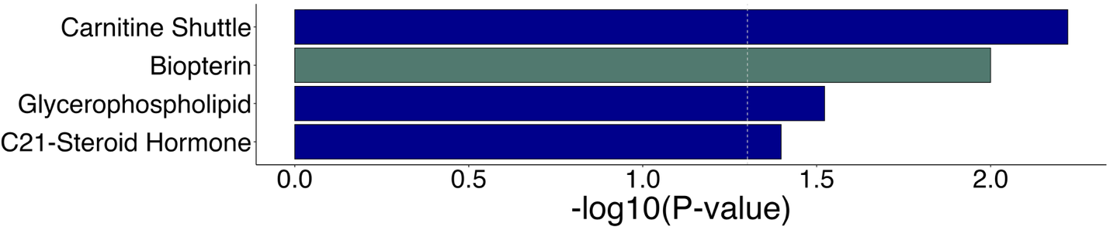
Figure S2. Significantly enriched pathways from the mummichog analysis of metabolic features from the multivariable linear regression model investigating the metabolome associations with craft and labor occupations adjusted for age, race/ethnicity, and education as potential confounders. Barplot depicting significantly altered metabolic pathways (y-axis) between craftsmen and laborers and men of other occupations with bars ordered by -log10(p-value). Color coding indicates if pathways were enriched among features detected in HILIC-positive mode only (blue) or C18-negative mode only (green).

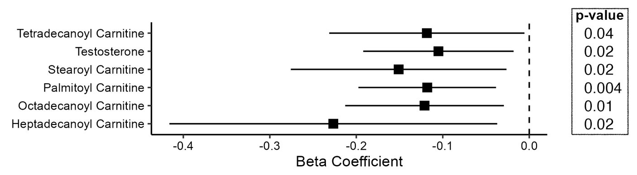
Figure S3. Forest plots of regression output for four significantly different metabolites contributing to enrichment of the carnitine shuttle pathway and testosterone from the C21-steroid hormone biosynthesis pathway, including point estimates ($β$-coefficients) and 95% confidence intervals. The x-axis shows the $β$-coefficients produced for each metabolite in the multivariable model, while the y-axis shows the metabolite annotations. Also depicted are p-values for each model. In the order of appearance in the forest plot, m/z, retention time, and adduct forms for each metabolite are: 372.3107, 27.2, and M+H; 307.2255, 26.3, and M+H; 428.3733, 26,4 and M+H; 400.3387, 26.5, and M+H; 426.3572, 25.8, and M+H; and 414.3577, 26.6, and M+H.

Figure S4. Steroid hormones from the C21-steroid hormone biosynthesis pathway detected via the multivariable model. Aldosterone and progesterone were more abundant in craftsmen and laborers, though not significantly so when only considering M+H adducts.

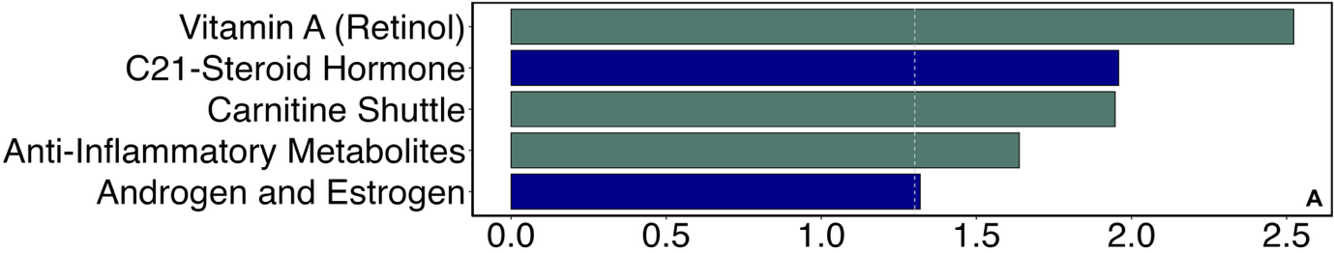
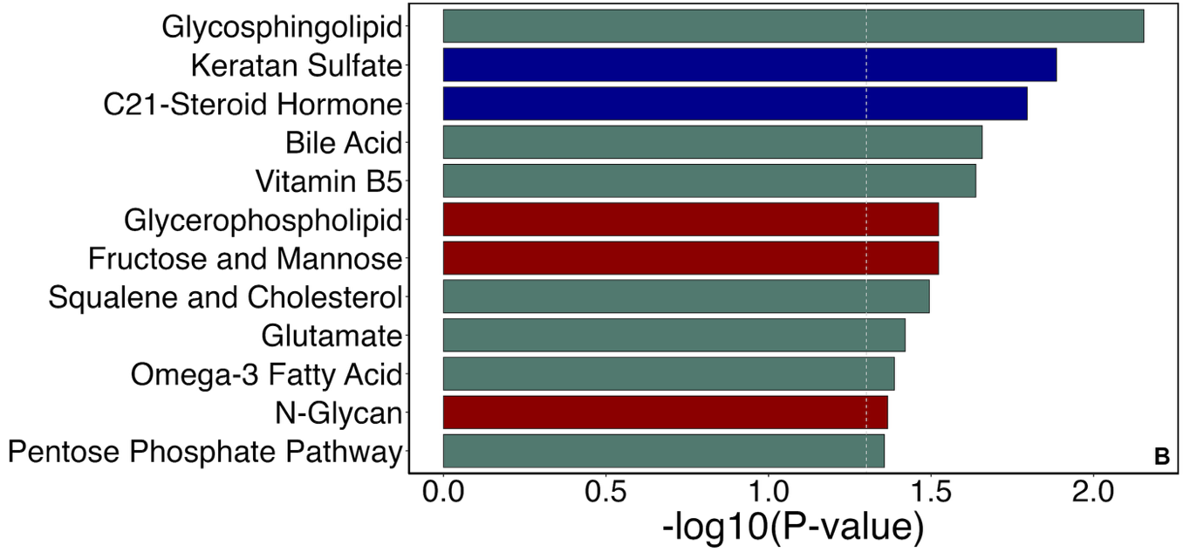
Figure S5. Significantly enriched pathways from the BMI-stratified mummichog analyses. Bar plot depicts altered metabolic pathways (y-axis) among craftsmen and laborers grouped by (A) BMI ≤ 25 and (B) BMI $≥$ 25, with bars ordered by the p value of each enriched pathway. Color coding indicates if pathways were enriched among features detected in HILIC-positive mode only (blue), C18-negative mode only (green), or both ionization modes (red).

