SUPPLEMENTARY MATERIAL
Supplementary material 1
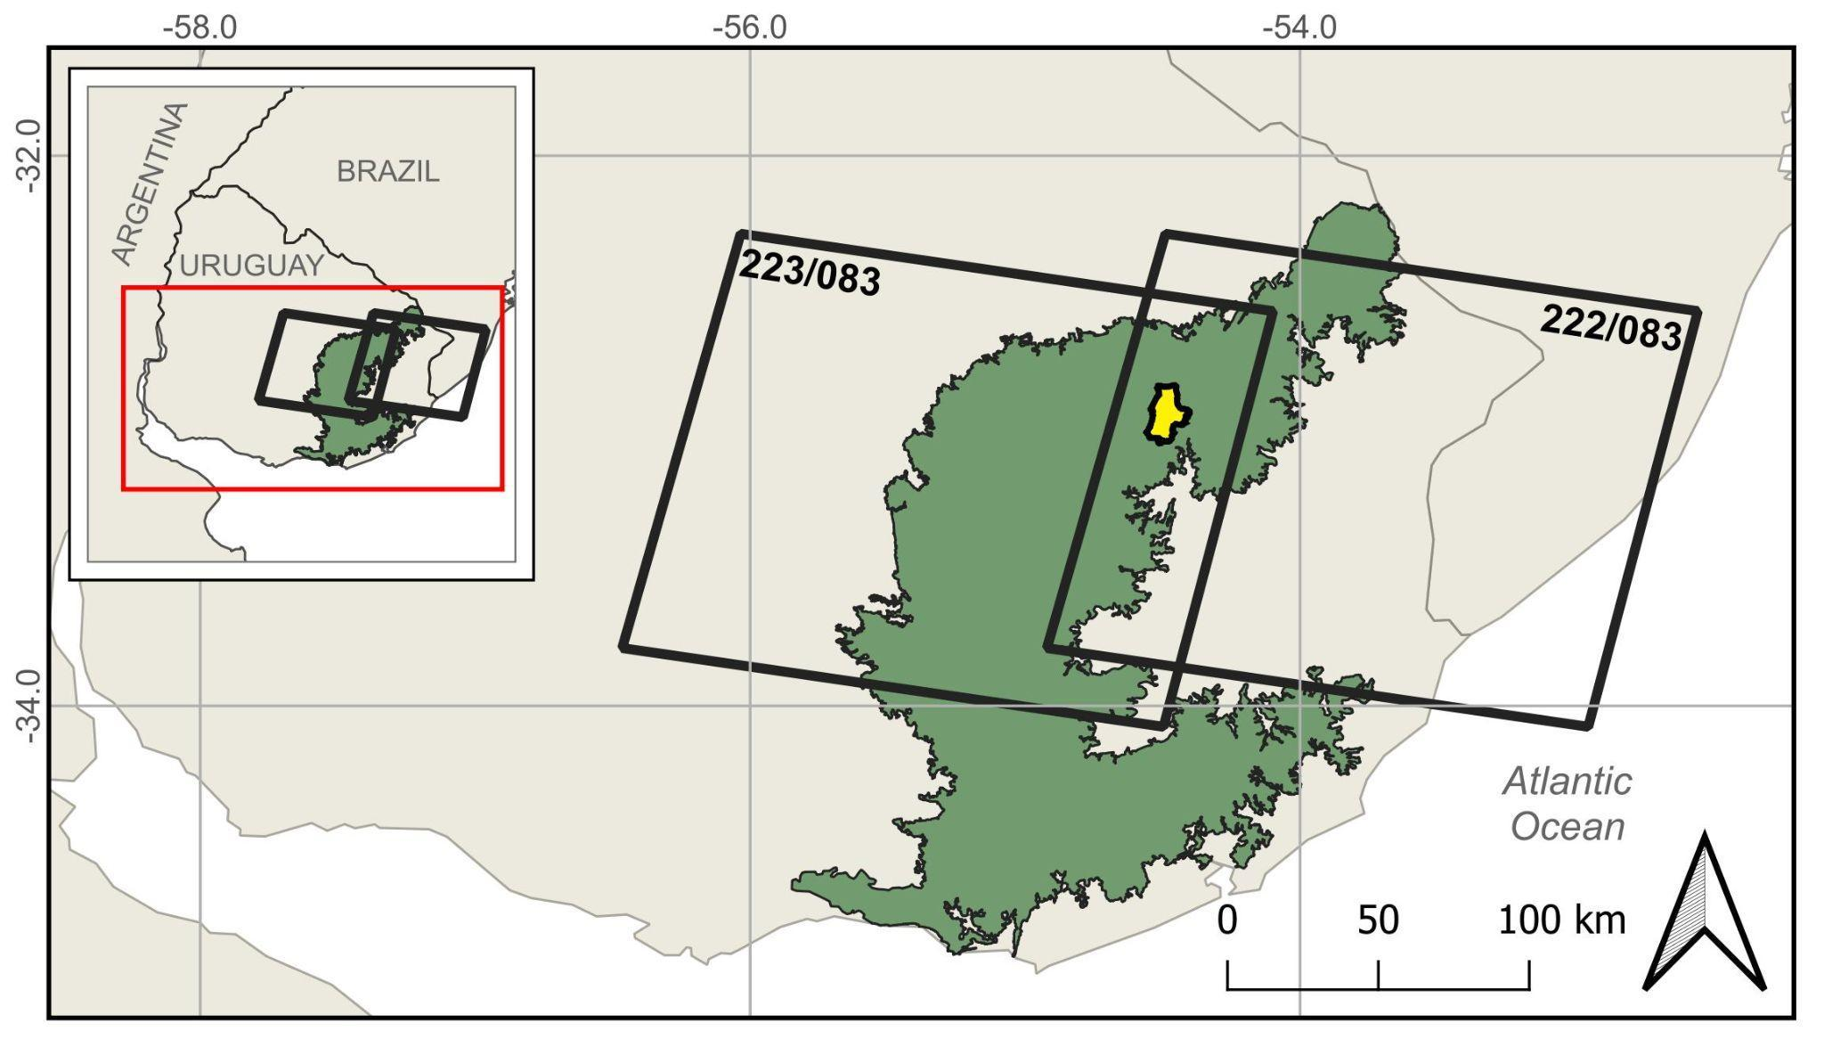
Figure S1: Location of the study area in Uruguay, including the Eastern Hills region and the Landsat scenes (path/row: 223/83 and 222/83) considered for the functional analysis.

Supplementary material 2
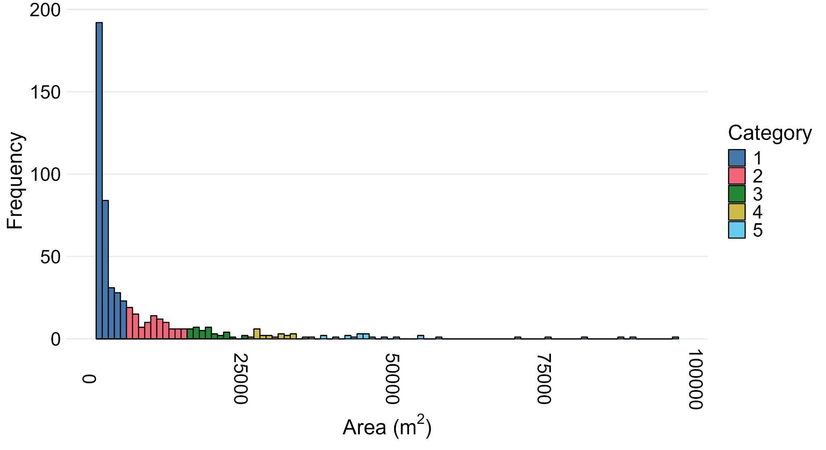
Figure S2: Histogram of burned patch frequency as a function of patch area (m²). Patches are classified into five categories: Category 1 (0–5,000 m²), Category 2 (5,001–15,000 m²), Category 3 (15,001–25,000 m²), Category 4 (25,001–35,000 m²), and Category 5 (≥35,001 m²).

Supplementary material 3
Table S1. Number of burned sites by size category and fire event used in the functional analysis. Category 1 (0–5,000 m²), Category 2 (5,001–15,000 m²), Category 3 (15,001–25,000 m²), Category 4 (25,001–35,000 m²), and Category 5 (≥35,001 m²).
 |  | Categories
 |  | 1 | 2 | 3 | 4 | 5 | Total
Fire event | Aug-09 | 4 | 16 | 0 | 2 | 0 | 22
Fire event | Aug-13 | 0 | 1 | 2 | 1 | 2 | 6
Fire event | Oct-13 | 1 | 2 | 6 | 4 | 3 | 16
Fire event | Nov-16 | 0 | 7 | 2 | 1 | 1 | 11
 | Aug-19 | 2 | 11 | 7 | 4 | 5 | 29
 | Total | 7 | 37 | 17 | 12 | 11 | 84

Supplementary material 4
Table S2. Mean impact of fire on ecosystem functioning, expressed as the relative difference in NDVI between burned and unburned sites, and the corresponding recovery time (days) following each fire event.
Fire event | Impact | Recovery time (days)
Aug-09 | 0.899 | 72
Aug-13 | 0.799 | 80
Oct-13 | 0.766 | 103
Nov-16 | 0.812 | 64
Aug-19 | 0.814 | 72

Supplementary material 5
Table S3. Cumulative precipitation (mm; INIA-GRAS, 2025) during the semesters preceding and following each fire event.
Fire event | Cumulative precipitation (mm) during the semester prior to burning | Cumulative precipitation (mm) during the semester following the burning
Aug-09 | 598 | 1148
Aug-13 | 624 | 899
Oct-13 | 793 | 800
Nov-16 | 513 | 556
Aug-19 | 622 | 723

Supplementary material 6
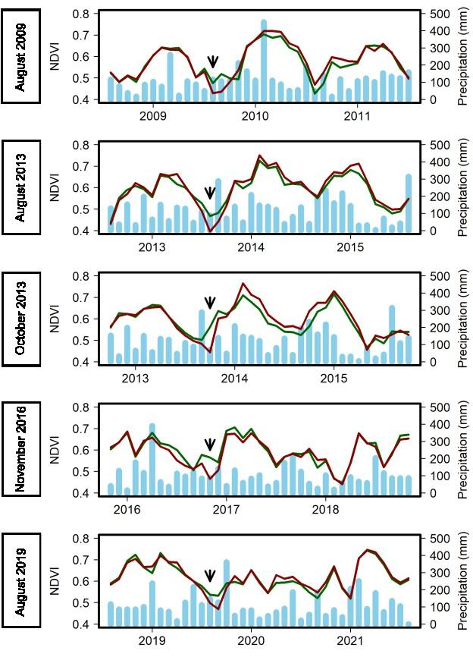
Figure S3. Temporal dynamics of NDVI in burned (red) and unburned (green) sites, together with monthly accumulated precipitation (INIA-GRAS, 2025). Bars indicate monthly accumulated precipitation. The vertical dashed line marks the timing of the fire event.

