Supplementary Material
A novel hexasegmented virus isolated from the phytopathogenic fungus Verticillium nonalfalfae

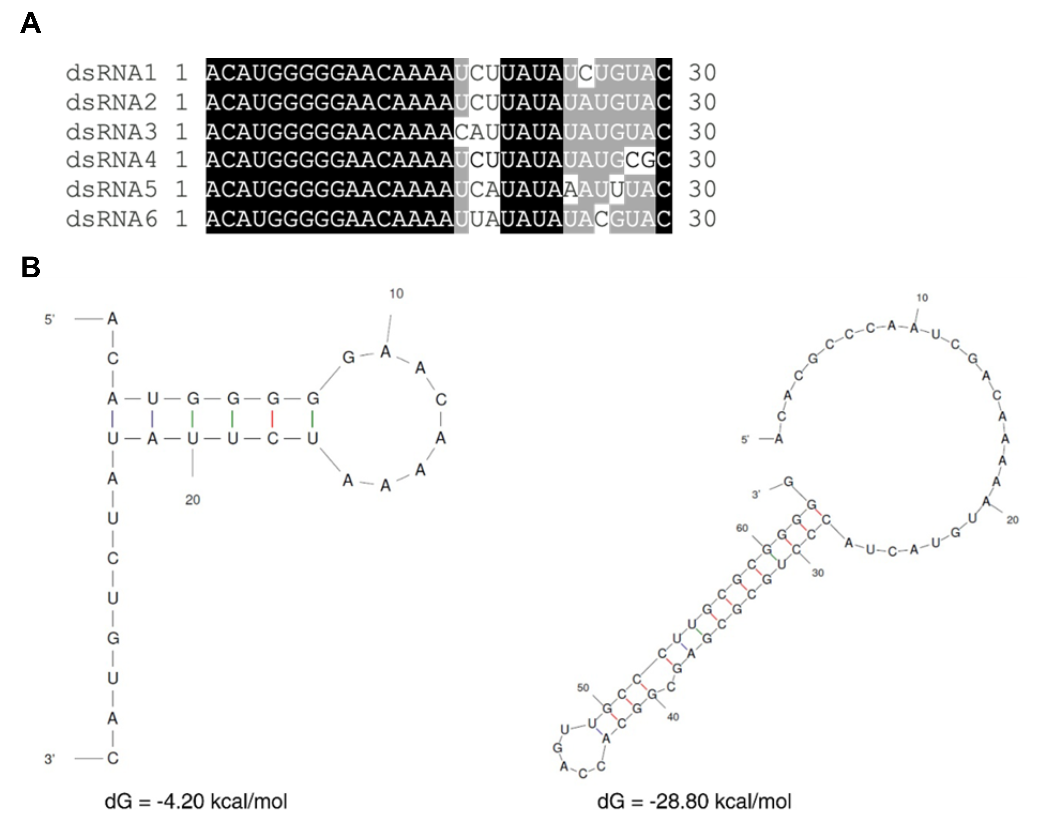
Supplementary Figure 1: (A) Alignment of the initial 30 nt of the Verticillium nonalfalfae virus M six genomic segments shows high conservation of the viral 5’terminal sequences. Black-shaded nucleotides are universally conserved across all dsRNA molecules, while gray-shaded residues are conserved in five of six genomic sequences. (B) The predicted secondary structures with the lowest energy are shown for the 5′ (left) and 3′ (right) termini of RNA1.

Primer Name | Sequence (5′ → 3′)
5′_dsRNA1 | GATTACGCCAAGCTTCGGTCGATGATGGAATTGGTGAGCCCCT
3′_dsRNA1 | GATTACGCCAAGCTTTGACAACCAGCTCTTTTCCGCCCGC
5′_dsRNA2 | GATTACGCCAAGCTTCGGTGGACACAGATGGGGCTAATAGGGC
3′_dsRNA2 | GATTACGCCAAGCTTGCGAGCGTTGCCAGACTTTCTCCCG
5′_dsRNA3 | GATTACGCCAAGCTTTCGGAGTAAAGGGCGTCGATGGTGCAAA
3′_dsRNA3 | GATTACGCCAAGCTTCTCGACCGCCTTCTCTCCTGTGCCA
5′_dsRNA4 | GATTACGCCAAGCTTAGTCACACTGAAACTGTCGTAGCCGCGC
3′_dsRNA4 | GATTACGCCAAGCTTCTGGGGCAGGGCTGTATGTCATCGC
5′_dsRNA5 | GATTACGCCAAGCTTGATCGGACAGCAGACCAAGATCGCGAGC
3′_dsRNA5 | GATTACGCCAAGCTTAGGCGCAACAACAGCTTCTTCCCGG
5′_dsRNA6 | GATTACGCCAAGCTTGTGGGGTTGCGGTTGATCTCCTCCTTGA
3′_dsRNA6 | GATTACGCCAAGCTTAGGAGATCAACCGCAACCCCACCCT
Supplementary Table 1: List of primers used for 5’- and 3’- RACE. Each has 15 bp overlaps (GATTACGCCAAGCTT) with the vector at their 5’ ends to facilitate In-Fusion cloning according to the manufacturer’s instructions.

