Appendix

Appendix A – GAEN Architecture
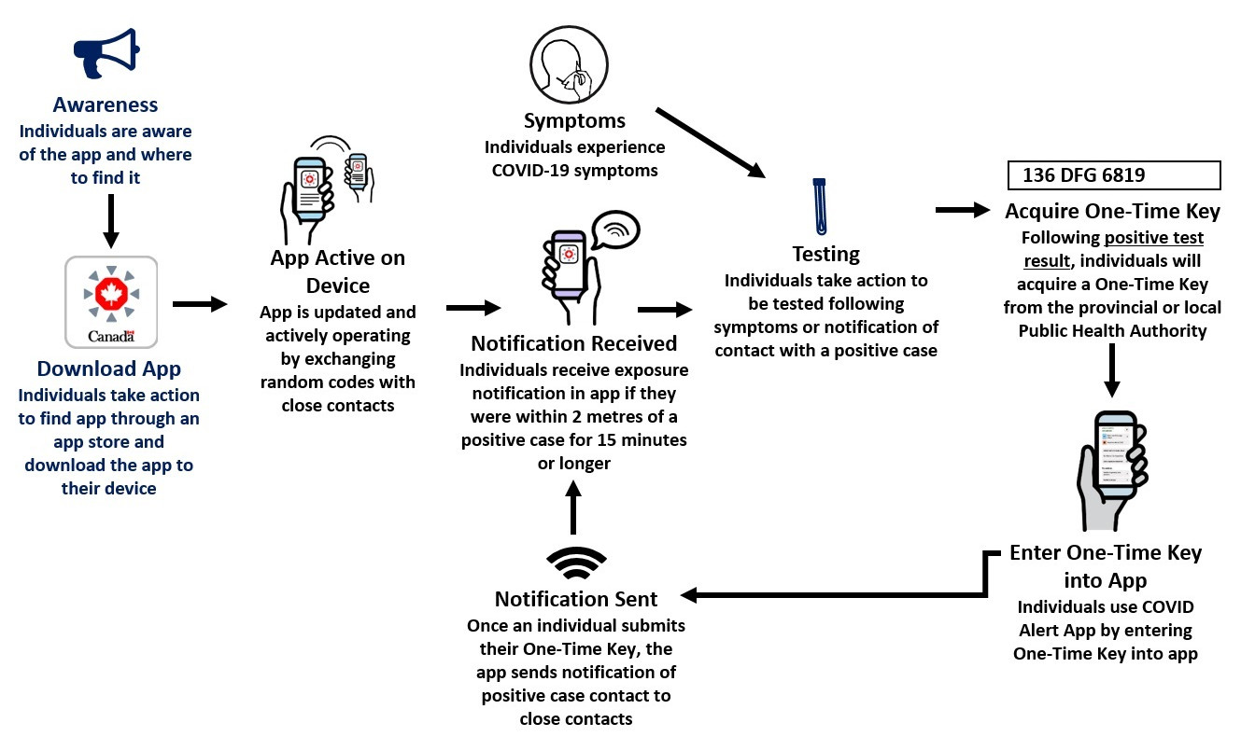

Appendix B – Search Strategy
The following strategy outlines the search terms used for each database, as well as the number of identified publications associated with the search term, as identified in our search on May 9, 2024.

PubMed Search Terms
(smartphone based contact trac* [tiab] OR Digital contact trac*[tiab] OR contact tracing apps [tiab] OR contact tracing application [tiab] OR "digital trac*" [tiab] OR automated contact trac* [tiab] OR digital and manual contact trac* [tiab]) OR ("exposure noti*" OR "exposure notifications "[tiab] OR GAEN OR "Google Apple Exposure Notifi*"[tiab] OR "Google Apple EN"[tiab] OR GAEN-based [tiab]OR "digital EN appli*"[tiab]) OR (bluetooth based contact trac* OR proximity awareness application OR Digital proximity trac* OR Bluetooth-enabled contact trac*) AND (COVID-19 OR "COVID-19"[Mesh] OR SARS-CoV-2 OR "SARS-CoV-2"[Mesh] OR coronavirus OR "Coronavirus"[Mesh] OR Coronaviridae OR "Coronaviridae"[Mesh] OR "Coronaviridae Infections"[Mesh] OR “coronaviridae infections” OR "Coronavirus Infections"[Mesh] OR “coronavirus infections” OR "coronavirus infections"[MeSH] OR "coronavirus disease 2019" OR "severe acute respiratory syndrome coronavirus 2" OR "2019-NCoV" OR "2019 novel coronavirus")
References = 488

Web of Science Search Terms
(smartphone based contact trac* [tiab] OR Digital contact trac*[tiab] OR contact tracing apps [tiab] OR contact tracing application [tiab] OR "digital trac*" [tiab] OR automated contact trac* [tiab] OR digital and manual contact trac* [tiab]) OR ("exposure noti*" OR "exposure notifications "[tiab] OR GAEN OR "Google Apple Exposure Notifi*"[tiab] OR "Google Apple EN"[tiab] OR GAEN-based [tiab]OR "digital EN appli*"[tiab]) OR (bluetooth based contact trac* OR proximity awareness application OR Digital proximity trac* OR Bluetooth-enabled contact trac*) AND (COVID-19 OR "COVID-19"[Mesh] OR SARS-CoV-2 OR "SARS-CoV-2"[Mesh] OR coronavirus OR "Coronavirus"[Mesh] OR Coronaviridae OR "Coronaviridae"[Mesh] OR "Coronaviridae Infections"[Mesh] OR “coronaviridae infections” OR "Coronavirus Infections"[Mesh] OR “coronavirus infections” OR "coronavirus infections"[MeSH] OR "coronavirus disease 2019" OR "severe acute respiratory syndrome coronavirus 2" OR "2019-NCoV" OR "2019 novel coronavirus")
References = 169

Embase Search Terms
('smartphone-based contact trac*':ti,ab OR 'digital contact trac*':ti,ab OR 'contract tracing app':ti,ab OR 'contact tracing application':ti,ab OR 'digital trac*':ti,ab OR 'automated contact trac*':ti,ab OR 'digital and manual contact trac*':ti,ab) OR (exposure noti*' OR 'exposure notifications':ti,ab OR 'GAEN' OR 'Google Apple Exposure Notifi*':ti,ab OR 'Google Apple EN':ti,ab OR 'GAEN-based':ti,ab OR 'digital EN appli*':ti,ab) OR ('bluetooth based contact trac*' OR 'proximity awareness application':ti,ab OR 'digital proximity trac*':ti,ab OR 'bluetooth-enabled contact trac*':ti,ab) AND ('covid 19'/exp OR 'covid 19' OR 'sars co v 2' OR 'coronavirus'/exp OR coronavirus OR 'coronaviridae'/exp OR coronaviridae OR 'coronaviridae infections'/exp OR 'coronaviridae infections' OR 'coronavirus infections'/exp OR 'coronavirus infections')
References = 264

ProQuest – PAIS Index
TIAB(smartphone based contact trac* OR Digital contact trac* OR contact tracing apps OR contact tracing application OR "digital trac*" OR automated contact trac* OR digital AND manual contact trac*) OR ("exposure noti*" OR "exposure notifications"OR GAEN OR "Google Apple Exposure Notifi*" OR "Google Apple EN" OR GAEN-based OR "digital EN appli*") OR (bluetooth based contact trac* OR "proximity awareness application" OR "Digital proximity trac*" OR Bluetooth-enabled contact trac*) AND (COVID-19 OR "COVID-19" OR SARS-CoV-2 OR "SARS-CoV-2" OR coronavirus OR "Coronavirus" OR Coronaviridae OR "Coronaviridae" OR "Coronaviridae Infections" OR “coronaviridae infections” OR "Coronavirus Infections"OR “coronavirus infections” OR "coronavirus infections" OR "coronavirus disease 2019" OR "severe acute respiratory syndrome coronavirus 2" OR "2019-NCoV" OR "2019 novel coronavirus")
References = 135

Appendix C – Data Extraction Template
Domain | Variable | Description
Study Identification | Study ID | Unique identifier assigned to each included study
 | Title | Full title of the study
 | DOI | Digital Object Identifier
 | Publication | Journal or source of publication
 | Date of publication | Publication date
Study Context | Country | Country where the study was conducted
 | US State(s) | U.S. state(s), if applicable
 | Date of study | Time period during which the study was conducted
Exposure Notification (EN) System Characteristics | GAEN system | Whether customized, ENX, or mixed systems
 | App name(s) | Name(s) of EN application(s) evaluated
 | Notes on EN system | Additional details about system functionality or implementation
 | App launch date | Date the EN app was launched
 | App deactivation date | Date the EN app was discontinued
 | Was the app still deployed during the study period? | Whether the app remained active during the study timeframe
 | Total adoption | Reported uptake or adoption level of the EN app
Study Characteristics | Aim of study | Stated objective(s) of the study
 | Study design | Study design (e.g., modeling, observational)
 | Type of study | Classification of study type
 | Notes on methods | Additional methodological details
 | Data source | Source(s) of data used in the study
Model Characteristics | Model used | Type of model (e.g., SEIR, agent-based)
 | Adoption level used for model | Assumed adoption level in modeling scenarios
 | Population size for model | Population size used in the model
Outcomes | Outcome | Primary outcome(s) reported
 | Comparator | Comparator used (if applicable)
 | Full epidemiological impact | Reported epidemiological impact (e.g., cases averted, transmission reduction)
 | Additional notes/outcomes | Additional findings or notes
Bias and Funding Considerations | Declared conflict of interest | Whether conflicts of interest were reported
 | Industry or independent study | Funding source or affiliation

