Computational analysis by molecular docking of 30 alkaloid compounds from medicinal plants as potent inhibitors of SARS-CoV-2 main protease

Tunga Kuhana A.ª, Jason T. Kilembeª, Aristote Matondoª, Khamis M. Yussuf^{b}, Lauraine Nininahazwe^{b} , Fils K. Nkatuª, Milka N. Tshingambª, Emmanuel K. Vanguª, Junior T. Kindalaª. Shetonde O. Mihigoª, Sungula J. Kayembeª, Yves S. Kafutiª, Agboyibor Clement^{b}, Kalulu M. Tabaª

ª Department of Chemistry, Faculty of Sciences, University of Kinshasa, P.O Box 190, Kinshasa XI, Democratic Republic of Congo

^{b} School of Pharmaceutical Science, Zhengzhou University, 100 Kexue Avenue, Zhengzhou, Henan 450001, China

*Corresponding author:
Tunga Kuhana A.
E-mail address: arsene_tunga@yahoo.fr; Tel: +8618595742489;

SUPPLEMENTARY MATERIAL

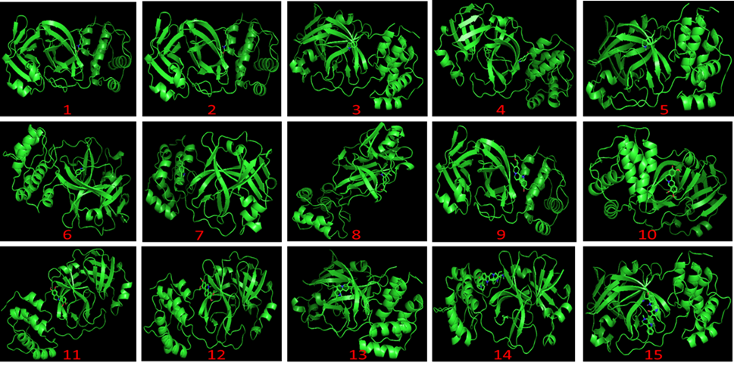
Figure S1. Docked indole alkaloids Ligands in the binding pocket of the protein (complexes)
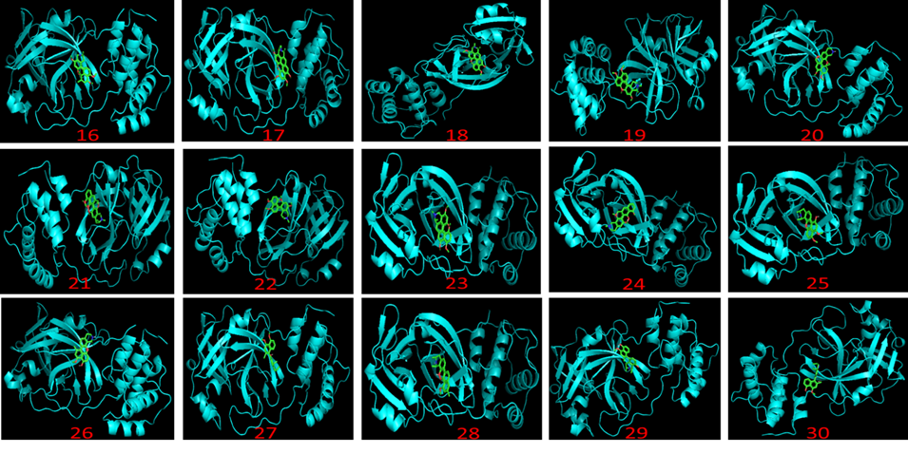
Figure S2. Docked naphthoisoquinolines ligands in the binding pocket of the protein (complexes)

