Table 2 Docking results of alkaloid compounds: binding affinity (kcal/mol), ligands-COVID-19 Mpro interactions and the drug-likeness properties
Ligands | Binding Affinity | Interaction map between ligands and SARS-CoV-2 main protease | Drug-likeness properties (Lipinski’s rule of five)
Ref-Ligand | -8.80 | 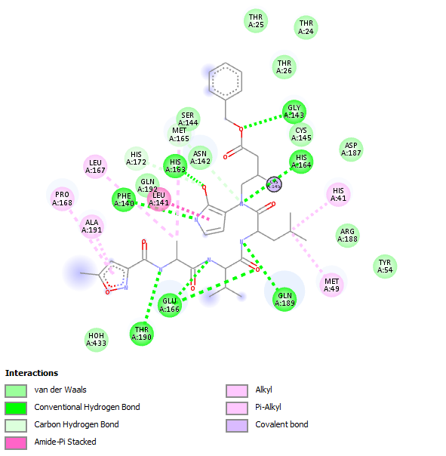 | MW (< 500 Da): 779.92  Log P (< 5): 4.51  HBD (< 5): 6  HBA (< 10): 10  MlogP (< 4.15): 0.12  Violations: 3
Tadalafil | -8.80 | 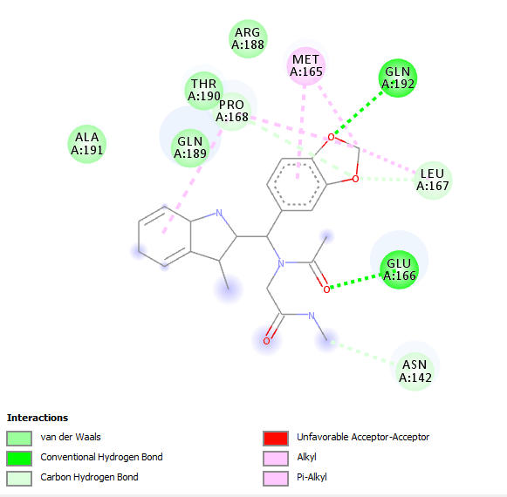 | MW (< 500 Da): 391.42  Log P (< 5): 2.83  HBD (< 5): 1  HBA (< 10): 4  MlogP (< 4.15): 1.60  Violations: 0
Lopinavir | -8.19 | 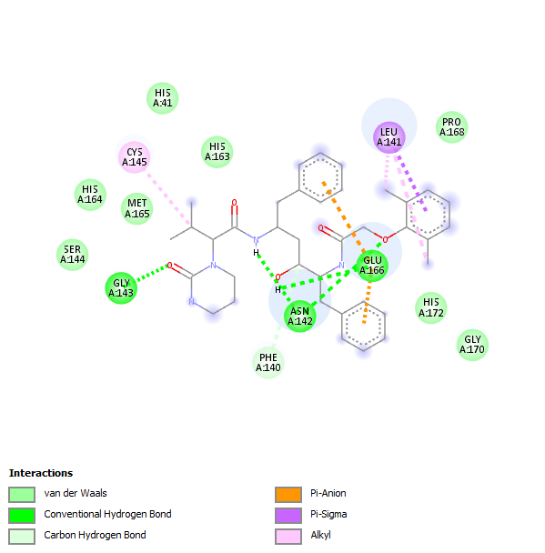 | MW (< 500 Da): 628.80  Log P (< 5): 3.44  HBD (< 5): 4  HBA (< 10): 4  MlogP (< 4.15): 2.93  Violations: 1
1 | -6.61 | 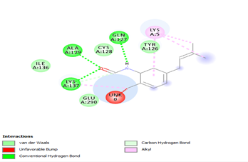 | MW (< 500 Da): 201.26  Log P (< 5): 2.44  HBD (< 5): 1  HBA (< 10): 1  MlogP (< 4.15): 2.51  Violations: 0
2 | -7.49 | 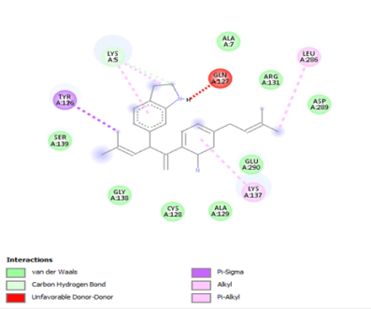 | MW (< 500 Da): 368.51  Log P (< 5): 3.90  HBD (< 5): 0  HBA (< 10): 2  MlogP (< 4.15): 4.83  Violations: 1
3 | -5.52 | 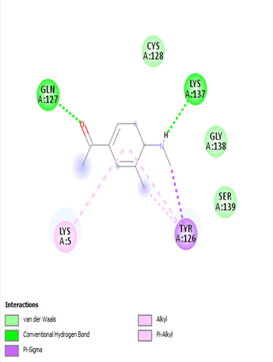 | MW (< 500 Da): 159.18  Log P (< 5): 1.51  HBD (< 5): 1  HBA (< 10): 1  MlogP (< 4.15): − 1.18  Violations: 0
4 | -5.59 | 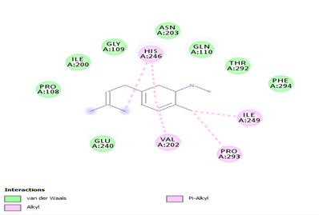 | MW (< 500 Da): 185.26  Log P (< 5): 2.46  HBD (< 5): 0  HBA (< 10): 1  MlogP (< 4.15): − 2.95  Violations: 0
5 | -5.87 | 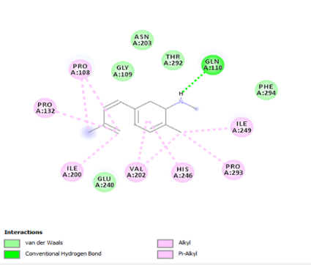 | MW (< 500 Da):183.25  Log P (< 5): 2.42  HBD (< 5): 0  HBA (< 10): 1  MlogP (< 4.15): 2.87  Violations: 0
6 | -5.71 | 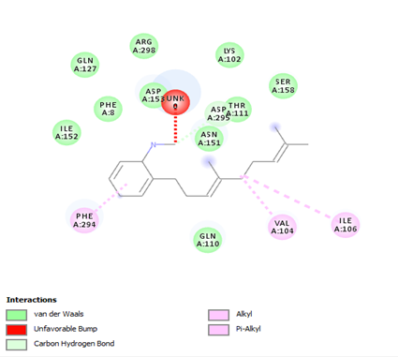 | MW (< 500 Da): 253.38  Log P (< 5): 3.45  HBD (< 5): 0  HBA (< 10): 1  MlogP (< 4.15): 4.12  Violations: 0
7 | -6.53 | 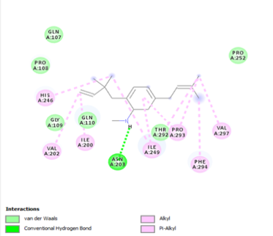 | MW (< 500 Da): 253.38  Log P (< 5): 3.32  HBD (< 5): 0  HBA (< 10): 1  MlogP (< 4.15): 4.12  Violations: 0
8 | -7.88 | 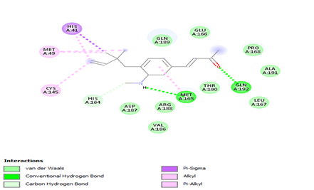 | MW (< 500 Da): 253.34  Log P (< 5): 2.68  HBD (< 5): 1  HBA (< 10): 1  MlogP (< 4.15): 2.88  Violations: 0
9 | -7.73 | 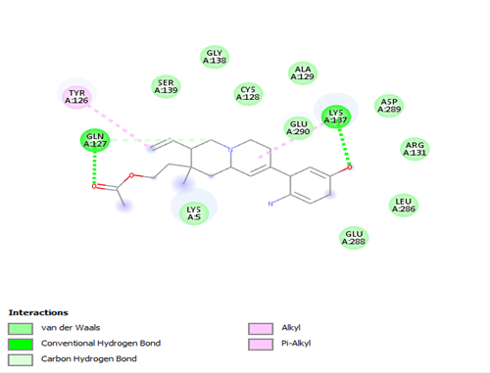 | MW (< 500 Da): 368.47  Log P (< 5): 3.15  HBD (< 5): 2  HAD (< 10): 4  MlogP (< 4.15): 2.62  Violations: 0
10 | -9.33 | 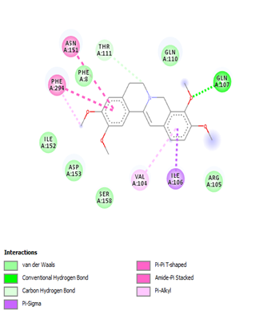 | MW (< 500 Da): 352.40  Log P (< 5): 0.00  HBD (< 5): 0  HBA (< 10): 4  MlogP (< 4.15): 2.01  Violations: 0
11 | -9.05 | 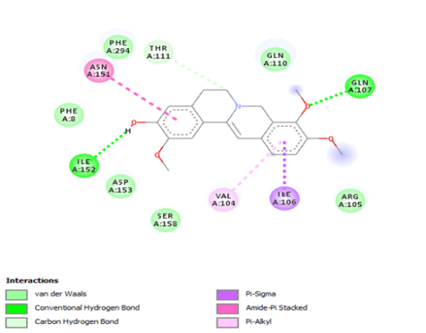 | MW (< 500 Da): 338.38  Log P (< 5): 0.0  HBD (< 5): 1  HBA (< 10): 4  MlogP (< 4.15): 1.78  Violations: 0
12 | -8.17 | 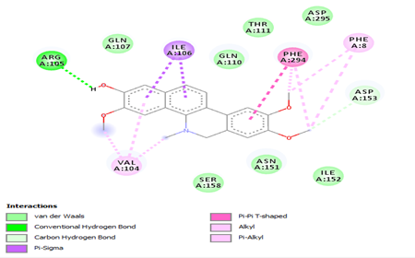 | MW (< 500 Da): 350.39  Log P (< 5): 3.32  HBD (< 5): 1  HBA (< 10): 4  MlogP (< 4.15): 2.13  Violations: 0
13 | -6.33 | 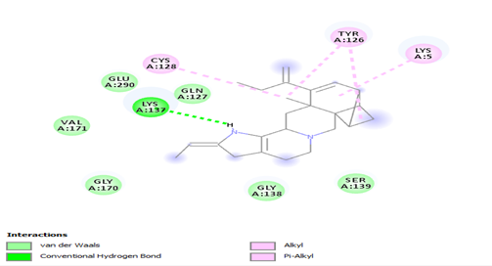 | MW (< 500 Da): 371.54  Log P (< 5): 0.00  HBD (< 5): 1  HBA (< 10): 0  MlogP (< 4.15): 5.01  Violations: 1
14 | -9.73 | 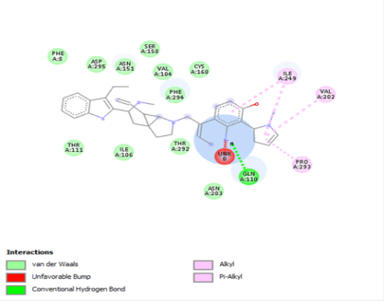 | MW (< 500 Da): 549.75  Log P (< 5): 4.62  HBD (< 5): 3  HBA (< 10): 4  MlogP (< 4.15): 3.51  Violations: 1
15 | -7.77 | 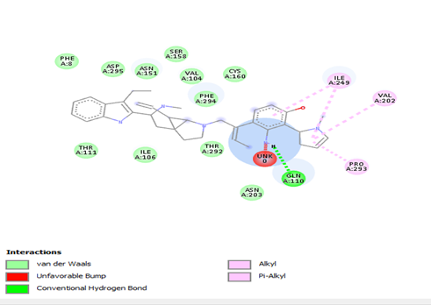 | MW (< 500 Da): 560  Log P (< 5): 0.00  HBD (< 5): 4  HBA (< 10): 4  MlogP (< 4.15): 2.77  Violations: 1
16 | -7.56 | 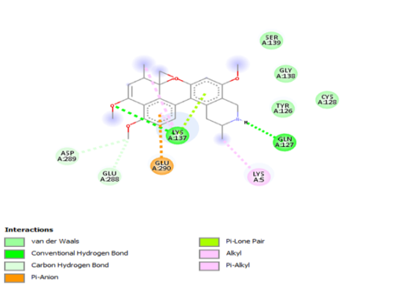 | MW (< 500 Da): 407.50  Log P (< 5): 4.26  HBD (< 5): 1  HBA(< 10): 5  MlogP (< 4.15): 2.86  Violations: 0
17 | -7.51 | 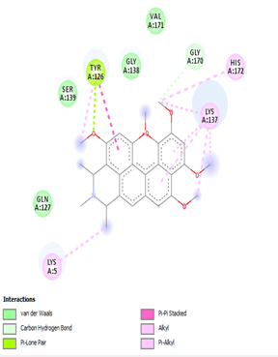 | MW (< 500 Da): 465.58  Log P (< 5): 4.71  HBD (< 5): 0  HBA (< 10): 6  MlogP (< 4.15): 2.92  Violations: 0
18 | -12.26 | 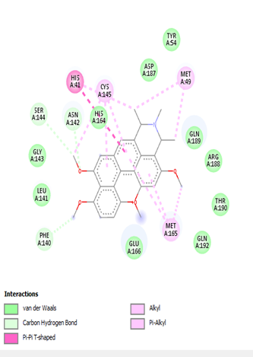 | MW (< 500 Da): 435.56  Log P (< 5): 4.58  HBD (< 5): 0  HBA (< 10): 5  MlogP (< 4.15): 3.26  Violations: 0
19 | -7.50 | 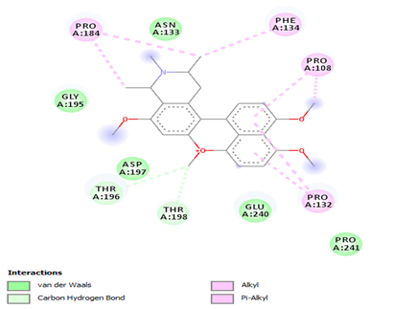 | MW (< 500 Da): 421.53  Log P (< 5): 4.42  HBD (< 5): 0  HBA (< 10): 5  MlogP (< 4.15): 3.06  Violations: 0
20 | -7.60 | 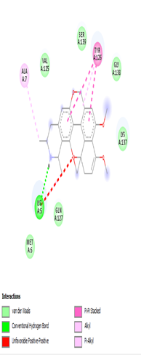 | MW (< 500 Da): 407.50  Log P (< 5): 4.15  HBD (< 5): 2  HBA (< 10): 5  MlogP (< 4.15): 2.86  Violations: 0
21 | -9.97 | 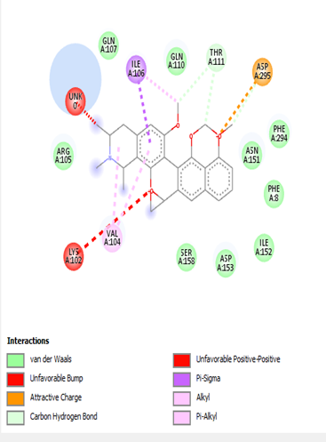 | MW(< 500 Da): 435.56  Log P (< 5): 4.35  HBD (< 5): 0  HBA (< 10): 5  MlogP (< 4.15): 3.26  Violations: 0
22 | -9.60 | 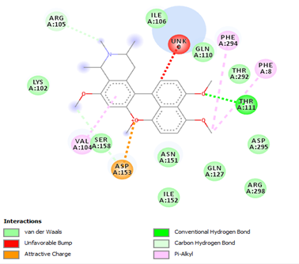 | MW (< 500 Da): 419.51  Log P (< 5): 4.14  HBD (< 5): 0  HBA (< 10): 5  MlogP (< 4.15): 2.99  Violations: 0
23 | -10.99 | 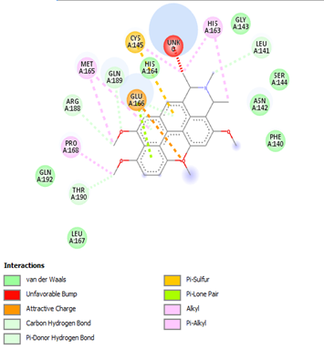 | MW (< 500 Da): 435.56  Log P (< 5): 4.58  HBD (<5): 0  HBA (< 10): 5  MlogP (< 4.15): 3.26  Violations: 0
24 | -11.28 | 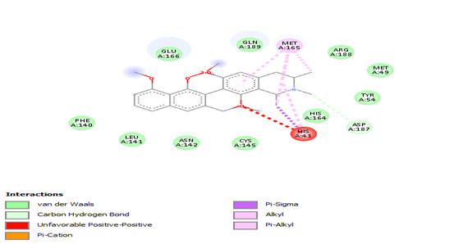 | MW (< 500 Da): 421.53  Log P (< 5): 4.31  HBD (< 5): 1  HBA (< 10): 5  MlogP (< 4.15): 3.06  Violations: 0
25 | -9.99 | 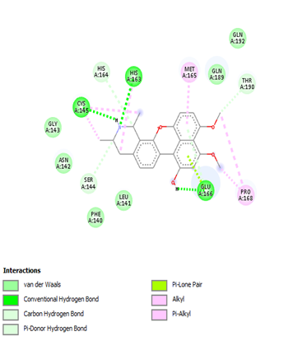 | MW(< 500 Da): 379.45  Log P (< 5): 3.78  HBD (< 5): 3  HBA (< 10): 5  MlogP (< 4.15): 2.44  Violations: 0
26 | -8.27 | 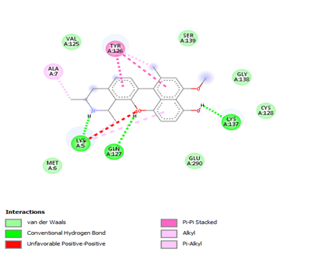 | MW (< 500 Da): 363.45  Log P (< 5): 3.76  HBD (< 5): 3  HBA (< 10): 4  MlogP (< 4.15): 3.00  Violations: 0
27 | -7.49 | 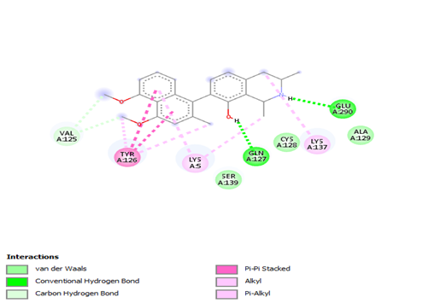 | MW (< 500 Da): 377.48  Log P (< 5): 3.98  HBD (< 5): 2  HBA (< 10): 4  MlogP (< 4.15): 3.21  Violations: 0
28 | -10.70 | 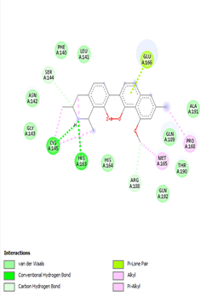 | MW (< 500 Da): 363.45  Log P (< 5): 3.72  HBD (< 5): 3  HBA (< 10): 4  MlogP (< 4.15): 3.00  Violations: 0
29 | -7.11 | 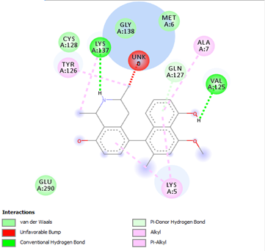 | MW (< 500 Da): 363.42  Log P (< 5): 3.33  HBD (< 5): 3  HBA (< 10): 4  MlogP (< 4.15): 3.00  Violations: 0
30 | -7.81 | 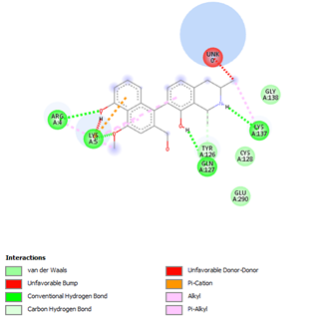 | MW (< 500 Da): 363.45  Log P (< 5): 3.33  HBD (< 5): 3  HB A(< 10): 4  MlogP (< 4.15): 3.00  Violations: 0
MW: Molecular weight (Da), Log P: Octanol-water partition coefficient, HBD: Hydrogen bond donors, HBA: Hydrogen bond acceptors

