AWARENESS AND UTILIZATION OF GENERIC MEDICINES AT JAN AUSHADHI KENDRA
AMONG BENEFICIARIES VISTING SUB DISTRICT HOSPITAL OF CHAMOLI, UTTARAKHAND

Dissertation submitted to the faculty of the National Institute of Health and Family Welfare in partial fulfilment of the requirement for award of
POST GRADUATE DIPLOMA
IN
PUBLIC HEALTH MANAGEMENT
(Session: 2024 –2025)
By
Dr. Harish C Thapliyal
PGDPHM (2024-2025)
NIHFW, New Delhi-110067

Under the Guidance of
Dr. Sarita Gautam
Assistant Professor
Dept. of Social Sciences
NIHFW New Delhi- 110067



NATIONAL INSTITUTE OF HEALTH AND FAMILY WELFARE
MUNIRKA, NEW DELHI – 110067

DECLARATION
I, Dr. Harish C Thapliyal, student of the Post Graduate Diploma in Public Health Management course for the year 2024-2025 at the National Institute of Health and Family Welfare (NIHFW), Baba Gang Nath Marg, Munirka, New Delhi, declare that this project entitled “Awareness and Utilization of Generic medicines at Jan Aushadhi Kendra among beneficiaries visiting Sub District Hospital of Chamoli Uttarakhand” is a bonafide work, was carried out by me under guidance of Dr. Sarita Gautam, Assistant Professor, Department of Social Sciences, The National institute of Health and Family Welfare, New Delhi.


(Signature of Student)
Dr. Harish C Thapliyal
PGDPHM student (2024-2025)
NIHFW, New Delhi-110067

THE NATIONAL INSTITUTE OF HEALTH AND FAMILY WELFARE
MUNIRKA, NEW DELHI – 110067

CERTIFICATE
This is to certify that the dissertation titled, “Awareness and Utilization of Generic medicines at Jan Aushadhi Kendra among beneficiaries visiting Sub District Hospital of Chamoli Uttarakhand” was undertaken by Dr. Harish C Thapliyal, a student of the post graduate diploma in public health management course for the year 2024-2025 at National Institute of Health and Family Welfare, New Delhi under the guidance, supervision of Dr. Sarita Gautam, in pursuance of partial fulfilment for the requirement of award for Degree of Post Graduate Diploma in Public Health Management.
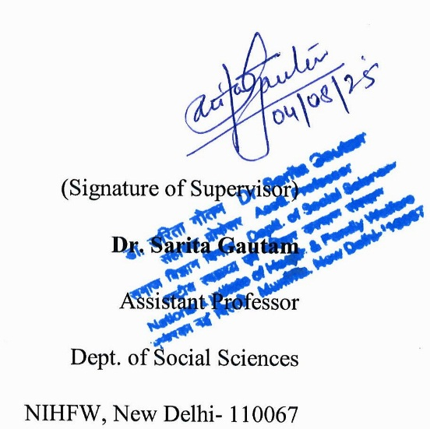

ACKNOWLEDGEMENT
At the very beginning, I express my heartfelt gratitude to the Almighty for granting me the strength, patience, and wisdom that sustained me throughout the course of this thesis. This work would not have been possible without divine support.
I extend my deepest appreciation to my advisor, Dr. Sarita Gautam, Assistant Professor in the Department of Social Sciences, NIHFW New Delhi, for her invaluable guidance, expertise, and unwavering encouragement throughout every stage of my research.
My heartfelt thanks go to my family for their unfailing love and support, especially my parents, whose blessings, constant encouragement, and unwavering belief in me have been a guiding force throughout my academic journey. I am equally grateful to my wife Dr Pooja Kukreti and son Arjun Thapliyal whose understanding and sacrifices inspired me to strive harder even during the most demanding moments. Their faith and patience provided the emotional foundation for this work.
I am especially grateful to my course coordinator, Dr. S. Ramachandra Rao, Reader and former head Department of Reproductive Bio-medicine, NIHFW for his constant support and exceptional guidance throughout the course. His constant encouragement has been instrumental in helping me overcome challenges and remain focused on my goals.
I also extend special thanks to Prof. U. Dutta Consultant, DLC NIHFW New Delhi, for his inputs, which enriched the quality and rigor of this thesis. My sincere gratitude is also extended to Dr. B. P. Purohit, Dr. Ankit Bhatt, Dr. Vishal Panwar, Rakesh Thapliyal, and Vinay Bahuguna for their unwavering support, thoughtful advice, and warm camaraderie throughout my professional journey.
Additionally, my heartfelt thanks to Dr. Surbhi Singh for her constant support, encouragement, and readiness to assist wherever needed throughout the entire course since nomination.
I wish to express my sincere appreciation to the Director, Dean, and all the faculty members, Researcher Office and Assistant Research Office of NIHFW New Delhi for their support, which greatly facilitated my research process.
Finally, I extend my heartfelt gratitude to all those whose contributions may not be individually mentioned here but whose support and encouragement have, in various ways, enriched this journey.
Thank you all for being an integral part of this endeavour.

Dr Harish C Thapliyal

ABBREVIATIONS
ANM : Auxiliary Nurse Midwife
ASHA : Accredited Social Health Activist
CDSCO : Central Drugs Standard Control Organization
FDA : Food and Drug Administration
GM : Generic Medicine
GMP : Good Manufacturing Practices
HCW : Healthcare Worker
IEC : Information, Education, and Communication
IPD : In-Patient Department
IT : Information and Technology
JAK : Jan Aushadhi Kendra
JAS : Jan Aushdhi Scheme
LMICs : Low- and Middle-Income Countries
MS : Microsoft
NABL : National Accreditation Board for Testing and Calibration Laboratories
NCD : Non-Communicable Disease
NHA : National Health Account
NHSRC : National Health System Resource Centre
NLEM : National List of Essential Medicines
OOPE : out-of-pocket expenditures
PBS : Pharmaceutical Benefits Scheme (Australia)
PGDPHM : Post Graduate Diploma in Public Health Management
PMBI : Pharmaceuticals & Medical Devices Bureau of India
PMBJP : Pradhan Mantri Bhartiya Janaushadhi Pariyojana
SDH : Sub District Hospital
SPSS : Statistical Package for the Social Sciences
WHO : World Health Organization

TABLE OF CONTENTS
DECLARATION i
CERTIFICATE ii
ACKNOWLEDGEMENT iii
ABBREVIATIONS v
TABLE OF CONTENTS vi
LIST OF TABLES vii
LIST OF FIGURES viii
EXECUTIVE SUMMARY ix

INTRODUCTION 1-6
RATIONALE OF THE STUDY 7-8
REVIEW OF LITERATURE 9-13
OBJECTIVES 14-15
METHODOLOGY 16-20
RESULTS 21-37
DISCUSSION 38-42
CONCLUSION 43-45
LIMITATIONS 46-47
RECOMENDATIONS 48-49
REFERENCES 50-56

ANNEXURES 57-65
Annexure I: Information Sheet for the Respondents 58
Annexure II: Patient Informed Consent form (PICF) (ENGLISH) 59
Annexure III: Questionnaire 60
Annexure IV: Data Collection Permission Letter 64
Annexure V: Ethical Committee Approval 65

LIST OF TABLES
Table 1: Different global Programs Supporting Generic Medicine 3
Table 2: Sociodemographic Profile of the beneficiaries Visiting Jan Aushdhi Kendra 22
Table 3: Relationship between respondents’ age and distance to travel for Jan Aushdhi Kendra 25
Table 4: Relationship between Gender and Awareness of generic medicine among the respondents 27
Table 5: Belief assessment for effectiveness, safety, cost and quality of generic medicines among respondents 30
Table 6: Generic medicine utilization by illness category among respondents 33
Table 7: Barrier to accessing Generic medicine and Jan Aushadhi Kendra among respondents 36

LIST OF FIGURES
Figure 1: Comparative analysis of awareness among beneficiaries for PMBJP (Pradhan Mantri Bhartiya Janaushadhi Pariyojana), generic medicine and Jan Aushadhi Kendra 26
Figure 2: Heatmap: Awareness of Jan Aushadhi Kendra by Education level among the respondents 28
Figure 3: Relationship between Distance travelled by beneficiaries for Jan Aushdhi Kendra and utilization of Generic Medicine by them 29
Figure 4: Trust in efficacy of generic medicines among respondents 31
Figure 5: Preference Patterns for Generic Medicine and Jan Aushadhu Kendra among respondents 32
Figure 6: Comparison of beneficiaries request for generic medicine and healthcare worker explanations about generic medicines among respondents 34
Figure 7: Source of Information about generic medicine and Jan Aushdhi Kendra among respondents 35
Figure 8: Suggestions by respondents for promoting generic medicine and Jan Aushadhi Kendra 37

EXECUTIVE SUMMARY
EXECUTIVE SUMMARY
Introduction
Healthcare affordability and access remain significant challenges in India, especially for vulnerable and low-income populations in remote, hilly regions such as Uttarakhand. Despite India's strong presence in global pharmaceutical manufacturing, the high cost of branded medicines and substantial out-of-pocket expenses compel many families to delay or forgo essential treatments. This issue is further intensified by the rising prevalence of non-communicable diseases, which increase the demand for long-term, affordable medication. To tackle these challenges, the Pradhan Mantri Bhartiya Janaushadhi Pariyojana (PMBJP) was introduced, evolving from the earlier Jan Aushadhi Scheme launched in 2008. The PMBJP aims to provide quality-assured, low-cost generic medicines through dedicated Jan Aushadhi Kendras (JAKs) nationwide. These generic medicines, rigorously tested for quality and bioequivalence, offer a crucial cost-saving alternative to branded drugs and are central to India's goal of achieving universal health coverage.
However, several barriers—including limited public awareness, socio-cultural skepticism, concerns over efficacy and safety, and logistical obstacles like stock-outs and difficulty accessing remote areas—continue to hamper optimal utilization. Addressing these challenges requires effective information dissemination, where healthcare professionals, particularly doctors and pharmacists, play a vital role in educating and influencing the public to accept generic medicines These challenges are particularly pronounced in difficult terrains such as the Himalayas, where healthcare delivery logistics are complex. This study focuses on assessing the awareness and utilization of generic medicines among individuals attending the Jan Aushadhi Kendra at the Sub District Hospital in Karanprayag, Chamoli district. The research seeks to provide evidence-based insights into the reach, perceived value, and barriers to the use of generics, thereby guiding public health policy and improving program implementation in underserved regions.
Objectives
The primary objective of this study was to assess the awareness and utilization of generic medicines at Jan Aushadhi Kendras among beneficiaries to Sub District Hospital Karanprayag, Chamoli, Uttarakhand. Additionally, the research examined key factors affecting accessibility to these outlets, information source and identified principal barriers and facilitators influencing generic medicine use within this population.
Methodology
This cross-sectional study at the Jan Aushadhi Kendra, Sub District Hospital Karanprayag, included 211 consenting beneficiaries aged 18 and above. Data on sociodemographic, awareness, beliefs, utilization, accessibility, barriers, and information sources about generic medicines were collected via a pretested semi- structured questionnaire. Sample size was based on prevalence estimates. Analysis was done using MS Excel, SPSS (v26), and Python. Ethical standards were upheld with informed consent and confidentiality maintained.
Results and Discussion
This study of 211 respondents at the Jan Aushadhi Kendra, Sub District Hospital Karanprayag, Chamoli, revealed a nearly equal gender split with most aged 21–50 years. A significant number belonged to lower and middle-income groups, with 36% living over 20 km from the centre, highlighting access challenges. Awareness and utilization of generic medicines and the Jan Aushadhi scheme were high, with over 85% familiar with generics and nearly 90% having procured medicines there. Most respondents viewed generics as effective (82.5%), safe (79.6%), and affordable (87.3%), though confidence in quality was somewhat lower (76.5%). Usage of generic medicines was reported for different conditions: 35.1% of respondents used them for chronic illnesses, 30.3% for acute illnesses, and another 30.3% for both acute and chronic conditions. Posters and IEC materials were the main information sources (76.3%), followed by pharmacists (49.8%) and community health workers (45%), while doctors were the least cited (26.5%), indicating a gap in healthcare provider advocacy. Key barriers included medicine unavailability (50.7%), distance (40.3%), and lack of awareness (38.4%).
Compared to other remote area study this setting shows markedly higher awareness and acceptance, which may be attributed to the longer duration of the scheme’s implementation and the effective use of prominently displayed IEC materials. However persistent reliance on passive channels and limited doctor involvement remains challenges. The findings align with national and international studies, emphasizing the need to enhance healthcare provider communication to further improve generic medicine uptake in resource-limited regions.
Conclusion
This study highlights the significant role of generic medicines in improving healthcare access in a semi-urban, mountainous region of Uttarakhand. Awareness and utilization of generics through Jan Aushadhi Kendras are impressively high, with most respondents viewing them as effective, safe, and affordable. Generics are widely used for managing chronic conditions. However, barriers such as medicine unavailability, distance, and limited healthcare provider advocacy persist. Strengthening supply chains, targeted education, and increased professional engagement are essential to enhance the equitable use of generic medicines in underserved communities.

INTRODUCTION

INTRODUCTION
Healthcare affordability and accessibility are pivotal issues in India, a country that, despite being dubbed the “Pharmacy of the World” for its robust pharmaceutical sector, continues to struggle with the challenge of ensuring equitable access to essential medicines for all its citizens.⁽¹) The financial burden of healthcare in India remains significant, with out-of-pocket expenditure accounting for over half of total health spending, pushing millions below the poverty line each year. The escalation of non-communicable diseases (NCDs), such as diabetes, cancer, and cardiovascular diseases, has exacerbated the healthcare burden, particularly for economically disadvantaged populations. It is estimated that nearly 100 million Indians are pushed into poverty annually due to high healthcare expenses⁽²⁾, a majority of which are attributable to the cost of medicines. Branded drugs, are often priced out of reach for a large segment of the population, necessitating government intervention to provide cost-effective alternatives.
Generic medicines are defined as formulations containing the same active ingredient, dosage form, strength, and route of administration as a brand-name product, but are typically marketed under their chemical name once the original patent has expired.⁽³⁾ The global reliance on generic medicines has grown significantly, especially in response to rising healthcare expenditures and the expiration of patents on widely prescribed drugs—most notably across the United States and Europe. In these economically advanced regions, a range of policy measures has actively encouraged the use of generic alternatives, and such strategies have been systematically tracked and assessed. However, there remains considerable uncertainty regarding the types of policy approaches that low- and middle-income countries (LMICs) should adopt to enhance access to affordable medicines through increased generic usage.⁽⁴) In the last decade, studies on medicine prices in LMICs have revealed high prices for originator medicines in the large majority of settings, often 2 to 5 times higher than lowest priced generic products.⁽⁵⁾
Different global Programs Supporting Generic Medicine Use are shown in Table 1.

Table 1: Different global Programs Supporting Generic Medicine
Country | Policy / Program | Outcome | Reference
Australia ⁽⁶⁾ | Pharmaceutical Benefits Scheme (PBS) | Wide access to generics; significantly reduced out-of-pocket payments | https://www.pbs.gov.au/info/about-the-pbs
Ireland ⁽⁷⁾ | Health (Pricing and Supply of Medical Goods) Act 2013 | Mandated substitution; increased generic usage by pharmacists | https://bmcresnotes.biomedcentral.com/articles/10.1186/s13104-015-1764-x
Sweden /  Denmark ⁽⁸⁾ | Tender-based procurement systems | Competitive bidding for generics; substantial savings for public health systems | https://www.iqvia.com/-/media/iqvia/pdfs/library/white-papers/iqvia-true-value-of-generic-medicines-04-24-forweb.pdf
Brazil ⁽⁹⁾ | National Antiretroviral (ARV) Generic Program | Improved HIV treatment access; reduced mortality and cost through local generics | https://msfaccess.org/sites/default/files/MSF_assets/HIV_AIDS/Docs/AIDS_medjourno_ART-TherapyInDevelopingCountries_ENG_2007.pdf
United States ⁽¹⁰⁾ | FDA-regulated generic drug approvals | Generics comprise ~90% of prescriptions; ~$250 billion saved annually | https://www.fda.gov/drugs/generic-drugs/generic-drug-facts
In India and worldwide, generics offer equivalent efficacy and quality to branded drugs but at substantially lower cost – studies show generics often cost 30–80% less than the brand-name equivalent^{.(3,11)} The World Health Organization (W.H.O.) emphasizes that shifting from branded to generic medicines can reduce pharmaceutical expenditures by about 60%, a critical consideration in resource-constrained health systems.⁽¹²⁾ Indeed, affordable generics expand access to essential treatment and are a cornerstone of strategies for universal health coverage.⁽¹³⁾ In India – where over 60% of health spending remains out-of-pocket – generics can save patients substantial sums and prevent impoverishment from medical costs.^{(3,14)} To ensure quality and safety, generic drugs in India are regulated by the Central Drugs Standard Control Organization (CDSCO). Manufacturers must demonstrate bioequivalence to the innovator product under the New Drugs and Clinical Trial rules⁽¹⁵⁾. For government-distributed generics (e.g. Jan Aushadhi drugs), procurement is limited to WHO–GMP–certified manufacturers and each batch undergoes testing at NABL-accredited labs.⁽¹⁶⁾ Thus, regulatory standards in India require that generic medicines match branded drugs in performance, ensuring that cost savings do not compromise efficacy or safety. Collectively, generic medicines are acknowledged as a highly cost-effective intervention: they reduce treatment costs without sacrificing outcomes, enabling broader access to care.^{(3,4)}
The Pradhan Mantri Bhartiya Janaushadhi Pariyojana (PMBJP) is India’s flagship program to popularize generic drugs. Originally launched in November 2008 as the Jan Aushadhi scheme by the Department of Pharmaceuticals (Ministry of Chemicals & Fertilizers), it was rebranded PMBJP in 2015 to expand its reach.⁽¹¹) The vision was to provide quality medicines, consumables, and surgical items at affordable prices to all, thereby reducing out-of-pocket expenditure (OOPE) and dispelling misconceptions regarding the efficacy of generic drugs. Under PMBJP, dedicated retail outlets called Jan Aushadhi Kendras (JAKs) sell quality generic medicines and surgical products at steeply discounted prices (typically 50–80% below branded prices).⁽¹⁷⁾ The scheme is managed by the Pharmaceuticals & Medical Devices Bureau of India (PMBI) and involves both government-run and private-entrepreneur-operated stores.⁽¹¹⁾ Its objectives are explicitly to provide affordable, unbranded medicines to all, reduce patients’ out-of-pocket expenses, and increase awareness and use of generics. Since inception, PMBJP has seen dramatic scale-up. As of November 2023, over 10,000 Janaushadhi Kendras were operational nationwide. Most recently, data show 15,057 Kendras open across India⁽¹⁸⁾ (by Feb 28, 2025) Achieving the government’s target of 15,000 Kendras by March 2025. States with the largest numbers include Uttar Pradesh (2,658), Kerala (1,528), Karnataka (1,425), and Tamil Nadu (1,363), Even in Uttarakhand, 313 Kendras have been established.⁽¹⁸⁾ Reflecting broad geographic coverage. The PMBJP product basket has also grown by 2023 it included over 1,900 medicines and nearly 300 surgical items across all major therapeutic categories.⁽¹⁹⁾ Operationally, PMBJP maintains an IT-enabled supply chain to ensure Kendras are stocked. One central warehouse (at Gurugram) and four regional warehouses support 36 distributors across the country. Fast-moving medicines are monitored, and JAK owners receive incentives to maintain stock of essential drugs. For quality assurance, only WHO–GMP–certified manufacturers are used, and every drug batch is tested in NABL-accredited labs before distribution.⁽¹⁸⁾ Outreach efforts include awareness campaigns (e.g. Jan Aushadhi Diwas each March) and partnerships with doctors: the government actively encourages public hospital physicians to prescribe generics by name. Financial incentives – including additional one-time grants up to ₹2.0 lakh for JAKs in Himalayan, North-Eastern or underserved areas – have been introduced to promote stores in remote regions.⁽¹¹⁾ Through these policy measures and continuous expansion, PMBJP aims to embed affordable generics into India’s health system, linking each district and sub-district health facility with affordable drug access.
India’s healthcare spending is notable for its heavy reliance on out-of-pocket expenditures (OOPE) by individuals. According to the latest National Health Accounts by NHSRC, household OOPE still accounts for over 60% of total health expenditure– among the highest rates globally. A 2022 study noted that 62.6% of India’s health spending is paid directly by patients.⁽²⁰⁾ Such high OOPE erodes financial protection: millions are pushed into poverty each year because they must pay for medicines and care out of pocket. In one estimate, more than 55 million Indians became impoverished in a single year due solely to spending on medicines⁽²¹⁾ Medicines constitute the largest share of these out-of-pocket costs. An analysis by WHO and Indian surveys finds that roughly 60–70% of household health spending goes to medicines. For example, one study estimated that medicines account for 69% of OOP healthcare expenses, and another found 63%. Even basic visits – such as outpatient care – often incur high drug bills. In both rural and urban India, patients typically spend a majority of their health outlay on medications. This burden falls hardest on low-income and rural families. Public health services are under-resourced: only about 42% of healthcare utilization occurs in government facilities.⁽²²⁾ As a result, many patients (especially in rural areas) rely on private clinics and pharmacies, paying full market prices. The rural poor often must travel long distances for care, and when supplies at local government clinics run out, they buy the same drugs at higher prices from private chemists. In aggregate, the large OOPE on medicines makes healthcare unaffordable for many Indians and underscores the need for schemes like PMBJP.
Awareness and Utilization of Generic Medicines and Jan Aushadhi Kendras
Despite the availability of generic alternatives and JAK outlets, awareness and utilization remain limited in many communities. Studies show that patients often have poor knowledge of the Jan Aushadhi scheme and generics. For instance, a cross-sectional survey⁽²³⁾ in the Andaman & Nicobar Islands found most respondents were unaware of JAKs and erroneously believed generics were inferior in quality to branded drugs. In general, ingrained perceptions – such as the idea that higher price equals better quality – deter acceptance of generics. Many patients and even healthcare providers remain unconvinced about bioequivalence, leading to distrust. Additionally, logistical barriers curb utilization: JAK outlets, though growing, may not be easily accessible in remote rural areas, and stock-outs can occur. One study in Maharashtra noted that availability of essential medicines at PMBJP outlets was only about 47%, indicating supply-chain gaps.⁽²⁴) Government strategies to overcome these barriers include multi-pronged awareness campaigns and incentives. Media publicity, Jan Aushadhi Diwas events, and workshops for doctors and pharmacists have been deployed to spread information about generics. Regulatory reforms have also been enacted: in 2016 the Medical Council of India amended its Code of Ethics to “prescribe drugs with generic names…ensuring rational prescription”⁽²⁵⁾, and discussions continue about making generic prescribing mandatory. Financial measures help too: PMBJP offers higher wholesale discounts and franchise incentives to JAKs, especially in under-served zones. For example, Kendras in Himalayan and other difficult areas receive additional start-up grants.⁽²⁶⁾ Uttarakhand, being a predominantly hilly state, is a beneficiary of such provisions and hosts over 300 JAKs.⁽¹⁸⁾ By bringing affordable generics into rural clinics and hospitals, these efforts address the disproportionate rural health burden – where public spending is low and high OOPE often forces families to defer or skip treatment. In short, expanding awareness and ensuring the utilization of generic drugs through JAKs is seen as essential to reduce the financial strain on beneficiaries, especially in remote regions like Chamoli.

RATIONALE OF THE STUDY

RATIONALE
Despite the proven safety and efficacy of generic medicines, patient awareness and utilization in India remain below desired levels among patients in India, particularly in semi-urban and remote areas like Karanprayag, Chamoli. Although generic medicines are stringently regulated to ensure therapeutic equivalence with branded drugs, deep-rooted misconceptions about their quality—as well as limited information about Jan Aushadhi Kendras (JAKs)—hinder their acceptance and uptake. This gap persists even as the Government of India’s Jan Aushadhi Scheme seeks to increase access to affordable generics nationwide via a vast network of JAKs.
In the context of Karanprayag, where geographical challenges and limited availability further restrict access to health services, the inadequate use of generics translates to higher out-of-pocket spending and missed opportunities for affordable care. Most residents rely heavily on public health facilities, and in the absence of robust awareness or accessible JAKs, many patients end up paying more for branded medicines at private pharmacies. Therefore, this study aims to assess beneficiaries’ awareness and utilization of generic medicines at the sole Jan Aushadhi Kendra in Karanprayag. By identifying barriers and facilitators unique to this region, the research will provide vital evidence for designing targeted interventions that improve generic medicine uptake, reduce financial burdens, and promote equitable healthcare delivery in challenging Himalayan settings.
As per present protocol of PGDPHM course, the candidate has to prepare a dissertation report on a specific subject, which could be applicable in future in their workplace, Present effort is on this direction.

REVIEW OF LITERATURE

REVIEW OF LITERATURE
In striving toward equitable healthcare, the promotion of generic medicines is recognized as a potent approach for expanding access and minimizing out-of-pocket expenses. The significance of this topic is underscored by multiple studies in India that have examined awareness and utilization issues surrounding generic drugs and Jan Aushadhi Kendras. These investigations collectively emphasize the necessity of focused attention and targeted interventions to maximize impact. Accordingly, for the present review of literature, select studies have been included to enable a meaningful understanding and comparison of the unique and shared challenges affecting generic medicine adoption in rural and semi-urban contexts
In a study assessing knowledge, attitudes, and practices regarding the Jan Aushadhi scheme among doctors and patients in Jammu, Sadiq et al. (2017) found that although awareness of the scheme was 100% among prescribers, only 16.66% of doctors prescribed Jan Aushadhi generic medicines. On the patient side, 75% were unaware of the scheme; nonetheless, nearly all patients recognized that branded medicines are more expensive, and 87.5% believed that using Jan Aushadhi medicines could help reduce healthcare expenses. Despite these perceptions, 64.28% of patients felt that doctors seldom prefer prescribing low-priced medicines.⁽²⁷⁾.
Thawani et al. (2017) reported that many marginalized Indians cannot afford costly branded medicines, emphasizing the urgent need for accessible generic alternatives through the Jan Aushadhi Scheme. However, Jan Aushadhi Scheme has struggled due to limited public awareness, lack of support, supply chain problems and reluctance among doctors to prescribe generics. These barriers have significantly limited the scheme’s impact.²⁸⁾ .
An observational study in a rural area of Dehradun, Uttarakhand conducted by Nautiyal et al. in 2019, to assess prescription patterns and utilization of generic drugs reported that 74% of prescribed drugs were generics, indicating substantial acceptance of generic prescribing in the rural healthcare context. The authors highlighted that the Indian pharmaceutical market’s wide range of branded drugs and irregularities in prescription efficiency remain challenges, but local adoption of generic drugs appeared robust in this Uttarakhand rural setting⁽²⁹⁾.
Ballala et al. (2019) reported low knowledge about generic medicines among 57.9% of their surveyed Indian population, irrespective of socio-economic or demographic factors. Following a brief educational intervention explaining the benefits and quality of generics, 55% developed a positive attitude towards their use. Despite this, the actual switch from branded to generic medicines remained limited, with only 4.6% of respondents having made the transition in the past six months, primarily motivated by cost considerations. This study highlights the critical need for continuous public education to improve both awareness and utilization of generic medicines under government schemes like Jan Aushadhi.⁽³⁰⁾
In a multi-centric Indian study conducted by Charan et al. (2020) among 345 patients and found that only 33.6% had heard of generic medicines, reflecting low overall awareness. Among those aware, actual utilization of generics was even lower. Key barriers included doubts about efficacy and inadequate information—41% of patients questioned generics’ effectiveness due to their low price, and 33% lacked trust in generics compared to branded medicines. The study concludes that poor awareness and persistent misconceptions remain major obstacles to generic medicine use, highlighting the need for better communication and public education to improve awareness and acceptance⁽³¹⁾ .
Nagarajappa et al. (2020) examined beneficiary attitudes in Bengaluru and identified key factors influencing the adoption of Jan Aushadhi medicines, including perceived drug effectiveness, physician recommendations, affordability, and confidence in quality. The study that both availability and cost significantly affected uptake. Moreover, a strong positive association was observed between physicians’ prescribing patterns of generic medicines and their subsequent utilization by patients, emphasizing the critical role of prescribers in promoting generic medicine use⁽³²⁾.
Heena Rathi et al. (2021) analysed awareness and perception among the general population and healthcare professionals and found that 78.6% had heard about generics but knowledge about governmental initiatives and regulations was limited (only 40.4% recognized that generics are government-promoted, and 63.3% were unaware of relevant rules). Although 54.8% preferred to buy generics. The study identified misinformation and negative perceptions as key barriers to broader acceptance.⁽³³⁾
Saha et al. (2022) reported perceptions regarding generic versus branded among Indian population and found that 96.4% of respondents had knowledge about generic medicines, yet only 50% believed generics were as safe as branded drugs. A majority (78.6%) recognized that generics are less expensive than branded counterparts, but 67.9% preferred generic medicines, indicating a gap between Knowledge and actual utilization. The role of healthcare professionals was significant, with 60.7% reporting they switched from branded to generic drugs on a doctor’s advice⁽³⁴⁾.
Gupta et al. (2023) conducted a descriptive cross-sectional study among including patients, healthcare professionals, and the general public—to assess knowledge and practices regarding generic medicines in India. It was found through 97% of respondents have heard of generic medicines, only 73% accepted generics as they perform like branded products, and 23% did not believe generics are as safe as branded medicines. Importantly, 89% agreed that generics are less expensive⁽³⁵⁾.
Chaturvedi et al. (2024) reported awareness, perceptions and the perceived utility of Jan Aushdhi Kendras and generic medicine in the Andaman and Nicobar Islands. It was found that most respondents were not fully aware of the Jan Aushdhi Scheme but only 29% believed in generic as their efficacy comparable to branded drugs⁽²³⁾.
Chandok et al. (2024) study reiterated persistent gaps in both awareness and trust, recommending Information-Education-Communication (IEC) campaigns and enhanced engagement of healthcare providers to further the PMBJP’s impact and public trust in generics⁽³⁶⁾.
A study conducted in Kerala by Vayalambron et al. in 2024, provide cricuial insights into the landscape of generic medicine uptake in India’s public health sector. It was reported that while 60% of patients in Kerala were aware of the Jan Aushadhi Kendra (JAK) system, even then actual demand for generic medicines remained low. This gap between awareness and use is largely due to persistent misconceptions and lack of trust regarding the safety and efficacy of generics. The study highlights that simply increasing the number of JAK outlets is insufficient without targeted information campaigns and trust-building efforts to promote genuine utilization of generic medicines⁽³⁷⁾.
Tekulapally et al. (2024) conducted a cross-sectional study at a tertiary care teaching hospital in Telangana, examining both prescribers and patients. The study found that while all prescribers (100%) had heard of generic medicines, only 36% of patients were aware of them. Correct knowledge regarding the definition of generic medicines was present in 56.4% of prescribers and just 25.6% of patients. Awareness of Jan Aushadhi Kendra as a source for generic medicines was limited, with only 23.1% of patients recognizing this option. Though 53.8% of patients agreed that the price of generics is lower, 41% expressed scepticism about their quality due to reduced cost. 64% of patients purchased 1–2 medications monthly, but only 7.7% reported actively requesting a switch from branded to generic drugs.⁽³⁸⁾.
Misra et al. (2025) conducted a study among female university students in Lucknow, to assess awareness and utilization of generic medicine. The results showed that most students had low awareness and rarely used generic medicines or Pradhan Mantri Bhartiya Jan Aushadhi Kendras (PMBJKs). Many did not know about the cost benefits of PMBJK medicines, and even after learning about generics, most still preferred branded drugs ⁽³⁹⁾.

OBJECTIVES

OBJECTIVES
Primary Objective
- To describe the awareness and utilization level of generic medicines at Jan Aushadhi Kendras among beneficiaries attending Sub District Hospital Karanprayag, Chamoli, Uttarakhand.

Secondary Objectives
- To find the association between socio-demographic characteristics and awareness of generic medicine and JAK.

- To identify the specific barriers that hinder, as well as the facilitators that promote, the effective utilization of generic medicines dispensed through Jan Aushadhi Kendra among the study population.

- To find the various sources through which beneficiaries visiting the Jan Aushadhi Kendra, Sub District Hospital Karanprayag receive information about generic medicines and Jan Aushadhi Kendra.

METHODOLOGY
METHODOLOGY
Study Design
The Study is Descriptive Cross-Sectional Study
Study Area
The Study was conducted in Jan Aushadhi Kendra located at Sub District Hospital Karanprayag, Chamoli, Uttarakhand
Study Population
The study population consisted of adult beneficiaries visiting Jan Aushadhi Kendra located at Sub District Hospital Karanprayag,
Variables
Independent: Age, Gender, Occupation, Education Status, Marital status, Income level, Distance from hospital, Mode of transport to Hospital, Sources of Health Information, Presence of Chronic Illness, Barriers and facilitators
Dependent: Awareness of generic medicines and Jan Aushadhi Kendra, Utilization (use or prescription) of generic medicines.
Selection Criteria
Inclusion Criteria: Adults (18 yrs or above) visiting JAK at Sub District Hospital Karanprayag, Chamoli, who give informed consent.
Exclusion Criteria: Patients with severe acute illness or unable to communicate.
Sample Size
We had calculated the sample size using Cochran’s formula
N= Z²×p×q/ d²
Z=1.96 (for 95% confidence)
p=0.45 (estimated prevalence) ⁽²³⁾
q=1−p 0.55
d=0.05 (absolute precision, 5%)
Therefore, calculated sample size, n=sample size= 381
Due to time constraint, sample size is limited to 200.

Sampling Technique
- Convenience sampling technique was used to select Sub District Hospital where the study was conducted.
- A random sampling method was employed to select Respondents.
Data Collection Technique
After obtaining written informed consent, data was collected through face-to-face interviews using the Semi-Structured Interview Schedule. Privacy and confidentiality were ensured throughout the process.
Data Collection Tools
- Interview Schedule consisted of 4 sections.
- In Section 1 included sociodemographic characteristics such as age, gender, marital status, educations, occupation, family income, distance to travel JAK and mode of transport.
- Section 2 consisted of awareness related items. It was the multidimensional scale with 16 items. This was calculated by assigning score of 0,1 and 2 to the response categories, respectively of “No”, “Yes” and “Not Sure”
- Section 3 consisted of 6 utilization related items. Again, it was multidimensional scale with 6 items with multi coding option based on response ranging from 0-3. Last two questions were about the problem focused and coded by 1-4.
- Section 4 consisted of Health system- Information Source (Multi-response) and Barriers and suggestions, at the end of study these are complied, and coding was done by giving 1-7 codes.
Data Analysis
Collected data was coded, tabulated, entered and analysed by using MS Excel spreadsheet, SPSS version 26 and Python.

Ethical Consideration
- Data collected after the ethical clearance obtained from Institution Ethical Committee of National Institue of Health and Family Welfare, Munirka, New Delhi.
- Permission was taken from the Chief Medical Superintendent of SDH Karanprayag, Uttarakhand
- Written informed consent was also taken from all the respondents before including into the study.
OPERATIONAL DEFINITIONS
- Jan Aushadhi Kendra (JAK) - A government-approved pharmacy outlet established under the Pradhan Mantri Bhartiya Janaushadhi Pariyojana (PMBJP) scheme, authorized to dispense generic medicines at subsidized rates to the public. (As per Ministry of Chemical and Fertilizers- Pradhan Mantri Bhartiya Janaushadhi Pariyojana)⁽¹¹⁾. In this study, a JAK refers specifically to the one located in or associated with Sub District Hospital Karanprayag, Chamoli.
- Generic Medicine- A pharmaceutical product sold under its chemical (non-proprietary) name, containing the same active ingredient(s), dosage form, strength, route of administration, safety, quality, and intended use as a branded (innovator) medicine, but marketed at a significantly lower cost ⁽¹³⁾. For this study, generic medicines are those dispensed through Jan Aushadhi Kendras.
- Awareness- The extent to which beneficiaries have heard of, know about, or are familiar with the existence, purpose, and functioning of Jan Aushadhi Kendras and generic medicines. This will be assessed through direct questions in a structured questionnaire, measured as a proportion (%) of respondents who respond positively to knowledge-based items.
- Utilization- The act of purchasing or obtaining medicines from Jan Aushadhi Kendras by beneficiaries or prescribing/recommending generic medicines by healthcare providers. In this study, utilization will be quantified as the percentage of respondents reporting actual use or prescription of generics from JAKs within the past six months.
- Healthcare Provider- Medical professionals (doctors, nurses, pharmacists, etc.) working in Sub District Hospital Karanprayag, Chamoli, who are involved in prescribing, dispensing, or advising on medicines.
- Barriers and Enablers- Barriers refer to the factors that hinder awareness, acceptance, or use of Jan Aushadhi Kendras and generic medicines (e.g., misconceptions, lack of supply, negative past experiences). Enablers are the factors that facilitate or encourage their use (e.g., positive recommendations, cost savings, accessibility).

RESULTS

RESULTS
The study was conducted among more than 200 beneficiaries visiting Jan Aushdhi Kendra in Sub District Hospital Karanprayag, Chamoli. Collected data were coded, tabulated, entered and analysed by using MS Excel, SPSS version 26 and Python.
Table 2: Sociodemographic Profile of the beneficiaries Visiting Jan Aushdhi Kendra
Variable | Category | Frequency (N) | Percentage (%)
Gender | Male | 110 | 52.1
Gender | Female | 99 | 46.9
Gender | Transgender | 2 | 0.9
Gender | Total | 211 | 100
Age Group | ≤20 | 11 | 5.2
Age Group | 21–30 | 46 | 21.8
Age Group | 31–40 | 46 | 21.8
Age Group | 41–50 | 45 | 21.3
Age Group | 51–60 | 25 | 11.8
Age Group | 61–70 | 22 | 10.4
Age Group | >70 | 16 | 7.6
Age Group | Total | 211 | 100
Marital Status | Married | 162 | 76.8
Marital Status | Unmarried | 38 | 18.0
Marital Status | Widowed | 11 | 5.2
Marital Status | Total | 211 | 100
Education | Illiterate | 9 | 4.3
Education | Primary | 17 | 8.1
Education | Middle School | 41 | 19.4
Education | High School | 46 | 21.8
Education | Intermediate | 8 | 3.8
Education | Graduate | 82 | 38.9
Education | Postgraduate | 8 | 3.8
Education | Total | 211 | 100
Income Group (As per Modified Kuppuswamy Scale) | < ₹11,000 | 66 | 31.3
Income Group (As per Modified Kuppuswamy Scale) | ₹11,000–32,000 | 68 | 32.2
Income Group (As per Modified Kuppuswamy Scale) | ₹32,001–53,000 | 31 | 14.7
Income Group (As per Modified Kuppuswamy Scale) | ₹53,001–80,000 | 19 | 9.0
Income Group (As per Modified Kuppuswamy Scale) | < ₹1.7 lakh | 14 | 6.6
Income Group (As per Modified Kuppuswamy Scale) | < ₹2.14 lakh | 6 | 2.8
Income Group (As per Modified Kuppuswamy Scale) | > ₹2.14 lakh | 7 | 3.3
Income Group (As per Modified Kuppuswamy Scale) | Total | 211 | 100
Occupation | Self-Employed | 78 | 37.0
Occupation | Housewife | 74 | 35.1
Occupation | Salaried | 24 | 11.4
Occupation | Retired | 15 | 7.1
Occupation | Student | 14 | 6.6
Occupation | Unemployed/Other | 6 | 2.8
Occupation | Total | 211 | 100
Distance | ≤5 km | 59 | 28.0
Distance | 6–10 km | 29 | 13.7
Distance | 11–20 km | 47 | 22.3
Distance | >20 km | 76 | 36.0
Distance | Total | 211 | 100
Mode of Transport | Public Transport | 104 | 49.3
Mode of Transport | Private Vehicle | 67 | 31.8
Mode of Transport | On Foot | 40 | 19.0
Mode of Transport | Total | 211 | 100

Table 2 shows overall 211 respondents with almost balanced gender representation, 52.1% males (n=110), 46.9% females (n=99), and 0.9% transgender individuals (n=2). Most respondents belonged to the productive age group of 21–50 years (64.9%), distributed as 21.8% (n=46) aged 21–30, 21.8% (n=46) aged 31–40, and 21.3% (n=45) aged 41–50. Older adults comprised 29.8%, including 11.8% (n=25) aged 51–60, 10.4% (n=22) aged 61–70, and 7.6% (n=16) aged above 70 years and less than 20 years represent 5.2% (n=11). Marriage status showed 76.8% (n=162) married, with 18.0% (n=38) unmarried and the remaining widowed or separated. (Table 1)
Among the total respondents (N = 211), the majority were graduates (38.9%), followed by those who had completed high school (21.8%) and middle school education (19.4%), respectively. a smaller proportion had studied up to the primary level (8.1%) or were illiterate (4.3%). Additionally, 3.8% each had attained intermediate and postgraduate qualifications. Occupationally, 37.0% (n=78) were self-employed, 35.1% (n=74) housewives, 11.4% (n=24) salaried employees, with retirees (7.1%), students (6.6%), and unemployed/others (2.8%) comprising the remainder. Out of the total sample (N = 211), the largest proportion belonged to the ₹11,000–32,000 income group (32.2%), followed closely by those earning less than ₹11,000 (31.3%). Respondents with a monthly income between ₹32,001–53,000 accounted for 14.7%, while 9.0% reported incomes ranging from ₹53,001–80,000. Smaller proportions fell into higher income brackets, with 6.6% earning up to ₹1.7 lakh, 2.8% up to ₹2.14 lakh, and 3.3% reporting incomes above ₹2.14 lakh (Table 2).
Of the total 211 respondents, the distance of respondents’ residences from the nearest Jan Aushadhi Kendra (JAK), the highest proportion (36.0%) lived more than 20 km far away, while 28.0% were located within 5 km of a JAK. About 22.3% resided at 11–20 km, and 13.7% were within the 6–10 km range. Among the 211 respondents, nearly half (49.3%) reported using public transport, while 31.8% relied on private vehicles. A further 19.0% accessed the facility by walking only (Table 2).

Table 3: Relationship between respondents’ age and distance to travel for Jan Aushdhi Kendra
Age Groups in Years | <20  yrs | 21–30  yrs | 31–40  yrs | 41–50  yrs | 51–60  yrs | 61–70  yrs | >70  yrs | Total
Distance Group in Km
1–5 km | 5 | 18 | 17 | 9 | 7 | 3 | 0 | 59
6–10 km | 1 | 9 | 7 | 5 | 3 | 3 | 1 | 29
11–20 km | 0 | 7 | 9 | 13 | 8 | 6 | 4 | 47
>20 km | 1 | 16 | 13 | 18 | 7 | 10 | 11 | 76
Total | 7 | 50 | 46 | 45 | 25 | 22 | 16 | 211

As shown in Table 3, a notable proportion of younger respondents (below 30 years) resided within 5–10 km of a JAK, whereas 55.3% of older respondents (≥60 years) lived in the >20 km distance group. Specifically, it was found that 36.0% of all the respondents lived 20 km far away from the JAK, with a disproportionately higher share among the elderly. Correlation analysis supported this trend, indicating a moderate positive association between age and distance (Spearman’s ρ ≈ 0.25, p < 0.001).

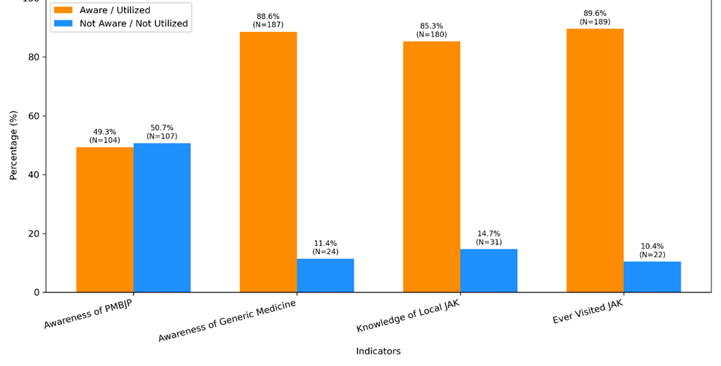
Figure 1: Comparative analysis of awareness among beneficiaries for PMBJP (Pradhan Mantri Bhartiya Janaushadhi Pariyojana), generic medicine and Jan Aushadhi Kendra

As shown in figure 1, a comparative analysis was conducted to assess the level of awareness and utilization regarding four key health indicators among respondents: Awareness of PMBJP, Awareness of Generic Medicine, Knowledge of Local Jan Aushadhi Kendra (JAK), and ever visited JAK. It was found that equal proportions of respondents reported awareness (49.3%) and lack of awareness (50.7%) of the PMBJP scheme. In contrast, a substantially higher proportion (88.6%) were aware of generic medicines, while only 11.4% reported no awareness. Similarly, 85.3% of respondents stated that they knew about their local Jan Aushadhi Kendra, compared to 14.7% who did not. The highest utilization was observed for the indicator “have you visited JAK in last 6 months” with 89.6% of respondents reporting that they had visited a Jan Aushadhi Kendra at least once in last 6 months while only 10.4% respondents had never visited. There were strong and statistically significant associations (all p-values < 0.05) between awareness of PMBJP, awareness of generic medicine, knowledge of local JAK, and having ever visited a JAK.

Table 4: Relationship between Gender and Awareness of generic medicine among the respondents
Gender of Respondent | Yes |  | No |  | Not Sure |  | Total (n)
Gender of Respondent | Frequency (N) | Percentage (%) | Frequency (N) | Percentage (%) | Frequency (N) | Percentage (%) | Total (n)
Male | 63 | 57.3 | 44 | 40.0 | 3 | 2.7 | 110
Female | 48 | 48.5 | 50 | 50.5 | 1 | 1.0 | 99
Transgender | 1 | 50.0 | 1 | 50.0 | 0 | 0.0 | 2
Total | 112 | 53.1 | 95 | 45.0 | 4 | 1.9 | 211

As per table 4, out of the 211 Respondents, awareness (“Yes”) is slightly higher among males (57.3%) compared to females (48.5%). A marginally higher proportion of females (50.5%) report “No” awareness compared to males (40.0%). Very few respondents (1.9%) were unsure, with almost equal distribution among males and females. The “Transgender” category is too small (n=2) for meaningful interpretation but has a 50–50 split.

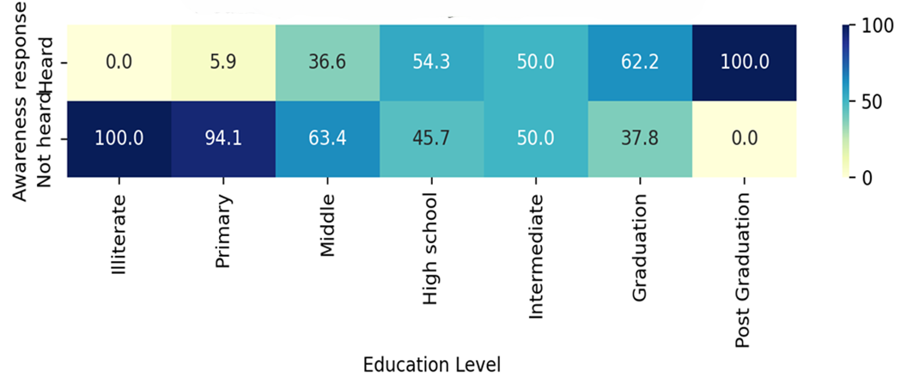
Figure 2: Heatmap: Awareness of Jan Aushadhi Kendra by education level among the respondents

As shown in figure 2, awareness is highest among post-graduates (100%), with substantially lower levels at lower education tiers—ranging from negligible awareness among illiterate respondents (0%) to approximately 6% at the primary education level. Awareness increases notably at the middle-school level (37%), rises to 54% at high school, and reaches 60% among graduates, reflecting a clear positive correlation between education level and generic medicine awareness.

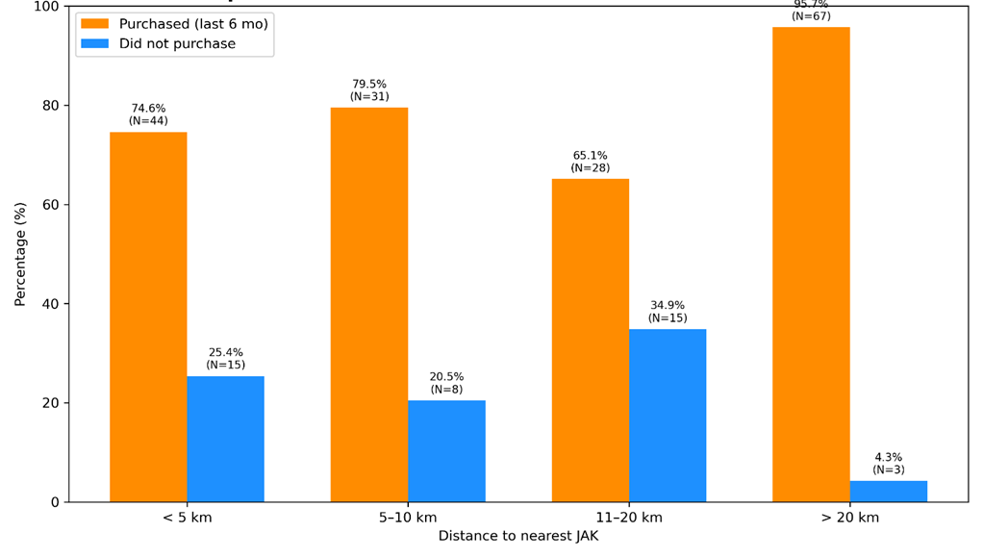
Figure 3: Relationship between distance travelled by beneficiaries for Jan Aushdhi Kendra and utilization of Generic Medicine by them

Figure 3 shows, the relationship between the distance to Jan Aushadhi Kendras (JAK) and the utilization of generic medicines was examined among 211 respondents. Distance was categorized into four groups: less than 5 km, 5 to 10 km, 11 to 20 km, and more than 20 km. Utilization was defined as purchase of generic medicines from JAK within the past six months. A cross-tabulation revealed that 95.7% of respondents residing more than 20 km from the JAK reported recent purchases, a higher rate than some closer groups. The lowest utilization was observed within the 11–20 km group. A Chi-square test confirmed a significant association between distance and utilization (χ² = 10.37, df = 3, p = 0.015), indicating that distance influences generic medicine uptake from JAK. These findings suggest that factors beyond physical proximity, potentially including transport availability, awareness, and stock consistency, may affect access and usage patterns.

Table 5: Belief assessment for effectiveness, safety, cost and quality of generic medicines among respondents
Belief Category | Yes (N) | Yes (%) | No (N) | No (%) | Total (N)
Belief in Effectiveness | 174 | 82.5% | 37 | 17.5% | 211
Belief in Safety | 168 | 79.6% | 43 | 20.4% | 211
Belief in Cost-Effectiveness | 184 | 87.3% | 27 | 12.7% | 211
Belief in Quality | 162 | 76.5% | 49 | 23.5% | 211

As shown in Table 5, most respondents expressed positive opinion about generic medicines. Specifically, 82.5% (n = 174) agreed that generics are effective, while 79.6% (n = 168) believed in their safety. Belief in cost-effectiveness was the strongest, with 87.3% (n = 184) reporting agreement, indicating a widespread perception of economic benefit. However, trust in quality was comparatively lower, with 76.5% (n = 162) expressing confidence, and nearly a quarter (23.5%, n = 49) indicating doubts.

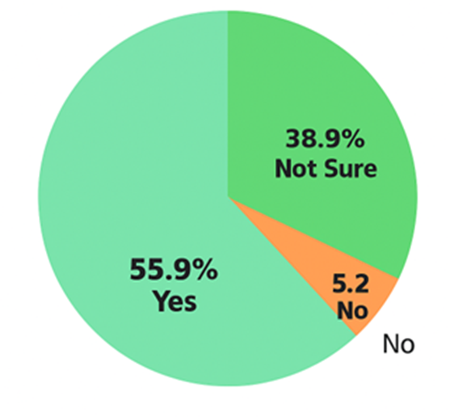
Figure 4: Trust in efficacy of generic medicines among respondents

In figure 4, analysis of the study findings revealed a nuanced trust landscape regarding the efficacy of generic medicines. While 55.9% of respondents explicitly expressed trust in the efficacy of generics, a substantial proportion—38.9%, or nearly four out of every ten—remained uncertain, and only meagre percentage of respondents (5.2%) had outright distrust on generic medicine.

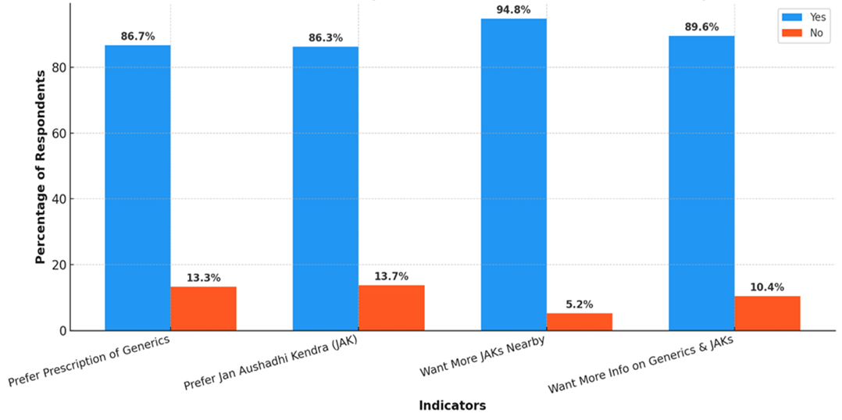
Figure 5: Preference Patterns for Generic Medicine and Jan Aushadhu Kendra among respondents

As per figure 5, the study assessed respondents’ preferences and demands related to generic medicines and the Jan Aushadhi Kendra (JAK). Results showed that 86.7% of respondents preferred prescriptions of generic medicines, while 13.3% did not. Similarly, 86.3% favoured procuring medicines from Jan Aushadhi Kendras as opposed to private outlets, with 13.7% having an alternate preference. A substantial majority of 94.8% expressed a desire for more JAKs to be established nearby, compared to 5.2% who did not. Additionally, 89.6% of respondents indicated a need for more information on generics and JAK services, whereas 10.4% felt this was unnecessary (Figure 5)

Table 6: Generic medicine utilization by illness category among respondents
Type of Illness for which generic was purchased | Count (N) | Percentage (%)
Chronic Illness | 74 | 35.1
Both Acute & Chronic | 64 | 30.3
Acute Illness | 38 | 18.0
Not Ever Purchased | 35 | 16.6

As shown in Table 6, among respondents, 35.1% (n=74) purchased generics for chronic illnesses, while 30.3% (n=64) did so for both acute and chronic conditions. Purchases for only acute illnesses accounted for 18.0% (n=38) of respondents. Notably, 16.6% (n=35) indicated they had never purchased generic medicines from a JAK.

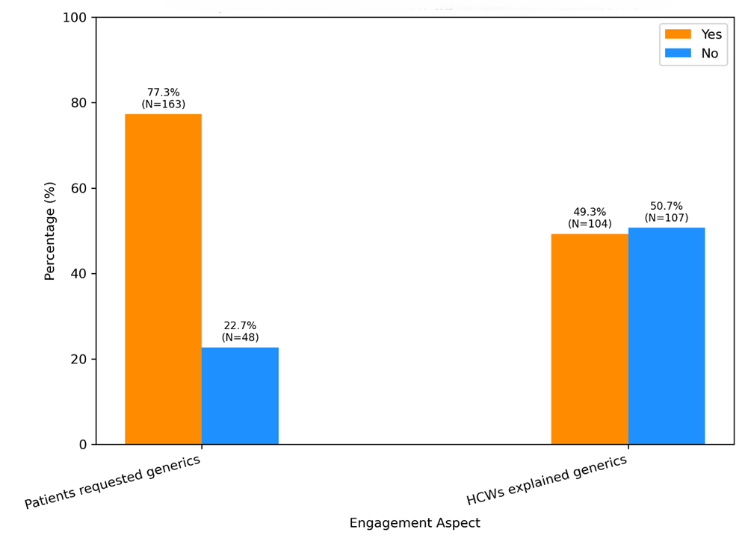
Figure 6: Comparison of beneficiaries request for generic medicine and healthcare worker explanations about generic medicines among respondents

In order to know more about acceptance or preference of Generic medicine, the study reveals a significant communication gap: As shown in Figure 6, while 77.3% of beneficiaries (n = 163) reported actively requesting generic medicines, only 49.3% (n = 104) stated that healthcare workers (HCWs) explained what generic medicines are—information that was reported solely by the respondents themselves. Notably, only beneficiaries indicated that doctors were not providing explanations about generics. The association between beneficiaries -initiated requests and receiving an explanation was statistically significant (χ² = 29.7, p < 0.001), suggesting that respondents who request generics are substantially more likely to receive information, but such communication is largely dependent on patient initiative. This underscores the need to strengthen provider-led communication about generic medicines rather than relying solely on patient prompts.

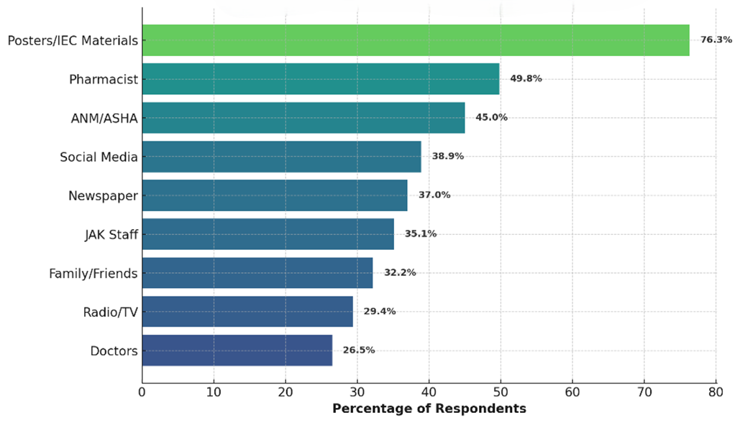
Figure 7: Source of Information about generic medicine and Jan Aushdhi Kendra among respondents

To identify the primary channels through which respondents became aware of generic medicines, respondents were asked about their main sources of information. This assessment was intended to highlight existing communication pathways and identify areas requiring targeted awareness efforts. As shown in Figure 7, among the respondents, the most frequently cited source was Posters/IEC materials, reported by 161 individuals (76.3%). Pharmacists (105 respondents, 49.8%) and ANM/ASHA workers (95 respondents, 45.0%) were also significant sources of information. Notably, social media (82 respondents, 38.9%) surpassed traditional media such as newspapers (78 respondents, 37.0%) and radio/TV (62 respondents, 29.4%) (Figure 7) Doctors were among the least mentioned sources, identified by only 56 respondents (26.5%). A Chi-square test revealed significant variation across these information sources (χ² = 178.4, p < 0.001), indicating highly uneven preferences and underscoring the need to strengthen underutilized communication channels.

Table 7: Barrier to accessing Generic medicine and Jan Aushadhi Kendra among respondents
Barrier | Frequency (N) | % of Respondents  (Multi response)
Lack of trust in quality | 26 | 12.3%
Preference for branded medicines | 35 | 16.6%
Negative past experience | 45 | 21.3%
Lack of awareness | 81 | 38.4%
Distance from Jan Aushadhi Kendra | 85 | 40.3%
Non-availability of medicines | 107 | 50.7%

As shown in table 7, the most reported barrier in this multi-response question was the non-availability of medicines, cited by 107 respondents (50.7%). Distance from the Jan Aushadhi Kendra was identified as a barrier by 85 respondents (40.3%), while lack of awareness was mentioned by 81 respondents (38.4%). Negative past experiences accounted for 45 respondents (21.3%), and preference for branded medicines was noted by 35 respondents (16.6%). Finally, lack of trust in the quality of generic medicines was perceived as a barrier by 26 respondents (12.3%) (Table 7).
A Chi-square goodness of fit test was conducted to determine whether the frequency with which each barrier was reported differed significantly from what would be expected by chance (i.e., if all barriers were equally likely to be cited). The test result was highly significant (χ² = 82.7, p < 0.001), indicating that certain barriers—such as the non-availability of medicines (reported by 107 respondents, 50.7%) and distance from Jan Aushadhi Kendra (85 respondents, 40.3%)—were cited much more frequently than others (Table 7). This statistical evidence confirms that the observed differences in reported barriers are not due to random variation but reflect meaningful patterns in the population’s experiences and perceptions.

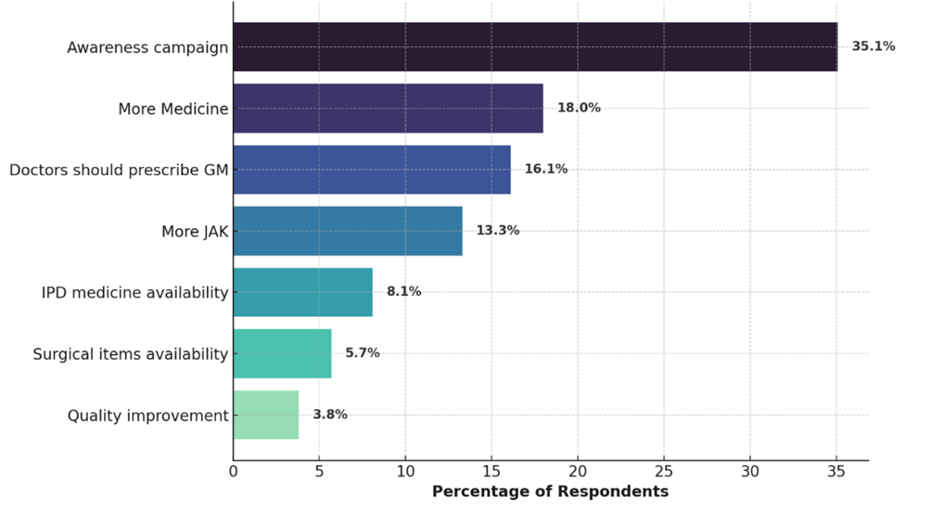
Figure 8: Suggestions by respondents for promoting generic medicine and
Jan Aushadhi Kendra

To identify key strategies for promoting Jan Aushadhi Kendras (JAKs) and generic medicines, respondents were asked to recommend measures they believed would be most effective. As shown in Figure 8, the responses revealed distinct preferences among the 211 respondents. Awareness campaigns emerged as the most frequently recommended strategy, endorsed by 74 respondents (35.1%). Improved medicine availability was suggested by 38 respondents (18.0%), while encouraging doctors to prescribe generic medicines was recommended by 34 respondents (16.1%). Additionally, 28 respondents (13.3%) advocated for establishing more JAKs, particularly in underserved areas. Suggestions for enhancing the availability of IPD/surgical items and improving quality were noted by a smaller proportion of respondents (Figure 8).
A chi-square test comparing the distribution of these recommendations indicated significant variation (χ² = 52.7, p < 0.001), underscoring that certain strategies—especially awareness campaigns—were prioritized substantially more often than others. This highlights a clear, non-random pattern in the collective preferences for advancing access to generic medicines and JAK services.

DISCUSSION

DISCUSSION
This facility-based cross-sectional study, conducted at the Jan Aushadhi Kendra (JAK) in SDH Karanprayag, Chamoli, offers an insight about the generic medicine and the patterns of awareness and utilization of generic medicines within a semi-urban mountainous region of Uttarakhand
Of the 211 respondents enrolled in this study, a nearly equal proportion of male and females were considered in this study. This fair participation by females and inclusion of transgender individuals sets this study apart from older reports, where patriarchal influences restricted female engagement in healthcare decision-making; however, this parity now reflects shifting social attitudes even in semi-rural India. Chaturvedi et al. (2024) similarly noted near-equal proportions of males (55%) and females (45%) in a cross-sectional assessment of JAK beneficiaries in Andaman and Nicobar Islands, underscoring the broad appeal and societal penetration of the generic medicine program regardless of gender or social status.⁽²³⁾ The age distribution, with 64.9% aged 21–50, reveals a youthful and productive patient base. Young-to-middle-aged adults are typically the most economically and socially active, responsible for family health expenditure, and thus most responsive to affordable medicine schemes. The presence of older adults (age range up to 70+) implies the study also captured chronic medicine users, who are ideal candidates for generic substitution. This aligns closely with the findings of Chaturvedi et al. (2024), who reported the majority of JAK users were below 50 years.⁽²³⁾ By contrast, older studies⁽⁴⁰⁾ ⁽⁴¹⁾ often found either a skew towards seniors (due to chronic disease load) or towards youth (due to child health burdens), but the present even spread highlights JAK’s broader utility. ⁽⁴²⁾
Income and occupational data underscore that Jan Aushadhi Kendras are reaching their intended target groups. Nearly two-thirds of respondents earned less than ₹32,000/month; 31.3% had a household income under ₹11,000. This mirrors Vayalambron et al. where approximately 69% of users lived below the poverty line and confirms that cost-saving policy is yielding tangible benefits for low-income populations. ⁽³⁷⁾ Occupationally, 37% were self-employed and 35.1% housewives. These groups are recognized as highly price-sensitive due to irregular income and larger household roles, a demographic also emphasized in the Shimoga study by Manjula Bai 2021.⁽⁴³⁾ This contrasts with metropolitan studies, where utilization is sometimes skewed towards salaried individuals with consistent health coverage.
Important focus of the present study is the detailed examination of respondents’ beliefs about generic medicines across several domains. The majority, 82.5%, perceive generics as effective, while 79.6% agree that generics are safe. An even greater proportion—87.3%—recognize generics as offering high value for money. However, only 76.5% express trust in the quality of generics, which is notably lower than other positive perceptions and highlights a persistent “trust gap.” Overall, these findings indicate a substantial positive shift in perceptions relative to pre-2019 research, when scepticism about generics was much higher. Several Indian studies like Chaturvedi et al. ⁽²³⁾ ⁽⁴⁴⁾ support this trend toward increased acceptance, particularly among regular users of generic prescriptions. Nevertheless, concerns about quality endure, consistent with the observations of Hadia et al. (2021), who found that patients often associate lower prices with lower quality with lower quality. ⁽⁴⁵⁾
The largest segment of JAK users were patients with chronic diseases (35.1%), followed by those with both acute and chronic needs (30.3%). This pattern resonates with findings in Chaturvedi et al. (2024), which highlights that chronic patients, facing prolonged medication needs, are the greatest beneficiaries of price differentials between branded and generic medicines. ⁽²³⁾ Multiple reports indicate that patients with diabetes, hypertension, and heart disease predominantly drive demand for consistent, affordable access via JAKs. ⁽⁴⁶⁾ ⁽⁴⁷⁾ It is worth noting that national policy design—by including a large proportion of chronic disease drugs in the JAK portfolio—directly supports such usage. The overlap between chronic and mixed illness respondents signals that some households are managing both chronic and acute conditions, magnifying perceived benefits from generics.
A substantial majority (77.3%) of respondents reported initiating requests for generics, while only 49.3% noted that healthcare providers proactively explained generic drug options. This identifies a notable engagement gap, where patient empowerment now exceeds provider-driven counselling—a reversal of traditional information hierarchies. Chaturvedi et al. (2024) also recorded this “initiative flip,” calling for intensive reorientation and training of health workers to ensure generics are not merely dispensed but credibly advocated by all staff. ⁽²³⁾ Hadia et al. (2021), in work from North India, found similar patterns, noting that doctor reluctance or omission in advocacy stemmed from ingrained biases or insufficient continuing education. ⁽⁴⁵⁾ Where providers are less proactive, misinformation persists, and scepticism remains unnecessarily high.
The principal barriers identified were: Non-availability of medicines (50.7%), Distance from Kendra (40.3%), Lack of awareness (38.4%), Negative past experience (21.3%), Preference for branded medicines (16.6%) and Lack of trust in quality (12.3%). These results echo the “last-mile delivery” and logistics problems outlined in Dr. Rakesh Sharma’s Policy Paper (2025), which identified erratic supply chains and geographic inaccessibility—especially in hilly districts—as the most consistent inhibitors of full reach. ⁽⁴⁸⁾ The higher-than-typical rate of “negative past experience” (21.3%) may reflect local information dynamics: as observed by Chaturvedi et al. (2024), rare adverse experiences can become magnified in rural or close-knit populations, discouraging uptake far more than in cities where reputational impact is diluted. ⁽²³⁾ This is a well-studied effect in rural sociology.
At 49.3%, community awareness of the broader PMBJP falls below the desired threshold. This mirrors Perceived Utility of Jan Aushadhi Outlets (2024), where 45% were aware of the program’s structure and goals. ⁽²³⁾ Persistent information bottlenecks—often exacerbated by minimal involvement of stakeholder’s involvement, low literacy, irregular internet access, or lack of community engagement events—require remedial policy attention.
Comparative Analysis: Consistencies and Local Uniqueness- High patient initiative: The phenomenon of patients outpacing providers in requesting generics is a new and positive shift but also highlights gaps in HCW training and the need for regular CME (continuing medical education) on the generic program (Chaturvedi et al., 2024. ⁽²³⁾ Quality perceptions: Despite improvements, the “trust in quality” lag demands strong quality-assurance messaging and perhaps “audit-and-display” practices, as advocated in national surveys. Social amplification of adverse events: High negative-experience reporting, above national averages, likely results from regional sociocultural dynamics—a pattern validated in global and Indian rural medicine literature like study in 2018 by Aivalli et al, ⁽⁴⁹⁾ Nanjunda et al. 2019 ⁽⁵⁰⁾ and Rathi et al. 2021 ⁽³³⁾ Distance and availability: These structural realities affect all mountainous settings, as evidenced in national cost-effectiveness reports (PMBJP, 2024. ⁽⁵¹⁾
A high proportion of respondents (83.1%) agreed that cheaper generics improved medication adherence in their households. This supports the evidence from Dudhia et al., who highlighted the positive impact of affordability on adherence rates among Indian populations. ⁽⁴⁴⁾ Nearly 27.8% of respondents expressed ongoing concerns regarding potential side effects or lesser safety associated with generic medicines, despite high general trust in value and efficacy. These reservations align with the findings of Bhagavathula et al., who observed persistent safety-related scepticism across multiple regions in India, especially among older adults and those with chronic illnesses. ⁽⁴¹⁾

CONCLUSION

CONCLUSION
This study focused on the beneficiaries visiting the Jan Aushadhi Kendra at the Sub District Hospital in Karanprayag, Chamoli, to understand awareness level and how generic medicines are perceived and used in this semi-urban and mountainous region of Uttarakhand. The results show that awareness about generic medicines is quite high among the people here, with most respondents knowing about generic medicines and their local Jan Aushadhi Kendra. This indicates that the Jan Aushadhi Scheme is effectively reaching out to the community and informing them about affordable medicine options. Most people in the study had positive views about generic medicines. They believe these medicines are effective, safe, and budget friendly, while trust in quality was slightly lower compared to other aspects, a majority still had confidence in generics. This is important because it shows that generic medicines are becoming an acceptable alternative to branded medicines, especially for managing long-term health issues such as chronic diseases. The community studied is diverse, including men and women from different age groups, occupations, and income levels. A significant number of people, particularly those with lower incomes, rely on generic medicines to manage both acute and chronic health conditions. This highlights the important role that generic medicines play in making healthcare affordable and accessible for vulnerable groups.
However, the study also found some challenges that prevent wider use of generic medicines. Many respondents mentioned that medicines are not always available at the Jan Aushadhi Kendra. Others said that traveling long distances to the Kendra makes it difficult to access these medicines regularly. Some people are still unaware of generic medicines or have doubts about their quality based on past experiences or a preference for branded medicines. These barriers suggest the need for improving the supply chain, increasing awareness, and building more trust in generic products.
Information from banner and posters in campus, encouragement from pharmacy staff are helping increase acceptance of generic medicines. Still, healthcare providers could do more to promote generics consistently and confidently. Better training and support for doctors and other medical staff could help them become stronger advocates for generic medicines, which would likely increase acceptance even further.
In conclusion, the findings of this study may inform for healthcare planners and policymakers. to improve the use of generic medicines, efforts should focus on addressing supply issues, more JAK outlets, reducing travel difficulties, enhancing public knowledge, and strengthening trust. By tackling these challenges, access to affordable medicines can be improved, especially in underserved semi-urban areas like Karanprayag. This will, in turn, help make healthcare more equitable and reduce the financial burden on patients and families.

LIMITATIONS

LIMITATIONS
- This study’s cross-sectional design provides valuable snapshot insights into the awareness and utilization of generic medicines but inherently limits the ability to establish causal relationships between variables. Additionally, the research was confined to a single geographic area—Chamoli district in Uttarakhand—which may constrain the generalizability of findings to other regions with different demographic profiles, terrain, or healthcare infrastructure.
- The study did not assess the quality and accuracy of the information provided by the beneficiaries. There is a possibility of information bias if the information provided was incomplete, inaccurate, or inconsistent.
- Unpredictable weather conditions, such as monsoon rains and resulting road blockages, occasionally disrupted the supply chain and accessibility of the Jan Aushadhi Kendra during the study period. These logistical challenges may have temporarily affected the availability of generic medicines and could have influenced respondents’ responses regarding stock outs and utilization patterns. Such seasonal and infrastructural constraints are characteristic of mountainous regions and should be considered when interpreting the findings.

RECOMENDATIONS

RECOMMENDATIONS
- Strengthen the availability of generic medicines at Jan Aushadhi Kendras through improved supply chain management and inventory control.
- Expand outreach and accessibility for populations living in remote or hard-to-reach areas by establishing additional Jan Aushdhi Kendras or distribution points or mobile pharmacy services.
- Implement targeted awareness and educational campaigns tailored to low-literacy groups to increase knowledge and acceptance of generic medicines.
- Enhance trust in the quality of generic medicines by prominently displaying quality certifications and addressing patient concerns proactively.
- Increase the involvement and training of healthcare providers specially doctors to actively advocate for generic medicines and counsel patients effectively.
- Leverage community networks and digital media platforms to promote accurate information and dispel misconceptions about generic medicines.

REFERENCES

REFERENCES
1. Kotwani A. Where are we now: assessing the price, availability and affordability of essential medicines in Delhi as India plans free medicine for all. BMC Health Serv Res. 2013 July 25;13:285.
2. Arshath Jyothi PS, Raj AS, Yadava R. Vaidya saadhana: Healthcare economics through ages - From cost crisis to zero-cost diabetes care. Int J Ayurveda Res. 2025 June;6(2):161.
3. Joshi S, Shetty Y, Karande S. Generic drugs – The Indian scenario. J Postgrad Med. 2019;65(2):67–9.
4. Kaplan W, Wirtz V, Nguyen A, Ewen M, Vogler S, Laing R. Policy Options for Promoting the Use of Generic Medicines in Low- and Middle-income Countries.
5. Cameron A, Ewen M, Ross-Degnan D, Ball D, Laing R. Medicine prices, availability, and affordability in 36 developing and middle-income countries: a secondary analysis. Lancet Lond Engl. 2009 Jan 17;373(9659):240–9.
6. Australian Government Department of Health D and A. Pharmaceutical Benefits Scheme (PBS) | About the PBS [Internet]. Australian Government Department of Health, Disability and Ageing; [cited 2025 July 24]. Available from: https://www.pbs.gov.au/info/about-the-pbs
7. O’Leary A, Usher C, Lynch M, Hall M, Hemeryk L, Spillane S, et al. Generic medicines and generic substitution: contrasting perspectives of stakeholders in Ireland. BMC Res Notes. 2015 Dec 15;8(1):790.
8. Troein P, Newton M, Travaglio M, Stoddart K. Beneath the Surface: Unravelling the True Value of Generic Medicines.
9. Ford N, Wilson D, Chaves GC, Lotrowska M, Kijtiwatchakul K. Sustaining access to antiretroviral therapy in developing countries: lessons from Brazil and Thailand.
10. Research C for DE and. Generic Drug Facts. FDA [Internet]. 2021 Oct 22 [cited 2025 July 24]; Available from: https://www.fda.gov/drugs/generic-drugs/generic-drug-facts
11. Jan Aushadhi Diwas 2025 [Internet]. [cited 2025 July 5]. Available from: https://www.pib.gov.in/www.pib.gov.in/Pressreleaseshare.aspx?PRID=2108862
12. World Health Organization. Better access to generic medicines [Internet]. Geneva: World Health Organization; 2011 Feb 18 [cited 2025 Aug 3]. Available from: https://www.who.int/director-general/speeches/detail/better-access-to-generic-medicines
13. Access to Medicines and Health Products [Internet]. [cited 2025 July 5]. Available from: https://www.who.int/our-work/access-to-medicines-and-health-products
14. Sriram S, Albadrani M. Impoverishing effects of out-of-pocket healthcare expenditures in India. J Fam Med Prim Care. 2022 Nov;11(11):7120–8.
15. BA/BE [Internet]. [cited 2025 July 5]. Available from: https://cdsco.gov.in/ opencms/opencms/en/bioequi_bioavail/
16. Under Pradhan Mantri Bhartiya Janaushadhi Pariyojana only quality medicines are supplied through Jan Aushadhi Kendras [Internet]. [cited 2025 July 18]. Available from: https://www.pib.gov.in/www.pib.gov.in/Pressreleaseshare.aspx?PRID= 2043774
17. Janodia M. Differences in Price of Medicines Available from Pharmaceutical Companies and “Jan Aushadhi” Stores. Value Health. 2015 Nov 1;18(7):A850.
18. Under the Pradhan Mantri Bhartiya Janaushadhi Pariyojana, 15,057 Jan Aushadhi Kendras (JAKs) have been opened till 28.2.2025 across the country [Internet]. [cited 2025 July 5]. Available from: https://www.pib.gov.in/www.pib.gov.in/ Pressreleaseshare.aspx?PRID=2114994
19. Year end review of Department of Pharmaceuticals [Internet]. [cited 2025 July 5]. Available from: https://www.pib.gov.in/www.pib.gov.in/Pressreleaseshare.aspx? PRID=1991501
20. Berman P, Ahuja R. India’s health financing: Persistent concerns and new pathways. Lancet Reg Health Southeast Asia. 2022;3:100050. doi:10.1016/j. lansea.2022.100050.
21. Selvaraj, S., & Karan, A. K. (2012). Why publicly-financed health insurance schemes are ineffective in providing financial risk protection. Economic and Political Weekly, 47(11), 60–68.
22. Bagchi T, Das A, Dawad S, Dalal K. Non-utilization of public healthcare facilities during sickness: a national study in India. J Public Health. 2022 Apr 1;30(4):943–51.
23. Chaturvedi A, Dubey AK, Naveen A, Sravani MR. Perceived Utility of Jan Aushadhi Outlets and Awareness of Generic Medicines at the Andaman and Nicobar Islands: A Cross-Sectional Study. Cureus. 2024 Apr;16(4):e57630.
24. Lavtepatil S, Ghosh S. Improving access to medicines by popularising generics: a study of ‘India’s People’s Medicine’ scheme in two districts of Maharashtra. BMC Health Serv Res. 2022 May 13;22.
25. Roy V, Rana P. Prescribing generics: All in a name. Indian J Med Res. 2018 May;147(5):442–4.
26. Procedure_for_Reimbursement_of_Special_Incentive.pdf [Internet]. [cited 2025 July 17]. Available from: https://janaushadhi.gov.in/pdf/Procedure_for_ Reimbursement_of_Special_Incentive.pdf?utm_source=chatgpt.com
27. Sadiq S, Khajuria V, Khajuria K. Knowledge, attitude, and practices towards Jan Aushadhi scheme. 2017;7(9).
28. Thawani V, Mani A, Upmanyu N. Why the Jan Aushadhi Scheme Has Lost Its Steam in India? J Pharmacol Pharmacother. 2017;8(3):134–6.
29. Nautiyal H, Pankaj B, Himani P, Saleem S. A Study of Prescription Practice for Drugs in Rural Area of Dehradun, Uttarakhand, Using WHO Indicators. J Pharm Technol Res Manag. 1970 Jan 1;7:37–45.
30. Ballala K, Rao CR, Chaudhary AS, Bidnurmath AS, Pandey AK. Knowledge, attitude and practices regarding generic medicines and its usage: a community-based study. Int J Community Med Public Health. 2019 Apr 27;6(5):2182–8.
31. Charan J, Saxena D, Chaudhari M, Dutta S, Kaur RJ, Bhardwaj P. Opinion of patients seeking primary care regarding prescription of generic drugs: A cross-sectional study. J Fam Med Prim Care. 2020 Nov;9(11):5725.
32. Nagarajappa MH, Srivatsa HS. Modelling Customers’ Buying Behaviour of Jan Aushadhi (Generic Medicines). Indian J Pharm Educ Res. 2019 Dec 31;54(1):175–86.
33. Rathi H, Biyani M. Knowledge, attitude and perception of Indian population about generic verus branded medicine: A web based study. Asian J Pharm Clin Res. 2021 Feb 7;95–8.
34. Saha S, Paul S, Karar S, Pervin M, Saha M, Mukherjee T, et al. A Cross-Sectional Online Survey on Perception of Indians on Branded and Generic Drugs. [cited 2025 July 26]; Available from: https://www.ijmrhs.com/medical-research/a-crosssectional-online-survey-on-perception-of-indians-on-branded-and-generic-drugs-88937.html
35. Admin. A study on knowledge, practice and experience on the use of generic medicine among patients, healthcare professionals & common people- International journal of pharmaceutical sciences and research [Internet]. 2023 [cited 2025 July 26]. Available from: https://ijpsr.com/bft-article/a-study-on-knowledge-practice-and-experience-on-the-use-of-generic-medicines-among-patients-healthcare-professionals-common-people/
36. Mehak Chandhok SG. Effectiveness, Accessibility, Affordability, Availability, and Customer Satisfaction of Generic Medicines in Pradhan Mantri Jan Aushadhi Yojana. 2024 Apr 3 [cited 2025 July 26]; Available from: https://zenodo.org/doi/10.5281/zenodo.10913039
37. Vayalambron L. An Analysis of Consumer Awareness Regarding Jan Aushadhi Kendras. 2024;
38. Tekulapally K, Rao GVK, Prasanna V. Awareness, Attitude and Usage of Generic Medicines among Prescribers and Patients in a Tertiary Care Teaching Hospital; A Cross-Sectional Study. SSR Inst Int J Life Sci. 2024 May;10(3):5595–603.
39. JETIR2504A28.pdf [Internet]. [cited 2025 July 26]. Available from: https://www.jetir.org/papers/JETIR2504A28.pdf
40. Sah BNK, Sultana S, Kumar J. A Study on Drug Utilization in Geriatric Patients.
41. Bhagavathula AS, Vidyasagar K, Chhabra M, Rashid M, Sharma R, Bandari DK, et al. Prevalence of Polypharmacy, Hyperpolypharmacy and Potentially Inappropriate Medication Use in Older Adults in India: A Systematic Review and Meta-Analysis. Front Pharmacol [Internet]. 2021 May 19 [cited 2025 July 28];12. Available from: https://www.frontiersin.org/journals/pharmacology/articles/ 10.3389/fphar.2021.685518/full
42. Panigrahy S, Chaudhari S. Knowledge and Perceptions of Generic Drugs: A Cross-Sectional Study: A cross sectional study. J Drug Deliv Ther. 2022 Apr 15;12(2-S):53–7.
43. Bai HM. A Study on Customer Awareness towards Pradhan Mantri Bharatiya Jnanaushadi Kendra’s with Reference to Shimoga. ComFin Res. 2021 Jan 1;9(1):1–10.
44. Dudhia SH, Parmar KA, Mehta MD. Study of Knowledge, Attitude, and Practice of Prescribing Generic Medicines by Resident Doctors at a Tertiary Care Teaching Hospital. Asian J Pharm Res Health Care. 2023 Sept;15(3):223.
45. Hadia RB, Joshi DB, Gohel KH, Khambhati N. Knowledge, attitude, and practice of generic medicines among physicians at multispecialty hospital: An observational study. Perspect Clin Res. 2022;13(3):155–60.
46. Janaushadhi kendras: 5 of top 10 selling generic medicines are for diabetes, hypertension [Internet]. The Indian Express. 2023 [cited 2025 July 28]. Available from: https://indianexpress.com/article/cities/mumbai/janaushadhi-kendras-5-of-top-10-selling-generic-medicines-are-for-diabetes-hypertension-8929762/
47. Union Minister Smt. Nirmala Sitharaman says medicines are 50 to 80 per cent cheaper at PM Jan Aushadi Kendra [Internet]. [cited 2025 July 28]. Available from: https://www.pib.gov.in/www.pib.gov.in/Pressreleaseshare.aspx?PRID=1981290
48. Policy Paper: Barriers to Mandating Generic Medicine Prescriptions in India and Implications for Healthcare Reform [Internet]. [cited 2025 July 28]. Available from: https://www.linkedin.com/pulse/policy-paper-barriers-mandating-generic-medicine-dr-rakesh-v8kzc
49. Aivalli PK, Elias MA, Pati MK, Bhanuprakash S, Munegowda C, Shroff ZC, et al. Perceptions of the quality of generic medicines: implications for trust in public services within the local health system in Tumkur, India. BMJ Glob Health. 2018 Jan 13;2(Suppl 3):e000644.
50. Nanjunda DC. Health, Disease, and Social Structure in Rural India. J Health Allied Sci NU. 2019 Jan;09(01):22–7.
51. 89.PMBJP_(PGIMER).pdf [Internet]. [cited 2025 July 28]. Available from: https://htain.dhr.gov.in/images/pdf/outcome_reports/89.PMBJP_(PGIMER).pdf

ANNEXURES

Annexure I

THE NATIONAL INSTITUTE OF HEALTH AND FAMILY WELFARE
MUNIRKA, NEW DELHI – 110067

Information Sheet for the Participants
I am Dr. Harish C Thapliyal, a student at the National Institute of Health & Family Welfare (NIHFW). I am currently carrying out field work for my thesis titled “Awareness and Utilization of Generic medicines at Jan Aushadhi Kendra among beneficiaries visiting Sub District Hospital of Chamoli Uttarakhand”. The purpose of my research is to study for the partial fulfilment of Post Graduate Diploma in Public Health Management course. In this regard, I seek your interview where I would like to ask some questions about your particular experience. I would like to emphasize here that your participation in the study would be volumetry, and you can withdraw at any time without any consequences. Any information given by you will be kept confidential and you will remain anonymous throughout the study. If you decide to agree to participate, please give your consent. Thank you in advance for your valuable time.

Investigator
Name of the Student
Dr Harish C Thapliyal

Annexure II
THE NATIONAL INSTITUTE OF HEALTH AND FAMILY WELFARE
MUNIRKA, NEW DELHI – 110067

Patient Informed Consent form (PICF) (ENGLISH)
Patient identification number: ______________________
Title of project “Awareness and Utilization of Generic medicines at Jan Aushadhi Kendra among beneficiaries visiting Sub District Hospital of Chamoli Uttarakhand”.
Name of Investigator: Dr. Harish C Thapliyal Phone number: 9760214969
The contents of the information sheet dated ___________ that was provided have been carefully read by me / explained in detail to me, in a language that I comprehend, and I have fully understood the contents.
I confirm that I have had the opportunity to ask questions. The nature and purpose of the study and its potential risks / benefits and expected duration of the study, and other relevant details of the study have been explained to me in detail. I understand that my participation is voluntary and that I am free to withdraw at any time, without giving any reason, without my medical care or legal rights being affected.
I agree for my participation in the above study.
(Signature / Left Thumb Impression)
Date: ________________
Place: ________________
Name of the Respondents: _______________________
Son / Daughter / Spouse of: ______________________
Complete postal address: ________________________
Witness Name: ________________ Investigator Name: Dr. Harish C Thapliyal
Signature: ____________________ Signature: ____________________

Annexure III
THE NATIONAL INSTITUTE OF HEALTH AND FAMILY WELFARE
MUNIRKA, NEW DELHI – 110067

Questionnaire
Dear Participants,
Thank you for taking the time to participate in the questionnaire. This questionnaire is about “Awareness and Utilization of Generic medicines at Jan Aushadhi Kendra among beneficiaries visiting Sub District Hospital of Chamoli Uttarakhand”. Please carefully read the accompanying instructions before starting the questionnaire. Please report freely to this questionnaire. Your contribution to this is valuable. It will only take a few minutes to complete, and all responses will remain anonymous and confidential.
Your cooperation in this endeavour is well appreciated. Please read each question carefully and choose answer/answers from the options provided accordingly.
SECTION I
Socio-Demographic Profile
- Name/ID: (Optional)
- Age: _____ years
- Gender: ☐ Male ☐ Female ☐ Other
- Address/Locality: ________________________
- Contact Number: _________________________
- Marital Status: ☐ Married ☐ Unmarried ☐ Widowed ☐ Divorced/Separated
- Education Level: ☐ Illiterate ☐ Primary ☐ Secondary ☐ Senior Secondary ☐ Graduate ☐ Postgraduate and above
- Occupation: ☐ Employed ☐ Self-employed ☐ Unemployed ☐ Homemaker ☐ Retired ☐ Student ☐ Other: ___________
- Annual Family Income: ☐ Below ₹27,000 ☐ ₹27,000–2,50,000 ☐ ₹2,50,001–5,00,000 ☐ ₹5,00,001–7,50,000 ☐ Above ₹7,50,000
- Distance from Home to Hospital/JAK: ____ km
- Mode of Trasport- ☐ Walking ☐ Public Trasport ☐ Private Vehicle

SECTION II
Awareness and Knowledge
- Have you ever heard of the “Jan Aushadhi Scheme” (PMBJP)?
☐ Yes ☐ No
- Are you aware of the Jan Aushadhi Kendra in this hospital/area?
☐ Yes ☐ No
- Have you ever visited a Jan Aushadhi Kendra?
☐ Yes ☐ No
- Have you heard about “generic medicines”?s
☐ Yes ☐ No
- Do you know the difference between generic and branded medicines?
☐ Yes ☐ No ☐ Not Sure
- Do you think generic medicines are as effective as branded medicines?
☐ Yes ☐ No ☐ Don’t know
- Do you think generic medicines are as safe as branded medicines?
☐ Yes ☐ No ☐ Don’t know
- Do you think generic medicines are less expensive than branded medicines?
☐ Yes ☐ No ☐ Don’t know
- Are generic medicines available at Jan Aushadhi Kendra?
☐ Yes ☐ No ☐ Partial
- Are you aware of government guidelines regarding the use/prescription of generic medicines?
☐ Yes ☐ No
- Do you believe Jan Aushadhi Kendra medicines are of good quality?
☐ Yes ☐ No ☐ Don’t know
- Would you prefer your doctor to prescribe generic medicines if available?
☐ Yes ☐ No
- Are you willing to purchase medicines from Jan Aushadhi Kendra instead of private pharmacies?
☐ Yes ☐ No
- Do you trust the efficacy of medicines provided at Jan Aushadhi Kendra?
☐ Yes ☐ No ☐ Don’t know
- Do you think government should open more Jan Aushadhi Kendras in your area?
☐ Yes ☐ No
- Would you like more information/education about generic medicines and Jan Aushadhi Scheme?
☐ Yes ☐ No
SECTION III
Utilization and Practice
- Have you purchased medicines from a Jan Aushadhi Kendra in the last 6 months?
☐ Yes ☐ No
- If yes, what kind of medicines did you purchase?
☐ For acute illness ☐ For chronic illness ☐ Never Purchased
- Did you request your doctor/pharmacist to prescribe or dispense generic medicines?
☐ Yes ☐ No
- Has any healthcare provider explained to you the difference between generic and branded medicines?
☐ Yes ☐ No
- Did you face any difficulty while buying medicines from Jan Aushadhi Kendra? (Select all that apply)
☐ non-availability of prescribed drug
☐ Long waiting time
☐ Negative attitude of staff
☐ Inadequate information
☐ Other:
- If you did not purchase from Jan Aushadhi Kendra, what were your reasons?
☐ Lack of awareness ☐ Distance ☐ Preference for branded drugs ☐ Negative past experience ☐ Other:
SECTION IV
Health System Information
- From which source/Sources you got information about JAK and Generic Medicine ☐ Doctors ☐ Pharmacist ☐ ASHA/ANM ☐ TV/Radio ☐ Newspaper/ Magazine ☐ social media ☐ Family/Friend ☐ JAK staff ☐ Poster/ Holdings
Barriers and Recommendations
- What do you think are the main barriers to using Jan Aushadhi Kendra and generic medicines in your area?
(Open-ended)
- What would encourage you or others to use Jan Aushadhi Kendra more frequently?
(Open-ended)

Annexure IV

Data Collection Permission Letter
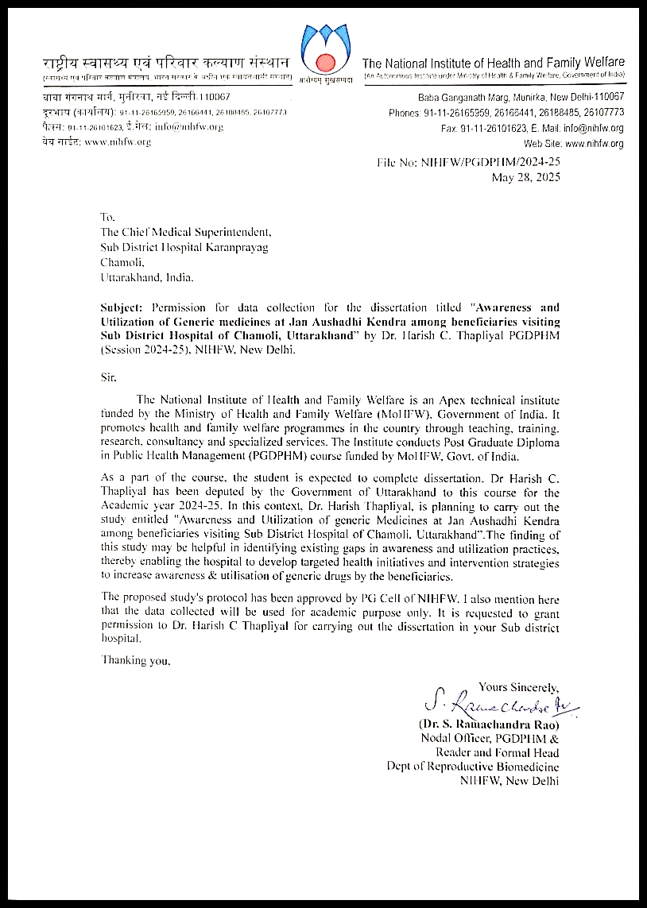

Annexure V

Ethical Committee Approval
