Supporting Information
Title: Patterns of microbiome-mediated plant-soil feedback intensity in organic versus conventional farm soils

Authors: Liang Cheng¹, Connor Gibian-Lane¹, Antonio DiTommaso¹, and Jenny Kao-Kniffin¹*
Affiliation: ¹School of Integrative Plant Science, Cornell University, Ithaca, NY 14853

*Corresponding Author:
jtk57@cornell.edu

Submitted to: Oecologia
April 20, 2026

Fig. S1. Plant-soil feedback prediction accuracy using (A, B) Random Forest (RF) and (C, D) Support Vector Regression (SVR). Models are based on (A, C) unfiltered OTUs or (B, D) Pearson (P) correlation-filtered OTUs. See Table S1 for model performance metrics.

- RF
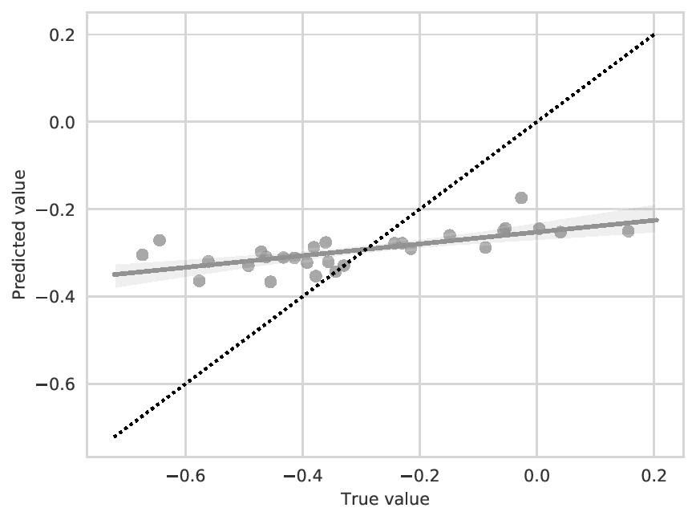
- PRF
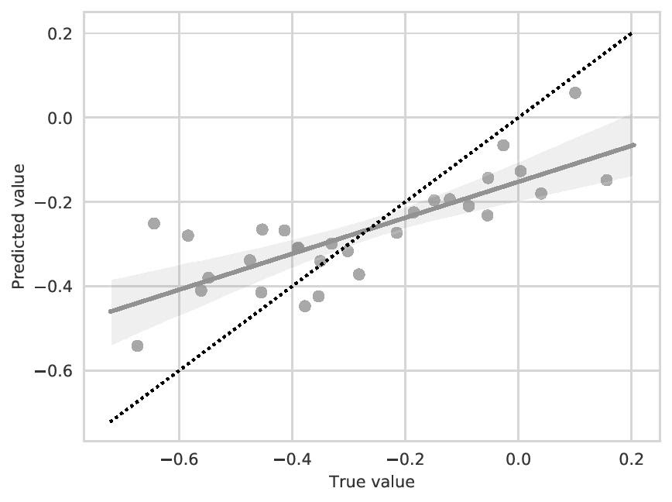

- SVR
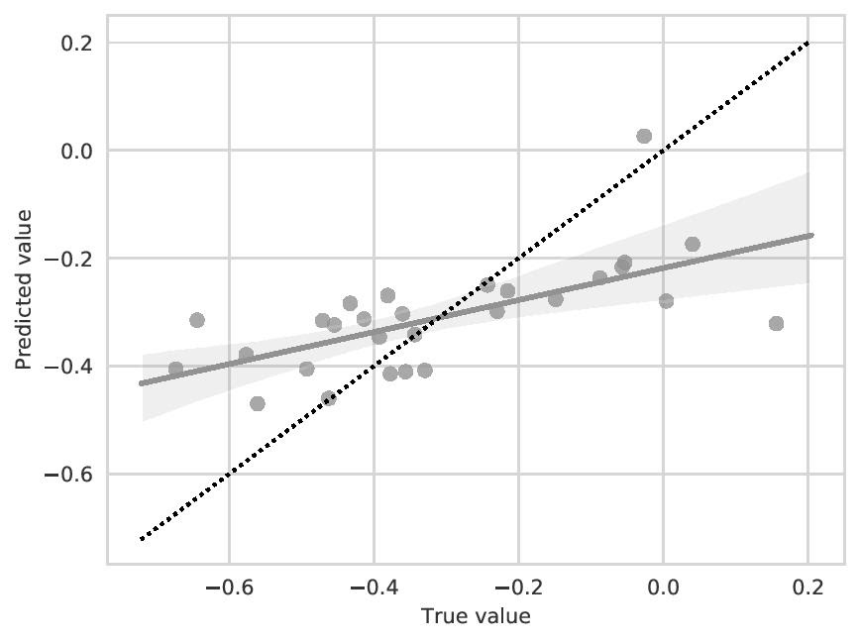
- PSVR
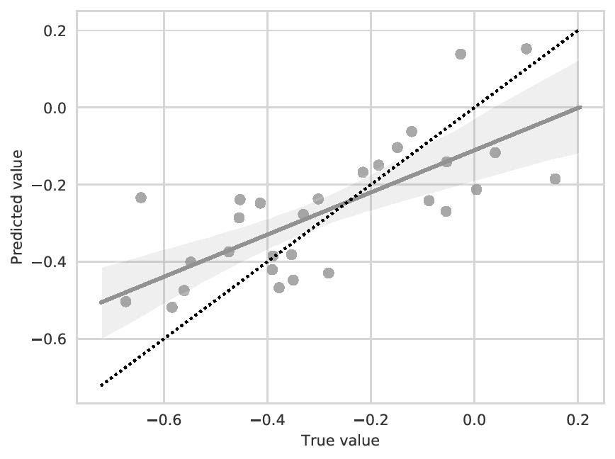

Fig. S2. Correlations between α-diversity metrics and PSF strength. These correlations are shown for the top 10% of OTUs associated with PSF (3,314 OTUs). Two α-diversity metrics, (a, b) Chao1 and (c, d) observed OTUs, are presented for (a, c) organic farm samples and (b, d) conventional farm samples.

- Organic systems
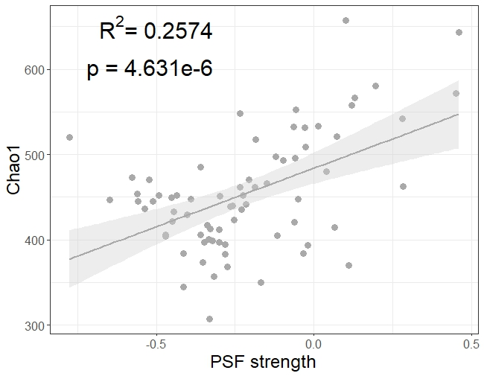
- Conventional systems
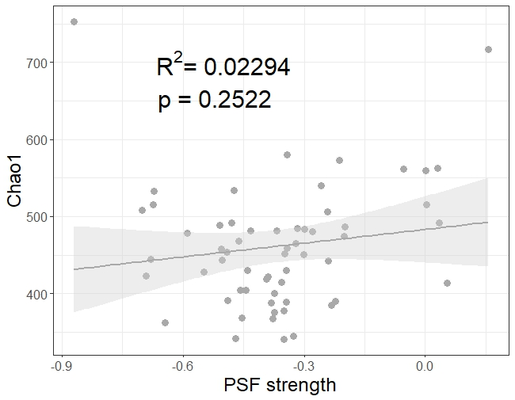

- Organic systems
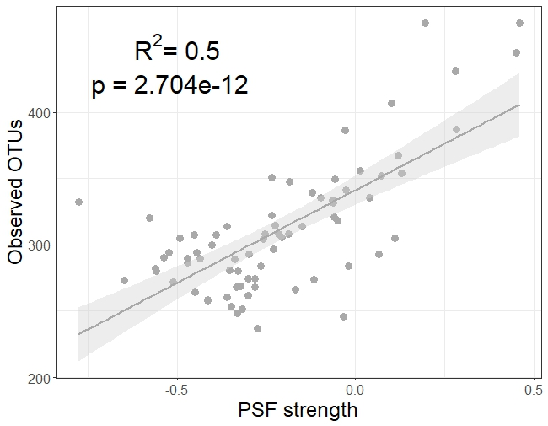
- Conventional systems
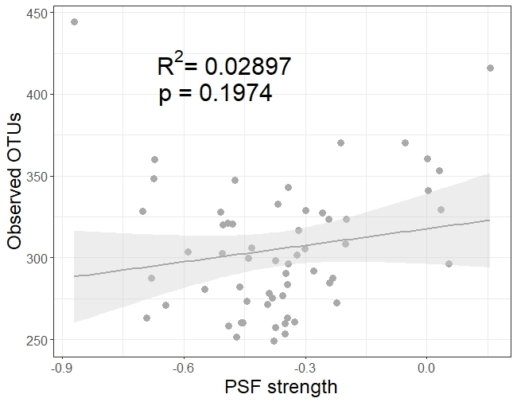

Fig. S3. Median, interquartile range, and 1.5 × interquartile range (with outliers) of A) Shannon, B) Chao1, and C) observed OTUs. These α-diversity metrics were calculated for the top 10% of OTUs correlated with PSF (3,314 OTUs). Samples were rarefied to 1800 observations and iterated ten times. Twelve samples with less than 1800 observations were excluded. This method resulted in a total of 132 samples (73 organic and 59 conventional).
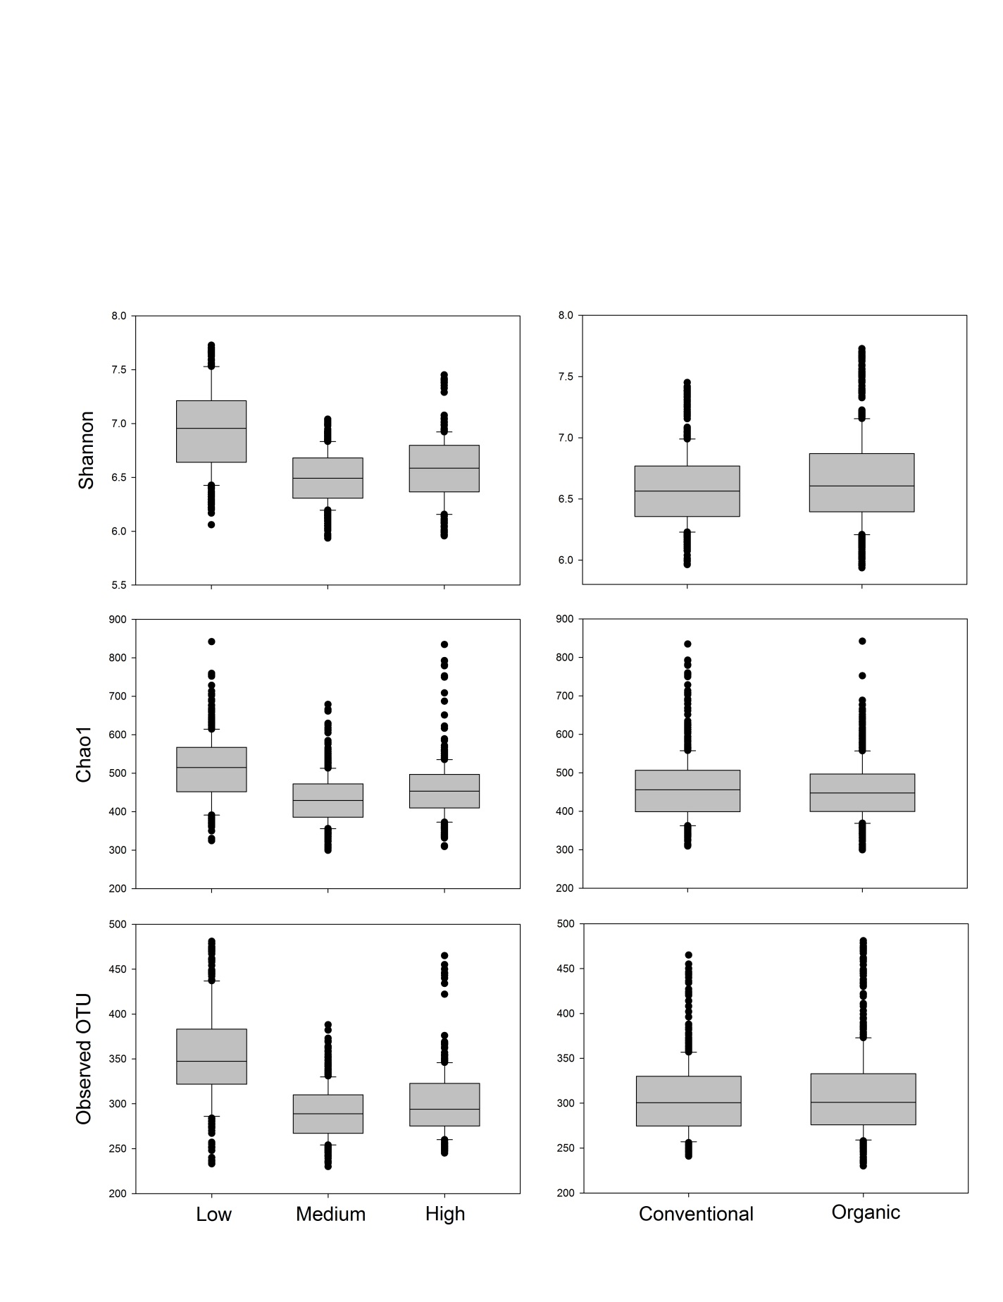
B
A
C

Table S1. Model performance summary. Models based on the entire dataset using Random Forest (RF) and Support Vector Regression (SVR) were compared with models based on Pearson correlation-filtered OTUs using Random Forest (PRF) and Support Vector Regression (PSVR).

Model | Mean squared error | r-value | R² | P | Std Error | Slope | Intercept
RF | 0.035085143 | 0.540191305 | 0.291806646 | 0.00300388 | 0.048712439 | 0.159440341 | –0.24460554
PRF | 0.022513 | 0.784516 | 0.615466 | 4.74E-07 | 0.064921 | 0.426778 | –0.152221
SVR | 0.02816 | 0.643105 | 0.413584 | 0.000223 | 0.069274 | 0.296643 | –0.218219
PSVR | 0.023963 | 0.730244 | 0.533257 | 0.000007 | 0.09851 | 0.54713 | –0.110781

