ESM Table 1 – Regression equations for the full and basic models for each C-peptide outcome, developed in the training dataset of GoFUSION. Regression coefficients for continuous predictors represent the effect per unit increase, except for triglycerides, which were transformed using a power of –0.5.
Model | Formulae
C-peptide threshold: | ≥600pmol/L
Full model | y = 3.1 + 0.527(sexFemale) + 0.053(BMI) – 0.143(DiabDuration) + 0.123(TimeToInsulin) – 0.921(HDL) + 1.456(BasalBolusFalse) – 0.021(HbA1c) + 0.011(Creatinine) – 3.333(TG^-0.5)
Basic model | y= 0.09(BMI) – 0.143(DiabDuration) + 0.126(TimeToInsulin) + 1.267(BasalBolusFalse) – 2.03
C-peptide threshold: | ≥900pmol/L
Full model | y = 0.685(sexFemale) + 0.03(Age) + 0.06(BMI) – 0.125(DiabDuration) + 0.07(TimeToInsulin) + 0.012(ALT) – 0.938(HDL) – 0.72(OnSUFalse) + 0.812(BasalBolusFalse) – 0.013(HbA1c) + 0.008(Creatinine) – 2.51(TG^-0.5) – 0.139
Basic model | y= 0.075(BMI) – 0.119(DiabDuration) + 0.08(TimeToInsulin) + 0.98(BasalBolusFalse) – 2.2

ESM Table 2 – baseline characteristics for DARE (Exeter) participants
 | Whole cohort | C-peptide <600pmol/L | C-peptide ≥600pmol/L | p-value | C-peptide <900pmol/L | C-peptide ≥900pmol/L | p-value
n | 250 | 62 | 188 |  | 138 | 112
Male, n (%) | 160 (64%) | 38 (61.3%) | 122 (64.9%) | 0.719 | 67 (59.8%) | 93 (67.4%) | 0.268
Age, years | 69.0 [32.0, 75.0] | 68.8 [62,74.2] | 69 [62.5,75] | 0.943 | 68.6 [62,74.5] | 69 [63,75] | 0.911
C-peptide, pmol/L | 1011.0 [602.5, 1557.5] | 431.5 [211.4, 522.5] | 1235.0 [852.3, 1805.0] | <0.001 | 563.0 [365.0, 705.0] | 1540.0 [1180.0, 1995.0] | <0.001
Diabetes duration, years | 16.0 [12.0, 21.0] | 18 [12.3,24] | 15 [12,20] | 0.037 | 17 [12,23.3] | 15 [11.3,19] | 0.013
BMI, kg/m² | 31.4 [28.1, 35.7] | 29.1 [25.8,33.3] | 32.3 [29.1,36.3] | <0.001 | 29.84 [26.97,34.4] | 32.36 [29.9,36.6] | <0.001
Time to insulin initiation, years | 7.0 [4.0, 10.8] | 6.75[3.12,11.5] | 7 [4.6,10.3] | 0.382 | 7 [4,10] | 7 [4.9,11] | 0.211
On basal bolus insulin regime (%) | 36 (14.4%) | 18 (29.0%) | 18 (9.6%) | <0.001 | 26 (23.2%) | 10 (7.3%) | 0.001
On sulphonylurea (%) | 78 (31.2%) | 7 (11.3%) | 71 (37.8%) | <0.001 | 19 (17.0%) | 59 (42.8%) | 0.000
HbA1c, mmol/mol | 64.0 [57.3, 76.5] | 64 [58,74.3] | 63.5 [57,77] | 0.826 | 63 [57,74] | 66 [58,78] | 0.252
ALT, U/L | 22 [17,29] | 21 [16,28] | 23 [18,30.3] | 0.046 | 20.5 [16,27.8] | 25 [19,33] | 0.001
HDL cholesterol, mmol/L | 1.19 [1.12, 1.29] | 1.35 [1.19,1.67] | 1.12 [0.95,1.37] | <0.001 | 1.32 [1.11,1.6] | 1.07 [0.9,1.28] | <0.001
Triglycerides, mmol/L | 1.49 [1.08, 2.21] | 1.4 [0.9,1.81] | 1.56 [1.23,2.26] | 0.016 | 1.28 [0.92,1.71] | 1.89 [1.36,2.63] | <0.001
Creatinine, µmol/L | 88.0 [73.0, 113.0] | 81.5 [69.5,94.25] | 90 [73.8,118.3] | 0.018 | 83 [72,96.5] | 92.5 [73,121.75] | 0.020

ESM Table 3 – AIC values of models developed without transformation of continuous explanatory covariates, with transformation of continuous explanatory covariates and when substituting BMI with waist circumference. Full model was selected based on the lowest AIC value.
Models | AIC value
C-peptide threshold: ≥600pmol/L
Without transformation of variables | 880.07
With polynomial transformation using power of 2 | 875.73
Transformation of triglycerides level using power of -0.5 | 864.29
C-peptide threshold: ≥900pmol/L
Without transformation of variables | 1086.7
With polynomial transformation using power of 2 | 1080
Transformation of triglycerides level using power of -0.5 | 1073

ESM Figure 1: TRIPOD -AI guidelines
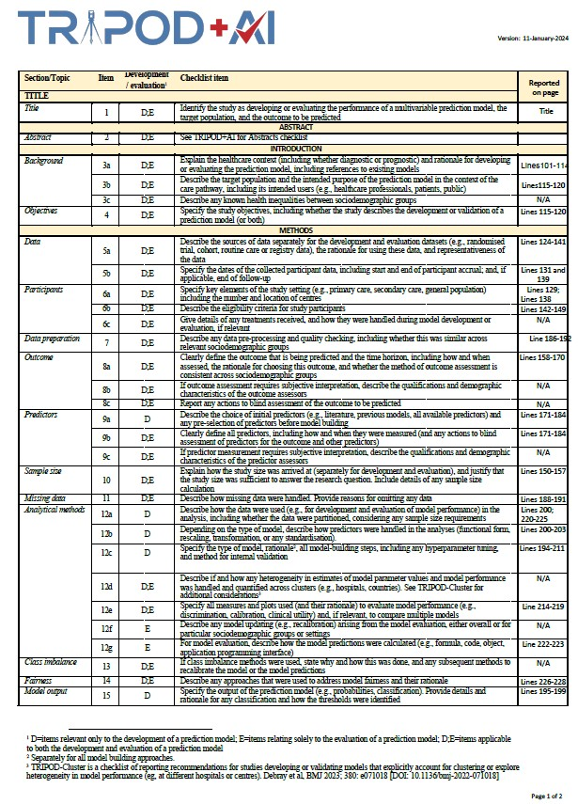

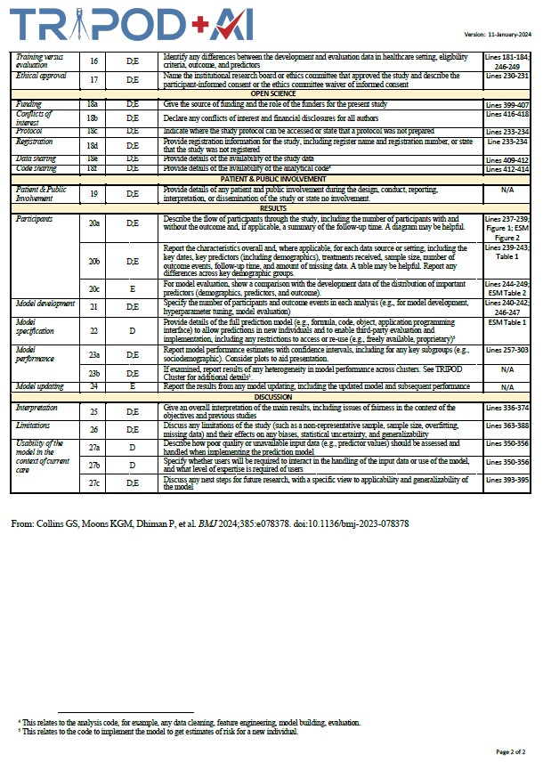

ESM Figure 2 – flow diagram of participants for DARE.
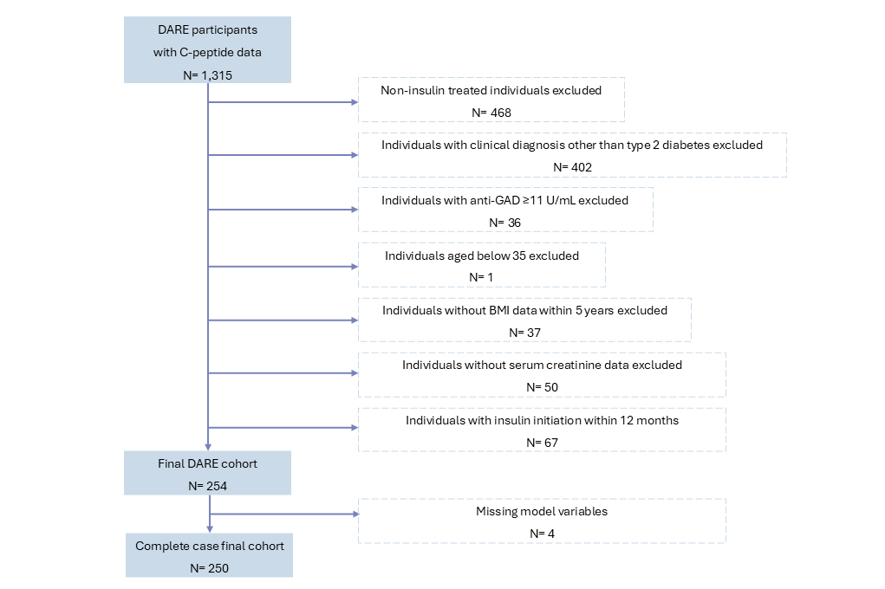
ESM Figure 3: Forest plots showing odds ratios (OR) and 95% confidence intervals for predictors of the full model (C-peptide ≥600pmol/L) in GoFUSION training dataset.
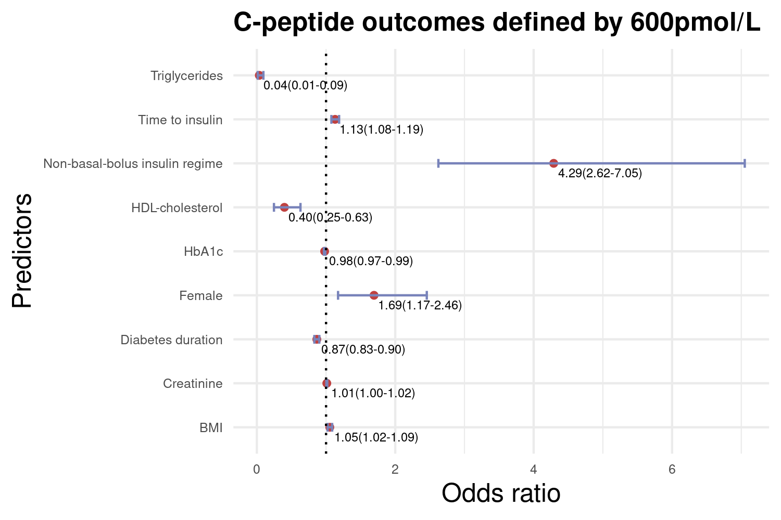

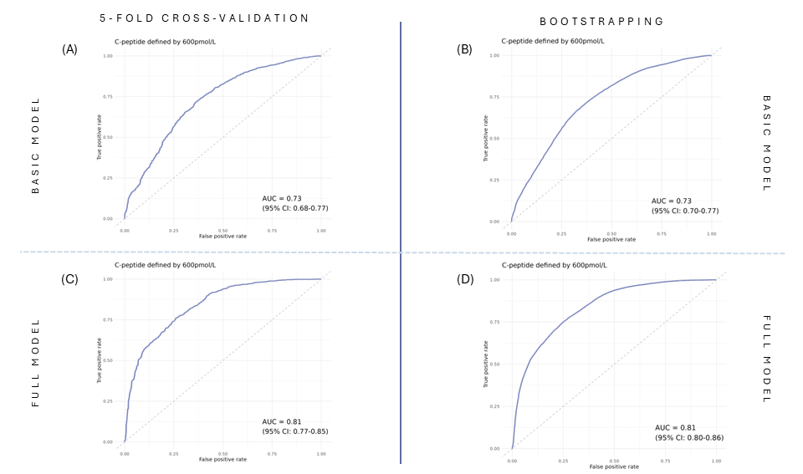
ESM Figure 4: ROC curves from internal validation (using 5-fold cross-validation and bootstrapping) of basic and full models (C-peptide ≥600pmol/L). The top row (figures 4A and 4B) demonstrates ROC curves of the basic model and the bottom row (figures 4C and 4D) demonstrates ROC curves of the full model.

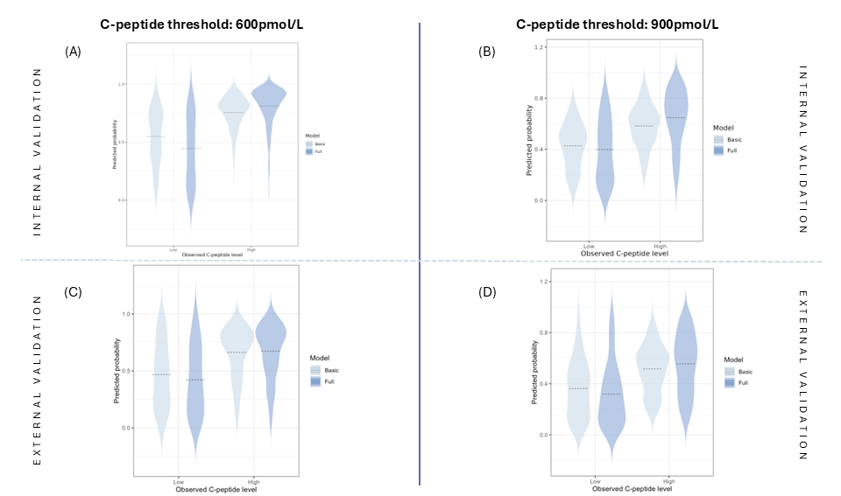
ESM Figure 5 – Violin plots of models probabilities grouped by observed C-peptide outcomes (light blue represents basic models and darker blue represents full models). Plots (A) and (B) show violin plots using GoFUSION testing dataset for C-peptide ≥600 and ≥900pmol/L respectively. Plots (C) and (D) show violine plots using external validation using DARE dataset for C-peptide ≥600 and ≥900pmol/L respectively.

ESM Figure 6: Forest plots showing odds ratios (OR) and 95% confidence intervals for predictors of the full model (C-peptide ≥900pmol/L) in GoFUSION training dataset.
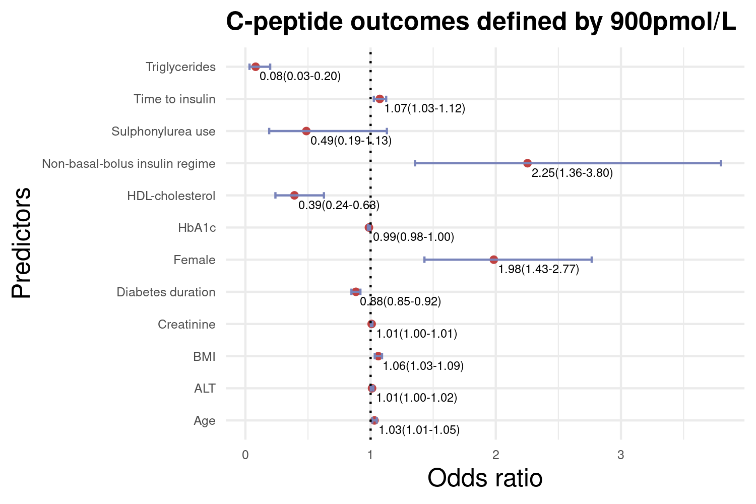

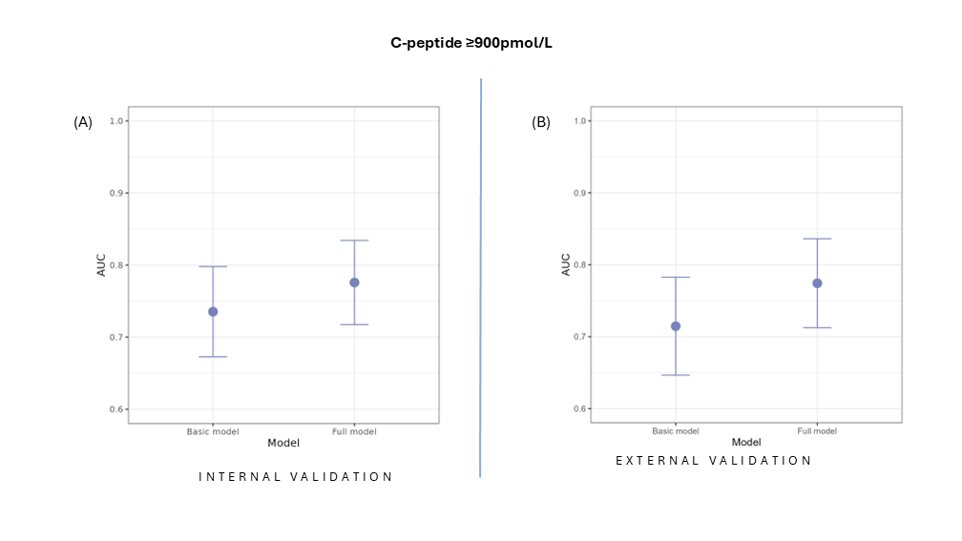
ESM Figure 7 - Comparison of AUROC with 95% confidence intervals for full and basic models (C-peptide ≥900pmol/L). Plot (A) shows AUROC in GoFUSION testing dataset (internal validation). The full model achieved AUROC 0.78 (95% C.I. 0.72-0.83) and the basic model achieved AUROC of 0.73 (95% C.I. 0.67-0.80). Plot (B) shows AUROC in DARE dataset (external validation). The full model achieved AUROC of 0.76 (95% C.I. 0.7-0.82) and the basic model achieved AUROC of 0.70 (95% C.I. 0.63-0.77).

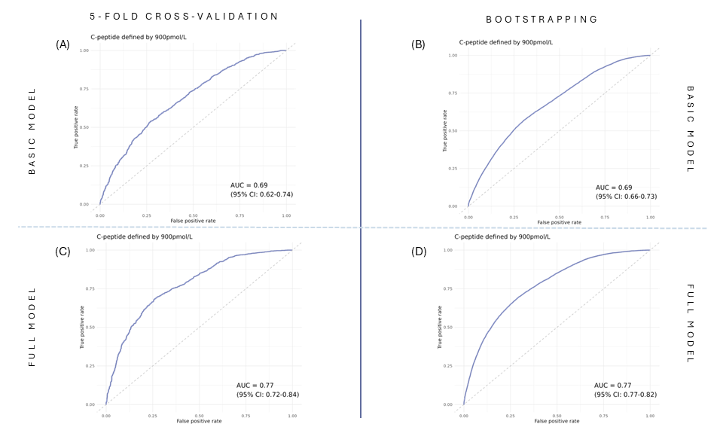
ESM Figure 8 - ROC curves from internal validation (using 5-fold cross-validation and bootstrapping) of basic and full models (C-peptide ≥900pmol/L). The top row (figures 8A and 8B) demonstrates ROC curves of the basic model and the bottom row (figures 8C and 8D) demonstrates ROC curves of the full model.

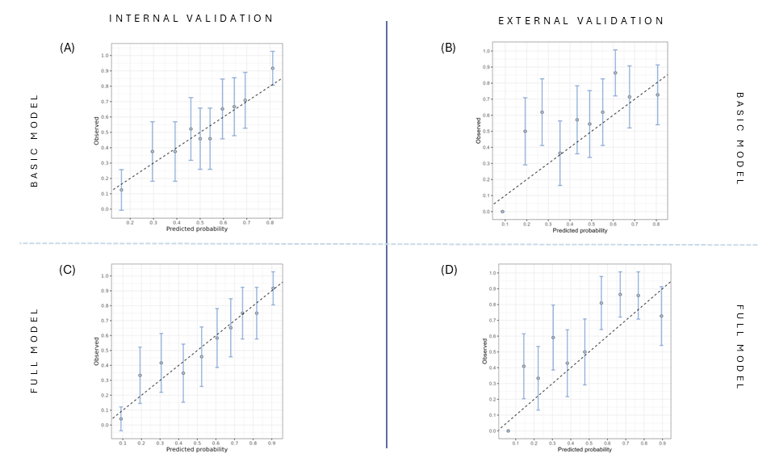
ESM Figure 9 - Calibration plots during internal (plots A and C) and external validation (plots B and D) of full and basic models (C-peptide ≥900pmol/L). Calibration plot for internal validation was plotted using the GoFUSION testing dataset. Plot (A) and (B) show calibration plots of basic model. Plots (C) and (D) show calibration plots of full model.

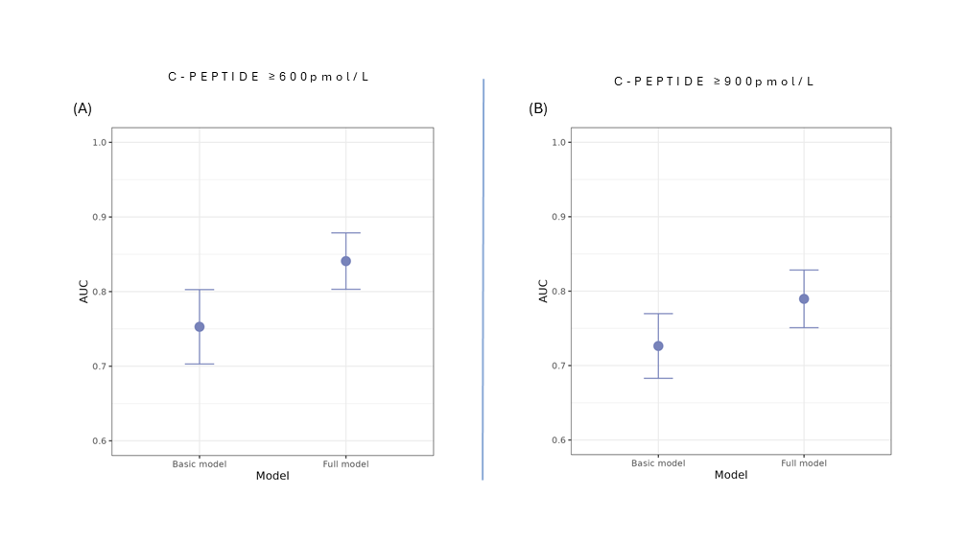
ESM Figure 10: Subgroup analysis for GoFUSION participants aged ≥70. Comparison of AUROC with 95% confidence intervals for basic and full models using C-peptide outcomes defined by (A) 600pmol/L and (B) 900pmol/L.

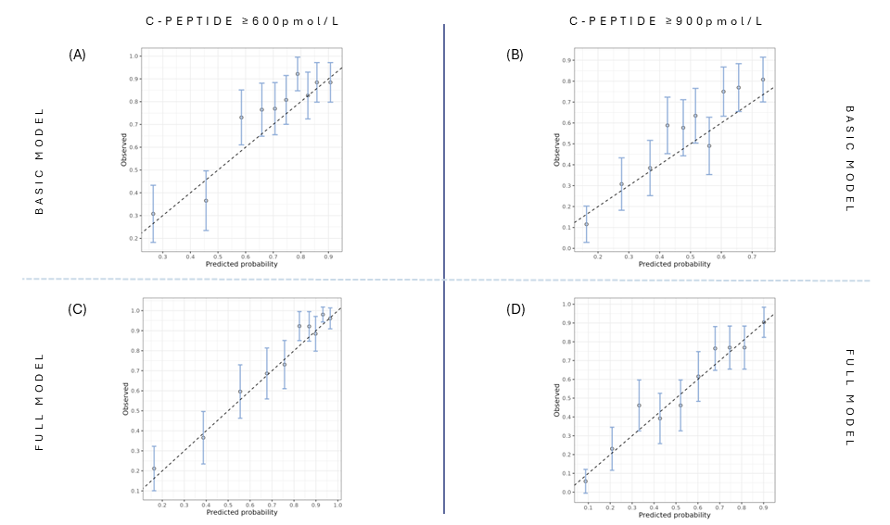
ESM Figure 11: Subgroup analysis for GoFUSION participants aged ≥70. Calibration plots for basic and full models using C-peptide outcomes defined by 600pmol/L and 900pmol/L.

