Supplementary information
Supplementary Methods 2
1. Participant Demographics and Exclusion Criteria 2
2. Calculation of ADOS Calibrated Severity Score (CSS) 2
3. MRI Data Quality Assessment, Exclusion of Scans, and Manual Edits 3
4. Canonical Correlation Analysis (CCA) 4
Supplementary Tables 5
Supplementary Tables S1 5
Supplementary Table S2 6
Supplementary Table S3 7
Supplementary Table S4 8
Supplementary Figures 9
Supplementary Figure S1. 9
Supplementary Figure S2. 10
Supplementary Figure S3. 11
Supplementary Figure S4. 12
Supplementary Figure S5 13
Supplementary Figure S6 14
Supplementary Figure S7. 15
Supplementary Figure S8. 16
Supplementary Figure S9. 17
Supplementary Figure S10 18
References 19

Supplementary Methods

1. Participant Demographics and Exclusion Criteria
Participants were recruited and assessed at three sites: (1) the Institute of Psychiatry, Psychology, and Neuroscience (IoPPN), London, UK (n=39 including 25 microdeletion carriers and 14 typically developing (TD) controls); (2) the Semel Institute for Neuroscience and Human Behavior, University of California (UCLA), Los Angeles, US (n=39 including 25 microdeletion carriers and 14 TD controls); and (3) the Department of Child and Adolescent Psychiatry, University Hospital, Goethe University, Frankfurt, Germany (n=53 including 40 individuals with idiopathic ASD and 13 TD controls). All individuals with idiopathic ASD met the criteria for ASD (see Methods in main document), except for two females. One female scored above cut-off in the reciprocal social interaction and the repetitive behaviors domains but fell short in the communication domain. For another female, ADI-R information was unattainable, but this female scored well above the threshold on the calibrated severity score (CSS) of the ADOS (score 8 out of 10) (see Supplementary Methods 2 for further information on ADOS CSS). As our sample included few females, we decided to include both of these datasets to ensure groups were as gender-balanced as possible.
Exclusion criteria for all participants included contraindications to MRI, a medical condition or chromosomal anomaly other than 22q11.2DS, which may be associated with ASD or psychosis (e.g. tuberous sclerosis, Fragile X syndrome, or Prader-Willi syndrome). However, individuals with co-morbid neuropsychiatric disorders (e.g. anxiety, depression, attention deficit hyperactivity disorder (ADHD)) were included in the 22q11.2DS and idiopathic ASD groups, as these are common co-morbid features of both conditions. All participants, and accompanying parents for those under 18 years of age, gave informed written consent in accordance with ethics approval by the Ethics Committee of the Faculty of Medicine of the Goethe University Frankfurt, the National Research Ethics Service (NRES) Committee South Central (study reference: 12/SC/0576), or the UCLA Institutional Review Board (IRB).

2. Calculation of ADOS Calibrated Severity Score (CSS)
To allow comparability of ADOS total severity scores across different ADOS versions and modules, we computed ADOS Calibrated Severity Scores (CSS). The majority of individuals received Module 3 or 4 of ADOS-G in London and Los Angeles and of ADOS-2 in Frankfurt. While ADOS-2 total severity scores were calculated according to the ADOS-2 Manual (1), the calculation of the CSS for Module 4 was conducted according to Hus & Lord (2014) (2). As for ADOS-G, raw scores were initially mapped onto ADOS-2 raw scores (1-3) and subsequently CSS was calculated accordingly. One participant in the 22q11.nonASD group received an ADOS-G Module 2, while one participant in the idiopathic ASD group received an ADOS-2 Module 1. The calculation of ADOS CSS for Modules 1 and 2 is analogue to Module 3 (1).

3. MRI Data Quality Assessment, Exclusion of Scans, and Manual Edits
The FreeSurfer derived surface models were visually inspected for reconstruction errors, and the quality of each scan was rated using one of the following three options: (1) accept as is (no visible reconstruction errors or artefacts), (2) prescribe manual edits (visible reconstruction errors in either pial or white matter surface (or both) that might be recoverable using manual edits), or (3) exclude (gross anatomical abnormalities or severe acquisition artefacts). Manual edits were performed by making changes to either the pial (i.e. grey matter) or white matter surface, or both. Following manual editing, images were (re-)pre-processed and re-assessed for reconstruction errors.

22q11.2DS and controls from IoP and UCLA:
In this study, we started off with 172 scans in total, acquired across two sites (n=81 at IoPPN, n=91 at UCLA), for which FreeSurfer pre-processing was performed. The resulting surface models were then visually inspected for reconstruction errors and scans were either (1) accepted ‘as is’ (n=112 out of 172 or 65%), (2) rejected ‘as is’ (n=34 out of 172 or 20%) - mostly due to severe (motion) artefacts, segmentation errors, or the existence of extra-brain tissue (e.g. dura) that precluded a successful FreeSurfer reconstruction, or (3) referred for manual editing (n=26 out of 172 or 15%) in case of smaller ‘local’ reconstruction errors. Out of the 26 scans that were re-preprocessed, 19 surface reconstructions (73%) did not improve significantly following manual editing and were subsequently excluded from the statistical analysis. This meant that a total of 53 scans (31%) were excluded overall. This overall dropout was approximately equal across sites, with 28 out of 91 scans being excluded from UCLA (i.e. 30.77% including n=15 controls, n=4 22q11.ASD, and n=9 22q11.nonASD individuals), and 25 out of 81 scans being excluded from the IoPPN (i.e. 30.86% including n=12 controls, n=6 22q11.ASD, and n=7 22q11.nonASD individuals). In terms of diagnostic categories, we excluded a total of 27 out of 84 controls (32%), and 26 out of 88 22q11.2DS individuals (29.5%). Dropout rates for cases and controls were therefore very closely matched. Moreover, out of 81 individuals with available ADI-R data, we excluded 10 out of 40 (i.e. 25%) 22q11.ASD individuals, and 16 out of 41 (39%) 22q11.nonASD individuals. However, the difference in the proportion of excluded ASD and nonASD individuals was not statistically significant (χ² = 1.2403, df = 1, p = 0.2654). Thus, although the dropout of ~30% is relatively high, we are confident that there is no systematic sampling bias that could have influenced our results in terms of the 22q11.2 groups and their matched controls.
For the purpose of the present study, 7 out of the original n=62 with 22q11.2DS did not have ADI-R information, and a further 5 were too old to be matched with the idiopathic ASD group so were further excluded. Of the 57 controls, we selected n=14 to match our overall groups.
Idiopathic ASD and controls from Frankfurt
The scans acquired in Frankfurt were selected from an ongoing study examining the neuroanatomical underpinnings of autism in children and adolescents with idiopathic ASD relative to TD controls based on participant’s age, gender, and IQ. Here, quality assessments and manual edits were conducted using the same stringent criteria as outlined for the 22q11.2DS group.

4. Canonical Correlation Analysis (CCA)
CCA aims to describe the linear relationship between a set of n x p predictor variables X and n x q outcome measures Y, where n indicates the number of participants. Initially, CCA estimates two parameter vectors $α$ and $β$ so that the correlation $ρ$ between the linear combinations $\hat{X}=α^{T}X$ and $\hat{Y}=β^{T}Y$ is maximised, i.e.
$ρ=corr\left(\hat{X},\hat{Y}\right)=\max_{α,β}{ }corr\left(α^{T}X,β^{T}Y\right)$.
The resulting predicted variables ${\hat{X}}_{1}$ and ${\hat{Y}}_{1}$ are the first pair of canonical variates (CV), and their correlation $ρ_{1}$ is the first canonical correlation (CC). Similar to Principle Component Analysis (PCA), the 2nd set of parameter estimates maximising $ρ$ is then derived subject to the constraint of being uncorrelated with the first pair of canonical variates. This procedure may be continued up to $i$ times, where $i=min\{p,q\}$, resulting in maximally $i$ canonical variate pairs.
CCA was initially applied to the non22q11.2DS individuals to establish the relationship between neuroanatomical variability and inter-individual differences in autistic symptom profiles. The same canonical model was then fitted to individuals with the 22q11.2 microdeletion. To compare results across groups, two different visual representations were utilized: (1) canonical loading plots based on the individuals features spanning $X$ and $Y$, which represent the correlations between each feature and the respective canonical variates (i.e. $r\left(x_{1…n},{\hat{X}}_{i}\right)$ or $r\left(y_{1…n},{\hat{Y}}_{i}\right)$) (see Fig. 2B, Fig. 3B, Fig. 4 in main manuscript and Supplmentary Fig. S5), and (2) scatter plots of the individual observations (i.e. cases) based on their canonical variate scores (i.e. ${\hat{X}}_{i}$ or ${\hat{Y}}_{i}$) (see Fig. 2C and Fig. 3C in main manuscript).

Supplementary Tables

Supplementary Tables S1. Post-hoc multiple comparisons of means

IQ: F(3)=21.01, p<0.001

TD > ASD > 22q11.ASD = 22q11.nonASD

 | 22q11.ASD | 22q11.nonASD | TD controls | ASD
22q11.ASD |  | 0.619 | <0.001 | <0.001
22q11.nonASD | 0.619 |  | <0.001 | 0.020
TD | <0.001 | <0.001 |  | 0.057
ASD | <0.001 | 0.020 | 0.057
Note: Scheffé Test – signicance values between groups.

Total Cortical Volume: F(3)=10.56, p<0.001

ASD = TD control > 22q11.ASD = 22q11.nonASD

 | 22q11.ASD | 22q11.nonASD | TD controls | ASD
22q11.ASD |  | 0.861 | 0.048 | 0.003
22q11.nonASD | 0.861 |  | 0.003 | <0.001
TD | 0.048 | 0.003 |  | 0.701
ASD | 0.003 | <0.001 | 0.701
Note: Scheffé Test – signicance values between groups.

Surface Area: F(3)=12.41, p<0.001

ASD = TD control > 22q11.ASD = 22q11.nonASD

 | 22q11.ASD | 22q11.nonASD | TD controls | ASD
22q11.ASD |  | 0.852 | 0.011 | 0.001
22q11.nonASD | 0.852 |  | <0.001 | <0.001
TD | 0.011 | <0.001 |  | 0.883
ASD | 0.001 | <0.001 | 0.883
Note: Scheffé Test – signicance values between groups.

Cortical thickness: F(3)=3.74, p<0.05

22q11.ASD = 22q11.nonASD > ASD = TD control

 | 22q11.ASD | 22q11.nonASD | TD controls | ASD
22q11.ASD |  | 0.988 | 0.218 | 0.194
22q11.nonASD | 0.988 |  | 0.101 | 0.088
TD | 0.218 | 0.101 |  | 0.100
ASD | 0.194 | 0.088 | 0.100
Note: Scheffé Test – signicance values between groups.

Supplementary Table S2. Clusters with significantly increased and decreased regional cortical volume (rCV), surface area (SA), and cortical thickness (CT) for the main effect of 22q11.2DS
Contrast |  | Cluster | Region Labels | Hemisphere | BA | Vertices | Talairach |  |  | t_{max} | p_{cluster}
 |  |  |  |  |  |  | x | y | z | t_{max} | p_{cluster}
Regional Cortical Volume
 | 22q11.2DS > non22q11.2DS
 |  | 1 | Insula, pars opercularis, postcentral gyrus, precentral gyrus, supramarginal gyrus | R | 1-4, 6, 13, 40, 43- 44 | 10963 | 32 | 10 | 11 | 5.26 | 1.97 x 10⁻⁵
 |  | 2 | Insula, lateral orbital frontal cortex, pars orbitalis, supramarginal gyrus | L | 6, 13, 40, 43-45, 47 | 7242 | -35 | -18 | 1 | 5.25 | 1.97 x 10⁻⁵
 |  | 3 | Postcentral gyrus, precentral gyrus | L | 1-4 | 4035 | -61 | -8 | 26 | 4.31 | 1.97 x 10⁻⁵
 |  | 4 | Precentral gyrus, superior frontal gyrus | R | 4, 6, 8-9 | 3404 | 20 | 15 | 51 | 4.14 | 1.97 x 10⁻⁵
 |  | 5 | Middle temporal gyrus | L | 21, 38 | 1103 | -49 | -6 | -25 | 4.46 | 8.18 x 10⁻⁵
 |  | 6 | Medial orbital frontal cortex | R | 11, 25 | 909 | 8 | 18 | -18 | 3.92 | 4.26 x 10⁻⁴
 |  | 7 | Superior frontal gyrus | L | 6, 8-9 | 1265 | -19 | 33 | 43 | 3.32 | 6.16 x 10⁻⁴
 |  | 8 | Medial orbital frontal cortex | L | 11, 25 | 659 | -8 | 16 | -15 | 3.74 | 2.64 x 10⁻³
 |  | 9 | Lateral orbital frontal cortex | R | 46 | 701 | 31 | 33 | -8 | 3.14 | 6.06 x 10⁻³
 |  | 10 | Postcentral gyrus, precentral gyrus | L | 1-4, 43 | 901 | -57 | 0 | 17 | 3.62 | 1.37 x 10⁻²
 | 22q11.2DS < non22q11.2DS
 |  | 1 | Cuneus cortex, lingual gyrus, parahippocampal gyrus, pericalcarine cortex, precuneus cortex, superior parietal cortex | L | 7, 17-19, 36 | 9341 | -19 | -43 | -5 | -5.90 | 1.97 x 10⁻⁵
 |  | 2 | Cuneus cortex, isthmus cingulate cortex, lingual gyrus, precuneus cortex, superior parietal cortex | R | 7, 17, 19, 30 | 4061 | 18 | -53 | 21 | -4.52 | 1.97 x 10⁻⁵
 |  | 3 | Lingual gyrus, parahippocampal gyrus | R | 19, 36 | 1926 | 21 | -39 | -6 | -4.43 | 1.98 x 10⁻⁵
 |  | 4 | Fusiform gyrus, lateral occipital cortex | L | 19, 37 | 1839 | -31 | -81 | -7 | -4.59 | 2.09 x 10⁻⁵
 |  | 5 | Postcentral gyrus, precentral gyrus | R | 1-3, 5 | 1927 | 4 | -25 | 62 | -3.54 | 5.62 x 10⁻⁴
 |  | 6 | Caudal anterior cingulate cortex | L | 23-24, 33 | 760 | -6 | 25 | 17 | -3.10 | 1.58 x 10⁻³
 |  | 7 | Paracentral lobule | L | 4, 6 | 1291 | -7 | -33 | 53 | -4.12 | 2.99 x 10⁻³
 |  | 8 | Fusiform gyrus, lateral occipital cortex | R | 18-19, 37 | 937 | 29 | -79 | -3 | -4.37 | 3.41 x 10⁻³
 |  | 9 | Caudal anterior cingulate cortex | R | 24, 33 | 1098 | 9 | 30 | 11 | -3.82 | 4.42 x 10⁻³
Surface Area
 | 22q11.2DS > non22q11.2DS
 |  | 1 | Caudal middle frontal gyrus, insula, pars opercularis, postcentral gyrus, precentral gyrus | R | 1-4, 6, 13, 43-44 | 11464 | 37 | -10 | -8 | 5.87 | 1.26 x 10⁻⁵
 |  | 2 | Caudal middle frontal gyrus, insula, pars opercularis, postcentral gyrus, precentral gyrus, superior temporal gyrus, supramarginal gyrus | L | 1-4, 6, 13, 40-41, 43-44 | 11109 | -34 | -24 | 20 | 4.25 | 1.26 x 10⁻⁵
 |  | 3 | Precentral gyrus, superior frontal gyrus | R | 4, 6, 8-9 | 5760 | 22 | 7 | 54 | 5.01 | 1.26 x 10⁻⁵
 |  | 4 | Insula, lateral orbital frontal cortex, pars opercularis, pars orbitalis, pars triangularis | L | 13, 44-45, 47 | 3411 | -40 | 26 | -13 | 4.22 | 1.28 x 10⁻⁵
 |  | 5 | Superior frontal gyrus | L | 4, 6, 8-9 | 3952 | -18 | 0 | 61 | 3.73 | 1.49 x 10⁻⁵
 |  | 6 | Medial orbital frontal cortex | R | 11, 25 | 1134 | 8 | 25 | -10 | 3.66 | 1.42 x 10⁻⁴
 |  | 7 | Posterior cingulate cortex | L | 23 | 442 | -4 | -11 | 28 | 4.16 | 1.63 x 10⁻⁴
 | 22q11.2DS < non22q11.2DS
 |  | 1 | Cuneus cortex, fusiform gyrus, inferior parietal cortex, lateral occipital cortex, lingual gyrus, parahippocampal gyrus, pericalcarine cortex, precuneus cortex, superior parietal cortex | L | 7, 17-19, 30-31, 36-37, 39 | 18715 | -11 | -73 | 22 | -6.41 | 1.26 x 10⁻⁵
 |  | 2 | Cuneus cortex, fusiform gyrus, lateral occipital cortex, lingual gyrus, parahippocampal gyrus, pericalcarine cortex, precuneus cortex, superior parietal cortex | R | 7, 17-19, 30-31, 36-37 | 15034 | 25 | -72 | -1 | -5.65 | 1.26 x 10⁻⁵
 |  | 3 | Inferior temporal gyrus, temporal pole | L | 20, 38 | 1463 | -30 | -1 | -24 | -4.28 | 1.26 x 10⁻⁵
 |  | 4 | Caudal anterior cingulate cortex, superior frontal gyrus | L | 6, 9-10, 23, 32 | 2997 | -12 | 25 | 22 | -4.16 | 1.66 x 10⁻⁵
 |  | 5 | Fusiform gyrus, inferior temporal gyrus | R | 20, 37 | 2632 | 39 | -1 | -32 | -4.74 | 5.89 x 10⁻⁵
 |  | 6 | Paracentral lobule, superior frontal gyrus | R | 4, 6, 32 | 2072 | 8 | -24 | 54 | -3.94 | 2.48 x 10⁻⁴
 |  | 7 | Postcentral gyrus, precentral gyrus | R | 1-4 | 1857 | 23 | -27 | 65 | -3.92 | 1.80 x 10⁻³
 |  | 8 | Caudal anterior cingulate cortex, rostral anterior cingulate cortex, superior frontal gyrus | R | 6, 24, 32-33 | 1372 | 11 | 33 | 14 | -3.87 | 1.38 x 10⁻²
 |  | 9 | Paracentral lobule | L | 4 | 1103 | -13 | -21 | 35 | -4.02 | 2.32 x 10⁻²
 |  | 10 | Postcentral gyrus, precentral gyrus | L | 1-3 | 1258 | -29 | -25 | 46 | -3.10 | 3.89 x 10⁻²
Cortical Thickness
 | 22q11.2DS > non22q11.2DS
 |  | 1 | Postcentral gyrus | R | 1-3 | 947 | 51 | -11 | 29 | 4.04 | 1.64 x 10⁻²
 |  | 2 | Lingual gyrus | L | 17, 19 | 831 | -5 | -81 | 2 | 4.15 | 1.80 x 10⁻²
 |  | 3 | Pericalcarine cortex | R | 17, 19 | 767 | 12 | -86 | 12 | 4.13 | 2.26 x 10⁻²
 |  | 4 | Supramarginal gyrus | L | 40 | 759 | -46 | -32 | 34 | 3.83 | 4.02 x 10⁻²
 | 22q11.2DS < non22q11.2DS
 |  | 1 | Superior temporal gyrus, transverse temporal cortex | R | 22, 38, 41-42 | 3215 | 50 | -11 | -5 | -5.01 | 2.18 x 10⁻⁵
 |  | 2 | Superior temporal gyrus, transverse temporal cortex | L | 22, 38, 41-42 | 2933 | -51 | -13 | 2 | -5.06 | 2.18 x 10⁻⁵
 |  | 3 | Posterior cingulate cortex | R | 23-24 | 1042 | 4 | -8 | 34 | -4.52 | 2.19 x 10⁻⁵
 |  | 4 | Posterior cingulate cortex | L | 23-24 | 846 | -5 | 12 | 27 | -3.74 | 3.73 x 10⁻⁵
 |  | 5 | Parahippocampal gyrus | L | 36 | 976 | -21 | -29 | -14 | -4.71 | 8.65 x 10⁻⁵
 |  | 6 | Parahippocampal gyrus | R | 36 | 645 | 21 | -30 | -10 | -4.03 | 4.90 x 10⁻²
Note: Hemisphere: L: Left, R: Right; BA: approxminate Brodmann area(s); Vertices: number of vertices within the cluster; tmax: maximum t-statistic within the cluster; p-cluster: cluster-corrected p-value.

Supplementary Table S3. Clusters with significantly increased and decreased regional cortical volume (rCV), surface area (SA), and cortical thickness (CT) for the main effect of ASD
Contrast |  | Cluster | Region Labels | Hemisphere | BA | Vertices | Talairach |  |  | t_{max} | p_{cluster}
 |  |  |  |  |  |  | x | y | z | t_{max} | p_{cluster}
Regional Cortical Volume
 | ASD > nonASD
 |  | 1 | Insula, superior temporal gyrus, transverse temporal cortex | L | 13, 22, 41 | 2237 | -41 | -25 | 3 | 3.85 | 2.32 x 10⁻⁵
 |  | 2 | Inferior parietal cortex | R | 39 | 816 | 42 | -64 | 34 | 3.09 | 4.83 x 10⁻²
 | ASD < nonASD
 |  | 1 | Entorhinal cortex | L | 36 | 864 | -24 | -5 | -27 | -4.01 | 1.97 x 10⁻⁵
Surface Area
 | ASD > nonASD
 |  | 1 | Insula, superior temporal gyrus | L | 13, 22, 43 | 1613 | -42 | -24 | -1 | 4.99 | 6.72 x 10⁻⁴
 |  | 2 | Banks superior temporal sulcus, superior temporal gyrus , supramarginal gyrus | L | 40-42 | 2102 | -58 | -48 | 21 | 3.72 | 7.30 x 10⁻³
 |  | 3 | Fusiform gyrus, lingual gyrus, parahippocampal gyrus | L | 19, 36-37 | 1175 | -33 | -33 | -12 | 3.53 | 4.74 x 10⁻²
 | ASD < nonASD
 |  | 1 | Enthorinal cortex, fusiform gyrus | L | 36-38 | 1349 | -24 | -9 | -25 | -3.72 | 1.26 x 10⁻⁵
Cortical Thickness
 | ASD > nonASD
 |  | 1 | Isthmus cingulate cortex | R | 29 | 689 | 19 | -47 | 5 | 3.50 | 5.33 x 10⁻³
 |  | 2 | Superior temporal gyrus | R | 22, 41-42 | 917 | 49 | -25 | 0 | 3.36 | 1.56 x 10⁻²
Note: Hemisphere: L: Left, R: Right; BA: approxminate Brodmann area(s); Vertices: number of vertices within the cluster; tmax: maximum t-statistic within the cluster; p-cluster: cluster-corrected p-value.

Supplementary Table S4. Clusters with a significant 22q11.2DS-by-ASD interaction effect in regional cortical volume (rCV) and surface area (SA)
Contrast |  | Cluster | Region Labels | Hemisphere | BA | Vertices | Talairach |  |  | t_{max} | p_{cluster}
 |  |  |  |  |  |  | x | y | z | t_{max} | p_{cluster}
Regional Cortical Volume
 | 22q11.2DS*ASD
 |  | 1 | Pars opercularis, pars triangularis | L | 44-46 | 1302 | -43 | 25 | 13 | 3.84 | 3.09 x 10⁻⁴
 |  | 2 | Precentral gyrus | R | 4 | 1445 | 41 | -8 | 32 | 3.12 | 7.39 x 10⁻³
Surface Area
 | 22q11.2DS*ASD
 |  | 1 | Posterior cingulate cortex | L | 23-24, 31 | 1782 | -4 | -12 | 28 | 3.93 | 1.26 x 10⁻⁵
 |  | 2 | Pars opercularis, pars triangularis, precentral gyrus, rostral middle frontal gyrus | L | 44-46 | 3786 | -53 | 22 | 12 | 4.38 | 2.32 x 10⁻⁵
Note: Hemisphere: L: Left, R: Right; BA: approxminate Brodmann area(s); Vertices: number of vertices within the cluster; tmax: maximum t-statistic within the cluster; p-cluster: cluster-corrected p-value.

Supplementary Figures
Supplementary Figure S1. Between-group comparison for 22q11.2DS compared to Controls.
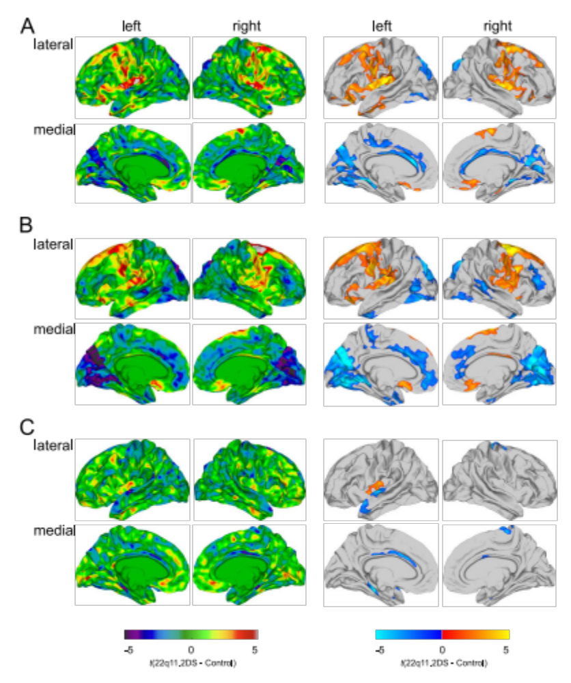

Significant differences in regional cortical volume (rCV; A), surface area (SA; B), and cortical thickness (CT; C) in all individuals with 22q11.2DS compared to typically developing controls. The left panel shows the un-thresholded t-maps where increases in 22q11.2DS relative to controls are indicated in yellow to red, and decreases in blue to cyan. The right panel shows the random-field-theory (RFT)-based cluster-corrected (p<0.05, two-tailed) difference maps indicating significant increases (marked in red to yellow) and decreases (marked in blue) following correction for multiple comparisons.

Supplementary Figure S2. Between-group comparison for idiopathic ASD compared to Controls.
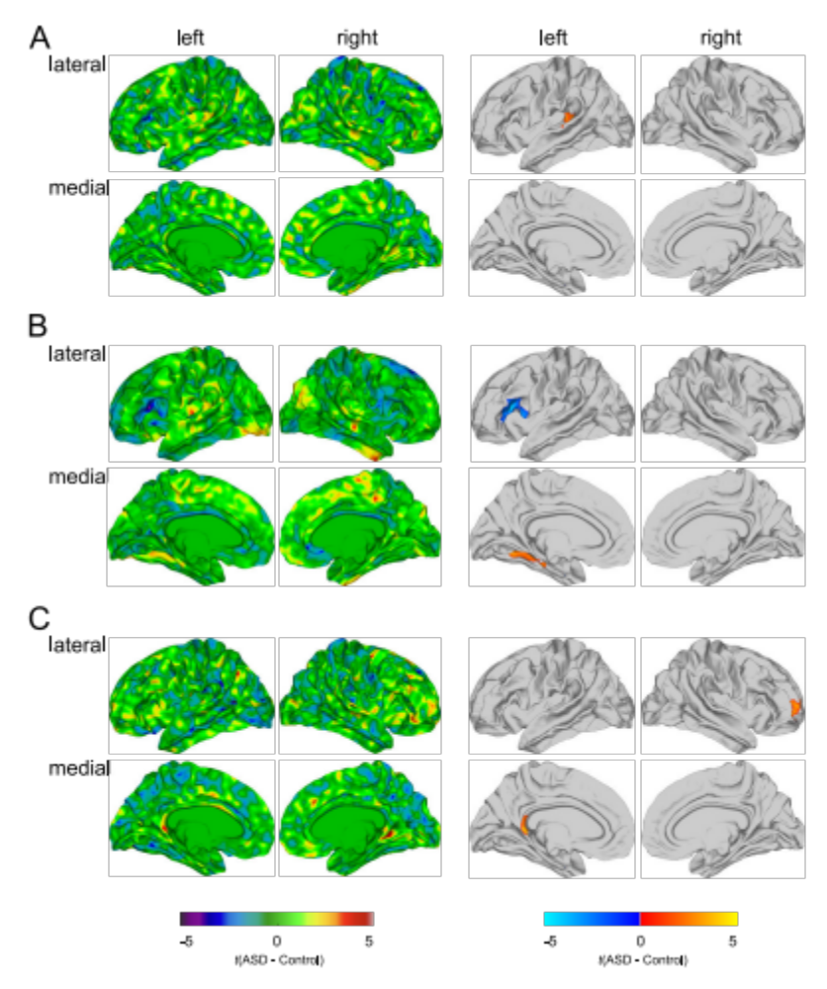

Significant differences in regional cortical volume (rCV; A), surface area (SA; B), and cortical thickness (CT; C) in individuals with idiopathic ASD compared to typically developing controls. The left panel shows the un-thresholded t-maps where increases in ASD relative to controls are indicated in yellow to red, and decreases in blue to cyan. The right panel shows the random-field-theory (RFT)-based cluster-corrected (p<0.05, two-tailed) difference maps indicating significant increases (marked in red to yellow) and decreases (marked in blue) following correction for multiple comparisons.
Supplementary Figure S3. Un-thresholded Results for the Categorical Analyses.
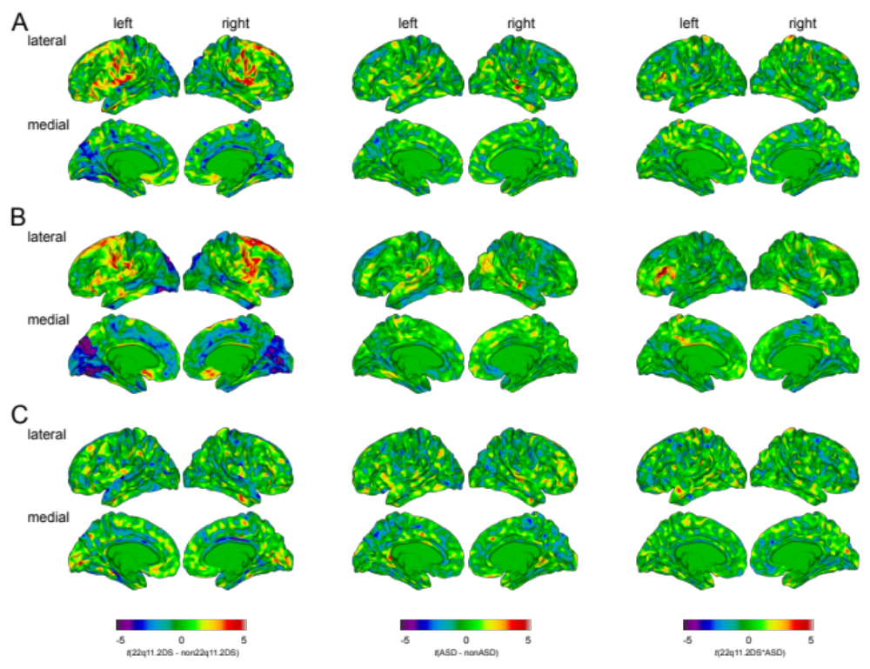
Significant differences in regional cortical volume (rCV; A), surface area (SA; B), and cortical thickness (CT; C) for the main effect of 22q11.2DS (left panel; i.e. all individuals with 22q11.2DS compared to typically developing (TD) controls and idiopathic ASD), the main effect of ASD (middle panel; i.e. all individuals with ASD symptomatology (22q11.ASD and idiopathic ASD) compared to nonASD individuals (TD controls and 22q11.nonASD), and for the 22q11.2DS-by-ASD interaction (right panel). Displayed are the un-thresholded t-maps where increased parameter estimates in 22q11.2DS, respectively ASD, are marked in red to yellow, and decreased parameters are marked in blue to cyan.

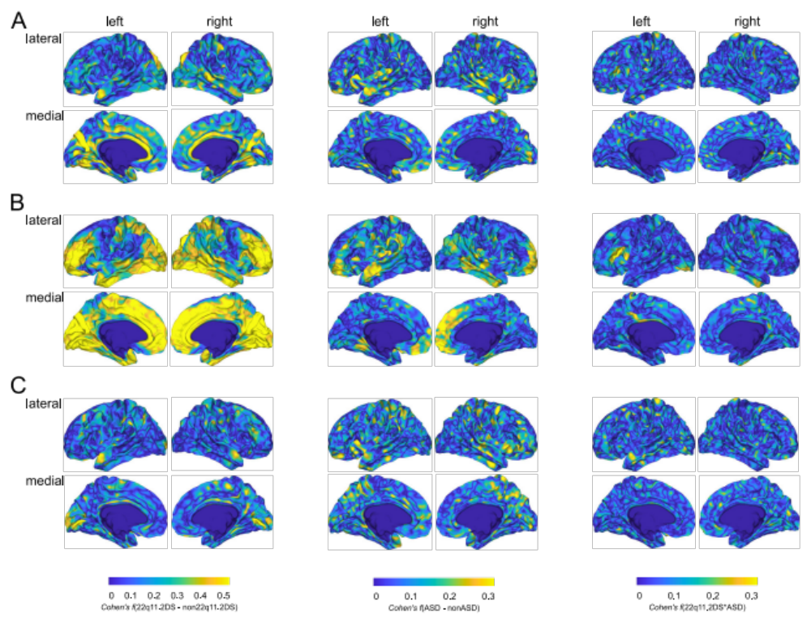
Supplementary Figure S4. Effect Sizes for Categorial results.

Effect sizes (Cohen’s f) for the main effect of 22q11.2DS (left panel), the main effect of ASD (middle panel), and for the 22q11.2DS-by-ASD interaction term (right panel). Effect sizes for vertex-wise estimates of regional cortical volume (rCV) are shown in (A), for surface area (SA) in (B), and cortical thickness (CT) in (C).

Supplementary Figure S5. (In)Homogeneity of Variance between idiopathic ASD and 22q11.ASD individuals.
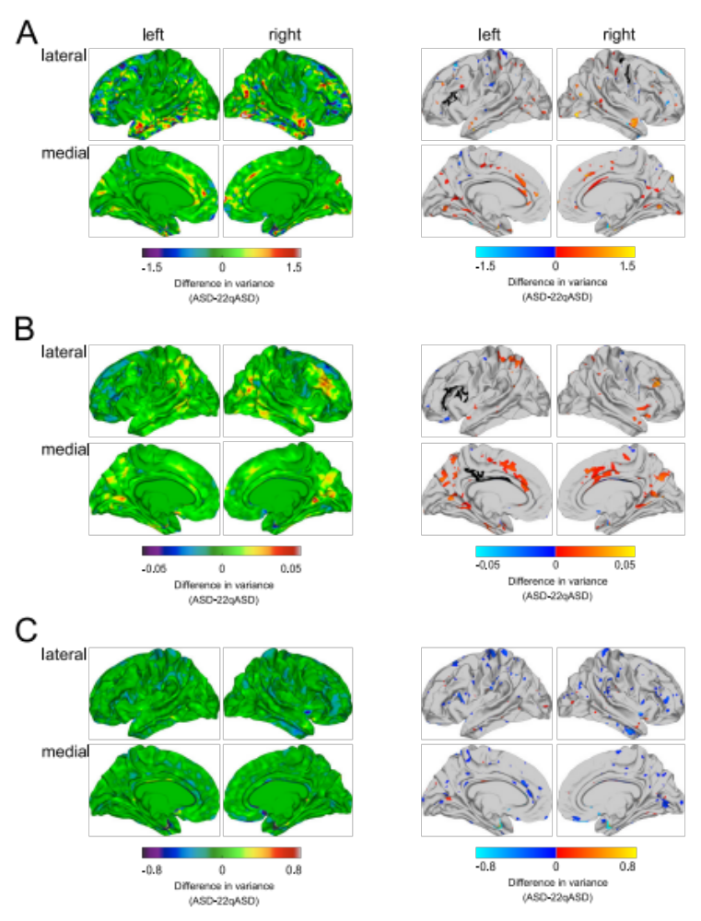

The left panel shows vertex-wise differences in variance between individuals with idiopathic ASD (ASD) and individuals with the 22q11.2 microdeletion and ASD (22qASD) for regional cortical volume (rCV; A), surface area (SA; B), and cortical thickness (CT; C). The right panel shows vertices with a significant difference in variance as assessed using Levene’s test of homogeneity of variance following a FDR correction for multiple comparisons. Significant increases in variance in ASD compared to 22qASD are marked in red to yellow, and decreased variances are marked in blue. The regions-of-interest marked by black lines correspond to the clusters with a significant 22q11.2DS-by-ASD interaction effect as resulting from the categorical analyses.

Supplementary Figure S6. Schematic Overview of the Methodology behind the Canonical Correlation Analysis (CCA).
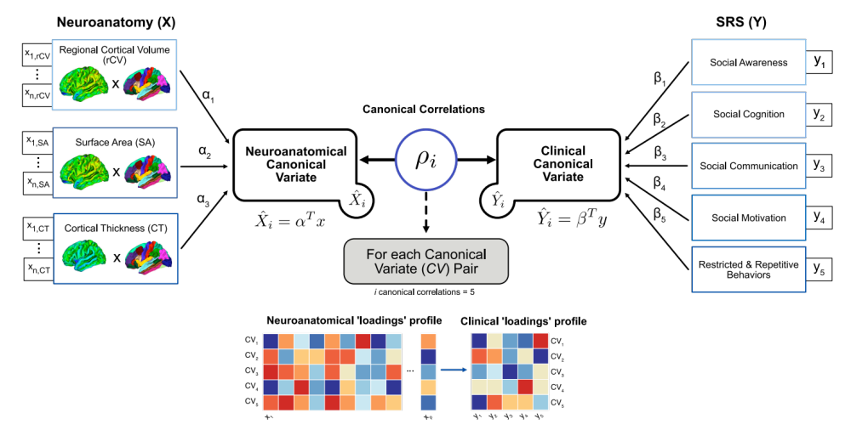
CCA was used to examine the relationship between neuroanatomical variability in regional cortical volume (rCV), surface area (SA), and cortical thickness (CT) as predictors (X; left panel), and the five Social Responsiveness Scale (SRS) subdomain scores in (1) social awareness (SAW), (2) social cognition (SCG), (3) social communication (SCM), (4) social motivation (SM), and (5) restricted and repetitive behaviors (RRB) as clinical outcomes (Y; right panel). CCA estimates two parameter vectors $α$ and $β$ so that the correlation $ρ$ between the linear combinations $\hat{X}=α^{T}X$ and $\hat{Y}=β^{T}Y$ is maximised. The resulting predicted variables ${\hat{X}}_{1}$ and ${\hat{Y}}_{1}$ are the first pair of canonical variates (CVs), and their correlation $ρ_{1}$ is the first canonical correlation (CC). The 2nd set of parameter estimates maximising $ρ$ is then derived subject to the constraint of being uncorrelated with the first pair of canonical variates. This procedure may be continued up to $i$ times, where $i=min\{p,q\}$, resulting in maximally $i$ canonical variate pairs.

Supplementary Figure S7. Boxplots for the significant 22q11.2DS-by-ASD Interaction Clusters.
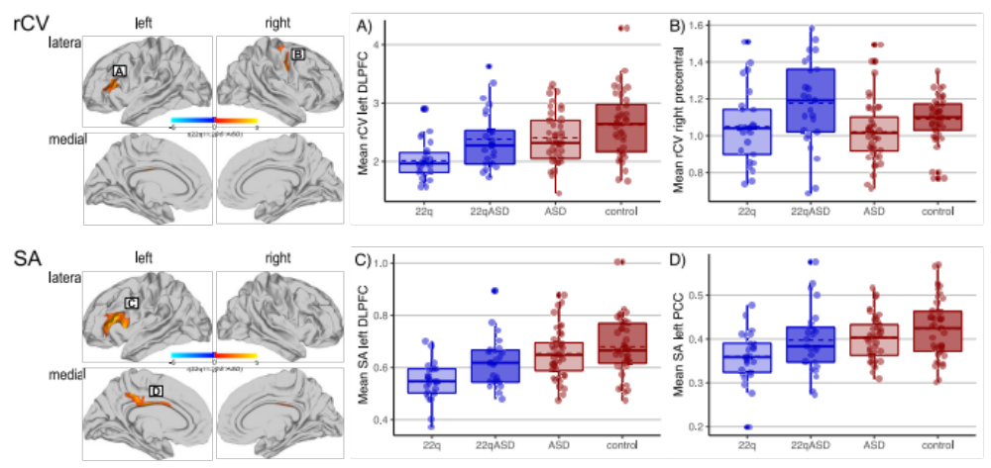
Boxplots displaying the significant 22q11.2DS-by-ASD interaction effects for regional cortical volume (rCV) in the left dorsolateral prefrontal cortex (DLPFC; BA 44-46; A) and the right precentral gyrus (BA 4; B); and for surface area (SA) in the left DLPFC (BA 44-46; C), and the left posterior cingulate cortex (PCC; BA 23-24/31; D). The solid bars indicate the median values of each group, with the lower and upper hinges corresponding to the first (the 25th percentile) and third (the 75th percentile) quartiles, while the dashed bars represent the mean values. ‘22q’ represents 22q11.2 deletion carriers without ASD symptomatology, ‘22qASD’ represents 22q11.2 deletion carriers with ASD symptomatology, ‘ASD’ represents individuals with idiopathic ASD, and ‘controls’ represents typically developing controls.

Supplementary Figure S8. Categorical 22q11.2DS-by-ASD Interaction Effect when covarying for repetitive symptoms.
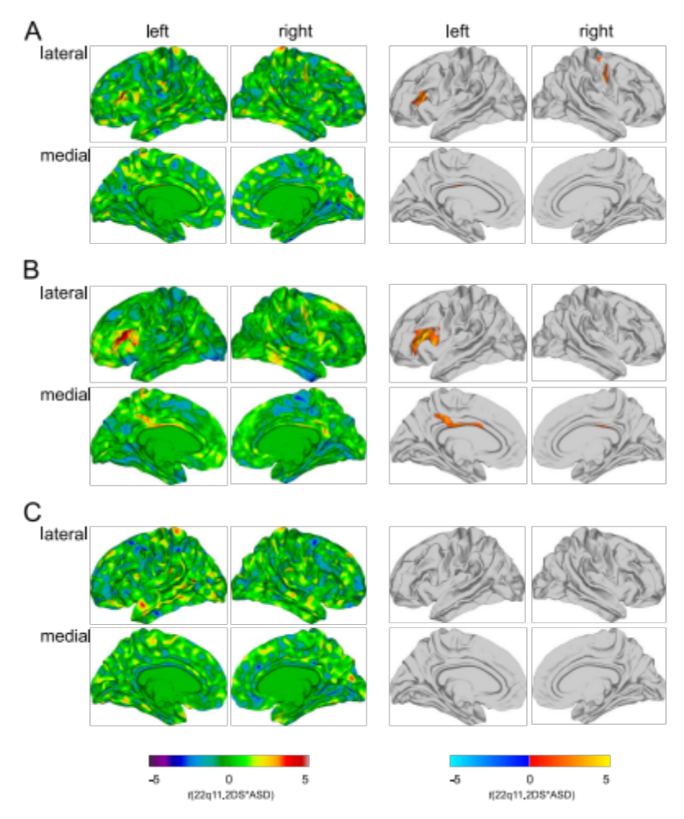
Significant 22q11.2DS-by-ASD interaction effects for regional cortical volume (rCV; A), surface area (SA; B), and cortical thickness (CT; C), when covarying for repetitive symptoms based on the Social Responsiveness Scale (SRS) Restricted Interests and Repetitive Behavior subscale. Displayed are the un-thresholded t-maps (left panel) and the random field theory (RFT)-based cluster corrected (p<0.05, 2-tailed) difference maps following multiple comparisons (right panel).

Supplementary Figure S9. Distribution of SRS subdomain and total scores across groups.
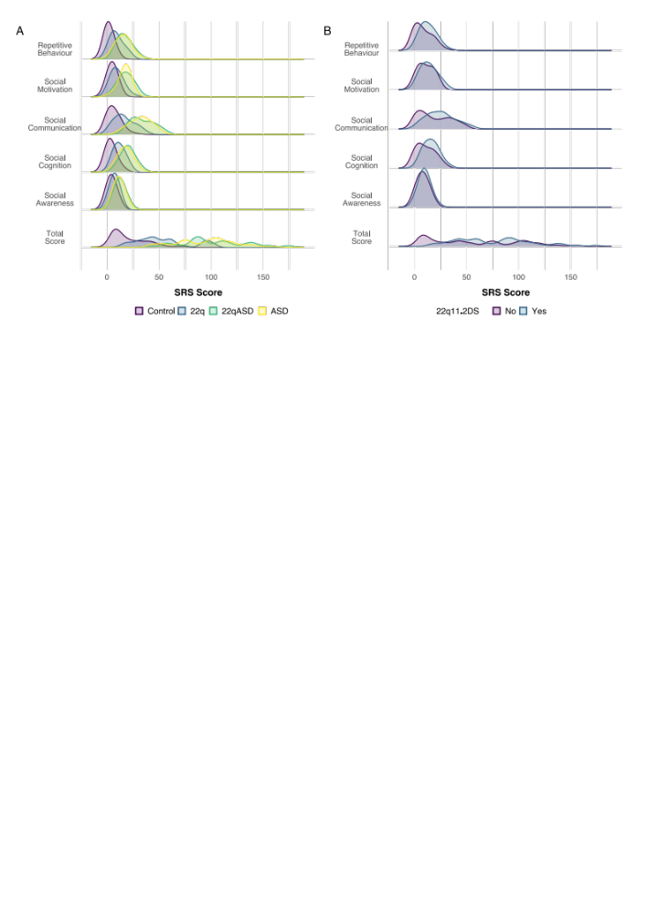
Histograms indicating the distribution of Social Responsiveness Scale scores between groups. Displayed are both the subdomain and total scores between groups (A) for typically developing controls (control; purple), individuals with 22q11.2DS without ASD (22q; blue), individuals with 22q11.2DS and ASD (22qASD; green), and idiopathic ASD individuals (ASD; yellow), as well as comparison of (B) individuals with 22q11.2DS (i.e. 22q and 22qASD; purple) compared to those without (i.e. control and ASD; blue).

Supplementary Figure S10. Neuroanatomical Canonical Loading Plots.
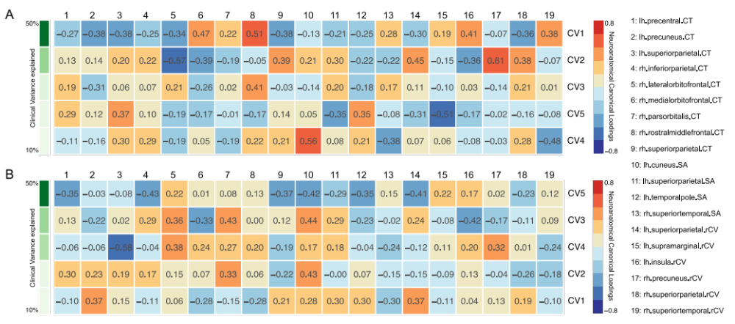
(A) Neuroanatomical loading plots illustrating the neuroanatomical canonical loadings (i.e. correlations) between measures of regional cortical volume (rCV), surface area (SA), and/or cortical thickness (CT) in the set of 19 ROIs with the respective five neuroanatomical canonical variates (CVs) within the individuals without the 22q11.2 microdeletion; (B) and within individuals with the 22q11.2 microdeletion. CVs are sorted in descending order based on the percentage of clinical variance explained, which is indicated in shades of green on the left

References

1. Gotham K, Pickles A, Lord C. Standardizing ADOS Scores for a Measure of Severity in Autism Spectrum Disorders. J Autism Dev Disord. 2009;39(5):693-705.
2. Hus V, Lord C. The Autism Diagnostic Observation Schedule, Module 4: Revised Algorithm and Standardized Severity Scores. J Autism Dev Disord. 2014;44(8):1996-2012.
3. Hus V, Gotham K, Lord C. Standardizing ADOS Domain Scores: Separating Severity of Social Affect and Restricted and Repetitive Behaviors. J Autism Dev Disord. 2014;44(10):2400-12.

