Supplementary information
Reconfigurable Hyperbolic Polaritonics with Correlated Oxide Metasurfaces
Neda Alsadat Aghamiri¹, Guangwei Hu^{2,3}, Alireza Fali¹, Zhen Zhang⁴, Jiahan Li⁵, Sivacarendran Balendhran⁶, Sumeet Walia^{7,8}, Sharath Sriram^{8,9}, James H. Edgar⁵, Shriram Ramanathan⁴, Andrea Alù^{2,10}, Yohannes Abate^{1*}
1 Department of Physics and Astronomy, University of Georgia, Athens, Georgia 30602, USA
2 Photonics Initiative, Advanced Science Research Center, City University of New York, New York, NY 10031, USA
3 Department of Electrical and Computer Engineering, National University of Singapore, Kent Ridge, Singapore 117583, Singapore
4 School of Materials Engineering, Purdue University, West Lafayette, IN 47907, USA
5 Tim Taylor Department of Chemical Engineering, Kansas State University, Manhattan, KN 66506, USA
6 School of Physics, University of Melbourne, Parkville, Victoria 3010, Australia
7 School of Engineering RMIT University Melbourne, Victoria, Australia
8 Functional Materials and Microsystems Research Group and the Micro Nano Research Facility RMIT University Melbourne, Victoria, Australia
9 ARC Centre of Excellence for Transformative Meta-Optical Systems, RMIT University, Melbourne, Victoria, Australia
10 Physics Program, Graduate Center, City University of New York, New York, NY 10016, USA
e-mail: yohannes.abate@uga.edu
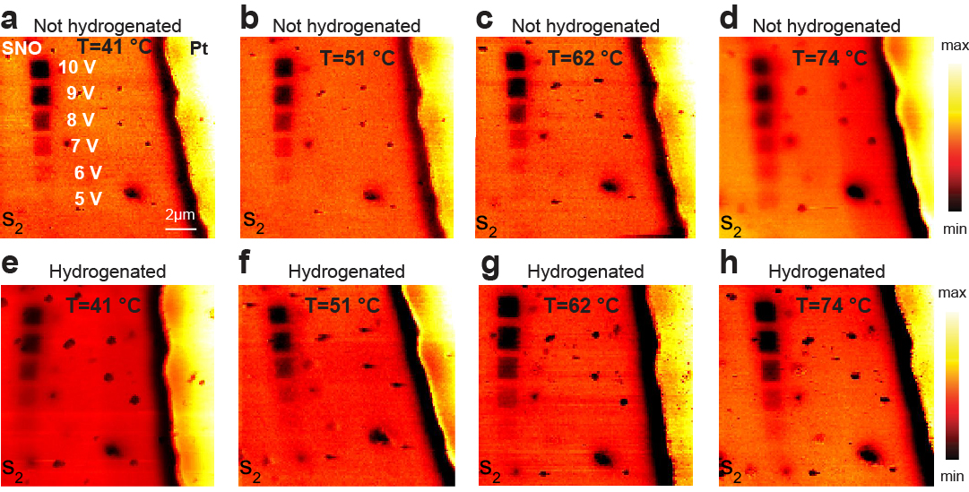
Fig. S1 | a-d, second harmonic near field amplitude s₂ images at different temperatures (no H₂ exposure). e-h, second harmonic near field amplitude s₂ images at different temperatures after exposing to 5% H₂ gas while heating at 100 °C all imaged at λ= 10.5 µm.

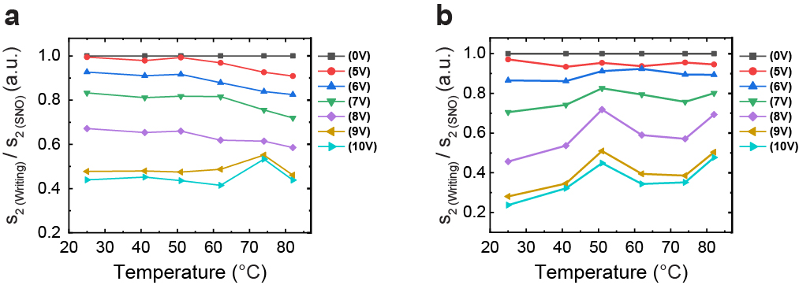
Fig. S2 | a, normalized amplitude s_{2(writing)}/s_{2(SNO)} without exposing to H₂ for different temperatures. b, normalized amplitude s_{2(writing)}/s_{2(SNO)} after being exposed to 5% H₂ gas while heating at 100 °C for different temperatures.

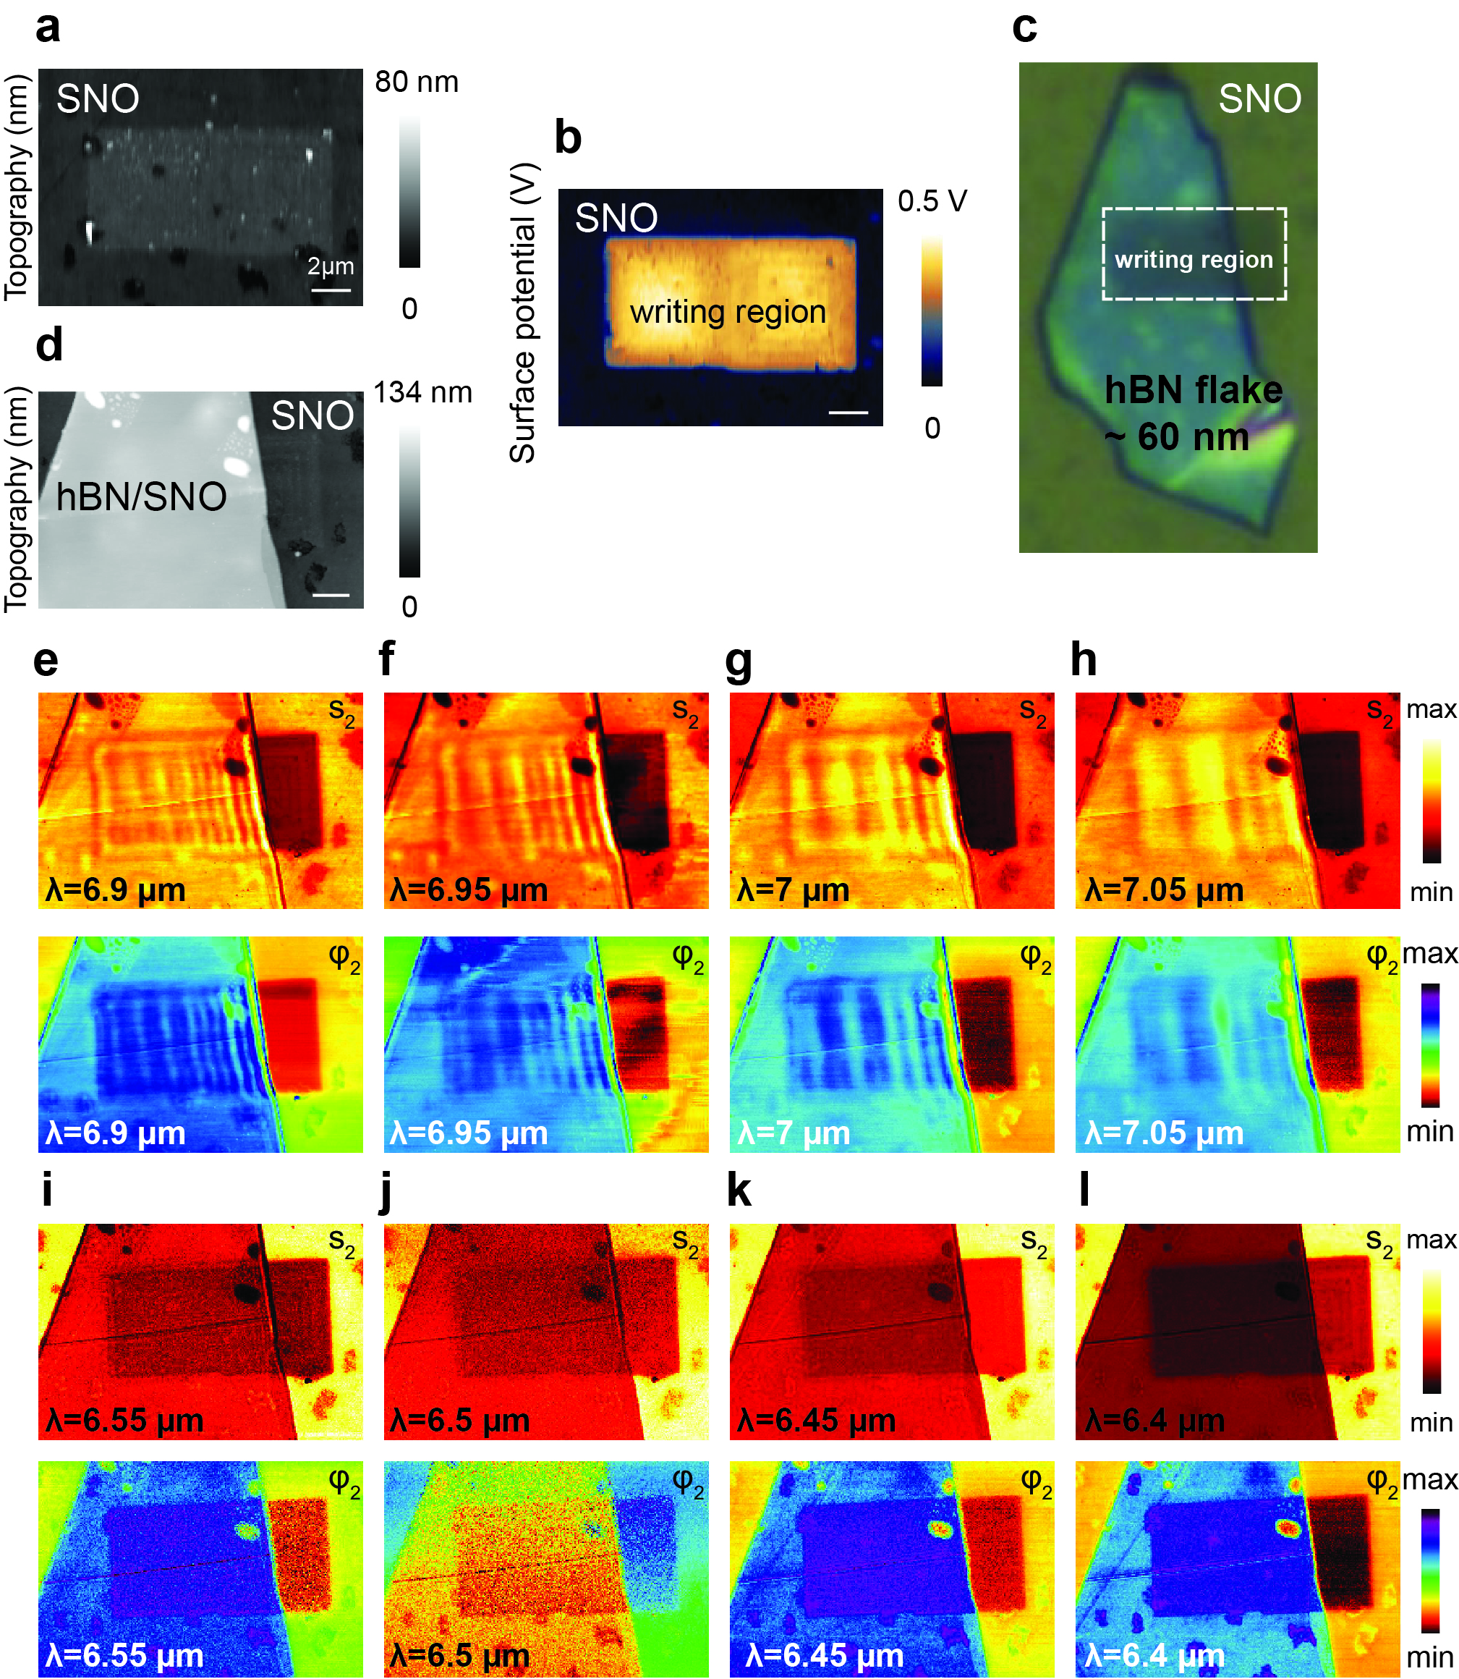
Fig. S3 | a, Topography b, Surface potential showing the lithography pattern made with SPM using 10 V. c picture of the flake transferred on the top of SNO including writing pattern of part b. d, Topography image of the pristine SNO with transferred hBN flake on the top. Corresponding second-harmonic near field amplitude s₂ and phase φ₂ images of part d at e, 6.9 µm f, 6.95 µm g, 7 µm h, 7.05 µm i, 6.55 µm j, 6.5 µm k, 6.45 µm and l, 6.9 µm.

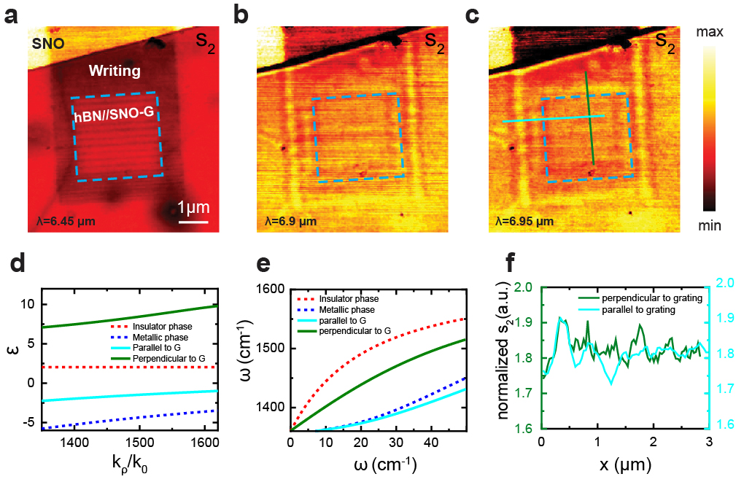
Fig. S4 | Anisotropic propagation of polaritons in hBN. IR s-SNOM second harmonic near field amplitude s₂ images of hBN/SNO-G at a, 6.45 µm b, 6.9 µm and c, 6.95 µm, scale bar is 2 µm. d, Amplitude s₂ line profile as indicated in panel c with green and blue lines showing polariton propagating parallel and perpendicular to the grating, the dash red line shows where grating starts. e, The effective permittivity of substrate, the red, blue, cyan and green solid lines represent the permittivity of SNO in insulator phase, SNO in metallic phase, SNO-G parallel to ribbon and SNO-G perpendicular to ribbon. f, the calculated polariton momentum with the substrate of insulator SNO (red dashed line), metallic SNO (blue dashed line), along SNO-G (cyan solid line) and perpendicular to SNO-G directions.
In-plane anisotropic propagation of polaritons can be realized by either exploiting natural in-plane anisotropic crystals ^{1,2} or structuring in-plane isotropic crystals to metasurfaces ^{3,4}. The later method however requires demanding fabrication techniques and suffers from nonlocality ⁵. In Fig. S4 we counterintuitively propose and demonstrate anisotropic propagation of polaritons in pristine in-plane isotropic crystal, via changing part of insulator SNO substrate to metallic phase, forming the SNO grating (SNO-G). As shown in Fig. S4a, we fabricate a hBN/SNO-G heterostructure, where the width of SNO in insulator and metallic phase are (W₁=) 132 and (W₂=) 160 nm. Figures S4b-c show s-SNOM second harmonic amplitude images of propagating polaritons taken at 6.9 µm and 6.95 µm laser wavelengths. The propagation of polaritons perpendicular to the grating is easily visible while the polariton propagation along the SNO ribbon is less obvious, as shown in Fig. S4f. This provides a clear signature of anisotropic propagation of polaritons which resulted due to the anisotropic patterns in SNO.
To model our system, we could homogenize deep-wavelength grating beneath with average medium theory, which is written as $ε_{∥}=ρε_{1}+\left(1-ρ\right)ε_{2}; ε_{⊥}={\left(\frac{ρ}{ε_{1}}+\frac{1-ρ}{ε_{2}}\right)}^{-1}$. Here, $ρ=\frac{W_{1}}{W_{1}+W_{2}}$, $ε_{1}$ and $ε_{2}$ are the permittivity of SNO in insulator and metallic phase; $ε_{∥}$ and $ε_{⊥}$ are the effective permittivity of substrate parallel and perpendicular to the SNO-G, which are plot in Fig. S4d. In that sense, we construct an anisotropic-isotropic interface that could tune the polaritonic response in hBN. The dispersion of hBN polaritons along two principal directions ($∥$ and $⊥$) is calculate by
$$k_{j}=-\frac{Φ}{d}\left[\operatorname{atan}\left(\frac{ε_{0}}{ε_{hBN,⊥}}Φ\right)+\operatorname{atan}\left(\frac{ε_{j}}{ε_{hBN,⊥}}Φ\right)+lπ\right]$$
Where $Φ=\sqrt{-\frac{ε_{hBN,∥}}{ε_{hBN,⊥}}}$, $ε_{j}$ is $ε_{∥}$ for momentum along SNO-G direction and is $ε_{⊥}$ perpendicular the SNO-G direction; $ε_{hBN,⊥}$ and $ε_{hBN,∥}$ are permittivity of hBN perpendicular and parallel to OA; and $l$ is the mode index. The calculated dispersion is provided in Fig. S4e, which shows strong difference of momentum along and perpendicular to the SNO-G, justifying the anisotropic propagation of hBN. This result provides an alternative avenue towards anisotropic propagation of polaritons, totally different from all previous methods, as it tailors the substrate’s anisotropy. Nevertheless, since the spatial resolution of tunable substrate can be further enhanced by our PCM techniques and other pattern can be directly applied, we expect more degree of freedoms to control the polaritons and more reconfigurable functional metamaterials devices can be developed from this technique ⁶.

1 Ma, W. et al. In-plane anisotropic and ultra-low-loss polaritons in a natural van der Waals crystal. Nature 562, 557-562, doi:10.1038/s41586-018-0618-9 (2018).
2 Zheng, Z. et al. A mid-infrared biaxial hyperbolic van der Waals crystal. Science Advances 5, eaav8690, doi:10.1126/sciadv.aav8690 (2019).
3 Li, P. et al. Infrared hyperbolic metasurface based on nanostructured van der Waals materials. Science 359, 892-896, doi:10.1126/science.aaq1704 (2018).
4 Hu, G., Shen, J., Qiu, C.-W., Alù, A. & Dai, S. Phonon Polaritons and Hyperbolic Response in van der Waals Materials. Advanced Optical Materials 8, 1901393, doi:https://doi.org/10.1002/adom.201901393 (2020).
5 Li, P. et al. Collective near-field coupling and nonlocal phenomena in infrared-phononic metasurfaces for nano-light canalization. Nature Communications 11, 3663, doi:10.1038/s41467-020-17425-9 (2020).
6 Dai, Z. et al. Artificial Metaphotonics Born Naturally in Two Dimensions. Chemical Reviews 120, 6197-6246, doi:10.1021/acs.chemrev.9b00592 (2020).

