Supplementary file
Figure S1. Lesion characteristics at 45 W comparing Perpendicular and Oblique catheter orientations in ex vivo ablation study
Comparison of lesion volume, surface area, surface diameter, and depth between perpendicular (90°) and oblique (45°) catheter orientations at 45 W output.
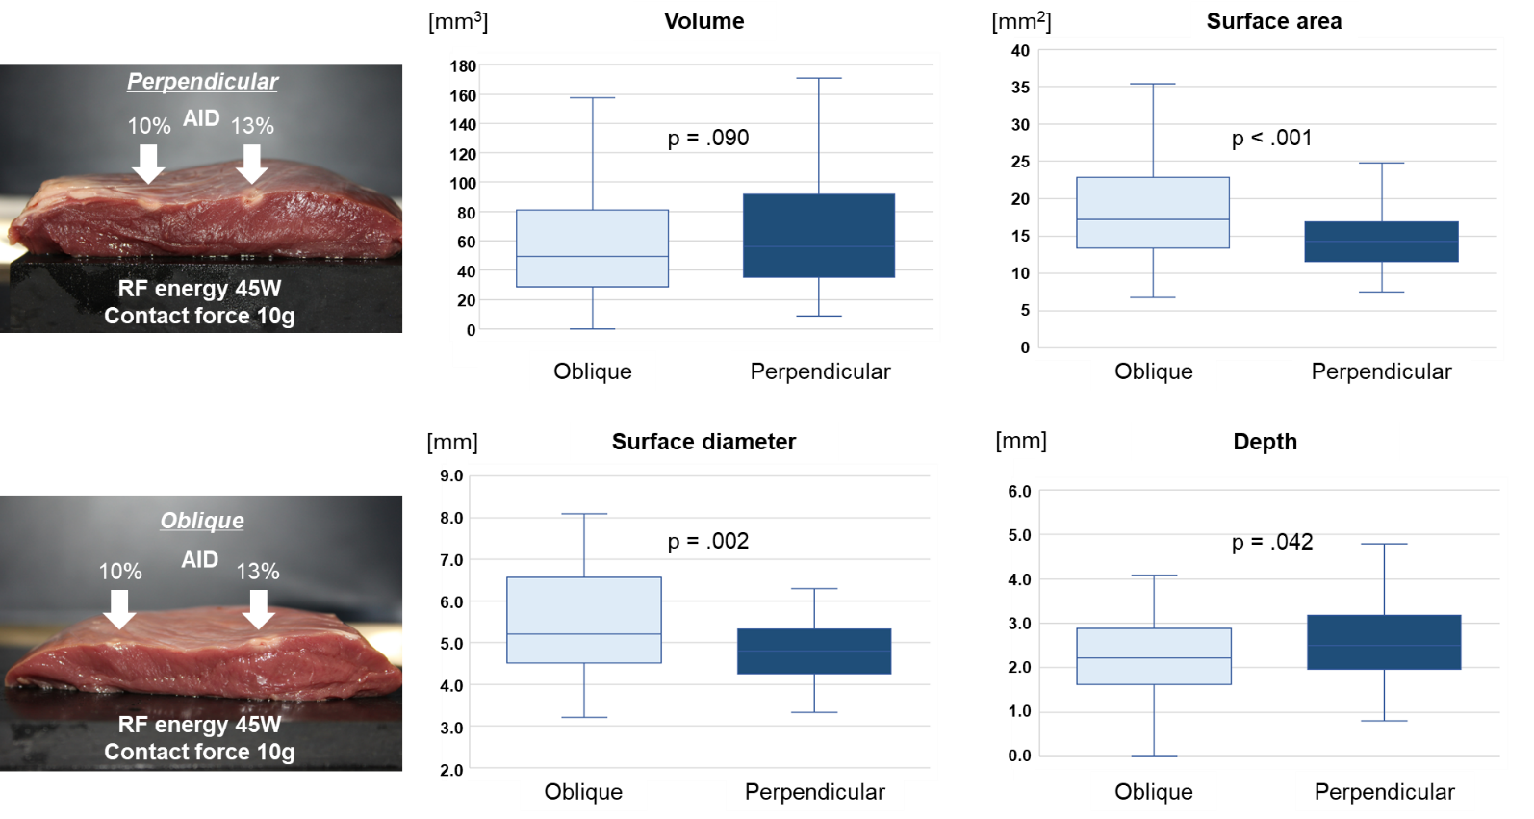

Figure S2. Comparison of first-pass isolation success between conventional and AID%-guided ablation.
Comparison of first pass isolation percentages between conventional and AID%-guided protocols.
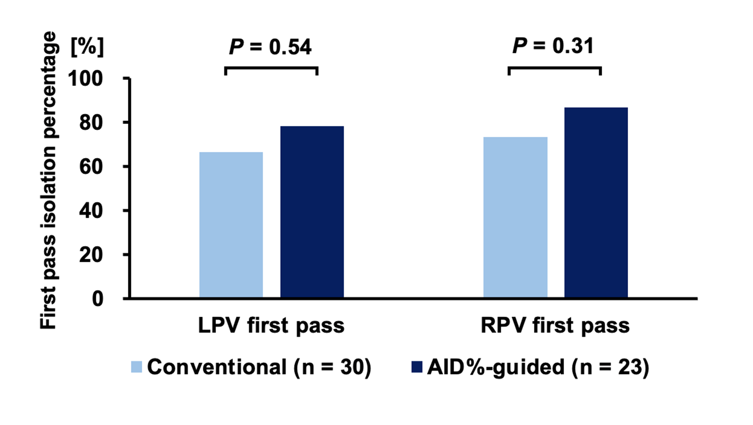

Table S1. Comparison of procedural and electrophysiological parameters between below- and above-targeted AID (%) groups.
Below-targeted AID (%) lesions had lower power, contact force, and impedance, with no significant difference in omnipolar voltage.
Abbreviations: CF = contact force; AID = averaged impedance drop; Imp = impedance; W = watt; mV = millivolt.
 | All  N=1224 | Below targeted AID(%) value  N=585 | Above targeted AID(%) value  N=639 | P-value
Average CF (g) | 11 [8-14] | 10 [7-13] | 11 [9-15] | <.001
Max CF (g) | 2 [1-4] | 26 [19-40] | 24 [18-36] | .09
Min CF (g) | 25 [18-38] | 1 [0-3] | 3 [1-5] | <.001
Max Temperature (℃) | 34 [33-36] | 34 [33-36] | 34 [33-36] | .99
Average Power (W) | 44 [39-48] | 44 [39-48] | 44 [41-48] | <.001
Duration (s) | 21 [19-26] | 22 [19-26] | 21 [18-26] | .18
Energy (W) | 977 [813-1111] | 977 [782-1350] | 977 [845-1102] | .65
Omnipolar voltage (mV) | 2.1 [0.9-3.8] | 2.0 [1.0-3.9] | 2.0 [0.9-3.8] | .62

