Supplementary material

Supplementary Table 1. Characteristics of hedgerow of the sampled rows of paddocks. The height of Hazel, Aronia, and Sitka spruce were at around 1.5 m, 1.0 m, and 1.75 m on average respectively.
Site | Hedgerow no | Length (m) | Pigs access to trees | Place in rotation | Grass cover june 2024 | Hedge age (Poplar trees) | Tree rows (Poplar) | Poplar height | Oak (Quercus robur) |  | Oak height | Species in diverse row | Hazel % | Aronia % | Mirabel % | Sitka spruce % | Species richness (trees)
Farm 1 | 1 | 417 | No | Spring barley | 100-125 | 7 | 5 | 16 | Yes |  | 16 | na | 0 | 0 | 10 | 0 | 2
Farm 1 | 2 | 444 | No | Spring barley | 100-125 | 7 | 5 | 16 | No |  | 0 | na | 0 | 0 | 6.7 | 0 | 2
Farm 1 | 3 | 444 | No | Spring barley | 100-125 | 7 | 5 | 16 | No |  | 0 | na | 0 | 0 | 3.4 | 0 | 2
Farm 1 | 4 | 506 | No | Spring barley | 100-125 | 7 | 3 | 16 | Yes |  | 16 | Crataegus laevigata , Physocarpus opulifolius | 0 | 0 | 0 | 0 | 4
Farm 1 | 7 | 534 | Yes | Sows with piglets | 75-100 | 7 | 5 | 16 | No |  | 0 | na | 0 | 0 | 5 | 13 | 3
Farm 1 | 8 | 598 | Yes | Sows with piglets | 75-100 | 7 | 5 | 16 | No |  | 0 | na | 0 | 0 | 5 | 13 | 3
Farm 1 | 9 | 598 | Yes | Sows with piglets | 75-100 | 7 | 3 | 16 | Yes |  | 10 | Crataegus laevigata, Ulmus glabra, Physocarpus opulifolius | 0 | 0 | 5 | 13 | 6
Farm 1 | 10 | 638 | Yes | Sows with piglets | 75-100 | 7 | 5 | 16 | No |  | 0 | na | 0 | 0 | 5 | 13 | 3
Farm 1 | 13 | 217 | No | Spring barley | 100-125 | 3 | 5 | 8 | No |  | 0 | na | 5 | 5 | 8 | 5 | 5
Farm 1 | 14 | 309 | No | Spring barley | 100-125 | 3 | 5 | 8 | No |  | 0 | na | 5 | 3 | 9 | 5 | 5
Farm 1 | 15 | 309 | No | Spring barley | 100-125 | 3 | 3 | 8 | Yes |  | 10 | Symphoricarpos albus,Crataegus laevigata, Malus sp, Acer campestre, Prunus serotina | 4 | 4 | 8 | 4 | 11
Farm 1 | 16 | 217 | No | Spring barley | 100-125 | 3 | 5 | 8 | No |  | 0 | na | 5 | 5 | 8 | 5 | 5
Farm 1 | 17 | 309 | No | Clover grass | 100-125 | 3 | 5 | 8 | No |  | 0 | na | 6 | 2 | 7 | 5 | 5
Farm 1 | 18 | 234 | No | Clover grass | 100-125 | 3 | 5 | 8 | No |  | 0 | na | 6 | 2 | 7 | 5 | 5
Farm 1 | 19 | 234 | No | Sows with piglets | 100-125 | 3 | 3 | 8 | Yes |  | 10 | Symphoricarpos albus, Crataegus laevigata, Malus sp, Acer campestre, Prunus serotina | 4 | 4 | 8 | 4 | 11
Farm 1 | 20 | 309 | No | Sows with piglets | 75-100 | 3 | 5 | 8 | No |  | 0 | na | 6 | 2 | 7 | 5 | 5
Farm 1 | 21 | 300 | No | Sows with piglets | 75-100 | 3 | 5 | 8 | No |  | 0 | na | 6 | 2 | 7 | 5 | 5
Farm 1 | 22 | 300 | No | Sows with piglets | 75-100 | 2 | 3 | 8 | Yes |  | 10 | Symphoricarpos albus, Crataegus laevigata, Malus sp, Acer campestre, Prunus serotina | 4 | 4 | 8 | 4 | 11
Farm 2 | 23 | 217 | No | Spring barley | 100-125 | 2 | 1 | 0 | No |  | 0 | na | 0 | 0 | 0 | 0 | 4
Farm 2 | 24 | 220 | No | Spring barley | 100-125 | 2 | 1 | 0 | No |  | 0 | na | 0 | 0 | 0 | 0 | 4
Farm 2 | 25 | 0 | No | Grass without pigs | 25-50 | No trees | 0 | 0 | No |  | 0 | na | 0 | 0 | 0 | 0 | 0
Farm 2 | 26 | 0 | No | Sows with piglets | 75-100 | No trees | 0 | 0 | No |  | 0 | na | 0 | 0 | 0 | 0 | 0
Farm 2 | 27 | 0 | No | Grass without pigs | 100-125 | No trees | 0 | 0 | No |  | 0 | na | 0 | 0 | 0 | 0 | 0

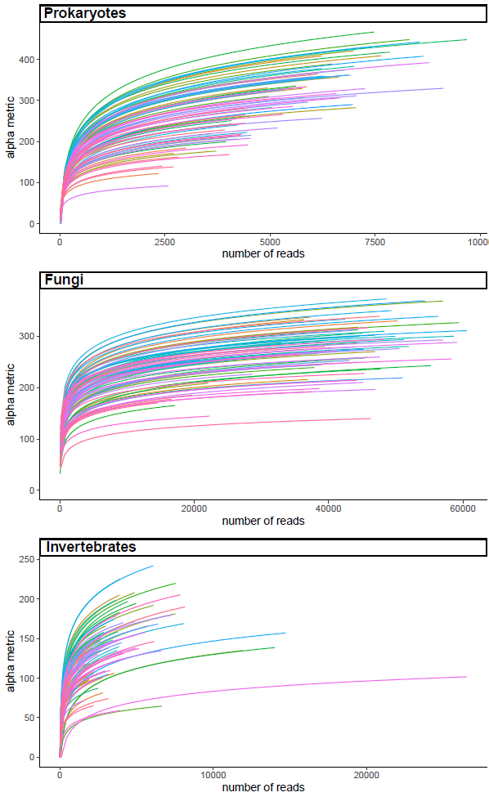
Supplementary Fig. 1: Rarefaction curves of the soil prokaryotic, fungal and invertebrate communities using ASV richness as a function of sequencing depth, showing that most samples approach an asymptote, indicating sufficient sequencing depth to capture most of the diversity.

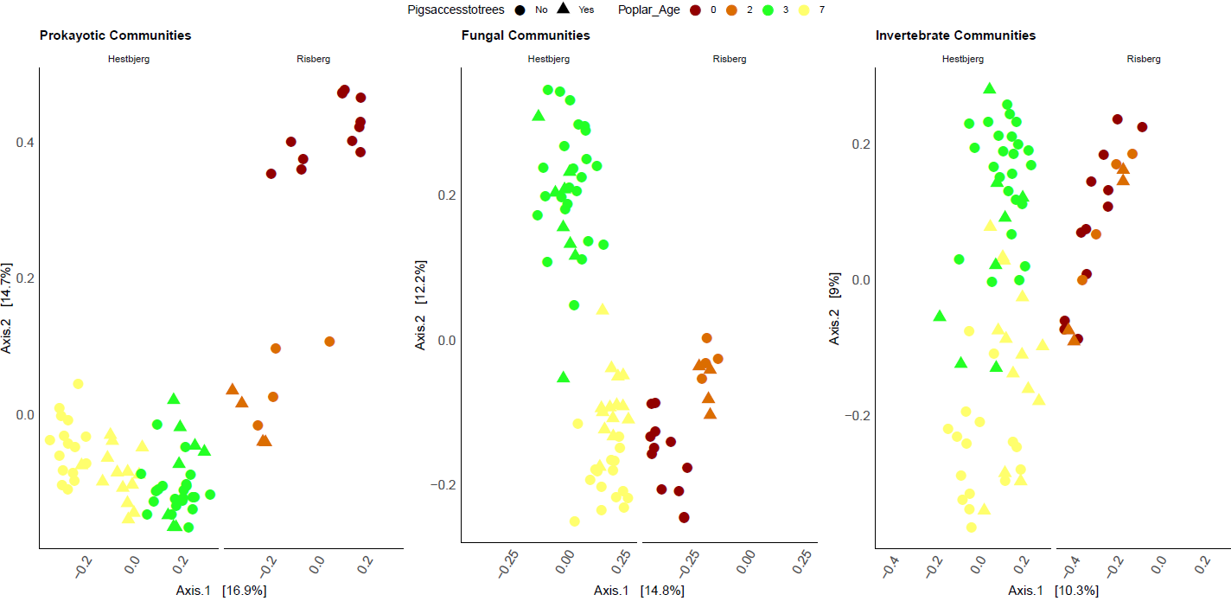Supplementary Fig. 2: Principal coordinate analysis (PCoA) of the soil prokaryotic, fungal and invertebrate communities using Bray-Curtis dissimilarity matrix. Two locations are shown separately. Pig access to paddocks is represented by different shapes and age of trees with colors.
Supplementary Fig. 3. Differentially enriched bacterial genera associated with pig access, identified using DESeq2. Bars represent the log2 fold change in relative abundance between conditions, with positive values indicating enrichment in soils with pig access and negative values indicating enrichment in soils without pig access.

Supplementary Fig. 4. Differentially enriched bacterial genera associated with hedgerow age, identified using DESeq2. Bars represent the log2 fold change in relative abundance between conditions, with positive values indicating enrichment in soils with hedgerow age of seven years and negative values indicating enrichment in soils without hedgerow age of three years.

