Supplemental online material for manuscript:

Impact of the full-scale Russian invasion on landscape sustainability in Eastern Ukraine: Insights from the Earth observation foundation model and social media

Oleksandr Karasov * ª, Usama Humayunª, Oleh Prylutskyi ^{b,c}, Henrikki Tenkanenª
ª - GIST Lab, Department of Built Environment, Aalto University, Finland
^{b} - Falz-Fein Biosphere Reserve “Askania Nova”, Askania Nova, Ukraine
^{c} - V. N. Karazin Kharkiv National University, Kharkiv, Ukraine
* Corresponding author: Oleksandr Karasov

Sustainability Science

Contents
Figure S1. Distribution of Flickr photos and users. 2
Figure S2. Distribution of tweets and Twitter users. 3
Figure S3. Distribution of VK photos and users . 4
Figure S4. Spatial distribution of the selected visited and unvisited H3 cells 5
Table S1. Raw outputs of the Random Forest modelling 6
Table S2. Outputs from the debiasing workflow 7
Table S3. Spatially blocked cross-validation metrics 9

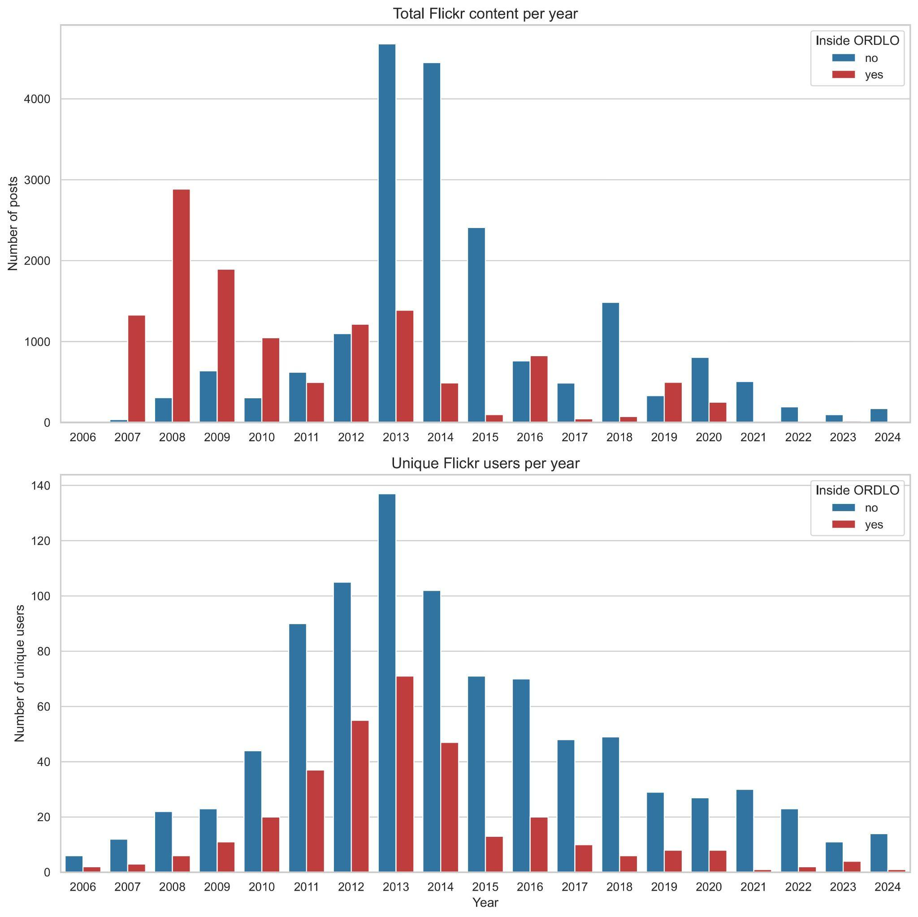
Figure S1. Distribution of Flickr photos and users in ORDLO and non-occupied territories of Ukraine over the years reveals a decline in Flickr's popularity during the study period and, overall, its lower representativeness.
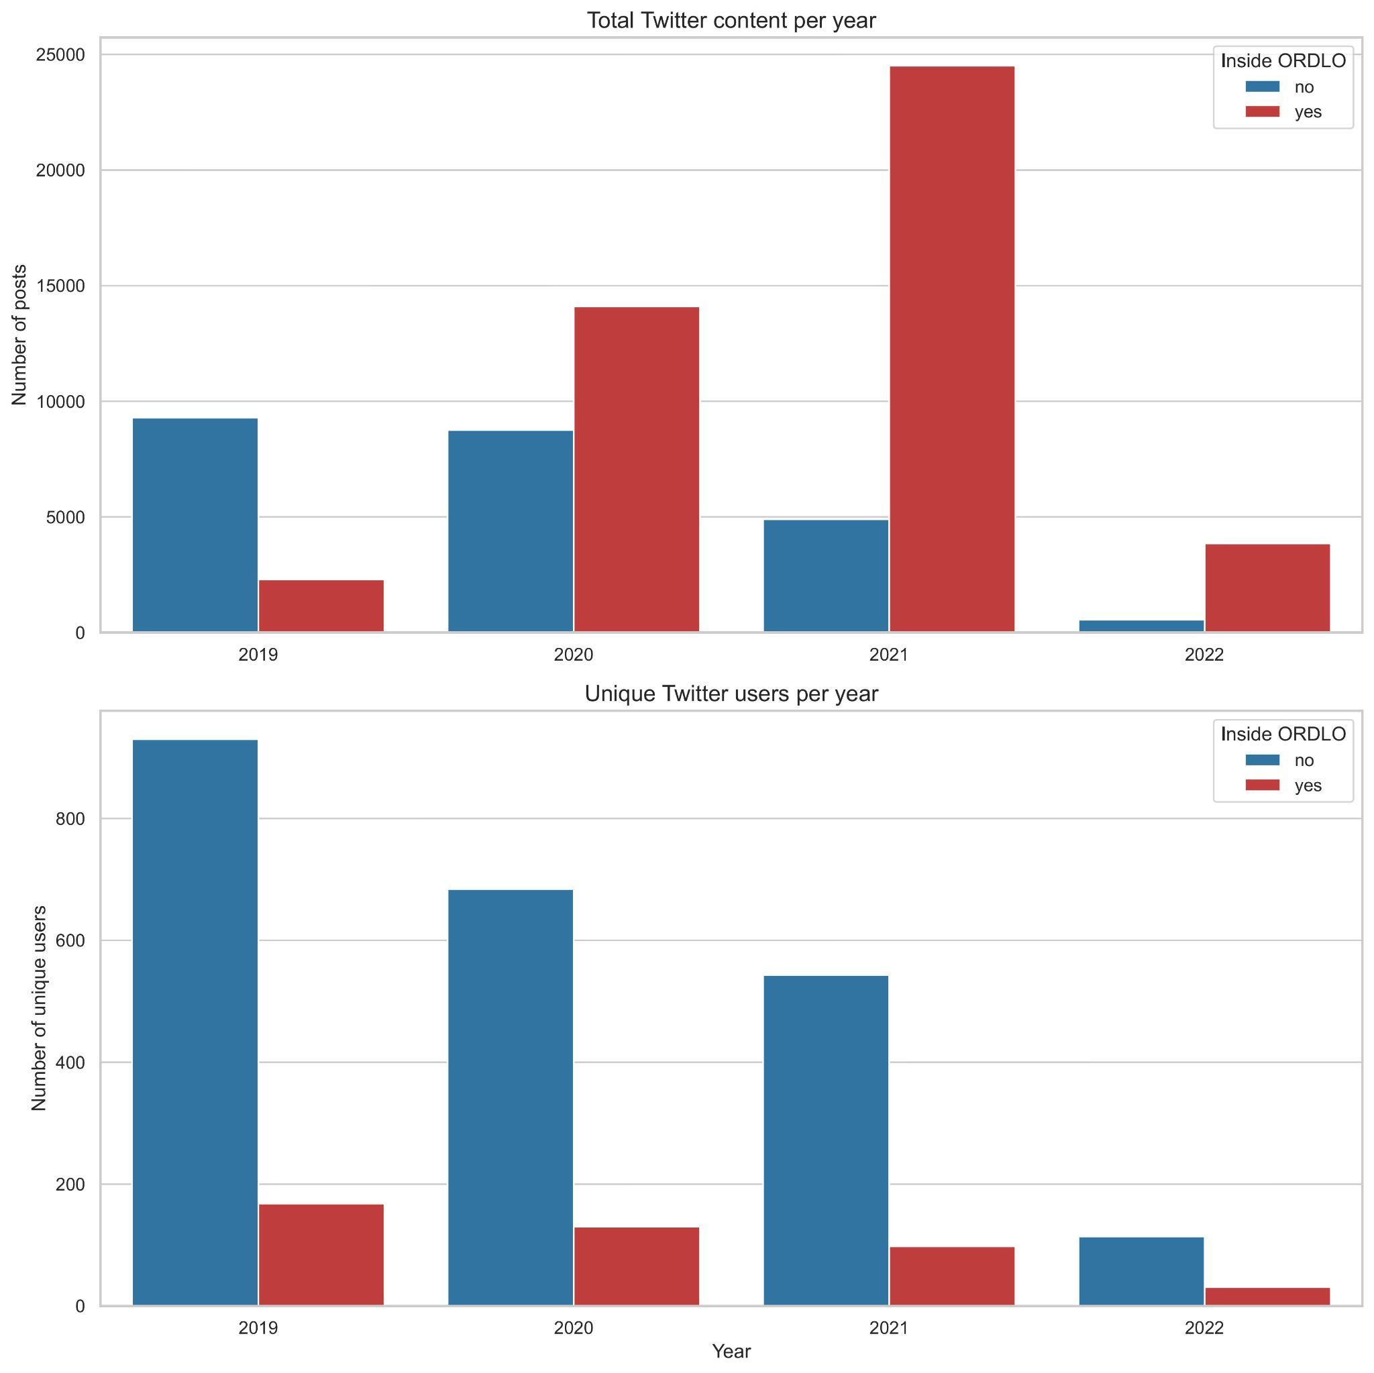
Figure S2. Distribution of tweets and Twitter users in ORDLO and non-occupied territories of Ukraine over the years (2019-2022). The dataset was compiled in 2023 during the Twitter Academic API's availability, so it is not possible to extend it to the temporal extent of Flickr and VK now. Nevertheless, Twitter demonstrates better popularity with more than 1,000 unique users in 2019.
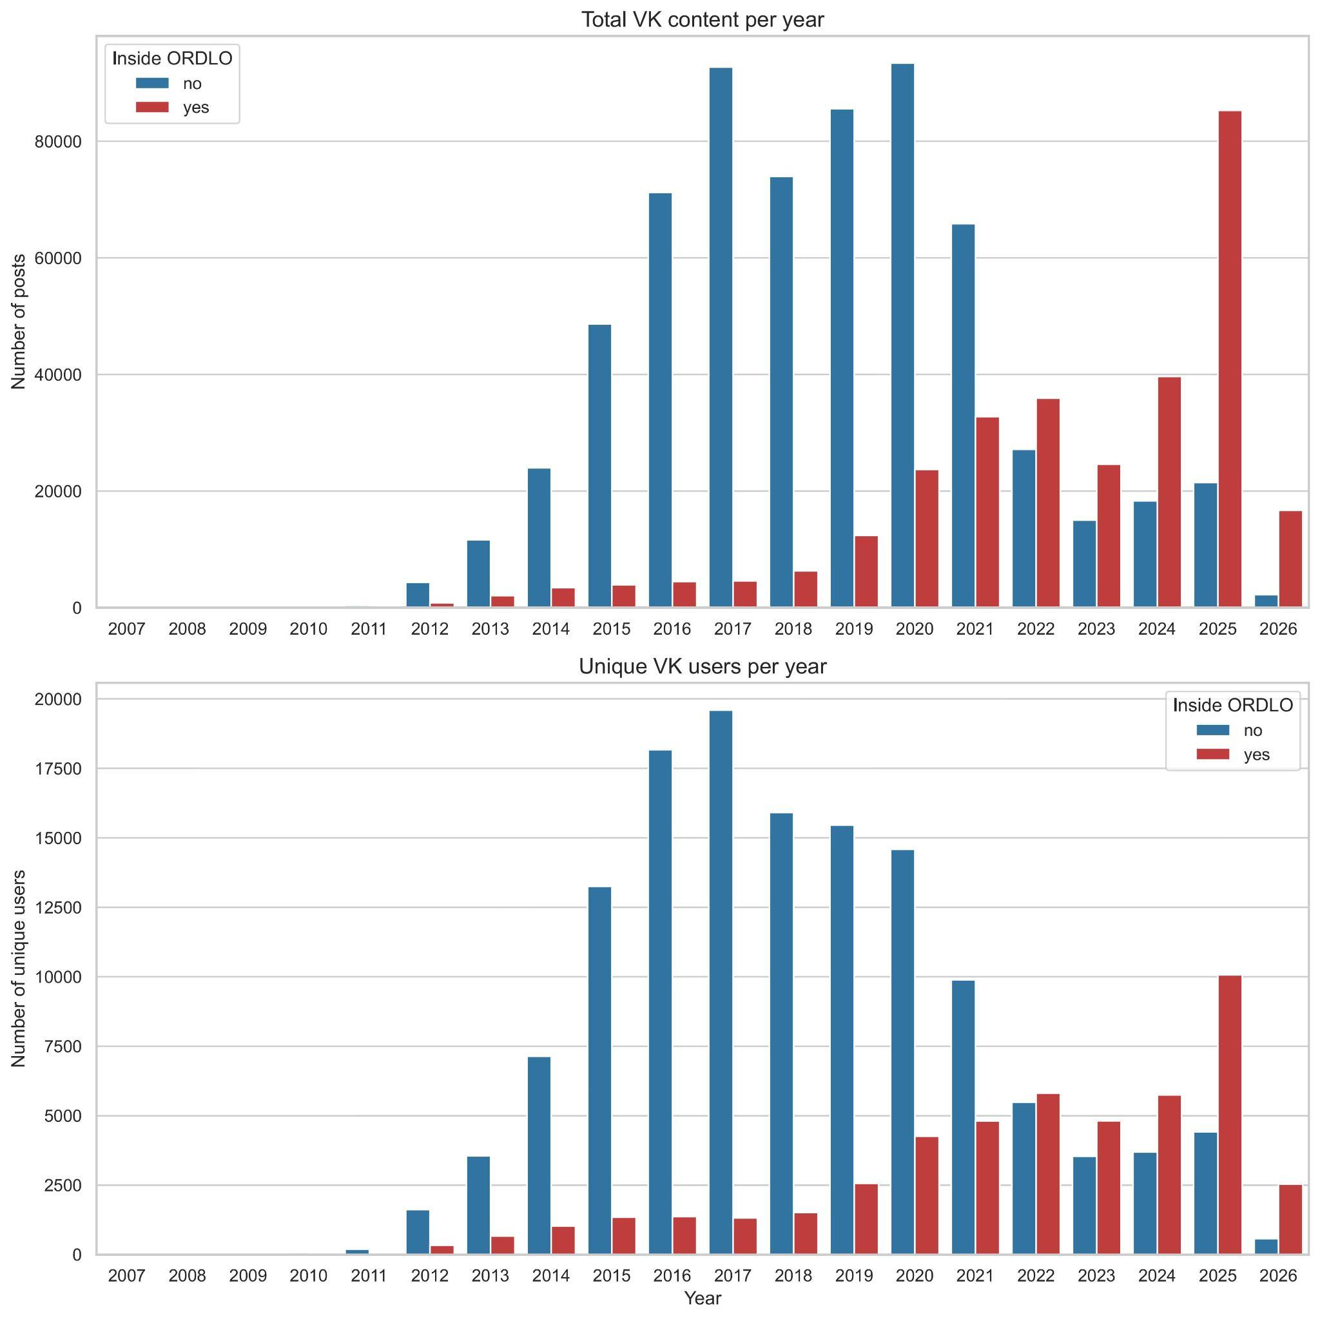
Figure S3. Distribution of VK photos and users in ORDLO and non-occupied territories of Ukraine over the years. This is the most extensive dataset due to VK's high popularity in the study area, and it greatly improves the representativeness of our dataset. One can notice that VK has become more popular in the ORDLO areas after 2022 due to shifts in the social media preferences of Ukrainian users and changing demographics (with a likely influx of the Russian population, which is active on VK).

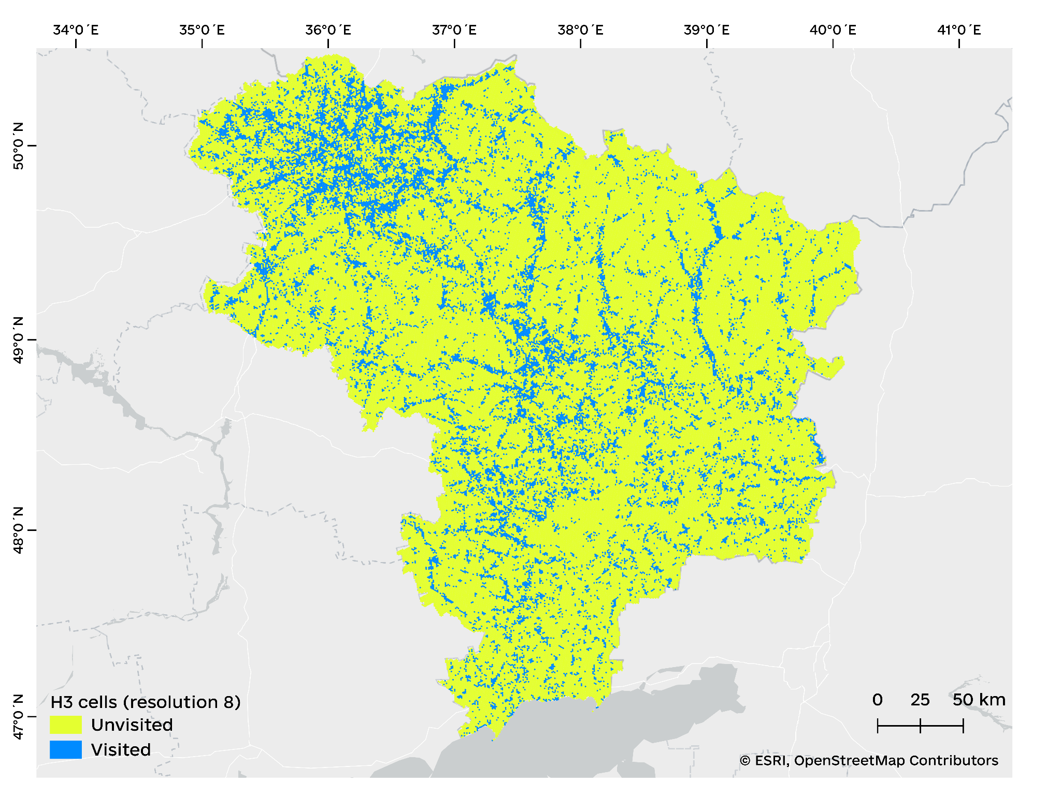
Figure S4. Spatial distribution of the selected visited and unvisited H3 cells across the study area (exact locations of the selected social media data cannot be shared due to privacy reasons)

Table S1. Raw outputs of the Random Forest modelling
# | Band name | Type / range | Interpretation
Pre-war and wartime suitability probabilities
01 | prob_prewar | Float [0–1] | Modelled habitat suitability probability for the pre-war baseline period, derived from the median of Google Satellite Embeddings for 2019–2021. Reflects the spatial distribution of the target habitat class under pre-conflict land-use conditions. This layer is the reference against which all subsequent change is measured.
02 | prob_wartime | Float [0–1] | Modelled suitability for the wartime period, derived from the median of embeddings for 2022–2024. Directly comparable to prob_prewar; differences between the two reflect a mix of war-related landscape change and background inter-annual variation. Used as input to the debiasing pipeline.
Difference map — median
03 | diff_median | Float [−1 to 1] | Raw difference: prob_prewar minus prob_wartime. Positive values indicate locations where suitability declined during the war years; negative values indicate locations where suitability increased (potential rewilding or land abandonment).
Annual wartime suitability probabilities
04 | prob_2022 | Float [0–1] | Modelled suitability for 2022, derived from the single-year embedding mosaic. The first full year of large-scale war; captures the immediate post-invasion landscape state.
05 | prob_2023 | Float [0–1] | Modelled suitability for 2023. Allows assessment of whether changes detected in 2022 persisted or reversed into the second year of the war.
06 | prob_2024 | Float [0–1] | Modelled suitability for 2024. Together with 2022 and 2023, it enables temporal trajectory analysis and identification of progressively worsening or recovering locations.
Annual difference maps
07 | diff_2022 | Float [−1 to 1] | Raw difference: prob_prewar minus prob_2022. Captures the magnitude and direction of change in the first year of conflict relative to the pre-war baseline.
08 | diff_2023 | Float [−1 to 1] | Raw difference: prob_prewar minus prob_2023.
09 | diff_2024 | Float [−1 to 1] | Raw difference: prob_prewar minus prob_2024.
Wartime summary statistics across 2022–2024
10 | prob_war_mean | Float [0–1] | Pixel-wise mean of prob_2022, prob_2023, and prob_2024. Provides a single summary wartime suitability estimate that smooths over year-to-year variation and is more robust than any individual annual layer.
11 | prob_war_min | Float [0–1] | Pixel-wise minimum of the three annual wartime probabilities. Represents the worst-case (most degraded) wartime state observed at each location across the three years.
12 | prob_war_max | Float [0–1] | Pixel-wise maximum of the three annual wartime probabilities. Represents the most favourable wartime suitability estimate, useful for identifying locations with at least partial recovery in any single year.
13 | prob_war_sd | Float [0–1] | Pixel-wise standard deviation of the three annual wartime probabilities. High values indicate temporal instability in the model's wartime output — locations where the predicted suitability varied substantially from year to year.

Table S2. Outputs from the debiasing workflow
# | Band name | Type / range | Interpretation
SDM probability surfaces — baseline and wartime
01 | prob_prewar | Float [0–1] | Modelled habitat suitability probability for the pre-war period (median of 2019–2021 satellite embeddings). This is the baseline against which all change is measured.
02 | prob_wartime_raw | Float [0–1] | Raw modelled suitability for the wartime period (median of 2022–2024), before any bias correction. Differences from prob_prewar reflect a mix of war-related change and background noise.
03 | prob_median_debiased | Float [0–1] | Bias-corrected wartime probability: the raw wartime probability shifted by the estimated background bias field. Represents the best estimate of what wartime suitability would be after removing non-war trends.
21 | prob_war_sd | Float [0–1] | Standard deviation of the three annual wartime probability estimates (2022, 2023, 2024). High values indicate temporal instability in the model output; pixels with SD > 0.10 are excluded from the analysis mask.
Debiasing intermediate layers — median period
04 | raw_median | Float [−1 to 1] | Raw difference: prob_prewar minus prob_wartime_raw, before smoothing or bias correction. Positive = suitability declined during the war; negative = increased. Contains both war signal and background noise.
05 | smooth_median | Float [−1 to 1] | Spatially smoothed version of raw_median (Gaussian σ = 1.5 km). Used as the input to bias field estimation; suppresses pixel-level noise while preserving landscape-scale patterns.
06 | diff_median | Float [−1 to 1] | Bias-corrected difference: smooth_median minus bias_median. The regional background trend estimated from control zones has been removed; residuals reflect change above and beyond what undisturbed areas show.
07 | zscore_median | Float [unbounded, typically −6 to +6] | Final calibrated z-score. The bias-corrected difference divided by local variability, then globally rescaled so that control-zone pixels have mean = 0 and SD = 1. This is the primary detection layer: values above +3 indicate damage, below −3 indicate rewilding, relative to the noise level of undisturbed control zones.
08 | bias_median | Float [−1 to 1] | Estimated spatial bias field: the spatially weighted average of the smoothed difference within control zones, interpolated across the full AOI (influence radius 100 km for RF, 50 km for Maxent). Represents the expected non-war background difference at each location.
09 | local_sd | Float [≥ 0.02] | Local standard deviation of the bias-corrected difference, estimated from the spatial variability of control-zone residuals. Used to normalise diff_median into a z-score. A minimum floor of 0.02 prevents inflation of z-scores in very stable areas.
Change detection — binary maps
10 | damage | Byte [0 or 1] | Binary damage map for the wartime median period. A pixel is flagged (1) where zscore_median > 3, the mean z-score of the surrounding 3×3 neighbourhood exceeds 2, and the resulting patch contains at least 8 contiguous pixels (~2 km²). Indicates a statistically significant decline in habitat suitability relative to the pre-war baseline.
11 | rewild | Byte [0 or 1] | Binary rewilding (war-wilding) map for the wartime median period. Symmetric to damage: flagged where zscore_median < −3 with equivalent neighbourhood and patch-size filters. Indicates a significant increase in suitability, consistent with land abandonment and vegetation recovery.
12 | damage_attributed | Byte [0 or 1] | Subset of damage pixels located within 30 km of a documented war event. These detections are spatially attributed to direct war influence.
13 | rewild_attributed | Byte [0 or 1] | Subset of rewild pixels located within 30 km of a documented war event.
Temporal persistence across annual maps (2022–2024)
14 | dmg_persist_count | Byte [0–3] | Number of individual years (out of 2022, 2023, 2024) in which a pixel was independently flagged as damaged. Higher values indicate more sustained, year-consistent damage rather than a transient signal.
15 | rew_persist_count | Byte [0–3] | As above for rewilding detections.
16 | damage_persist | Byte [0 or 1] | Binary persistent damage: pixels flagged as damaged in at least 2 of the 3 wartime years, subject to the same 8-pixel minimum patch filter. Interpreted as sustained conflict-related habitat disruption.
17 | rewild_persist | Byte [0 or 1] | Binary persistent rewilding: pixels showing consistent war-wilding signal across at least 2 of the 3 wartime years.
Spatial attribution and confidence
18 | dist_war_km | Float [≥ 0] | Euclidean distance (km) from each pixel to the nearest documented war event location. Used to attribute change detections to direct conflict influence; the 30 km attribution threshold is derived from this layer.
19 | confidence | Int [−3 to +3] | Composite confidence score. Positive values indicate damage confidence, negative values rewilding confidence. For each detected damage pixel, points are accumulated as follows: +1 for any detection with z-score >3.0; +2 if z-score is >4.0, or close to war events, or shows multi-year change; +2 if all the factors coincide. The sign is flipped for rewilding.
Ancillary reference layers
20 | lc | Int [ESA class codes] | ESA WorldCover v200 land cover classification (10 m, resampled to 500 m). Class codes: 10 = Tree cover, 20 = Shrubland, 30 = Grassland, 40 = Cropland, 50 = Built-up, 60 = Bare/sparse vegetation, 80 = Open water, 90 = Herbaceous wetland.

Table S3. Spatially blocked cross-validation quality metrics
Fold | Set | N presences | N absences | AUC | Log-Loss Score | Brier Score | Brier Skill Score | Mean probability presence | Mean probability absence | Cohen’s D
0 | test | 4019 | 3819 | 0.88 | 0.43 | 0.14 | 0.44 | 0.71 | 0.30 | 1.81
1 | test | 4009 | 3211 | 0.89 | 0.43 | 0.14 | 0.44 | 0.71 | 0.29 | 1.79
2 | test | 4022 | 4322 | 0.89 | 0.41 | 0.13 | 0.47 | 0.70 | 0.29 | 1.92
3 | test | 4045 | 4102 | 0.89 | 0.42 | 0.13 | 0.47 | 0.71 | 0.30 | 1.92
4 | test | 4024 | 4541 | 0.89 | 0.42 | 0.14 | 0.46 | 0.72 | 0.31 | 1.87
0 | train | 16100 | 16176 | 0.97 | 0.30 | 0.09 | 0.65 | 0.77 | 0.24 | 2.99
1 | train | 16110 | 16784 | 0.97 | 0.30 | 0.09 | 0.65 | 0.76 | 0.23 | 2.99
2 | train | 16097 | 15673 | 0.97 | 0.30 | 0.09 | 0.65 | 0.77 | 0.24 | 2.98
3 | train | 16074 | 15893 | 0.97 | 0.30 | 0.09 | 0.65 | 0.77 | 0.24 | 2.99
4 | train | 16095 | 15454 | 0.97 | 0.30 | 0.09 | 0.65 | 0.77 | 0.24 | 2.99

