Supplementary Table 1: Baseline characteristics of the study participants.
Baseline characteristics | Test group  (n = 21) | Control group  (n = 24) | p-value
Age (mean ± sd) | 60.81 ± 9.48 | 64.38 ± 13.59 | 0.202 ^{a,d}
Gender, N (%)
Male | 7 (33.3) | 11 (45.8) | 0.393 ^{b,d}
Female | 14 (66.7) | 13 (54.2) | 0.393 ^{b,d}
Health status, N (%)
Healthy | 9 (42.9) | 8 (33.3) | 0.511 ^{b,d}
Compromised | 12 (57.1) | 16 (66.7) | 0.511 ^{b,d}
a. Independent-Samples Mann-Whitney U Test
b. Pearson Chi-Square Test
c. Fisher’s exact test
d. Asymptotic significance is displayed
* Statistically significant difference at 0.05 level

Supplementary Table 2: Baseline whole mouth periodontal parameters.
Periodontal parameters | Test group (n=21)  (mean ± SD) | Control group (n=24)  (mean ± SD) | p-value
Probing depth (mm) | 2.68 ± 0.29 | 2.53 ± 0.31 | 0.569 ^{a,b}
Clinical attachment Level (m) | 3.10 ± 0.32 | 3.07 ± 0.33 | 0.578 ^{a,b}
Bleeding on probing (%) | 9.7 ± 3.9 | 8.6 ± 4.2 | 0.658 ^{a,b}
Full mouth plaque score (%) | 9.2 ± 5.2 | 8.9 ± 5.3 | 0.598 ^{a,b}
a. Independent-Samples Mann-Whitney U Test
b. Asymptotic significance is displayed
* Statistically significant difference at 0.05 level

Supplementary Table 3: Clinical peri-implant parameters.
Clinical parameters |  | Total (n = 45)  (mean ± SD) | Test group (n = 21)  (mean ± SD) | Control group (n = 24)  (mean ± SD) | Inter-group p-value
Probing depth (mm) | Baseline | 5.89 ± 1.14 | 5.74 ± 0.85 | 6.03 ± 1.35 | 0.715 ^{a,d}
Probing depth (mm) | 3 months | 4.04 ± 1.36 | 3.44 ± 1.03 | 4.58 ± 1.41 | 0.002 *^{a,d}
Probing depth (mm) | Intragroup p-value |  | < 0.001 *^{b,d} | < 0.001 *^{b,d}
Probing depth (mm) | Difference (3 months - Baseline) | -1.85 ± 0.72 | -2.30 ± 0.65 | -1.45 ± 0.52 | < 0.001 *^{a,d}
Bleeding on probing (%) | Baseline | 84.07 ± 26.10 | 89.68 ± 17.85 | 79.17 ± 31.18 | 0.328 ^{a,d}
Bleeding on probing (%) | 3 months | 27.41 ± 31.21 | 16.67 ± 21.08 | 36.81 ± 35.77 | 0.035 *^{a,d}
Bleeding on probing (%) | Intragroup p-value |  | < 0.001 *^{b,d} | < 0.001 *^{b,d}
Bleeding on probing (%) | Difference (3 months - Baseline) | -56.67 ± 35.07 | -73.02 ± 25.54 | -42.36 ± 36.44 | 0.004 *^{a,d}
Clinical attachment level (mm) | Baseline | 6.15 ± 1.27 | 5.90 ± 0.91 | 6.37 ± 1.51 | 0.374 ^{a,d}
Clinical attachment level (mm) | 3 months | 4.17 ± 1.66 | 3.33 ± 1.46 | 4.90 ± 1.50 | 0.002 *^{a,d}
Clinical attachment level (mm) | Intragroup p-value |  | < 0.001 *^{b,d} | < 0.001 *^{b,d}
Clinical attachment level (mm) | Difference (3 months - Baseline) | -1.98 ± 1.14 | -2.56 ± 1.21 | -1.47 ± 0.78 | 0.001 *^{a,d}
Plaque index (%) | Baseline | 20.00 ± 38.70 | 9.52 ± 30.08 | 29.17 ± 43.48 | 0.041*^{a,d}
Plaque index (%) | 3 months | 2.22 ± 9.13 | 0 ± 0 | 4.17 ± 12.29 | 0.097 ^{a,d}
Plaque index (%) | Intragroup p-value |  | 0.157 | 0.007 *^{b,d}
Plaque index (%) | Difference (3 months - Baseline) | -0.18 ± 0.35 | -0.10 ± 0.30 | -0.25 ± 0.38 | 0.051 ^{a,d}
Recession (mm) | Baseline | 0.27 ± 0.60 | 0.21 ± 0.49 | 0.33 ± 0.68 | 0.700 ^{a,d}
Recession (mm) | 3 months | 0.28 ± 0.57 | 0.25 ± 0.56 | 0.31 ± 0.59 | 0.557 ^{a,d}
Recession (mm) | Intragroup p-value |  | 0.496 | 0.719
Recession (mm) | Difference (3 months - Baseline) | 0 ± 0.29 | 0.03 ± 0.19 | -0.02 ± 0.36 | 0.464 ^{a,d}
Suppuration (%) | Baseline | 1.85 ± 8.12 | 0.79 ± 3.63 | 2.78 ± 10.61 | 0.617 ^{a,d}
Suppuration (%) | 3 months | 1.85 ± 7.30 | 1.59 ± 7.27 | 2.08 ± 7.47 | 0.655 ^{a,d}
Suppuration (%) | Intragroup p-value |  | 0.655 | 0.785
Suppuration (%) | Difference (3 months - Baseline) | 0 ± 0.09 | 0 ± 0.08 | 0 ± 0.10 | 0.661 ^{a,d}
Treatment success (%) | 3 months | 60 ± 49.50 | 81 ± 40.20 | 42 ± 50.40 | 0.007 *^{c,d}
a. Independent-Samples Mann-Whitney U Test
b. Related-Samples Wilcoxon Signed Rank Test
c. Pearson Chi-Square Test
d. Asymptotic significance is displayed
* Statistically significant difference at 0.05 level

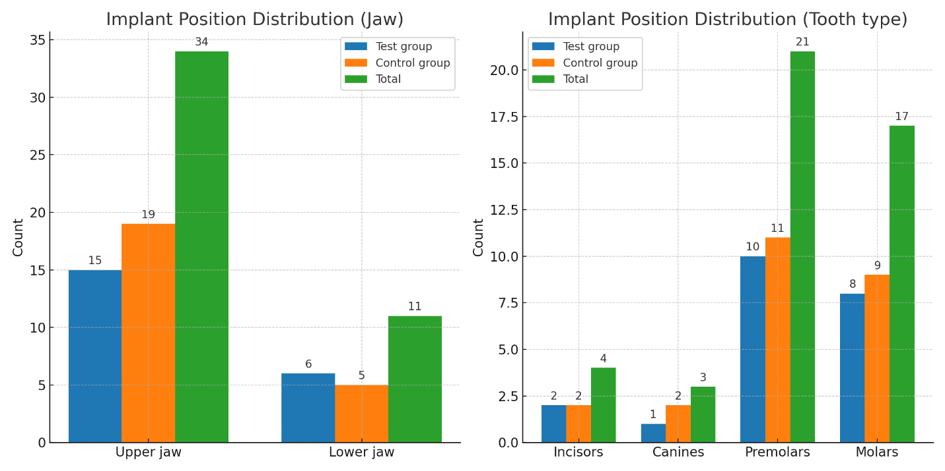
Supplementary Figure 1: Bar charts showing implant position distribution by jaw and tooth type.
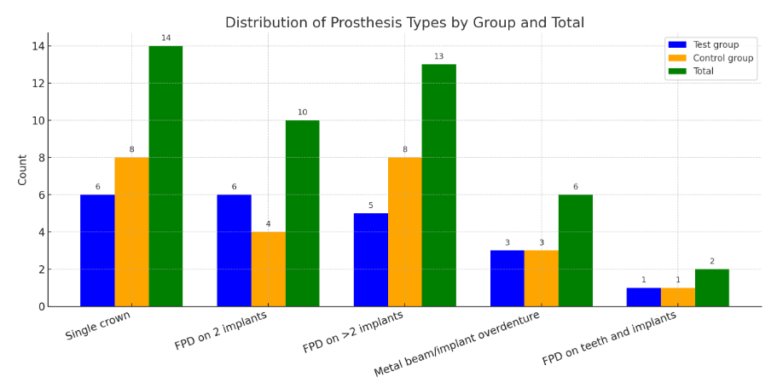
Supplementary Figure 2: Distribution of prosthesis types.

