Supplementary material 1
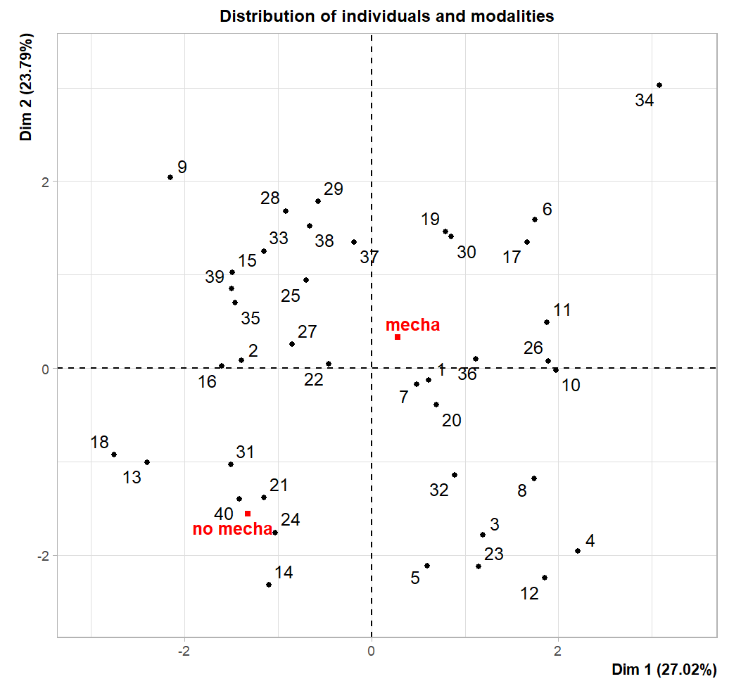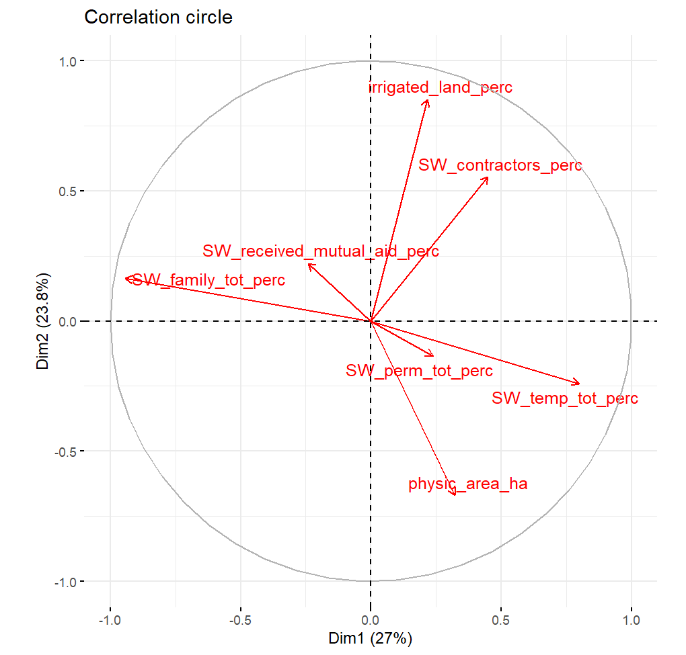

Supplementary material 2
Contribution of variables to axis 1
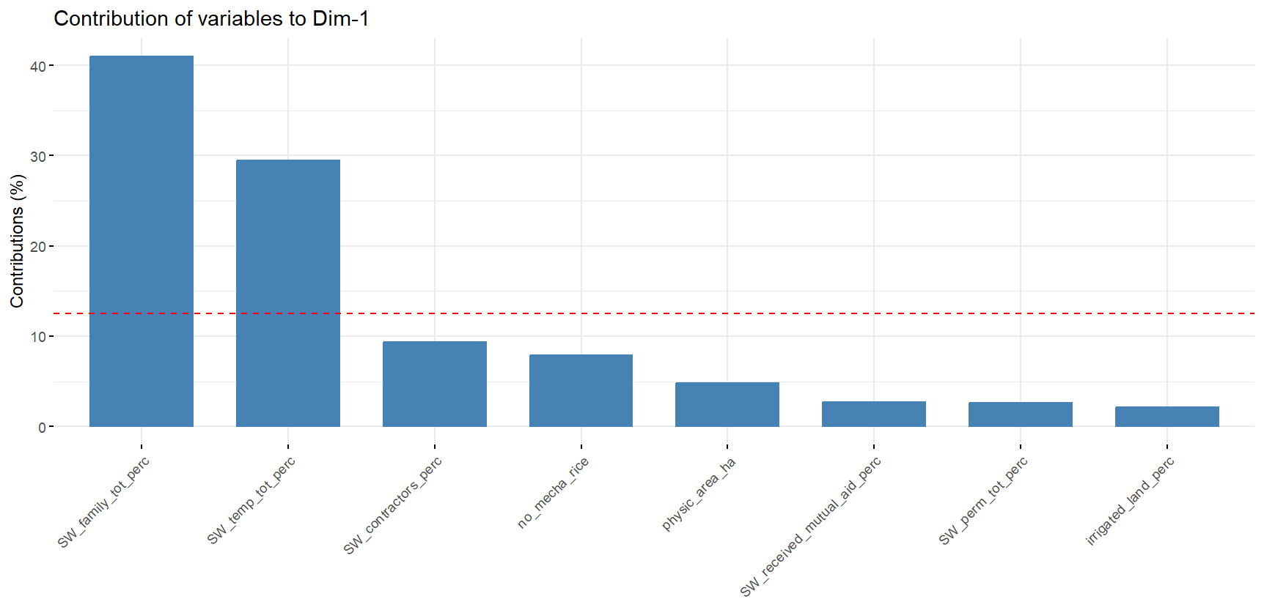
Contribution of variables to axis 2
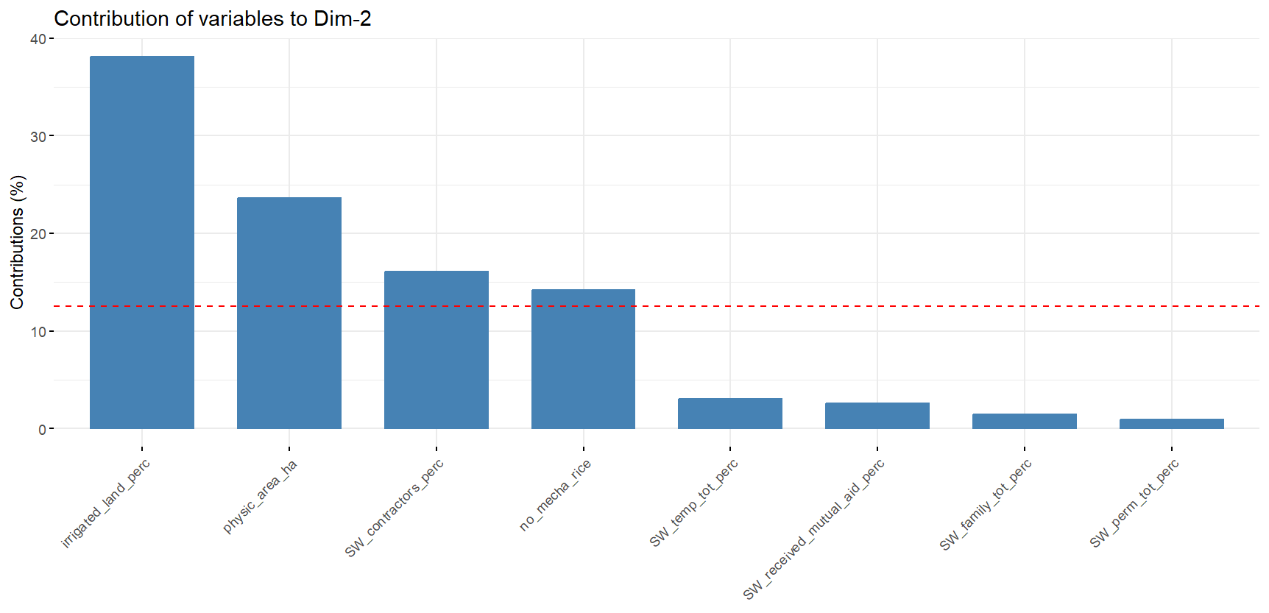

Supplementary material 3
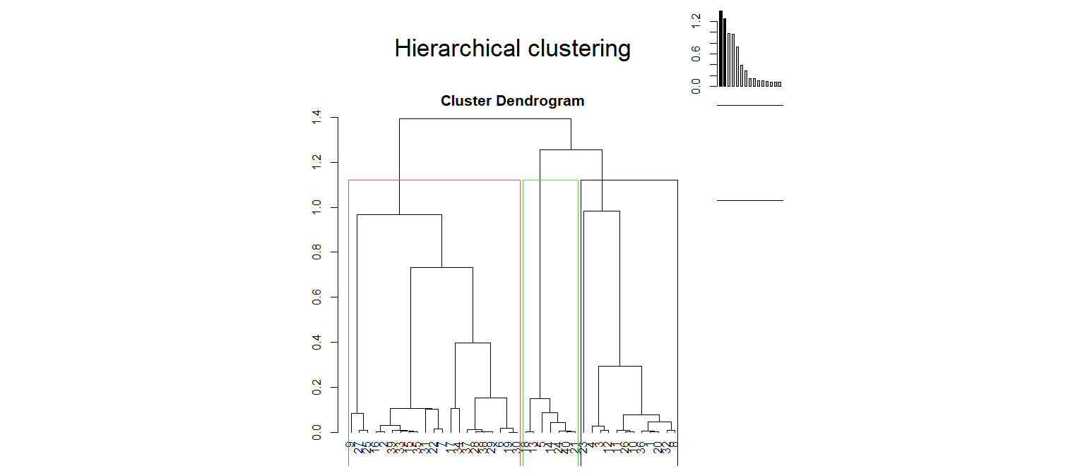

Projection of farm types
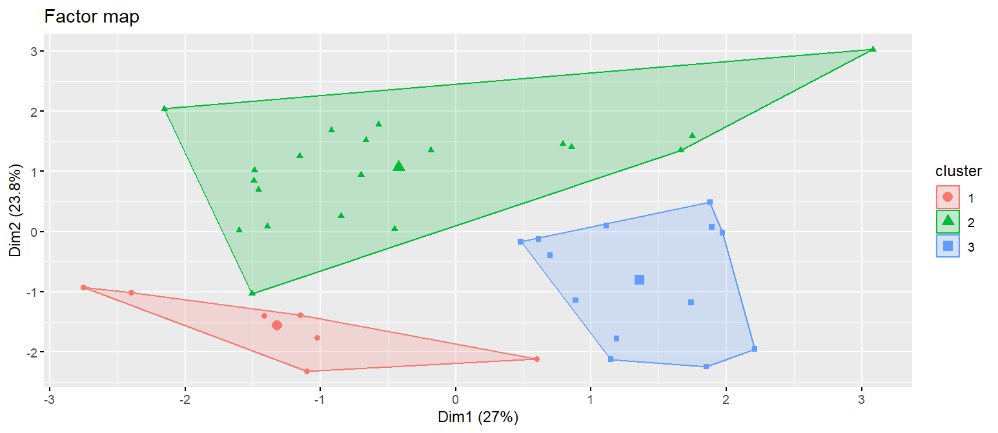

SW_tota 2.000936 423.6153846 327.4250000 237.7958201 208.3150124 4.539929e-02
SW_family_tot -2.489433 58.6923077 144.1000000 49.1455994 148.6683894 1.279470e-02
SW_total_ha -2.613921 75.2346537 130.8940967 58.7191406 92.2716901 8.950970e-03
SW_tot_WOMEN -2.711567 0.1917185 0.3565378 0.1903506 0.2633963 6.696598e-03
SW_family_tot_perc -3.963397 0.1736665 0.4680534 0.1259682 0.3218645 7.389088e-05

