Supporting Information
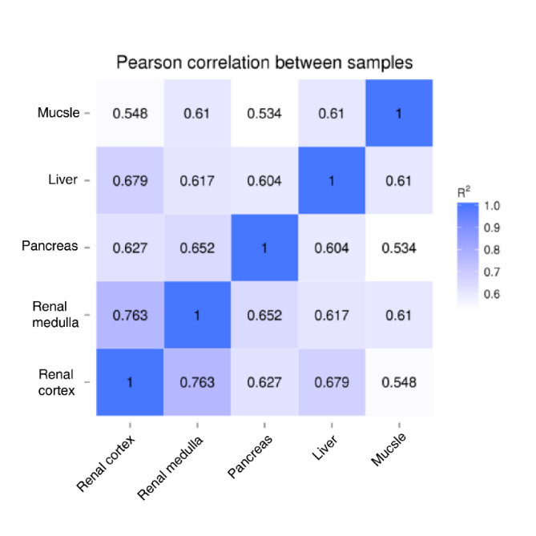
Fig. S1 Correlation matrix for all of genes from the five tissues.
Correlation matrix for the five tissues based on Pearson’s correlation coefficient for all of genes with high glucose-induced expression. The matrix was reordered based on FPKM values of the five tissues, with the R² < 0.8 representing that there were significantly different patterns between tissues

A B
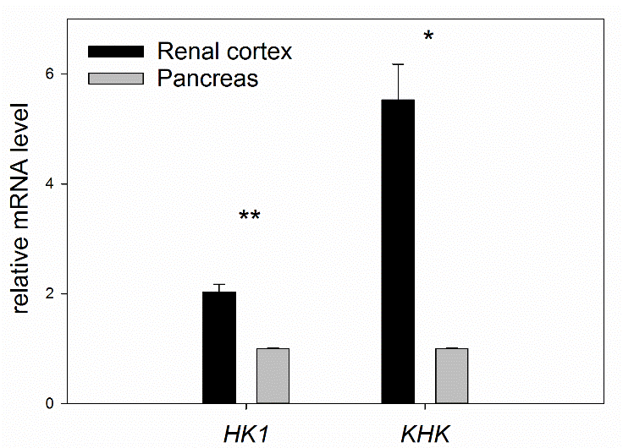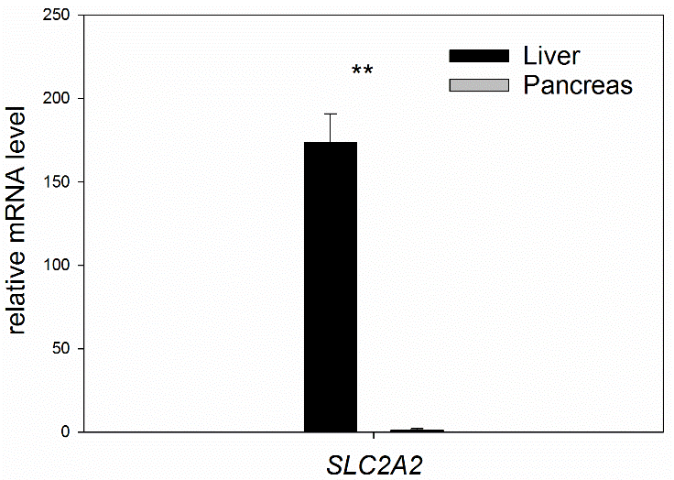

C D
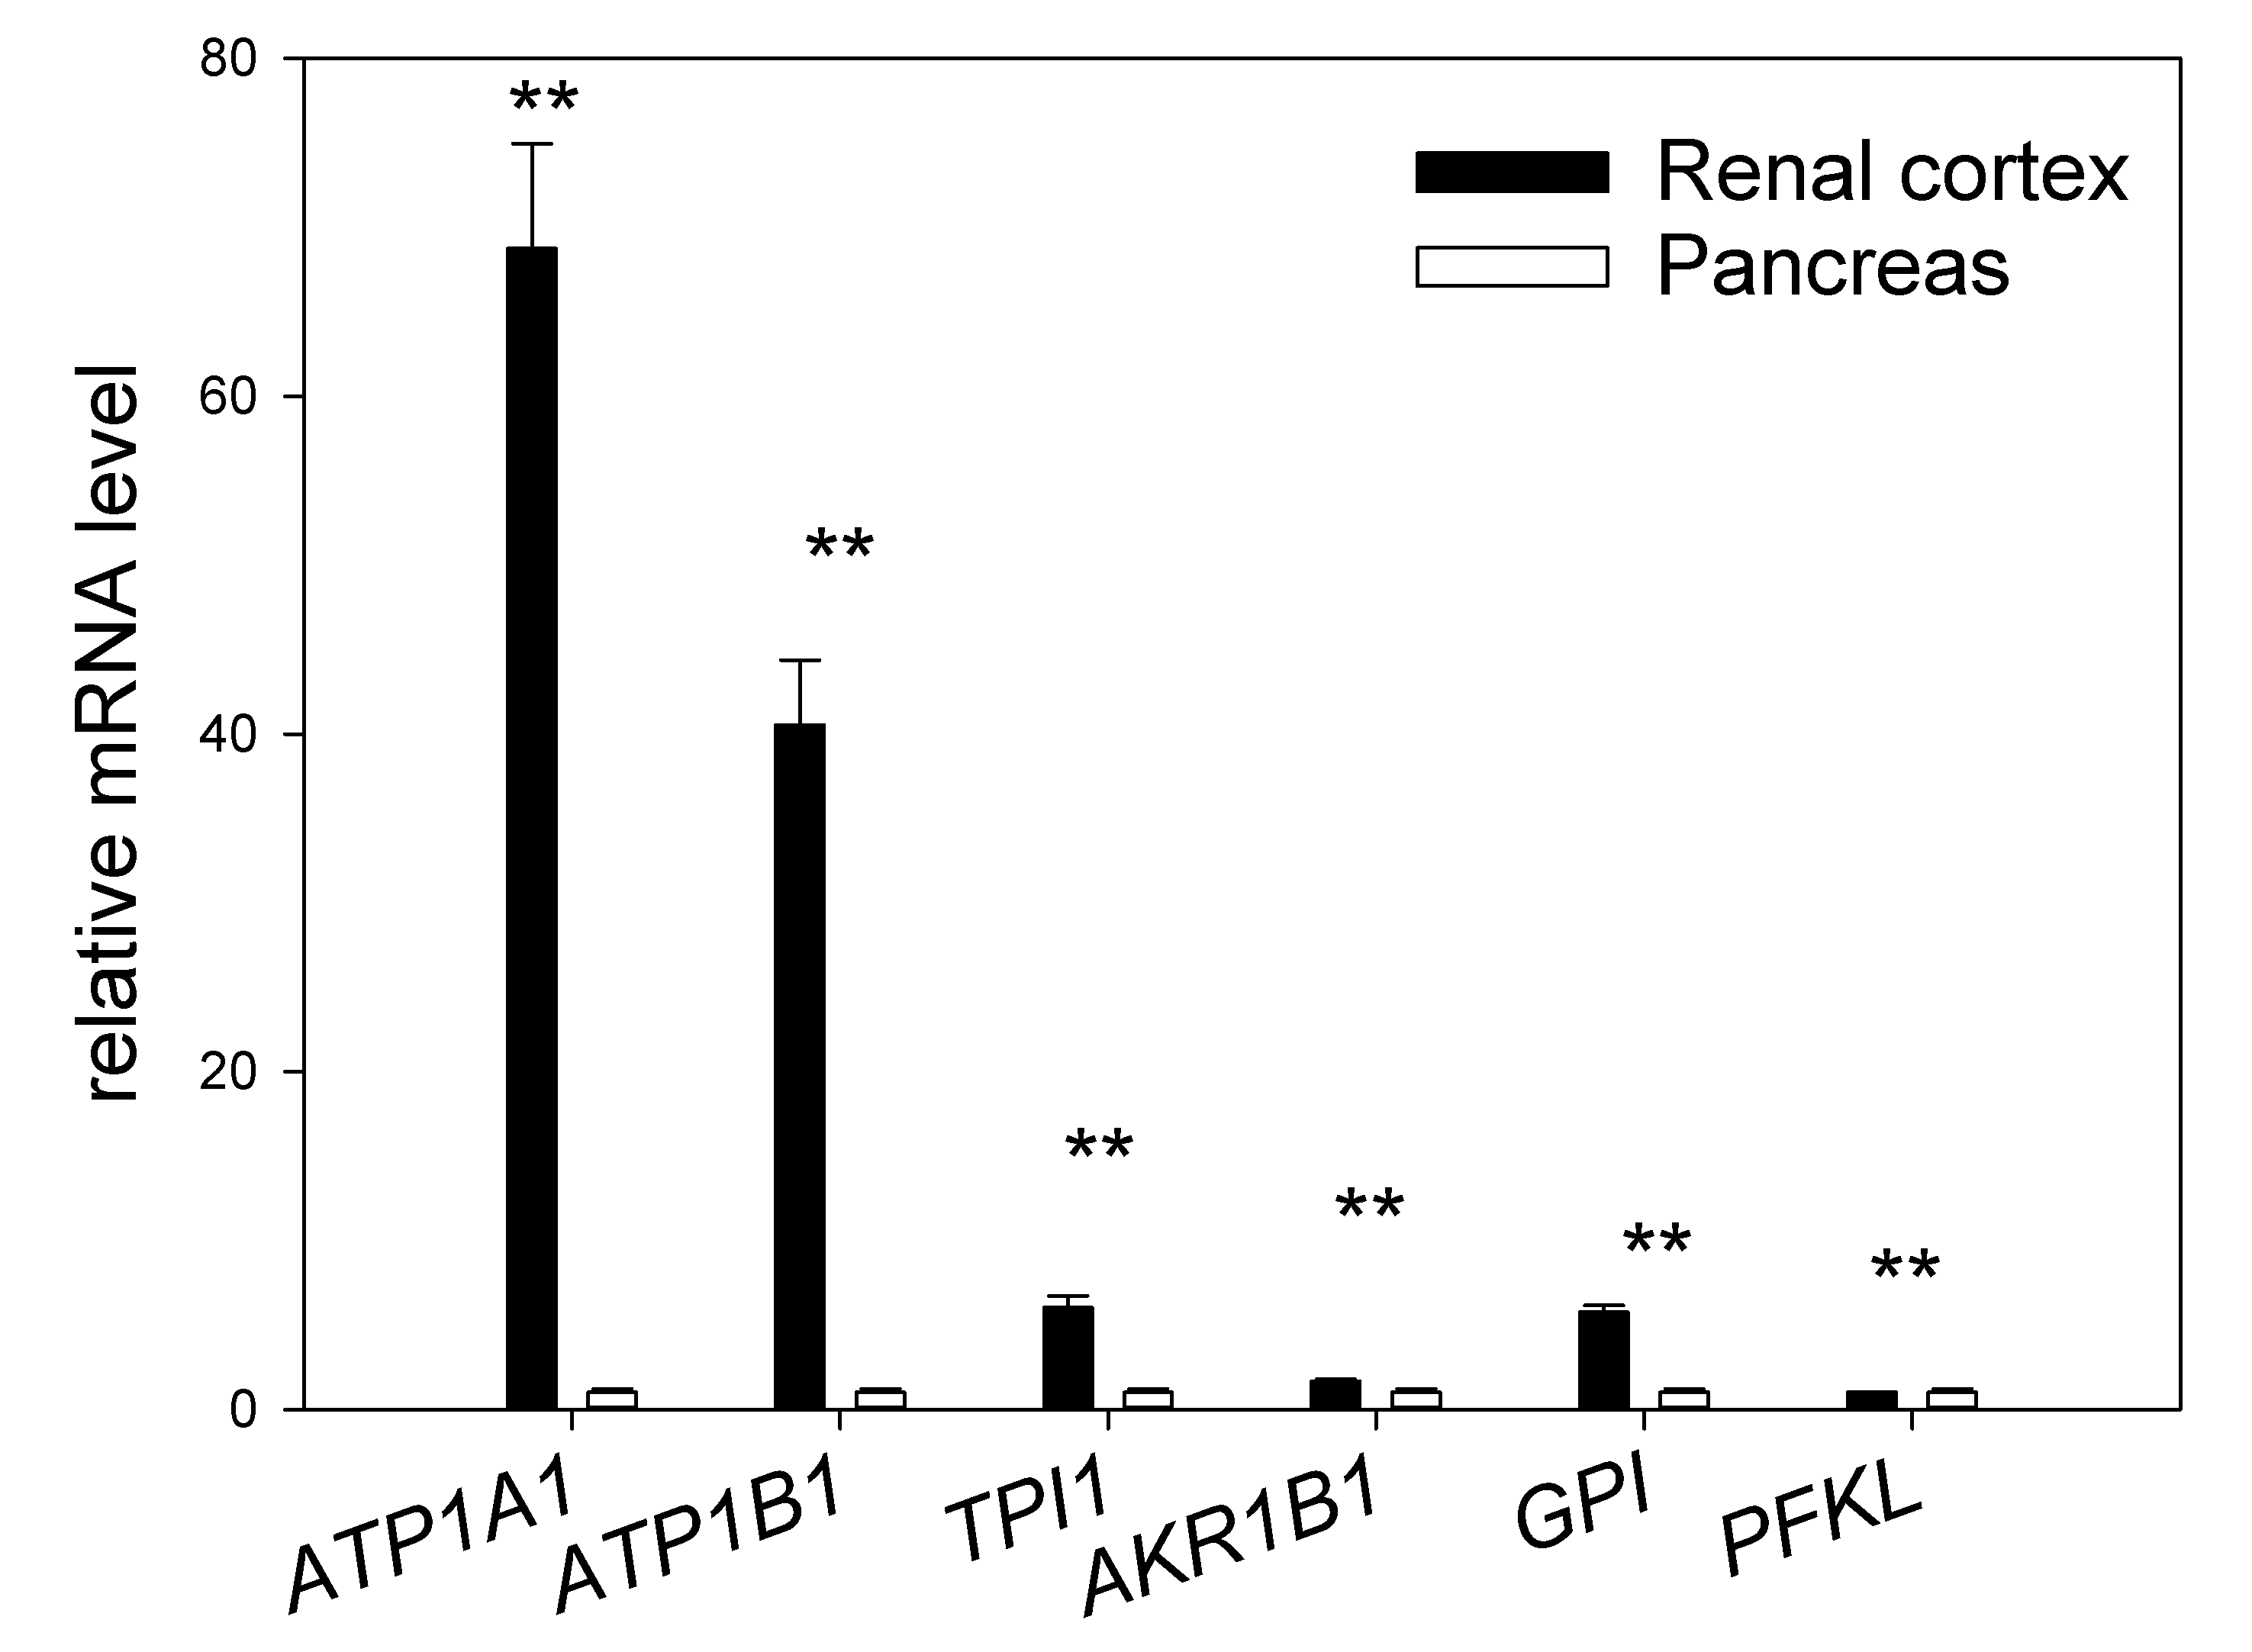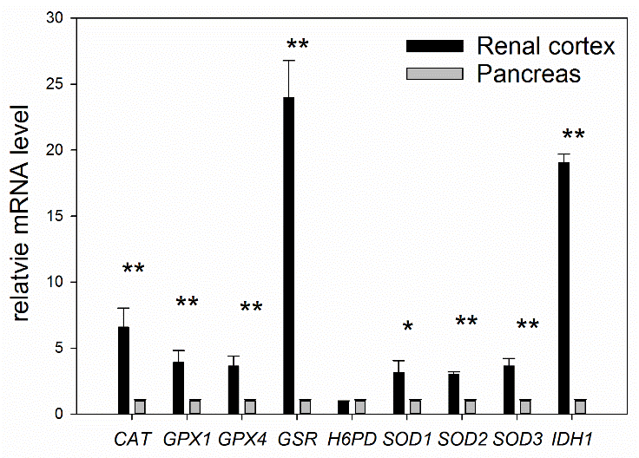
E F
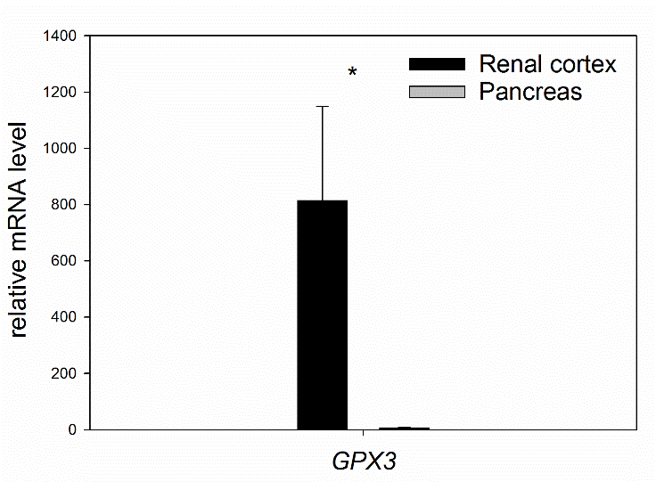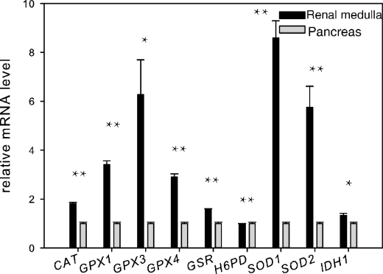
G H
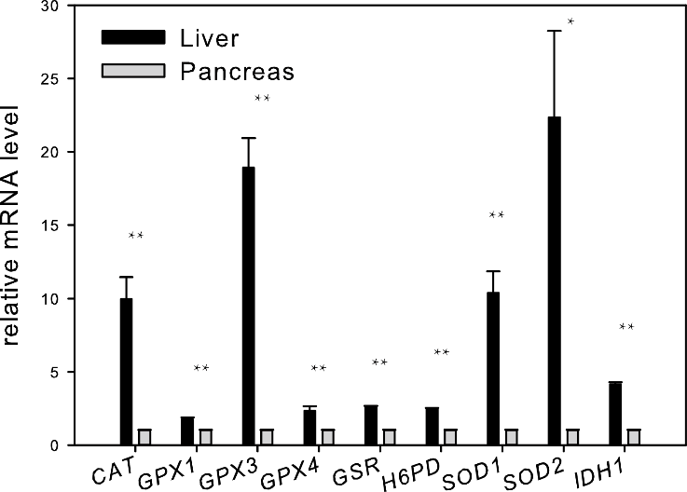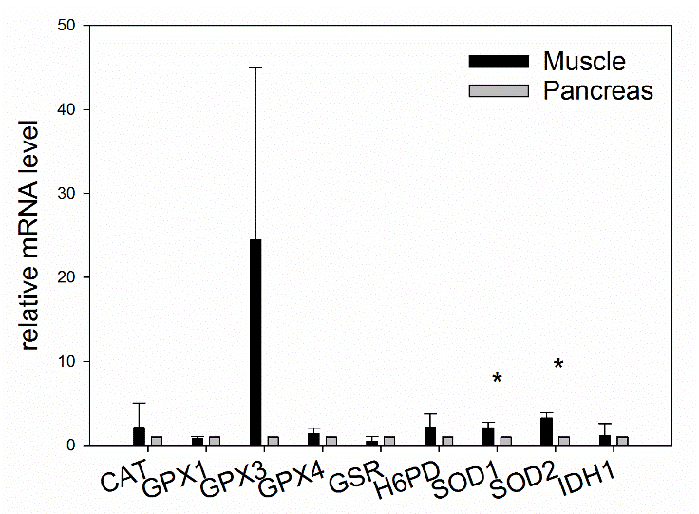

I
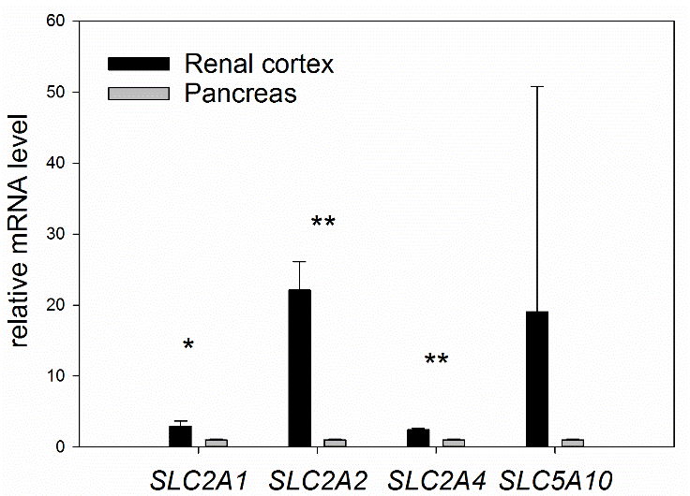

Fig. S2 Induction of Some Genes mRNAs from RNA-seq Data Measured by qPCR.
Data from (A-I) are presented as means ± SD of three independent experiments. *p < 0.05; **p < 0.01.

A
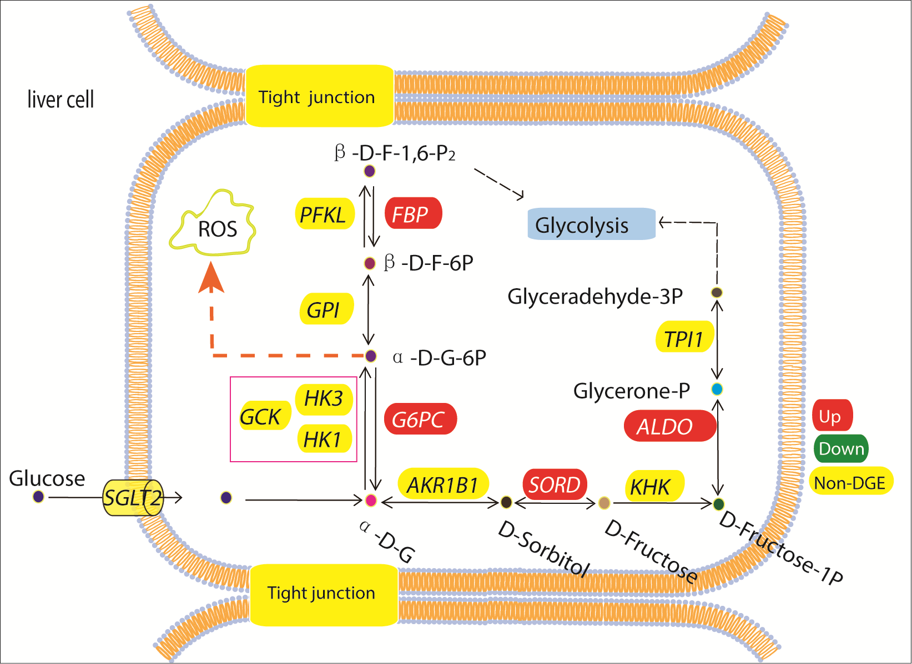

B
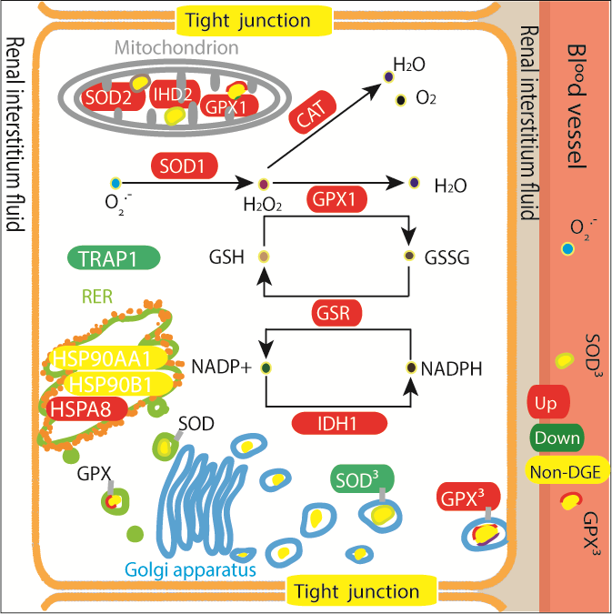

Fig. S3 Glucose Metabolism and Transport in Hepatocytes and Renal Cortical Cells
(A) Colors indicate up-regulated (red), down-regulated (green), non-expressed (yellow) and unexpressed (gray) expression levels of genes (encoding proteins that catalyze the indicated conversions) in liver compared with pancreas.
(B) Colors indicate increased (red), decreased (green), and unexpressed (gray) expression levels of genes (encoding proteins that catalyze the indicated conversions) in renal cortex compared with pancreas.

Fig S4. The Active Metabolism of Antioxidant Enzyme in the Renal Cortex Improves Environment of Cytoplasm, Endoplasmic Reticulum and Blood Vessel
Red rectangles indicate high expression levels of genes. Yellow particles represent proteins.

