Quantifying methodological trade-offs in the application of PSAT tridimensional acceleration data to estimate Atlantic halibut swimming speed and behaviour
Lucas Martin*, Institut des sciences de la mer, Université du Québec à Rimouski, Rimouski, Québec G5L 3A1, Canada
Hugues P. Benoît, Maurice Lamontagne Institute, Fisheries and Oceans Canada, Mont-Joli, QC G5H 3Z4, Canada
Jonathan A.D. Fisher, Centre for Fisheries Ecosystems Research, Fisheries and Marine Institute, Memorial University of Newfoundland, St. John’s, NL A1C 5R3, Canada
Dominique Robert, Institut des sciences de la mer, Université du Québec à Rimouski, Rimouski, Québec G5L 3A1, Canada
*Correspondence: lucas.martin@uqar.ca

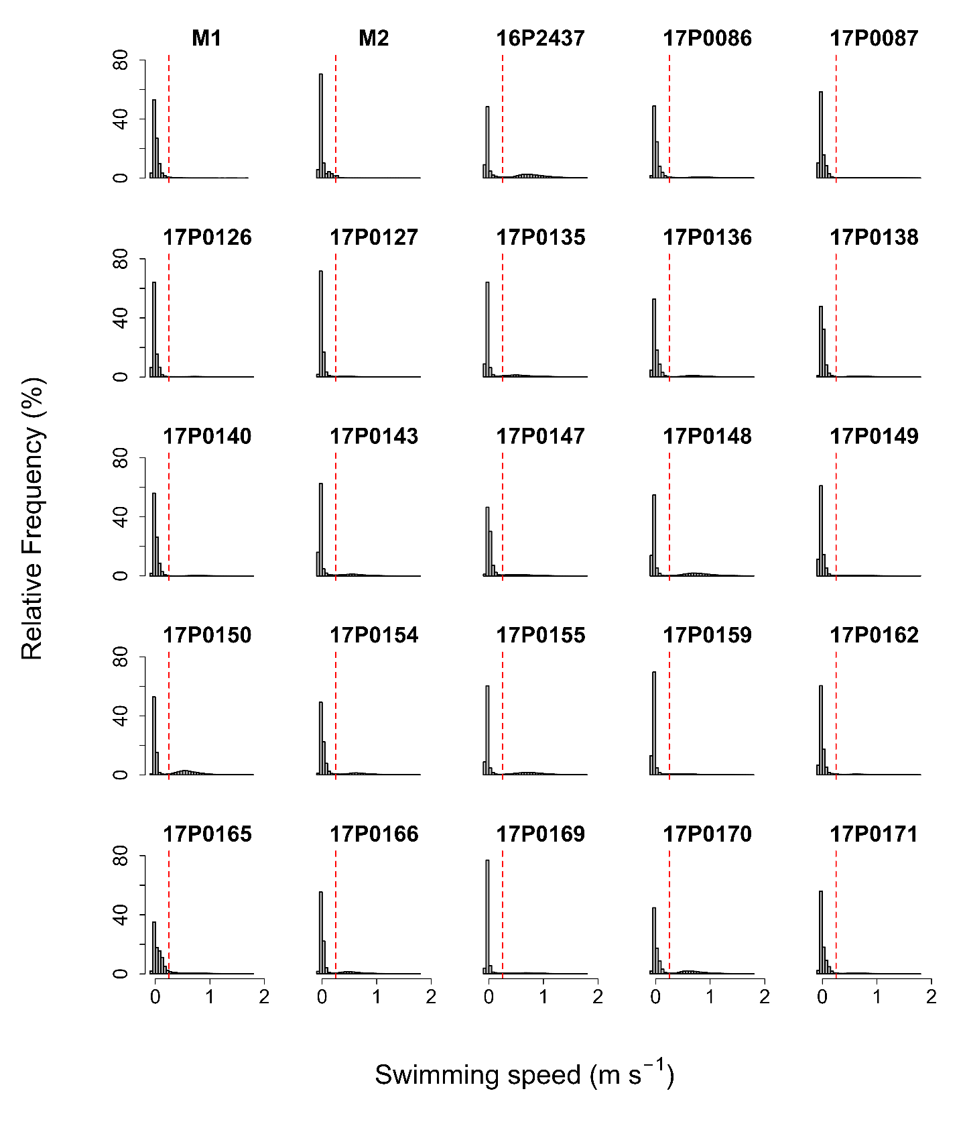
Figure A1: Histograms of velocities over the deployment period in two moored PSATs (M1/M2) and 43 Atlantic halibut. The vertical dotted red line represents the threshold between active and inactive behaviour (38.5°). Maximum swimming speed estimates correspond to the asymptote (79.87°).
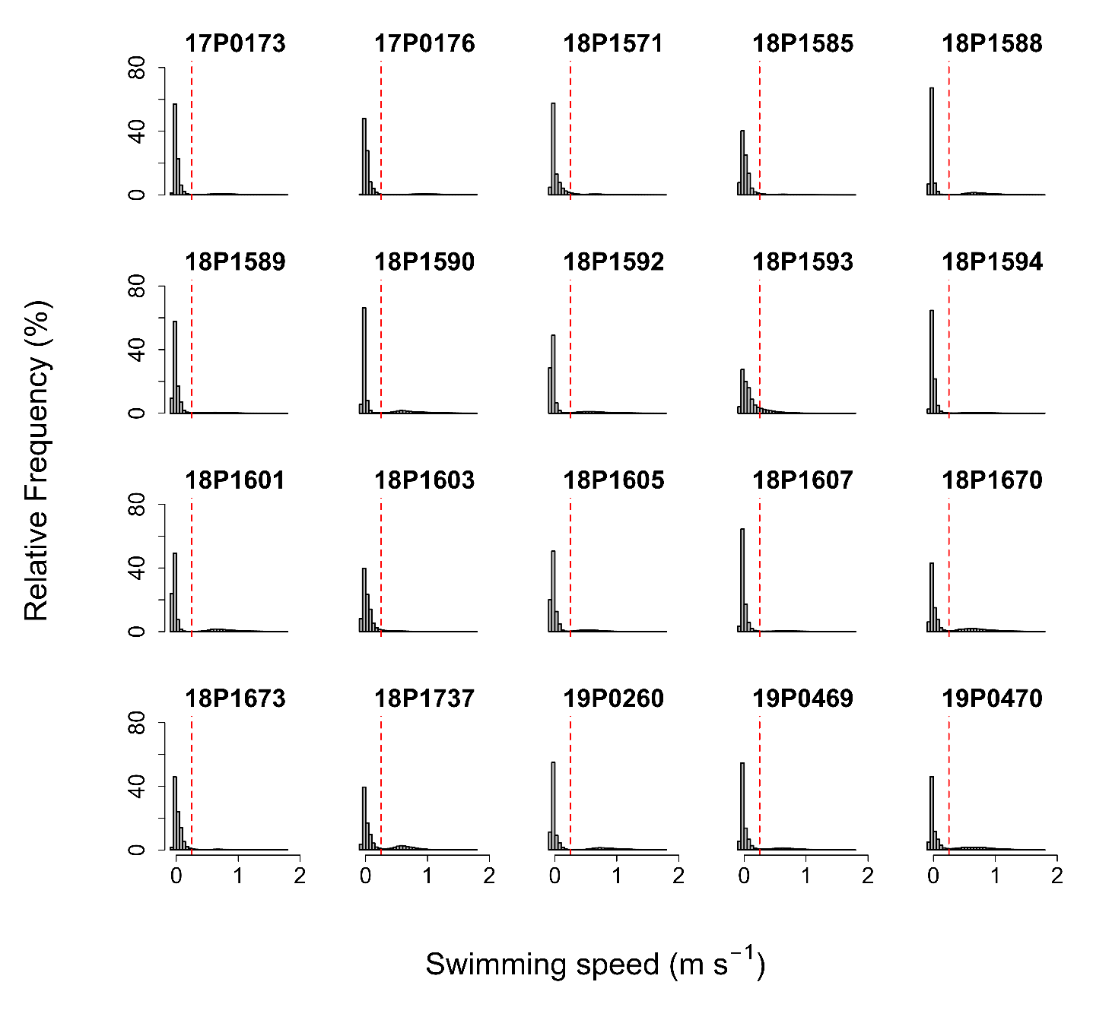
Figure A1 (continued): Histograms of velocities over the deployment period in two moored PSATs (M1/M2) and 43 Atlantic halibut. The vertical dotted red line represents the threshold between active and inactive behaviour (38.5°). Maximum swimming speed estimates correspond to the asymptote (79.87°).

Table A1: Halibut percentage of estimated time spent actively swimming and mean swimming speed during these periods over the deployment period.
PSAT ID | Fork length  (cm) | Date of  deployment | Deployment  time (days) | Percentage of estimated time spent actively swimming (%) | Mean swimming speed (m s⁻¹)
16P2437 | 164 | 25 Sept 2017 | 340 | 35.53 | 0.77
17P0086 | 146 | 19 Sept 2017 | 346 | 15.35 | 0.78
17P0087 | 148 | 3 Oct 2017 | 332 | 3.66 | 0.71
17P0126 | 145 | 23 Oct 2017 | 312 | 5.21 | 0.67
17P0127 | 147 | 23 Oct 2017 | 463 | 4.86 | 0.55
17P0135 | 159 | 25 Sept 2017 | 171 | 18.81 | 0.62
17P0136 | 138 | 3 Oct 2017 | 332 | 11.71 | 0.72
17P0138 | 166 | 3 Oct 2017 | 332 | 7.87 | 0.72
17P0140 | 161 | 3 Oct 2017 | 332 | 4.78 | 0.80
17P0143 | 146 | 27 Sept 2017 | 338 | 12.82 | 0.59
17P0147 | 171 | 10 Oct 2017 | 325 | 11.77 | 0.60
17P0148 | 171 | 26 Sept 2017 | 339 | 24.60 | 0.75
17P0149 | 150 | 23 Oct 2017 | 170 | 5.92 | 0.66
17P0150 | 155 | 25 Sept 2017 | 340 | 28.80 | 0.60
17P0154 | 180 | 23 Oct 2017 | 312 | 16.82 | 0.68
17P0155 | 160 | 25 Sept 2017 | 340 | 24.79 | 0.74
17P0159 | 146 | 27 Sept 2017 | 338 | 9.29 | 0.56
17P0162 | 143 | 23 Oct 2017 | 313 | 8.11 | 0.64
17P0165 | 130 | 16 Sept 2017 | 350 | 12.10 | 0.59
17P0166 | 135 | 3 Oct 2017 | 332 | 15.94 | 0.60
17P0169 | 130 | 27 Sept 2017 | 50 | 11.06 | 0.67
17P0170 | 139 | 3 Oct 2017 | 332 | 23.79 | 0.69
17P0171 | 165 | 3 Oct 2017 | 332 | 7.63 | 0.65
17P0173 | 168 | 15 Oct 2017 | 133 | 11.37 | 0.77
17P0176 | 202 | 23 Sept 2017 | 342 | 13.30 | 0.94
18P1571 | 118 | 8 Jun 2019 | 339 | 9.46 | 0.60
PSAT ID | Fork length (cm) | Date of  deployment | Deployment  time (days) | Percentage of estimated time spent actively swimming (%) | Mean swimming speed (m s⁻¹)
18P1585 | 87 | 24 Nov 2019 | 281 | 6.54 | 0.57
18P1588 | 164 | 29 Aug 2019 | 377 | 17.33 | 0.74
18P1589 | 135 | 31 Aug 2019 | 375 | 6.22 | 0.64
18P1590 | 165 | 29 Aug 2019 | 378 | 18.35 | 0.69
18P1592 | 147 | 29 Aug 2019 | 377 | 13.88 | 0.64
18P1593 | 175 | 31 Aug 2019 | 375 | 14.51 | 0.43
18P1594 | 160 | 28 Aug 2019 | 378 | 4.94 | 0.69
18P1601 | 189 | 29 Aug 2019 | 377 | 18.58 | 0.76
18P1603 | 136 | 31 Aug 2019 | 313 | 5.63 | 0.47
18P1605 | 153 | 28 Aug 2019 | 378 | 10.53 | 0.58
18P1607 | 156 | 25 Sept 2019 | 315 | 7.57 | 0.72
18P1670 | 138 | 24 Nov 2019 | 237 | 25.48 | 0.68
18P1673 | 133 | 24 Nov 2019 | 281 | 6.51 | 0.66
18P1737 | 184 | 24 Sept 2019 | 337 | 23.26 | 0.61
19P0260 | 158 | 26 Sept 2019 | 335 | 19.61 | 0.81
19P0469 | 99 | 24 Sept 2019 | 337 | 15.43 | 0.64
19P0470 | 105 | 24 Sept 2019 | 337 | 27.78 | 0.69
Mean | 150.39 ± 3.46 |  | 320 ± 11 | 13.90 ± 1.18 | 0.67 ± 0.01

