Antibiotic-Induced Gut Microbiota Dysbiosis in Mice: A Reproducible Model Capturing Microbial Community Collapse and Functional Restructuring

Kwangjun Lee¹ and Sooyeon Song^{1, 2*}

¹ Agriculture Convergence Technology, Jeonbuk National University, 587 Baekje-Daero, Deokjin-Gu, Jeonju-Si, Jellabuk-Do, 54896, South Korea
² Department of Animal Science, Jeonbuk National University, 587 Baekje-Daero, Deokjin-Gu, Jeonju-Si, Jellabuk-Do, 54896, South Korea

*For correspondence. E-mail songsy@jbnu.ac.kr
Tel.(+)82 63-270-2606; Fax. (82) 63-270-2612

Supplementary Tables

Table S1: Primer sequences information in qRT-PCR
Template | Target gene | F/R | Primer Sequence (5'→3') | Length (bp) | Tm (˚C) | Product size
Mus musculus | ZO-1 | Forward | GTTGGTACGGTGCCCTGAAAGA | 22 | 62.76 | 133 bp
Mus musculus | ZO-1 | Reverse | GCTGACAGGTAGGACAGACGAT | 22 | 61.53 | 133 bp
Mus musculus | COX-2 | Forward | GCGACATACTCAAGCAGGAGCA | 22 | 62.92 | 132 bp
Mus musculus | COX-2 | Reverse | AGTGGTAACCGCTCAGGTGTTG | 22 | 62.75 | 132 bp
Mus musculus | GAPDH | Forward | CATCACTGCCACCCAGAAGACTG | 23 | 63.28 | 153 bp
Mus musculus | GAPDH | Reverse | ATGCCAGTGAGCTTCCCGTTCAG | 23 | 65.15 | 153 bp
Mus musculus | β-actin | Forward | CAGCTGAGAGGGAAATCGTG | 20 | 57.4 | 150 bp
Mus musculus | β-actin | Reverse | CGTTGCCAATAGTGATGACC | 20 | 55.9 | 150 bp

Table S2: Taxonomy analysis of dominant species in Amox group (2 species)
Species | Average Abundance (%)
Bacteroides stercoris | 50.84%
Parabacteroides merdae | 49.16%

Table S3: Taxonomy analysis of dominant species in Control group (9 species)
Species | Average Abundance (%)
Lactobacillus johnsonii | 18.25%
Duncaniella dubosii | 15.37%
Muribaculum gordoncarteri | 6.25%
Duncaniella muris | 4.76%
Limosilactobacillus urinaemulieris | 4.70%
Ligilactobacillus apodemi | 4.11%
Bifidobacterium pseudolongum | 3.70%
Limosilactobacillus agrestis | 3.38%
Paramuribaculum intestinale | 3.35%
Others | 20.34%

Supplementary Figures
Fig. S1 PICRUSt2-predicted metabolic pathway alterations.
a) Heatmap showing the relative abundance of predicted MetaCyc metabolic pathways in Control and Amox samples based on PICRUSt2 analysis.
b) Expanded view of nucleotide-related metabolic pathways highlighting the reduction of nucleotide biosynthesis pathways in the Amox group compared with the Control group.

Fig. S2 Functional β-diversity of predicted metabolic pathways.
Principal coordinates analysis PCoA based on Bray–Curtis dissimilarity of PICRUSt2-predicted MetaCyc pathway abundance. Control and Amox samples formed distinct clusters, indicating separation of functional metabolic profiles between groups
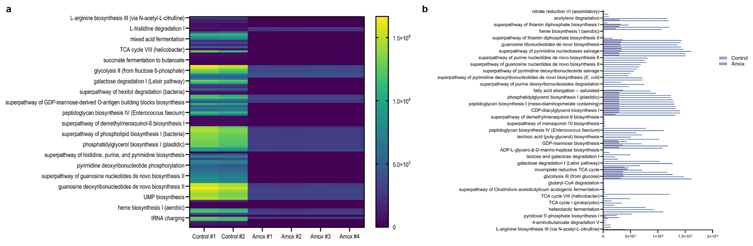
Fig. S1

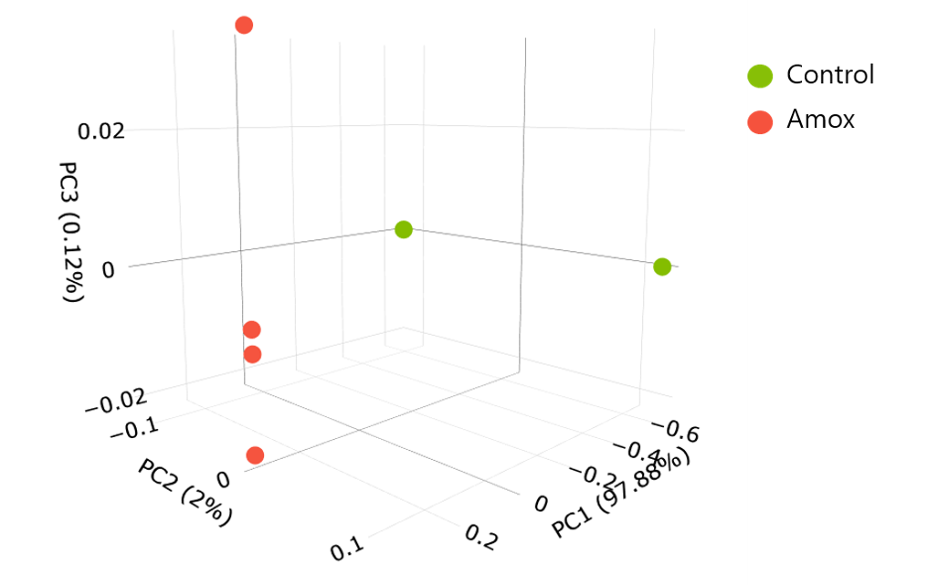
Fig. S2

