Supporting Information for

Increasing consumption-based biodiversity impacts are projected to decouple from economic growth in China by 2050

Contents
S1. Income-group classification for provinces 3
S2. Correspondance tables of economic sectors and land use classifications 4
S3. Details in panel data models 7
S4. Calibration factor for socio-economic variables 12
S5. Future land use simulation 16
S6. Changes in local and inter-provincial footprints from 2012 to 2017 23
S7. Independent contributions of drivers for each province 24
S8. Decoupling index in 2012 and 2015. 29

S1. Income-group classification for provinces
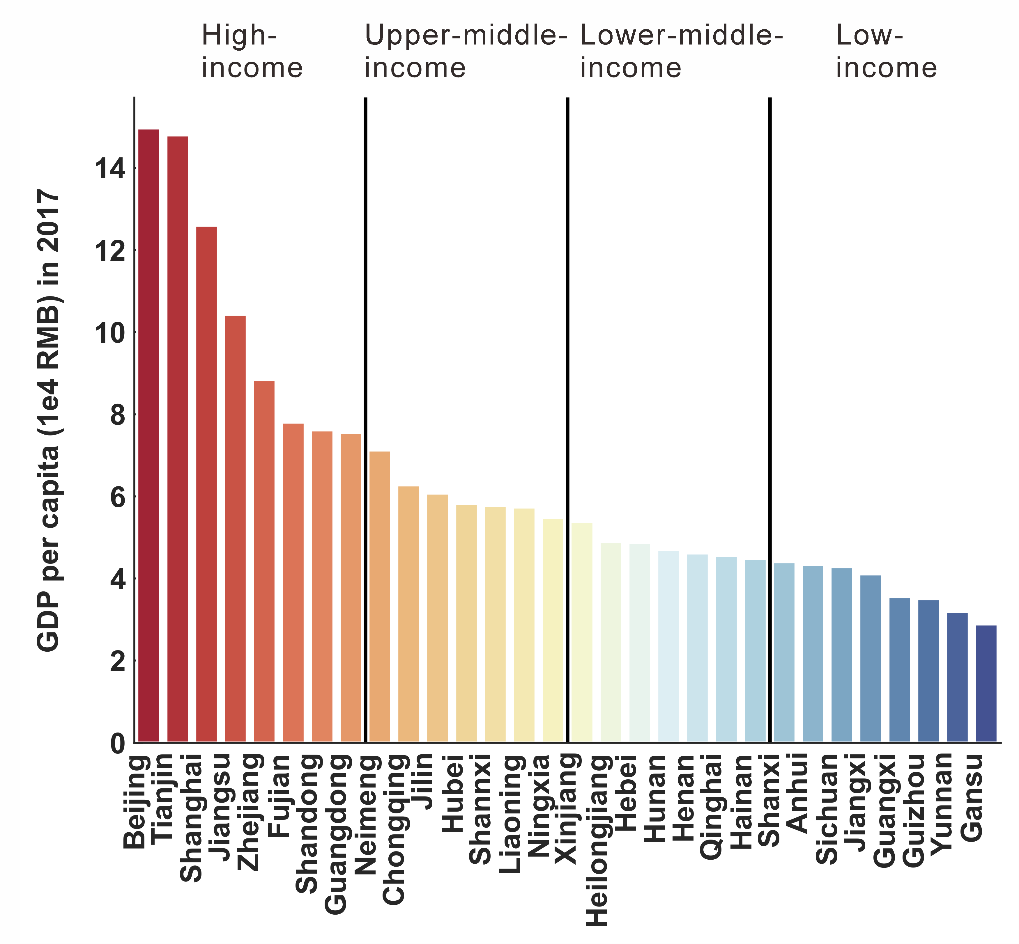
Figure S1. Income levels for provinces based on GDP per capita quartiles in 2017

S2. Correspondance tables of economic sectors and land use classifications
Table S1. Correspondance of sectors in GBT and the CO₂ emission inventory
ID | sector_GBT | sector_CO₂ emission inventory
1 | Agriculture, Forestry, Animal Husbandry and Fishery | Farming, Forestry, Animal Husbandry, Fishery and Water Conservancy
2 | Mining and washing of coal | Coal Mining and Dressing
3 | Extraction of petroleum and natural gas | Petroleum and Natural Gas Extraction
4 | Mining and processing of metal ores | Ferrous Metals Mining and Dressing
4 | Mining and processing of metal ores | Nonferrous Metals Mining and Dressing
5 | Mining and processing of nonmetal and other ores | Nonmetal Minerals Mining and Dressing
5 | Mining and processing of nonmetal and other ores | Other Minerals Mining and Dressing
6 | Food and tobacco processing | Food Processing
6 | Food and tobacco processing | Food Production
6 | Food and tobacco processing | Beverage Production
6 | Food and tobacco processing | Tobacco Processing
7 | Textile industry | Textile Industry
8 | Manufacture of leather, fur, feather and related products | Garments and Other Fiber Products
8 | Manufacture of leather, fur, feather and related products | Leather, Furs, Down and Related Products
9 | Processing of timber and furniture | Logging and Transport of Wood and Bamboo
9 | Processing of timber and furniture | Timber Processing, Bamboo, Cane, Palm Fiber & Straw Products
9 | Processing of timber and furniture | Furniture Manufacturing
10 | Manufacture of paper, printing and articles for culture, education and sport activity | Papermaking and Paper Products
10 | Manufacture of paper, printing and articles for culture, education and sport activity | Printing and Record Medium Reproduction
10 | Manufacture of paper, printing and articles for culture, education and sport activity | Cultural, Educational and Sports Articles
11 | Processing of petroleum, coking, processing of nuclear fuel | Petroleum Processing and Coking
12 | Manufacture of chemical products | Raw Chemical Materials and Chemical Products
12 | Manufacture of chemical products | Medical and Pharmaceutical Products
12 | Manufacture of chemical products | Chemical Fiber
12 | Manufacture of chemical products | Rubber Products
12 | Manufacture of chemical products | Plastic Products
13 | Manuf. of non -metallic mineral products | Nonmetal Mineral Products
14 | Smelting and processing of metals | Smelting and Pressing of Ferrous Metals
14 | Smelting and processing of metals | Smelting and Pressing of Nonferrous Metals
15 | Manufacture of metal products | Metal Products
16 | Manufacture of general purpose machinery | Ordinary Machinery
17 | Manufacture of special purpose machinery | Equipment for Special Purposes
18 | Manufacture of transport equipment | Transportation Equipment
19 | Manufacture of electrical machinery and equipment | Electric Equipment and Machinery
20 | Manufacture of communication equipment, computers and other electronic equipment | Electronic and Telecommunications Equipment
21 | Manufacture of measuring instruments | Instruments, Meters, Cultural and Office Machinery
22 | Other manufacturing and waste resources | Other Manufacturing Industry
22 | Other manufacturing and waste resources | Scrap and waste
23 | Repair of metal products, machinery and equipment | Other Manufacturing Industry
24 | Production and distribution of electric power and heat power | Production and Supply of Electric Power, Steam and Hot Water
25 | Production and distribution of gas | Production and Supply of Gas
26 | Production and distribution of tap water | Production and Supply of Tap Water
27 | Construction | Construction
28 | Wholesale and retail trades | Wholesale, Retail Trade and Catering Services
29 | Transport, storage, and postal services | Transportation, Storage, Post and Telecommunication Services
30 | Accommodation and catering | Wholesale, Retail Trade and Catering Services
31 | Information transfer, software and information technology services | Transportation, Storage, Post and Telecommunication Services
32 | Finance | Others
33 | Real estate | Others
34 | Leasing and commercial services | Others
35 | Scientific research | Others
36 | Polytechnic services | Others
37 | Administration of water, environment, and public facilities | Others
38 | Resident, repair and other services | Others
39 | Education | Others
40 | Health care and social work | Others
41 | Culture, sports, and entertainment | Others
42 | Public administration, social insurance, and social organizations | Others

Table S2. Land use reclassification scheme
Land use classification in this study | Land use classification  in the MCD12Q1 product | Land use classification in Luo et al [1]
Cropland | Croplands | Cropland
 | Cropland/natural vegetation mosaics
Forest | Evergreen needleleaf forests | Forest
 | Evergreen broadleaf forests | Shrub
 | Deciduous needleleaf forests
 | Deciduous broadleaf forests
 | Mixed forests
 | Closed shrublands
 | Open shrublands
 | Woody savannas
Grassland | Savannas | Grassland
 | Grasslands
Water | Permanent wetlands | Water
 | Snow and ice | Ice
 | Water bodies
Urban | Urban and built-up lands | Urban
Unused | Barren | Bareland

Reference
1. Luo, M. et al. 1 km land use/land cover change of China under comprehensive socioeconomic and climate scenarios for 2020–2100. Sci Data 9, 110 (2022).

S3. Details in panel data models
Table S3. Results of the backward elimination
lnFootprint | Full_RE |  | Model2_RE |  | Projection_RE
lnPOP | 0.804 | *** | 0.786 | *** | 0.907 | ***
 | (0.116) |  | (0.0940) |  | (0.0652)
lnURBD | 0.566 | *** | 0.555 | *** | 0.465 | **
 | (0.168) |  | (0.163) |  | (0.159)
lnURBR | -0.183 |  | -0.208 |  | -0.298 | **
 | (0.145) |  | (0.110) |  | (0.101)
lnAGR | -0.270 | *** | -0.269 | *** | -0.235 | ***
 | (0.0534) |  | (0.0531) |  | (0.0509)
lnPRI | 0.151 |  | 0.147
 | (0.0863) |  | (0.0845)
lnTER | -0.0225
 | (0.0864)
Elevation | 0.341 | *** | 0.342 | *** | 0.310 | **
 | (0.0938) |  | (0.0937) |  | (0.0950)
Tropical | 0.555 | *** | 0.562 | *** | 0.643 | ***
 | (0.133) |  | (0.129) |  | (0.125)
Inter | 0.771 | ** | 0.767 | ** | 0.685 | **
 | (0.235) |  | (0.234) |  | (0.237)
_cons | -1.074 |  | -1.150 | * | -1.637 | ***
 | (0.586) |  | (0.506) |  | (0.435)
Obs | 90 |  | 90 |  | 90
df | 12 |  | 11 |  | 10
LR chi2(1) | Ref |  | 0.07 |  | 2.93
p for LR test | Ref |  | 0.795 |  | 0.868
Standard errors in parentheses
* p<0.05, ** p<0.01, *** p<0.001
All models were estimated using re mle
LR indicates the Likelihood Ratio test

Table S4. Results of the statistical tests for model specification
Model | BP test | Hausman test
Full_POLS | chibar2(01) = 6.20  p-value = 0.0064
Full_RE (finally selected) | chibar2(01) = 6.20  p-value = 0.0064 | chi2(6) = 18.60  p-value = 0.0049
Full_FE |  | chi2(6) = 18.60  p-value = 0.0049
Projection_POLS | chibar2(01) = 7.15  p-value = 0.0037
Projection_RE (finally selected) | chibar2(01) = 7.15  p-value = 0.0037 | chi2(4) = 5.44
Projection_FE |  | p-value = 0.2448

The name of the model listed above aligns with that in the Article, Table 2. Models of the same type (Full model or Projection model) with the same prefix share the same variables. Notably, although the Hausman test indicated that the Full_FE was more suitable, it was not used in our study due to several problems: (1) the log transformation decreased within-group variations of the variables, resulting in significant biases in FE estimation, and (2) the population and tertiary GDP exhibited strong collinearity in FE estimation (after removing the mean value), although they did not show such collinearity in RE estimation. We attempted to construct an available FE estimation by (1) using standardization instead of log transformation and (2) removing population and tertiary GDP. However, we ultimately did not employ this model due to the statistical insignificance of key variables, with the exception of total population.

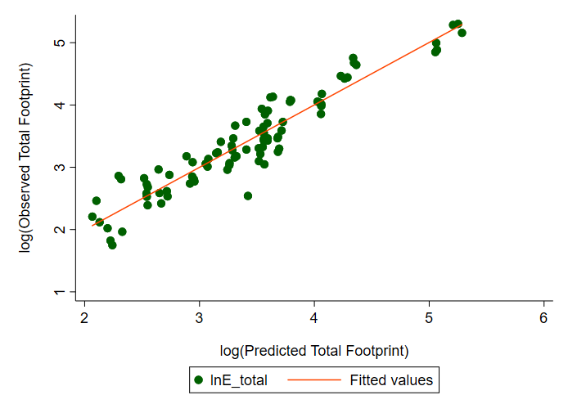
Figure S2. Biodiversity footprints calculated using the EE-MRIO model and the predicted biodiversity footprints from the Projection_RE model (see Article, Table 2) across 30 Chinese provinces in 2012, 2015, and 2017.

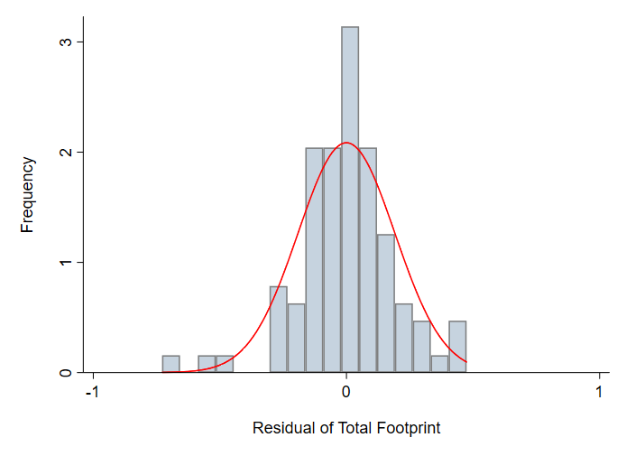
Figure S3. Histogram of the residuals from the Projection_RE model (see Article, Table 2).
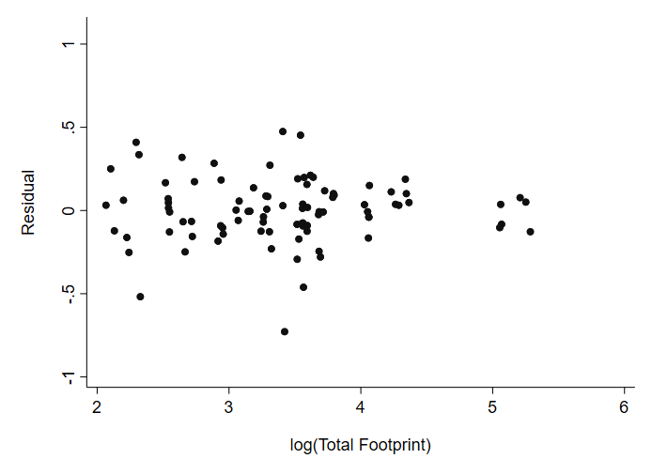
Figure S4. Scatter plot of the residuals and predicted biodiversity footprints from the Projection_RE model (see Article, Table 2) across 30 provinces in 2012, 2015, and 2017.
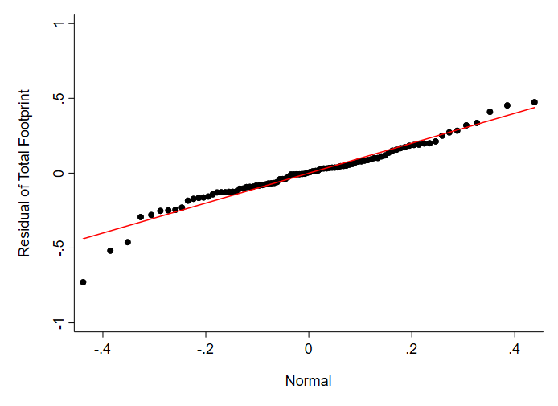
Figure S5. Quantile-quantile (Q-Q) plot of the residuals from the Projection_RE model (see Article, Table 2) across 30 provinces in 2012, 2015, and 2017.

Table S5. Random-effects models for local footprints and inter-provincial footprints
lnFootprint | Local |  | Inter-provincial
lnPOP | 0.979 | *** | 0.249
 | (0.188) |  | (0.153)
lnURBD | 0.321 |  | 0.185
 | (0.343) |  | (0.211)
lnURBR | -1.230 | *** | 0.407 | *
 | (0.259) |  | (0.191)
lnAGR | -0.496 | *** | 0.042
 | (0.121) |  | (0.067)
lnPRI | 0.259 |  | 0.031
 | (0.133) |  | (0.112)
lnTER | -0.114 |  | 0.488 | ***
 | (0.0736) |  | (0.122)
Elevation | 0.666 | ** | -0.027
 | (0.231) |  | (0.117)
Tropical | 1.032 | ** | 0.149
 | (0.318) |  | (0.167)
Inter | 0.316 |  | 0.044
 | (0.584) |  | (0.293)
_cons | -2.620 | * | -4.007 | ***
 | (1.189) |  | (0.763)

S4. Calibration factor for socio-economic variables
Table S6. Calibration factors for the total population in each province under SSPs based on the China Statistical Yearbook 2020.
pid | province | SSP1 | SSP2 | SSP3 | SSP4 | SSP5
1 | Beijing | 0.978352 | 0.969505 | 0.960399 | 0.965048 | 0.971784
2 | Tianjin | 1.020754 | 1.01241 | 0.996639 | 1.003879 | 1.009061
3 | Hebei | 0.979593 | 0.96815 | 0.957975 | 0.96321 | 0.964656
4 | Shanxi | 0.964817 | 0.964975 | 0.951925 | 0.957891 | 0.959424
5 | Neimeng | 0.862217 | 0.821389 | 0.83142 | 0.844983 | 0.865533
6 | Liaoning | 1.026949 | 1.021254 | 1.006744 | 1.01205 | 1.016233
7 | Jilin | 0.962041 | 0.962818 | 0.948896 | 0.955888 | 0.96088
8 | Heilongjiang | 0.940313 | 0.9267 | 0.918223 | 0.92745 | 0.934928
9 | Shanghai | 0.884811 | 0.888985 | 0.87209 | 0.879493 | 0.881315
10 | Jiangsu | 0.986961 | 0.984332 | 0.971114 | 0.976293 | 0.979921
11 | Zhejiang | 1.005264 | 1.007044 | 0.991173 | 0.998572 | 1.002309
12 | Anhui | 1.009352 | 1.013474 | 0.996766 | 1.005065 | 1.006256
13 | Fujian | 1.010595 | 1.003769 | 0.991086 | 0.998344 | 1.002927
14 | Jiangxi | 0.985809 | 0.989975 | 0.972503 | 0.980104 | 0.983033
15 | Shandong | 1.001015 | 0.998535 | 0.98376 | 0.990738 | 0.992738
16 | Henan | 1.010956 | 1.014778 | 0.997482 | 1.005565 | 1.006696
17 | Hubei | 1.004721 | 1.009139 | 0.991885 | 0.999741 | 1.003591
18 | Hunan | 1.002097 | 1.008027 | 0.98919 | 0.997374 | 1.000612
19 | Guangdong | 0.977375 | 0.981743 | 0.966213 | 0.973283 | 0.977599
20 | Guangxi | 1.000676 | 1.000965 | 0.98269 | 0.992556 | 0.995743
21 | Hainan | 1.033969 | 1.029629 | 1.011443 | 1.020783 | 1.021355
22 | Chongqing | 1.037817 | 1.044273 | 1.021192 | 1.032503 | 1.036186
23 | Sichuan | 1.015065 | 1.020288 | 1.002327 | 1.012142 | 1.015731
24 | Guizhou | 1.010867 | 1.015055 | 0.995084 | 1.005743 | 1.008908
25 | Yunnan | 0.986906 | 0.989965 | 0.972163 | 0.982879 | 0.98684
26 | Shannxi | 1.004184 | 1.006837 | 0.98958 | 0.998391 | 1.001512
27 | Gansu | 0.961097 | 0.956799 | 0.944561 | 0.95473 | 0.960955
28 | Qinghai | 0.853982 | 0.816546 | 0.825742 | 0.849025 | 0.870253
29 | Ningxia | 0.943006 | 0.942958 | 0.928743 | 0.936542 | 0.943301
30 | Xinjiang | 0.863955 | 0.835138 | 0.839402 | 0.852259 | 0.870279

Table S7. Calibration factors for the urban population in each province under SSPs based on the China Statistical Yearbook 2020.
pid | province | SSP1 | SSP2 | SSP3 | SSP4 | SSP5
1 | Beijing | 0.847663 | 0.843682 | 0.828358 | 0.83477 | 0.83784
2 | Tianjin | 0.965556 | 0.957034 | 0.940675 | 0.948097 | 0.952453
3 | Hebei | 0.920995 | 0.914118 | 0.899226 | 0.904679 | 0.906604
4 | Shanxi | 0.911735 | 0.916181 | 0.89696 | 0.904279 | 0.908377
5 | Neimeng | 0.815935 | 0.819972 | 0.80645 | 0.810759 | 0.813337
6 | Liaoning | 0.965278 | 0.971282 | 0.953004 | 0.96046 | 0.96225
7 | Jilin | 0.787767 | 0.793613 | 0.779464 | 0.784363 | 0.786296
8 | Heilongjiang | 0.882101 | 0.885731 | 0.86937 | 0.873079 | 0.877929
9 | Shanghai | 0.821714 | 0.827068 | 0.810938 | 0.818204 | 0.819676
10 | Jiangsu | 0.937878 | 0.937725 | 0.920861 | 0.928179 | 0.930438
11 | Zhejiang | 0.96273 | 0.967326 | 0.949418 | 0.957162 | 0.96041
12 | Anhui | 0.941587 | 0.942171 | 0.926083 | 0.93259 | 0.93521
13 | Fujian | 1.044758 | 1.048424 | 1.028298 | 1.037457 | 1.039347
14 | Jiangxi | 0.952895 | 0.954799 | 0.937354 | 0.941962 | 0.945663
15 | Shandong | 0.839953 | 0.840371 | 0.82538 | 0.831364 | 0.833756
16 | Henan | 0.981088 | 0.98395 | 0.964922 | 0.971807 | 0.974579
17 | Hubei | 0.917482 | 0.920287 | 0.902584 | 0.908685 | 0.913291
18 | Hunan | 1.00337 | 1.006499 | 0.987632 | 0.996865 | 1.000424
19 | Guangdong | 1.034958 | 1.046223 | 1.025134 | 1.034703 | 1.037536
20 | Guangxi | 1.105873 | 1.107 | 1.085358 | 1.094082 | 1.100042
21 | Hainan | 1.38319 | 1.388995 | 1.364049 | 1.379529 | 1.374635
22 | Chongqing | 1.162029 | 1.169829 | 1.143272 | 1.155574 | 1.160635
23 | Sichuan | 0.894708 | 0.899496 | 0.882158 | 0.890537 | 0.89203
24 | Guizhou | 0.949997 | 0.959866 | 0.93933 | 0.947682 | 0.948642
25 | Yunnan | 1.320658 | 1.333542 | 1.30522 | 1.317556 | 1.322181
26 | Shannxi | 0.917939 | 0.920436 | 0.90191 | 0.909689 | 0.912958
27 | Gansu | 1.271958 | 1.277373 | 1.254836 | 1.266305 | 1.271881
28 | Qinghai | 1.198722 | 1.210545 | 1.186426 | 1.195463 | 1.202379
29 | Ningxia | 1.271978 | 1.283818 | 1.254888 | 1.263169 | 1.267866
30 | Xinjiang | 0.865282 | 0.872555 | 0.858561 | 0.86744 | 0.865889

Table S8. Calibration factors for the primary GDP in each province under SSPs based on the China Statistical Yearbook 2020.
pid | province | SSP1 | SSP2 | SSP3 | SSP4 | SSP5
1 | Beijing | 0.935089 | 0.948774 | 0.957044 | 0.964593 | 0.947188
2 | Tianjin | 1.120601 | 1.127515 | 1.165207 | 1.160895 | 1.152555
3 | Hebei | 1.342326 | 1.342005 | 1.364723 | 1.362088 | 1.358416
4 | Shanxi | 1.322641 | 1.330335 | 1.342142 | 1.344353 | 1.340033
5 | Neimeng | 1.292479 | 1.326512 | 1.353952 | 1.364287 | 1.360008
6 | Liaoning | 1.24855 | 1.245854 | 1.271913 | 1.265011 | 1.261003
7 | Jilin | 1.33726 | 1.370008 | 1.407302 | 1.414493 | 1.393075
8 | Heilongjiang | 1.159751 | 1.176868 | 1.22039 | 1.208822 | 1.219347
9 | Shanghai | 1.025243 | 1.000966 | 1.070602 | 1.041428 | 1.023925
10 | Jiangsu | 1.18089 | 1.173216 | 1.211669 | 1.208667 | 1.206414
11 | Zhejiang | 1.224924 | 1.208943 | 1.234734 | 1.248478 | 1.232293
12 | Anhui | 1.329426 | 1.31789 | 1.332837 | 1.335122 | 1.335738
13 | Fujian | 1.295288 | 1.285798 | 1.309404 | 1.298631 | 1.292861
14 | Jiangxi | 1.328554 | 1.316445 | 1.338207 | 1.331292 | 1.333565
15 | Shandong | 1.188466 | 1.172583 | 1.198367 | 1.200583 | 1.192678
16 | Henan | 1.359849 | 1.345377 | 1.370887 | 1.383735 | 1.369267
17 | Hubei | 1.304174 | 1.298147 | 1.31435 | 1.318263 | 1.318267
18 | Hunan | 1.440468 | 1.430082 | 1.44524 | 1.451876 | 1.451573
19 | Guangdong | 1.395219 | 1.383777 | 1.39658 | 1.399604 | 1.408348
20 | Guangxi | 1.333846 | 1.339009 | 1.339938 | 1.348833 | 1.352691
21 | Hainan | 1.33629 | 1.321783 | 1.338636 | 1.340706 | 1.340057
22 | Chongqing | 1.415165 | 1.403009 | 1.428222 | 1.420941 | 1.417946
23 | Sichuan | 1.38064 | 1.384207 | 1.412928 | 1.405526 | 1.404816
24 | Guizhou | 1.314883 | 1.336315 | 1.334833 | 1.331 | 1.341417
25 | Yunnan | 1.494092 | 1.496827 | 1.503744 | 1.502181 | 1.505618
26 | Shannxi | 1.325721 | 1.31998 | 1.348209 | 1.349164 | 1.337332
27 | Gansu | 1.481984 | 1.466745 | 1.4934 | 1.486932 | 1.485034
28 | Qinghai | 1.758271 | 1.733651 | 1.823786 | 1.858668 | 1.733292
29 | Ningxia | 1.420389 | 1.413558 | 1.437423 | 1.427046 | 1.416698
30 | Xinjiang | 1.457702 | 1.468746 | 1.503475 | 1.504434 | 1.4924

Table S9. Calibration factors for the tertiary GDP in each province under SSPs based on the China Statistical Yearbook 2020.
pid | province | SSP1 | SSP2 | SSP3 | SSP4 | SSP5
1 | Beijing | 1.067112 | 1.072991 | 1.072559 | 1.135336 | 1.098635
2 | Tianjin | 1.160582 | 1.176579 | 1.176637 | 1.190354 | 1.187557
3 | Hebei | 1.235927 | 1.253703 | 1.262172 | 1.242033 | 1.167705
4 | Shanxi | 1.226225 | 1.244039 | 1.245266 | 1.226921 | 1.230679
5 | Neimeng | 1.166046 | 1.162522 | 1.202253 | 1.218331 | 1.17238
6 | Liaoning | 1.090487 | 1.066258 | 1.045911 | 1.044264 | 1.068716
7 | Jilin | 1.152021 | 1.124843 | 1.147442 | 1.172032 | 1.120177
8 | Heilongjiang | 1.087027 | 1.097559 | 1.165966 | 1.141489 | 1.121042
9 | Shanghai | 1.260048 | 1.240607 | 1.308044 | 1.275513 | 1.225706
10 | Jiangsu | 1.2341 | 1.200149 | 1.250985 | 1.212313 | 1.213898
11 | Zhejiang | 1.301212 | 1.268768 | 1.330193 | 1.282986 | 1.273257
12 | Anhui | 1.35154 | 1.356211 | 1.357697 | 1.337147 | 1.312887
13 | Fujian | 1.327465 | 1.333012 | 1.397456 | 1.354939 | 1.316127
14 | Jiangxi | 1.293524 | 1.30461 | 1.312409 | 1.276248 | 1.25623
15 | Shandong | 1.17133 | 1.162402 | 1.220555 | 1.176199 | 1.155684
16 | Henan | 1.270179 | 1.243341 | 1.29055 | 1.247315 | 1.219404
17 | Hubei | 1.233679 | 1.247878 | 1.249458 | 1.229526 | 1.20678
18 | Hunan | 1.247265 | 1.222886 | 1.266352 | 1.249687 | 1.20414
19 | Guangdong | 1.278249 | 1.274998 | 1.308267 | 1.300906 | 1.259759
20 | Guangxi | 1.306661 | 1.300008 | 1.282736 | 1.316579 | 1.269132
21 | Hainan | 1.332383 | 1.333739 | 1.349447 | 1.331523 | 1.319215
22 | Chongqing | 1.263545 | 1.270355 | 1.282881 | 1.253442 | 1.257982
23 | Sichuan | 1.27161 | 1.237479 | 1.287948 | 1.248767 | 1.225612
24 | Guizhou | 1.290743 | 1.286837 | 1.190089 | 1.281835 | 1.262446
25 | Yunnan | 1.334948 | 1.323591 | 1.315395 | 1.308856 | 1.296467
26 | Shannxi | 1.267534 | 1.24255 | 1.27938 | 1.287482 | 1.231629
27 | Gansu | 1.205416 | 1.217099 | 1.223576 | 1.179475 | 1.184702
28 | Qinghai | 1.456165 | 1.469171 | 1.463725 | 1.477067 | 1.452952
29 | Ningxia | 1.321747 | 1.323662 | 1.350029 | 1.310287 | 1.296165
30 | Xinjiang | 1.223846 | 1.225267 | 1.238635 | 1.219743 | 1.185575

S5. Future land use simulation
The future land use dynamics were simulated using Future Land Use Simulation (FLUS) model. The FLUS model can simulates dynamic patterns of multiple land use types and considers the complex interactions between human activities and natural environments, thus having a higher precision compared to other mainstream local CA-based models^{1,2}. The first part of FLUS model utilized a back propagation artificial neural network (BP-ANN) module to estimate the suitability of each land use type on each grid cell utilizing natural, social and economic driving factors. BP-ANN is well-suited for modeling large-scale land use transformations due to its strong ability to capture complex non-linear interaction relationships among different variables. A sigmoid function is used to activate the output of the hidden layers. The back-propagation iterative mechanism is employed to automatically adjust weight matrices, to minimize the errors between estimated land use type of network output and actual land use type in historical remote sensing images. After iterations, the well-trained BP-ANN model is then used to obtain occurrence probability maps of each land use type.
In the second part, land use types are allocated to each pixel based on an elaborated self-adaptive inertia and a roulette-based competition mechanism. For each land use type, an inertia coefficient is defined to accelerate the convergence of allocated land use amount to macro demand amount, as described below:
$$\begin{aligned}I_{c}^{t}=\left\{\begin{aligned}I_{c}^{t-1} if \left|D_{c}^{t-2}\right|≥\left|D_{c}^{t-1}\right| \\ I_{c}^{t-1}×\frac{D_{c}^{t-2}}{D_{c}^{t-1}} if 0>D_{c}^{t-2}>D_{c}^{t-1} \\ I_{c}^{t-1}×\frac{D_{k}^{t-1}}{D_{c}^{t-2}} if 0<D_{c}^{t-2}<D_{c}^{t-1}\end{aligned}\right..\#\left(S seq equation 1\right)\end{aligned}$$
In Eq. ($S1$), $I_{c}^{t}$represents the time-dependent self-adaptive inertia coefficient for land use type $c$ at simulation time $t$. $D_{c}^{t-1}$ denotes the differences between the total demand and the currently allocated amount of land use type $c$ at simulation time $t-1$. During the iteration, the total conversion probabilities of each land use types are calculated according to the following equation:
$$\begin{aligned}{TP}_{p,c}^{t}={OP}_{p,c}×Ω_{p,c}^{t}×I_{c}^{t}×R_{l→c},\#\left(S seq equation 2\right)\end{aligned}$$
where ${TP}_{p,c}^{t}$ represents the total conversion probability of land use type $c$ at pixel $p$ in simulation time $t$. ${OP}_{p,c}$ denotes the occurrence probability of land use type $c$ at pixel $p$ estimated by BP-ANN model. $Ω_{p,c}^{t}$ represents 3$×$3 Moore neighborhood, which considers the influence of surrounding preexisting pixels on the likelihood of land use transition of land use type $c$ at pixel $p$ in simulation time $t$. $I_{c}^{t}$ calculated by Eq. ($S1$) denotes the inertia coefficient of land use type $c$ at simulation time $t$. And $R_{l→c}$ is the binary conversion cost matrix, where the value $∈\left[0, 1\right]$ represents the conversion difficulties. Based on the total conversion probabilities ${TP}_{p,c}^{t}$, each land use type is then allocated to pixels by randomly selecting a subregion of a roulette wheel, where the area of each subregion is proportional to the total conversion probability of the corresponding land use type. This probability-based allocation method retains the conversion advantages of the main land use types as well as the conversion possibility of land use type with a small probability.
Evaluation of simulation accuracy adopted the ‘Figure of Merit’ (FoM) indicator. Unlike other metrics such as the Kappa coefficient and overall accuracy (OA), FoM only focuses the change pixels between the initial and the predicted land use maps, thus avoiding overestimating simulation precision due to accounting for similar patterns of large unchanged areas^{2,3}. The calculation of FoM is described as:
$$\begin{aligned}FoM=\frac{B}{A+B+C+D},\#\left(S seq equation 3\right)\end{aligned}$$
where $A, B, C$ and $D$ indicate the total area of land use types which observed as changed but predicted as unchanged, both observed and predicted as changed correctly, predicted as changed but actually changed to false types and observed as unchanged but predicted as changed, respectively.
The key process of future land use change simulation is allocating total demand area of each land use type to grid cells based on their total conversion probability. The future demands of each land use type under SSP scenarios were determined using baseline scenarios of the comprehensive SSP-RCP scenario LULC dataset. To address the mismatch of land use amount between the comprehensive SSP-RCP scenario LULC dataset and the MODIS Land Cover Type Product (MCD12Q1) used in this study, we applied a trend matching method, which is described as follows:
$$\begin{aligned}{D_{est}}_{c}^{t+1}=\frac{{A_{DS}}_{c}^{t+1}}{{A_{DS}}_{c}^{2020}}×{A_{MODIS}}_{c}^{2020} ,\#\left(S seq equation 4\right)\end{aligned}$$
$$\begin{aligned}{D_{adj}}_{c}^{t}=\frac{\sum_{c=1}^{k-1}{{A_{MODIS}}_{c}^{2020}}}{\sum_{c=1}^{k-1}{{D_{est}}_{c}^{t}}}×{D_{est}}_{c}^{t} .\#\left(S seq equation 5\right)\end{aligned}$$
In Eq. ($S4$), ${D_{est}}_{c}^{t+1}$ represents the estimated total demand area of land use type $c$ at simulation time $t+1$. ${A_{DS}}_{c}^{t+1}$ and ${A_{DS}}_{c}^{2020}$ indicate the area of land use type $c$ calculated from the comprehensive SSP-RCP scenario LULC dataset at simulation time $t+1$ and year 2020, respectively. ${A_{MODIS}}_{c}^{2020}$ represents the area of land use type $c$ at year 2020 derived from the MCD12Q1 product. We then applied a constraint of the total territory land area on total demand of all land use types ${D_{est}}_{c}^{t}$ according to Eq. ($S5$), where ${D_{adj}}_{c}^{t}$ denotes the finally adjusted demand of land use type $c$ at simulation time $t$. In our analysis, we used MCD12Q1 images of 2001 and 2015 to train and evaluate the FLUS model, respectively. Aligning with other studies^{1,2,4}, we assumed that urban land cannot convert to other land use types, and the water area remains unchanged in the future simulations.

Table S10. Data sources for driving factors used in the FLUS model
Category | Driving Factor | Resolution | Year | Data sources
Natural  environmental | Elevation  Slope | 30 m | 1996 | USGS GTOPO 30  (https://www.usgs.gov/)
Natural  environmental | Annual mean temperature  Annual mean precipitation | 1 km | 2000 | WorldClim v2.1 (http://www.worldclim.org/)
Natural  environmental | Soil nutrient availability  Soil oxygen availability  Soil excess Salt  Soil workability | 5′ | 2008 | Global Agro-Ecological Zones (GAEZ v4.0) (https://gaez.fao.org/)
Natural  environmental | Euclidean distance to rivers and lakes | 1 km | 2010 | Resource and Environment Data Cloud Platform (http://www.resdc.cn/)
Socio-economic | Population | 1 km | 2010 | Gaughan et al. [5]
Socio-economic | GDP | 1 km | 2015 | Kummu et al. [6]
Socio-economic | Kernel density of POI of restaurant and hotel | 1 km | 2012 | Gaode Map API  (https://lbs.amap.com/api)
transportation accessibility | Euclidean distance to urban centers | 1 km | 2015 | GHS Urban Centre Database (GHS-UCDB) [7]
transportation accessibility | Euclidean distance to railways  Euclidean distance to highways  Euclidean distance to primary roads  Euclidean distance to secondary roads | 1 km | 2018 | The Global Roads Inventory Project (GRIP 4) [8]

Reference
1. Chen, G., Zhuang, H. & Liu, X. Cell-level coupling of a mechanistic model to cellular automata for improving land simulation. GIScience & Remote Sensing 60, 2166443 (2023).
2. Li, X. et al. A New Global Land-Use and Land-Cover Change Product at a 1-km Resolution for 2010 to 2100 Based on Human–Environment Interactions. Annals of the American Association of Geographers 107, 1040–1059 (2017).
3. Pontius, R. G. et al. Comparing the input, output, and validation maps for several models of land change. Ann Reg Sci 42, 11–37 (2008).
4. Luo, M. et al. 1 km land use/land cover change of China under comprehensive socioeconomic and climate scenarios for 2020–2100. Sci Data 9, 110 (2022).
5. Gaughan, A. E. et al. Spatiotemporal patterns of population in mainland China, 1990 to 2010. Sci Data 3, 160005 (2016).
6. Kummu, M., Taka, M. & Guillaume, J. H. A. Gridded global datasets for Gross Domestic Product and Human Development Index over 1990–2015. Sci Data 5, 180004 (2018).
7. Florczyk, A. et al. GHS-UCDB R2019A - GHS Urban Centre Database 2015, multitemporal and multidimensional attributes. (2019).
8. Meijer, J. R., Huijbregts, M. A. J., Schotten, K. C. G. J. & Schipper, A. M. Global patterns of current and future road infrastructure. Environ. Res. Lett. 13, 064006 (2018).

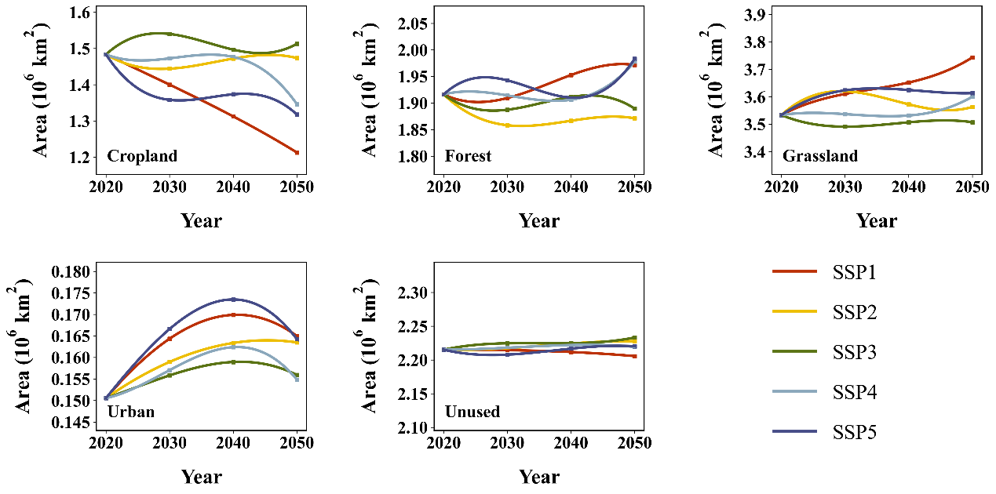
Figure S6. Adjusted land use demands for cropland, forest, grassland, urban and unused land under five SSP scenarios from 2020 to 2050.

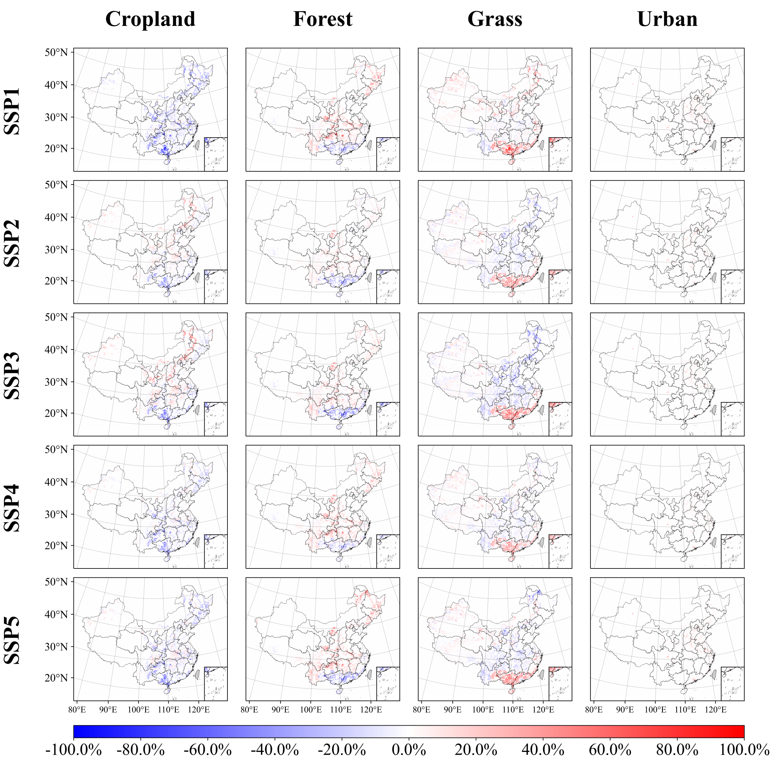
Figure S7. Future land use simulation results for cropland, forest, grassland, and urban areas under five SSP scenarios for 2050 are presented. The color bar indicates the percentage change in area for each land use type from 2017 to 2050. This change was calculated by aggregating 100 1 km $×$ 1 km pixels at a resolution of 0.125 arc degrees and determining the area difference between the two years.

S6. Changes in local and inter-provincial footprints from 2012 to 2017
Figure S8. Temporal changes in the local footprints (blue bar), inter-provincial footprints (red bar), total footprints (green line and dot), and footprint intensities (yellow line and dot) for all provinces from 2012 to 2017.

S7. Independent contributions of drivers for each province
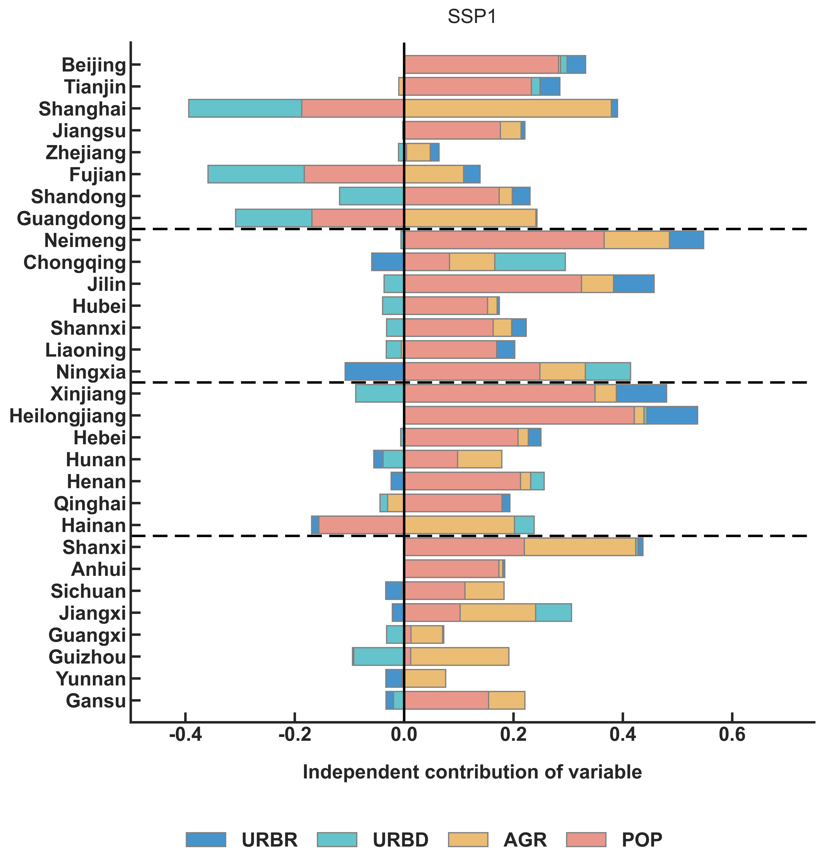
Figure S9. Independent contributions of each driver to changes in the log-transformed biodiversity footprint across 30 provinces from 2017 to 2050 under SSP1.
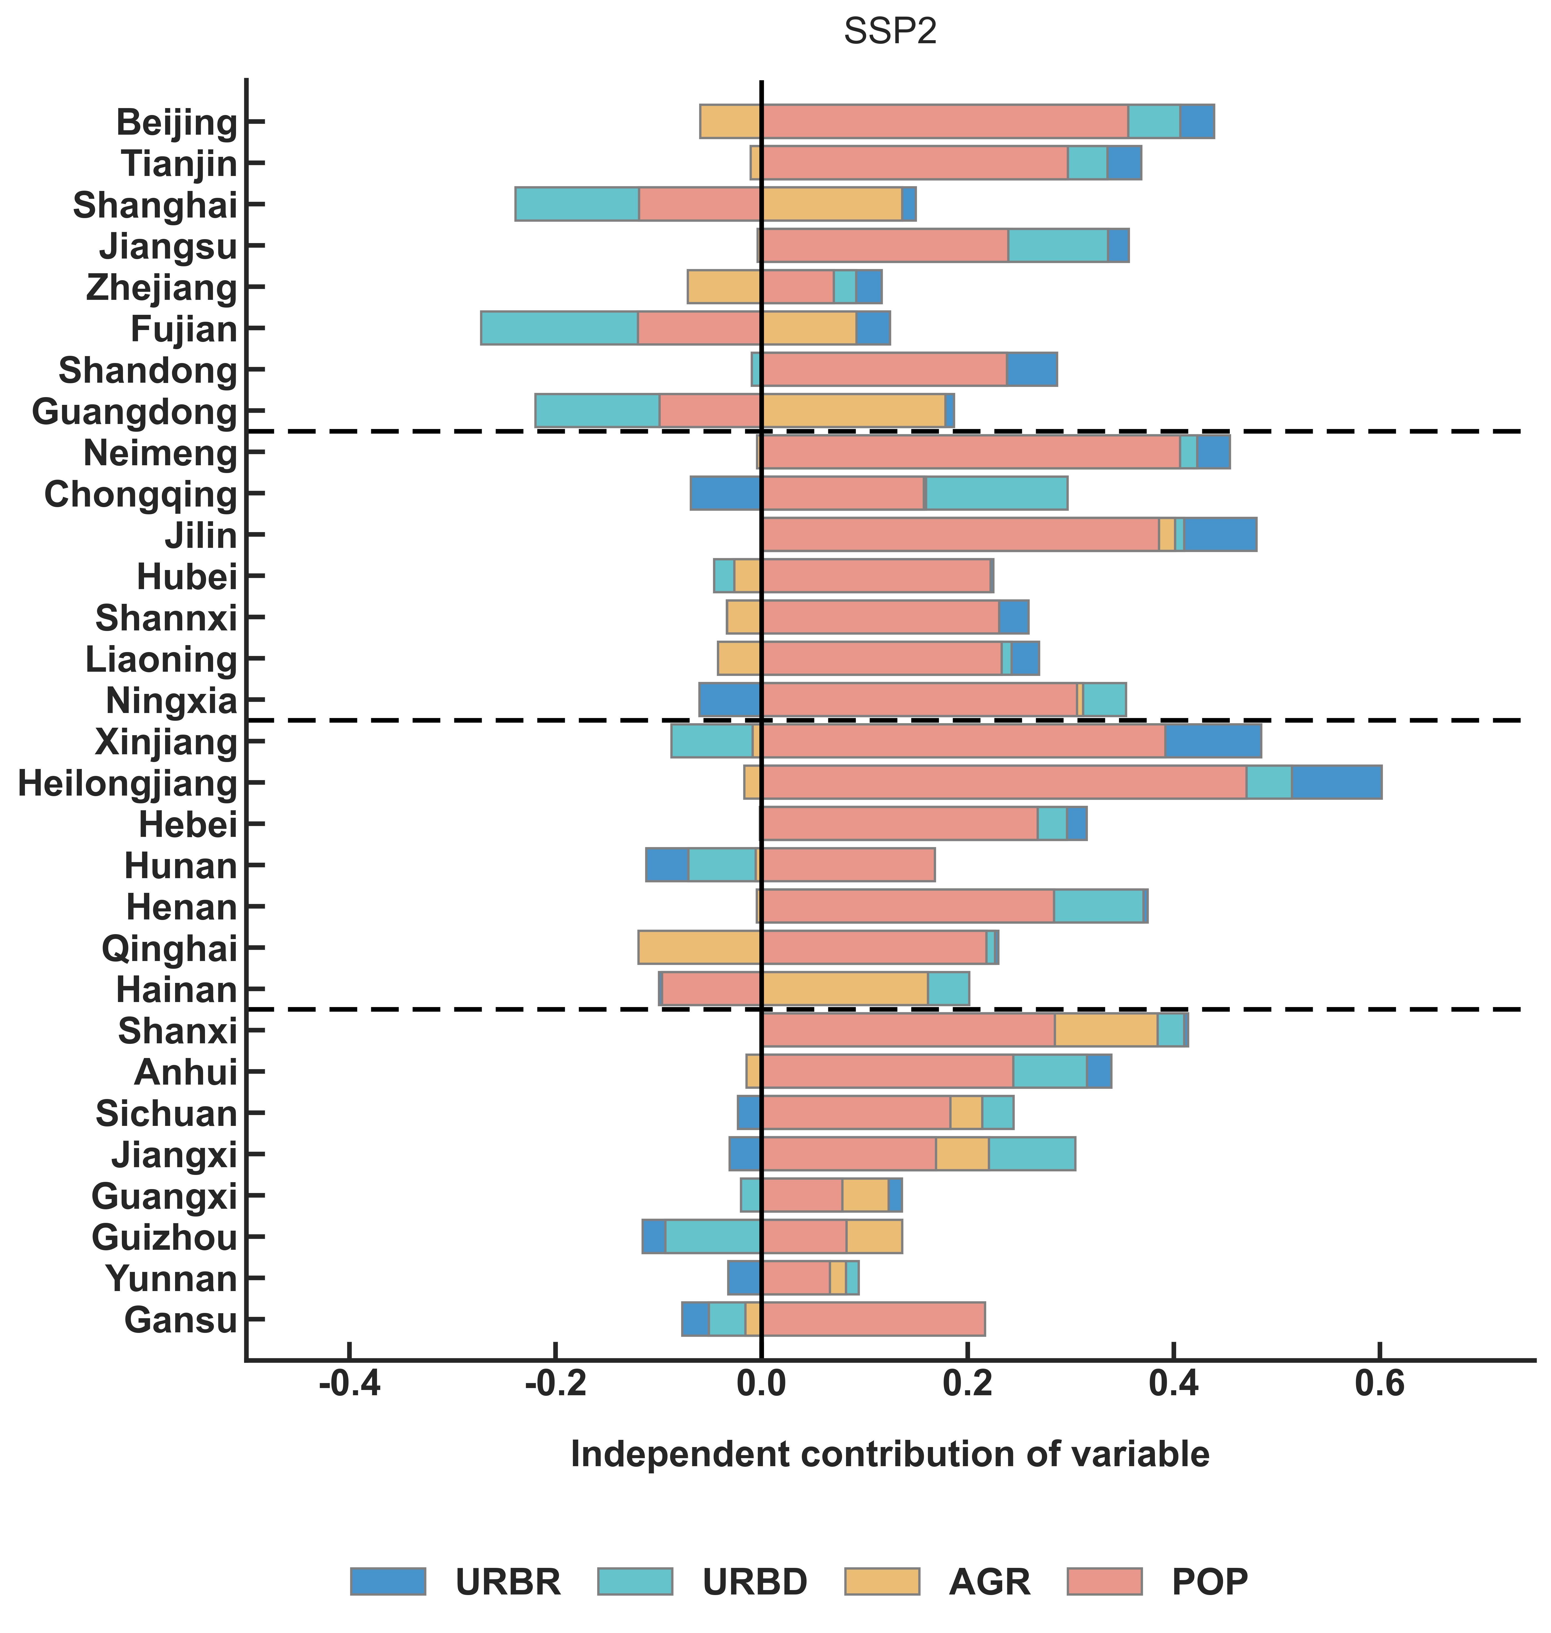
Figure S10. Independent contributions of each driver to changes in the log-transformed biodiversity footprint across 30 provinces from 2017 to 2050 under SSP2.
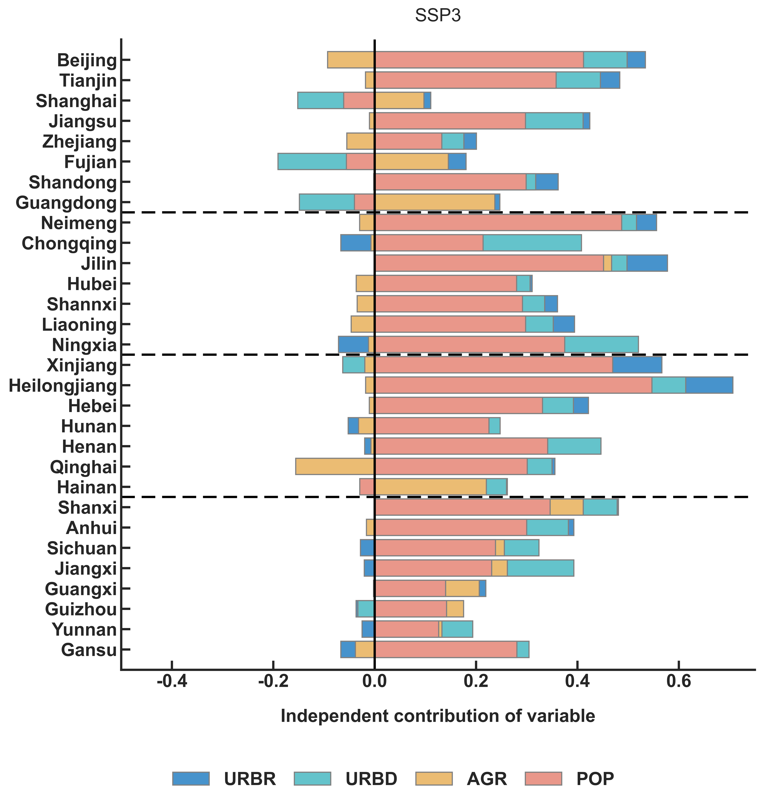
Figure S11. Independent contributions of each driver to changes in the log-transformed biodiversity footprint across 30 provinces from 2017 to 2050 under SSP3.
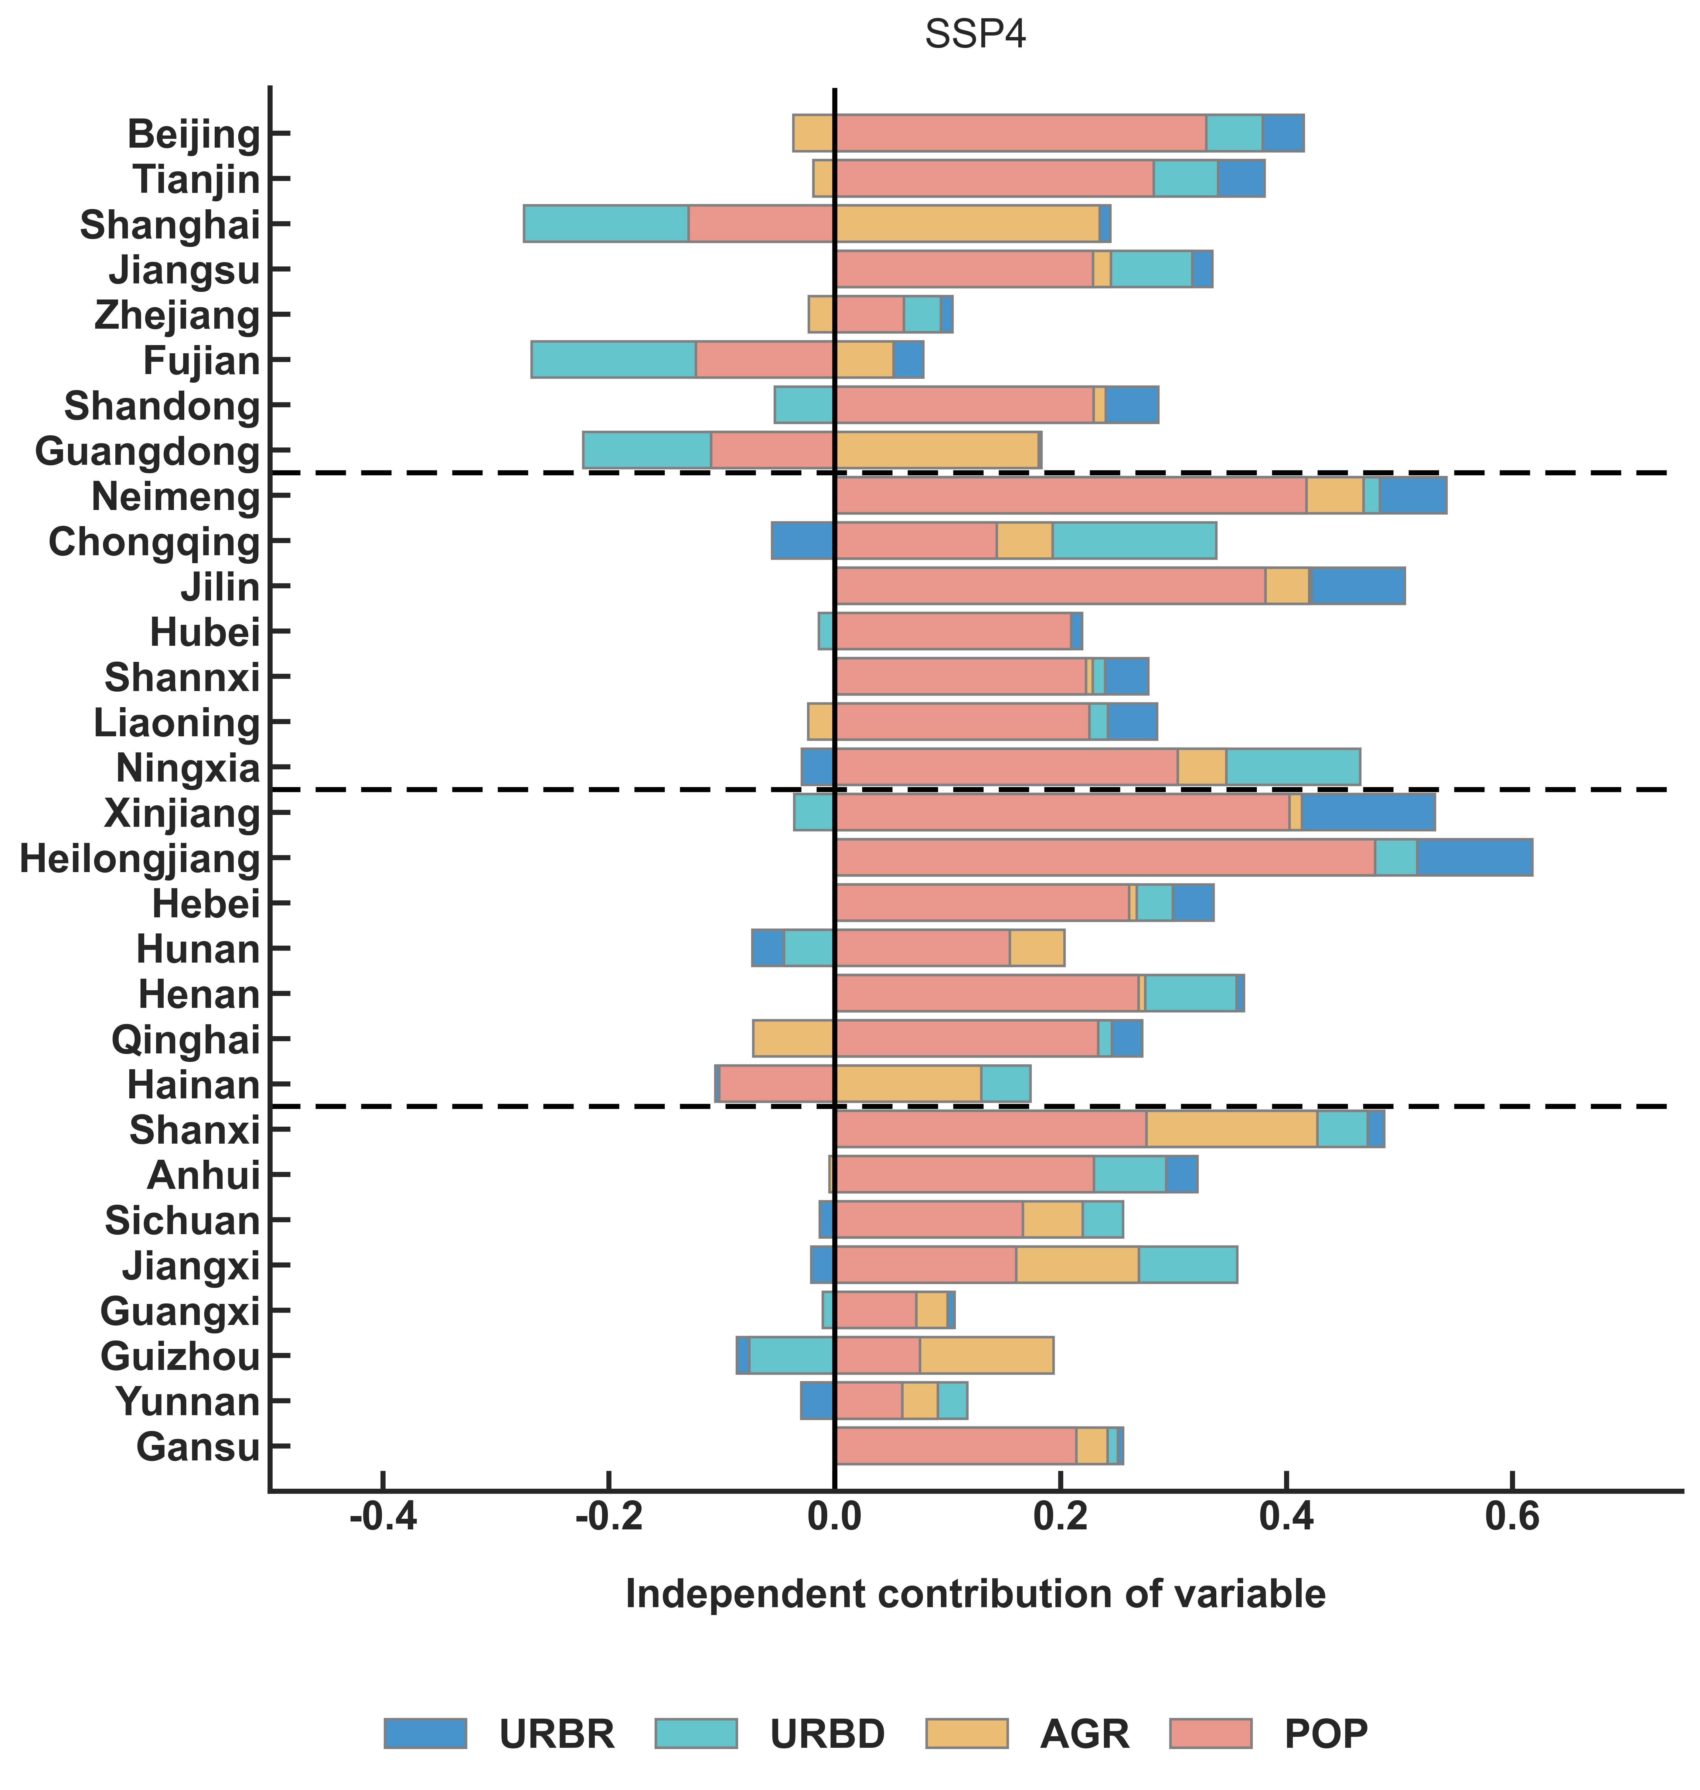
Figure S12. Independent contributions of each driver to changes in the log-transformed biodiversity footprint across 30 provinces from 2017 to 2050 under SSP4.
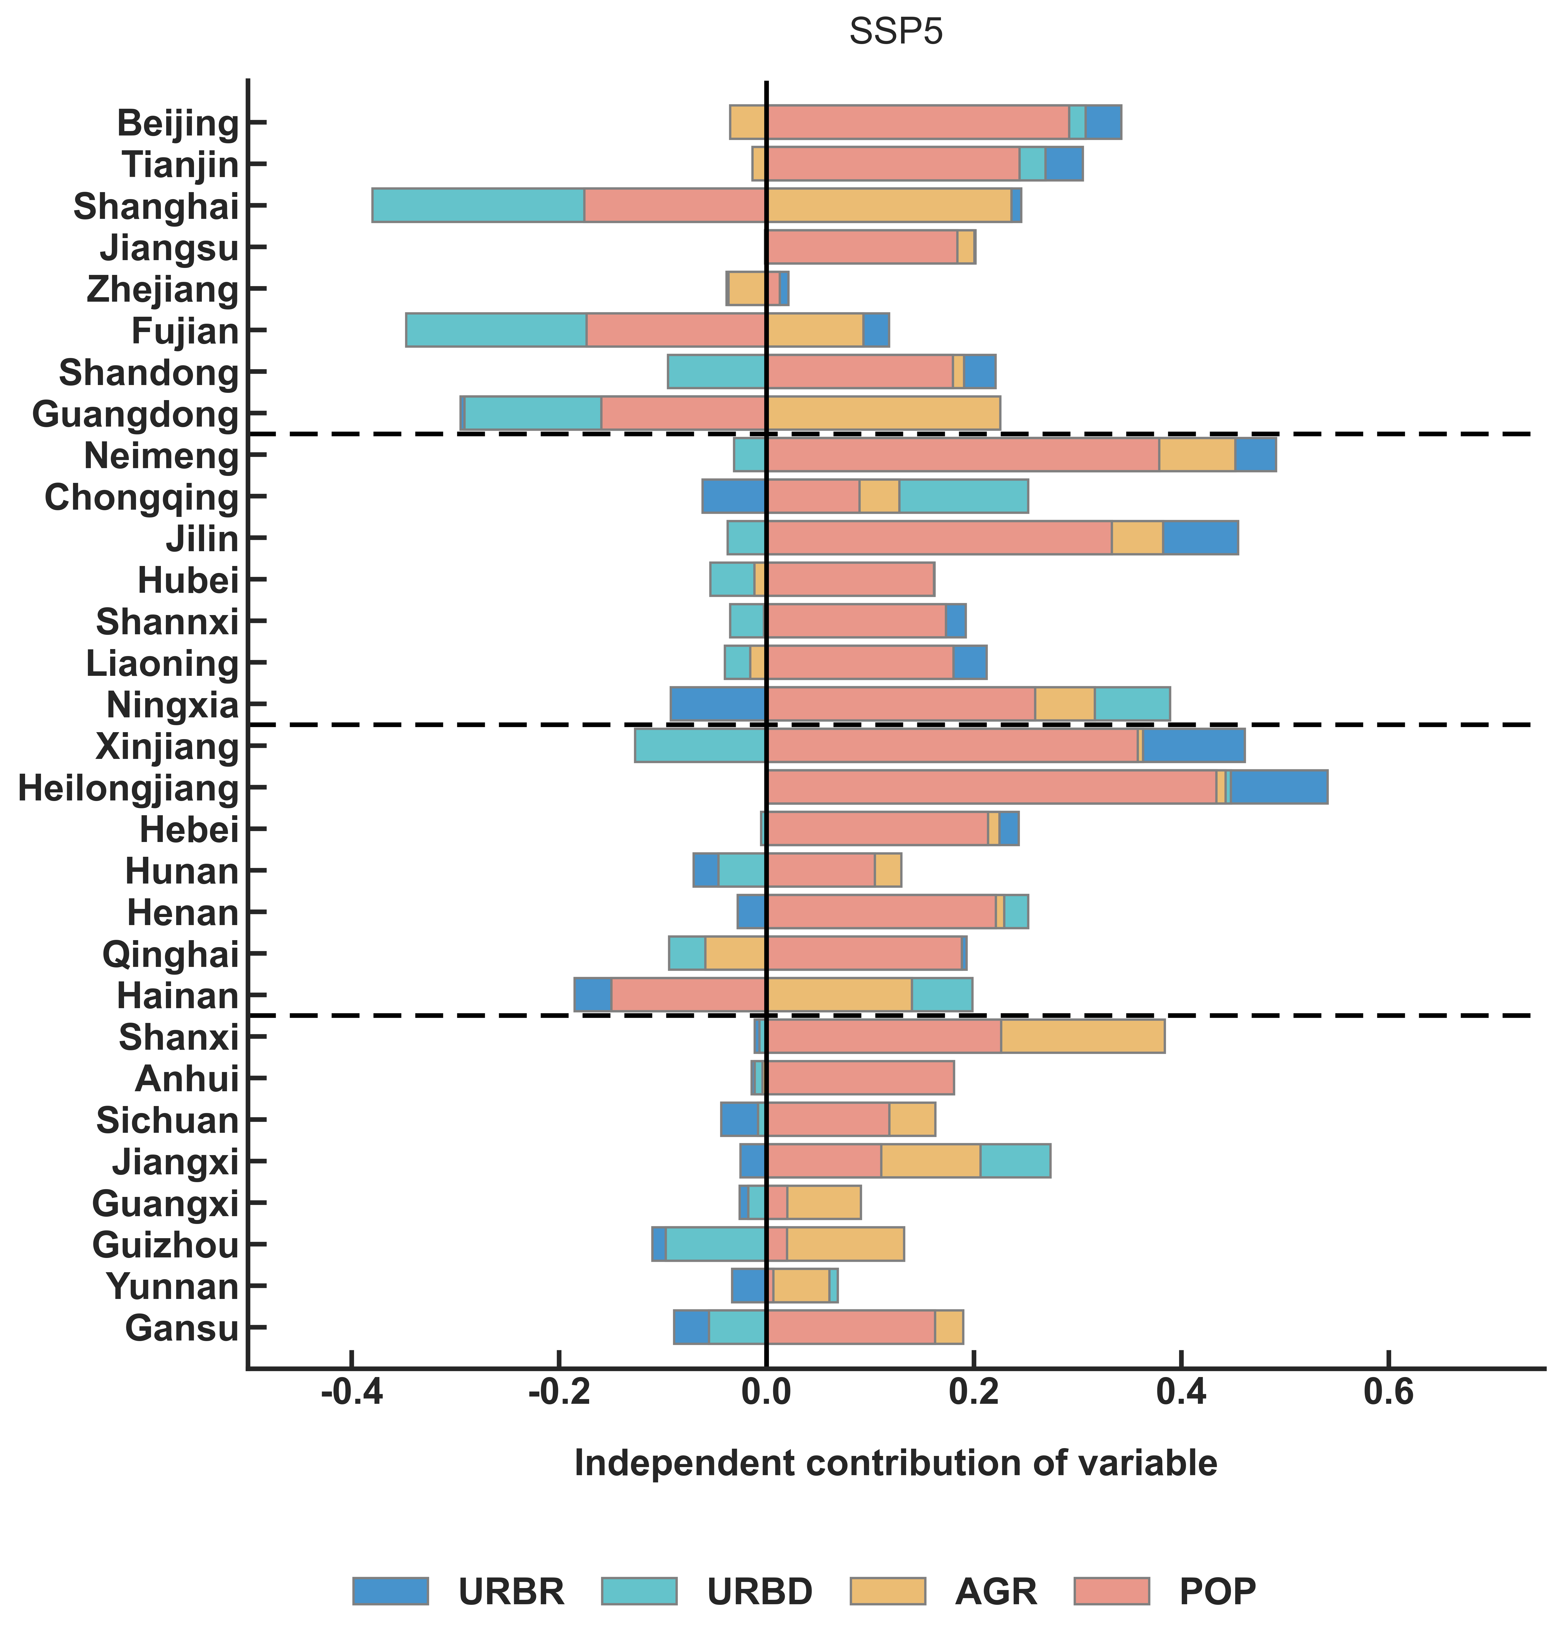
Figure S13. Independent contributions of each driver to changes in the log-transformed biodiversity footprint across 30 provinces from 2017 to 2050 under SSP5.

S8. Decoupling index in 2012 and 2015.
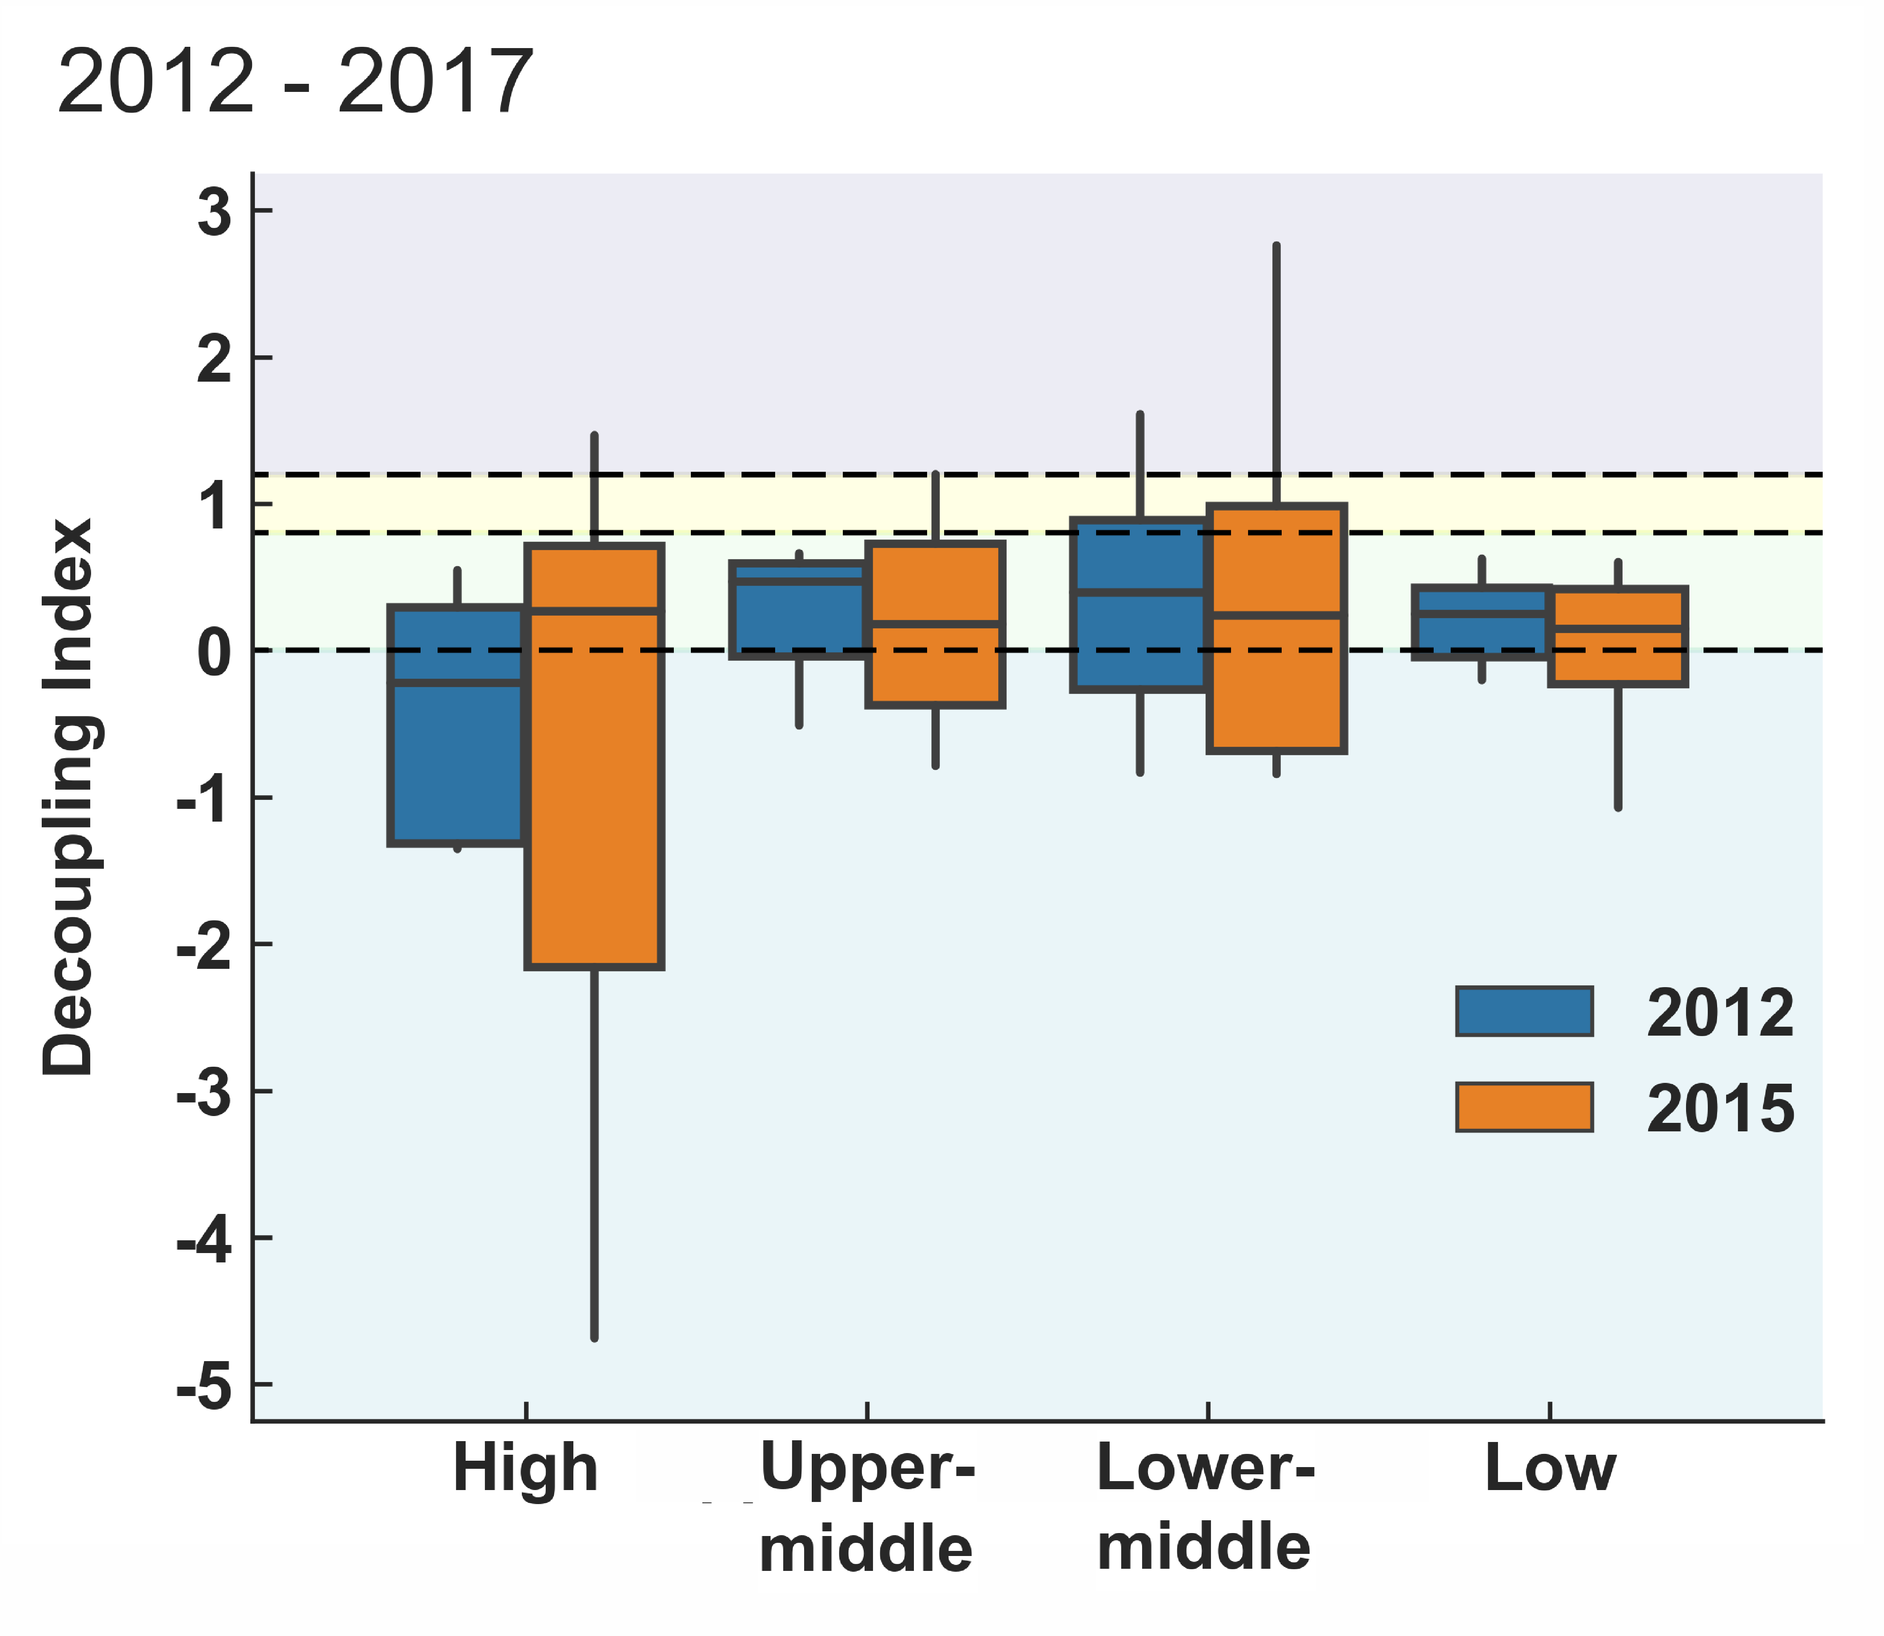
Figure S14. Decoupling index (DI) defined as the elasticity of the biodiversity footprints to GDP for the periods from 2012 to 2017, and from 2015 to 2017. Elasticity is calculated as the ratio of the percentage change in total biodiversity footprint to the percentage change in GDP. Different DI ranges correspond to distinct decoupling statuses: strong decoupling (SD, light blue; DI < 0), weak decoupling (WD, light green; DI between 0 and 0.8), expansive coupling (EC, light yellow; DI between 0.8 and 1.2), and expansive negative decoupling (END, light purple; DI > 1.2).

