Entry for the Table of Contents
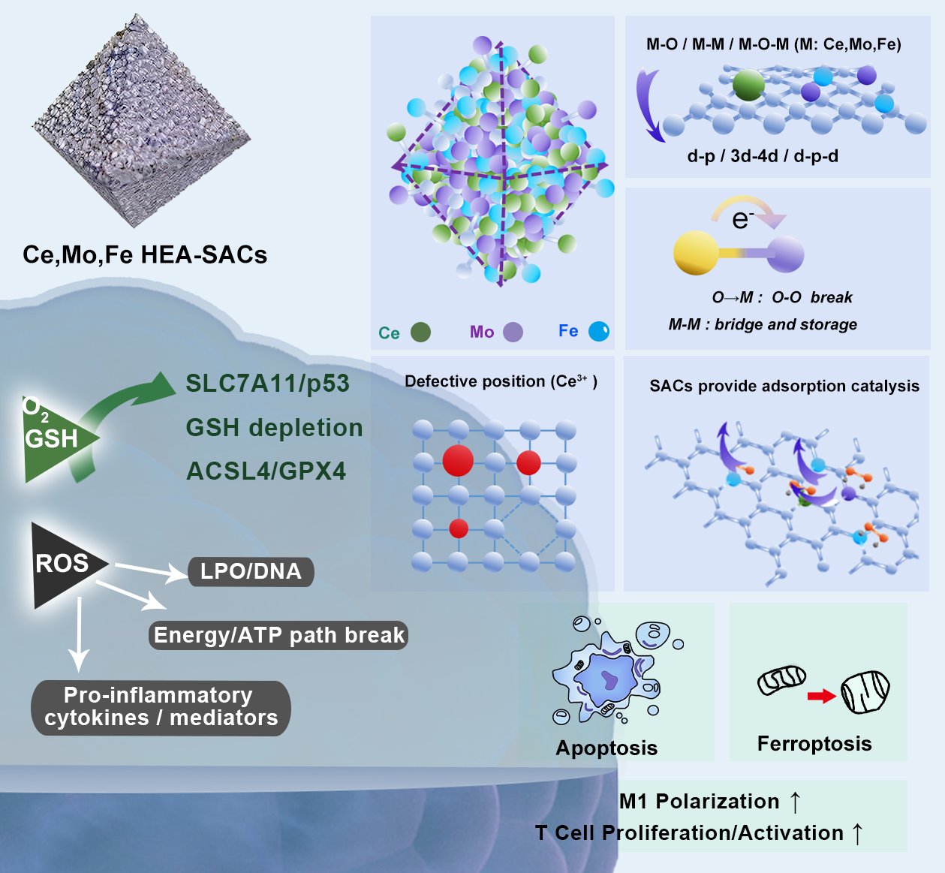
By combining high entropy alloy (HEA) with single atom (SAC) functionality, a Ce,Mo,Fe HEA-SACs (CMF HESACs) with ternary heterogeneous metals were successfully constructed based on the MIL framework. Under the guidance of near-infrared (NIR), the synergistic effect of d-band center regulation and multi-metal active center entropy catalysis is utilized to optimize the adsorption of key intermediates in the reaction, achieving enhanced thermal-derive catalytic therapy targeting tumor apoptosis and ferroptosis.

