Appendix

Table 1: Item wise mean, standard deviation, Estimate and Cronbach value

Constructs | Item | Mean | Std. Deviation | Estimate (β) | Cronbach α
Credibility of Influencer | I trust the information provided by influencers. (CI1) | 3.97 | 0.855 | 0.822 | 0.895
Credibility of Influencer | I consider influencers to be experts in their field. (CI2) | 3.95 | 0.950 | 0.835 | 0.895
Credibility of Influencer | Influencers’ opinions are important to my purchasing decisions. (CI3) | 3.93 | 0.972 | 0.809 | 0.895
Credibility of Influencer | I feel connected to influencers who share similar interests with me. (CI4) | 3.83 | 0.903 | 0.773 | 0.895
Credibility of Influencer | Influencers’ recommendations often lead me to purchase luxury items. (CI5) | 3.72 | 0.905 | 0.725 | 0.895
Desire for Uniqueness | I like to own things that are unique and exclusive. (DU1) | 3.44 | 1.050 | 0.748 | 0.911
Desire for Uniqueness | I prefer products that help me stand out from others. (DU2) | 3.53 | 1.066 | 0.845 | 0.911
Desire for Uniqueness | I feel satisfied when I own something that is different from what others have. (DU3) | 3.70 | 1.101 | 0.852 | 0.911
Desire for Uniqueness | I buy luxury items to express my individuality.(DU4) | 3.62 | 1.103 | 0.819 | 0.911
Desire for Uniqueness | My purchasing decisions are influenced by my desire to be unique. (DU5) | 3.66 | 1.027 | 0.834 | 0.911
Desire to Be Part of a High-Status Social Group | I aspire to be part of a high-status social group. (DHS1) | 3.63 | 1.033 | 0.785 | 0.897
Desire to Be Part of a High-Status Social Group | I purchase luxury items to gain social acceptance. (DHS2) | 3.70 | 1.058 | 0.811 | 0.897
Desire to Be Part of a High-Status Social Group | Being associated with a high-status group is important to me. (DHS3) | 3.74 | 1.077 | 0.832 | 0.897
Desire to Be Part of a High-Status Social Group | I buy luxury products to enhance my social standing. (DHS4) | 3.72 | 0.994 | 0.774 | 0.897
Desire to Be Part of a High-Status Social Group | My desire to be part of a prestigious group influences my purchases. (DHS5) | 3.67 | 1.021 | 0.779 | 0.897
Sense of Pride | I feel proud when I own luxury items.(SP1) | 3.55 | 0.834 | 0.786 | 0.893
Sense of Pride | Owning expensive products boosts my self-esteem. (SP2) | 3.71 | 0.910 | 0.824 | 0.893
Sense of Pride | I purchase luxury goods to showcase my achievements. (SP3) | 3.59 | 0.955 | 0.803 | 0.893
Sense of Pride | I feel accomplished when others recognize my luxurious possessions. (SP4) | 3.69 | 0.913 | 0.812 | 0.893
Sense of Pride | My sense of pride influences my purchasing decisions. (SP5) | 3.61 | 0.962 | 0.729 | 0.893
Peer Connect | My friends’ opinions influence my purchasing decisions. (PC1) | 3.59 | 0.628 | 0.851 | 0.89
Peer Connect | I feel pressured to match my peers’ consumption patterns. (PC2) | 3.61 | 0.731 | 0.728 | 0.89
Peer Connect | I buy luxury items to fit in with my social circle.(PC3) | 3.38 | 0.775 | 0.777 | 0.89
Peer Connect | My peers’ lifestyles motivate me to purchase luxury goods.(PC4) | 3.69 | 0.654 | 0.809 | 0.89
Peer Connect | Peer pressure affects my consumption choices. (PC5) | 3.62 | 0.651 | 0.765 | 0.89
Conspicuous Consumption | I often purchase luxury items to showcase my wealth. (CC1) | 4.06 | 0.939 | 0.881 | 0.927
Conspicuous Consumption | I prefer products that are visible symbols of my status. (CC2) | 3.94 | 0.923 | 0.827 | 0.927
Conspicuous Consumption | I believe owning expensive goods makes a statement about who I am. (CC3) | 4.11 | 0.937 | 0.874 | 0.927
Conspicuous Consumption | I choose luxury products to be noticed by others. (CC4) | 4.00 | 0.991 | 0.88 | 0.927
Conspicuous Consumption | My spending habits are influenced by a desire to display my affluence. (CC5) | 3.82 | 0.960 | 0.771 | 0.927
Egoist Motivation | I buy luxury items to improve my self-image. (EM1) | 3.55 | 0.768 | 0.775 | 0.9
Egoist Motivation | My purchasing decisions are driven by a desire to appear successful. (EM2) | 3.69 | 0.792 | 0.816 | 0.9
Egoist Motivation | I consume conspicuously to gain recognition from others. (EM3) | 3.64 | 0.816 | 0.803 | 0.9
Egoist Motivation | My egoistic desires influence my spending on luxury goods. (EM4) | 3.42 | 0.788 | 0.744 | 0.9
Egoist Motivation | I believe owning luxury items enhances my social status. (EM5) | 3.60 | 0.791 | 0.87 | 0.9

Table 2: summary of Items and Sources.
Construct | Item | Measure | Source
Credibility of Influencer | CI1  CI2  CI3  CI4  CI5 | I trust the information provided by influencers.  I consider influencers to be experts in their field.  Influencers’ opinions are important to my purchasing decisions.  I feel connected to influencers who share similar interests with me.  Influencers’ recommendations often lead me to purchase luxury items. | (Belanche et al., 2021)
Desire for Uniqueness | DU1  DU2  DU3  DU4  DU5 | I like to own things that are unique and exclusive.  I prefer products that help me stand out from others.  I feel satisfied when I own something that is different from what others have.  I buy luxury items to express my individuality.  My purchasing decisions are influenced by my desire to be unique. | (A. Ruvio et al., 2008; A. A. Ruvio, 2010)
Sense of Pride | SP1  SP2  SP3  SP4  SP5 | I feel proud when I own luxury items.  Owning expensive products boosts my self-esteem.  I purchase luxury goods to showcase my achievements.  I feel accomplished when others recognize my luxurious possessions.  My sense of pride influences my purchasing decisions. | (Tracy & Robins, 2007)
Desire to Be Part of a High-Status Social Group | DHS1  DHS2  DHS3  DHS4  DHS5 | I aspire to be part of a high-status social group.  I purchase luxury items to gain social acceptance.  Being associated with a high-status group is important to me.  I buy luxury products to enhance my social standing.  My desire to be part of a prestigious group influences my purchases. | (Flynn et al., 2006)
Peer Connect | PC1  PC2  PC3  PC4  PC5 | My friends’ opinions influence my purchasing decisions.  I feel pressured to match my peers’ consumption patterns.  I buy luxury items to fit in with my social circle.  My peers’ lifestyles motivate me to purchase luxury goods.  Peer pressure affects my consumption choices. | (Bearden & Etzel, 1982; Park & Lessig, 1977)
Egoist Motivation | EM1  EM2  EM3  EM4  EM5 | I buy luxury items to improve my self-image.  My purchasing decisions are driven by a desire to appear successful.  I consume conspicuously to gain recognition from others.  My egoistic desires influence my spending on luxury goods.  I believe owning luxury items enhances my social status. | (Birch et al., 2018)
Conspicuous Consumption | CC1  CC2  CC3  CC4  CC5 | I often purchase luxury items to showcase my wealth.  I prefer products that are visible symbols of my status.  I believe owning expensive goods makes a statement about who I am.  I choose luxury products to be noticed by others.  My spending habits are influenced by a desire to display my affluence. | (Ivanova et al., 2019; Philip et al., 2021)
Source: Author’s own

Graphical Abstract
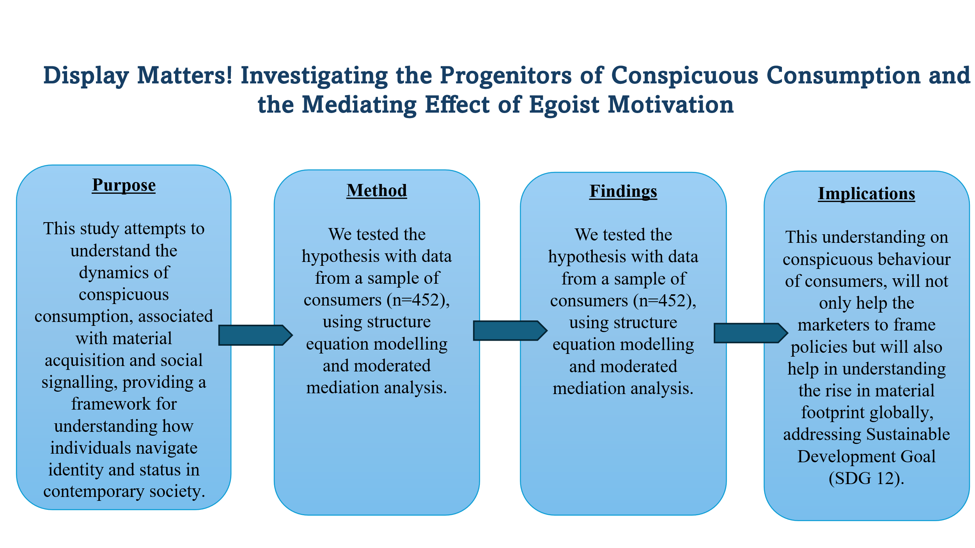
Source : Authors’ created

References
Bearden, W. O., & Etzel, M. J. (1982). Reference Group Influence on Product and Brand Purchase Decisions. Journal of Consumer Research, 9(2), 183. https://doi.org/10.1086/208911
Belanche, D., Casaló, L. V., Flavián, M., & Ibáñez-Sánchez, S. (2021). Building influencers’ credibility on Instagram: Effects on followers’ attitudes and behavioral responses toward the influencer. Journal of Retailing and Consumer Services, 61(June). https://doi.org/10.1016/j.jretconser.2021.102585
Birch, D., Memery, J., & De Silva Kanakaratne, M. (2018). The mindful consumer: Balancing egoistic and altruistic motivations to purchase local food. Journal of Retailing and Consumer Services, 40(October 2017), 221–228. https://doi.org/10.1016/j.jretconser.2017.10.013
Flynn, F. J., Reagans, R. E., Amanatullah, E. T., & Ames, D. R. (2006). Helping one’s way to the top: Self-monitors achieve status by helping others and knowing who helps whom. Journal of Personality and Social Psychology, 91(6), 1123–1137. https://doi.org/10.1037/0022-3514.91.6.1123
Ivanova, O., Flores-Zamora, J., Khelladi, I., & Ivanaj, S. (2019). The generational cohort effect in the context of responsible consumption. Management Decision, 57(5), 1162–1183. https://doi.org/10.1108/MD-12-2016-0915
Park, C. W., & Lessig, V. P. (1977). Students and Housewives: Differences in Susceptibility to Reference Group Influence. Journal of Consumer Research, 4(2), 102. https://doi.org/10.1086/208685
Philip, M., Mathew, M., & Soundararajan, G. (2021). Antecedents of Conspicuous Consumption, Status Aspiration, and Its Consequences: An Empirical Study on Migrant Blue-Collar Workers in GCC. Open Journal of Business and Management, 09(02), 731–751. https://doi.org/10.4236/ojbm.2021.92038
Ruvio, A. A. (2010). Consumers’ Need for Uniqueness. Wiley International Encyclopedia of Marketing, 28(1), 50–66. https://doi.org/10.1002/9781444316568.wiem03062
Ruvio, A., Shoham, A., & Brenčič, M. M. (2008). Consumers’ need for uniqueness: Short-form scale development and cross-cultural validation. International Marketing Review, 25(1), 33–53. https://doi.org/10.1108/02651330810851872
Tracy, J. L., & Robins, R. W. (2007). The psychological structure of pride: A tale of two facets. Journal of Personality and Social Psychology, 92(3), 506–525. https://doi.org/10.1037/0022-3514.92.3.506

