Supplementary material

Radio-sensitization of mutated KRAS G12C non-small cell lung cancer with KRAS G12C tyrosine kinase inhibitor and Carbon ions irradiation

Mathieu Césaire, Kilian Lecrosnier, Juliette Montanari, Mateusz Sitarz, Sahra Messaoudi, Elisabeth Chartier-Garcia, Isabelle Testard, Guénaëlle Levallet, Serge Candéias, François Chevalier

Sup Table 1

Primer name | sequence
Nestin F3 | 5'-AGGAAAAGACCATCTGCCCG-3'
Nestin R3 | 5'-TCCTTTGCCACACCCCTTTT-3'
Vimentin s | 5’-CCTGCAATCTTTCAGACAGG-3’
Vimentin as | 5’-CTCCTGGATTTCCTCTTCGT -3’
CD166 s | 5’-TGGCAATATCACATGGTACAGGAA-3’
CD166 as | 5’-CCAGGGTGGAAGTCATGGTATAGAG-3’

Supplementary data 1

Western-blot analysis of H358 cell extracts (uncropped membranes on next page)
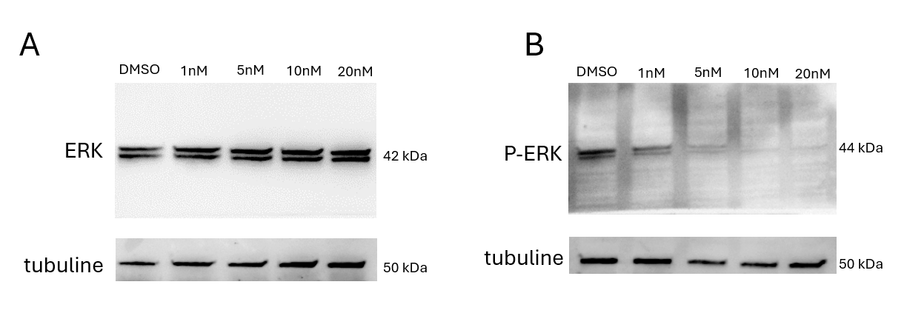

Detailed protocol for WB:
The protein samples were denatured and loaded on a 4-15% SDS-PAGE precast gel and transferred onto a PVDF (PolyVinylidene DiFluoride) membrane (Bio-Rad, Hercules, USA). The blots were blocked 1 h with 5% nonfat dry milk in 0.05% TBS-Tween 1X then incubated with primary antibodies: anti-p-ERK (#9101), anti-ERK (#9102) (Cell Signaling Technology, Danvers, USA) or anti-Tubulin (T6199) (Sigma-Aldrich, Saint-Louis, USA). After one night, the blots were incubated 1 h with the horseradish peroxidase-conjugate secondary antibody: anti-rabbit (#7074) (Cell Signaling Technology, Danvers, USA) or anti-mouse (#NA931V) (Amersham, USA). Revelation was achieved using clarity western electroluminescence detection reagent (Bio-Rad, Hercules, USA) and the signal was captured using the ImageQuantLAS4000 (GE Healthcare, Little Chalfont, United-Kingdom)

Uncropped membranes (Western-blot analysis of H358 cell extracts)

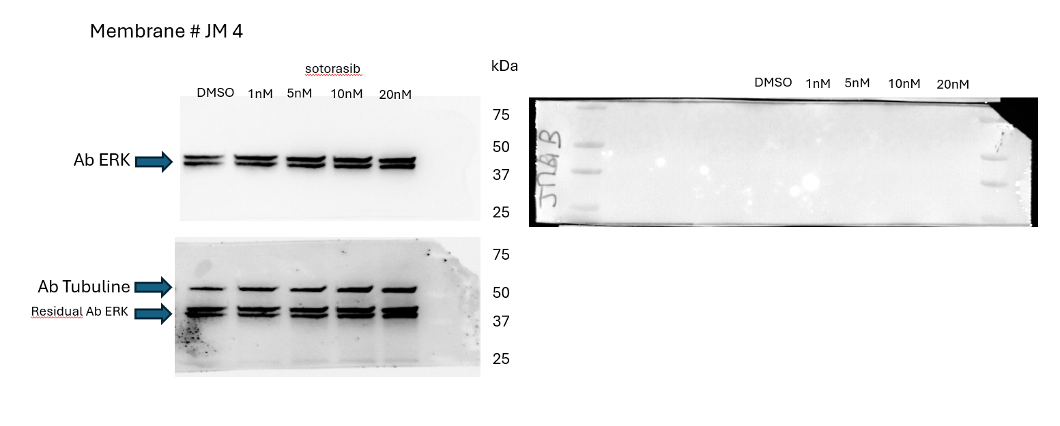

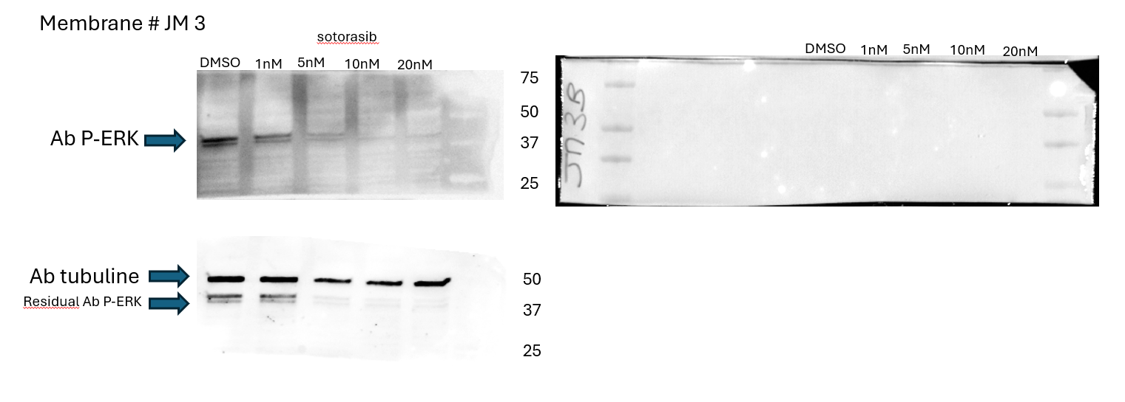

Supplementary data 2

RTq PCR analysis of A549 and H358 cell extracts
Relative expression of CD166 (CSC marker), Nestin and Vimentin (EMT markers) after treatment with Sotorasib and X-rays (A) or C-ions irradiation (B) in H358 cells.

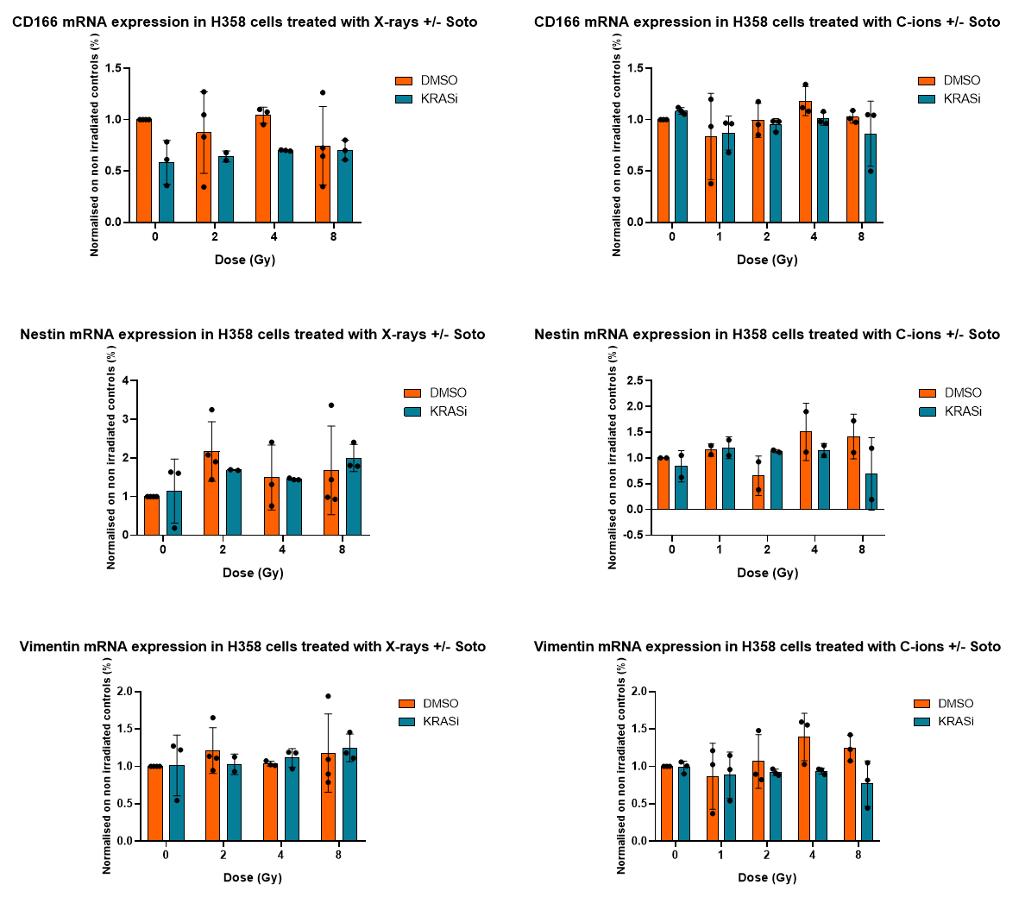

Relative expression of CD166, Nestin and Vimentin markers was obtained by RTq PCR and expressed on comparison to the control without Sotorasib and irradiation.
No significant differences were observed in any condition.

