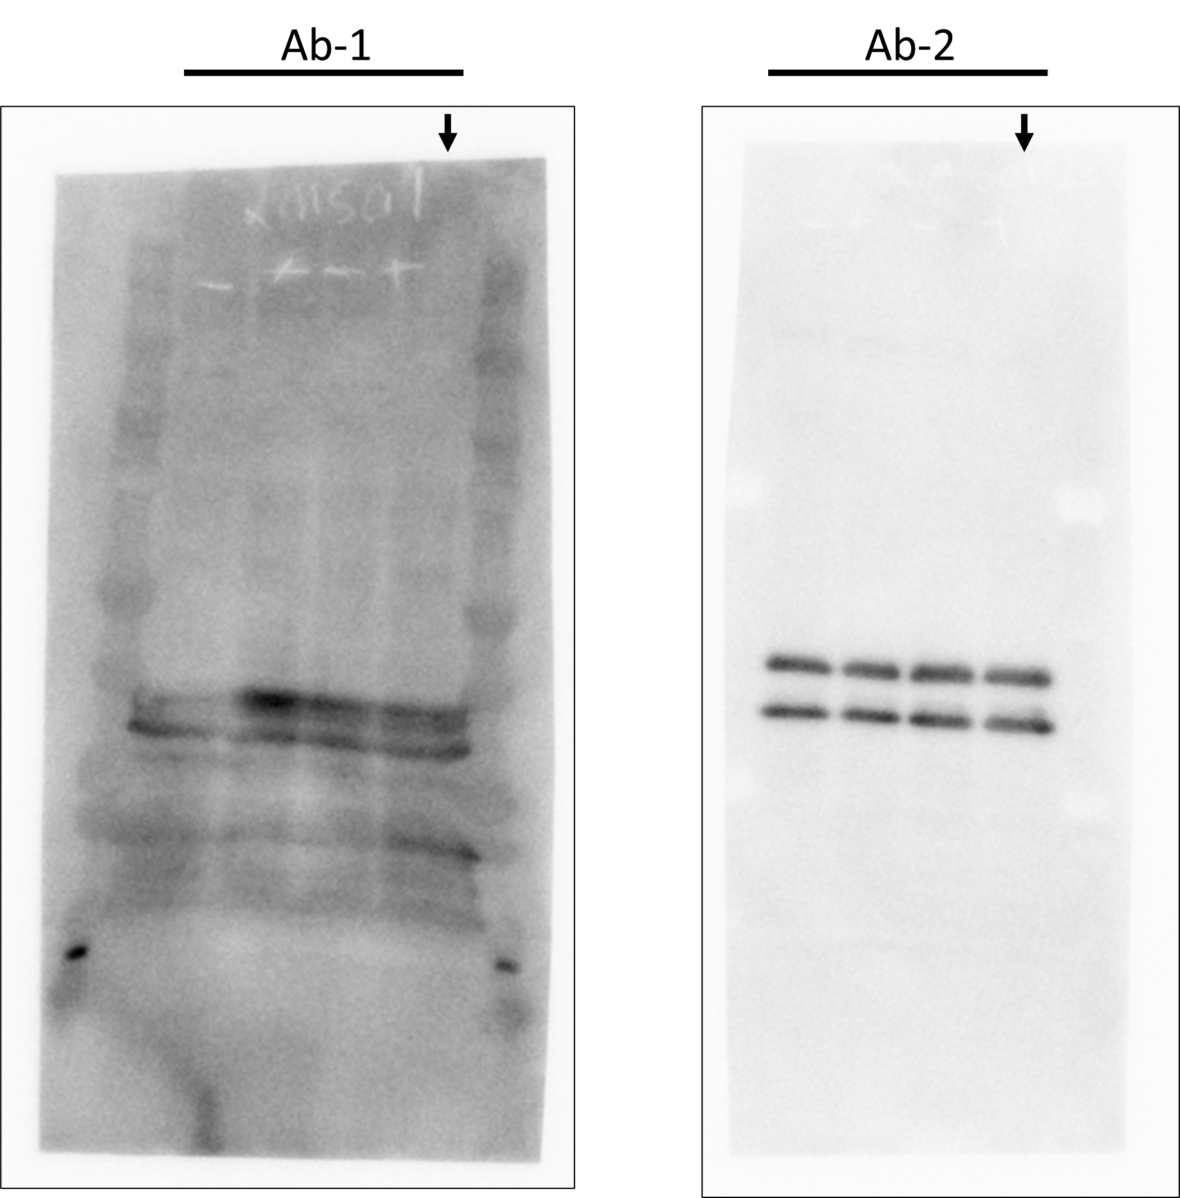
Fig. S2. Full uncropped Western blots image
Western blot analysis of MSA detected using two rabbit anti-MSA antibodies (Ab-1 and Ab-2), with four replicates. The fourth lane in each image (arrow) was used to generate the image shown in Figure 2.

