Supplementary information to
Estuarine water levels diverge from nearshore trends

Rosey Hart^{a*}, Ben S. Hague^{b}, Michael Hughes^{a,c}, William Glamore^{d}, Neda Sharifi Soltaniª, Danial Khojasteh^{a,e*}

ª Science and Insights Division, NSW Department of Climate Change, Energy, the Environment and Water, Sydney, NSW, Australia
^{b} Bureau of Meteorology, Melbourne, VIC, Australia
^{c} School of Earth, Atmospheric and Life Sciences, University of Wollongong, North Wollongong, NSW, Australia
^{d} Water Research Laboratory, School of Civil and Environmental Engineering, UNSW, Sydney, NSW, Australia
^{e} Centre for Marine Science and Innovation, School of Biological, Earth and Environmental Science, UNSW Sydney, NSW, Australia

* Corresponding authors:
R. Hart (rosey.hart@dcceew.nsw.gov.au)
D. Khojasteh (danial.khojasteh@dcceew.nsw.gov.au)

This file includes:

Supplementary Tables:
Table S1: Rates of change in nearshore water levels.
Table S2: Rates of change in estuarine water levels.
Table S3: Characteristics of analysed estuaries.

Supplementary Figures
Figure S1: Comparison of rates of change in estuarine water levels.
Figure S2: Locations of analysed estuaries and water level gauges along the NSW coastline.
Figure S3: Water level time series showing flood events at Grafton and Taree stations.

Table S1 – Rates of change in nearshore water levels.
Summary of measured rates of change in low (5th percentile), mean (50th percentile), and high (95th percentile) water levels from nearshore tide gauges used to characterise ocean conditions for the period 2005–2024 (inclusive). Rates of change were calculated using linear regression (refer to Methods for details), and only statistically significant trends (ρ ≤ 0.05) are presented. Gauges are ordered from north to south along the New South Wales coastline (latitude shown in decimal degrees).
Gauge Name | Latitude  (degrees) | Rate of Change (mm year⁻¹)
Gauge Name | Latitude  (degrees) | Low Water Level  (5th percentile) | Mean Water Level  (50th percentile) | High Water Level  (95th percentile)
Tweed Entrance South | -28.17 | 4.22 | 3.47 | 2.67
Yamba | -29.43 | 4.6 | 3.84 | 3.75
Coffs Harbour | -30.3 | 6.48 | 6.3 | 6.44
Port Macquarie | -31.43 | 1.95 | 2.41 | 2.88
Crowdy Head | -31.84 | 5.24 | 4.73 | 4.06
Forster | -32.18 | 7.16 | 6.1 | 6.16
Patonga | -33.55 | 5.66 | 6.05 | 6.12
Port Kembla | -34.47 | 4.64 | 4.99 | 4.71
Jervis Bay | -35.12 | 6.15 | 5.5 | 4.55
Bermagui | -36.42 | 4.11 | 4.12 | 4.09
Eden | -37.07 | 4.51 | 4.13 | 3.02

Table S2 – Rates of change in estuarine water levels.
Summary of measured rates of change in low (5th percentile), mean (50th percentile), and high (95th percentile) water levels for all gauges located within the analysed estuaries. Rates of change were calculated using linear regression applied to monthly water level percentiles over the period 2005–2024 (inclusive). Estuaries are ordered from north to south along the New South Wales coastline, with gauges listed by increasing distance from the estuary entrance. Gauges located within the main stem of each estuary are indicated in bold.
Estuary | Gauge name | Distance from entrance  (km) | Rate of change (mm year⁻¹)
Estuary | Gauge name | Distance from entrance  (km) | Low water level  (5th percentile) | Mean water level (50th percentile) | High water level (95th percentile)
Tweed River | Dry Dock | 6.1 | 3.8 | 5.06 | 6.48
Tweed River | Barneys Point | 7.5 | 3.13 | 4.77 | 7.21
Tweed River | Cobaki | 9.1 | 2.95 | 4.32 | 5.91
Tweed River | Terranora | 9.4 | 3.23 | 4.13 | 5.85
Tweed River | North Murwillumbah | 30.1 | ρ≥0.05 | 4.28 | 7.19
Tweed River | Murwillumbah Bridge | 30.3 | -2.59 | ρ≥0.05 | 4.69
Cudgen Creek | Kingscliff | 0.3 | 10.74 | 9.56 | 8.84
Cudgen Creek | Bogangar | 11.9 | 5.65 | 5.40 | ρ≥0.05
Brunswick River | Brunswick Heads | 0.6 | 5.38 | 5.17 | 5.08
Brunswick River | Orana Bridge | 3.9 | ρ≥0.05 | 2.54 | 3.31
Brunswick River | Billinudgel | 9.5 | 1.59 | 2.5 | 3.5
Brunswick River | Mullumbimby | 11.6 | ρ≥0.05 | 2.26 | 2.01
Richmond River | Byrnes Point | 6.7 | 5.23 | 6.22 | 7.48
Richmond River | Wardell | 18.3 | ρ≥0.05 | ρ≥0.05 | ρ≥0.05
Richmond River | Woodburn | 42.7 | 5.32 | 5.59 | 6.7
Richmond River | Rocky Mouth Creek | 46.3 | 4.368 | 2.94 | ρ≥0.05
Richmond River | Bungawalbin | 55.4 | 9.76 | 9.42 | 9.5
Richmond River | Coraki | 63.5 | 3.81 | 3.71 | 3.92
Clarence River | Yamba | 0.9 | 4.6 | 4.09 | 3.91
Clarence River | Oyster Channel | 7.8 | 3.86 | 3.54 | 4.62
Clarence River | Palmers Island Bridge | 17.1 | 2.47 | 2.86 | 3.39
Clarence River | Maclean | 25.1 | 4.61 | 4.35 | 5.25
Clarence River | Lawrence | 36.9 | 3.77 | 3.31 | 3.92
Clarence River | Tyndale | 42.3 | 3.56 | 2.68 | 2.74
Clarence River | Grafton | 67.7 | 7.99 | 8.43 | 8.85
Clarence River | Rogans Bridge | 91.3 | 4.82 | 4.35 | 6.64
Boambee Creek | Boambee Entrance | 0.8 | ρ≥0.05 | 3.21 | 5.98
Boambee Creek | Boambee | 5.7 | ρ≥0.05 | ρ≥0.05 | 3.43
Boambee Creek | Newports Creek | 6.1 | 1.43 | 3.3 | 5.9
Bellinger River | Urunga | 2. | 3.67 | 4.42 | 5.15
Bellinger River | Repton | 7.8 | 4.35 | 3.61 | 3.72
Nambucca River | Stuarts Island | 2.9 | ρ≥0.05 | 2.43 | 5.65
Nambucca River | Utungun | 23.1 | 1.94 | 2.73 | 6.6
Macleay River | South West Rocks | 2.3 | 2.56 | 4.39 | 4.56
Macleay River | Smithtown | 24.1 | 2.66 | 3.24 | 3.92
Macleay River | Kempsey | 41.5 | ρ≥0.05 | 2.2 | 7.58
Hastings River | Port Macquarie | 0.6 | 1.95 | 2.58 | 3.1
Hastings River | Settlement Point | 3.4 | 5.85 | 6.42 | 6.69
Hastings River | Dennis Bridge Downstream | 13 | ρ≥0.05 | ρ≥0.05 | ρ≥0.05
Hastings River | Wauchope Railway Bridge | 26.1 | 4.37 | 5.35 | 5.43
Hastings River | Telegraph Point | 30.9 | 2.99 | 3.82 | 4.9
Camden Haven | North Haven | 1.5 | 1.59 | 2.5 | 3.5
Camden Haven | West Haven | 5.7 | ρ≥0.05 | 2.26 | 2.01
Camden Haven | Watson Taylor Lake | 13.8 | 5.38 | 5.17 | 5.08
Manning River | Harrington | 1 | 3 | 4.02 | 11.12
Manning River | Croki | 13 | -5.64 | ρ≥0.05 | 7.04
Manning River | Dumaresq Island | 22.7 | -5.49 | ρ≥0.05 | 6.54
Manning River | Taree | 28.8 | -5.62 | ρ≥0.05 | 9.78
Manning River | Wingham | 47.4 | ρ≥0.05 | ρ≥0.05 | 9.39
Hunter River | Stockton Bridge | 6.8 | 7.43 | 6.85 | 5.51
Hunter River | Hexham Bridge | 20.5 | 6.92 | 5.75 | 4.36
Hunter River | Raymond Terrace | 32.4 | 6.64 | 4.68 | 2.68
Hunter River | Green Rocks | 40.9 | 7.16 | 5.66 | 4.17
Hunter River | Seaham | 47.1 | 5.5 | 3.74 | 1.92
Hunter River | Hinton Bridge | 48.6 | 4.70 | 4.93 | 5.14
Hunter River | Morpeth | 49.3 | 3 | 2.8 | 3.13
Hunter River | Dunmore | 55.6 | 3.5 | 4.01 | 4.86
Hunter River | Wallis Creek Downstream | 56.7 | -3.31 | ρ≥0.05 | 2.84
Hunter River | Belmore Bridge | 58.9 | 4.73 | 5.85 | 5.6
Hunter River | Paterson Railway Bridge | 70.1 | ρ≥0.05 | ρ≥0.05 | ρ≥0.05
Brisbane Water | Ettalong | 4.6 | 3.99 | 3.91 | 4.07
Brisbane Water | Koolewong | 12 | 3.09 | 3.44 | 4
Brisbane Water | Punt Bridge | 16.6 | 4.13 | 4.29 | 4.74
Hawkesbury River | Patonga | 6 | 5.66 | 6.08 | 6.14
Hawkesbury River | Spencer | 31.5 | 3.91 | 4.78 | 5.35
Hawkesbury River | Gunderman Caravan Park | 47.9 | 5.74 | 5.67 | 5.24
Hawkesbury River | Webbs Creek | 60.5 | 8.8 | 8.41 | 7.06
Hawkesbury River | Colo Junction | 78.8 | 8.46 | 6.04 | 4.17
Hawkesbury River | Sackville | 94.1 | 10.55 | 7.83 | 5.3
Hawkesbury River | Ebenezer | 108.6 | 9.42 | 7.31 | 2.69
Hawkesbury River | Windsor | 122.7 | 10.05 | 6.87 | ρ≥0.05
Hawkesbury River | Freemans Reach | 13 | -5.55 | 2.91 | 15.25
Botany Bay | Tempe Bridge | 2.9 | 4.01 | 4.3 | 4.36
Botany Bay | Canterbury Road | 8.6 | -1.47 | 5.46 | 4.67
Botany Bay | Como Bridge | 9.1 | 4.28 | 5.19 | 6
Botany Bay | Picnic Point Downstream | 19.9 | 3.78 | 4.77 | 4.72
Botany Bay | Lansdowne Bridge | 34.9 | 4.06 | 5.27 | 5.45
Botany Bay | Irelands Bridge | 37.7 | 3.81 | 4.44 | 5.11
Botany Bay | Scrivener Street | 39.1 | 3.46 | 4.05 | 4.69
Shoalhaven River | Crookhaven Heads | 1.1 | 5.89 | 5.72 | 5.46
Shoalhaven River | Greenwell Point | 3.2 | 6.1 | 5.47 | 4.56
Shoalhaven River | Hay Street | 10 | 3.58 | 5.59 | 7.41
Shoalhaven River | Shoalhaven Heads | 11.8 | 3.94 | 5.46 | 6.73
Shoalhaven River | Terara | 17.6 | 2.85 | 6.08 | 10
Shoalhaven River | Nowra Bridge | 19.6 | ρ≥0.05 | 3.53 | 7.70

Table S3 – Characteristics of analysed estuaries.
Summary of key physical and geomorphic characteristics of the estuaries analysed in this study, including estuary type according to Roy (1984), catchment area (DCCEEW, 2011), entrance width, present-day tidal limit, and entrance condition (trained or natural). Entrance width is measured at the most seaward constriction of the estuary mouth using aerial imagery. Estuaries are ordered from north to south along the New South Wales coastline.
Estuary |  | Type / Classification | Catchment Size  (km²) | Entrance Width  (m) | Tidal Limit  (km) | Entrance conditions
Tweed River |  | Barrier estuary | 1077.5 | 180 | 42.0 | Training walls (2)
Cudgen Creek |  | Brackish barrier lake | 70.8 | 55 | 13.7 | Training walls (2)
Brunswick River |  | Barrier estuary | 229.9 | 80 | 14.0 | Training walls (2)
Richmond River |  | Barrier estuary | 6900.2 | 350 | 115.5 | Training walls (2)
Clarence River |  | Barrier estuary | 22187.4 | 360 | 109.5 | Training walls (2)
Boambee Creek |  | Barrier estuary | 49.5 | 85 | 8.2 | Natural
Bellinger River |  | Barrier estuary | 1108.5 | 220 | 26.1 | Single training wall
Nambucca River |  | Barrier estuary | 1311.6 | 500 | 31.8 | Single training wall
Macleay River |  | Barrier estuary | 11318.7 | 210 | 56.7 | Training walls (2)
Hastings River |  | Barrier estuary | 3688.5 | 205 | 42.3 | Training walls (2)
Camden Haven River |  | Barrier estuary | 621.1 | 145 | 25.9 | Training walls (2)
Manning River |  | Barrier estuary | 8159.2 | 1980 | 53.9 | Single training wall
Hunter River |  | Barrier estuary | 21414.0 | 500 | 74.2 | Training walls (2)
Brisbane Water |  | Barrier estuary | 180.9 | 390 | 24.0 | Natural
Hawkesbury River |  | Drowned valley estuary | 21738.5 | 3890 | 138.5 | Natural
Botany Bay | Cooks River | Drowned valley estuary | 111.8 | 121 | 13.0 | Training walls (2)
Botany Bay | Georges River | Drowned valley estuary | 957.5 | 1000 | 39.9 | Natural
Shoalhaven River |  | Barrier estuary | 7117.7 | 470 | 50.2 | Single training wall

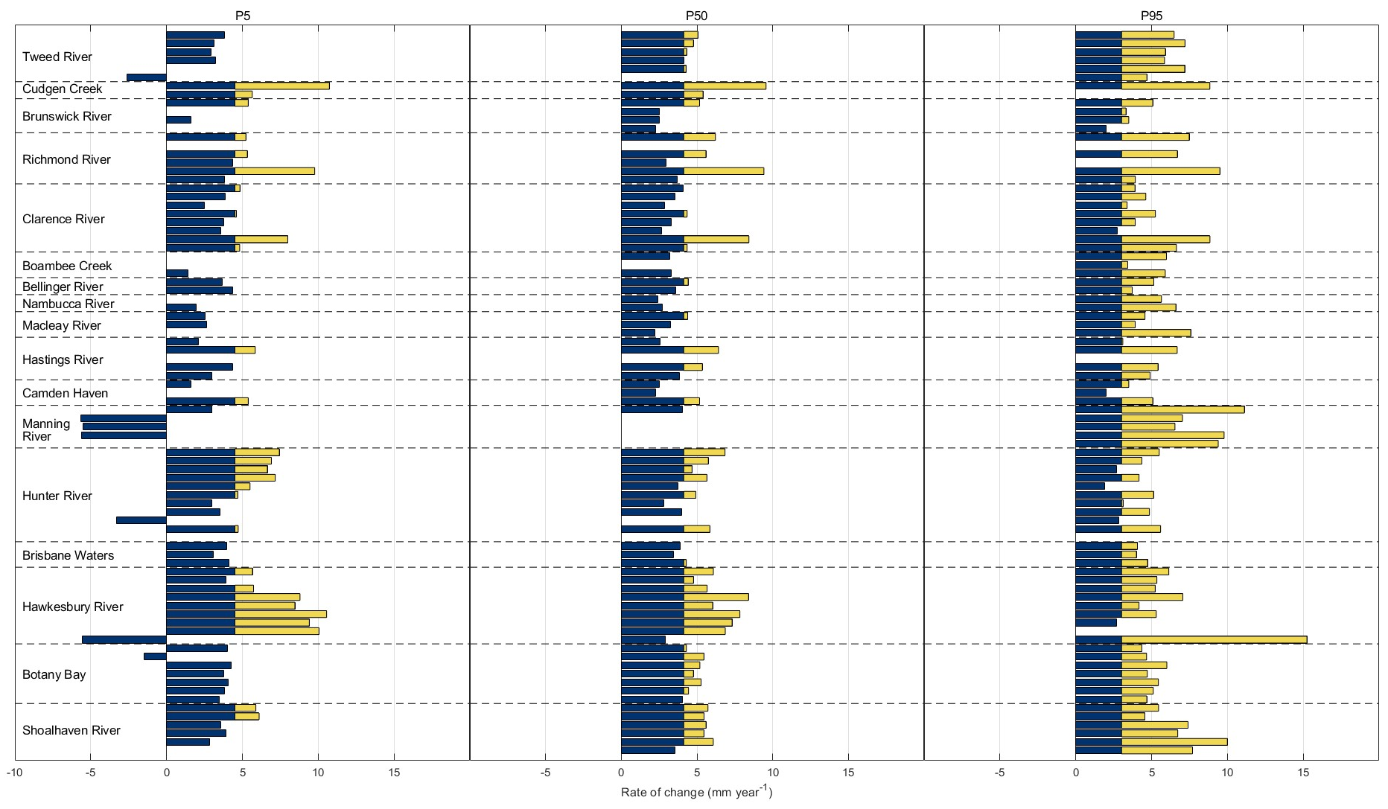
Figure S1 – Comparison of rates of change in estuarine water levels for gauges within all tributaries.
Rates of change in estuarine water levels for low (5th percentile; P5, left column), mean (50th percentile; P50, middle column), and high (95th percentile; P95, right column) calculated using linear regression applied to monthly water level percentiles for the period 2005–2024 (inclusive). Estuaries are ordered from north to south. Each bar represents a gauge located along any tributary of an estuary (i.e., within the main stem or any secondary tributaries leading into the main stem), ordered from top to bottom by increasing distance from the estuary entrance. Bars shown in yellow indicate rates of change exceeding those observed offshore, using data from the Port Kembla sea level monitoring station as a proxy for nearshore conditions. Empty bars indicate gauges for which trends were not statistically significant (ρ > 0.05).

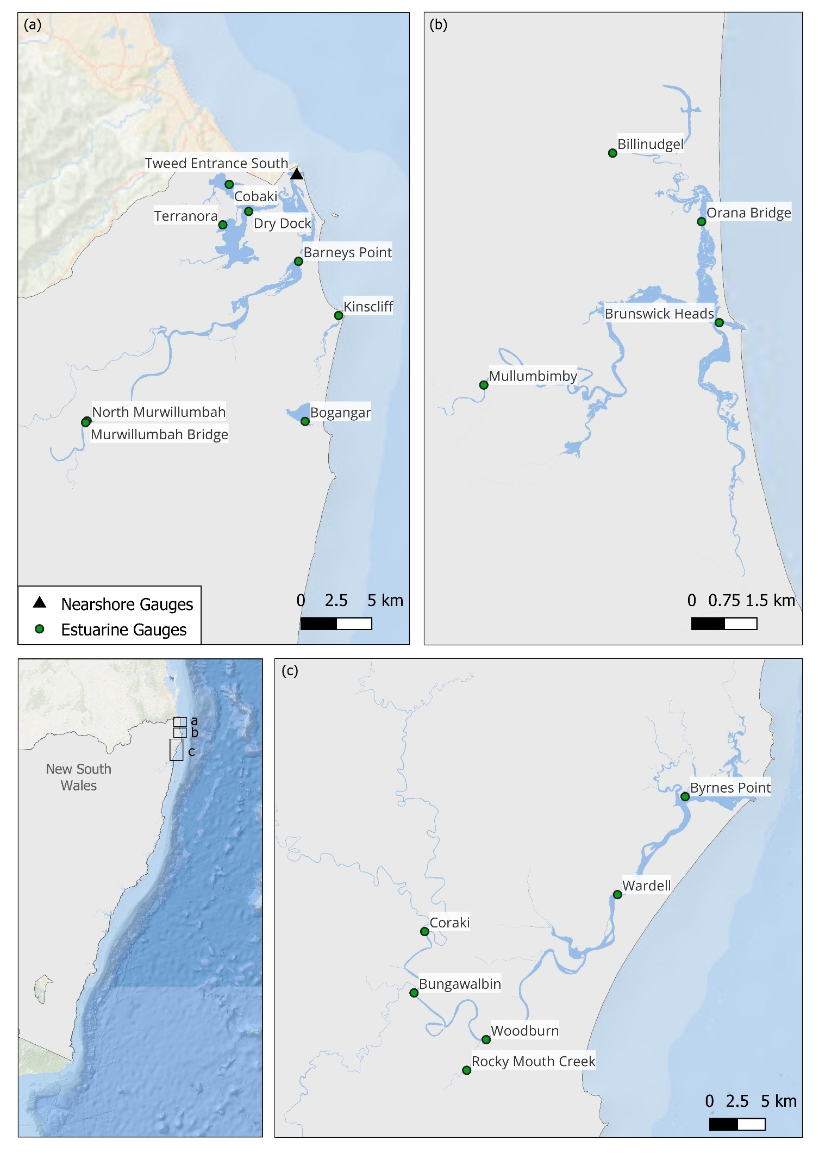
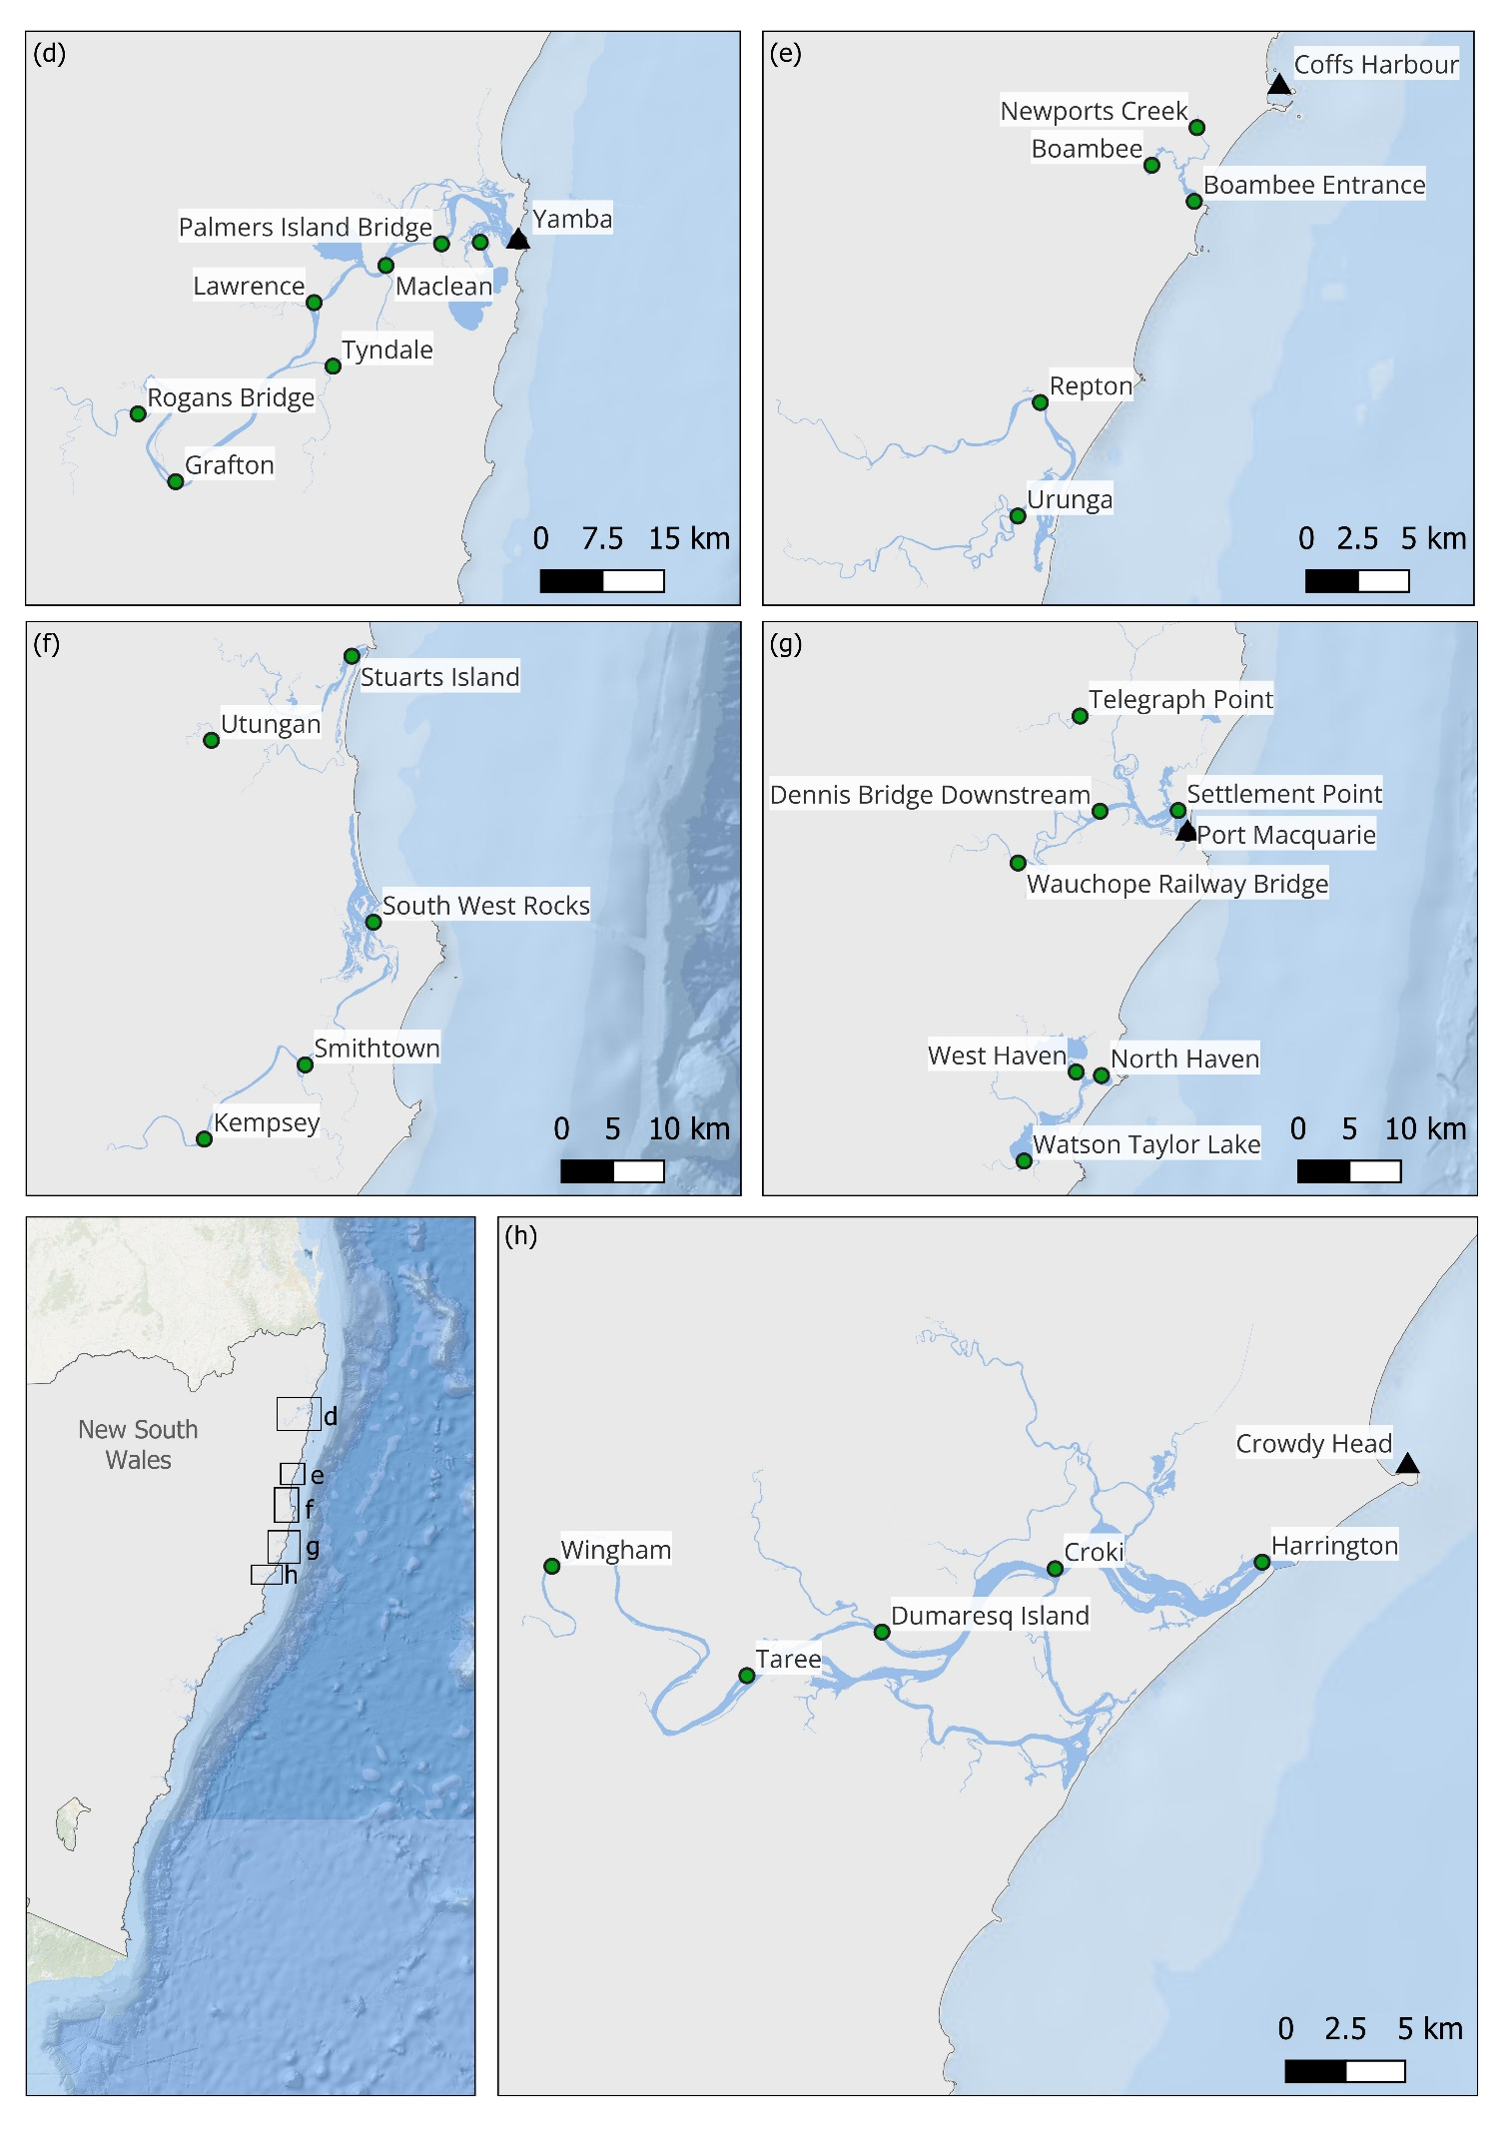
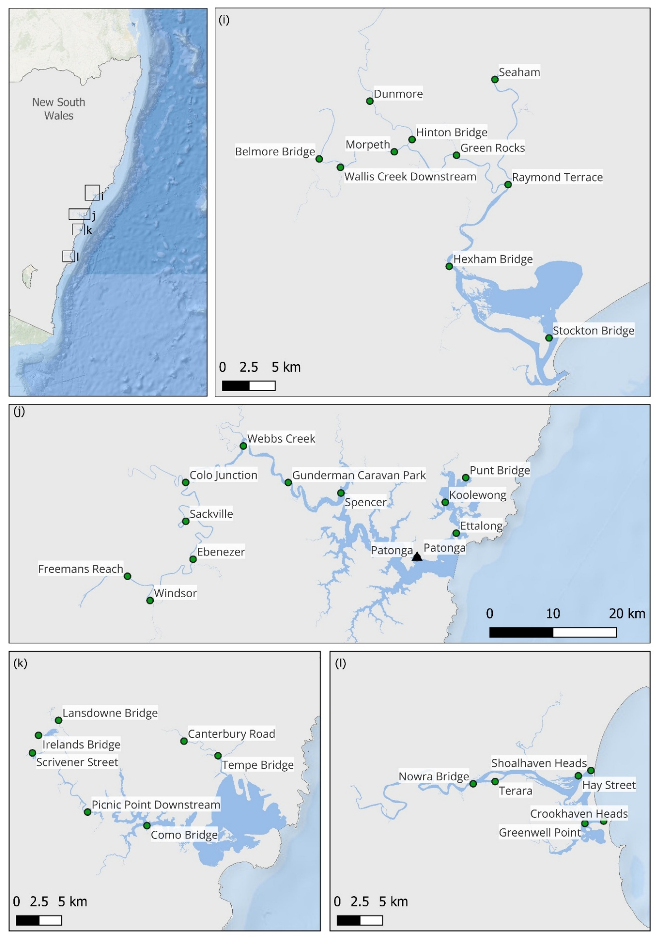
Figure S2 – Locations of analysed estuaries and nearshore water level gauges along the NSW coastline.
Maps showing the locations of estuarine and nearshore water level gauges in NSW. An inset map is provided on each map showing the location of estuaries relative to the NSW coastline. Estuaries shown are the Tweed River and Cudgen Creek estuaries (a), Brunswick River estuary (b), Richmond River estuary (c), Clarence River estuary (d), Boambee Creek and Bellinger River estuaries (e), Nambucca River and Macleay River estuaries (f), Hastings River and Camden Haven estuaries (g), Manning River estuary (h), Hunter River estuary (i), Brisbane Water and Hawkesbury River estuaries (j), Botany Bay estuary (k), and Shoalhaven River estuary (l).

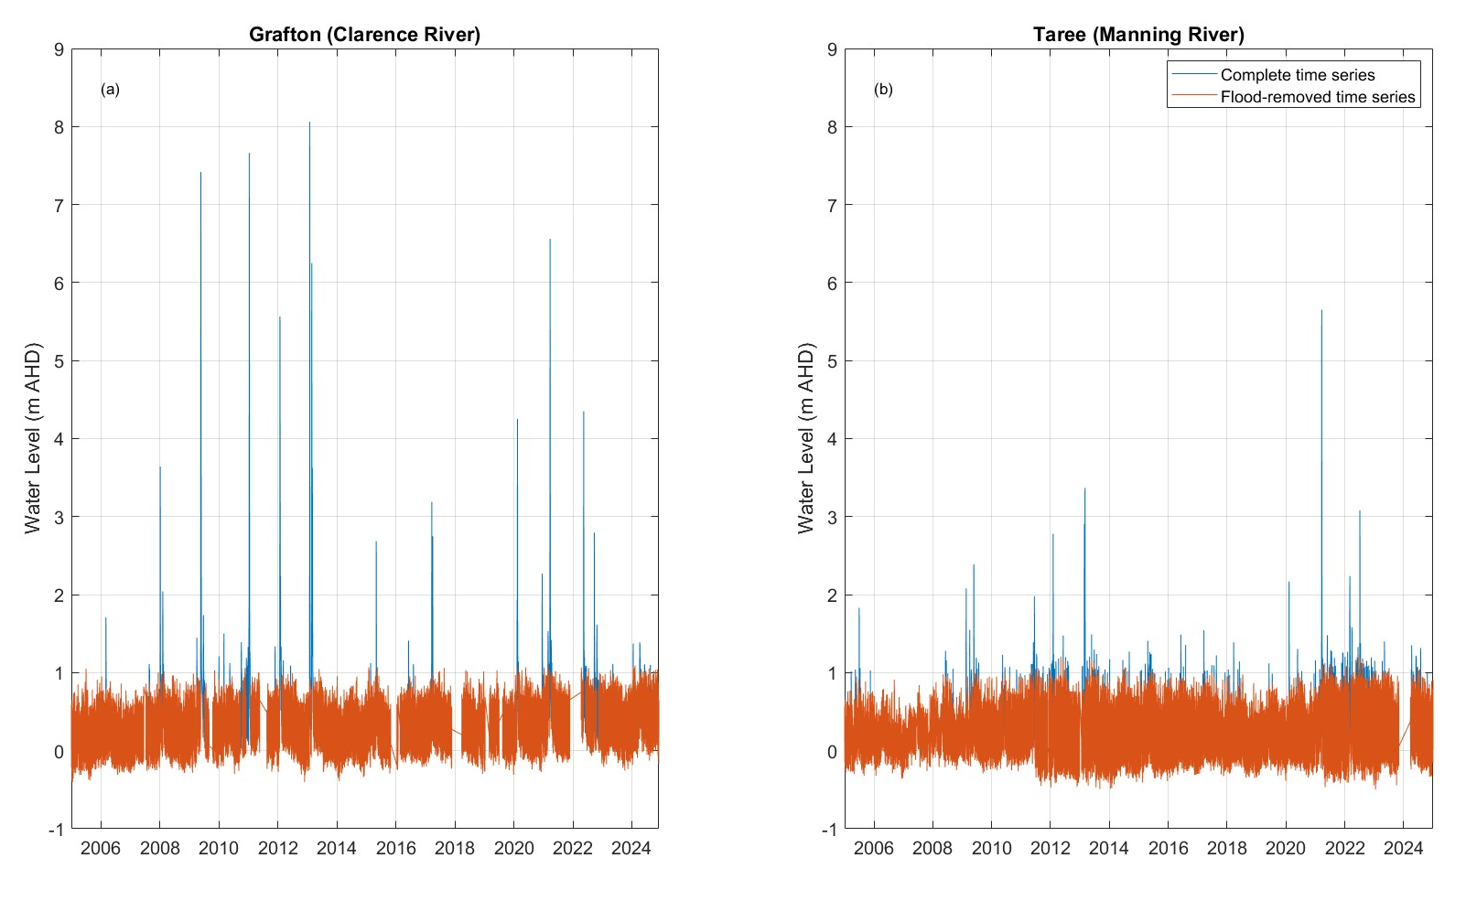
Figure S3 – Water level time series showing flood events at Grafton (Clarence River estuary) and Taree (Manning River estuary).
Water level time series from Grafton in the Clarence River estuary (a) and Taree in the Manning River estuary (b), illustrating differences in event magnitudes between the two gauges. The original time series is shown in blue, while the processed series following flood removal (see Methods for details) is shown in orange. Water levels are expressed in metres relative to the Australian Height Datum (AHD).

