Appendix
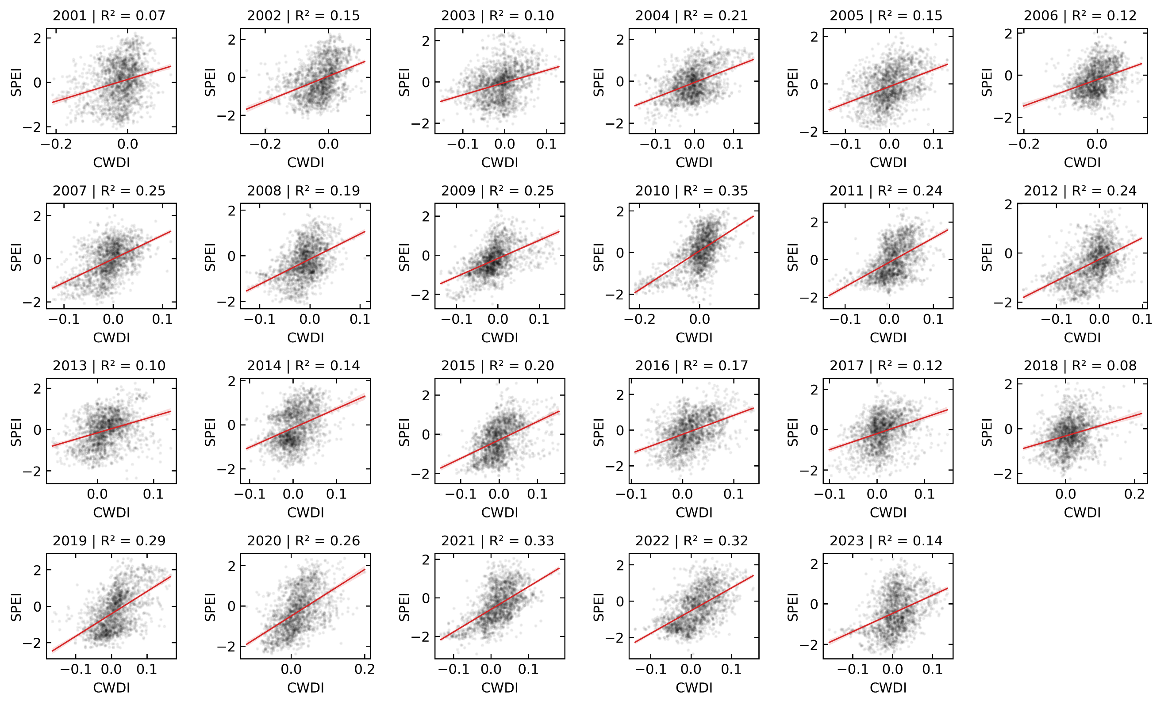
Figure 4. Interannual CWDI – SPEI relationships (2001 - 2023).
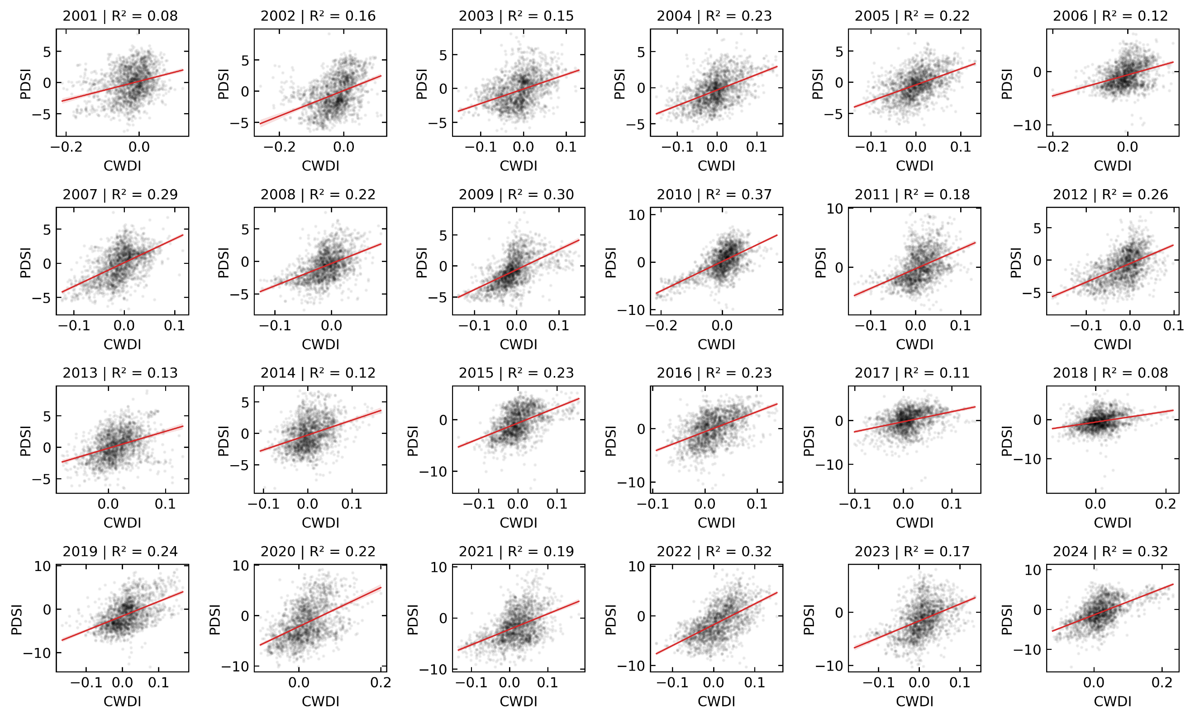
Figure 5. Interannual CWDI – PDSI relationships (2001 - 2024).

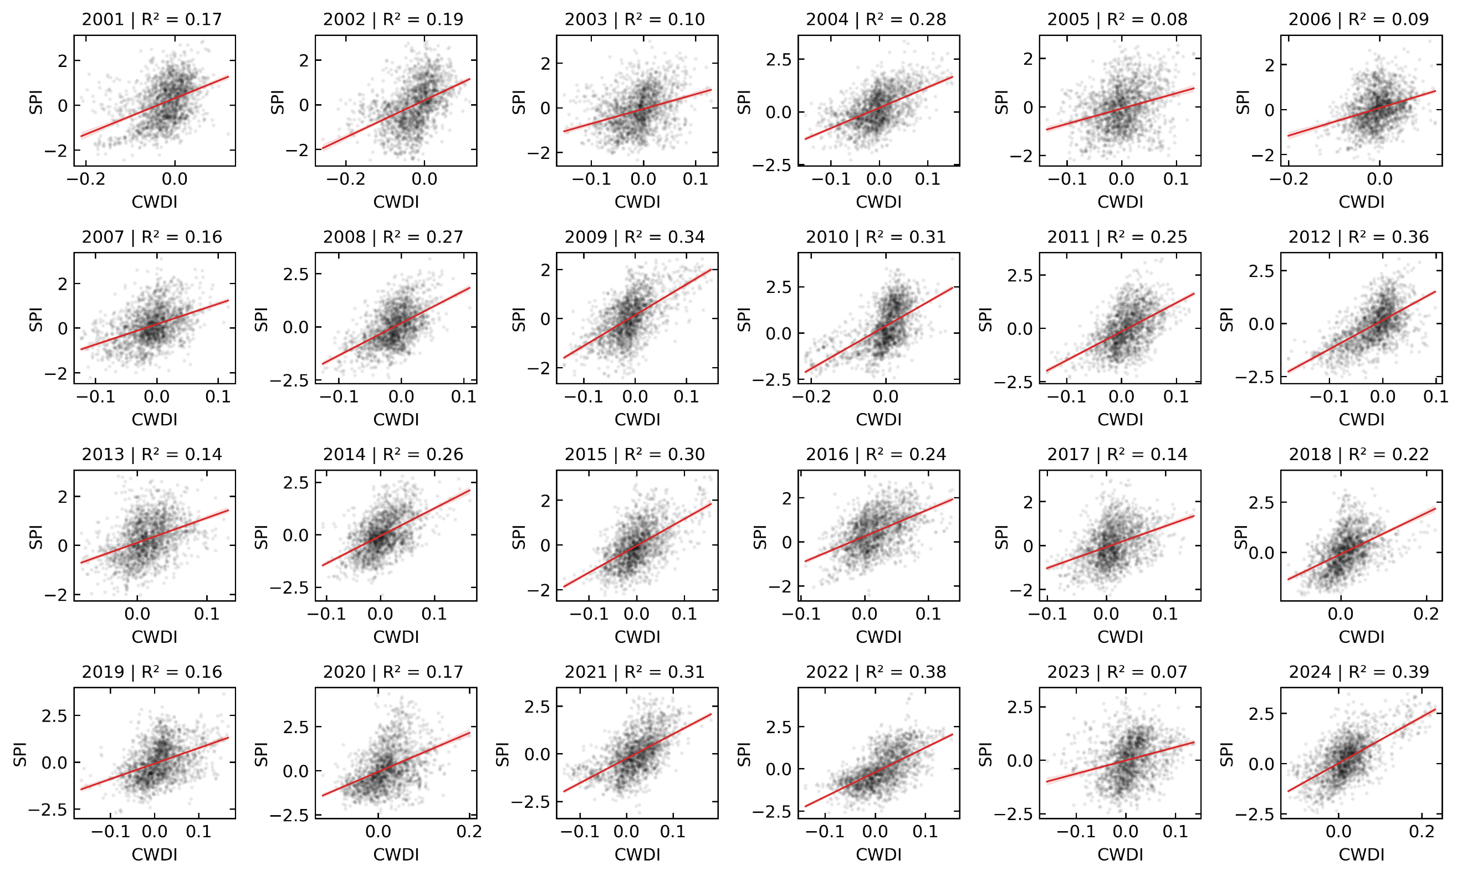
Figure 6. Interannual CWDI – SPI relationships (2001 - 2024).

