Symptom Clusters in Postoperative Chemotherapy Patients with Ovarian Cancer and the Relationship with Self-Efficacy: A Network Analysis
Rui Lian^{1†}, Lin Li^{1†}, Lei Zhang², Ning Han¹, Minghui Yao¹, Jun Hu¹, Yan Zhang^{1*}
¹ Gynecological and Reproductive Medicine Center, Peking University First Hospital, Beijing,China
² Nursing Department, Peking University First Hospital, Beijing,China

Correspondence:
Yan Zhang, Email:Zhangyan66@bjmu.edu.cn
†These authors have contributed equally to this work.

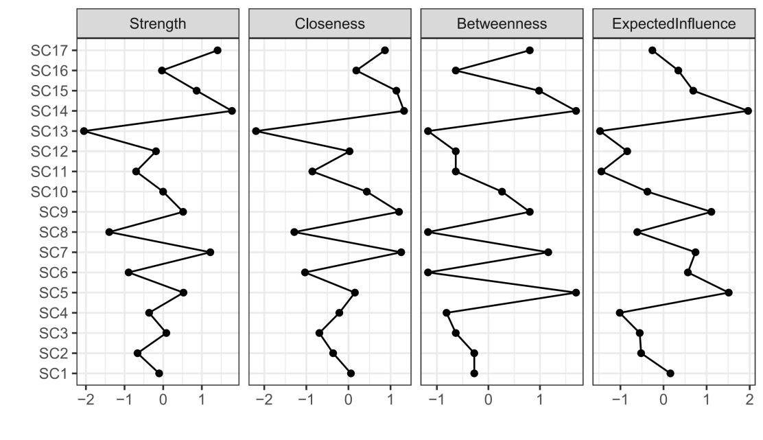
Fig.1 Centrality indicators of symptom networks in OC chemotherapy patients.
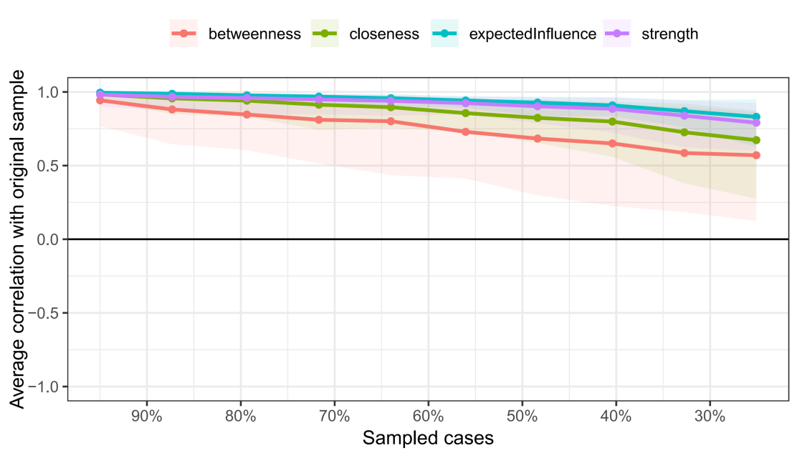
The 17 symptom codes represented in the node are as follows: SC1, Difficulty concentrating; SC2, Lack of energy; SC3, Feeling nervous; SC4, Difficulty sleeping; SC5, Feeling sad; SC6, Worrying; SC7, Feeling irritable; SC8, Numbness/tingling in hands/feet; SC9, Skin itching; SC10, Lack of appetite; SC11, Change in the way food tastes; SC12, Hair loss; SC13, Constipation; SC14, “I don’t look like myself.”; SC15, Changes in skin; SC16, Nausea; SC17, Vomiting.
Fig.2 Correlation stability coefficients of the symptom network in OC chemotherapy patients.
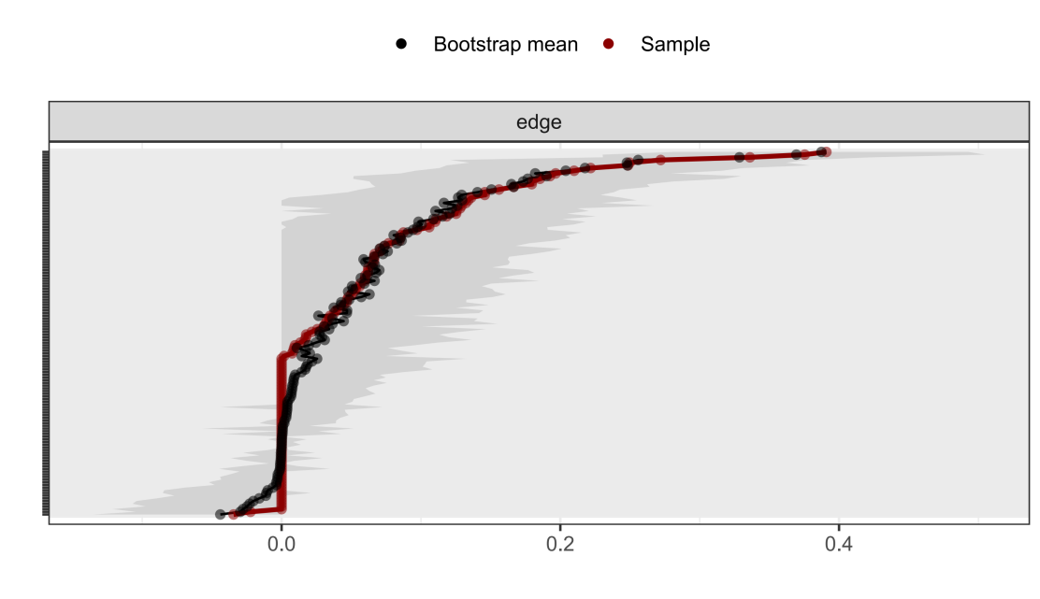
Fig.3 Bootstrap analysis results of the edge weights.
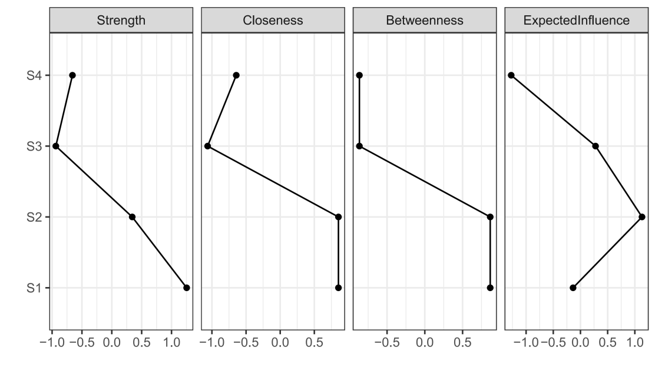
Fig.4 Centrality indicators of symptom clusters and self-efficacy networks in chemotherapy patients with OC patients.
The three symptom clusters codes represented in the node are as follows: S1, psychological emotional symptoms; S2, sensory and body image symptoms; S3, gastrointestinal symptoms; S4, Self-Management Effectiveness.

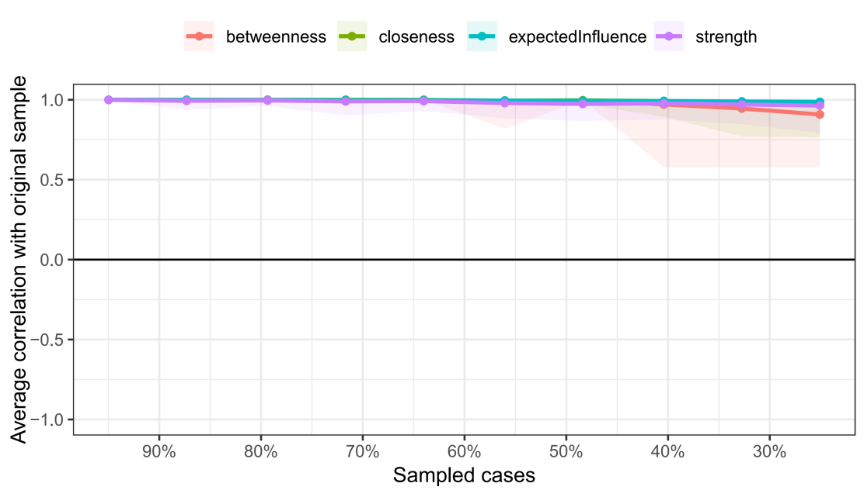
Fig.5 Correlation stability coefficients of the symptom clusters and self-efficacy network in OC chemotherapy patients.
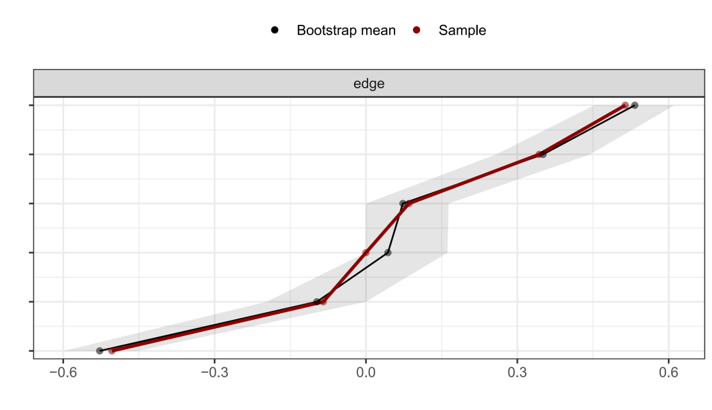
Fig.6 Bootstrap analysis results of the edge weights.

