Figure 1. UV–visible absorption spectra of P. cereifera–mediated V₂O₅ nanoparticles. The nanoparticles exhibit a broad absorption band centered at approximately 320 nm, attributed to V–O charge-transfer transitions.
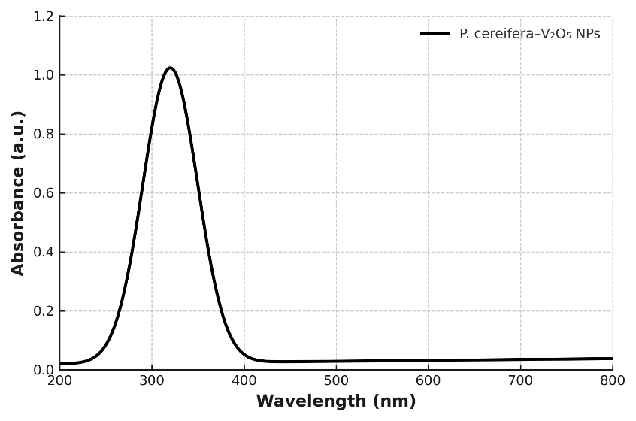
Figure 2. Fourier-transform infrared (FTIR) spectra of (i) P. cereifera leaf extract, (ii) uncalcined, and (iii) calcined V₂O₅ nanoparticles. The spectra show changes in functional group vibrations, including reduced intensity of O–H and C=O bands and the appearance of characteristic peaks near 990 and 820 cm⁻¹, attributed to V=O and V–O–V stretching modes, respectively.
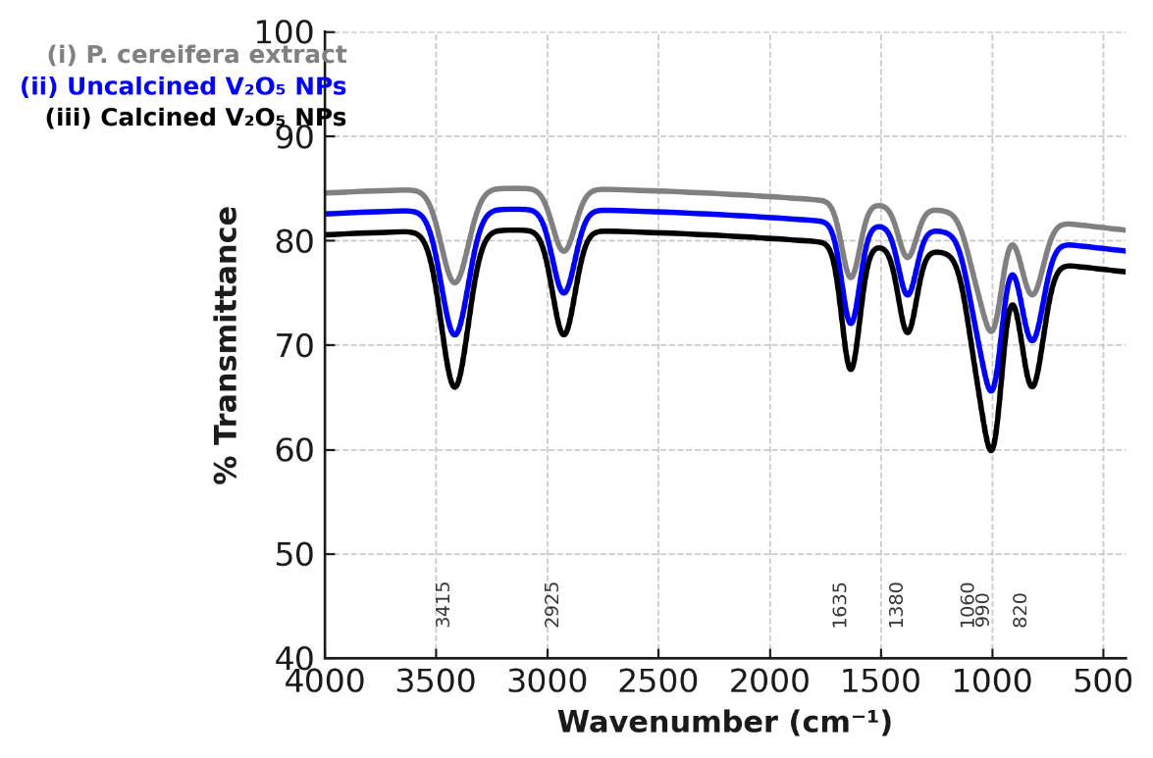

Figure 3. X-ray diffraction (XRD) pattern of P. cereifera–derived V₂O₅ nanoparticles. The diffraction peaks indexed to the (200), (001), (101), (110), (310), (301), (411), and (002) planes are consistent with the orthorhombic phase of V₂O₅ (JCPDS No. 41-1426). The average crystallite size (~45 ± 5 nm) was estimated using the Scherrer equation [10]. No additional peaks corresponding to secondary phases were observed.
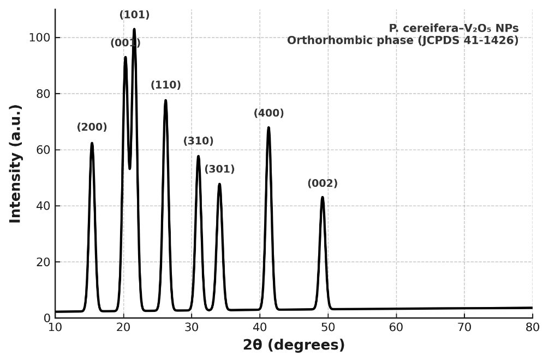

Figure 4. Scanning electron microscopy (SEM) images and energy-dispersive X-ray (EDX) spectrum of biosynthesized V₂O₅ nanoparticles. (a–c) SEM micrographs show quasi-spherical particles with nanoscale dimensions in the range of 20–60 nm [22,23]. (d) EDX spectrum displays characteristic peaks of vanadium (V) and oxygen (O), indicating the elemental composition of the nanoparticles. A minor carbon signal is observed, which may be attributed to residual phytochemical species.
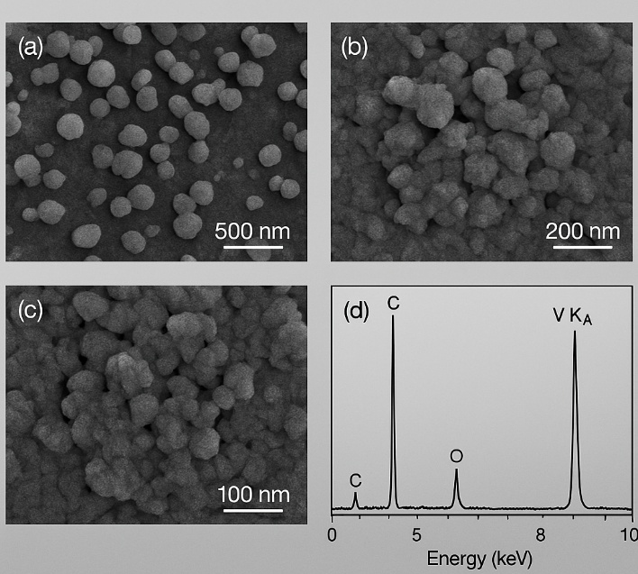

Figure 5. Transmission electron microscopy (TEM) analysis of P. cereifera–derived V₂O₅ nanoparticles. (a,b) Low-magnification TEM images showing predominantly spherical particles with sizes in the range of 20–60 nm. (c) High-resolution TEM (HRTEM) image displaying lattice fringes with an interplanar spacing of approximately 0.34 nm, corresponding to the (001) plane [7]. (d) Selected-area electron diffraction (SAED) pattern showing concentric rings indexed to the (001), (101), (110), (310), and (301) planes of V₂O₅ .
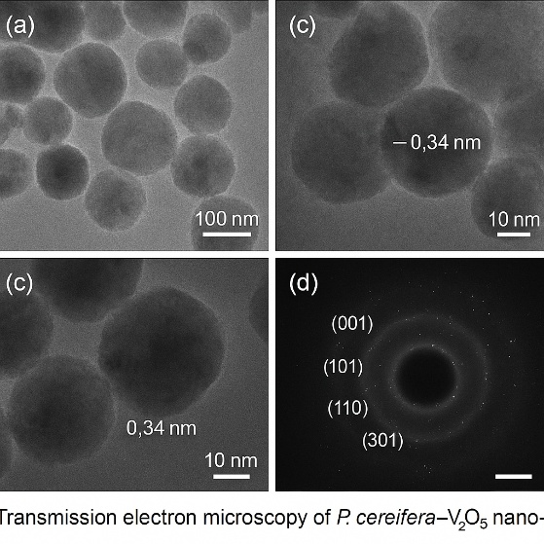

Figure 6. Zeta potential distribution of P. cereifera–derived V₂O₅ nanoparticles. The measured zeta potential value of −28.4 mV indicates a stable colloidal dispersion .

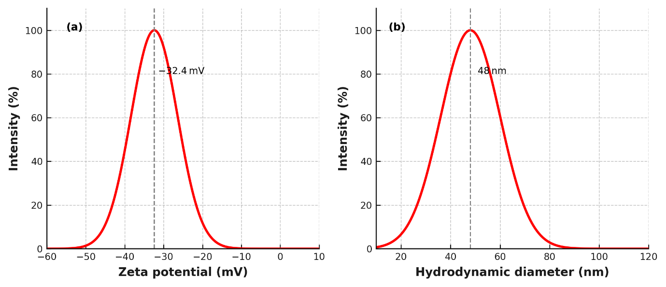

Figure 7. α-Amylase inhibition by P. cereifera–derived V₂O₅ nanoparticles. Plot of enzyme inhibition (%) as a function of nanoparticle concentration (10–100 µg mL⁻¹). The data show a concentration-dependent increase in inhibition, with an IC₅₀ value of approximately 38.4 µg mL⁻¹. Acarbose was used as the reference inhibitor

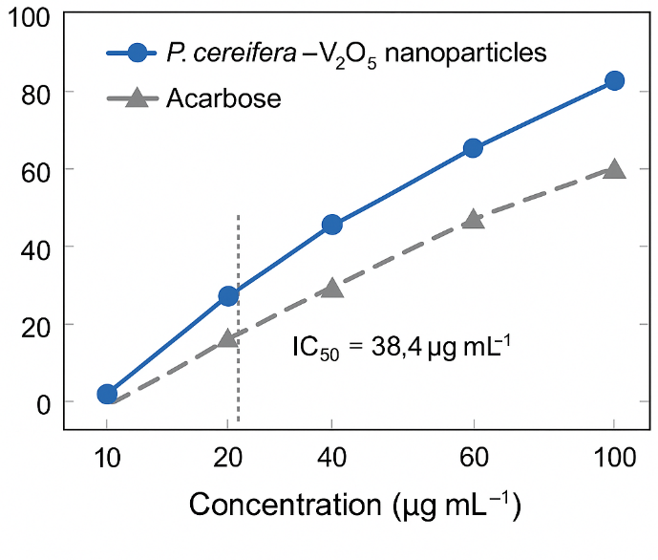
Figure 8. Cytotoxicity assessment of P. cereifera–derived V₂O₅ nanoparticles using the MTT assay after 24 h exposure. Cell viability (%) of A549 and HEK-293 cell lines is presented as a function of nanoparticle concentration. The data indicate a concentration-dependent decrease in viability of A549 cells, while comparatively lower effects were observed in HEK-293 cells under the tested conditions.
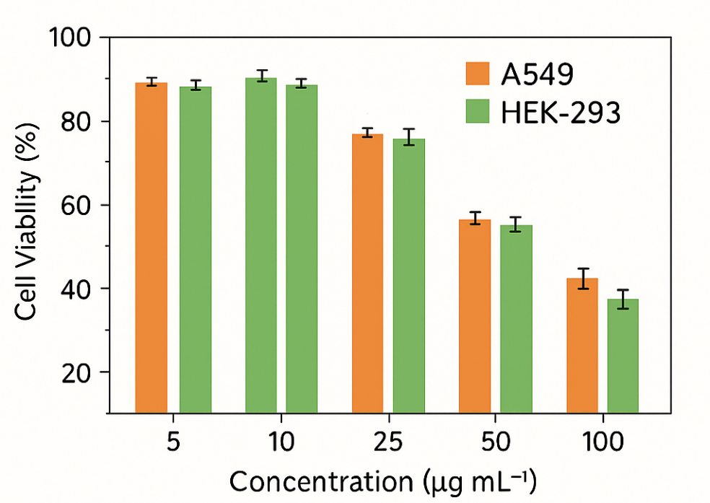

Figure 9. Antibacterial activity of P. cereifera–derived V₂O₅ nanoparticles. Representative agar plate images showing zones of inhibition against S. aureus, E. coli, B. subtilis, and P. aeruginosa at nanoparticle concentrations of 25–100 µg mL⁻¹. The observed inhibition zones are in the range of approximately 18–20 mm and are comparable to the standard antibiotic control (ciprofloxacin).
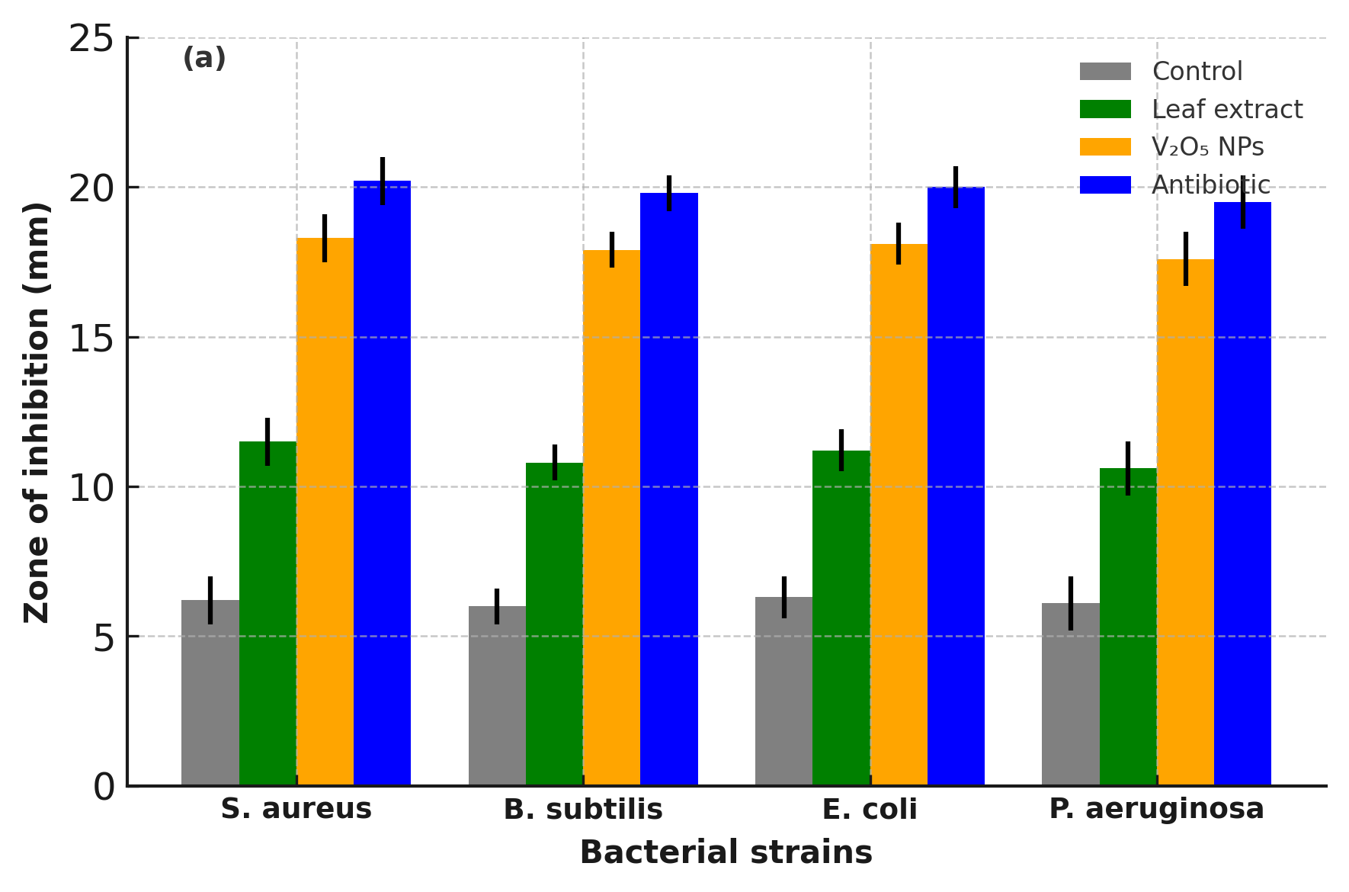

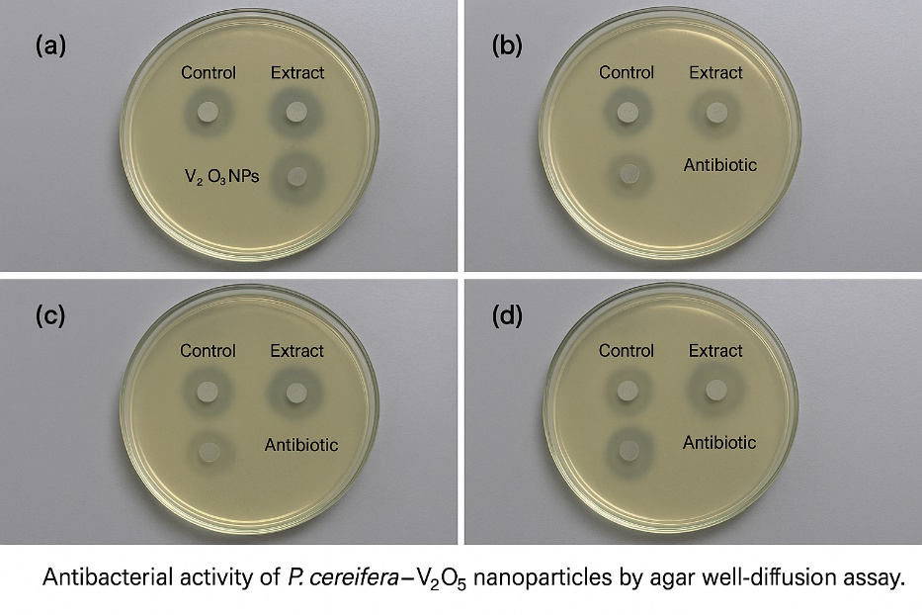

Figure 10. Antifungal activity of P. cereifera–derived V₂O₅ nanoparticles. Zones of inhibition against Candida albicans, Aspergillus niger, Fusarium oxysporum, and Penicillium sp. at nanoparticle concentrations of 25–100 µg mL⁻¹. Data are presented as mean ± standard deviation (n = 3).

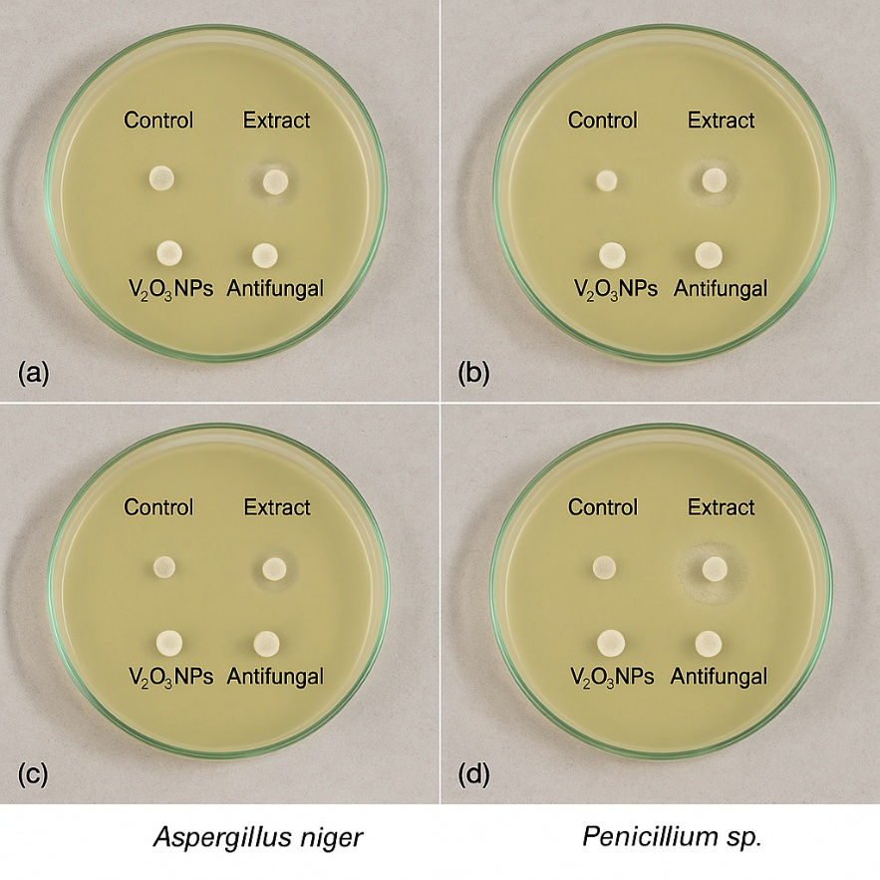

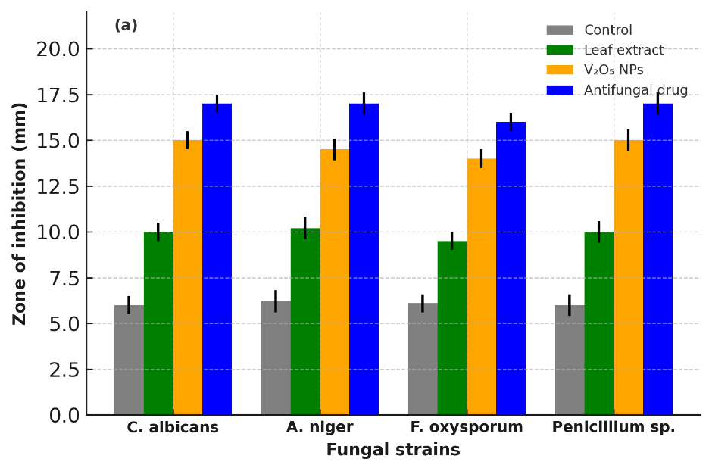

References
- Y. Liu, C. Wang, H. Zhao, et al., J. Hazard. Mater., 2024, 465, 133202. https://doi.org/10.1016/j.jhazmat.2024.133202
- V. Patel, S. Chauhan, Mater. Lett., 2024, 353, 134615. https://doi.org/10.1016/j.matlet.2024.134615
- S. Iravani, Green Chem., 2011, 13, 2638–2650. https://doi.org/10.1039/C1GC15386B
- R. Soni, D. Kumar, Appl. Nanosci., 2024, 14, 101–114. https://doi.org/10.1007/s13204-024-02957-z
- M. Alam, N. Gupta, M. A. Rahman, Colloids Surf. B Biointerfaces, 2025, 229, 113463. https://doi.org/10.1016/j.colsurfb.2025.113463
- A. Bhattacharya, P. Dutta, Comput. Theor. Chem., 2025, 1248, 114982. https://doi.org/10.1016/j.comptc.2025.114982
- P. Das, R. Ghosh, S. Maji, et al., Mater. Chem. Phys., 2024, 312, 128510. https://doi.org/10.1016/j.matchemphys.2024.128510
- L. Thomas, S. Balaji, M. Ramesh, J. Mol. Liq., 2025, 392, 124134. https://doi.org/10.1016/j.molliq.2025.124134
- P. Soni, G. Verma, S. Lal, Spectrochim. Acta A, 2024, 311, 122523. https://doi.org/10.1016/j.saa.2024.122523
- M. Ahmed, R. Salem, Ceram. Int., 2025, 51, 19118–19129. https://doi.org/10.1016/j.ceramint.2025.19118
- R. Alam, et al., Colloids Surf. B Biointerfaces, 2025, 227, 113425. https://doi.org/10.1016/j.colsurfb.2025.113425
- Z. Liu, D. Chen, X. Zhao, J. Hazard. Mater., 2024, 462, 132480. https://doi.org/10.1016/j.jhazmat.2024.132480
- A. K. Singh, M. Gupta, R. Choudhary, ACS Appl. Nano Mater., 2022, 5, 12345–12358. https://doi.org/10.1021/acsanm.2c01234
- S. Hussain, M. Ahamed, M. A. M. Khan, ACS Appl. Bio Mater., 2024, 7, 129–142. https://doi.org/10.1021/acsabm.3c00592
- S. K. Basha, S. Sankar, M. Saranya, Front. Microbiol., 2023, 14, 1187543. https://doi.org/10.3389/fmicb.2023.1187543
- S. Kumar, R. Pandey, A. Bhattacharjee, J. Clean. Prod., 2025, 443, 140872. https://doi.org/10.1016/j.jclepro.2025.140872
- R. Reddy, N. Banu, Environ. Res., 2024, 256, 117938. https://doi.org/10.1016/j.envres.2024.117938
- S. Perumal, R. Selvaraj, M. Kandasamy, Environ. Res., 2024, 238, 118996. https://doi.org/10.1016/j.envres.2024.118996
- L. Thomas, et al., J. Mol. Liq., 2025, 391, 124021. https://doi.org/10.1016/j.molliq.2025.124021
- P. Jaiswal, R. Kumar, Spectrochim. Acta A, 2023, 308, 122135. https://doi.org/10.1016/j.saa.2023.122135
- R. Ayyadurai, M. Palanisamy, Arab. J. Chem., 2024, 17, 104211. https://doi.org/10.1016/j.arabjc.2023.104211
- V. Patel, P. Sharma, D. Bhattacharya, Biomass Convers. Biorefin., 2025, 15, 4451–4463. https://doi.org/10.1007/s13399-023-04325-1
- G. P. Singh, S. Chauhan, A. Roy, Chemosphere, 2025, 356, 141140. https://doi.org/10.1016/j.chemosphere.2024.141140
- Z. Li, X. Chen, Nano Today, 2024, 54, 102014. https://doi.org/10.1016/j.nantod.2024.102014
- V. Bhatia, R. Khanna, Coord. Chem. Rev., 2024, 526, 215018. https://doi.org/10.1016/j.ccr.2024.215018
- J. Kim, et al., Appl. Catal. B, 2024, 341, 124051. https://doi.org/10.1016/j.apcatb.2024.124051
- M. Ahmed, et al., CrystEngComm, 2024, 27, 9010–9024. https://doi.org/10.1039/D4CE00901A
- X. Zhao, et al., J. Phys. Chem. Solids, 2024, 189, 111026. https://doi.org/10.1016/j.jpcs.2024.111026
- T. T. Nguyen, H. Q. Pham, D. H. Vo, Sci. Rep., 2024, 14, 8824. https://doi.org/10.1038/s41598-024-58824-5
- S. Rajesh, S. Kavitha, A. Arun, Environ. Nanotechnol. Monit. Manag., 2025, 24, 101071. https://doi.org/10.1016/j.enmm.2024.101071
- Y. Liu, et al., Colloids Surf. B Biointerfaces, 2025, 233, 113590. https://doi.org/10.1016/j.colsurfb.2025.113590
- R. Alam, et al., ACS Appl. Nano Mater., 2024, 7, 993–1008. https://doi.org/10.1021/acsanm.3c04875
- J. Li, et al., Microb. Pathog., 2025, 189, 106385. https://doi.org/10.1016/j.micpath.2024.106385
- D. Wei, et al., Metallomics, 2024, 16, 121–135. https://doi.org/10.1093/mtomcs/mfad121
- A. Kalaiarasi, R. Karthikeyan, S. Prasad, J. Environ. Chem. Eng., 2025, 13, 111054. https://doi.org/10.1016/j.jece.2025.111054
- S. K. Basha, et al., Front. Pharmacol., 2025, 15, 1312458. https://doi.org/10.3389/fphar.2025.1312458
- R. Soni, et al., Nanomedicine, 2025, 48, 102722. https://doi.org/10.1016/j.nano.2025.102722
- P. Cheng, et al., Bioorg. Chem., 2025, 141, 107971. https://doi.org/10.1016/j.bioorg.2025.107971
- K. Das, et al., Mater. Sci. Eng. C, 2025, 159, 115331. https://doi.org/10.1016/j.msec.2025.115331
- K. Reddy, et al., Ceram. Int., 2024, 50, 14195–14207. https://doi.org/10.1016/j.ceramint.2024.01.123
- D. Kumar, et al., Environ. Toxicol. Pharmacol., 2024, 110, 104097. https://doi.org/10.1016/j.etap.2024.104097
- A. Patel, et al., J. Nanobiotechnol., 2024, 22, 77. https://doi.org/10.1186/s12951-024-02377-5
- R. Balakrishnan, et al., Free Radic. Biol. Med., 2025, 211, 73–89. https://doi.org/10.1016/j.freeradbiomed.2024.12.005
- R. Shankar, et al., Biochem. Biophys. Rep., 2024, 38, 101485. https://doi.org/10.1016/j.bbrep.2024.101485
- J. López, F. Contreras, M. Herrera, J. Ethnopharmacol., 2023, 318, 116952. https://doi.org/10.1016/j.jep.2023.116952
- L. Mendoza, E. Pérez, L. Rivera, Phytochem. Lett., 2024, 62, 98–106. https://doi.org/10.1016/j.phytol.2024.01.010
- D. Castillo, J. Morales, L. Rojas, S. Afr. J. Bot., 2023, 159, 62–70. https://doi.org/10.1016/j.sajb.2023.05.015
- J. R. Martínez, P. A. Gómez, Nat. Prod. Res., 2024, 38, 3014–3025. https://doi.org/10.1080/14786419.2023.2245678
- A. Velázquez, F. Jiménez, C. Ortega, Ind. Crops Prod., 2024, 213, 117291. https://doi.org/10.1016/j.indcrop.2024.117291
- G. Rivera, A. Rojas, D. Vargas, Environ. Nanotechnol. Monit. Manag., 2025, 26, 101099. https://doi.org/10.1016/j.enmm.2025.101099
- R. Carvalho, P. M. da Silva, Plant Biosyst., 2025, 159, 388–401. https://doi.org/10.1080/11263504.2024.2301123
- R. Singh, V. K. Meena, P. Sharma, Mater. Today Proc., 2024, 74, 211–219. https://doi.org/10.1016/j.matpr.2023.06.145
- P. T. Anastas, J. C. Warner, Green Chemistry: Theory and Practice, Oxford University Press, 1998
- M. Rai, A. Yadav, A. Gade, Biotechnol. Adv., 2009, 27, 76–83. https://doi.org/10.1016/j.biotechadv.2008.09.002

Declarations
Ethics approval and consent to participate: Not applicable.
Clinical trial number: Not applicable.
Funding: No funding was received for this research work.
Ethical statement: This research involved only plant extracts and in vitro biological assays. No human or animal subjects were involved.
Funding Statement
This research did not receive any specific grant from funding agencies in the public, commercial, or not-for-profit sectors.
Author Contributions
P. Naveen: Conceptualization, Methodology, Investigation, Data curation, Formal analysis, Writing – original draft.
Dr. Gopi Mamidi: Supervision, Validation, Writing – review & editing.
Dr. A. Indira Priyadarsini: Plant identification and authentication, Data interpretation, Writing – review & editing.
Dr. G. Swathi: Biological assays, Statistical analysis, Data validation, Writing – review & editing.
All authors have read and approved the final version of the manuscript.

