Supporting Information
Optimization of OSA-Ag NPs/SA/AM Hydrogel
The synthesis of the SA/AM hydrogel involves three stages: free radical generation, chain growth and crosslinking, and chain termination. The initiator ammonium persulfate undergoes a redox reaction at 50°C to produce free radicals, which add to the C=C double bonds of the acrylamide monomer, initiating chain growth. The crosslinker N,N'-methylenebisacrylamide reacts with the free radicals on the growing polyacrylamide (PAM) chains through its own double bonds, bridging multiple PAM chains into a three-dimensional covalent network. Once the free radicals in the system are depleted, the crosslinked network solidifies, and the sodium alginate molecular chains become physically entangled and fixed within the PAM network, thereby forming the basic hydrogel structure. To impart SERS activity to the hydrogel, this study employs silver nanoparticles modified with oxidized sodium alginate (OSA-Ag NPs) as the polymerization solvent to optimize the composite hydrogel. 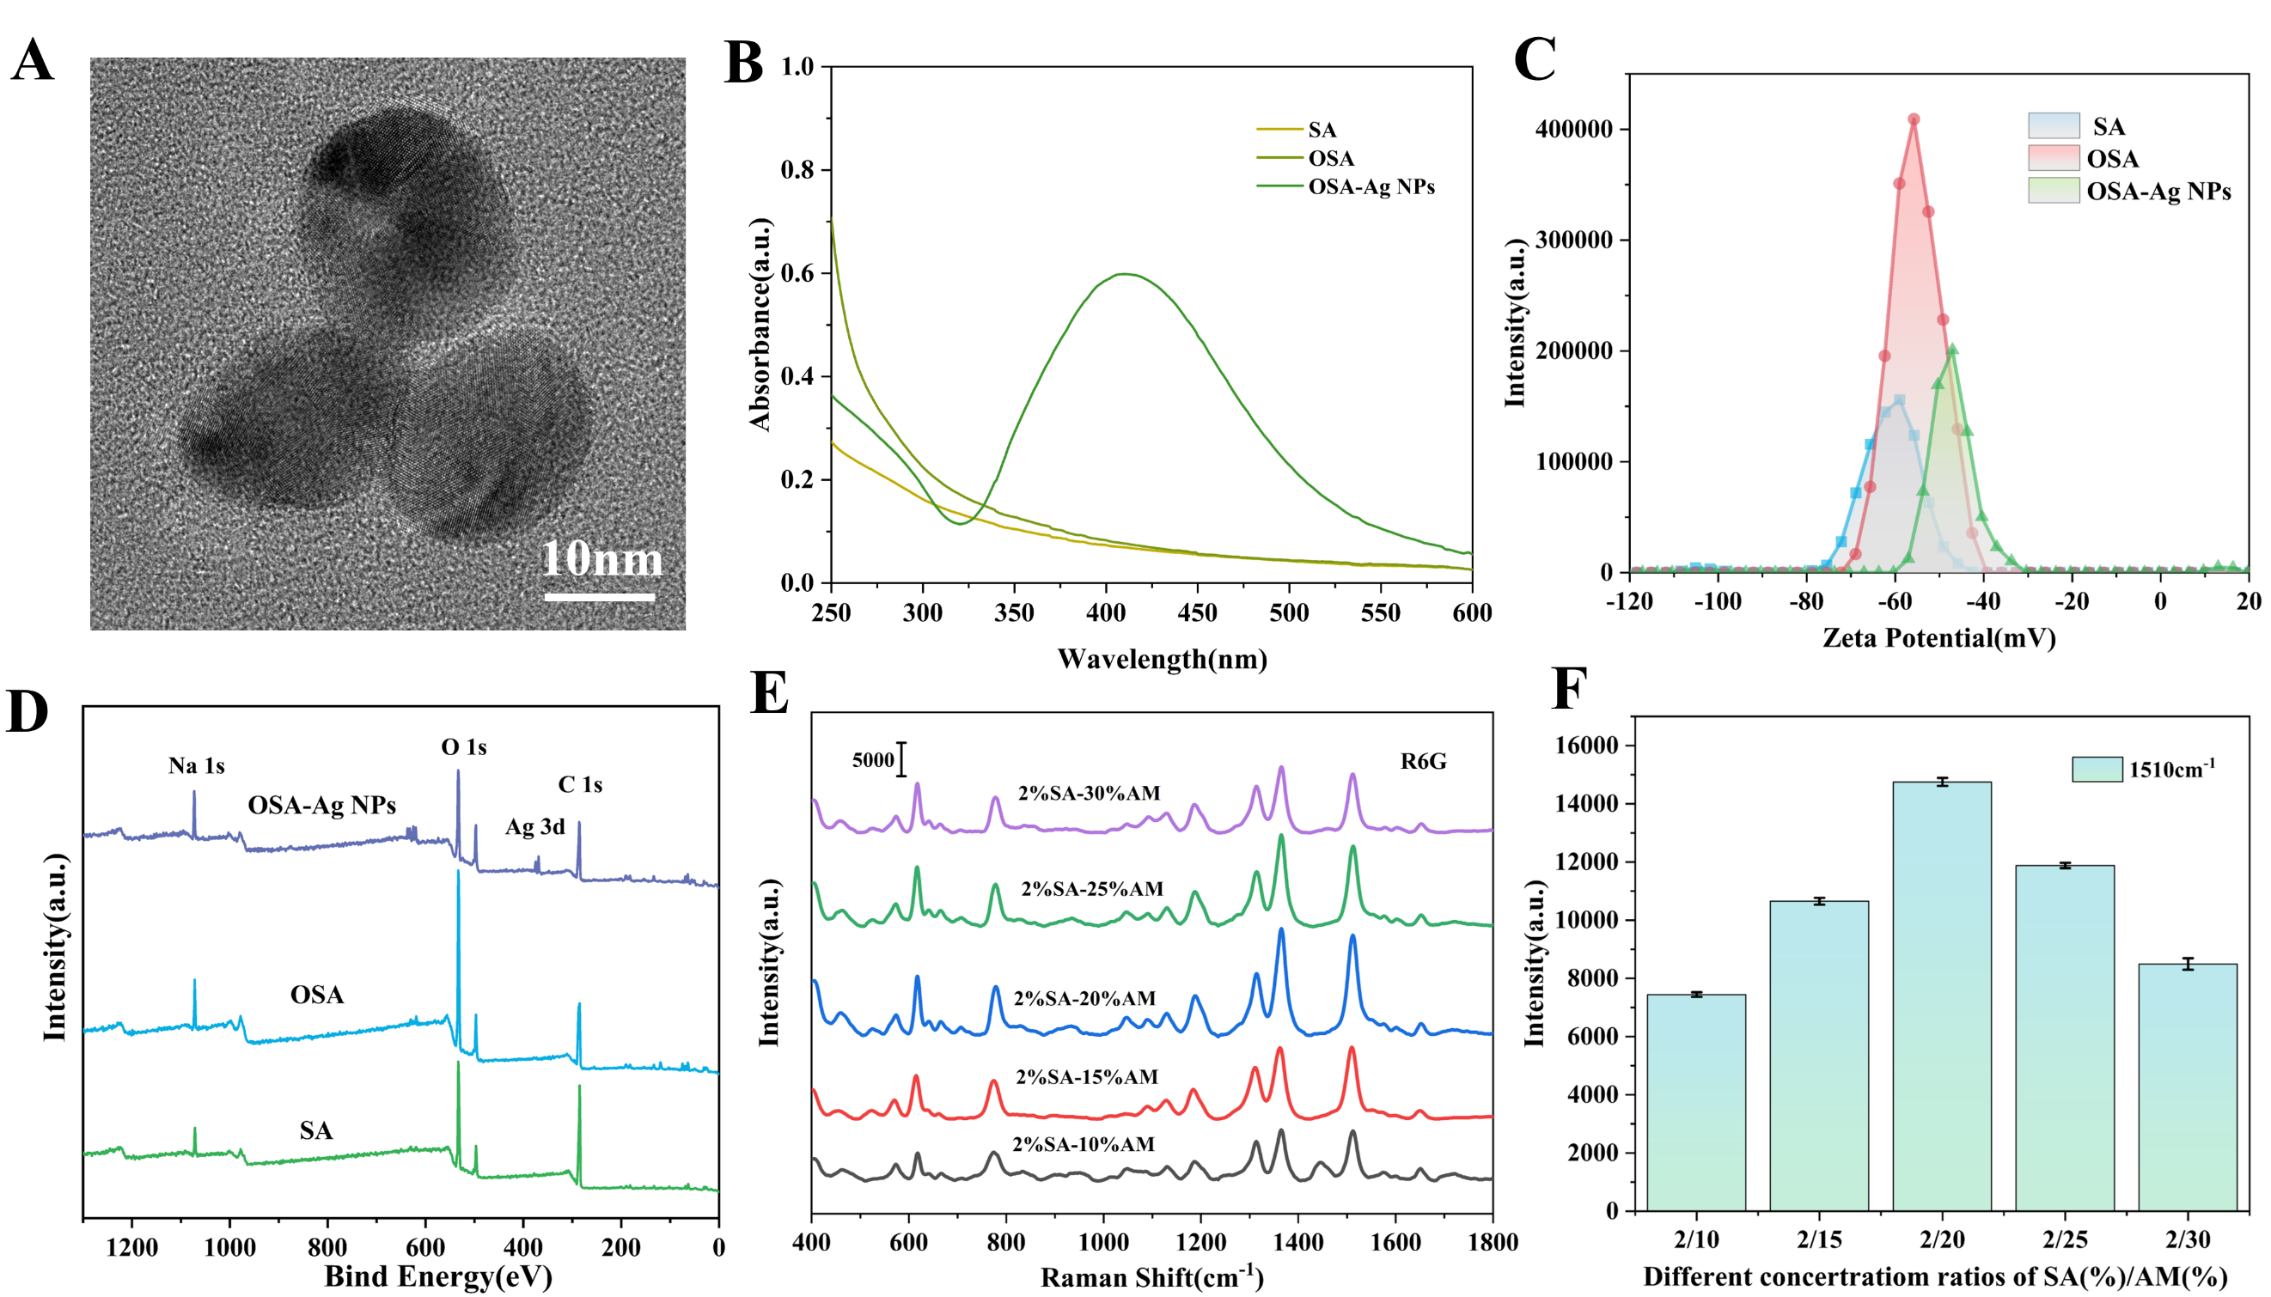

Fig.S1. (A) TEM diagram of OSA-Ag NPs;(B)UV-visible spectra of SA, OSA, OSA-Ag NPs;(C) Zeta potential of SA、OSA、OSA-Ag NPs;(D) XPS graph of SA、OSA、OSA-Ag NPs; (E) SERS spectra of OSA-Ag NPs/SA/AM hydrogels at different concentrations of AM; (F) SERS signal strength of 10-5M R6G at 1510cm⁻¹.
During the synthesis of OSA-Ag NPs, OSA functions as both a reducing agent and a stabilizer, reducing silver ions (Ag⁺) to metallic silver (Ag⁰) while enhancing the substrate's high-salt stability and sensitivity of the substrate. TEM images (Fig.S1A) reveal that the OSA-Ag NPs are spherical and uniform in morphology. To monitor changes during material formation, Fig.S1B-D respectively present the surface charge, UV-Vis absorption spectra, and XPS spectra. In Fig.S1B, neither SA nor OSA exhibit significant absorption peaks in the 250–600 nm range, whereas OSA-Ag NPs display a characteristic absorption peak of silver nanoparticles at 420 nm, confirming the successful synthesis of OSA-Ag NPs. The charge variations during material synthesis are shown in Fig.S1C. Following the oxidation of SA to OSA, the zeta potential increased from -51.11 mV to -40.31 mV, indicating that some hydroxyl groups in SA were oxidized to aldehyde groups. The zeta potential of OSA-Ag NPs is -46.5 mV, suggesting that Ag NPs were successfully loaded onto the OSA surface and that the nanoparticles are well stabilized. Fig.S1D presents the XPS survey spectra of OSA-Ag NPs, OSA, and SA, demonstrating that the main structure and functional groups of alginate were preserved after oxidation. Characteristic Ag 3d peaks were observed in OSA-Ag NPs, further confirming their successful synthesis. Fig.S1E-F illustrate the effect of acrylamide concentration on the SERS performance of OSA-Ag NPs/SA/AM hydrogels. As the acrylamide concentration increases, the Raman signal intensity of the hydrogel initially rises and then declines, reaching an optimal SERS response at 20% acrylamide concentration. This behavior is attributed to the shorter polymer network segments and sparser crosslinking points at lower AM concentrations, resulting in a loose network that cannot effectively immobilize OSA-Ag NPs and exhibits weak adsorption and enrichment capacity for analytes, thereby failing to concentrate target molecules near the “hot spots.” Conversely, at excessively high acrylamide concentrations, the polymer chains become denser, crosslinking points increase, and a highly compact three-dimensional network forms, significantly reducing the hydrogel’s pore size. This hinders analyte diffusion into the hydrogel and may physically shield the nanoparticle surfaces, further diminishing SERS enhancement efficiency. Therefore, a 20% AM concentration was selected for subsequent experiments.
Optimization of Au NRs-Cellulose
Ag NPs exhibit outstanding SERS enhancement properties, but their surfaces are prone to oxidation, forming SERS passivation layers^{[1]}. Compared to silver nanoparticles, gold nanoparticles demonstrate superior biocompatibility and long-term stability. Therefore, introducing Au NRs into the OSA-Ag NPs/SA/AM hydrogel system creates a stronger, more uniform electromagnetic field “hot spot” through Ag-Au bimetallic synergistic enhancement, enhancing the stability and uniformity of SERS signals. Centrifugal concentration of Au NRs severely disrupts the CTAB double-layer equilibrium, causing irreversible aggregation and precipitation between nanorods due to strong van der Waals forces. This leads to a drastic decline or even failure of their optical properties. Therefore, exploring a suitable cellulose dispersion for redispersing centrifuged Au NRs is essential to enable their subsequent uniform and stable immobilization within the three-dimensional network of the OSA-Ag NPs/SA/AM hydrogel.
Au NRs were synthesized using the method reported by Ruan^{[2]}. The morphology of Au NRs was characterized by TEM, as shown in Fig.S2A. The Au NRs exhibited a uniform rod-like structure with well-defined dimensions, with a length of 64.8 nm and width of 21.9 nm.
UV-visible absorption spectroscopy was used to analyze the localized surface plasmon resonance (LSPR) properties of pure Au NRs and Au NR composites with various cellulose derivatives (CMC, CCNF, HEC, BC, CNF). As shown in Fig.S2B, pure Au NRs had two distinct characteristic peaks at 511 nm and 782 nm. The peak at 511 nm corresponds to the transverse plasmon resonance (TPR) peak, while the 782 nm peak corresponds to the longitudinal plasmon resonance (LPR) peak. This is a typical manifestation of the “long-axis effect” of gold nanorods, confirming their successful synthesis. Furthermore, after different celluloses interacted with Au NR surfaces, the positions and shapes of the absorption peaks changed to varying degrees—indicating differences in the dispersion and anti-agglomeration capabilities of different celluloses toward Au NRs^{[3]}.
Fig.S2. (A) TEM image of Au NRs; (B) UV-vis spectra of Au NRs, Au NRs-CMC, Au NRs-CCNF, Au NRs-HEC, Au NRs-BC, and Au NRs-CNF; (C–D) Zeta potential plots of CMC, CCNF, HEC, BC, and CNF; (E) SERS spectra of Au NRs mixed with different cellulose solutions; (F) SERS signal intensity of 10⁻⁵ M R6G at 1510 cm⁻¹; (G) SERS spectra of Au NRs mixed with HEC solutions at different concentrations; (H) SERS signal intensity of 10⁻⁵ M R6G at 1510 cm⁻¹.
To clarify the reasons for these stability differences, the zeta potential of various celluloses and their Au NR composites was measured. Zeta potential is a key indicator of colloidal system stability: higher absolute values (greater than ±30 mV) indicate enhanced stability via electrostatic repulsion. Fig.S2C shows the zeta potentials of different celluloses. Cellulose nanofibrils (CNF, −53.36 mV) have a high negative potential, attributed to abundant anionic carboxylate groups (−COO⁻) introduced by TEMPO-mediated oxidation. In contrast, carboxymethyl cellulose (CMC, −28.11 mV) gains negative charge from carboxymethyl substituents; BC has a negative charge (−26.79 mV) due to surface anionic groups. HEC, a nonionic ether, shows near-neutral characteristics (+1.54 mV) because of its non-ionizable hydroxyethyl groups. CCNF exhibits a strongly positive potential (+38.64 mV) due to quaternary ammonium groups.
Fig.S2D illustrates zeta potential changes of Au NRs in different cellulose solutions. Pristine Au NRs carry a positive charge (+24.90 mV) due to residual CTAB from synthesis. When interacting with cellulose: CCNF’s strong positive charge increases Au NRs’ potential (+33.02 mV); negatively charged CMC, BC, and CNF undergo electrostatic neutralization with positively charged Au NRs. CMC-Au NRs (−40.30 mV) and CNF-Au NRs (−8.42 mV) show charge reversal via strong electrostatic adsorption; BC-Au NRs (+9.19 mV) have reduced absolute potential due to partial charge neutralization. HEC (nearly neutral) interacts weakly with Au NRs via minimal hydrogen bonding or van der Waals forces, so HEC-Au NRs exhibit a positive potential nearly identical to pristine Au NRs (+25.88 mV).
The SERS enhancement effect of Au NRs and different cellulose composites toward 10⁻⁵ M R6G was evaluated using SERS spectra and the signal intensity of probe molecule R6G. Fig. S2E-F shows significant differences in R6G Raman peak intensity with different celluloses—Au NRs combined with HEC exhibit the strongest SERS signal. This enhancement is attributed to distinct stabilization mechanisms of ionic vs. nonionic celluloses: ionic celluloses (e.g., CMC, CCNF, BC) significantly alter Au NRs’ surface charge via strong electrostatic interactions, often causing random agglomeration or excessive dispersion of nanoparticles. In contrast, HEC (a nonionic polymer) stabilizes Au NRs via steric hindrance. This mechanism promotes the formation of numerous, uniform, stable nanogaps between particles—constructing optimal SERS hotspots without irreversible agglomeration. Furthermore, HEC’s electrical neutrality minimizes competitive adsorption with analytes, allowing free diffusion and enrichment in the enhanced field. Concurrently, HEC’s cellulose network concentrates analyte molecules near Au NR surfaces via physical adsorption and capillary effects, further enhancing SERS detection sensitivity.
To optimize the substrate’s SERS performance, the effect of HEC concentration on SERS enhancement was investigated. As shown in Fig.S2G-H, SERS signal intensity first increased then decreased with varying HEC concentration. Intensity analysis at 1510 cm⁻¹ (Fig.S2H) shows the SERS signal reached maximum at 0.2% HEC concentration. This is because: at excessively low concentrations, insufficient HEC fails to prevent Au NR aggregation—leading to excessive particle clustering and sedimentation, which reduces effective “hot spots”; at excessively high concentrations, overly thick polymer layers may physically isolate analytes from Au NR surfaces (beyond the electromagnetic field enhancement range) and hinder the formation of dense inter-particle gaps required for strong “hot spots.” Thus, 0.2% HEC-Au NR composites were selected for subsequent experiments.
Optimization of Au NRs-HEC Dosage
In OSA-Ag NPs/SA/AM hydrogels, although Ag NPs can generate SERS "hot spots," their chemical reactivity makes them prone to oxidation, and the distribution of hot spots in a single-metal system is uneven, resulting in limited signal stability. To address these issues, this study introduces HEC-modified gold nanorods (Au NRs-HEC), leveraging the synergistic enhancement effect of Ag-Au bimetallic systems to improve both electromagnetic field strength and chemical stability. Additionally, the steric hindrance effect of HEC promotes uniform nanoparticle dispersion, enhancing signal uniformity. Therefore, it is necessary to further optimize the concentration of Au NRs-HEC to balance dispersibility and enhancement efficiency, thereby achieving optimal SERS performance.
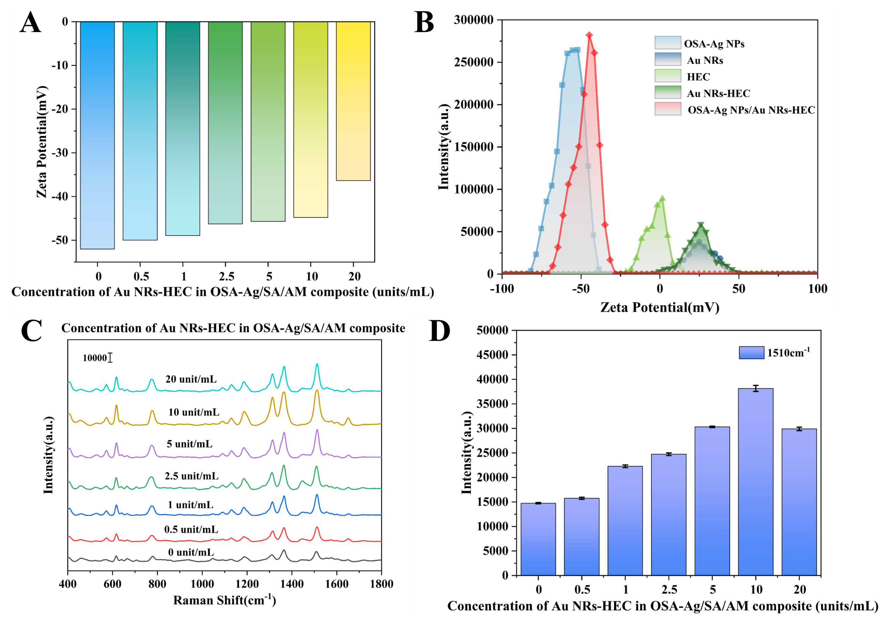
Fig.S3.(A) Zeta potential plots of OSA-Ag NPs/SA/AM/Au NRs-HEC precursor solutions at varying Au NRs-HEC concentrations; (B) Zeta potential plots of OSA-Ag NPs, Au NRs, HEC, Au NRs-HEC and OSA-Ag NPs/Au NRs-HEC; (C) SERS spectra of OSA-Ag NPs/SA/AM/Au NRs-HEC hydrogels at different Au NRs-HEC concentrations and (D) SERS signal intensity at 1510 ‍cm^{-‍1}.
Zeta potential measurements (Fig.S3A-B) were used to investigate the effects of varying Au NRs-HEC concentrations on the colloidal stability and surface charge variation of the OSA-Ag NPs/SA/AM composite. As the Au NRs-HEC concentration increased from 0 to 20 units/mL, the zeta potential of the composite solution gradually shifted from approximately -52.05 mV to -36.36 mV. This trend indicates that the positively charged Au NRs-HEC neutralizes part of the negative charge in the OSA-Ag NPs/SA/AM system (OSA-Ag NPs exhibit a strong negative potential, as shown in Fig.S3B). The reduced absolute value of the zeta potential reflects a transition from a state dominated by the negative charge of OSA-Ag NPs to a more balanced charge state achieved by incorporating Au NRs-HEC. The zeta potential distribution in Fig.S3B further clarifies the charge characteristics of individual components and the composite. OSA-Ag NPs show a distinct negative peak, while HEC exhibits a near-neutral distribution. Au NRs display a positive peak, and Au NRs-HEC inherits the positive charge of Au NRs—with slight modulation by HEC—resulting in a charge profile similar to that of Au NRs. The peak position of the OSA-Ag NPs/Au NRs-HEC composite lies between those of OSA-Ag NPs and Au NRs-HEC, confirming electrostatic interactions and charge neutralization between the negatively charged OSA-Ag NPs/SA/AM matrix and positively charged Au NRs-HEC.
The enhancement effect of Au NRs-HEC on the OSA-Ag NPs/SA/AM system was evaluated via SERS spectroscopy (Fig.S3C) and quantitative analysis of the characteristic peak intensity at 1510 cm⁻¹ (Fig.S3D). Without Au NRs-HEC (0 units/mL), the SERS spectral intensity of R6G was relatively weak. As the Au NRs-HEC concentration increased from 0.5 to 10 units/mL (where “units/mL” refers to the amount of Au NRs-HEC added per mL of the OSA-Ag NPs/SA/AM system; 1 unit corresponds to the Au NRs concentration in a 1 mL centrifuge tube), the Raman characteristic peak intensity increased progressively—indicating enhanced SERS activity. When the concentration exceeded 10 units/mL (e.g., 20 units/mL), the peak intensity began to decrease.
This phenomenon is associated with the system’s charge state: the OSA-Ag NPs/SA/AM itself carries a strong negative charge, which maintains colloidal stability via electrostatic repulsion but also limits its interaction with positively charged analytes or other positively charged components. The introduction of positively charged Au NRs-HEC induces a charge neutralization effect in the system. Within the moderate concentration range (0-10 units/mL), this neutralization optimizes the balance of electrostatic forces—it prevents excessive agglomeration while promoting close-proximity plasmonic coupling between Ag and Au nanostructures, thereby enhancing the SERS signal. However, excessive Au NRs-HEC causes charge overcompensation: it weakens electrostatic repulsion, increases the risk of random particle agglomeration, and disrupts the uniformity of hotspot distribution. At 10 units/mL, the coverage density of Au NRs-HEC reaches an optimal level—enabling the formation of numerous Ag–Au hotspots while avoiding overcrowding or agglomeration. Thus, 10 units/mL of Au NRs-HEC was selected for incorporation into the OSA-Ag NPs/SA/AM hydrogel system, yielding the OSA-Ag NPs/SA/AM/Au NRs-HEC hydrogel.

[1] Liu H Q, Gao X, Xu C, et al. SERS Tags for Biomedical Detection and Bioimaging[J]. Theranostics, 2022, 12(4): 1870-1903.
[2] Ruan S, Wang W, Qiu L, et al. Preparation of 3D flexible SERS substrates by mixing gold nanorods in hydrogels for the detection of malachite green and crystal violet[J]. Microchimica Acta, 2024, 191(4): 205.
[3] Ogundare S A, Van Zyl W E. A review of cellulose-based substrates for SERS: fundamentals, design principles, applications[J]. Cellulose, 2019, 26(11): 6489-6528.

