Title: Irisin mediates exercise-induced glymphatic α-synuclein clearance by upregulating astrocytic REV-ERBα in Parkinson’s disease
Authors list: Ruoyu Li^{1,2,#}, Jinbao Zhang^{1,2,#}, Xining Ren^{1,2,#}, Bingyu Li^{1,2}, Xuerui Xiang^{1,2}, Yunxi Liu^{1,2}, Yunjiao Zhou^{1,2}, Yunping Song^{1,2} and Lingjing Jin^{1,2,3,4,*}

Author affiliations:
¹ Department of Neurology and Neurological Rehabilitation, Shanghai Disabled Persons' Federation Key Laboratory of Intelligent Rehabilitation Assistive Devices and Technologies, Yangzhi Rehabilitation Hospital (Shanghai Sunshine Rehabilitation Center), School of Medicine, Tongji University, Shanghai, China.
² Neurotoxin Research Center, Cooperated Laboratory with China Biotech Co., Ltd., Lanzhou Biotech Development Co., Ltd. and Tongji University, Yangzhi Rehabilitation Hospital (Shanghai Sunshine Rehabilitation Center), School of Medicine, Tongji University, Shanghai, China.
³ Collaborative Innovation Center for Brain Science, Tongji University, Shanghai, China.
⁴ Shanghai Key Laboratory of Wearable Robotics and Human-Machine Interaction, Shanghai, China.

# These authors contributed equally to this work.
* Corresponding author: Lingjing Jin, Department of Neurology and Neurological Rehabilitation, Yangzhi Rehabilitation Hospital (Shanghai Sunshine Rehabilitation Center), School of Medicine, Tongji University, Shanghai 201619, China. Electronic address: lingjingjin@tongji.edu.cn.

Supplementary figures

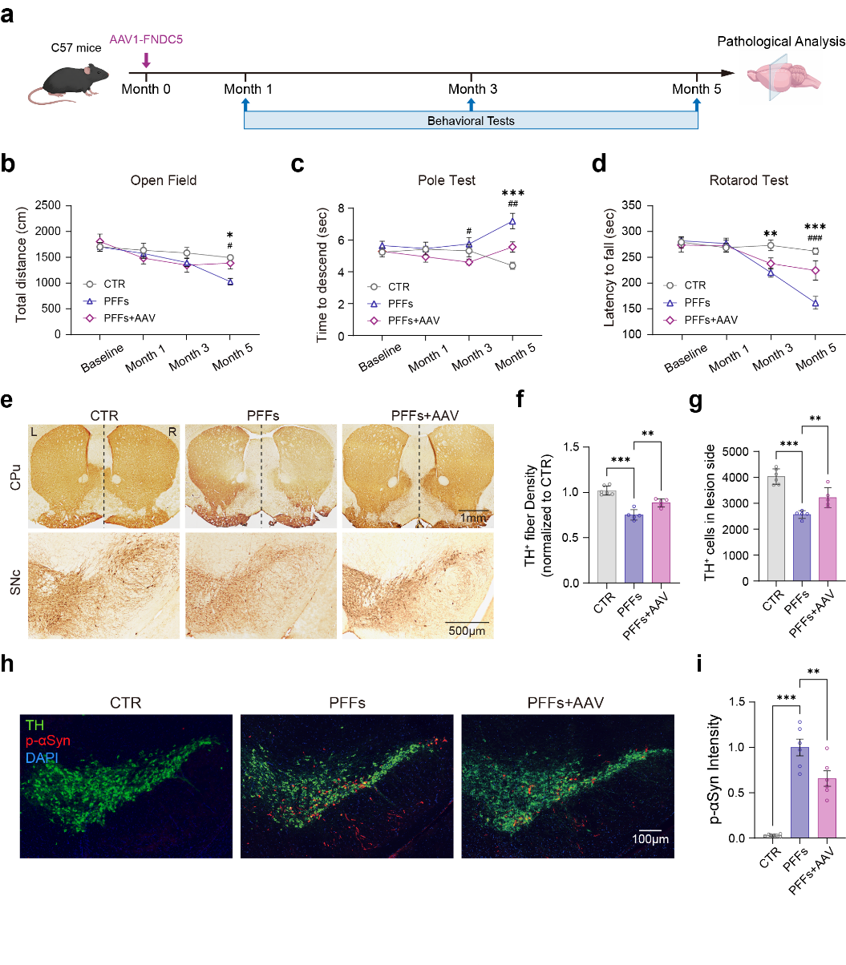
Supplementary Figure 1. Representative electron microscopy images of αSyn PFFs before being sonicated, αSyn PFFs after being sonicated and αSyn PFF after ATTO-488 labeling. Scale bar, 100 nm.
Supplementary Figure 2. Irisin overexpression ameliorates motor deficits and PD pathology.
a, Experimental schematic showing systemic overexpression of irisin via tail-vein injection of AAV1-FNDC5 in the αSyn PFFs mouse model. Behavioral tests were performed monthly, and mice were sacrificed for pathological analysis at 5 months after PFFs injection. b, Serum irisin levels detected using ELISA. c–e, Behavioral assessments. Motor performance was evaluated by open field test (c), pole test (d) and rotarod test (e). Data are presented as mean ± SEM, Two-way ANOVA followed by Dunnett’s post hoc test (n=6). *p < 0.05, **p < 0.01, ***p < 0.001 for PFFs vs CTR; #p < 0.05, ##p < 0.01, ###p < 0.001 for PFFs vs PFFs+AAV. f, Representative immunohistochemical staining of TH immunohistochemistry in the CPu (Scale bars, 1mm) and SNc (Scale bars, 500 μm). g, Quantification of TH-positive fiber density in the lesioned striatum. h, Quantification of TH-positive dopaminergic neurons in the lesioned SNc. i, Representative immunofluorescence images showing TH (green), p-αSyn (red), and DAPI (blue) in the SNc. Scale bars, 100 μm. j, Quantification of p-αSyn immunoreactivity in the lesioned SNc. Data are presented as mean ± SEM. Statistics were analyzed using one-way ANOVA followed by Dunnett’s post hoc test (n=5) for f,j,i. **p < 0.01, ***p < 0.001.
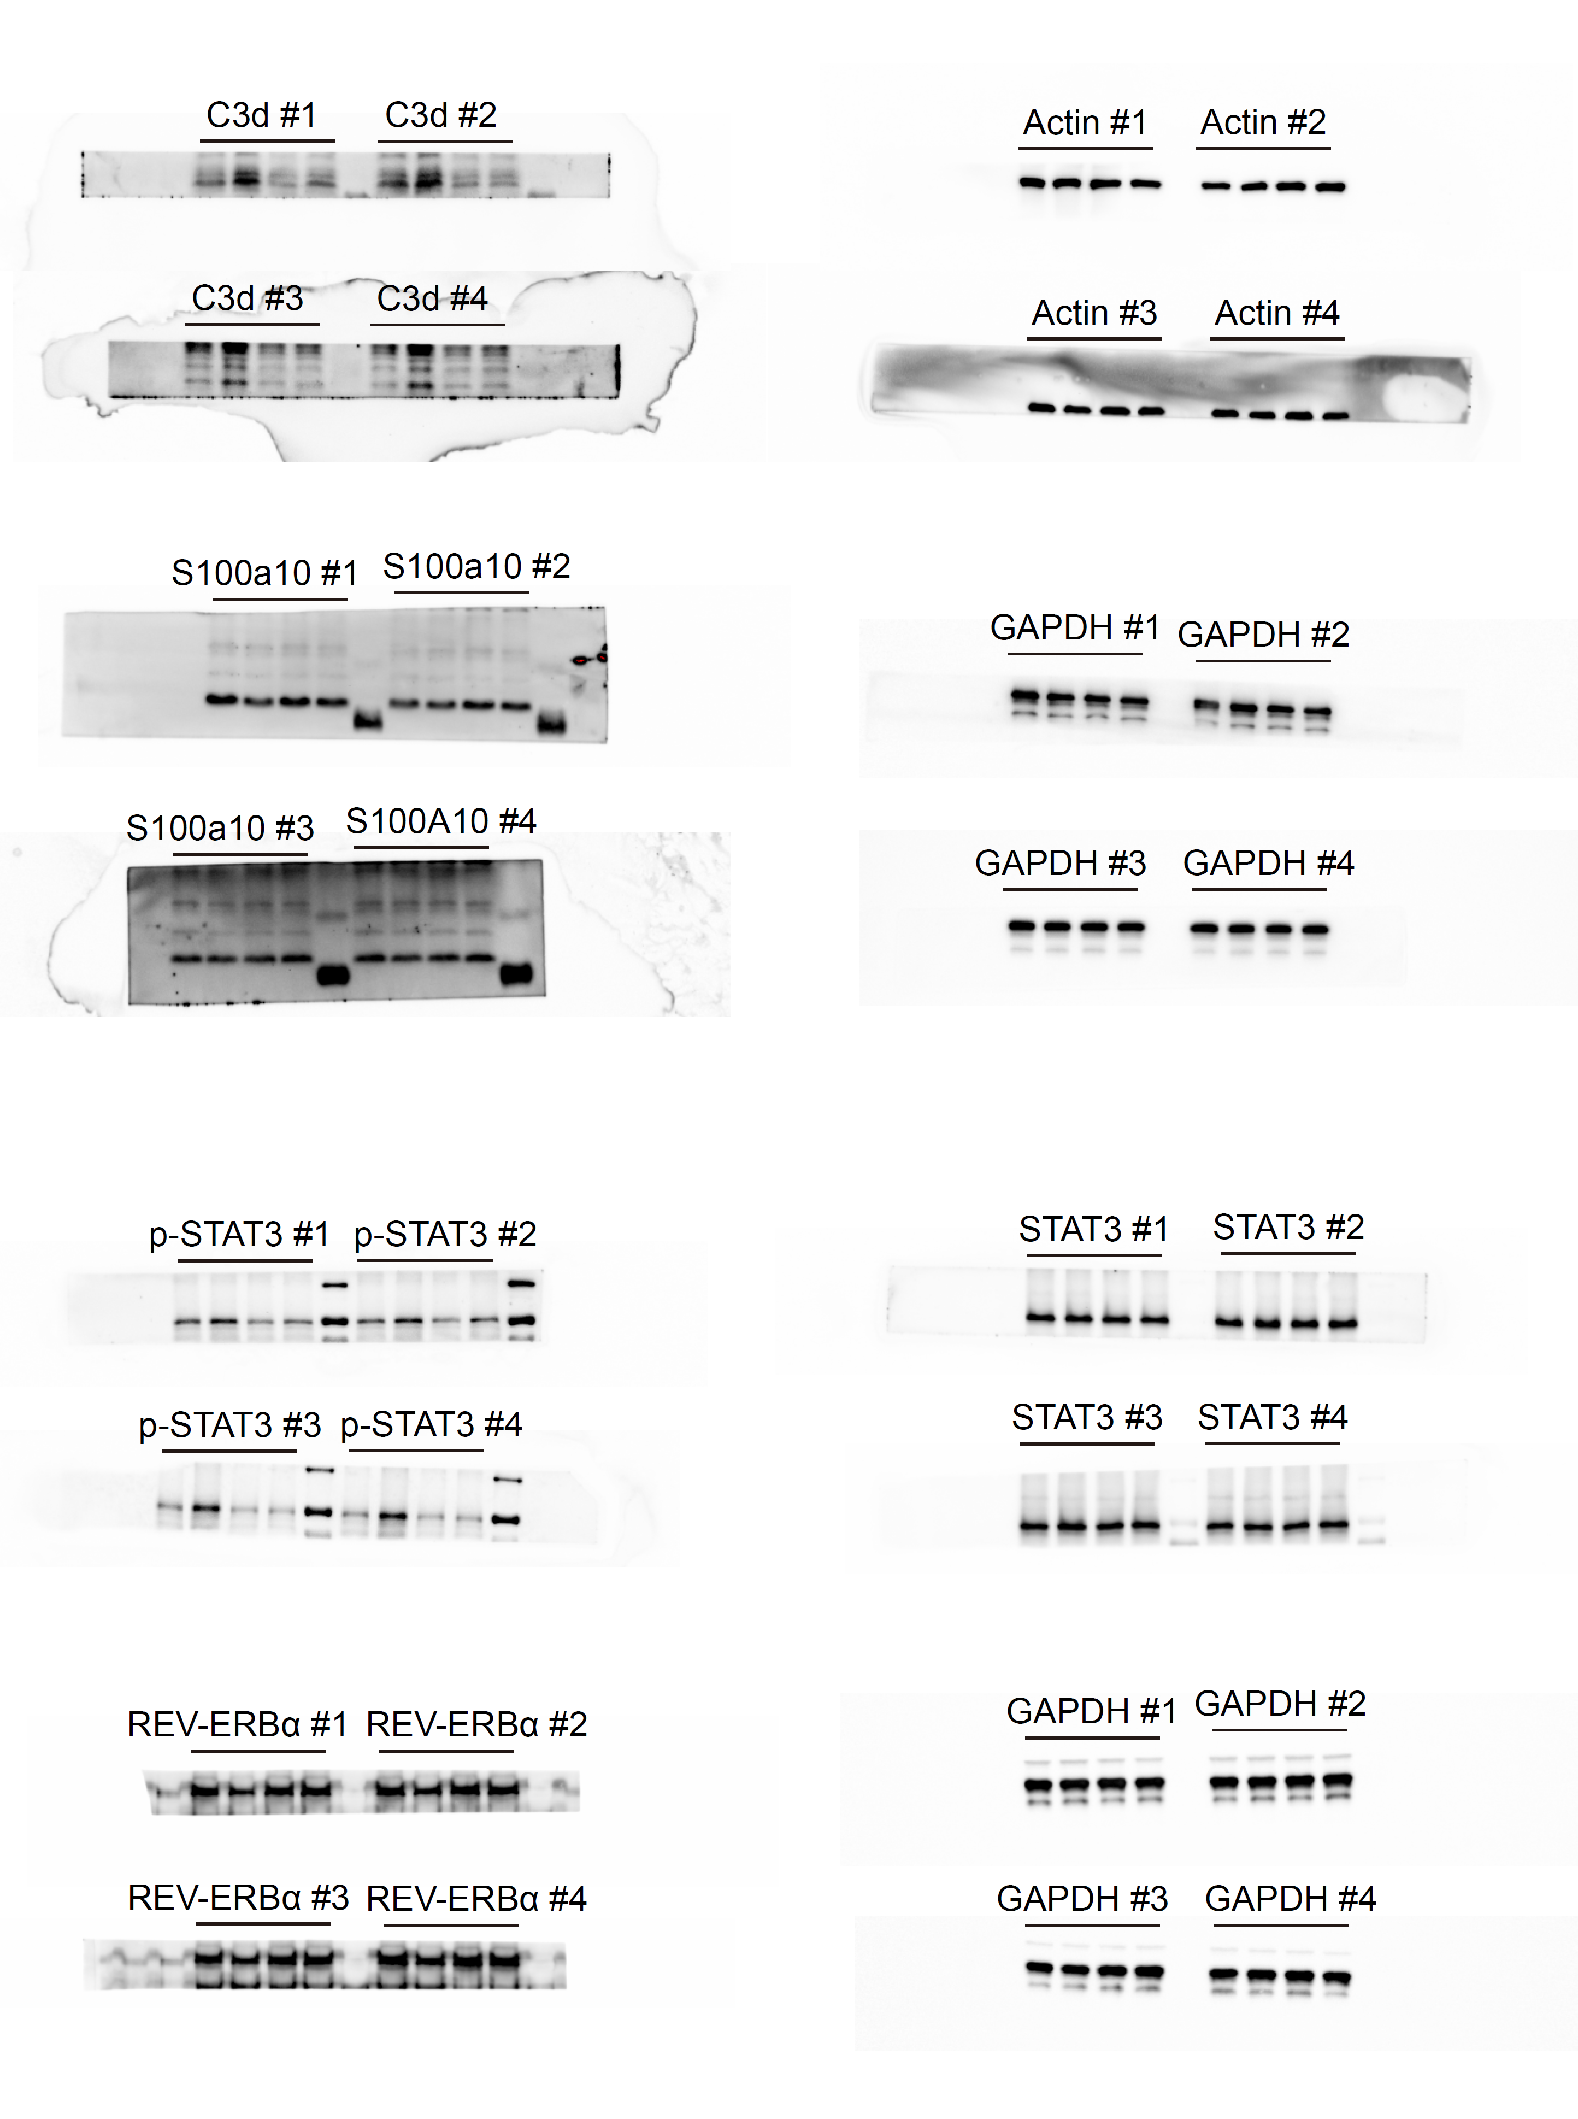
Supplementary Figure 3. Original uncropped gel images and experimental repeats in Figure 7. All the sampling are following sequences: PFFs+Irisin, PFFs, PBS+Irisin, PBS.

Supplementary tables
Supplementary Table 1. Primary antibodies used for immunostaining and western blotting.
Antibodies | Scource | Dilution rate | Identifier
Anti-TH | Sigma | 1:2000 | T1299
Anti-p-αSyn (Ser129) | Abcam | 1:500 | ab51253
Anti-AQP4 | CST | 1:1000 | 59678
Anti-CD31 | R&D Systems | 1:100 | AF3628
Anti-GFAP-Cy3 | Sigma | 1:500 | C9205
Anti-GFAP | Wako | 1:500 | 018-27283
Anti-C3d | R&D Systems | 1:200 | AF2655
Anti-S100a10 | Thermo | 1:500 | PA5-95505
Anti-p-STAT3 | CST | 1:1000 | 9145
Anti-STAT3 | CST | 1:1000 | 9139
Anti-β-actin | Sigma | 1:10000 | A3854
Anti-GAPDH | Proteintech | 1:20000 | 60004-1

