Supplementary Materials
Cost-Effectiveness of Virtual Patient Integration in Dermatology Education:
Evidence for Precision Education by Learner Expertise
Contents
Supplementary Table S1. Learning Outcomes Stratified by Baseline Knowledge Level
Supplementary Table S2. Process Measures: Cognitive Load and Critical Thinking (FC+VP Period, N = 161)
Supplementary Figure S1. Participant Flow Diagram
Supplementary Figure S2. Incremental Cost-Effectiveness Ratio (ICER) by Training Level

Supplementary Table S1. Learning Outcomes Stratified by Baseline Knowledge Level
Baseline Knowledge Level | Measure | FC | FC+VP | p-value
Low (≤ 40%) | n | 49 | 50
 | Cohen's d | 7.07 | 6.93
 | Incremental Δd | — | −0.14
 | Achievement rate (%) | 95.9 | 100.0 | .466
Medium (40–60%) | n | 52 | 83
 | Cohen's d | 0.00ᵃ | 0.00ᵃ
 | Incremental Δd | — | 0.00
 | Achievement rate (%) | 100.0 | 97.6 | .692
High (> 60%) | n | 30 | 28
 | Cohen's d | 0.00ᵃ | 0.00ᵃ
 | Incremental Δd | — | 0.00
 | Achievement rate (%) | 100.0 | 100.0 | 1.000
Note. FC = Flipped Classroom; FC+VP = Flipped Classroom with Virtual Patients; Δd = incremental effect size (FC+VP minus FC). ᵃCohen's d = 0.00 due to ceiling effects—in medium and high baseline strata, all or nearly all students achieved maximum or near-maximum post-test scores, limiting score variability needed to calculate meaningful effect sizes.

Supplementary Table S2. Process Measures: Cognitive Load and Critical Thinking (FC+VP Period, N = 161)
Measure | Items | Mean (SD) | Cronbach α | r with Progress | Regression β (SE) | p-value
Critical Thinking Disposition (CT) | 6 | 5.12 (0.89) | .933 | .342** | 0.98 (1.15) | .421
Intrinsic Cognitive Load (ICL) | 2 | 4.23 (1.05) | .700 | .089 | −0.42 (1.04) | .687
Extraneous Cognitive Load (ECL) | 3 | 3.18 (1.23) | .867 | −.156* | −0.35 (0.57) | .542
Germane Cognitive Load (GCL) | 3 | 5.48 (0.76) | .839 | .521*** | 3.96 (1.62) | .015
Note. All measures assessed in FC+VP period only (N = 161) using 7-point Likert scales (1 = strongly disagree, 7 = strongly agree). Cronbach's α indicates internal consistency reliability (α ≥ .70 considered acceptable). Correlation coefficients (r) from Pearson correlation analysis with learning progress (post-test minus pre-test score). Regression coefficients (β) and standard errors (SE) from multiple linear regression controlling for all four cognitive process measures simultaneously (R² = .271). *p < .05, **p < .01, ***p < .001.

Supplementary Figure S1. Participant Flow Diagram.
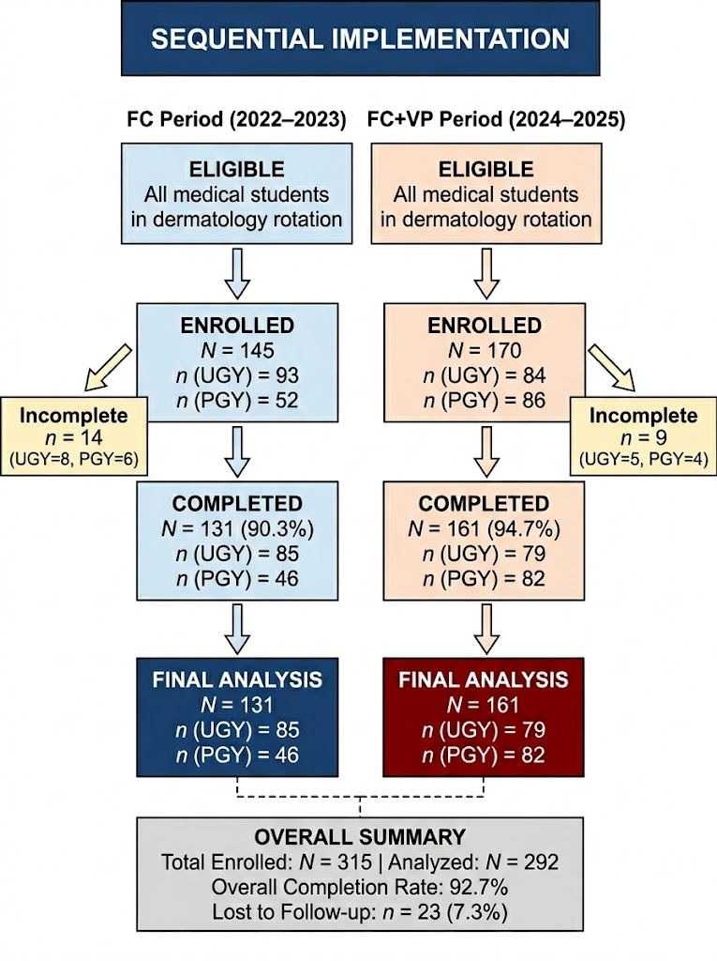
Sequential implementation study comparing flipped classroom (FC, 2022–2023) versus FC with virtual patients (FC+VP, 2024–2025). FC period: 145 enrolled, 131 completed (90.3% completion rate; n = 14 incomplete [UGY = 8, PGY = 6]). FC+VP period: 170 enrolled, 161 completed (94.7% completion rate; n = 9 incomplete [UGY = 5, PGY = 4]). Overall: 292/315 (92.7%) completed all assessments. Completion rates did not differ across training levels (UGY: 92.7%; PGY: 92.8%; χ²(1) = 0.001, p = .975). Incomplete records defined as failure to complete both pre-test and post-test assessments, or missing questionnaire data; these were excluded from analysis. UGY = undergraduate medical students (fifth-year clinical clerkship, 2-week rotations); PGY = postgraduate year 1–2 residents (4-week rotations).

Supplementary Figure S2. Incremental Cost-Effectiveness Ratio (ICER) by Training Level.
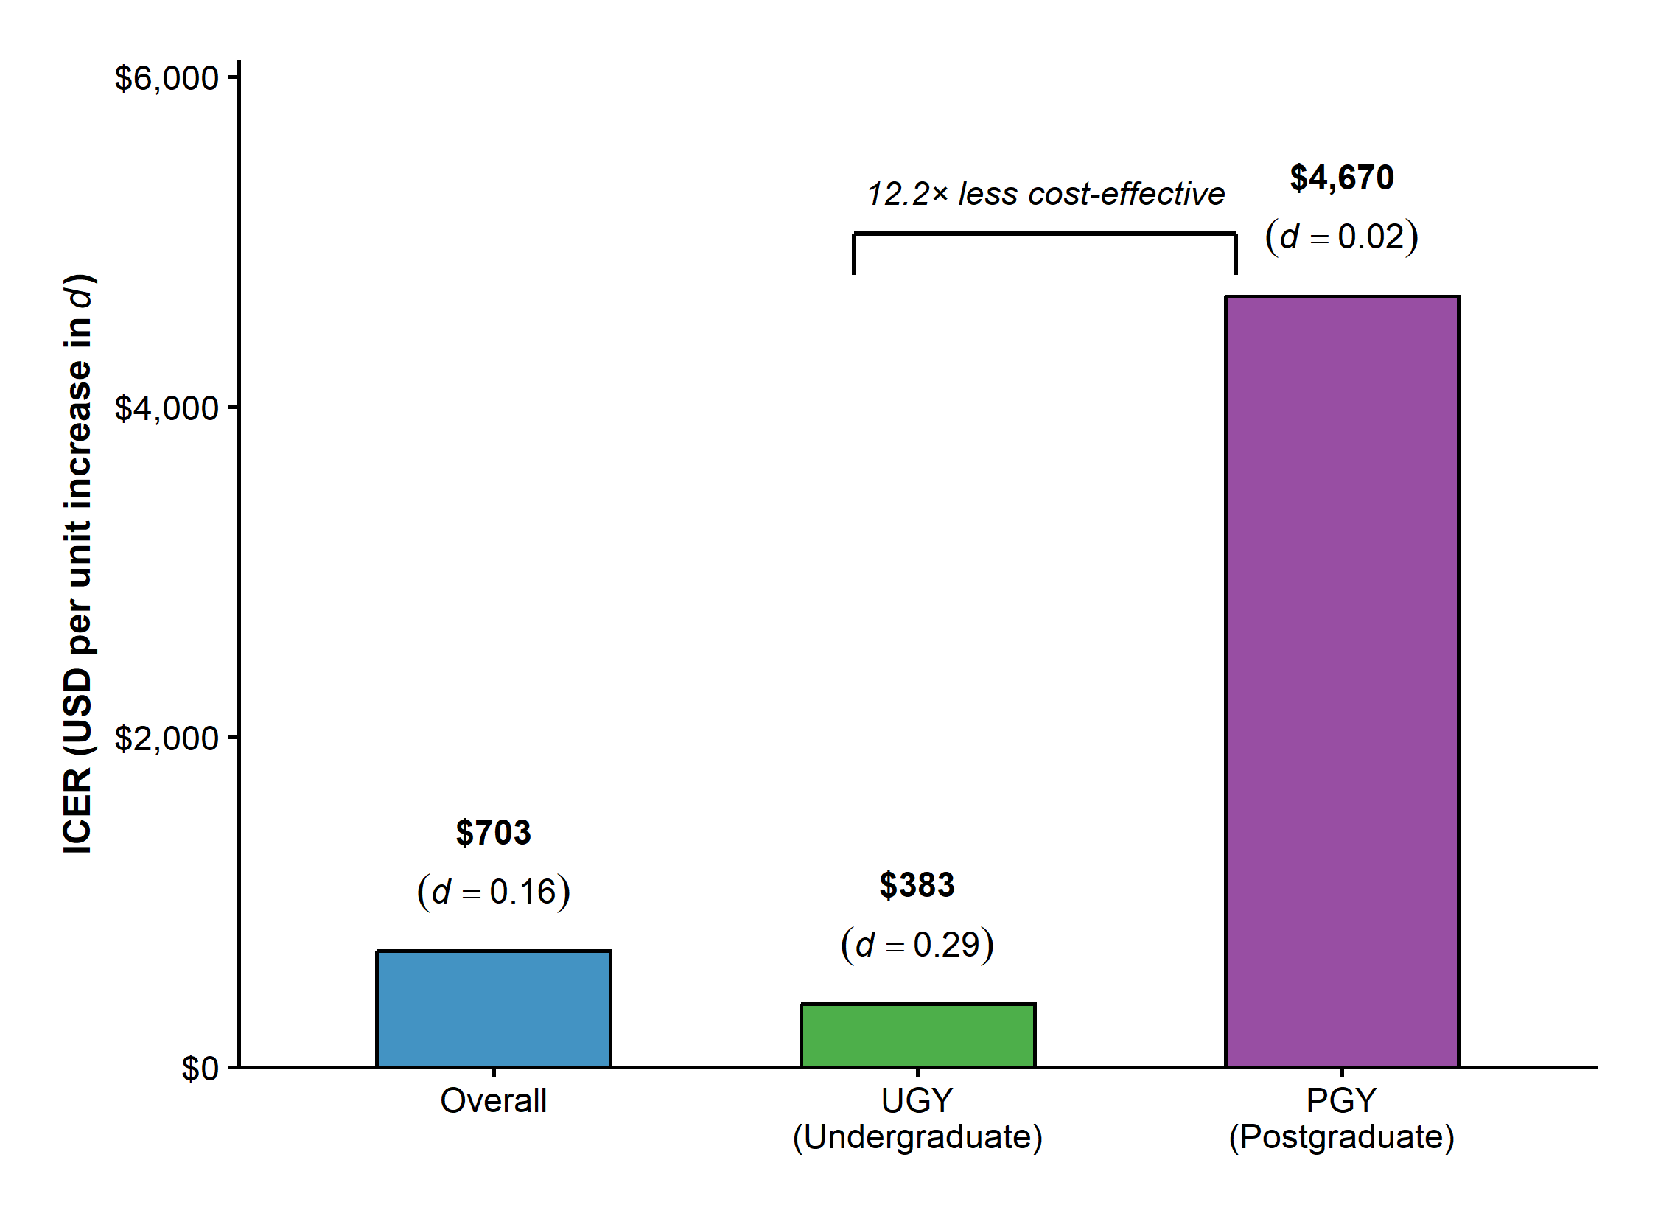
Bar chart displaying ICER (USD per unit increase in Cohen's d effect size) for virtual patient integration across three comparison groups: overall (N = 292), undergraduate students (UGY; n = 164), and postgraduate residents (PGY; n = 128). FC+VP required $163 per student versus $53 for FC (3.08-fold higher investment; incremental cost = $110 per student). ICER = [FC+VP cost per student − FC cost per student] ÷ [Cohen's d (FC+VP) − Cohen's d (FC)]. Overall ICER = $703 (Δd = +0.16); UGY ICER = $383 (Δd = +0.29, universal achievement); PGY ICER = $4,670 (Δd = +0.02, no change in achievement rates). The 12.2-fold ICER differential indicates virtual patient integration provides substantially more cost-effective incremental benefit for novice undergraduate learners than for advanced postgraduate residents who achieve comparable educational outcomes through the simpler flipped classroom approach.

