Hydrodynamic properties of plasmid DNA from physical and ionic treatment influence E. coli transform

Achilles E. Espaldon ^{a, b, c} *, Stephen G. Sabinay ^{d}, Ignacio A. Catelo ^{e}, Noel Peter B. Tan ^{a, b}

ª Center for Advanced New Materials, Engineering, and Emerging Technologies (CANMEET), University of San Agustin, Iloilo City, Philippines
^{b} Department of Chemical Engineering, University of San Agustin, Iloilo City, Philippines
^{c} Gregor Mendel Research Laboratories, University of San Agustin, Iloilo City, Philippines
^{d} West Visayas State University, Iloilo City, Philippines
^{e} Department of Human Anatomy, Pamantasan ng Lungsod ng Maynila, Intramuros, Metro Manila, Philippines

* Corresponding author:
Achilles E. Espaldon
Mailing address:
Center for Advanced New Materials, Engineering, and Emerging Technologies (CANMEET), University of San Agustin, 5000 General Luna St.
Iloilo City, Philippines
E-mail: aeespaldon@gmail.com
Supplementary information

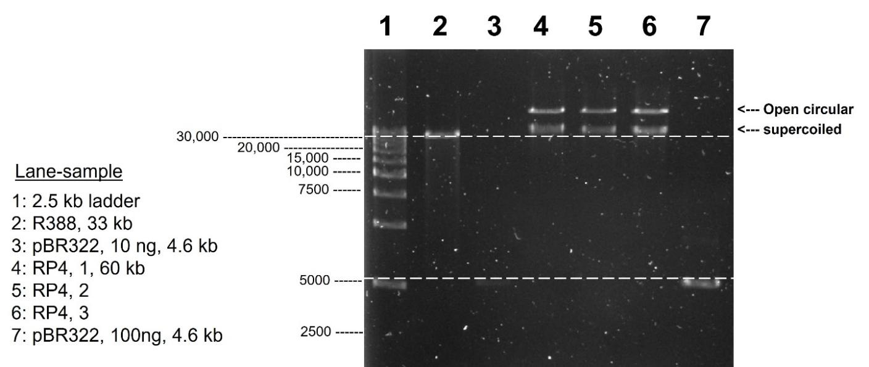
Fig S1. Agarose gel image of RP4, R388 and pBR322 plasmids.

Table S1 Measure of dispersion via range of sizes and SDI peaks for the DLS measurement (RP4)
 | D_{H} range  (max and min. values), nm | SDI* Peaks, % contribution
BB-20 | 75.7 (108-32.3) | 152 nm (55%), 2396 nm. (44%)
BB-10 | 126.2 (169.9 - 43.7) | 155 nm (45%), 1624 nm. (55%)
N | 47.6 (79.9 - 32.3) | 70 nm (14%), 460 nm. (84%)
MT-0.3 | 44.8 (68.7 - 23.9) | 89 nm (23%), 518 nm. (74%)
MT-2 | 19.24 (32.3 – 13.1) | 163 nm (59%), 2699 nm. (25%)
MT-5 | 62.2 (79.9 - 17.7) | 134 nm (65%), 2329 nm. (32%)
*- size distribution by intensity

Table S2 Mean RT-qPCR Ct values comparison of amplified traG amplicons comparing N and BB-10 (plasmid concentration, 0.6 ng/uL, n > 3)
 |  | Mean * | SD
 | N | 19.2 | 1.196
 | BB-10 | 19.3 | 0.31
 | p value | 0.89 (not significant)
* - two-tailed paired t-test, p < 0.05

