Table 1: Detail review of soil water balance models used for studying impact of climate and land use change in water balance components.
S.N | Abbreviation of Models | Models Full Name | Impact of CC and LUC | Citation
1. | SWAT | Soil and Water Assessment Tool | For CC | (Ebrahim et al., 2020; Ebrahimi et al., 2023; Li et al., 2014; Senent-Aparicio et al., 2024)
2. | SWAT+ | Soil and Water Assessment Tool Plus | Both CC and LUC | (Chandra and Sahoo, 2024; Mohsenifard et al., 2023; Oliver et al., 2024; Tola and Deyassa, 2024)
3. | HELP | Hydrologic Evaluation of Landfill Performance | Both CC and LUC | (Andaryani et al., 2022; Soundala and Saraphirom, 2022)
4. | WAVES | Wealth Accounting and the Valuation of Ecosystem Services | Both CC and LUC | (Crosbie et al., 2012; Tan et al., 2023; Van Huijgevoort et al., 2020)
5. | WETSPASS | Water and Energy Transfer Between Soil, Plants, and Atmosphere under quasi-Steady State | Both CC and LUC | (Abdirahman et al., 2024; Chuko and Abdissa, 2023; Neupane et al., 2023; Waiyasusri et al., 2024)
6. | BILAN | Water Balance Accounting Model | For CC | (Pekárová et al., 2026; Hu et al., 2019; Stanislav Horáček et al., 2008)
7. | HYDROBAL | Hydrological Balance model | For CC | (Touhami et al., 2015; Dubois et al., 2022; Waco and Taylor, 2010)
7. | SWAT-MODFLOW | SWAT connects to the Modular Flow (MODFLOW) | Both CC and LUC | (Seibert et al., 2024; Feng et al., 2024; Jarsja et al., 2020; Abd-Elaty et al., 2019)
8. | MIKE-SHE | Modular Integrated Knowledge Environment-Systeme Hydrologique Européen | Both CC and LUC | (GarcÃ­a et al., 2018; Karim et al., 2023; Nguyen-Ngan et al., 2024; Rasmussen et al., 2023; Seidenfaden et al., 2022)
9. | SWAT-HYDRUS-1D | SWAT links to Hydration and Unsaturated Flow in Soil – 1 Dimension (HYDRUS-1D) | Both CC and LUC | (Amanambu et al., 2020; Holman et al., 2012; Patle et al., 2018; Yoshioka et al., 2016)
10. | HELP-FEFLOW | HELP connects to Finite Element Subsurface Flow (FEFLOW) | Both CC and LUC | (Epting et al., 2022; Kovaics and Jakab, 2021; Lam et al., 2021; Paradis et al., 2016)
11. | SWAT-MT3DMS | SWAT connects with the Modular Three-Dimensional Multi-Species Transport (MT3DMS) | Both CC and LUC | (Ngo et al., 2024; Seibert et al., 2024; Lyra et al., 2024b; Asadi et al., 2023; Daniel et al., 2022; Shrestha et al., 2020)
12. | SWAT-MODFLOW-SEAWAT | SWAT-MODFLOW connects to Seawater and Fresh Water Transport (SEAWAT) | Both CC and LUC | (Abd-Elaty et al., 2023; Almazan-Benitacz et al., 2024; Lyra et al., 2024a; Musallam et al., 2023; Tiwari et al., 2024)
13. | SWAT-MODFLOW-SUTRA | SWAT-MODFLOW relates to Saturated–Unsaturated Transport (SUTRA) | Both CC and LUC | (Bremer et al., 2021; Chun et al., 2018; Larocque et al., 2019; Venetsanou et al., 2016; Zeydalinejad and Nassery, 2023)
14. | SWAT-MODFLOW-WEAP-AHP/TOPSIS | MCDMs are integrated into the SWBs-NHMs along with the Water Evaluation and Planning (WEAP) model | Both CC and LUC | (Hanifehlou et al., 2022; Moumane et al., 2021; Mundetia et al., 2024; Paul and Roy, 2024)

Table 2: Type of data input with their sources for intended use in the study.
Input Data | Description | Sources | Use in SWAT+
Topography | DEM 3 arc-second global coverage (90 m spatial resolution) | Using Open Topography DEM Downloader plugin in QGIS and downloaded from https://ecat.ga.gov.au/geonetwork/ srv/eng/catalog.search#/metadata/75990. | Watershed delineation
Soil | 90 m resolution soil properties maps of Australia | https://esoil.io/TERNLandscapes/Public/Pages/  SLGA/GetData-COGSDataStore.html. | HRU definition
Land use change | LUC maps grid cell resolution of 0.01 degrees (~1.1 km) of Australia under CC. | https://data.csiro.au/collection/csiro:15111 | HRU definition and simulation with LUC data.
Climate change | CC maps 5 km gridded data projections from CMIP5 GCMs for Australia. | https://data-cbr.csiro.au/thredds/catalog/catch_all/oa-aus5km/Climate_Change_in_Australia_User_Data/ Application_Ready_Data_Gridded_Daily/catalog.html. | Input data for simulation
Reanalysis river discharge | Stream flow data (2012-2025) for CBRB. | https://water-monitoring.information.qld.gov.au/ mobtext/basins/BALONNE_COND.htm. | Model calibration and validation
Reanalysis crop yield | Crop yield data (2012-2025) for MDRB. | https://www.agriculture.gov.au/abares/research-topics/agricultural-outlook/australian-crop-report/december-2025. | Model calibration and validation

Table 3: Crop management schedule in land-use management systems of SWAT+ model.

S.N | crop | operation | rot_yr | month | day | hu_frac | operation | auto_sched  _till | auto_sched  _ fertile/harvest
1 | wwht150 | plant | 1 | 6 | 20 | 0 |  | mulch_till_1 | fert_sprg_side
 | Represent Winter Wheat as winter cereals | harvest and kill | 1 | 0 | 0 | 0.86 | grain
 |  | irrm | 1 | 0 | 0 | 0.35 | sprikler_high
2 | swht110 | plant | 1 | 10 | 15 | 0 |  | mulch_till_2 | fert_stess_test
 | Represent Spring Wheat as summer cereals | harvest and kill | 1 | 0 | 0 | 1 | grain
 |  | irrm | 1 | 0 | 0 | 0.45 | sprikler_high
3 | lent | plant | 1 | 5 | 20 | 0 |  | no_till | fert_rot_1
 | Represent lentil as legumes | harvest and kill | 1 | 0 | 0 | 0.95 | grain
 |  | irrm | 1 | 0 | 0 | 0.5 | sprikler_med
4 | soyb105 | plant | 1 | 11 | 15 | 0 |  | no_till | fert_rot_1
 | Represent Soybean as oil seeds | harvest and kill | 1 | 0 | 0 | 0.86 | grain
 |  | irrm | 1 | 0 | 0 | 0.35 | sprikler_high
5. | cotp155 | plant | 1 | 10 | 15 | 0 |  | mulch_till_2 | fert_rot_1
 | Represent Cotton as annual crop | harvest and kill | 1 | 0 | 0 | 1.1 | cotton_picker
 |  | irrm | 1 | 0 | 0 | 0.5 | sprikler_high
6 | corn110 | plant | 1 | 2 | 10 | 0 | corn | mulch_till_2 | fert_rot_1
 | Represent Corn for silage in dairy | harvest and kill | 1 | 0 | 0 | 0.85 | grain
 |  | irrm |  | 0 | 0 | 0.35 | sprikler_high
7. | clvr | plant | 1 | 3 | 10 | 0 |  | no_till | fert_stess_test, hay_cutting
 | Represent Clover as hay | harvest and kill | 1 | 0 | 0 | 0.86 | hay_cut_high
 |  | irrm | 1 | 0 | 0 | 0.25 | sprinkler_med
8 | rngb_suhf | plant | 1 | 2 | 10 | 0 |  | no_till | graze_summer
 | Represent pasture for beef | graze | 1 | 0 | 0 | 0.65 | sheep_high
 |  | irrm | 1 | 0 | 0 | 0.3 | sprinkler_med
9 | rngb_sums | plant | 1 | 1 | 15 | 0 |  | no_till | graze_summer
 | Represent pasture for sheep | graze | 1 | 0 | 0 | 0.60 | beef_high
 |  | irrm | 1 | 0 | 0 | 0.25
10. | frst_suhf | plant | 1 | 1 | 1 | 0 |  | no_till | forest_cut
 | Represent as not modelled area includes forest land, bare and residential area. | harvest | 3 | 6 | 20 | 0 | forest_cut
11. | cedr | plant | 1 | 1 | 1 | 0 |  | no_till | forest_cut
 | Represent plantation area for carbon stocking | harvest | 3 | 6 | 15 | 0 | forest_cut

Table 4: Setup of streamflow and crop parameters for calibration and validation of the SWAT + model.

S.N | Stream Flow Parameters | Description | Change Type | Range for Change
1. | cn2.hru | Condition II curve number | percent | ±30
2. | cn3_swf.hru | Curve number adjustment factor | percent | ±30
3. | ovn.hru | Manning’s ‘n’ value for overland flow | replace | 0.01-30
4. | alpha.aqu | Lag factor for GW recession curve | replace | 0.1-1
5. | flo_min.aqu | Threshold depth of water in shallow aquifer required for return flow to occur. | replace | 0.1-50
6. | revap_min.aqua | Threshold depth of water in shallow aquifer required for ‘revap’ to occur. | replace | 0.1-50
7. | revap_co.aqua | Groundwater revap coefficient | replace | 0.02-0.2
8. | esco.hru | Soil evaporation compensation factor | replace | 0.01-1
9. | canmax.hru | Maximum canopy storage (mm H₂O) | replace | 1-100
10. | perco.hru | Percolation coefficient bottom soil layer due to an impermeable layer | replace | 0.1-1
11. | awc.sol | available water capacity of soil layer | percent | ±30
12. | k.sol | saturated hydraulic conductivity of soil layer (mm/hr). | percent | ±30
13. | z.sol | depth of bottom of soil layer (mm) | percent | ±30
14. | alb.sol | Moist soil albedo | replace | 0.01-0.25
Crop Parameters
1. | epco.hru | Plant uptake compensation factor | replace | 0.01-1.0
2. | lai_pot.hru | Potential maximum leaf area index | replace | 0.01-12.0
3. | biomix.hru | Biological mixing efficiency | replace | 0.01-1.0
4. | harv_idx.hru | Harvest Index | replace | 0.01-0.95

Table 5: The most influential model parameters distinguished from the multisite approach.

S.N | Stream Flow Parameters | Order of Sensitivity based on stream flow and rank | Order of Sensitivity based on crop yield and rank | Fitted Value for stream flow | Fitted Value for crop yield
1. | cn2.hru | 1.04778 (1) | -0.034938 (17) | 30.67 | +20.481
2. | cn3_swf.hru | 0.01378 (3) | -0.000142 (14) | 25.345 | -0.030
3. | ovn.hru | 0.00000 (10) | 0.000014 (9) | 2.567 | 10.536
4. | alpha.aqu | 0.00781 (4) | 0.0000008 (12) | 0.4 | 0.259
5. | flo_min.aqu | -0.000197 (14) | 0.0000023 (11) | 5.234 | 50.00
6. | revap_min.aqua | -0.000219 (16) | 0.0000085 (10) | 41.654 | 35.365
7. | revap_co.aqua | 0.00004 (6) | 0.00000025 (13) | 0.19 | 0.116
8. | esco.hru | -0.00081 (18) | 1.368179 (1) | 0.81 | 1.000
9. | canmax.hru | 0.24022 (2) | 0.124498 (2) | 45.890 | 1.000
10. | perco.hru | -0.000011 (13) | 0.000087 (7) | 0.51 | 0.723
11. | awc.sol | -0.000481 (17) | -0.023910 (17) | -0.178 | -4.677
12. | k.sol | -0.000005 (12) | -0.0008367 (15) | 5.89 | 0.763
13. | z.sol | -0.000218 (15) | -0.0152088 (16) | 0.178 | -30.000
14. | alb.sol | 0.00001 (7) | 0.000045 (8) | 0.04 | 0.229
Crop Parameters
1. | epco.hru | 0.00000 (9) | 0.0054678 (5) | 0.4
2. | lai_pot.hru | 0.00000 (8) | 0.0123456 (4) | 3.567 | 6.563
3. | biomix.hru | 0.00007 (5) | 0.085478 (3) | 0.41 | 0.579
4. | harv_idx.hru | 0.00000 (11) | 0.000234 (6) | 0.26 | 0.191
Table 6: Performance indicators before and after calibration and validation period for stream flow and crop yield.
Performance Indicators Before Calibration
S.N | Channel and Basin Name | Observation Station | KGE | NSE | MSE | RMSE | PBIAS | MARE
1 | 75-main ch. (SF) | Creek station Doog Gill | 0.43 | 0.75 | 106.38 | 10.31 | 33.33 | 0.33
2 | 72-main ch. (SF) | River Station Cotwood | 0.42 | 0.60 | 102.56 | 10.62 | 33.33 | 0.33
3 | 31-branch ch. (SF) | River station Bedarra | 0.49 | 0.66 | 98.67 | 7.36 | 37.50 | 0.38
4 | 38-branch ch. (SF) | River station Chinchilla | 0.46 | 0.74 | 56.57 | 3.67 | 38.76 | 0.37
5 | 39-branch ch. (SF) | Creek Charly Chinchilla | 0.44 | 0.72 | 13.34 | 1.16 | 37.50 | 0.37
6 | 34-branch ch. (SF) | River sation Birgalaw | 0.47 | 0.76 | 27.60 | 5.26 | 37.50 | 0.37
7 | Basin (CY) | Northern part of QLD | 0.45 | 0.76 | 13.41 | 1.85 | 16.28 | 0.37
Performance Indicators After Calibration
S.N | Channel and Basin Name | Observation Station | KGE | NSE | MSE | RMSE | PBIAS | MARE
1 | 75-main ch. (SF) | Creek station Doog Gill | 0.87 | 0.98 | 0.01 | 0.01 | 7.58 | 0.11
2 | 72-main ch. (SF) | River station Cotwood | 0.90 | 0.98 | 2.26 | 2.06 | 6.15 | 0.11
3 | 31-branch ch. (SF) | River station Bedarra | 0.94 | 0.99 | 1.88 | 1.37 | 3.65 | 0.11
4 | 38-branch ch. (SF) | River station Chinchilla | 0.89 | 0.83 | 0.57 | 0.76 | 0.46 | 0.28
5 | 39-branch ch. (SF) | Creek Charly Chinchilla | 0.87 | 0.92 | 0.30 | 0.54 | 6.56 | 0.23
6 | 34-branch ch. (SF) | River sation Birgalaw | 0.96 | 0.98 | 1.42 | 1.19 | 1.57 | 0.17
7 | Basin (CY) | Northern part of QLD | 0.88 | 0.86 | 0.69 | 0.83 | 8.15 | 0.08
Performance Indicators during Validation
S.N | Channel and Basin Name | Observation Station | KGE | NSE | MSE | RMSE | PBIAS | MARE
1 | 75-main ch. (SF) | Creek station Doog Gill | 0.95 | 0.97 | 0.02 | 0.14 | 6.06 | 0.13
2 | 72-main ch. (SF) | River Station Cotwood | 0.86 | 0.98 | 3.37 | 3.20 | 5.06 | 0.12
3 | 31-branch ch. (SF) | River station Bedarra | 0.98 | 0.98 | 2.63 | 1.62 | 1.63 | 0.12
4 | 38-branch ch. (SF) | River station Chinchilla | 0.94 | 0.98 | 0.04 | 0.19 | 1.61 | 0.11
5 | 39-branch ch. (SF) | Creek Charly Chinchilla | 0.84 | 0.98 | 0.06 | 0.25 | 4.96 | 0.12
6 | 34-branch ch. (SF) | River station Birgalaw | 0.97 | 0.98 | 0.91 | 0.95 | 1.80 | 0.11
7 | Basin (CY) | Northern part of QLD | 0.86 | 0.87 | 0.41 | 0.85 | 6.28 | 0.07
Table 7: Maximum and Minimum temperature variation within Sub-basin of CBRB in baseline and future periods.
Period | tmax_Maranoa | tmax_Condamine | tmax_Balonne | tmax_Walam | chg_Maranoa | chg_Condamine | chg_Balonne | chg_Walam
Reference | 26.51 | 26.45 | 26.82 | 26.66 | 0 | 0 | 0 | 0
2030s | 27.79 | 27.56 | 27.97 | 27.73 | 1.36 | 1.11 | 1.21 | 1.07
2040s | 28.09 | 27.86 | 28.27 | 28.04 | 1.66 | 1.41 | 1.51 | 1.37
2050s | 28.39 | 28.16 | 28.57 | 28.34 | 1.96 | 1.71 | 1.81 | 1.68
2060s | 28.69 | 28.46 | 28.87 | 28.64 | 2.26 | 2.02 | 2.11 | 1.98
2070s | 28.99 | 28.76 | 29.17 | 28.94 | 2.56 | 2.32 | 2.41 | 2.28
2080s | 29.29 | 29.06 | 29.47 | 29.24 | 2.86 | 2.59 | 2.71 | 2.58
2090s | 29.59 | 29.36 | 29.77 | 29.77 | 3.16 | 2.92 | 3.01 | 3.11
2100s | 29.89 | 29.67 | 30.07 | 30.07 | 3.46 | 3.22 | 3.31 | 3.41
Period | tmin_Maranoa | tmin_Condamine | tmin_Balonne | tmin_Walam | chg_Maranoa | chg_Condamine | chg_Balonne | chg_Walam
Reference | 15.95 | 16.00 | 16.28 | 16.47 | 0.00 | 0.00 | 0.00 | 0.00
2030s | 17.28 | 17.34 | 17.62 | 17.80 | 1.33 | 1.35 | 1.34 | 1.33
2040s | 17.57 | 17.63 | 17.91 | 18.09 | 1.62 | 1.64 | 1.63 | 1.62
2050s | 17.86 | 17.92 | 18.20 | 18.38 | 1.92 | 1.93 | 1.92 | 1.92
2060s | 18.15 | 18.21 | 18.49 | 18.67 | 2.21 | 2.22 | 2.21 | 2.21
2070s | 18.44 | 18.51 | 18.79 | 18.96 | 2.50 | 2.51 | 2.51 | 2.50
2080s | 18.73 | 18.80 | 19.08 | 19.25 | 2.79 | 2.80 | 2.80 | 2.79
2090s | 19.03 | 19.09 | 19.37 | 19.54 | 3.08 | 3.09 | 3.09 | 3.08
2100s | 19.32 | 19.38 | 19.66 | 19.83 | 3.37 | 3.38 | 3.38 | 3.37
Table 8: Maximum seasonal temperature variation within Sub-basin of CBRB in baseline and future periods.
Period | Season | tmax_Maranoa | chg_Maranoa | tmax_Condamine | chg_Condamine | tmax_Balonne | chg_Balonne | tmax_Walam | chg_Walam
Reference | Summer | 31.93 | 0.00 | 31.73 | 0.00 | 32.39 | 0.00 | 32.85 | 0.00
Reference | Autumn | 27.24 | 0.00 | 27.73 | 0.00 | 27.89 | 0.00 | 27.88 | 0.00
Reference | Winter | 19.17 | 0.00 | 19.26 | 0.00 | 19.00 | 0.00 | 18.65 | 0.00
Reference | Spring | 27.94 | 0.00 | 27.49 | 0.00 | 28.34 | 0.00 | 27.66 | 0.00
2030s | Summer | 33.40 | 1.47 | 32.96 | 1.23 | 33.49 | 1.10 | 33.99 | 1.14
2030s | Autumn | 27.97 | 1.30 | 28.33 | 1.02 | 28.43 | 1.13 | 28.53 | 1.05
2030s | Winter | 20.44 | 1.27 | 20.30 | 1.04 | 20.30 | 1.30 | 19.67 | 1.02
2030s | Spring | 29.34 | 1.40 | 28.64 | 1.16 | 29.64 | 1.30 | 28.74 | 1.09
2040s | Summer | 33.72 | 1.78 | 33.28 | 1.55 | 33.81 | 1.42 | 34.31 | 1.45
2040s | Autumn | 28.29 | 1.62 | 28.65 | 1.35 | 28.75 | 1.46 | 28.85 | 1.37
2040s | Winter | 20.72 | 1.55 | 20.59 | 1.32 | 20.59 | 1.58 | 19.95 | 1.30
2040s | Spring | 29.62 | 1.68 | 28.92 | 1.44 | 29.92 | 1.58 | 29.02 | 1.37
2050s | Summer | 34.03 | 2.10 | 33.59 | 1.87 | 34.13 | 1.73 | 34.63 | 1.77
2050s | Autumn | 28.62 | 1.95 | 28.98 | 1.67 | 29.08 | 1.78 | 29.18 | 1.70
2050s | Winter | 21.01 | 1.83 | 20.87 | 1.61 | 20.87 | 1.87 | 20.24 | 1.58
2050s | Spring | 29.90 | 1.96 | 29.20 | 1.72 | 30.20 | 1.86 | 29.30 | 1.65
2060s | Summer | 34.35 | 2.42 | 33.91 | 2.18 | 34.44 | 2.05 | 34.94 | 2.09
2060s | Autumn | 28.94 | 2.27 | 29.30 | 1.99 | 29.40 | 2.10 | 29.50 | 2.02
2060s | Winter | 21.29 | 2.12 | 21.15 | 1.89 | 21.15 | 2.15 | 20.52 | 1.87
2060s | Spring | 30.18 | 2.24 | 29.48 | 2.00 | 30.48 | 2.14 | 29.58 | 1.93
2070s | Summer | 34.67 | 2.73 | 34.23 | 2.50 | 34.76 | 2.37 | 35.26 | 2.40
2070s | Autumn | 29.26 | 2.59 | 29.62 | 2.32 | 29.72 | 2.43 | 29.82 | 2.34
2070s | Winter | 21.57 | 2.40 | 21.44 | 2.17 | 21.44 | 2.43 | 20.80 | 2.15
2070s | Spring | 30.46 | 2.52 | 29.76 | 2.28 | 30.76 | 2.42 | 29.86 | 2.21
2080s | Summer | 34.98 | 3.05 | 34.54 | 2.82 | 35.08 | 2.68 | 35.58 | 2.72
2080s | Autumn | 29.59 | 2.92 | 29.95 | 2.64 | 30.05 | 2.75 | 30.15 | 2.67
2080s | Winter | 21.86 | 2.68 | 21.72 | 2.46 | 21.72 | 2.72 | 21.09 | 2.43
2080s | Spring | 30.74 | 2.80 | 30.04 | 2.45 | 31.04 | 2.70 | 30.14 | 2.49
2090s | Summer | 35.30 | 3.37 | 34.86 | 3.13 | 35.39 | 3.00 | 35.39 | 2.54
2090s | Autumn | 29.91 | 3.24 | 30.27 | 2.96 | 30.37 | 3.07 | 30.37 | 2.89
2090s | Winter | 22.14 | 2.97 | 22.00 | 2.74 | 22.00 | 3.00 | 22.00 | 3.35
2090s | Spring | 31.02 | 3.08 | 30.32 | 2.84 | 31.32 | 2.98 | 31.32 | 3.67
2100s | Summer | 35.62 | 3.68 | 35.18 | 3.45 | 35.71 | 3.32 | 35.71 | 2.85
2100s | Autumn | 30.23 | 3.56 | 30.59 | 3.29 | 30.69 | 3.40 | 30.69 | 3.21
2100s | Winter | 22.42 | 3.25 | 22.29 | 3.02 | 22.29 | 3.28 | 22.29 | 3.63
2100s | Spring | 31.30 | 3.36 | 30.60 | 3.12 | 31.60 | 3.26 | 31.60 | 3.95
Table 9: Minimum seasonal temperature variation within Sub-basin of CBRB in baseline and future periods.
Period | Season | tmin_Maranoa | chg_Maranoa | tmin_Condamine | chg_Condamine | tmin_Balonne | chg_Balonne | tmin_Walam | chg_Walam
Reference | Summer | 20.94 | 0.00 | 21.31 | 0.00 | 21.28 | 0.00 | 21.18 | 0.00
Reference | Autumn | 17.50 | 0.00 | 16.96 | 0.00 | 16.83 | 0.00 | 16.90 | 0.00
Reference | Winter | 9.00 | 0.00 | 9.70 | 0.00 | 10.67 | 0.00 | 11.14 | 0.00
Reference | Spring | 16.35 | 0.00 | 16.01 | 0.00 | 16.35 | 0.00 | 16.65 | 0.00
2030s | Summer | 22.38 | 1.43 | 22.76 | 1.45 | 22.68 | 1.40 | 22.61 | 1.43
2030s | Autumn | 18.83 | 1.33 | 18.31 | 1.34 | 18.23 | 1.40 | 18.23 | 1.33
2030s | Winter | 10.20 | 1.20 | 10.91 | 1.21 | 11.93 | 1.27 | 12.34 | 1.20
2030s | Spring | 17.71 | 1.37 | 17.39 | 1.38 | 17.65 | 1.30 | 18.01 | 1.37
2040s | Summer | 22.67 | 1.73 | 23.05 | 1.74 | 22.97 | 1.70 | 22.91 | 1.73
2040s | Autumn | 19.10 | 1.61 | 18.58 | 1.62 | 18.50 | 1.67 | 18.50 | 1.61
2040s | Winter | 10.50 | 1.50 | 11.22 | 1.52 | 12.24 | 1.57 | 12.64 | 1.50
2040s | Spring | 18.00 | 1.66 | 17.68 | 1.67 | 17.94 | 1.59 | 18.30 | 1.66
2050s | Summer | 22.97 | 2.03 | 23.35 | 2.04 | 23.27 | 1.99 | 23.20 | 2.03
2050s | Autumn | 19.38 | 1.88 | 18.85 | 1.89 | 18.78 | 1.95 | 18.78 | 1.88
2050s | Winter | 10.81 | 1.81 | 11.52 | 1.82 | 12.54 | 1.87 | 12.95 | 1.81
2050s | Spring | 18.29 | 1.95 | 17.97 | 1.96 | 18.23 | 1.88 | 18.59 | 1.95
2060s | Summer | 23.27 | 2.32 | 23.65 | 2.34 | 23.57 | 2.29 | 23.50 | 2.32
2060s | Autumn | 19.65 | 2.15 | 19.13 | 2.16 | 19.05 | 2.22 | 19.05 | 2.15
2060s | Winter | 11.11 | 2.11 | 11.82 | 2.12 | 12.84 | 2.18 | 13.25 | 2.11
2060s | Spring | 18.58 | 2.24 | 18.26 | 2.25 | 18.52 | 2.17 | 18.88 | 2.24
2070s | Summer | 23.56 | 2.62 | 23.94 | 2.63 | 23.86 | 2.59 | 23.80 | 2.62
2070s | Autumn | 19.92 | 2.43 | 19.40 | 2.44 | 19.32 | 2.49 | 19.32 | 2.43
2070s | Winter | 11.41 | 2.41 | 12.13 | 2.43 | 13.15 | 2.48 | 13.55 | 2.41
2070s | Spring | 18.87 | 2.53 | 18.55 | 2.54 | 18.81 | 2.46 | 19.17 | 2.53
2080s | Summer | 23.86 | 2.92 | 24.24 | 2.93 | 24.16 | 2.88 | 24.09 | 2.92
2080s | Autumn | 20.20 | 2.70 | 19.67 | 2.71 | 19.60 | 2.77 | 19.60 | 2.70
2080s | Winter | 11.72 | 2.72 | 12.43 | 2.73 | 13.45 | 2.78 | 13.86 | 2.72
2080s | Spring | 19.16 | 2.82 | 18.84 | 2.83 | 19.10 | 2.75 | 19.46 | 2.82
2090s | Summer | 24.16 | 3.21 | 24.54 | 3.23 | 24.46 | 3.18 | 24.39 | 3.21
2090s | Autumn | 20.47 | 2.97 | 19.95 | 2.98 | 19.87 | 3.04 | 19.87 | 2.97
2090s | Winter | 12.02 | 3.02 | 12.73 | 3.03 | 13.75 | 3.09 | 14.16 | 3.02
2090s | Spring | 19.45 | 3.11 | 19.13 | 3.12 | 19.39 | 3.04 | 19.75 | 3.11
2100s | Summer | 24.45 | 3.51 | 24.83 | 3.52 | 24.75 | 3.48 | 24.69 | 3.51
2100s | Autumn | 20.74 | 3.25 | 20.22 | 3.26 | 20.14 | 3.31 | 20.14 | 3.25
2100s | Winter | 12.32 | 3.32 | 13.04 | 3.34 | 14.06 | 3.39 | 14.46 | 3.32
2100s | Spring | 19.74 | 3.40 | 19.42 | 3.41 | 19.68 | 3.33 | 20.04 | 3.40
Table 10: Annual rainfall variation within Sub-basin of CBRB in baseline and future periods.
Period | rain_Maranoa | Percent_Maranoa | rain_Condamine | Percent_Condamine | rain_Balonne | Percent_Balonne | rain_Walam | Percent_Walam
Reference | 618.56 | 0 | 684.56 | 0.00 | 573.28 | 0.00 | 449.52 | 0.00
2030s | 593.90 | -4.0 | 610.89 | -10.8 | 546.51 | -4.7 | 451.95 | 0.5
2040s | 575.19 | -7.0 | 612.51 | -10.5 | 522.81 | -8.8 | 414.36 | -7.8
2050s | 578.64 | -6.5 | 627.47 | -8.3 | 532.83 | -7.1 | 440.25 | -2.1
2060s | 558.80 | -9.7 | 625.97 | -8.6 | 523.52 | -8.7 | 416.24 | -7.4
2070s | 645.55 | 4.4 | 648.00 | -5.3 | 588.64 | 2.7 | 500.24 | 11.3
2080s | 631.21 | 2.0 | 652.00 | -4.8 | 574.84 | 0.3 | 471.62 | 4.9
2090s | 631.95 | 2.2 | 620.68 | -9.3 | 559.57 | -2.4 | 482.65 | 7.4
2100s | 483.14 | -21.9 | 558.05 | -18.5 | 451.30 | -21.3 | 334.25 | -25.6
Table 11: Seasonal annual rainfall variation within Sub-basin of CBRB in baseline and future periods.
Period | Season | rain_Maranoa | Perct_Maranoa | rain_Condamine | Perct_Condamine | rain_Balonne | Perct_Balonne | rain_Walam | Perct_Walam
Reference | Summer | 79.80 | 0.00 | 87.33 | 0.00 | 66.67 | 0.00 | 48.07 | 0.00
Reference | Autumn | 52.50 | 0.00 | 55.87 | 0.00 | 50.17 | 0.00 | 44.20 | 0.00
Reference | Winter | 24.50 | 0.00 | 28.80 | 0.00 | 26.93 | 0.00 | 24.47 | 0.00
Reference | Spring | 49.37 | 0.00 | 56.17 | 0.00 | 47.33 | 0.00 | 33.07 | 0.00
2030s | Summer | 90.43 | 14.30 | 92.37 | 8.20 | 83.20 | 27.73 | 69.30 | 44.10
2030s | Autumn | 32.00 | -38.20 | 33.40 | -36.30 | 28.53 | -40.03 | 23.00 | -47.57
2030s | Winter | 18.03 | -26.00 | 16.73 | -41.97 | 19.07 | -28.67 | 17.53 | -27.67
2030s | Spring | 57.53 | 25.23 | 61.07 | 11.83 | 51.33 | 11.73 | 40.87 | 27.60
2040s | Summer | 90.80 | 14.33 | 84.47 | -2.50 | 74.00 | 14.93 | 62.73 | 31.07
2040s | Autumn | 28.07 | -49.70 | 34.43 | -41.67 | 30.73 | -41.57 | 23.50 | -47.33
2040s | Winter | 21.97 | -12.77 | 25.40 | -12.00 | 23.30 | -12.90 | 20.77 | -12.80
2040s | Spring | 50.90 | 11.17 | 59.83 | 8.23 | 46.23 | 2.00 | 31.17 | 2.20
2050s | Summer | 80.00 | 1.30 | 92.87 | 8.83 | 77.67 | 20.00 | 63.23 | 32.70
2050s | Autumn | 38.83 | -26.17 | 36.30 | -29.60 | 30.63 | -36.20 | 25.87 | -41.67
2050s | Winter | 20.23 | -20.63 | 18.83 | -34.50 | 20.73 | -22.47 | 19.17 | -18.37
2050s | Spring | 53.83 | 17.07 | 61.10 | 8.97 | 48.60 | 4.53 | 38.50 | 20.07
2060s | Summer | 80.33 | 1.33 | 84.63 | -2.20 | 71.73 | 11.23 | 57.80 | 22.33
2060s | Autumn | 32.40 | -42.03 | 34.40 | -40.67 | 33.67 | -36.27 | 25.87 | -42.60
2060s | Winter | 27.37 | 4.07 | 30.53 | 6.23 | 26.73 | 0.10 | 25.77 | 11.67
2060s | Spring | 46.17 | 1.20 | 59.07 | 4.07 | 42.33 | -6.90 | 29.33 | -3.87
2070s | Summer | 89.43 | 13.43 | 86.70 | 3.50 | 83.00 | 29.63 | 72.27 | 50.37
2070s | Autumn | 37.30 | -27.83 | 39.40 | -23.03 | 31.83 | -30.93 | 25.57 | -41.00
2070s | Winter | 28.23 | 12.33 | 23.80 | -17.03 | 27.73 | 2.97 | 26.70 | 12.20
2070s | Spring | 60.23 | 38.47 | 66.07 | 21.17 | 53.63 | 20.67 | 42.23 | 36.40
2080s | Summer | 88.67 | 12.00 | 78.43 | -7.47 | 75.40 | 18.80 | 64.87 | 35.77
2080s | Autumn | 31.43 | -43.20 | 38.20 | -33.50 | 33.67 | -34.33 | 24.97 | -43.83
2080s | Winter | 37.60 | 45.00 | 36.23 | 26.20 | 35.47 | 31.90 | 34.53 | 48.27
2080s | Spring | 52.73 | 23.53 | 64.40 | 17.17 | 47.10 | 9.43 | 32.93 | 13.40
2090s | Summer | 83.03 | 5.50 | 84.17 | -0.63 | 75.47 | 16.20 | 64.43 | 35.03
2090s | Autumn | 39.07 | -24.17 | 39.53 | -24.07 | 32.07 | -32.27 | 26.73 | -38.67
2090s | Winter | 20.80 | -16.43 | 19.90 | -30.80 | 23.40 | -12.63 | 22.73 | -4.43
2090s | Spring | 67.77 | 51.27 | 60.23 | 11.77 | 54.07 | 20.03 | 52.10 | 47.30
2100s | Summer | 66.90 | -15.30 | 53.90 | -15.17 | 43.93 | -16.53 | 30.63 | -7.80
2100s | Autumn | 33.30 | -38.27 | 34.27 | -40.83 | 21.17 | -34.70 | 27.10 | -51.93
2100s | Winter | 22.30 | -12.90 | 25.13 | -20.37 | 25.60 | -6.47 | 28.87 | 10.03
2100s | Spring | 38.53 | -20.43 | 37.17 | -9.07 | 20.70 | -26.03 | 18.23 | -33.40
Table 12: Percentage of change in variation of land use change within Sub-basin of CBRB in baseline and future periods.
Period | Area Cereals (ha) | % Cereals | Area Cotton (ha) | % Cotton | Area Horticulture (ha) | % _Horticulture | Area Legumes (ha) | % _Legumes | Area Oilseed (ha) | % Oilseeds | Area Pasture (ha) | % _Pasture | Area Forage (ha) | % _Forage | Area Not modelled (ha) | % Not modelled
Baseline | 12,370 | 0 | 1831.0 | 0 | 51 | 0 | 1630 | 0 | 121.28 | 0 | 50,517 | 0 | 312.95 | 0 | 69832 | 0
2030s | 8,062 | -34.8 | 912 | -50.2 | 21.2 | -58.4 | 240.0 | -85.3 | 122.0 | 0.6 | 56592.0 | 12.0 | 1307.0 | 317.6 | 69418.0 | -0.6
2040s | 8,065 | -34.9 | 910 | -50.3 | 20.8 | -59.1 | 239.0 | -85.3 | 46.7 | -61.5 | 56940.5 | 12.7 | 1336.9 | 327.2 | 69418.0 | -0.6
2050s | 8,078 | -34.7 | 909 | -50.4 | 19.3 | -62.2 | 238.0 | -85.4 | 45.6 | -62.4 | 57627.4 | 14.1 | 1333.7 | 326.2 | 69418.0 | -0.6
2060s | 8,088 | -34.5 | 907 | -50.5 | 18.9 | -62.9 | 236.0 | -85.5 | 43.7 | -64.0 | 57943.8 | 14.7 | 1332.5 | 325.8 | 69418.0 | -0.6
2070s | 8,115 | -34.4 | 911.0 | -50.2 | 13.5 | -73.5 | 227.0 | -86.1 | 41.9 | -65.5 | 58456.8 | 15.7 | 1302.7 | 316.3 | 69330.7 | -0.7
2080s | 8,156 | -34.1 | 918.0 | -49.9 | 15.6 | -69.5 | 225.9 | -86.1 | 42.7 | -64.8 | 58946.9 | 16.7 | 1295.8 | 314.1 | 69330.7 | -0.7
2090s | 6,502 | -47.4 | 919.0 | -49.8 | 17.1 | -66.5 | 208.0 | -87.2 | 25.5 | -79.0 | 59487.5 | 17.8 | 1285.8 | 310.9 | 69466.9 | -0.5
2100s | 6,412 | -48.2 | 920.0 | -49.8 | 16.8 | -67.1 | 186.0 | -88.6 | 24.7 | -79.7 | 59896.8 | 18.6 | 1282.9 | 309.9 | 69466.9 | -0.5
Table 13: Water Balance Components and percentage of change of them under changing scenarios of climate change within study area of CBRB future periods within baseline period.
Period | P | P_% | ET | ET_% | SR | SR_% | LF | LF_% | PR | PR_% | GF | GF_% | Delta_SW
baseline | 651.36 | 0 | 325.68 | 0 | 162.84 | 0 | 52.11 | 0 | 78.16 | 0 | 32.568 | 0 | 0
2030s | 607.15 | -6.79 | 337.22 | 3.54 | 122.63 | -24.7 | 49.05 | -5.87 | 73.58 | -5.87 | 30.66 | -5.87 | 5.99
2040s | 605.49 | -7.04 | 344.08 | 5.65 | 125.12 | -23.16 | 50.05 | -3.95 | 75.07 | -3.95 | 31.28 | 2.03 | 20.11
2050s | 610.71 | -6.24 | 352.39 | 8.2 | 128.14 | -21.31 | 51.26 | -1.64 | 76.88 | -1.64 | 32.04 | 2.41 | 30
2060s | 612.53 | -5.96 | 355.14 | 9.04 | 129.14 | -20.7 | 51.66 | -0.87 | 77.48 | -0.87 | 32.29 | 0.78 | 33.18
2070s | 622.3 | -4.46 | 353.27 | 8.47 | 128.46 | -21.11 | 51.38 | -1.39 | 77.08 | -1.39 | 32.11 | -0.53 | 20
2080s | 631.53 | -3.04 | 352.55 | 8.25 | 128.2 | -21.27 | 51.28 | -1.59 | 76.92 | -1.59 | 32.05 | -0.2 | 9.47
2090s | 592.89 | -8.98 | 349.75 | 7.39 | 127.18 | -21.9 | 50.87 | -2.37 | 75.773 | -2.37 | 31.79 | -0.8 | 42.47
2100s | 574.67 | -11.77 | 345.4 | 6.06 | 125.6 | -22.87 | 50.24 | -3.59 | 75.36 | -3.59 | 31.4 | -1.24 | 53.33
Table 14: Water Balance Components and percentage of change of them under changing scenarios of climate change and land use within study area of CBRB future periods within baseline period.
Period | P | P_% | ET | ET_% | SR | SR_% | LR | LF_% | PR | PR_% | GF | GF_%
baseline | 651.36 | 0 | 325.68 | 0 | 162.84 | 0 | 52.11 | 0 | 78.16 | 0 | 32.57 | 0
2030s | 607.15 | -6.79 | 342.36 | 5.12 | 126.31 | -22.43 | 50.52 | -3.04 | 75.79 | -3.036 | 31.58 | -3.04
2040s | 605.49 | -7.04 | 348.25 | 6.93 | 121.91 | -25.14 | 48.76 | -6.42 | 73.15 | -3.95 | 30.48 | -6.42
2050s | 610.71 | -6.24 | 352.39 | 8.2 | 126.3 | -22.44 | 50.52 | -3.05 | 75.78 | -1.64 | 31.58 | -3.04
2060s | 612.53 | -5.96 | 356.28 | 9.4 | 126.29 | -22.45 | 50.51 | -3.06 | 75.77 | -0.87 | 32.29 | -0.86
2070s | 622.3 | -4.46 | 355.27 | 9.09 | 127.46 | -21.73 | 50.38 | -3.32 | 76.08 | -1.39 | 31.57 | -3.07
2080s | 631.53 | -3.04 | 357.28 | 9.7 | 126.29 | -22.45 | 50.51 | -3.06 | 75.77 | -1.59 | 31.05 | -4.67
2090s | 592.89 | -8.98 | 359.28 | 10.32 | 128.18 | -21.28 | 51.52 | -1.13 | 76.31 | -2.37 | 30.57 | -6.14
2100s | 574.67 | -11.77 | 349.3 | 7.25 | 126.29 | -22.45 | 50.82 | -2.48 | 76.77 | -3.59 | 31.57 | -3.07
Table 15: Average Crop Yield of irrigated crops and percentage of change of them under changing scenarios of climate change within study area of basin of CBRB future periods within baseline period.
period | plant_name | avg_yield_t_ha | percent_change_yield
base_line | corn110 | 2.5 | 0
base_line | cotp155 | 2.3 | 0
base_line | soyb105 | 5.5 | 0
base_line | lent | 2.4 | 0
base_line | swht110 | 4.7 | 0
base_line | wwht150 | 3.7 | 0
2030s | corn110 | 2.19 | -12.4
2030s | cotp155 | 2.01 | -12.61
2030s | soyb105 | 4.82 | -12.36
2030s | lent | 2.1 | -12.5
2030s | swht110 | 4.12 | -12.34
2030s | wwht150 | 3.24 | -12.43
2040s | corn110 | 2.11 | -15.6
2040s | cotp155 | 1.94 | -15.65
2040s | soyb105 | 4.64 | -15.64
2040s | lent | 2.03 | -15.42
2040s | swht110 | 3.97 | -15.53
2040s | wwht150 | 3.12 | -15.68
2050s | corn110 | 2.06 | -17.6
2050s | cotp155 | 1.89 | -17.83
2050s | soyb105 | 4.53 | -17.64
2050s | lent | 1.98 | -17.5
2050s | swht110 | 3.88 | -17.45
2050s | wwht150 | 3.05 | -17.57
2060s | corn110 | 1.99 | -20.4
2060s | cotp155 | 1.83 | -20.43
2060s | soyb105 | 4.37 | -20.55
2060s | lent | 1.91 | -20.42
2060s | swht110 | 3.74 | -20.43
2060s | wwht150 | 2.94 | -20.54
2070s | corn110 | 1.98 | -20.8
2070s | cotp155 | 1.82 | -20.87
2070s | soyb105 | 4.35 | -20.91
2070s | lent | 1.9 | -20.83
2070s | swht110 | 3.72 | -20.85
2070s | wwht150 | 2.93 | -20.81
2080s | corn110 | 1.93 | -22.8
2080s | cotp155 | 1.78 | -22.61
2080s | soyb105 | 4.25 | -22.73
2080s | lent | 1.85 | -22.92
2080s | swht110 | 3.63 | -22.77
2080s | wwht150 | 2.86 | -22.7
2090s | corn110 | 1.77 | -29.2
2090s | cotp155 | 1.63 | -29.13
2090s | soyb105 | 3.9 | -29.09
2090s | lent | 1.7 | -29.17
2090s | swht110 | 3.33 | -29.15
2090s | wwht150 | 2.62 | -29.19
2100s | corn110 | 1.68 | -32.8
2100s | cotp155 | 1.55 | -32.61
2100s | soyb105 | 3.7 | -32.73
2100s | lent | 1.62 | -32.5
2100s | swht110 | 3.16 | -32.77
2100s | wwht150 | 2.48 | -32.97
Table 16: % change of average land use and change average weighted crop yield of irrigated crops under changing scenarios of climate change and land use change within study area of basin of CBRB future periods within baseline period.
period | plant_name | avg_harv_area | avg_landuse_% | avg_yield_t_ha | Weighted_avg_yield
base_line | corn110 | 3552.68 | 3.34 | 2.5 | 0.08
base_line | cotp155 | 4439.01 | 4.16 | 2.3 | 0.10
base_line | soyb105 | 324.18 | 35.76 | 5.5 | 1.97
base_line | lent | 2036.62 | 3.75 | 2.4 | 0.09
base_line | swht110 | 51847.86 | 2.53 | 4.7 | 0.12
base_line | wwht150 | 82629.95 | 3.74 | 3.7 | 0.14
2030s | corn110 | 3412.70 | -3.94 | 2.19 | -0.09
2030s | cotp155 | 4298.83 | -3.16 | 2.01 | -0.06
2030s | soyb105 | 211.07 | -34.89 | 4.82 | -1.68
2030s | lent | 1960.12 | -3.76 | 2.1 | -0.08
2030s | swht110 | 50593.96 | -2.42 | 4.12 | -0.10
2030s | wwht150 | 80502.32 | -2.57 | 3.24 | -0.08
2040s | corn110 | 3344.45 | -5.86 | 2.11 | -0.12
2040s | cotp155 | 4212.86 | -5.09 | 1.94 | -0.10
2040s | soyb105 | 206.84 | -36.19 | 4.64 | -1.68
2040s | lent | 1920.91 | -5.68 | 2.03 | -0.12
2040s | swht110 | 49582.08 | -4.37 | 3.97 | -0.17
2040s | wwht150 | 78892.27 | -4.52 | 3.12 | -0.14
2050s | corn110 | 3244.11 | -8.69 | 2.06 | -0.18
2050s | cotp155 | 4086.47 | -7.94 | 1.89 | -0.15
2050s | soyb105 | 200.64 | -38.11 | 4.53 | -1.73
2050s | lent | 1863.29 | -8.51 | 1.98 | -0.17
2050s | swht110 | 48094.62 | -7.24 | 3.88 | -0.28
2050s | wwht150 | 76525.51 | -7.39 | 3.05 | -0.23
2060s | corn110 | 3179.23 | -10.51 | 1.99 | -0.21
2060s | cotp155 | 4004.74 | -9.78 | 1.83 | -0.18
2060s | soyb105 | 196.63 | -39.35 | 4.37 | -1.72
2060s | lent | 1826.02 | -10.34 | 1.91 | -0.20
2060s | swht110 | 47132.73 | -9.09 | 3.74 | -0.34
2060s | wwht150 | 74995.00 | -9.24 | 2.94 | -0.27
2070s | corn110 | 3147.44 | -11.41 | 1.98 | -0.23
2070s | cotp155 | 3964.69 | -10.69 | 1.82 | -0.19
2070s | soyb105 | 194.66 | -39.95 | 4.35 | -1.74
2070s | lent | 1807.76 | -11.24 | 1.9 | -0.21
2070s | swht110 | 46661.40 | -10.00 | 3.72 | -0.37
2070s | wwht150 | 74245.05 | -10.15 | 2.93 | -0.30
2080s | corn110 | 3084.49 | -13.18 | 1.93 | -0.25
2080s | cotp155 | 3885.40 | -12.47 | 1.78 | -0.22
2080s | soyb105 | 190.77 | -41.15 | 4.25 | -1.75
2080s | lent | 1771.61 | -13.01 | 1.85 | -0.24
2080s | swht110 | 45728.17 | -11.80 | 3.63 | -0.43
2080s | wwht150 | 72760.14 | -11.94 | 2.86 | -0.34
2090s | corn110 | 3022.80 | -14.91 | 1.77 | -0.26
2090s | cotp155 | 3807.69 | -14.22 | 1.63 | -0.23
2090s | soyb105 | 186.95 | -42.33 | 3.9 | -1.65
2090s | lent | 1736.17 | -14.75 | 1.7 | -0.25
2090s | swht110 | 44813.61 | -13.57 | 3.33 | -0.45
2090s | wwht150 | 71304.94 | -13.71 | 2.62 | -0.36
2100s | corn110 | 3143.71 | -11.51 | 1.68 | -0.19
2100s | cotp155 | 3960.00 | -10.79 | 1.55 | -0.17
2100s | soyb105 | 194.43 | -40.02 | 3.7 | -1.48
2100s | lent | 1805.62 | -11.34 | 1.62 | -0.18
2100s | swht110 | 46606.15 | -10.11 | 3.16 | -0.32
2100s | wwht150 | 74157.14 | -10.25 | 2.48 | -0.25

Download Spatial Data (CC, LUC) for Australia
Create Spatial Maps of CC and LUC for Baseline Scenario (2000-2025)
Select the CC Scenarios Maps (CanESM2 and RCP4.5) for (2000-2105)
Select LUC Scenarios from LUTO model (2000-2055)
Create Spatial Maps for CC (2030s-2100s) and LUC (2030s-2050s) from LUTO model
Create Spatial Maps for CC (2030s-2050s) by using CA-Markov model
Calibration of simulated LUC by calculating transition probability matrices for periods (2030s to 2040s)
Validation of simulated LUC maps by calculating Kappa coefficient for period 2050s
Derived simulated LUC maps for periods (2060s to 2100s) by using validated CA-Markov model

Data Pre-processing (ArcGIS Pro +Python)

Figure 1: Diagram of methodology applied to predict future CLUC scenarios.

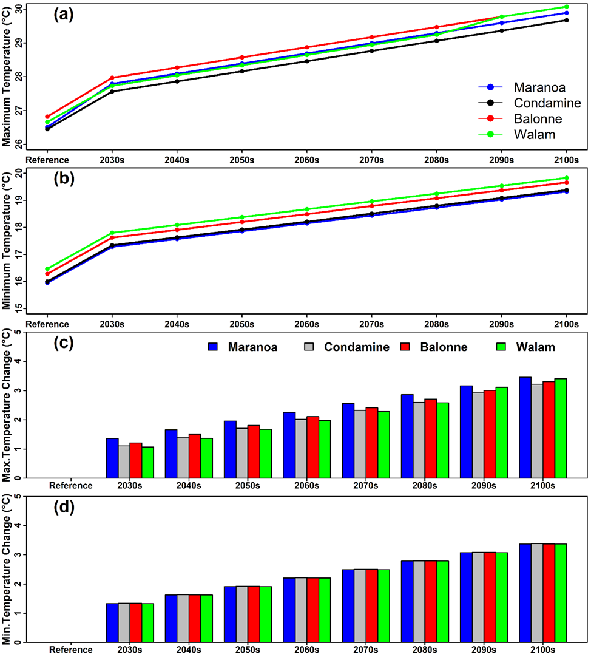
Figure 2: Graphical diagram of maximum and minimum temperature variation for future periods in sub-basin of CBRB (a) maximum temperature (b) minimum temperature (c) changes of maximum temperature and (d) change of minimum temperature based on reference (baseline) period.

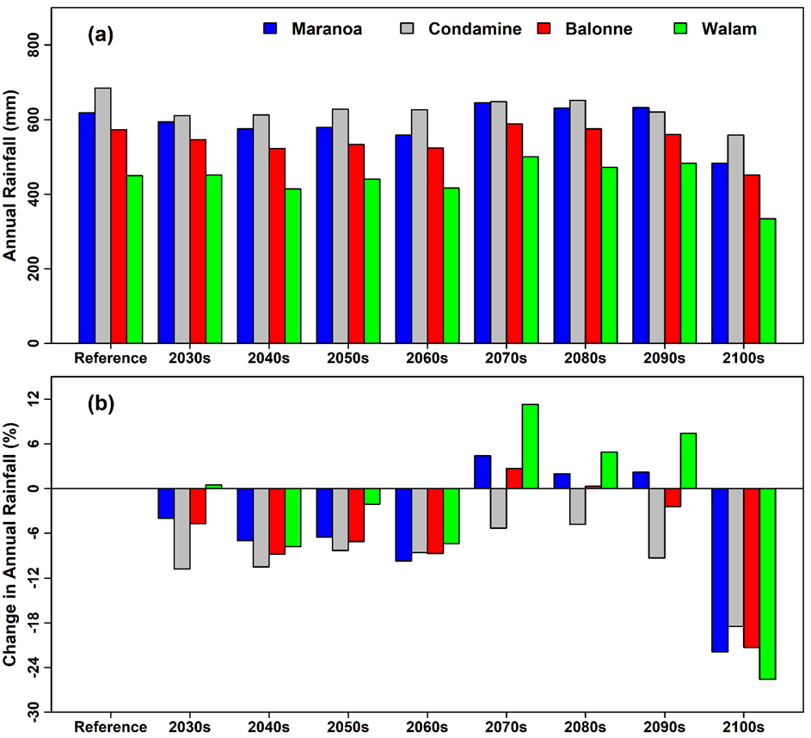
Figure 3: Graphical diagram of annual precipitation (rainfall) variation for future periods in sub-basin of CBRB (a) annual rainfall (b) % change of annual rainfall based on reference (baseline) period.

Figure 4: Graphical diagram of % of change in seasonal annual precipitation (rainfall) for future periods in sub-basin of CBRB (a) Summer, (b) Autumn, (c) Winter, and (d) Spring season based on reference (baseline) period.
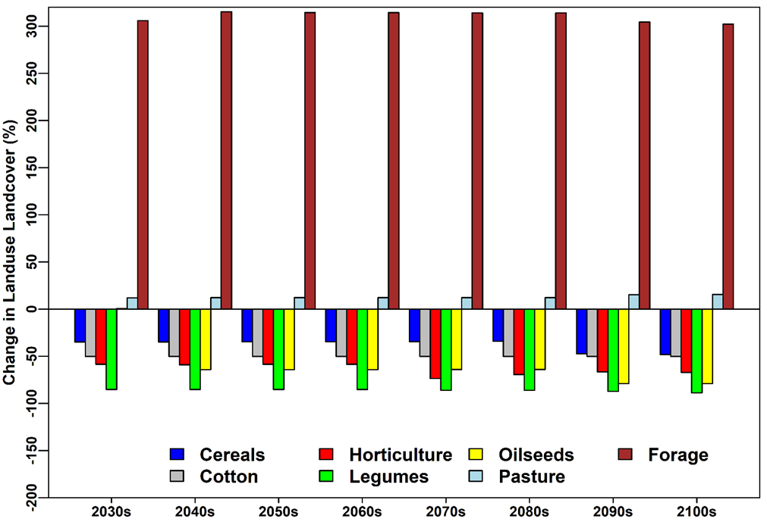
Figure 5: Graphical diagram of % of change in land use change for future periods in sub-basin of CBRB based on reference (baseline) period.
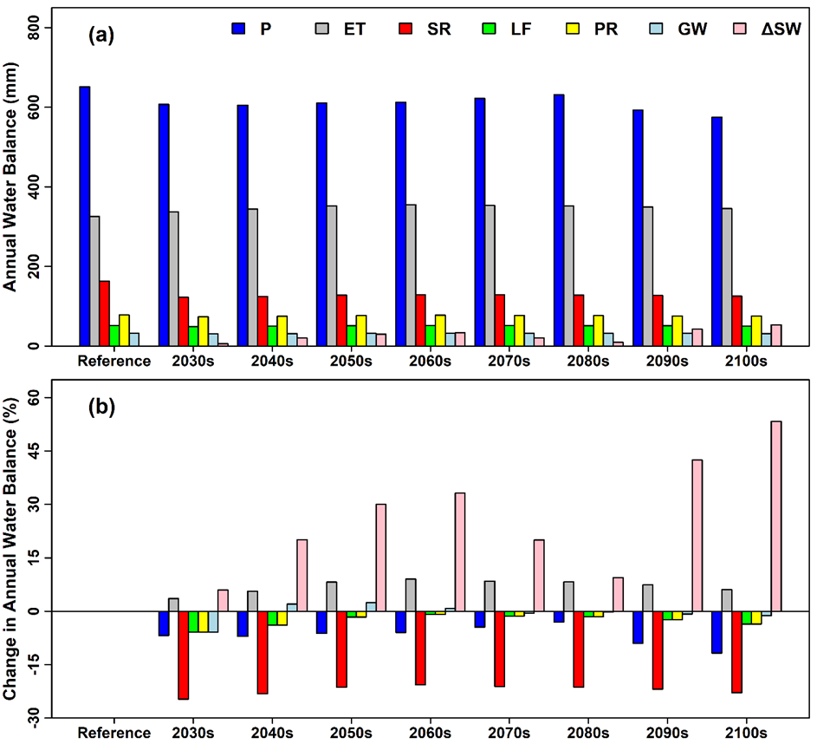
Figure 6: Graphical diagram of impact of CC on annual water balance and % of change in annual water balance for future periods based on reference (baseline) period (Note: P = Rainfall, ET = Evapotranspiration, SR = Surface Runoff, LF = Lateral Flow, PR = Percolation, GW = Baseline Flow, ΔS = Water Deficit).

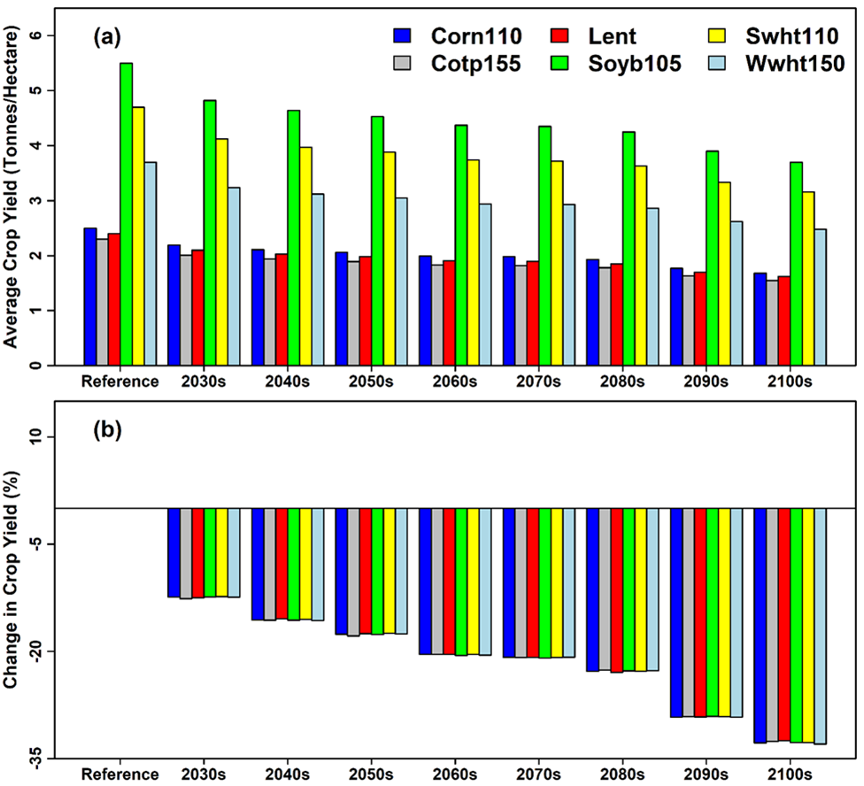
Figure 7: Graphical diagram of impact of CC on a) average crop yield of irrigated crops and b) % of change in average crop yield for future periods based on reference (baseline) period.

