Supplementary Table S1. Association between T2D Polygenic Risk Scores and Disease Risk across Multiple P-value Thresholds.

Threshold | OR | L95 | U95 | P_value
5e+08 | 1.421 | 1.156 | 1.746 | 0.0008328
0.001 | 1.438 | 1.164 | 1.775 | 0.0007343
0.01 | 1.523 | 1.223 | 1.897 | 0.000169
0.05 | 1.577 | 1.267 | 1.963 | 4.609e-05
0.1 | 1.63 | 1.311 | 2.028 | 1.115e-05
0.5 | 1.569 | 1.266 | 1.946 | 4.042e-05
1 | 1.499 | 1.212 | 1.854 | 0.0001909

Figure S1. Comparison of Predictive Performance for T2D Risk

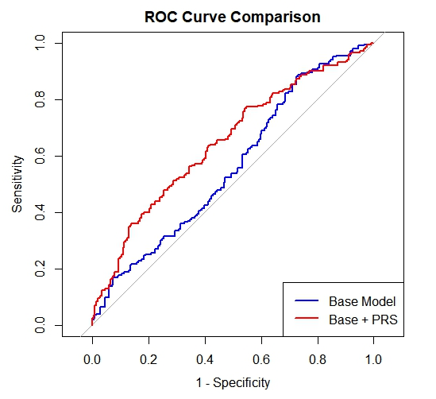

Note: Receiver operating characteristic (ROC) curves illustrate the discriminative ability of the base model (blue line: age, sex, and PC1–PC3) and the full model (red line: base model + PRS at P < 0.05). The inclusion of PRS significantly improved the area under the curve (AUC) from 0.562 to 0.648. Statistical significance was assessed using DeLong’s test (Z = -3.0916, P = 0.002)

Supplementary Table S2. Association between CRC Polygenic Risk Scores and Disease Risk across Multiple P-value Thresholds.
Threshold | OR | L95 | U95 | P_value
5e+08 | 1.22 | 0.991 | 1.502 | 0.06128
0.001 | 1.198 | 0.974 | 1.474 | 0.08738
0.01 | 1.356 | 1.098 | 1.675 | 0.004656
0.05 | 1.333 | 1.079 | 1.647 | 0.007699
0.1 | 1.241 | 1.008 | 1.528 | 0.04198
0.5 | 1.16 | 0.944 | 1.426 | 0.1573
1 | 1.165 | 0.947 | 1.432 | 0.1477

Figure S2. Comparison of Predictive Performance for CRC Risk
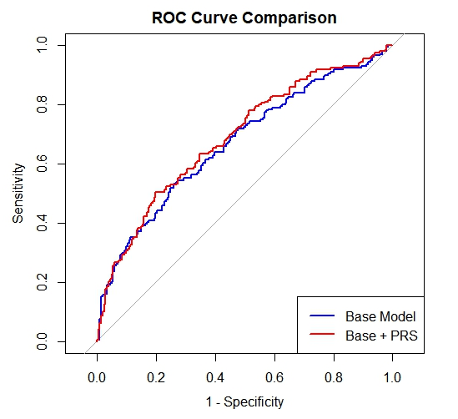
Note: Receiver operating characteristic (ROC) curves illustrate the discriminative ability of the base model (blue line: age, sex, and PC1–PC3) and the full model (red line: base model + PRS at ). While the inclusion of PRS improved the area under the curve (AUC) from 0.669 to 0.689, the incremental improvement did not reach statistical significance via DeLong’s test (Z = -1.524, p-value = 0.127).

