Supplementary File

Tables

Table ST1: Taguchi OA
Trial Number | Parameter level
Trial Number | 1 | 2 | 3 | 4 | Temperature (˚C) | Reaction Time (hrs) | AA:SL Ratio | Catalyst wt%
LAT1 | 1 | 1 | 1 | 1 | 50 | 2 | 2 | 1.5
LAT2 | 1 | 2 | 2 | 2 | 50 | 4 | 4 | 3.0
LAT3 | 1 | 3 | 3 | 3 | 50 | 6 | 6 | 4.5
LAT4 | 2 | 1 | 2 | 3 | 70 | 2 | 4 | 4.5
LAT5 | 2 | 2 | 3 | 1 | 70 | 4 | 6 | 1.5
LAT6 | 2 | 3 | 1 | 2 | 70 | 6 | 2 | 3.0
LAT7 | 3 | 1 | 3 | 2 | 90 | 2 | 6 | 3.0
LAT8 | 3 | 2 | 1 | 3 | 90 | 4 | 2 | 4.5
LAT9 | 3 | 3 | 2 | 1 | 90 | 6 | 4 | 1.5

Table ST2: 20 experimental runs based on CCD
Sample | CF A | CF B | CF C
Sample | Temperature (°C) | Reaction time (hr) | AA:SL ratio
LAR1 | 70 | 7 | 4
LAR2 | 70 | 4 | 1
LAR3 | 70 | 1 | 4
LAR4 | 70 | 4 | 4
LAR5 | 90 | 6 | 6
LAR6 | 36 | 4 | 4
LAR7 | 90 | 6 | 2
LAR8 | 70 | 4 | 4
LAR9 | 50 | 2 | 6
LAR10 | 70 | 4 | 4
LAR11 | 104 | 4 | 4
LAR12 | 70 | 4 | 4
LAR13 | 50 | 2 | 2
LAR14 | 50 | 6 | 6
LAR15 | 70 | 4 | 4
LAR16 | 70 | 4 | 7
LAR17 | 70 | 4 | 4
LAR18 | 90 | 2 | 2
LAR19 | 50 | 6 | 2
LAR20 | 90 | 2 | 6

Table ST3: Response based on the Taguchi design.
Trial Number | Column Number |  |  |  | Response (g)
Trial Number | 1 | 2 | 3 | 4 | R₁ | R₂
LAT1 | 1 | 1 | 1 | 1 | 3.214 | 3.775
LAT2 | 1 | 2 | 2 | 2 | 3.805 | 3.548
LAT3 | 1 | 3 | 3 | 3 | 3.477 | 2.757
LAT4 | 2 | 1 | 2 | 3 | 3.527 | 3.988
LAT5 | 2 | 2 | 3 | 1 | 3.984 | 3.540
LAT6 | 2 | 3 | 1 | 2 | 3.857 | 3.626
LAT7 | 3 | 1 | 3 | 2 | 3.829 | 4.291
LAT8 | 3 | 2 | 1 | 3 | 5.367 | 4.626
LAT9 | 3 | 3 | 2 | 1 | 3.470 | 4.254

Table ST4: Response for the S/N
CF | Level | M_{AVG} | Delta | Rank
Temperature | 1 | 10.684 | 1.943 | 1
Temperature | 2 | 11.489 | 1.943 | 1
Temperature | 3 | 12.627 | 1.943 | 1
Reaction Time | 1 | 11.512 | 1.239 | 2
Reaction Time | 2 | 12.264 | 1.239 | 2
Reaction Time | 3 | 11.024 | 1.239 | 2
AA Ratio | 1 | 12.101 | 0.916 | 3
AA Ratio | 2 | 11.515 | 0.916 | 3
AA Ratio | 3 | 11.185 | 0.916 | 3
Catalyst | 1 | 11.371 | 0.412 | 4
Catalyst | 2 | 11.647 | 0.412 | 4
Catalyst | 3 | 11.783 | 0.412 | 4

Table ST5: ANOVA and pooled ANOVA based on the S/N
CF | ANOVA |  |  | Pooled ANOVA
CF | S | V | Percentage | Error Variance | F | S’ | Percentage
Temperature | 5.82 | 2.91 | 60.34 | 0.02 | 158.99 | 5.78 | 59.97
Reaction time | 2.42 | 1.21 | 25.13 | 0.02 | 66.22 | 2.39 | 24.75
AA Ratio | 1.363 | 0.68 | 14.14 | 0.02 | 37.26 | 1.33 | 13.76
Catalyst | 0.04 | 0.02 | 0.38 | 0.02 | e | e | e
e = error

Table ST6: ANOVA for the LAA yield via RSM
Source | Sum of Squares | df | Mean Square | F-value | p-value
Model | 3.09 | 9 | 0.3433 | 14.7899 | 0.000115 | significant
A-Temperature | 1.80 | 1 | 1.8039 | 77.7254 | < 0.0001
B-Reaction Time | 0.07 | 1 | 0.0655 | 2.8220 | 0.1239
C-AA:SL Ratio | 0.34 | 1 | 0.3405 | 14.6694 | 0.0033
AB | 0.00 | 1 | 0.0000 | 0.0000 | 1.0000
AC | 0.00 | 1 | 0.0000 | 0.0000 | 1.0000
BC | 0.00 | 1 | 0.0000 | 0.0000 | 1.0000
A² | 0.02 | 1 | 0.0166 | 0.7174 | 0.4168
B² | 0.87 | 1 | 0.8715 | 37.5504 | 0.0001
C² | 0.00 | 1 | 0.0004 | 0.0182 | 0.8953
Residual | 0.23 | 10 | 0.0232
Lack of Fit | 0.19 | 5 | 0.0387 | 5.0286 | 0.0504 | not significant
Pure Error | 0.04 | 5 | 0.0077
Cor Total | 3.32 | 19

Table ST7: Statistical parameters estimated from ANOVA based on RSM
Parameter | Value | Parameter | Value
Std. Dev. | 0.1578 | R² | 0.9241
Mean | 3.9823 | Adjusted R² | 0.8557
C.V. % | 3.9621 | Predicted R² | 0.5258
 |  | Adeq Precision | 12.4237

Table ST8: Actual and predicted response value (LAA yield) by RSM
Sample | Temp  (°C) | Reaction  time (hrs) | AA  ratio | Actual  Value | Predicted  Value | Leverage
LAR1 | 70 | 7 | 4 | 3.4403 | 3.3668 | 0.0735
LAR2 | 70 | 4 | 1 | 4.3016 | 4.4351 | -0.1335
LAR3 | 70 | 1 | 4 | 3.5356 | 3.6012 | -0.0656
LAR4 | 70 | 4 | 4 | 4.1631 | 4.1567 | 0.0064
LAR5 | 90 | 6 | 6 | 4.0250 | 4.0393 | -0.0143
LAR6 | 36 | 4 | 4 | 3.6556 | 3.4716 | 0.1840
LAR7 | 90 | 6 | 2 | 4.4562 | 4.3537 | 0.1026
LAR8 | 70 | 4 | 4 | 4.2861 | 4.1567 | 0.1294
LAR9 | 50 | 2 | 6 | 3.3453 | 3.4536 | -0.1082
LAR10 | 70 | 4 | 4 | 3.9811 | 4.1567 | -0.1756
LAR11 | 104 | 4 | 4 | 4.5256 | 4.7018 | -0.1762
LAR12 | 70 | 4 | 4 | 4.1031 | 4.1567 | -0.0536
LAR13 | 50 | 2 | 2 | 3.7765 | 3.7679 | 0.0086
LAR14 | 50 | 6 | 6 | 3.1483 | 3.3157 | -0.1673
LAR15 | 70 | 4 | 4 | 4.2196 | 4.1567 | 0.0629
LAR16 | 70 | 4 | 7 | 4.0421 | 3.9007 | 0.1414
LAR17 | 70 | 4 | 4 | 4.1861 | 4.1567 | 0.0294
LAR18 | 90 | 2 | 2 | 4.6532 | 4.4915 | 0.1617
LAR19 | 50 | 6 | 2 | 3.5795 | 3.6300 | -0.0505
LAR20 | 90 | 2 | 6 | 4.2220 | 4.1772 | 0.0448

Figures

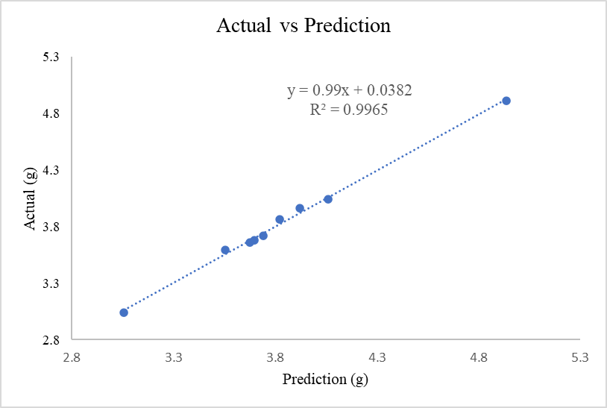
Fig. SF1: Actual vs Prediction graph

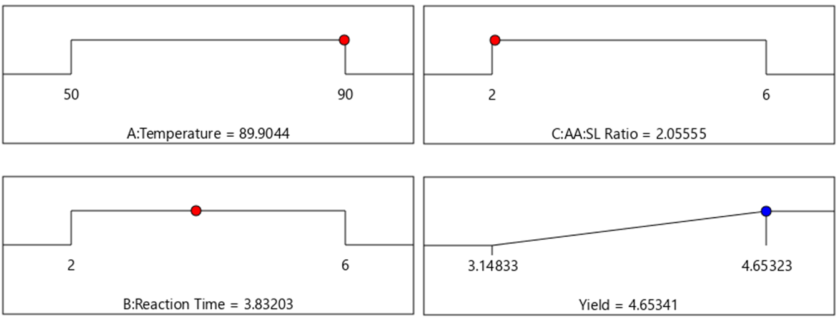
Fig. SF2: The optimal parameters for LAA production based on RSM.

