Supplementary Materials for

Substantial Shortwave Direct Radiative Forcing by Airborne Tire Wear Particles

Zhanfei Yan et al.

Corresponding author: Liwu Zhang, zhanglw@fudan.edu.cn; Tao Wang, wangtao_fd@fudan.edu.cn.

The PDF file includes:

Materials and Methods
Figs. S1 to S17
Tables S1 to S4
References

Materials and Methods
S1: Material preparation and measurements
Tire wear particles (TWPs) were generated from a new Chaoyang tire (205/55R16). The tire tread was first abraded with sandpaper and then ground using a household grinder. The resulting powder was sieved through a 300-mesh (50 μm) sieve. The sieved powder was then dry-ball milled in a high-speed vibratory ball mill (MSK-SFM-3, Kejing Materials Technology Co., Ltd., China) using agate grinding balls at a constant speed of 900 rpm for 5 h. The milled powder was then sieved through a 1340-mesh (10 μm) sieve.
Valence electron energy loss spectroscopy (VEELS, 0–50 eV) spectra of individual TWPs (400–5000 nm in diameter; n = 25) were collected using a spherical aberration-corrected transmission electron microscope (Spectra 300, Thermo Fisher Scientific, USA) equipped with a Gatan imaging filter (Model 1065) and operated at 300 kV. TWP samples were uniformly dispersed on TEM grids (200-mesh copper grids coated with a carbon film) to minimize agglomeration and significant orientation effects. Only particles with nearly circular morphologies were selected for point scanning to minimize shape-related uncertainties in subsequent optical analyses.
S2: Calculation of optical properties
The retrieval of ε(E) from VEELS data proceeds in three steps: (1) model and subtract the zero-loss peak (ZLP) to isolate the inelastic spectrum; (2) apply Fourier-log deconvolution to remove plural scattering and obtain the single-scattering distribution (SSD); and (3) perform Kramers-Kronig (KK) analysis on the SSD to retrieve ε(E) = ε₁ + iε₂ from Im[−1/ε] and Re[1/ε] (55). These processes were implemented using the Python package HyperSpy (56).
Given that low-loss features can be buried in the ZLP tail, the tail needs to be considered when separating ZLP, using the reflection tail method (57). Based on the theories of Raether, Egerton, and Ritchie, SSD is divided into bulk and surface contributions. Under the thin-film approximation, and neglecting retardation effects and instrumental broadening, SSD can be expressed in terms of the energy-loss function L(E) = Im[-1/ε(q, E)], which is the imaginary part of the function -1/ε(q, E) (42, 58-60). Here, ε(q, E) is the complex dielectric function at energy loss E and momentum transfer q. For small q, ε(q, E) varies weakly with q and is approximated as ε(E) (61).
$$L\left(E\right)=Im\left[-\frac{1}{ε\left(E\right)}\right]=\frac{πa_{0}m_{0}v^{2}}{2I_{0}tln[1+{(β/θ_{E})}^{2}]}[SSD-S_{s}\left(E\right)]（1）$$
Here, a₀ is the Bohr radius, m₀​ is the electron rest mass, v is the electron speed, I₀​ is the zero-loss intensity, t is the specimen thickness, β is the collection semi-angle, and θ_{E} ​= E/(γm₀​v²) is the characteristic scattering angle (where γ denotes the Lorentz factor). Ss(E) denotes the surface-loss term assuming no surface coupling, and is given by:
$S_{s}\left(E\right)=\frac{I_{0}}{πa_{0}k_{0}T}\left[\frac{\tan^{-1}(β/θ_{E})}{θ_{E}}-\frac{β}{\left(β^{2}+{θ_{E}}^{2}\right)}\right][\frac{4ε_{2}}{{\left(1+ε_{1}\right)}^{2}+{ε_{2}}^{2}}-Im\left(-\frac{1}{ε}\right)]$（2）
k₀ is the electromagnetic wavenumber, and T = m₀​v²/2 is the electron kinetic energy. When the acquisition position approaches the particle edge, enhanced surface‐plasmon excitations can invalidate the thin-film approximation. For particles larger than 50 nm, however, this approximation remains valid as long as the spectral acquisition point is at least 10 nm away from the particle edge, thereby minimizing uncertainties arising from surface contributions. The spectral sampling points used in this study satisfy this requirement.
By causality, the real and imaginary parts of the ε(E) are related through the Kramers-Kronig relations. Accordingly, Re[1/ε(E)] can be obtained from L(E) = Im[−1/ε(E)] via the Kramers-Kronig transformation (55), where P denotes the Cauchy principal value.
$$Re\left[\frac{1}{ε\left(E\right)}\right]=1-\frac{2}{π}P\int_{0}^{∞}{Im\left[-\frac{1}{ε\left(E^{'}\right)}\right]\frac{E^{'}}{{E^{'}}^{2}-E^{2}}dE^{'}}（3）$$
The real part ε₁ and imaginary part ε₂ of ε(E) were then calculated as
$$ε_{1}=\frac{Re\left(1/ε\right)}{{[Re\left(1/ε\right)]}^{2}+{[Im\left(-1/ε\right)]}^{2}}（4）$$
$$ε_{2}=\frac{Im\left(-1/ε\right)}{{[Re\left(1/ε\right)]}^{2}+{[Im\left(-1/ε\right)]}^{2}}（5）$$
$$ε=ε_{1}+iε_{2}（6）$$
The key single-particle optical parameters n and k of N can be obtained via Eq. 7 and 8.
$$n=\sqrt{\frac{1}{2}(\sqrt{{ε_{1}}^{2}+{ε_{2}}^{2}}+ε_{1})}（7）$$
$$k=\sqrt{\frac{1}{2}(\sqrt{{ε_{1}}^{2}+{ε_{2}}^{2}}-ε_{1})}（8）$$
Derived from Maxwell's equations for spherical particles, Mie theory describes the scattering and absorption characteristics of a particle (37). We modeled TWPs as ideal, homogeneous, optically smooth spheres, and used N to compute the single-particle scattering cross-section C_{sca}, absorption cross-section C_{abs}, and extinction cross-section C_{ext} through Mie theory.
$$C_{sca}=\frac{2π}{{k_{λ}}^{2}}\sum_{n=1}^{∞}{(2n+1)({\left|a_{n}\right|}^{2}+{\left|b_{n}\right|}^{2})}（9）$$
$$C_{ext}=\frac{2π}{{k_{λ}}^{2}}\sum_{n=1}^{∞}{(2n+1)Re(a_{n}+b_{n})}（10）$$
$$C_{ext}={C_{abs}+C}_{sca}（11）$$
In the Mie formulation, k_{λ} is the wavenumber, and a_{n}​ and b_{n}​ are the Mie scattering coefficients that are functions of the size parameter x = 2πa /λ (a is the particle radius, λ is obtained by photon-energy relation), N, Bessel functions, and Hankel functions. To facilitate comparison across particles, each cross-section can be normalized by the particle’s projected area G perpendicular to the incident wave, yielding the dimensionless scattering efficiency Q_{sca}, absorption efficiency Q_{abs}, and extinction efficiency Q_{ext}.
$$Q_{abs}=C_{abs}/G（12）$$
$$Q_{sca}=C_{sca}/G（13）$$
$$Q_{ext}=C_{ext}/G（14）$$
Under the homogeneous-sphere assumption for TWPs, the projected area is G = πa². The mass absorption, mass scattering, and mass extinction cross-sections (MAC, MSC and MEC) quantify, respectively, the absorption, scattering, and extinction per unit mass of TWPs. For a particle with density ρ, these quantities are calculated as follows:
$$MACp=\frac{{3C}_{abs}}{4πa^{3}ρ}（15）$$
$$MSCp=\frac{{3C}_{sca}}{4πa^{3}ρ}（16）$$
$$MECp=\frac{{3C}_{ext}}{4πa^{3}ρ}（17）$$
The key radiometric quantities of TWPs, single-scattering albedo (SSA), and asymmetry factor (g) are further calculated as
$$SSA=\frac{Q_{sca}}{Q_{ext}}=\frac{C_{sca}}{C_{ext}}（18）$$
$$g=\frac{4}{Q_{sca}x^{2}}[\sum_{n=1}^{n_{max}}{\frac{n\left(n+2\right)}{n+1}Re\left(a_{n}a_{n+1}^{*}+b_{n}b_{n+1}^{*}\right)}+\sum_{n=1}^{n_{max}}{\frac{2n+1}{n\left(n+1\right)}Re\left(a_{n}b_{n}^{*}\right)}]（19）$$
Using the mean n and k of 25 individual particles together with the particle size distribution measured with a Malvern particle sizer (Mastersizer 2000, Malvern Instruments, UK), we can further obtain the ensemble optical parameters. The measured size distribution of TWPs was fitted with a lognormal function over the diameter range of 1 nm to 10 μm, yielding a geometric mean diameter (GMD) of 0.314 μm and a geometric standard deviation (GSD) of 2.33. Among these ensemble optical parameters, MEC links TWP mass concentration to aerosol optical depth (AOD), which is calculated by vertically integrating the product of MEC and the aerosol mass concentration ρa(z) at different heights z, as shown in Eq. 20. The TWP mass concentration values used here were previously reported (3).
$$AOD=\int_{z_{1}}^{z_{2}}{\left[MECρa\left(z\right)\right]dz}（20）$$
The size distributions of TWPs vary substantially with material composition (62), emission conditions (52, 63, 64), fragmentation (65) and transport (66), thereby influencing ensemble optical properties and radiative forcing. To evaluate the uncertainty of simulated radiative forcing induced by particle size heterogeneity, two perturbed lognormal size distributions spanning the plausible size variation range of ambient TWPs were adopted for sensitivity analysis (46). Relative to the baseline size distribution (GMD = 314 nm, GSD = 2.33), the two perturbed schemes cover smaller and larger particle size regimes with distinct dispersion characteristics, including a fine-mode dominated distribution (GMD = 210 nm, GSD = 1.85) and a coarse-mode enhanced distribution (GMD = 403 nm, GSD = 2.52). Corresponding ensemble optical properties (AOD, SSA, and g) were recalculated following the identical Mie theoretical framework as the baseline simulation.
S3: Direct radiative forcing
Since most solar energy lies within 0.25–4.0 µm, this work focuses on the shortwave radiative effects of TWPs over this spectral range. The Santa Barbara DISORT Atmospheric Radiative Transfer model (SBDART) was employed to calculate the shortwave direct radiative forcing (DRF) induced by TWPs at the surface and top of the atmosphere (TOA) under clear-sky and cloudy conditions for the year 2014, with its domain discretized into 32 vertical layers from the surface to 100 km (67). Radiative transfer was evaluated at 3-hourly intervals to resolve the diurnal cycle and compute daily-mean fluxes at a 5° × 5° spatial resolution. The outputs were then aggregated to monthly means and averaged over the 12 months to obtain annual mean shortwave DRF.
For clear-sky simulations, SBDART required meteorological inputs including monthly mean total column water vapor, total column ozone, and surface albedo for 2014 from ERA5 reanalysis data (68). Under cloudy conditions, additional cloud parameters, including the cloud effective radius, cloud top height, and cloud optical thickness for 2014, were obtained from NASA datasets. In both cases, the TWP optical inputs consisted of ensemble AOD, SSA, and g at different pressure levels and wavelengths (8). These optical inputs were obtained from the Mie calculations and then interpolated into the SBDART grids.
Complementary to the baseline simulation constrained by measured particle size distribution in this study, additional groups of cloudy-sky TOA DRF simulations were conducted using the two perturbed lognormal size distributions. All meteorological inputs, model configurations, and spatiotemporal simulation settings were strictly consistent with the baseline experiment, ensuring that the discrepancies in simulated DRF were solely attributed to the variability of particle size distributions.
$${DRF}_{TOA, SUR}=\left(F^{↓}-F^{↑}\right)-\left({F_{0}}^{↓}-{F_{0}}^{↑}\right)（21）$$
Specifically, DRF is defined as the difference in net radiative flux between simulations with and without TWPs. Here, the net flux at a given level denotes downward minus upward radiative flux.

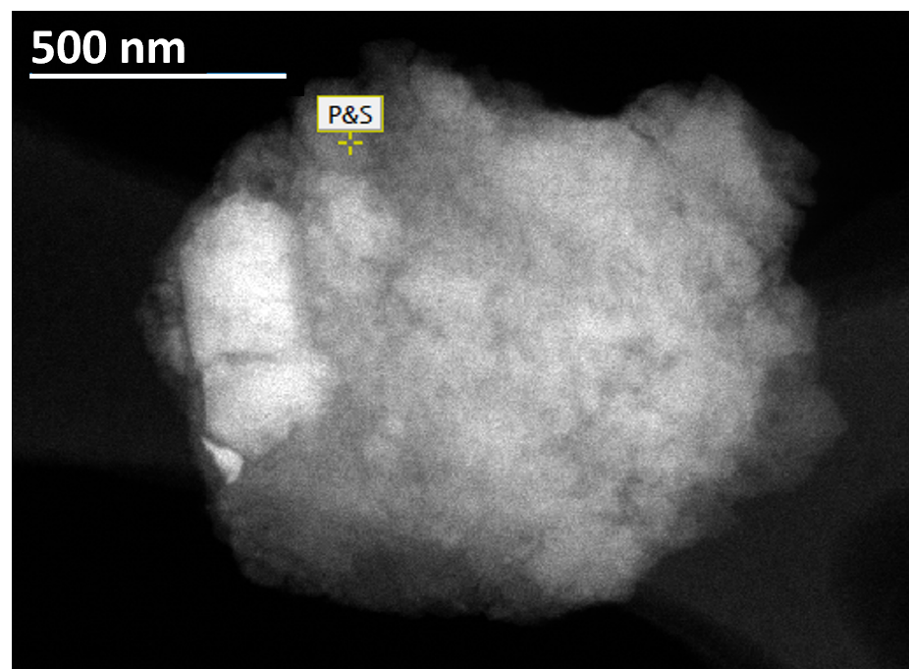

Fig. S1. STEM image of an individual TWP. The yellow marker indicates the scanning point.

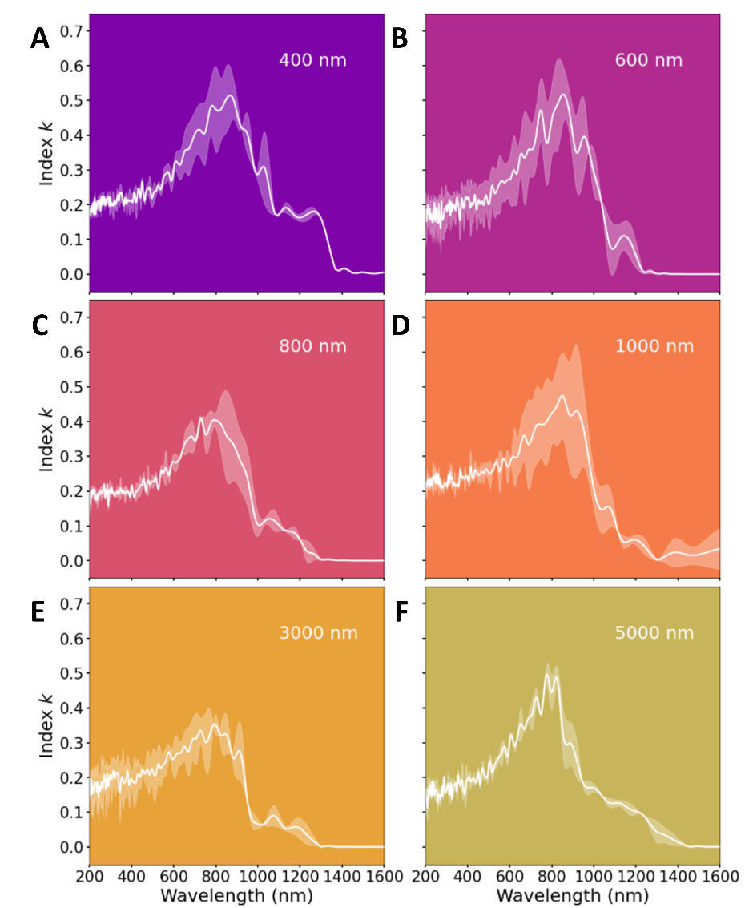

Fig. S2. Mean k values of individual TWPs across multiple particle size ranges. The imaginary part (k) of complex refractive index, obtained by VEELS, is plotted over the optical wavelength range of 200–1600 nm. The k shows a pronounced wavelength dependence, with a clear peak at wavelengths near 750 nm, followed by a rapid decay toward zero. Shaded regions represent the standard deviations.

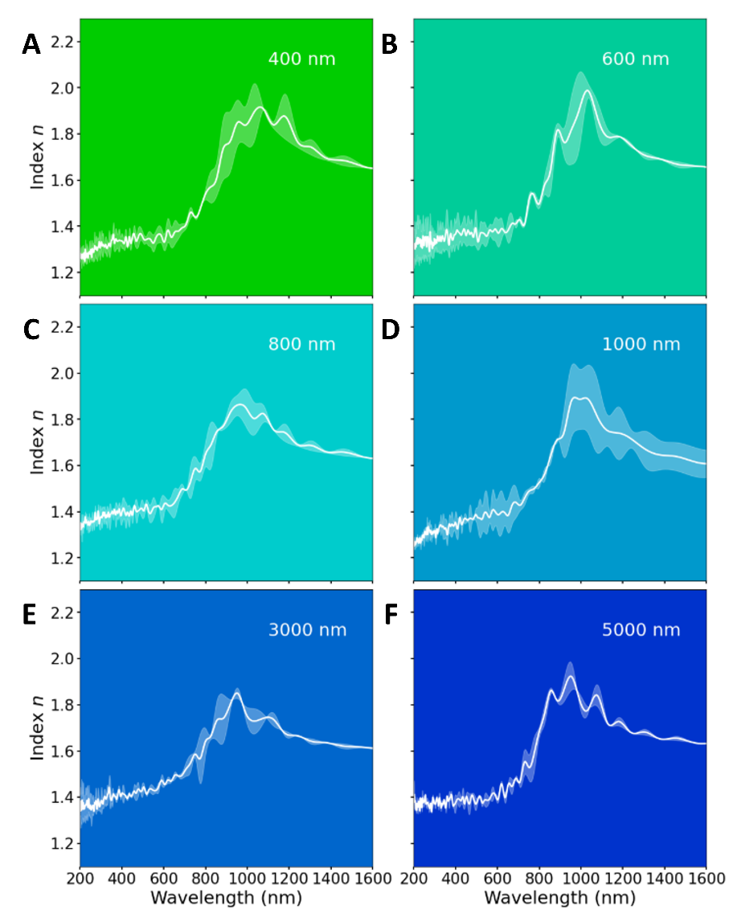

Fig. S3. Mean n values of individual TWPs across multiple particle size ranges. The real part (n) of complex refractive index, obtained by VEELS, is plotted over the optical wavelength range of 200–1600 nm. Like k in Supplementary Fig. 2, n also exhibits a pronounced wavelength dependence, but with a near-infrared inflection followed by a gentle decrease. Both n and k show size-independent spectral shapes, with only minor differences in amplitude. This suggests that intrinsic optical constants dominate the spectral behavior of single particles. TWPs exhibit absorption-dominated behavior in the ultraviolet (200–380 nm) and visible (380–780 nm) bands, while shifting toward scattering dominance in the infrared (780–1600 nm) band. Shaded regions represent the standard deviations.

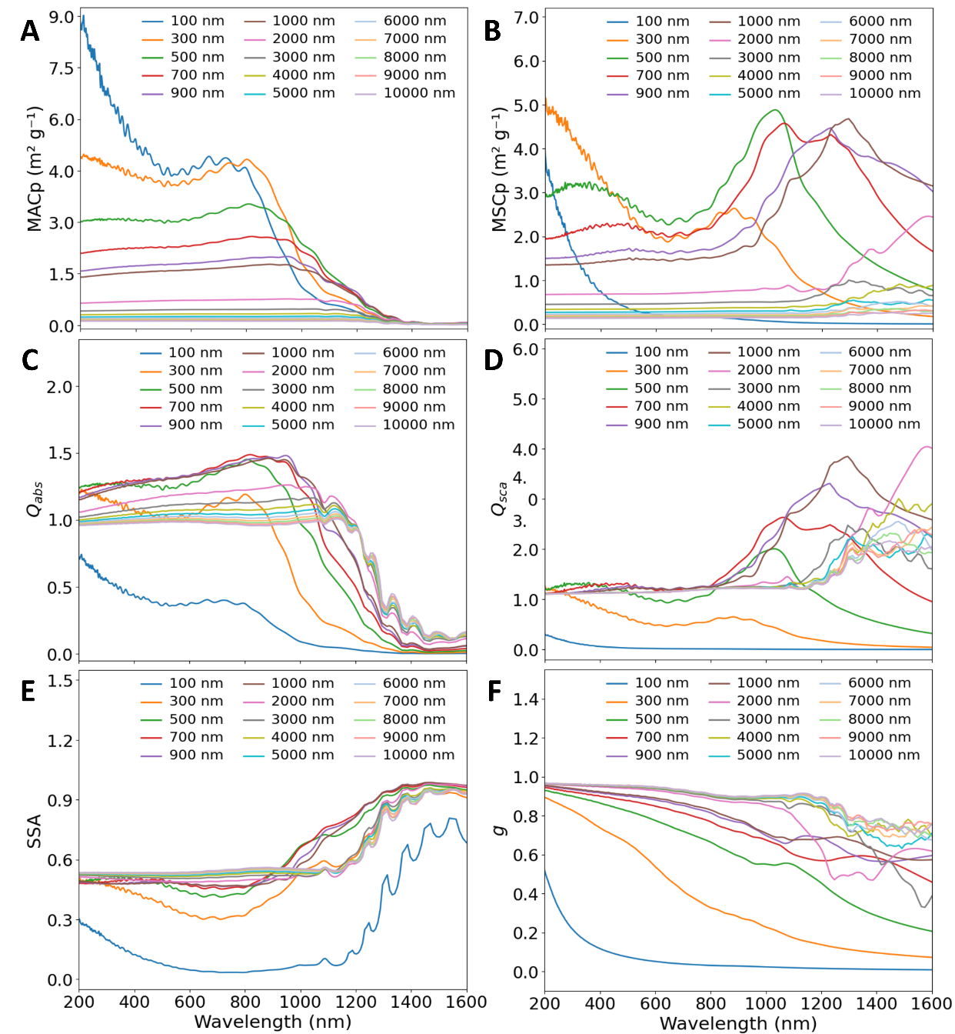

Fig. S4. Optical properties of individual TWPs. (A to F) The per-particle mass absorption cross-section MACp (A), per-particle mass scattering cross-section MSCp (B), absorption efficiency Q_{abs} (C), scattering efficiency Q_{sca} (D), single-scattering albedo SSA (E), and asymmetry factor g (F) of individual TWPs are shown with various particle sizes from 100 nm to 10 μm, as calculated by Mie theory using mean complex refractive indices over the optical wavelength range of 200–1600 nm. MACp and Q_{abs} are generally higher at shorter wavelengths, with stronger shortwave absorption for smaller particles and flatter spectra for larger particles. MSCp and Q_{sca} increase more strongly with particle size and exhibit size-dependent spectral peaks. Correspondingly, SSA is generally lower for smaller particles and higher for larger particles, with an overall increase toward longer wavelengths, while g is generally higher for larger particles but declines overall with increasing wavelength, indicating weaker forward scattering at longer wavelengths.
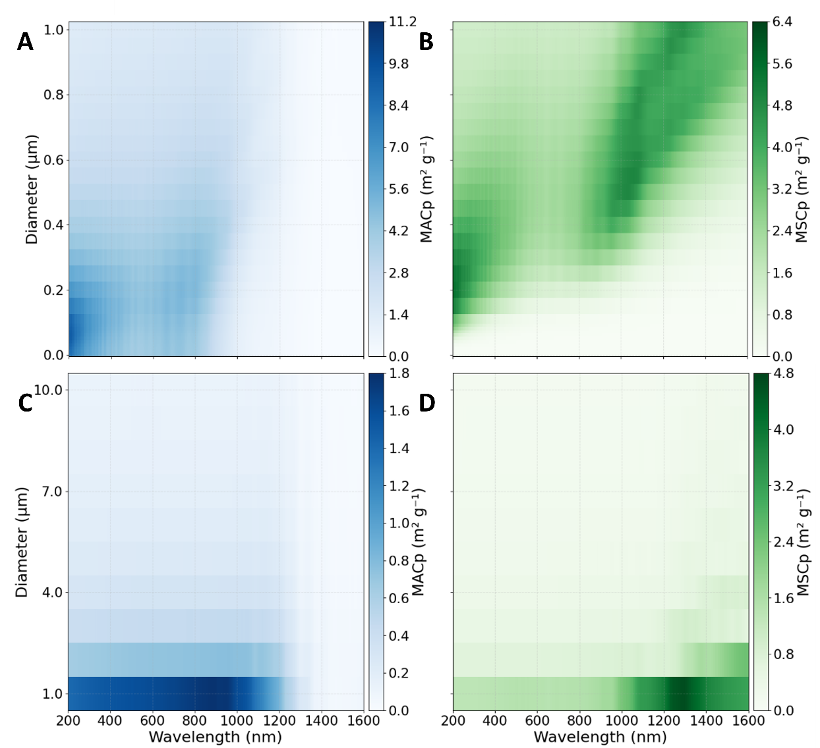

Fig. S5. Per-particle mass absorption (MACp) and per-particle mass scattering (MSCp) cross-section of TWPs below and above 1 μm. (A to D) The MACp and MSCp of TWPs with particle sizes below 1 μm (1 nm–1 µm) (A, B) and above 1 μm (1 µm–10 µm) (C, D) are shown over the optical wavelength range of 200–1600 nm. MACp exhibits an obvious decrease as TWP diameter increases from submicron to supermicron in the ultraviolet (200–380 nm) and visible (380–780 nm) bands, while MSCp shows enhanced size sensitivity that becomes more pronounced in the infrared (780–1600 nm) band.

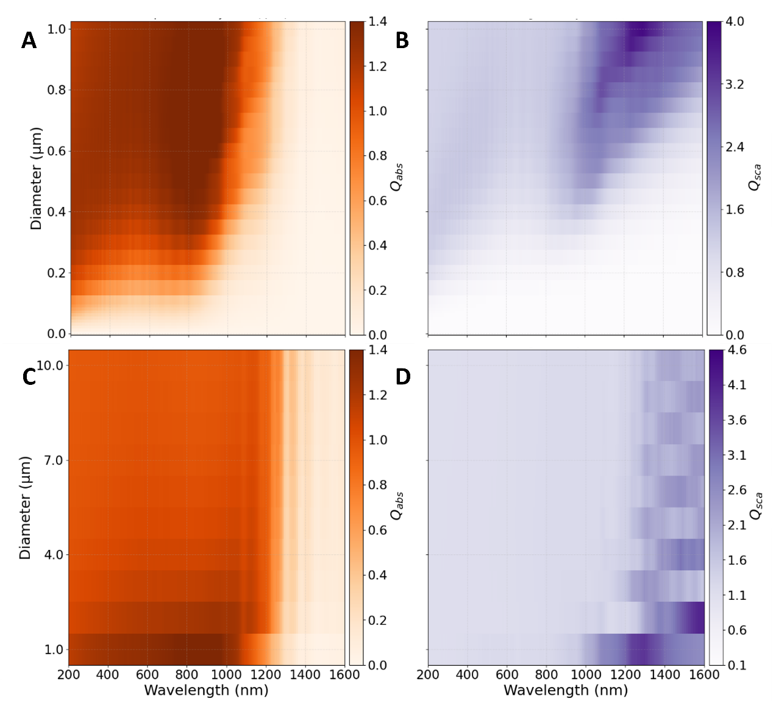

Fig. S6. Absorption (Q_{abs}) and scattering (Q_{sca}) efficiency of individual TWPs below and above 1 μm. (A to D) The Q_{abs} and Q_{sca} of individual TWPs with particle sizes below 1 μm (1 nm–1 µm) (A, B) and above 1 μm (1 µm–10 µm) (C, D) are plotted over the optical wavelength range of 200–1600 nm. In contrast to per-particle mass absorption (MACp), Q_{abs} increases with increasing diameter for submicron TWPs but shows opposite size-dependent trends at shorter and longer wavelengths for supermicron particles. Q_{sca} shows enhanced size dependence than Q_{abs}, and this dependence increases in the infrared for supermicron TWPs.

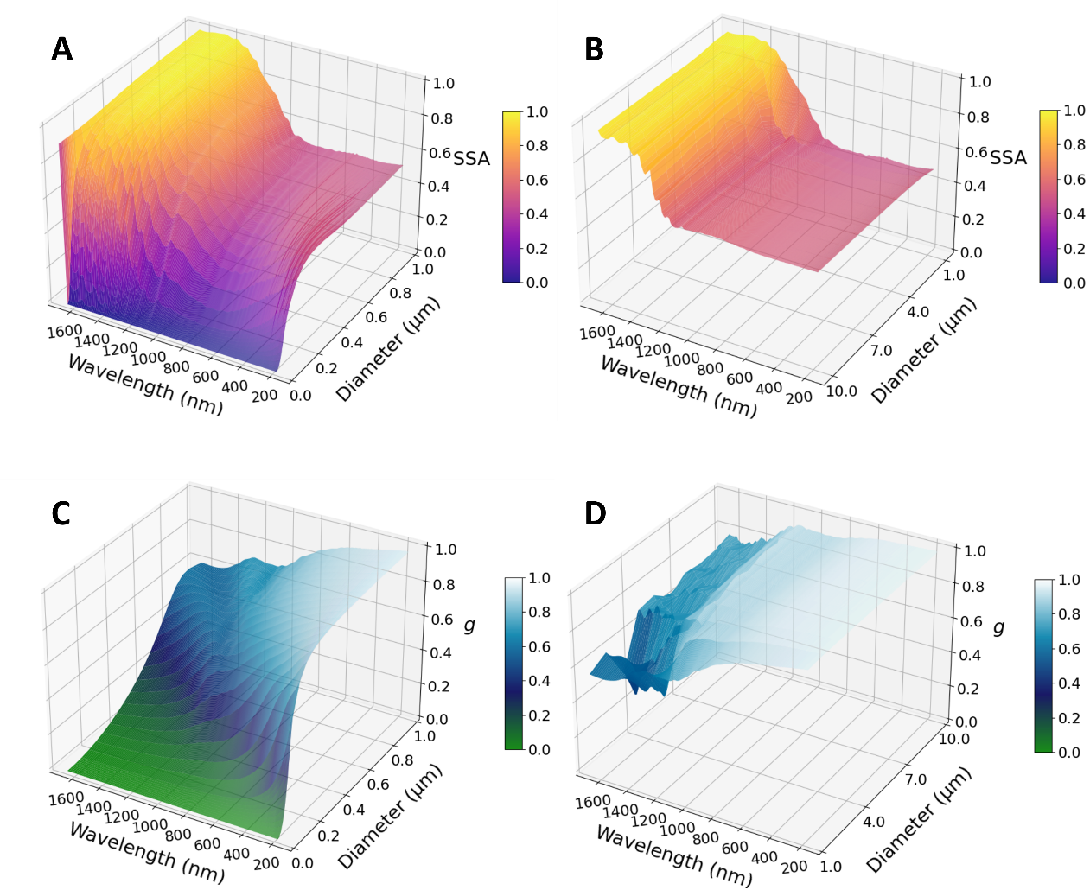

Fig. S7. Single-scattering albedo (SSA) and asymmetry factor (g) of individual TWPs below and above 1 μm. (A to D) The SSA and g of individual TWPs with particle sizes below 1 μm (1 nm–1 µm) (A, B) and above 1 μm (1 µm–10 µm) (C, D) are plotted over the optical wavelength range of 200–1600 nm. As diameter increases from submicron to supermicron range, g at shorter wavelengths increases significantly. Decreasing absorption and increasing scattering yield a monotonic increase in SSA with particle size at most wavelengths. Based on the spectral and size-based optical variations of individual particles, submicron individual TWPs display more pronounced absorption in the shortwave region compared to supermicron individual TWPs.

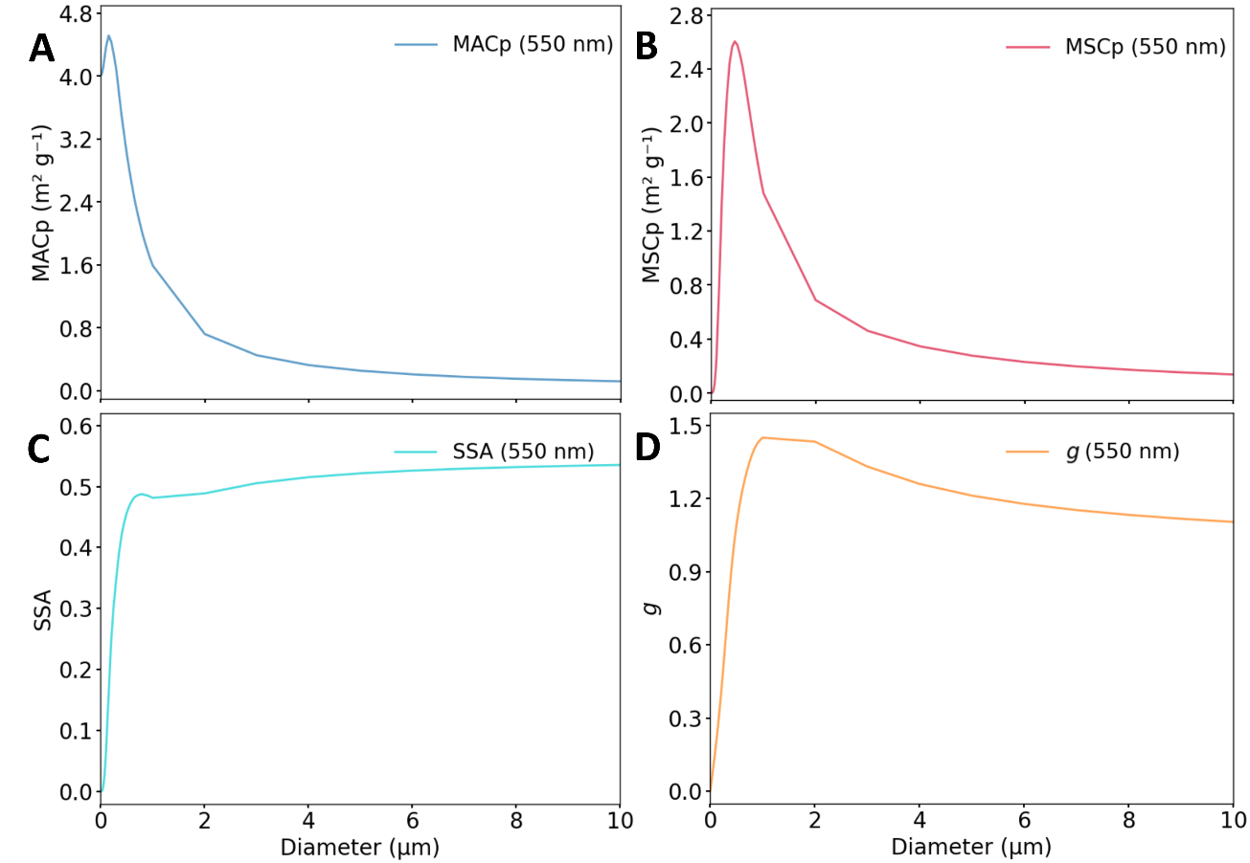

Fig. S8. Optical properties of individual TWPs at a wavelength of 550 nm. (A to D) Panels show MAC (A), MSC (B), single-scattering albedo SSA (C), and asymmetry factor g (D) as a function of particle size.

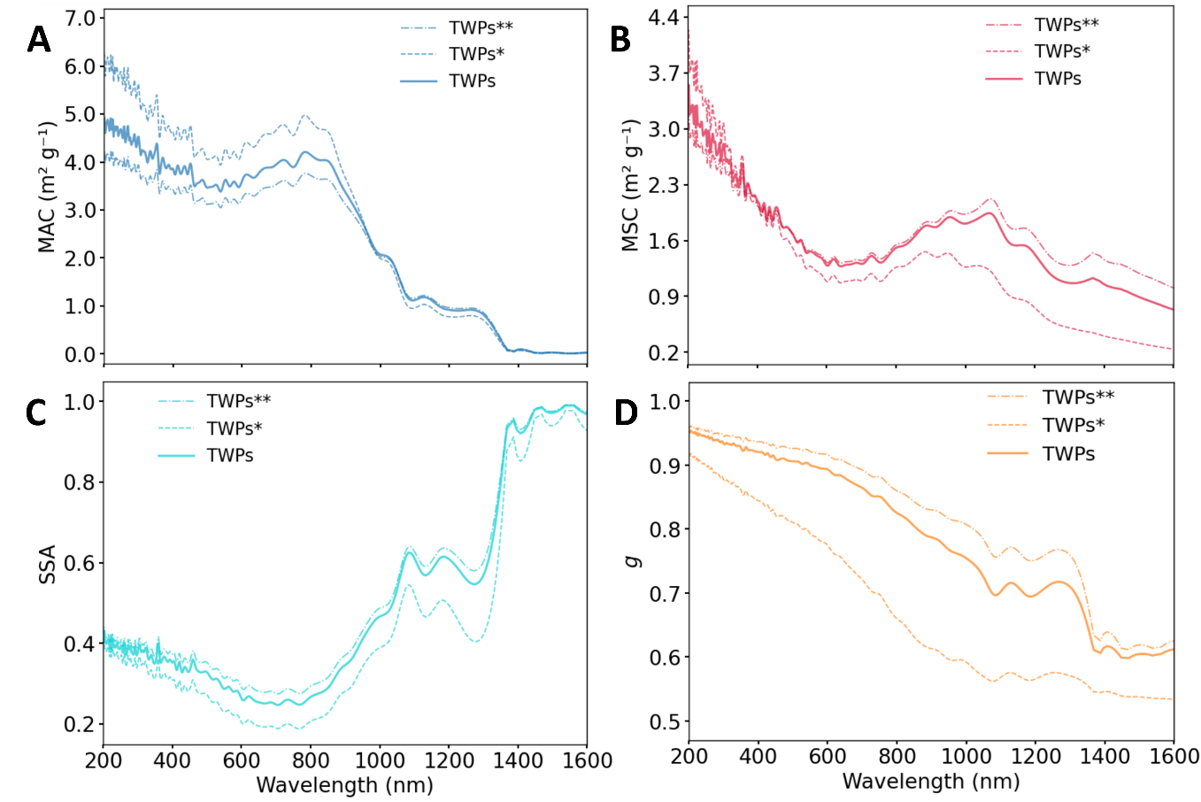

Fig. S9. Optical properties of TWPs under three distinct lognormal size distributions. (A to D) Ensemble mass absorption cross-section MAC (A), mass scattering cross-section MSC (B), single-scattering albedo SSA (C), and asymmetry factor g (D) calculated across 200–1600 nm wavelengths. Solid lines denote results from the baseline measured particle size distribution (referred to as TWPs throughout this work; geometric mean diameter, GMD = 314 nm; geometric standard deviation, GSD = 2.33); dashed lines represent two supplementary size spectra adopted for sensitivity tests: the fine-mode distribution (GMD = 210 nm, GSD = 1.85, defined as TWPs*) and the coarse-mode distribution (GMD = 403 nm, GSD = 2.52, defined as TWPs**). The two perturbed size distributions are derived from previous study (46).

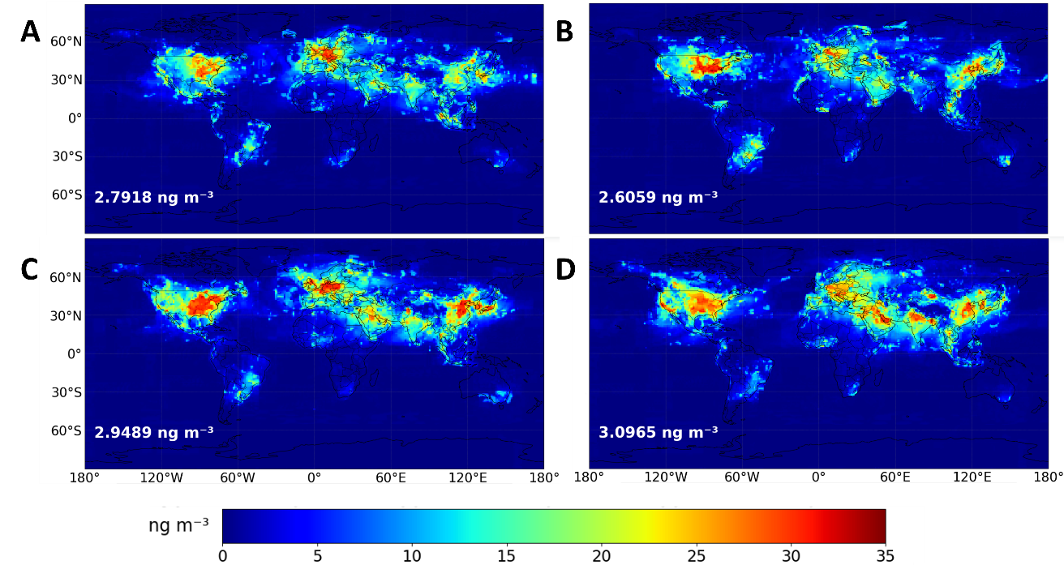

Fig. S10. Global seasonal mean surface concentration distribution of TWPs. (A to D) Panels show the values for March–May (A), June–August (B), September–November (C), and December–February (D), corresponding to spring, summer, autumn, and winter in the Northern Hemisphere, respectively. The global mean concentration from March to May is 2.7918 ng m⁻³, from June to August is 2.6059 ng m⁻³, from September to November is 2.9489 ng m⁻³, and from December to February is 3.0965 ng m⁻³. The data were published in the previous study (3).

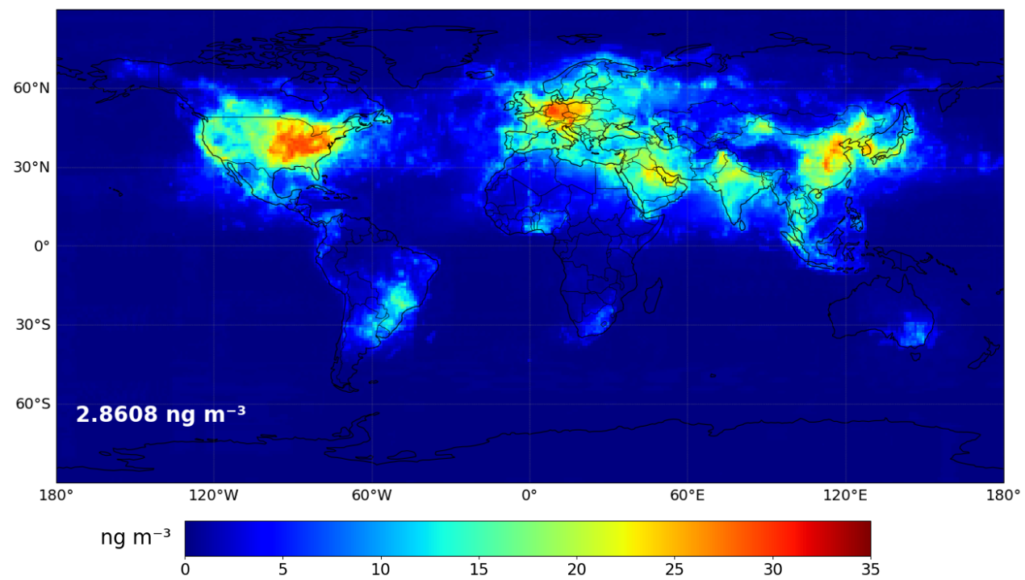

Fig. S11. Global annual mean surface concentration distribution of TWPs. The global annual mean concentration is 2.8608 ng m⁻³. The data were published in the previous study (3).

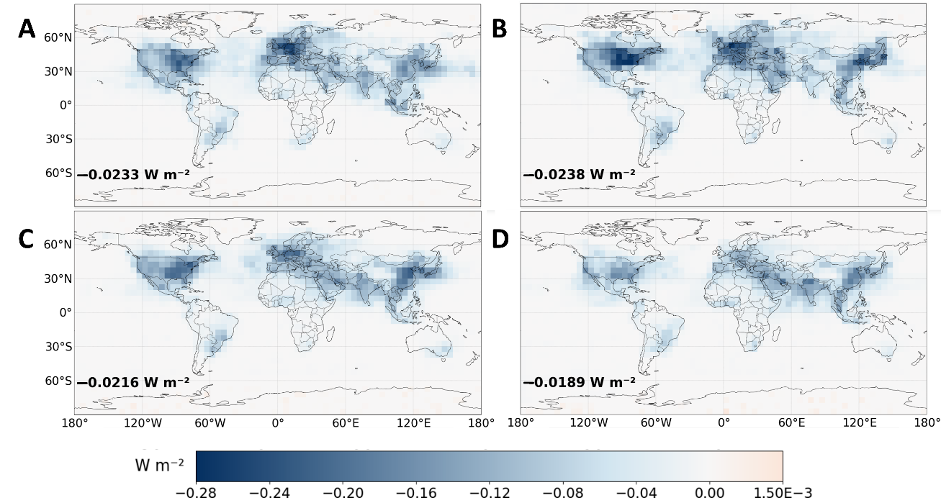

Fig. S12. Seasonal variation of global mean surface shortwave DRF of TWPs under clear-sky conditions. (A to D) Panels show the values for March–May (A), June–August (B), September–November (C), and December–February (D), corresponding to spring, summer, autumn, and winter in the Northern Hemisphere, respectively. The global mean surface DRF from March to May is −0.0233 W m⁻², from June to August is −0.0238 W m⁻², from September to November is −0.0216 W m⁻², and from December to February is −0.0189 W m⁻².

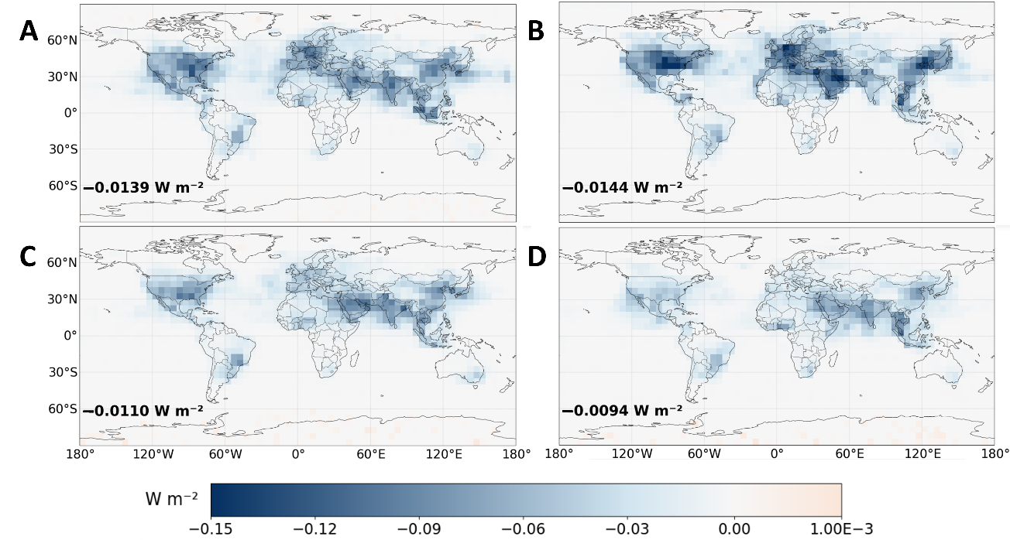

Fig. S13. Seasonal variation of global mean surface shortwave DRF of TWPs under cloudy conditions. (A to D) Panels show the values for March–May (A), June–August (B), September–November (C), and December–February (D), corresponding to spring, summer, autumn, and winter in the Northern Hemisphere, respectively. The global mean surface DRF from March to May is −0.0139 W m⁻², from June to August is −0.0144 W m⁻², from September to November is −0.0110 W m⁻², and from December to February is −0.0094 W m⁻².

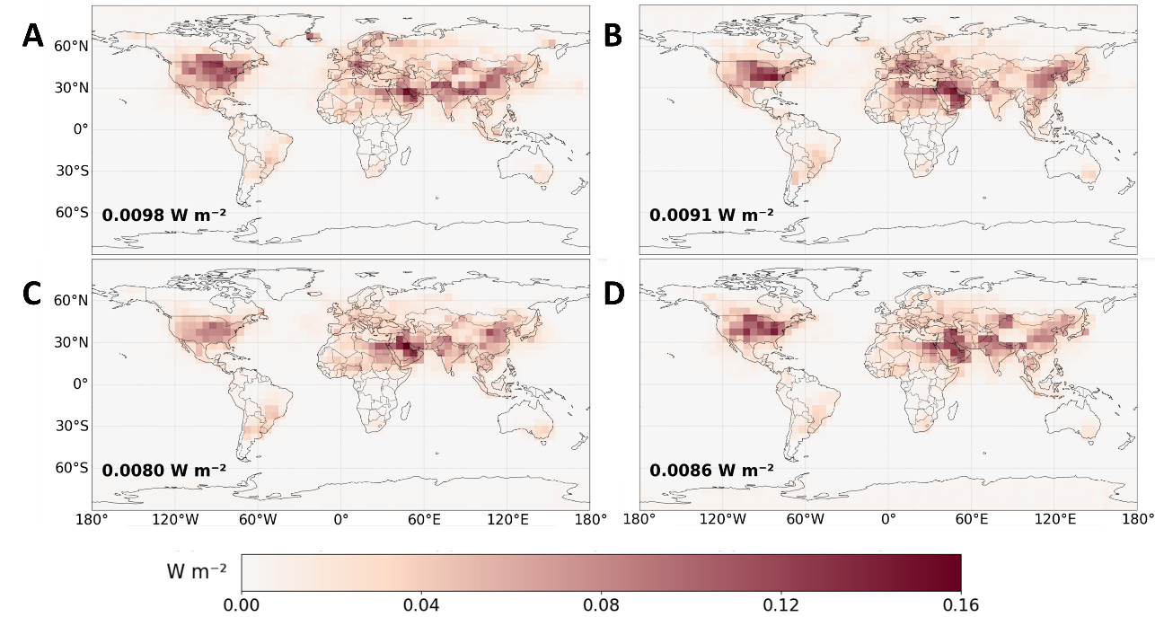

Fig. S14. Seasonal variation of global mean shortwave DRF at the top of atmosphere (TOA) of TWPs under clear-sky conditions. (A to D) Panels show the values for March–May (A), June–August (B), September–November (C), and December–February (D), corresponding to spring, summer, autumn, and winter in the Northern Hemisphere, respectively. The global mean TOA DRF from March to May is 0.0098 W m⁻², from June to August is 0.0091 W m⁻², from September to November is 0.0080 W m⁻², and from December to February is 0.0086 W m⁻².

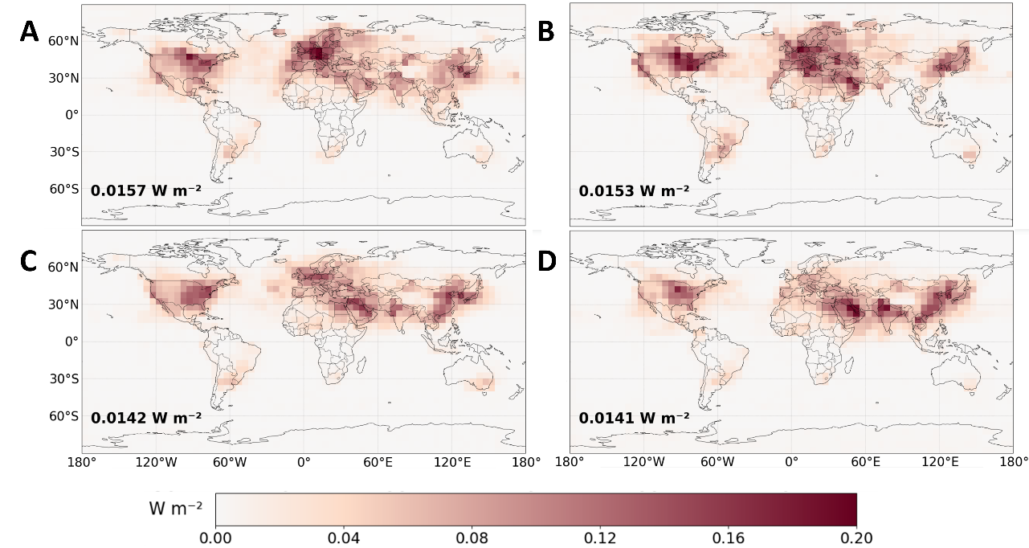

Fig. S15. Seasonal variation of global mean shortwave DRF at the top of atmosphere (TOA) of TWPs under cloudy conditions. (A to D) Panels show the values for March–May (A), June–August (B), September–November (C), and December–February (D), corresponding to spring, summer, autumn, and winter in the Northern Hemisphere, respectively. The global mean DRF at the TOA from March to May is 0.0157 W m⁻², from June to August is 0.0153 W m⁻², from September to November is 0.0142 W m⁻², and from December to February is 0.0141 W m⁻².

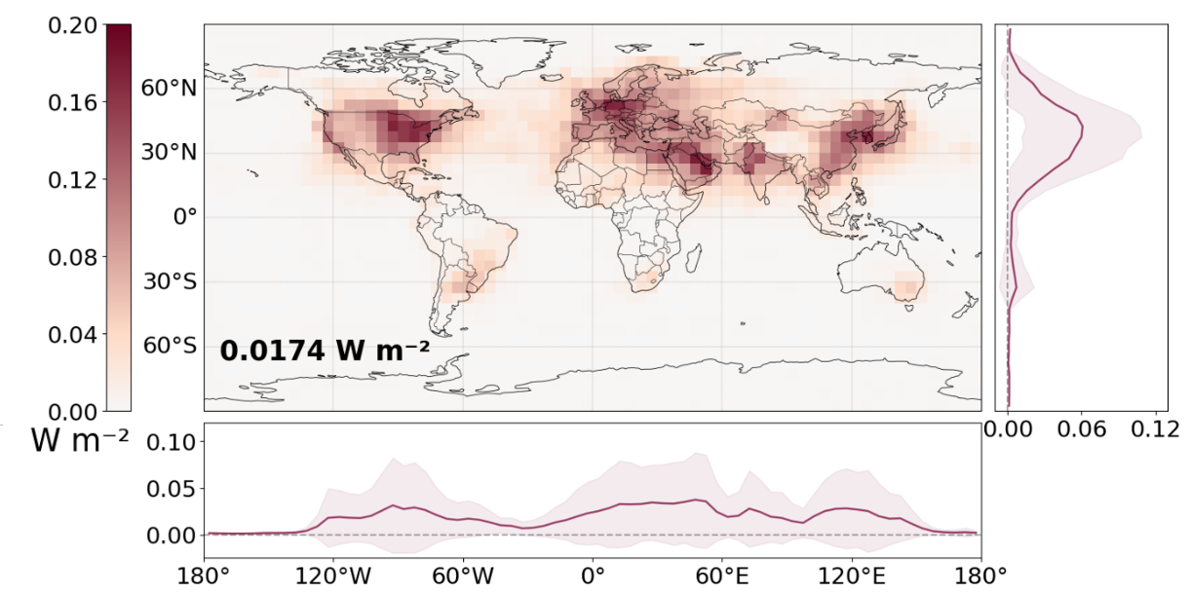

Fig. S16. Spatial distribution of annual mean cloudy-sky TOA shortwave DRF of fine-mode TWPs. This simulation adopts a lognormal particle size distribution with geometric mean diameter of 210 nm and geometric standard deviation of 1.85 derived from previous (46) for sensitivity tests, which is defined as TWPs* throughout this work.

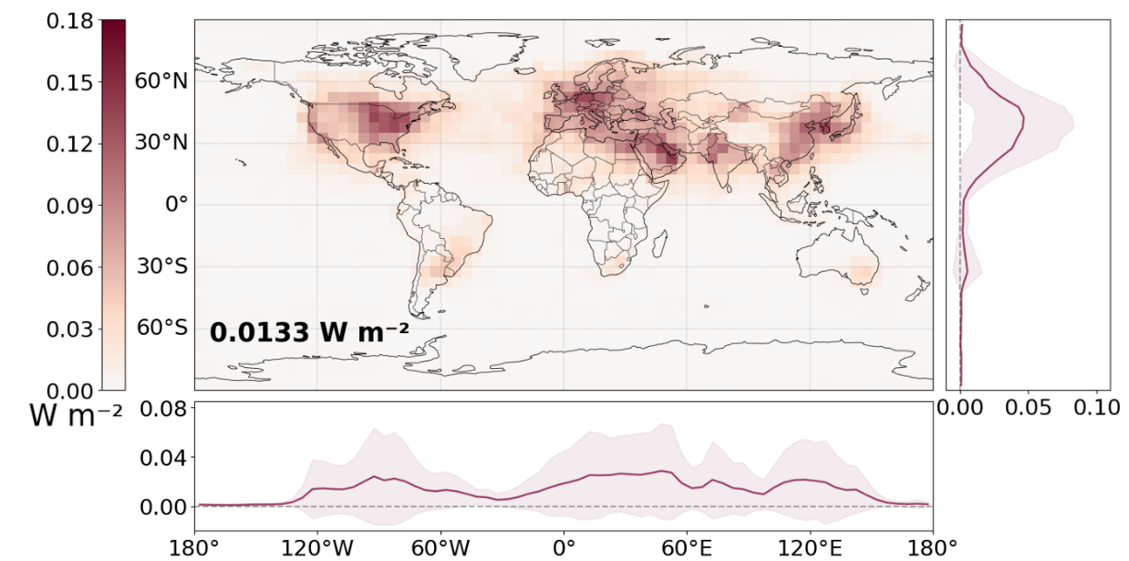

Fig. S17. Spatial distribution of annual mean cloudy-sky TOA shortwave DRF of coarse-mode TWPs. This simulation adopts a lognormal particle size distribution with geometric mean diameter of 403 nm and geometric standard deviation of 2.518 derived from previous study (46) for sensitivity tests, which is defined as TWPs** throughout this work.

Table S1. Optical parameters of TWPs and common light-absorbing carbonaceous aerosols at a wavelength of 550 nm.
Parameter | TWPs | BC (40) | BrC (40) | BrC* (41) | Black BrC-L† (42) | Black BrC-H‡ (42) | BC*§ (41) | Soot (45)
N = n – ki | 1.35−0.28i | 1.8−0.5i | 1.4−0.1i | 1.27−0.27i | 1.31−0.06i | 1.31−0.13i | 1.95−0.79i | 1.75−0.44i
Diameter¶ | 310 nm |  |  | 230 nm |  |  | 32 nm | 12 nm
MAC (m² g⁻¹) | 3.61 |  |  | 3.85 |  |  | 4.55 | 7.32
MSC (m² g⁻¹) | 1.46 |  |  | 3.45 |  |  | 1.35 | 1.93
σabs (× 10⁻¹⁴ m²) | 3.83 × 10¹ |  |  | 4.00 |  |  | 0.80 | 4.38 × 10⁻²
σsca (× 10⁻¹⁴ m²) | 3.43 ×10¹ |  |  | 3.20 |  |  | 0.20 | 1.16 × 10⁻²
SSA | 0.29 |  |  | 0.44 |  |  | 0.23 | 0.21
g | 0.90 |  |  |  |  |  |  | 0.336
The real (n) and imaginary (k) parts of complex refractive index for BC and BrC are properties of individual particles.
*, The BC and BrC are particles obtained under different conditions from another reference study.
†, Black BrC co-emitted with a low BC mass fraction.
‡, Black BrC co-emitted with a high BC mass fraction.
§, Soot carbon is approximately treated as BC* because its complex refractive index in the reference study is consistent with values commonly adopted for BC in aerosol-climate models and its particle size distribution is similar to that of airborne BC. (38, 44)
¶, The diameter denotes geometric mean diameter.

Table S2. Regional surface shortwave DRF induced by TWPs under clear-sky and cloudy conditions. The table shows the annual mean DRF of each region under different conditions, as well as its seasonal variations in March–May, June–August, September–November, and December–February, corresponding to spring, summer, autumn, and winter in the Northern Hemisphere, respectively. The unit of radiative forcing value is W m⁻².
 | Region | Annual | March–May | June–August | September–November | December–February | CV*
 | 66.5°N–90°N | −0.0046 | −0.0050 | −0.0094 | −0.0035 | −0.0005 | 69.8%
 | 23.5°N–66.5°N | −0.0567 | −0.0602 | −0.0681 | −0.0560 | −0.0424 | 16.4%
Clear-sky | 23.5°S–23.5°N | −0.0165 | −0.0176 | −0.0140 | −0.0162 | −0.0182 | 9.8%
 | 23.5°S–66.5°S | −0.0040 | −0.0041 | −0.0039 | −0.0043 | −0.0039 | 4.1%
 | 66.5°S–90°S | −0.0004 | −0.0003 | 0.0000 | −0.0004 | −0.0009 | 81.0%
 | 66.5°N–90°N | −0.0015 | −0.0018 | −0.0032 | −0.0010 | −0.0002 | 73.0%
 | 23.5°N–66.5°N | −0.0278 | −0.0327 | −0.0394 | −0.0233 | −0.0157 | 32.4%
Cloudy conditions | 23.5°S–23.5°N | −0.0116 | −0.0129 | −0.0102 | −0.0112 | −0.0120 | 8.6%
 | 23.5°S–66.5°S | −0.0020 | −0.0019 | −0.0016 | −0.0024 | −0.0022 | 15.2%
 | 66.5°S–90°S | −0.0002 | −0.0001 | 0.0000 | −0.0002 | −0.0004 | 74.0%
*The Coefficient of Variation (CV) is equal to the standard deviation of seasonal DRF divided by the annual mean DRF. It is a statistical indicator that measures the degree of seasonal fluctuations.

Table S3. Regional-scale statistical analysis of shortwave DRF at the top of atmosphere (TOA) induced by TWPs under clear-sky and cloudy conditions.
 | Region | Annual | March–May | June–August | September–November | December–February | CV*
 | 66.5°N–90°N | 0.0023 | 0.0046 | 0.0033 | 0.0010 | 0.0003 | 75.2%
 | 23.5°N–66.5°N | 0.0240 | 0.0275 | 0.0253 | 0.0202 | 0.0230 | 11.3%
Clear-sky | 23.5°S–23.5°N | 0.0062 | 0.0062 | 0.0058 | 0.0063 | 0.0063 | 3.3%
 | 23.5°S–66.5°S | 0.0013 | 0.0012 | 0.0013 | 0.0016 | 0.0012 | 12.6%
 | 66.5°S–90°S | 0.0010 | 0.0004 | 0.0000 | 0.0015 | 0.0021 | 84.0%
 | 66.5°N–90°N | 0.0052 | 0.0076 | 0.0099 | 0.0028 | 0.0004 | 72.4%
 | 23.5°N–66.5°N | 0.0413 | 0.0445 | 0.0462 | 0.0394 | 0.0351 | 10.6%
Cloudy conditions | 23.5°S–23.5°N | 0.0091 | 0.0093 | 0.0069 | 0.0088 | 0.0115 | 18.0%
 | 23.5°S–66.5°S | 0.0028 | 0.0027 | 0.0031 | 0.0031 | 0.0025 | 9.3%
 | 66.5°S–90°S | 0.0009 | 0.0004 | 0.0000 | 0.0013 | 0.0021 | 90.4%

Table S4. Global annual mean shortwave DRF at the top of atmosphere (TOA) of light-absorbing aerosols under cloudy conditions from different studies. GMD means geometric mean diameter, and GSD means geometric standard deviation.
Particle type | DRF (W m⁻²) | Explanation | References
BC | 0.88 |  | Bond et al., 2013 (18)
BC | 0.45 |  | Feng et al., 2013 (19)
BC | 0.22 |  | Wang et al., 2014 (20)
BC | 0.561† | Bottom-up estimation | Wang et al., 2016 Ⅰ (21)
BC | 0.681† | Bayesian estimation | Wang et al., 2016 Ⅱ (21)
BC | 0.17 |  | Wang et al., 2018 (22)
BC | 0.13 | External mixing mode (CTRL) | Tuccella et al., 2020 Ⅰ (23)
BC | 0.24 | Partial internal mixing mode (PIM) | Tuccella et al., 2020 Ⅱ (23)
BC | 0.25 | Core-shell mixing mode (CS) | Tuccella et al., 2020 Ⅲ (23)
BC | 0.36 |  | Matsui et al., 2020 (24)
BC | 0.37 |  | Szopa et al., 2021 Ⅰ (25)
BC | 0.13 |  | Szopa et al., 2021 Ⅱ (25)
BC | 0.35 |  | Szopa et al., 2021 Ⅲ (25)
BC | 0.26 |  | Szopa et al., 2021 IV (25)
BrC | 0.04 | Moderate absorption | Feng et al., 2013 Ⅰ (19)
BrC | 0.11 | Strong absorption | Feng et al., 2013 Ⅱ (19)
BrC | 0.03 |  | Hammer et al., 2016 (26)
BrC | 0.048 |  | Wang et al., 2018 (22)
BrC | 0.13 | BrC in the PIM state of BC | Tuccella et al., 2020 Ⅰ (23)
BrC | 0.15 | BrC in the CS state of BC | Tuccella et al., 2020 Ⅱ (23)
MNPs | 0.039 |  | Liu et al., 2026 (50)
TWPs | 0.0148 |  | This study (GMD = 314 nm, GSD = 2.33)
TWPs* | 0.0174 |  | This study (GMD = 210 nm, GSD = 1.85) (46)
TWPs** | 0.0133 |  | This study (GMD = 403 nm, GSD = 2.52) (46)
†The original value of reference (BC Ⅰ, 0.49; BC Ⅱ, 0.61) is the change between the value of present-day (2007) and pre-industrial (1750). To facilitate comparison, we use the value of 0.071 from Matsui et al. (24) for the year 1750 as a reference, and add the original value to obtain the value for 2007.

References and Notes
1. Y. Wang et al., A review of tire wear particles: Occurrence, adverse effects, and control strategies. Ecotoxicol Environ Saf 283, 116782 (2024).
2. M. Zhang et al., A comprehensive review of tyre wear particles: Formation, measurements, properties, and influencing factors. Atmospheric Environment 297, 119597 (2023).
3. N. Evangeliou et al., Atmospheric transport is a major pathway of microplastics to remote regions. Nat Commun 11, 3381 (2020).
4. B. A. Albrecht, Aerosols, cloud microphysics, and fractional cloudiness. Science 245, 1227-1230 (1989).
5. M. R. Allen, W. J. Ingram, Constraints on future changes in climate and the hydrologic cycle. Nature 419, 224-232 (2002).
6. L. A. Lee, C. L. Reddington, K. S. Carslaw, On the relationship between aerosol model uncertainty and radiative forcing uncertainty. Proc Natl Acad Sci U S A 113, 5820-5827 (2016).
7. V. Ramanathan, G. Carmichael, Global and regional climate changes due to black carbon. Nature Geoscience 1, 221-227 (2008).
8. P. Tiwari, J. B. Cohen, X. Wang, S. Wang, K. Qin, Radiative forcing bias calculation based on COSMO (Core-Shell Mie model Optimization) and AERONET data. npj Climate and Atmospheric Science 6, 193 (2023).
9. L. E. Revell, P. Kuma, E. C. Le Ru, W. R. C. Somerville, S. Gaw, Direct radiative effects of airborne microplastics. Nature 598, 462-467 (2021).
10. R. F. de Assis, F. M. Guerrini, L. A. Santa-Eulalia, W. de Paula Ferreira, An agent-based model for regional market penetration of electric vehicles in Brazil. Journal of Cleaner Production 421, 138477 (2023).
11. R. Kudłak, W. Kisiała, B. Kołsut, Systemic transformation, political reforms and car ownership in Poland. Journal of Transport Geography 117, 103893 (2024).
12. R. Choudhary, V. Vasudevan, Study of vehicle ownership for urban and rural households in India. Journal of Transport Geography 58, 52-58 (2017).
13. L. S. Martins, L. F. Guimaraes, A. B. Botelho Junior, J. A. S. Tenorio, D. C. R. Espinosa, Electric car battery: An overview on global demand, recycling and future approaches towards sustainability. J Environ Manage 295, 113091 (2021).
14. Y. Sun, J. van Wijnen, A. M. J. Ragas, Quantification and mapping of tyre wear emissions: from EU regional analysis to global projections. Environ Int 203, 109720 (2025).
15. R. Li et al., Estimation of Tire Wear Particle Emissions from Civilian Vehicles. Environ Sci Technol 60, 10211-10220 (2026).
16. IEA, Global EV Outlook 2025—Trends in electric car markets (IEA, Paris, 2025).
17. D. Tu, J. Xie, H. Chai, J. Liu, Non-exhaust emissions of battery electric vehicles and their impact on tunnel ventilation. Transportation Research Part D: Transport and Environment 147, 104929 (2025).
18. T. C. Bond et al., Bounding the role of black carbon in the climate system: A scientific assessment. Journal of Geophysical Research: Atmospheres 118, 5380-5552 (2013).
19. Y. Feng, V. Ramanathan, V. R. Kotamarthi, Brown carbon: a significant atmospheric absorber of solar radiation? Atmospheric Chemistry and Physics 13, 8607-8621 (2013).
20. X. Wang et al., Exploiting simultaneous observational constraints on mass and absorption to estimate the global direct radiative forcing of black carbon and brown carbon. Atmospheric Chemistry and Physics 14, 10989-11010 (2014).
21. R. Wang et al., Estimation of global black carbon direct radiative forcing and its uncertainty constrained by observations. Journal of Geophysical Research: Atmospheres 121, 5948-5971 (2016).
22. X. Wang et al., Exploring the observational constraints on the simulation of brown carbon. Atmospheric Chemistry and Physics 18, 635-653 (2018).
23. P. Tuccella, G. Curci, G. Pitari, S. Lee, D. S. Jo, Direct Radiative Effect of Absorbing Aerosols: Sensitivity to Mixing State, Brown Carbon, and Soil Dust Refractive Index and Shape. Journal of Geophysical Research: Atmospheres 125, e2019JD030967 (2020).
24. H. Matsui, Black Carbon Absorption Efficiency Under Preindustrial and Present‐Day Conditions Simulated by a Size‐ and Mixing‐State‐Resolved Global Aerosol Model. Journal of Geophysical Research: Atmospheres 125, e2019JD032316 (2020).
25. S. Szopa et al., Short-lived climate forcers. climate change 2021: the physical science basis. Contribution of Working Group I to the Sixth Assessment Report of the Intergovernmental Panel on Climate Change. Climate Change 2021: The Physical Science Basis. Contribution of Working Group I to the Sixth Assessment Report of the Intergovernmental Panel on Climate Change, 817-922 (2021).
26. M. S. Hammer et al., Interpreting the ultraviolet aerosol index observed with the OMI satellite instrument to understand absorption by organic aerosols: implications for atmospheric oxidation and direct radiative effects. Atmospheric Chemistry and Physics 16, 2507-2523 (2016).
27. Y. Yang et al., Global source attribution of sulfate concentration and direct and indirect radiative forcing. Atmospheric Chemistry and Physics 17, 8903-8922 (2017).
28. Z. Lu et al., Radiative Forcing of Nitrate Aerosols From 1975 to 2010 as Simulated by MOSAIC Module in CESM2‐MAM4. Journal of Geophysical Research: Atmospheres 126, e2021JD034809 (2021).
29. L. Li et al., Dust Direct Radiative Effect Including Large Particles and Component Minerals. Geophysical Research Letters 52, e2025GL119383 (2025).
30. R. L. Reynolds et al., Microplastic and Associated Black Particles From Road‐Tire Wear: Implications for Radiative Effects Across the Cryosphere and in the Atmosphere. Journal of Geophysical Research: Atmospheres 129, e2024JD041116 (2024).
31. C. L. Reddington et al., Primary versus secondary contributions to particle number concentrations in the European boundary layer. Atmospheric Chemistry and Physics 11, 12007-12036 (2011).
32. M. Parmar, A. Vaishya, N. Ojha, M. R. Pandya, I. A. Girach, Addressing observational gaps in aerosol parameters using machine learning: Implications to aerosol radiative forcing. Atmospheric Environment 333, 120661 (2024).
33. J. Haywood, O. Boucher, Estimates of the direct and indirect radiative forcing due to tropospheric aerosols: A review. Reviews of Geophysics 38, 513-543 (2000).
34. C. Chung, in Atmospheric Aerosols - Regional Characteristics - Chemistry and Physics, H. Abdul-Razzak, Ed. (IntechOpen, London, 2012).
35. H. Jethva, O. Torres, C. Ahn, Global assessment of OMI aerosol single‐scattering albedo using ground‐based AERONET inversion. Journal of Geophysical Research: Atmospheres 119, 9020-9040 (2014).
36. C. F. Bohren, D. R. Huffman, in Absorption and Scattering of Light by Small Particles. (1998), pp. 12-56.
37. L. Wang, M. Hasanzadeh Kafshgari, M. Meunier, Optical Properties and Applications of Plasmonic‐Metal Nanoparticles. Advanced Functional Materials 30, 2005400 (2020).
38. T. C. Bond, R. W. Bergstrom, Light Absorption by Carbonaceous Particles: An Investigative Review. Aerosol Science and Technology 40, 27-67 (2007).
39. S. Wagner, P. Klockner, T. Reemtsma, Aging of tire and road wear particles in terrestrial and freshwater environments - A review on processes, testing, analysis and impact. Chemosphere 288, 132467 (2022).
40. J. Zhu, P. A. Crozier, P. Ercius, J. R. Anderson, Derivation of optical properties of carbonaceous aerosols by monochromated electron energy-loss spectroscopy. Microsc Microanal 20, 748-759 (2014).
41. D. T. Alexander, P. A. Crozier, J. R. Anderson, Brown carbon spheres in East Asian outflow and their optical properties. Science 321, 833-836 (2008).
42. R. K. Chakrabarty et al., Shortwave absorption by wildfire smoke dominated by dark brown carbon. Nat Geosci 16, 683-688 (2023).
43. J. C. Anderson et al., Long-term statistical assessment of Aqua-MODIS aerosol optical depth over
coastal regions: bias characteristics and uncertainty sources. Tellus B: Chemical and Physical Meteorology 65, 20805 (2013).
44. A. J. A. Smith, R. G. Grainger, Simplifying the calculation of light scattering properties for black carbon fractal aggregates. Atmospheric Chemistry and Physics 14, 7825-7836 (2014).
45. M. Hess, P. Koepke, I. Schult, Optical Properties of Aerosols and Clouds: The Software Package OPAC. Bulletin of the American Meteorological Society 79, 831-844 (1998).
46. C. A. Alves et al., Physical and chemical properties of non-exhaust particles generated from wear between pavements and tyres. Atmospheric Environment 224, 117252 (2020).
47. I. B. Ocko, V. Ramaswamy, P. Ginoux, Y. Ming, L. W. Horowitz, Sensitivity of scattering and absorbing aerosol direct radiative forcing to physical climate factors. Journal of Geophysical Research: Atmospheres 117, D20203 (2012).
48. S. Fiedler et al., Anthropogenic aerosol forcing – insights from multiple estimates from aerosol-climate models with reduced complexity. Atmospheric Chemistry and Physics 19, 6821-6841 (2019).
49. R. Saleh et al., Contribution of brown carbon and lensing to the direct radiative effect of carbonaceous aerosols from biomass and biofuel burning emissions. Journal of Geophysical Research: Atmospheres 120, 10285–10296 (2015).
50. Y. Liu et al., Atmospheric warming contributions from airborne microplastics and nanoplastics. Nature Climate Change 16, 598–605 (2026).
51. J. Gao, Y. Huang, Y. Peng, J. S. Wright, Aerosol Effects on Clear‐Sky Shortwave Heating in the Asian Monsoon Tropopause Layer. Journal of Geophysical Research: Atmospheres 128, e2022JD036956 (2023).
52. I. Park, H. Kim, S. Lee, Characteristics of tire wear particles generated in a laboratory simulation of tire/road contact conditions. Journal of Aerosol Science 124, 30-40 (2018).
53. F. Sommer et al., Tire Abrasion as a Major Source of Microplastics in the Environment. Aerosol and Air Quality Research 18, 2014-2028 (2018).
54. C. Johannessen, J. Liggio, X. Zhang, A. Saini, T. Harner, Composition and transformation chemistry of tire-wear derived organic chemicals and implications for air pollution. Atmospheric Pollution Research 13, 101533 (2022).
55. J. A. Alexander et al., High-resolution monochromated electron energy-loss spectroscopy of organic photovoltaic materials. Ultramicroscopy 180, 125-132 (2017).
56. B. J. Sumlin, W. R. Heinson, R. K. Chakrabarty, Retrieving the aerosol complex refractive index using PyMieScatt: A Mie computational package with visualization capabilities. Journal of Quantitative Spectroscopy and Radiative Transfer 205, 127-134 (2018).
57. N. Sakaguchi, L. Tanda, Y. Kunisada, Improving the measurement of dielectric function by TEM-EELS: avoiding the retardation effect. Microscopy (Oxf) 65, 415-421 (2016).
58. H. Raether, Surface plasma oscillations as a tool for surface examinations. Surface Science 8, 233-246 (1967).
59. R. F. Egerton, Electron energy-loss spectroscopy in the TEM. Reports on Progress in Physics 72, 016502 (2009).
60. R. H. Ritchie, R. E. Wilems, Photon-Plasmon Interaction in a Nonuniform Electron Gas. I. Physical Review 178, 372-381 (1969).
61. G. V. Umoh et al., Complex dielectric function, Cole-Cole, and optical properties evaluation in BiMnO3 thin-films by Valence Electron Energy Loss Spectrometry (VEELS) analysis. Ceramics International 48, 22141-22146 (2022).
62. H. Yan, L. Zhang, L. Liu, S. Wen, Investigation of the external conditions and material compositions affecting the formation mechanism and size distribution of tire wear particles. Atmospheric Environment 244, 118018 (2021).
63. Q. Zhang et al., Size distribution, chemical composition and influencing factors of vehicle tire wear particles based on a novel test cycle. Environ Res 268, 120817 (2025).
64. C. Zhong et al., Characteristics of Vehicle Tire and Road Wear Particles’ Size Distribution and Influencing Factors Examined via Laboratory Test. Atmosphere 15, 423 (2024).
65. J. Kim et al., Potential release of nano-carbon black from tire-wear particles through the weathering effect. Journal of Industrial and Engineering Chemistry 96, 322-329 (2021).
66. S. Dittmar et al., Settling Velocities of Tire and Road Wear Particles: Analyzing Finely Graded Density Fractions of Samples from a Road Simulator and a Highway Tunnel. Environmental Science & Technology 59, 13434-13446 (2025).
67. P. Ricchiazzi, S. Yang, C. Gautier, D. Sowle, SBDART: A Research and Teaching Software Tool for Plane-Parallel Radiative Transfer in the Earth's Atmosphere. Bulletin of the American Meteorological Society 79, 2101-2114 (1998).
68. H. Hersbach et al., ERA5 monthly averaged data on single levels from 1940 to present (CDS, 2023).

