Table-of-contents
Supplementary Text
Table 1 to 4
Figs. 1 to 14
Supplementary Table 1 | Optical parameters of TWPs and common light-absorbing carbonaceous aerosols at a wavelength of 550 nm.
Parameter | TWPs | BC¹ | BrC¹ | BrC*² | Black BrC-L^{a3} | Black BrC-H^{b3} | BC*^{c2} | Soot⁴
N = n – ki | 1.35−0.28i | 1.8−0.5i | 1.4−0.1i | 1.67−0.27i | 1.31−0.06i | 1.31−0.13i | 1.95−0.79i | 1.75−0.44i
Diameter^{d} | 310 nm |  |  | 230 nm |  |  | 32 nm | 12 nm
MAC (m² g⁻¹) | 1.41 |  |  | 3.85 |  |  | 4.55 | 7.32
MSC (m² g⁻¹) | 1.28 |  |  | 3.45 |  |  | 1.35 | 1.93
σabs (× 10⁻¹⁴ m²) | 1.26 × 10² |  |  | 4.00 |  |  | 0.80 | 4.38 × 10⁻²
σsca (× 10⁻¹⁴ m²) | 1.15 ×10² |  |  | 3.20 |  |  | 0.20 | 1.16 × 10⁻²
SSA | 0.48 |  |  | 0.44 |  |  | 0.23 | 0.21
g | 0.91 |  |  |  |  |  |  | 0.336
The real (n) and imaginary (k) parts of complex refractive index for BC and BrC are properties of individual particles.
*, The BC and BrC are particles obtained under different conditions from another reference study.
a, Black BrC co-emitted with a high BC mass fraction.
b, Black BrC co-emitted with a low BC mass fraction.
c, Soot carbon is approximately treated as BC* because its complex refractive index in the reference study is consistent with values commonly adopted for BC in aerosol-climate models and its particle size distribution is similar to that of airborne BC.^{5,6}
d, The diameter denotes geometric mean diameter.

Supplementary Table 2 | Regional surface DRF induced by TWPs under clear-sky and cloudy conditions. The table shows the annual mean DRF of each region under different conditions, as well as its seasonal variations in March–May, June–August, September–November, and December–February, corresponding to spring, summer, autumn, and winter in the Northern Hemisphere, respectively. The unit of radiative forcing value is W m⁻².
 | Region | Annual | March–May | June–August | September–November | December–February | CV*
 | 66.5°N–90°N | −0.0318 | −0.0350 | −0.0637 | −0.0249 | −0.0036 | 78.2%
 | 23.5°N–66.5°N | −0.3718 | −0.3922 | −0.4363 | −0.3701 | −0.2884 | 13.1%
Clear-sky | 23.5°S–23.5°N | −0.1049 | −0.1119 | −0.0879 | −0.1024 | −0.1172 | 11.2%
 | 23.5°S–66.5°S | −0.0264 | −0.0268 | −0.0262 | −0.0279 | −0.0245 | 5.4%
 | 66.5°S–90°S | −0.0027 | −0.0018 | −0.0002 | −0.0027 | −0.0062 | 87.8%
 | 66.5°N–90°N | −0.0092 | −0.0106 | −0.0186 | −0.0062 | −0.0012 | 88.0%
 | 23.5°N–66.5°N | −0.1652 | −0.1947 | −0.2338 | −0.1385 | −0.0935 | 39.9%
Cloudy conditions | 23.5°S–23.5°N | −0.0695 | −0.0776 | −0.0611 | −0.0670 | −0.0723 | 10.3%
 | 23.5°S–66.5°S | −0.0119 | −0.0113 | −0.0095 | −0.0140 | −0.0130 | 13.4%
 | 66.5°S–90°S | −0.0011 | −0.0005 | −0.0001 | −0.0013 | −0.0026 | 90.9%
*The Coefficient of Variation (CV) is equal to the standard deviation of seasonal DRF divided by the annual mean DRF. It is a statistical indicator that measures the degree of seasonal fluctuations.
Supplementary Table 3 | Regional-scale statistical analysis of DRF at the top of atmosphere (TOA) induced by TWPs under clear-sky and cloudy conditions.
 | Region | Annual | March–May | June–August | September–November | December–February | CV*
 | 66.5°N–90°N | 0.0070 | 0.0183 | 0.0086 | 0.0006 | 0.0005 | 127.1%
 | 23.5°N–66.5°N | 0.0972 | 0.1192 | 0.1049 | 0.0709 | 0.0939 | 19.8%
Clear-sky | 23.5°S–23.5°N | 0.0257 | 0.0254 | 0.0263 | 0.0264 | 0.0245 | 3.1%
 | 23.5°S–66.5°S | 0.0044 | 0.0039 | 0.0031 | 0.0059 | 0.0048 | 25.0%
 | 66.5°S–90°S | 0.0055 | 0.0019 | 0.0002 | 0.0084 | 0.0115 | 98.2%
 | 66.5°N–90°N | 0.0291 | 0.0409 | 0.0579 | 0.0157 | 0.0020 | 93.5%
 | 23.5°N–66.5°N | 0.2387 | 0.2578 | 0.2639 | 0.2291 | 0.2387 | 6.3%
Cloudy conditions | 23.5°S–23.5°N | 0.0505 | 0.0512 | 0.0382 | 0.0484 | 0.0644 | 17.8%
 | 23.5°S–66.5°S | 0.0164 | 0.0158 | 0.0180 | 0.0177 | 0.0141 | 9.7%
 | 66.5°S–90°S | 0.0056 | 0.0024 | 0.0002 | 0.0074 | 0.0123 | 96.4%

Supplementary Table 4 | Global annual mean DRF at the top of atmosphere (TOA) of light-absorbing aerosols under cloudy conditions from different studies.
Particle type | DRF (W m⁻²) | Explanation | References
BC | 0.88 |  | Bond et al., 2013⁷
BC | 0.45 |  | Feng et al., 2013⁸
BC | 0.22 |  | Wang et al., 2014⁹
BC | 0.561* | Bottom-up estimation | Wang et al., 2016 Ⅰ¹⁰
BC | 0.681* | Bayesian estimation | Wang et al., 2016 Ⅱ¹⁰
BC | 0.17 |  | Wang et al., 2018¹¹
BC | 0.13 | external mixing mode (CTRL) | Tuccella et al., 2020 Ⅰ¹²
BC | 0.24 | partial internal mixing mode (PIM) | Tuccella et al., 2020 Ⅱ¹²
BC | 0.25 | core-shell mixing mode (CS) | Tuccella et al., 2020 Ⅲ¹²
BC | 0.36 |  | Matsui et al., 2020¹³
BrC | 0.04 | moderate absorption | Feng et al., 2013 Ⅰ⁸
BrC | 0.11 | strong absorption | Feng et al., 2013 Ⅱ⁸
BrC | 0.03 |  | Hammer et al., 2016¹⁴
BrC | 0.048 |  | Wang et al., 2018¹¹
BrC | 0.13 | BrC in the PIM state of BC | Tuccella et al., 2020 Ⅰ¹²
BrC | 0.15 | BrC in the CS state of BC | Tuccella et al., 2020 Ⅱ¹²
TWPs | 0.0847 |  | This study
*The original value of reference (BC Ⅰ, 0.49; BC Ⅱ, 0.61) is the change between the value of present-day (2007) and pre-industrial (1750). To facilitate comparison, we use the value of 0.071 from Matsui et al.¹³ for the year 1750 as a reference, and add the original value to obtain the value for 2007.

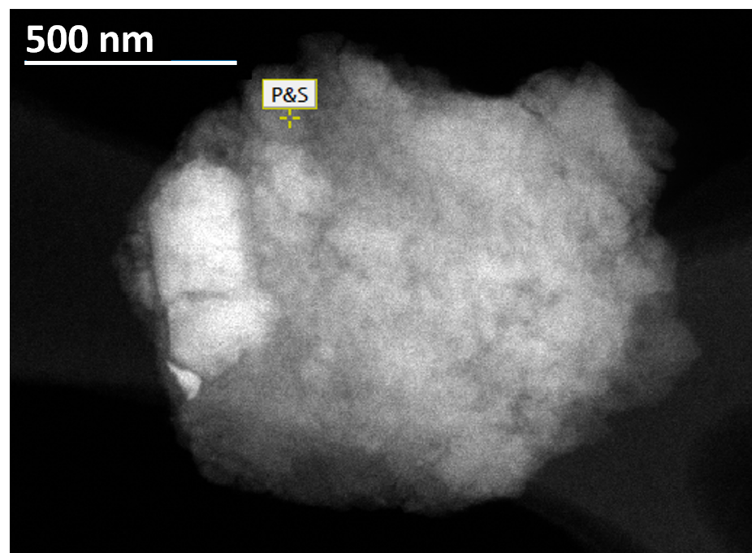
Supplementary Fig. 1 | STEM image of an individual TWP. The yellow maker indicates the scanning point.

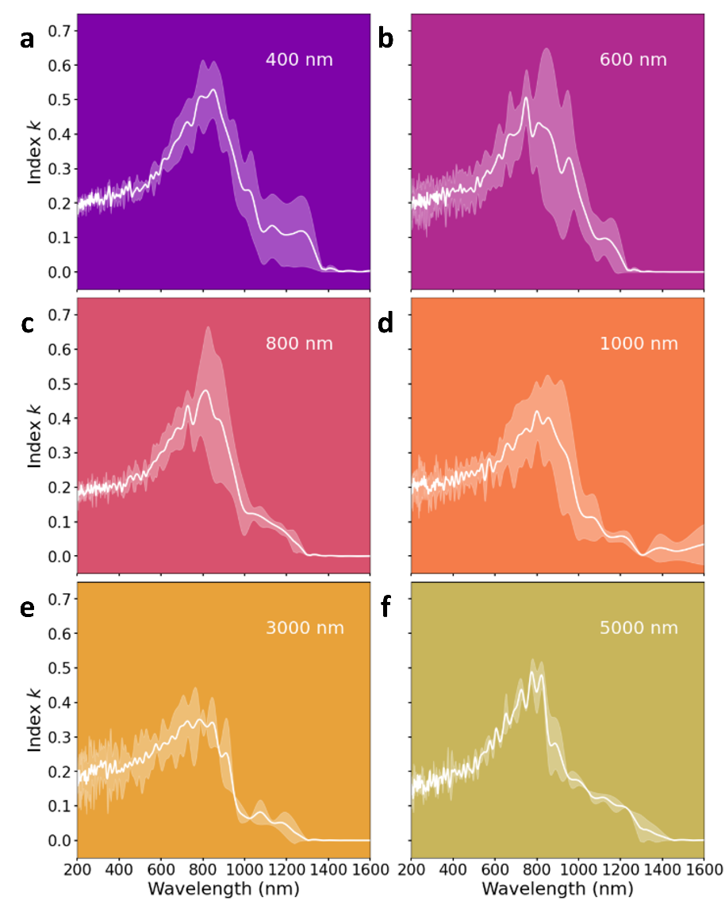
Supplementary Fig. 2 | Mean k values of individual TWPs across multiple particle size ranges. The imaginary part (k) of complex refractive index, obtained by VEELS, is plotted over the optical wavelength range of 200–1600 nm. The k shows a pronounced wavelength dependence, with a clear peak at wavelengths near 750 nm, followed by a rapid decay toward zero. Shaded regions represent the standard deviations.

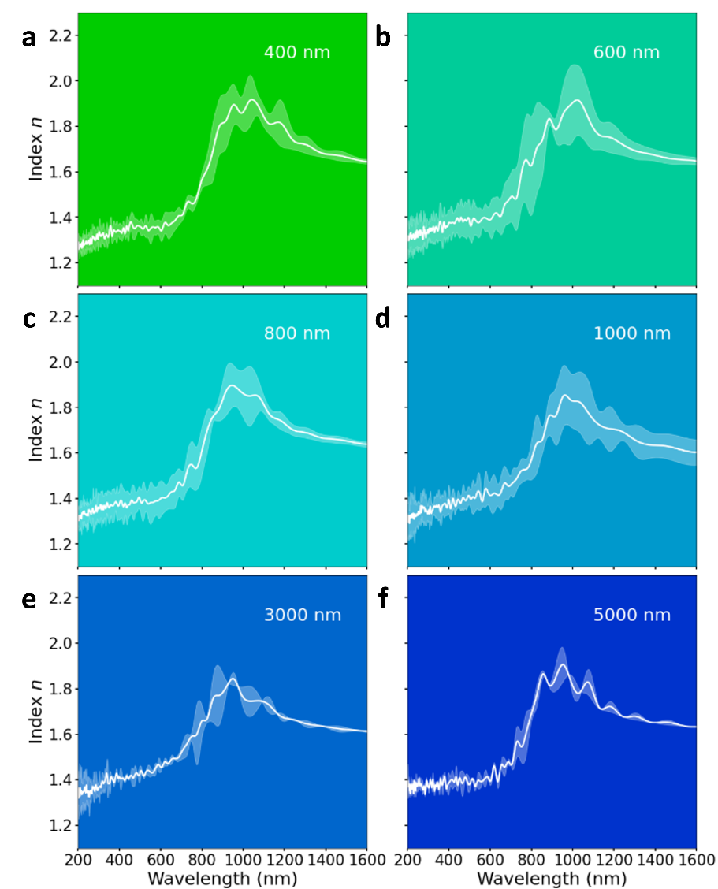
Supplementary Fig. 3 | Mean n values of individual TWPs across multiple particle size ranges. The real part (n) of complex refractive index, obtained by VEELS, is plotted over the optical wavelength range of 200–1600 nm. Like k in Supplementary Fig. 2, n also exhibits a pronounced wavelength dependence, but with a near-infrared inflection followed by a gentle decrease. Both n and k show size-independent spectral shapes, with only minor differences in amplitude. This suggests that intrinsic optical constants dominate the spectral behavior of single particles. TWPs exhibit absorption-dominated behavior in the ultraviolet (200–380 nm) and visible (380–780 nm) bands, while shifting toward scattering dominance in the infrared (780–1600 nm) band. Shaded regions represent the standard deviations.

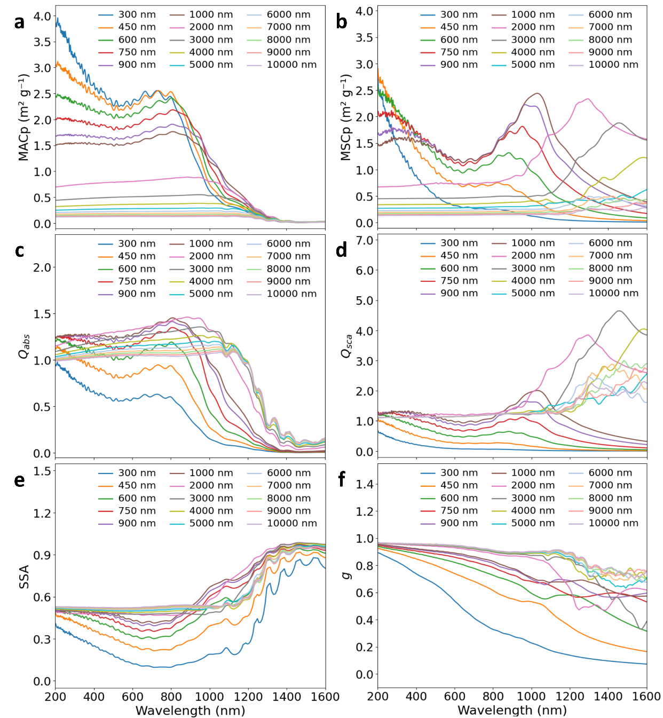
Supplementary Fig. 4 | Optical properties of individual TWPs. The per-particle mass absorption cross-section MACp (a), per-particle mass scattering cross-section MSCp (b), absorption efficiency Qabs (c), scattering efficiency Qsca (d), single-scattering albedo SSA (e), and asymmetry factor g (f) of individual TWPs are shown with various particle sizes from 300 nm to 10 μm, as calculated by Mie theory using mean complex refractive indices over the optical wavelength range of 200–1600 nm. Qabs​ and MACp of individual particles are higher at shorter wavelengths and generally decrease with increasing wavelength, whereas Qsca and MSCp rise markedly into the near-infrared. Correspondingly, SSA increases with increasing wavelength, while g declines overall, indicating reduced forward scattering at longer wavelengths.

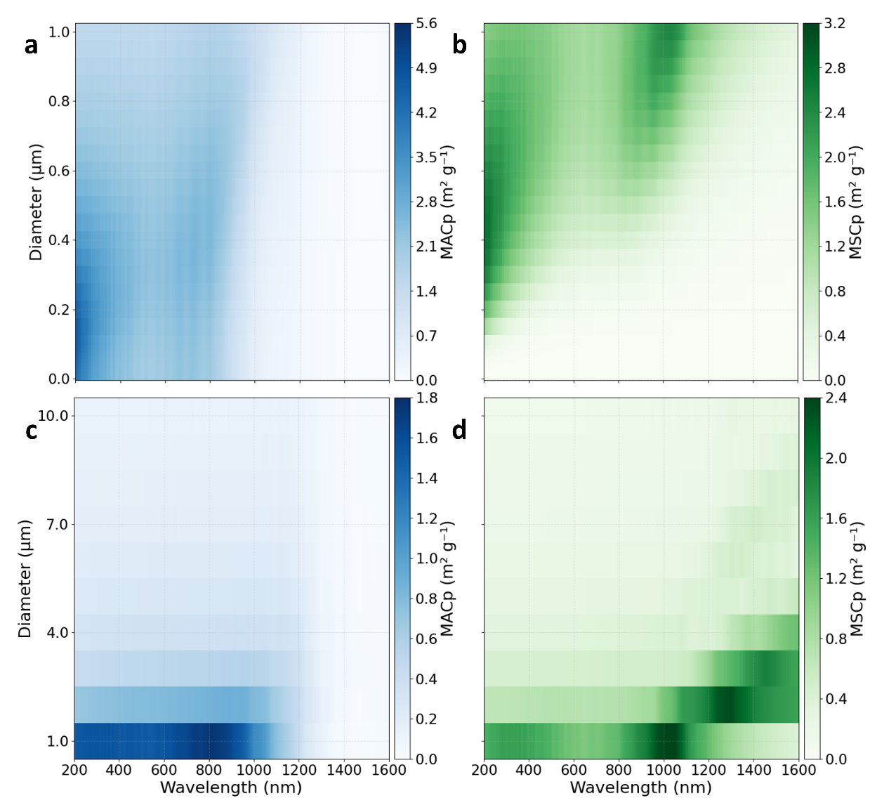
Supplementary Fig. 5 | Per-particle mass absorption (MACp) and per-particle mass scattering (MSCp) cross-section of TWPs below and above 1 μm. The MACp and MSCp of TWPs with particle sizes below 1 μm (1 nm–1 µm) (a, b) and above 1 μm (1 µm–10 µm) (c, d) are shown over the optical wavelength range of 200–1600 nm. MACp exhibits an obvious decrease as TWP diameter increases from submicron to supermicron in the ultraviolet (200–380 nm) and visible (380–780 nm) bands, while MSCp shows enhanced size sensitivity that becomes more pronounced in the infrared (780–1600 nm) band.

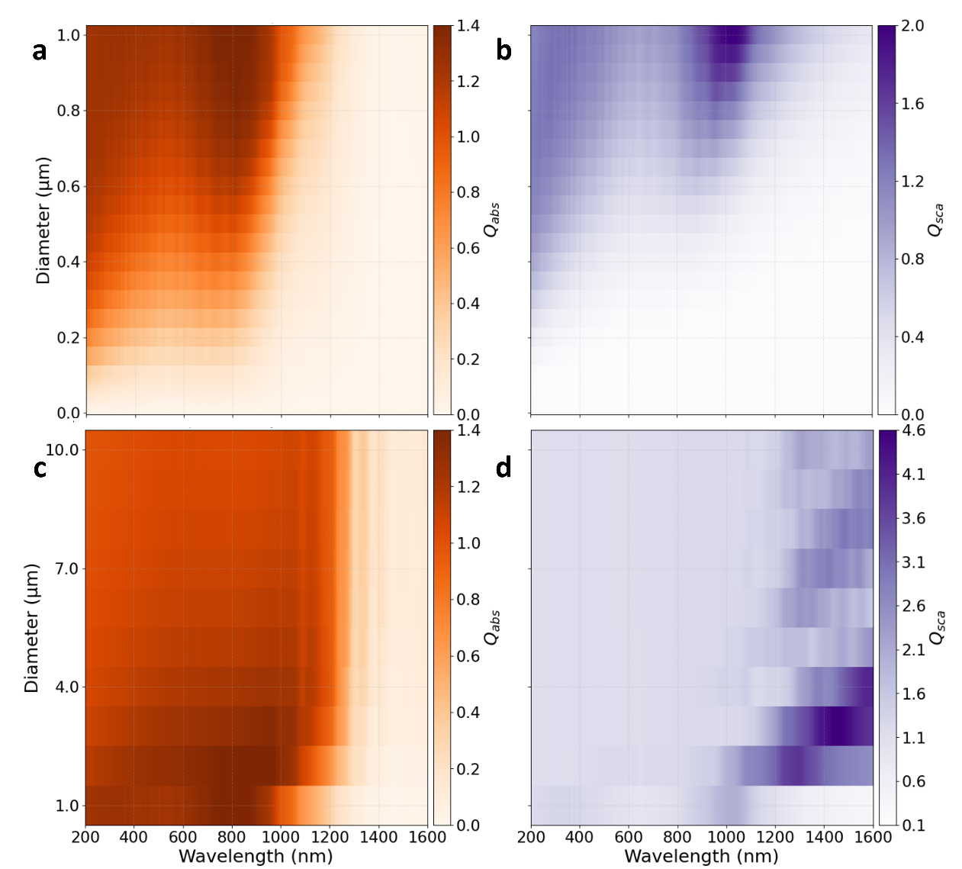
Supplementary Fig. 6 | Absorption (Qabs) and scattering (Qsca) efficiency of individual TWPs below and above 1 μm. The Qabs and Qsca of individual TWPs with particle sizes below 1 μm (1 nm–1 µm) (a, b) and above 1 μm (1 µm–10 µm) (c, d) are plotted over the optical wavelength range of 200–1600 nm. In contrast to per-particle mass absorption (MACp), Qabs increases with increasing diameter for submicron TWPs but shows opposite size-dependent trends at shorter and longer wavelengths for supermicron particles. Qsca shows enhanced size dependence than Qabs, and this dependence increases in the infrared for supermicron TWPs.

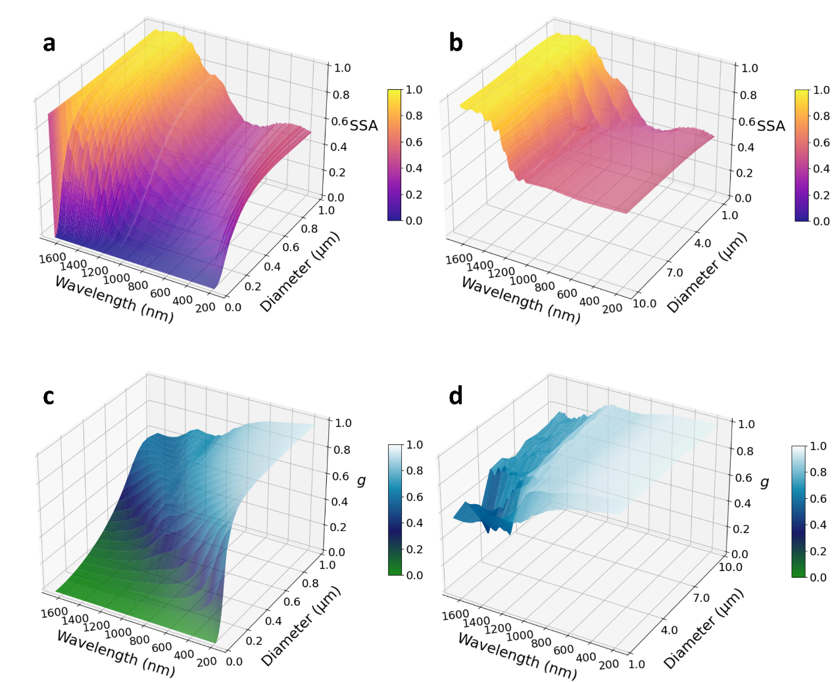
Supplementary Fig. 7 | Single-scattering albedo (SSA) and asymmetry factor (g) of individual TWPs below and above 1 μm. The SSA and g of individual TWPs with particle sizes below 1 μm (1 nm–1 µm) (a, b) and above 1 μm (1 µm–10 µm) (c, d) are plotted over the optical wavelength range of 200–1600 nm. As diameter increases from submicron to supermicron range, g at shorter wavelengths increases significantly. Decreasing absorption and increasing scattering yield a monotonic increase in SSA with particle size at most wavelengths. Based on the wavelength- and size-dependent variation trends of individual particles, submicron individual TWPs display more pronounced absorption in the shortwave region, while supermicron individual TWPs contribute predominantly to enhanced scattering in the infrared region.

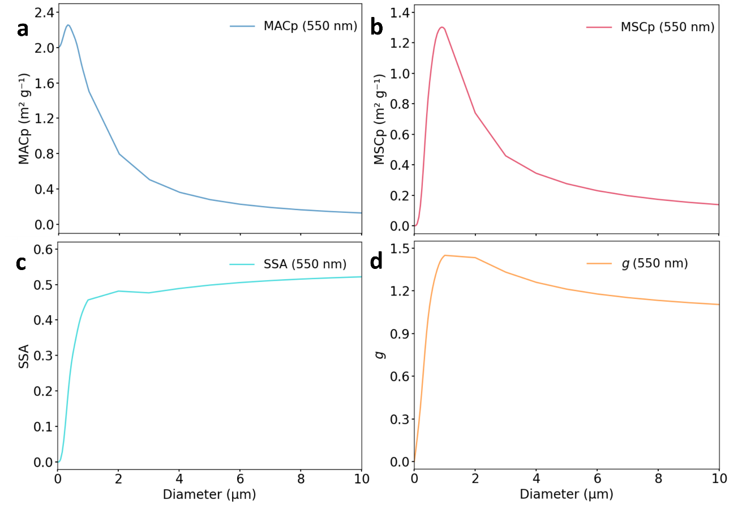
Supplementary Fig. 8 | Optical properties of individual TWPs at a wavelength of 550 nm. Panels show MAC (a), MSC (b), single-scattering albedo SSA (c), and asymmetry factor g (d) as a function of particle size.

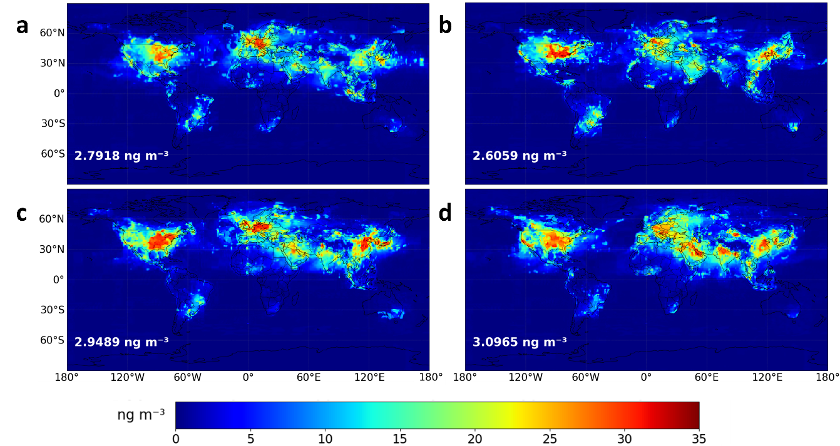
Supplementary Fig. 9 | Global seasonal mean surface concentration distribution of TWPs. Panels show the values for March–May (a), June–August (b), September–November (c), and December–February (d), corresponding to spring, summer, autumn, and winter in the Northern Hemisphere, respectively. The global mean concentration from March to May is 2.7918 ng m⁻³, from June to August is 2.6059 ng m⁻³, from September to November is 2.9489 ng m⁻³, and from December to February is 3.0965 ng m⁻³. The data were published in the previous study¹⁵.

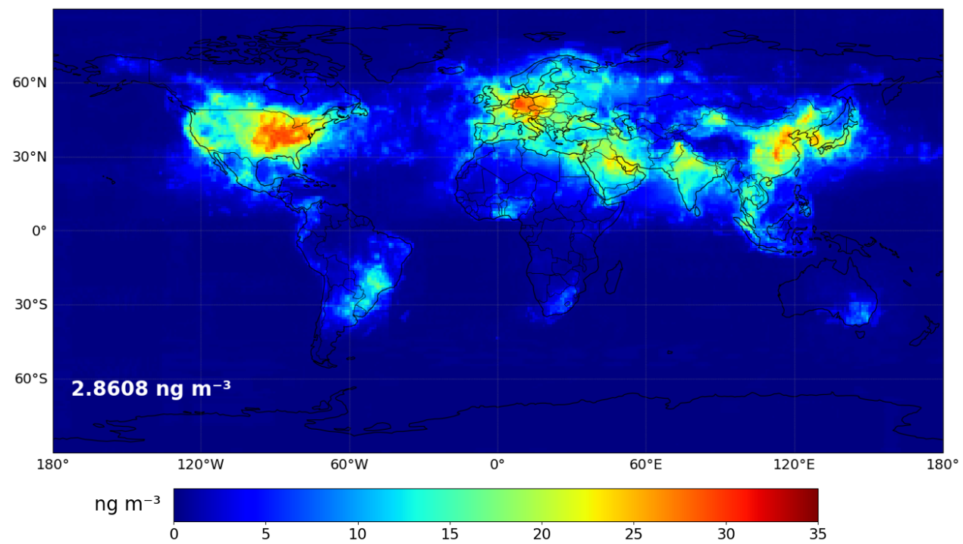
Supplementary Fig. 10 | Global annual mean surface concentration distribution of TWPs. The global annual mean concentration is 2.8608 ng m⁻³. The data were published in the previous study¹⁵.

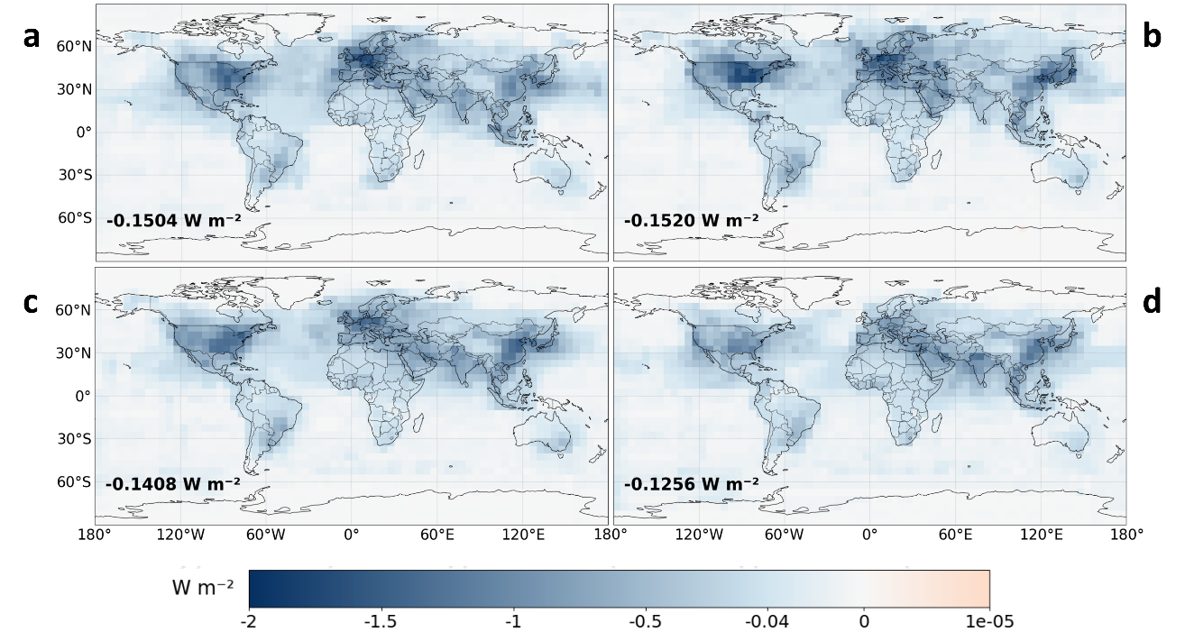
Supplementary Fig. 11 | Seasonal variation of global mean surface DRF of TWPs under clear-sky conditions. Panels show the values for March–May (a), June–August (b), September–November (c), and December–February (d), corresponding to spring, summer, autumn, and winter in the Northern Hemisphere, respectively. The global mean surface DRF from March to May is −0.1504 W m⁻², from June to August is −0.1520 W m⁻², from September to November is −0.1408 W m⁻², and from December to February is −0.1256 W m⁻².

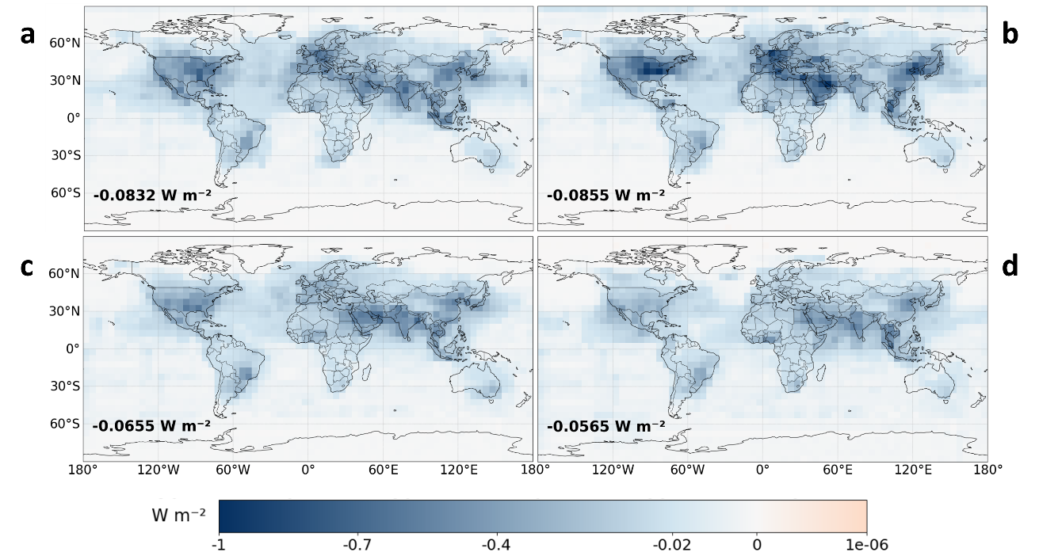
Supplementary Fig. 12 | Seasonal variation of global mean surface DRF of TWPs under cloudy conditions. Panels show the values for March–May (a), June–August (b), September–November (c), and December–February (d), corresponding to spring, summer, autumn, and winter in the Northern Hemisphere, respectively. The global mean surface DRF from March to May is −0.0832 W m⁻², from June to August is −0.0855 W m⁻², from September to November is −0.0655 W m⁻², and from December to February is −0.0565 W m⁻².

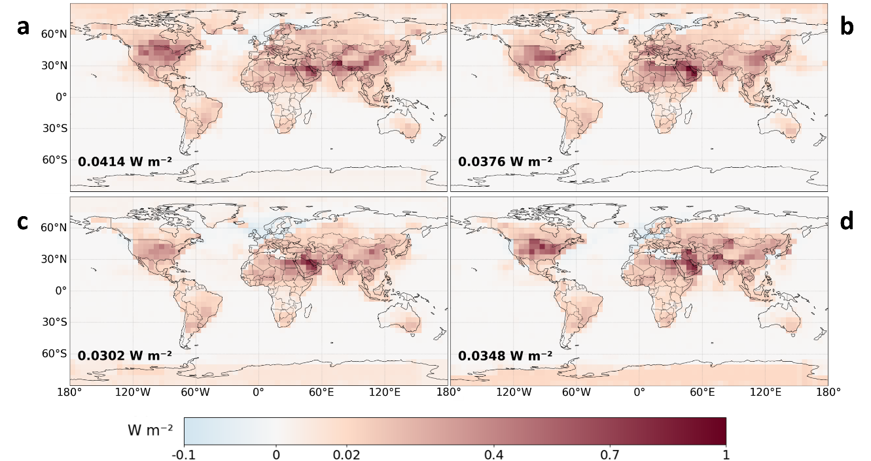
Supplementary Fig. 13 | Seasonal variation of global mean DRF at the top of atmosphere (TOA) of TWPs under clear-sky conditions. Panels show the values for March–May (a), June–August (b), September–November (c), and December–February (d), corresponding to spring, summer, autumn, and winter in the Northern Hemisphere, respectively. The global mean TOA DRF from March to May is 0.0414 W m⁻², from June to August is 0.0376 W m⁻², from September to November is 0.0302 W m⁻², and from December to February is 0.0348 W m⁻².

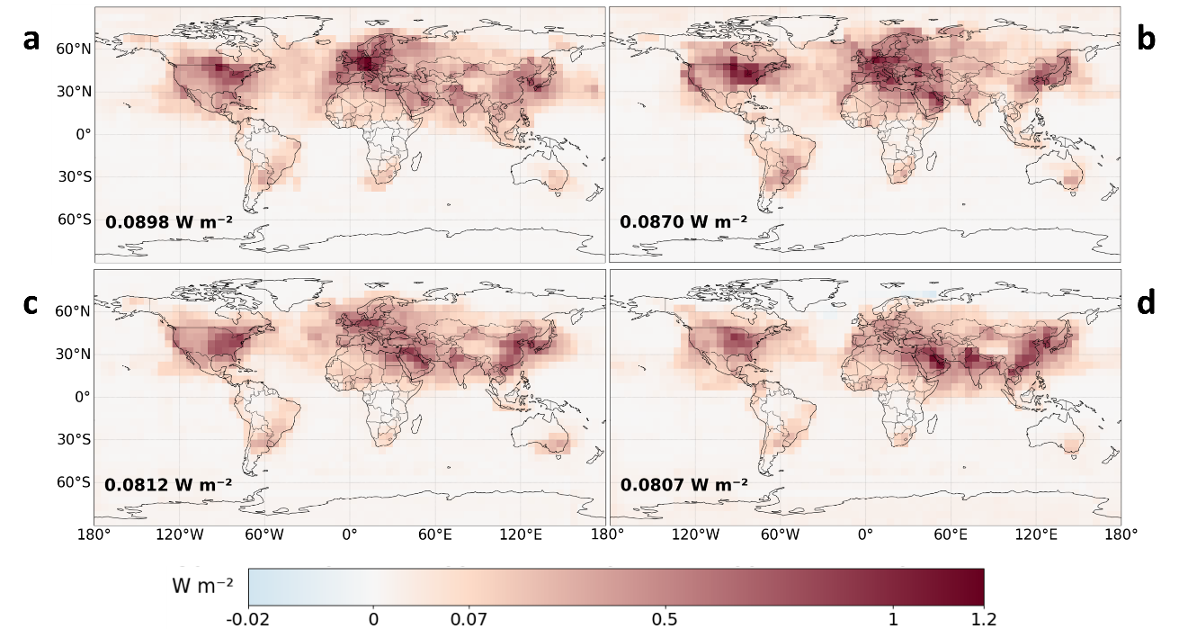
Supplementary Fig. 14 | Seasonal variation of global mean DRF at the top of atmosphere (TOA) of TWPs under cloudy conditions. March–May (a), June–August (b), September–November (c), December–February (d), corresponding to spring, summer, autumn, and winter in the Northern Hemisphere, respectively. The global mean DRF at the TOA from March to May is 0.0898 W m⁻², from June to August is 0.0870 W m⁻², from September to November is 0.0812 W m⁻², and from December to February is 0.0807 W m⁻².

References
1 Zhu, J., Crozier, P. A., Ercius, P. & Anderson, J. R. Derivation of optical properties of carbonaceous aerosols by monochromated electron energy-loss spectroscopy. Microsc Microanal 20, 748-759 (2014). https://doi.org/10.1017/S143192761400049X
2 Alexander, D. T., Crozier, P. A. & Anderson, J. R. Brown carbon spheres in East Asian outflow and their optical properties. Science 321, 833-836 (2008). https://doi.org/10.1126/science.1155296
3 Chakrabarty, R. K. et al. Shortwave absorption by wildfire smoke dominated by dark brown carbon. Nat Geosci 16, 683-688 (2023). https://doi.org/10.1038/s41561-023-01237-9
4 Hess, M., Koepke, P. & Schult, I. Optical Properties of Aerosols and Clouds: The Software Package OPAC. Bulletin of the American Meteorological Society 79, 831-844 (1998). https://doi.org/10.1175/1520-0477(1998)079<0831:Opoaac>2.0.Co;2
5 Bond, T. C. & Bergstrom, R. W. Light Absorption by Carbonaceous Particles: An Investigative Review. Aerosol Science and Technology 40, 27-67 (2007). https://doi.org/10.1080/02786820500421521
6 Smith, A. J. A. & Grainger, R. G. Simplifying the calculation of light scattering properties for black carbon fractal aggregates. Atmospheric Chemistry and Physics 14, 7825-7836 (2014). https://doi.org/10.5194/acp-14-7825-2014
7 Bond, T. C. et al. Bounding the role of black carbon in the climate system: A scientific assessment. Journal of Geophysical Research: Atmospheres 118, 5380-5552 (2013). https://doi.org/10.1002/jgrd.50171
8 Feng, Y., Ramanathan, V. & Kotamarthi, V. R. Brown carbon: a significant atmospheric absorber of solar radiation? Atmospheric Chemistry and Physics 13, 8607-8621 (2013). https://doi.org/10.5194/acp-13-8607-2013
9 Wang, X. et al. Exploiting simultaneous observational constraints on mass and absorption to estimate the global direct radiative forcing of black carbon and brown carbon. Atmospheric Chemistry and Physics 14, 10989-11010 (2014). https://doi.org/10.5194/acp-14-10989-2014
10 Wang, R. et al. Estimation of global black carbon direct radiative forcing and its uncertainty constrained by observations. Journal of Geophysical Research: Atmospheres 121, 5948-5971 (2016). https://doi.org/10.1002/2015jd024326
11 Wang, X. et al. Exploring the observational constraints on the simulation of brown carbon. Atmospheric Chemistry and Physics 18, 635-653 (2018). https://doi.org/10.5194/acp-18-635-2018
12 Tuccella, P., Curci, G., Pitari, G., Lee, S. & Jo, D. S. Direct Radiative Effect of Absorbing Aerosols: Sensitivity to Mixing State, Brown Carbon, and Soil Dust Refractive Index and Shape. Journal of Geophysical Research: Atmospheres 125 (2020). https://doi.org/10.1029/2019jd030967
13 Matsui, H. Black Carbon Absorption Efficiency Under Preindustrial and Present‐Day Conditions Simulated by a Size‐ and Mixing‐State‐Resolved Global Aerosol Model. Journal of Geophysical Research: Atmospheres 125 (2020). https://doi.org/10.1029/2019jd032316
14 Hammer, M. S. et al. Interpreting the ultraviolet aerosol index observed with the OMI satellite instrument to understand absorption by organic aerosols: implications for atmospheric oxidation and direct radiative effects. Atmospheric Chemistry and Physics 16, 2507-2523 (2016). https://doi.org/10.5194/acp-16-2507-2016
15 Evangeliou, N. et al. Atmospheric transport is a major pathway of microplastics to remote regions. Nat Commun 11, 3381 (2020). https://doi.org/10.1038/s41467-020-17201-9

