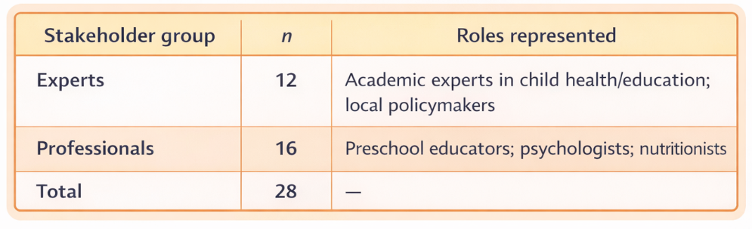
Table 1. Participant groups and roles.

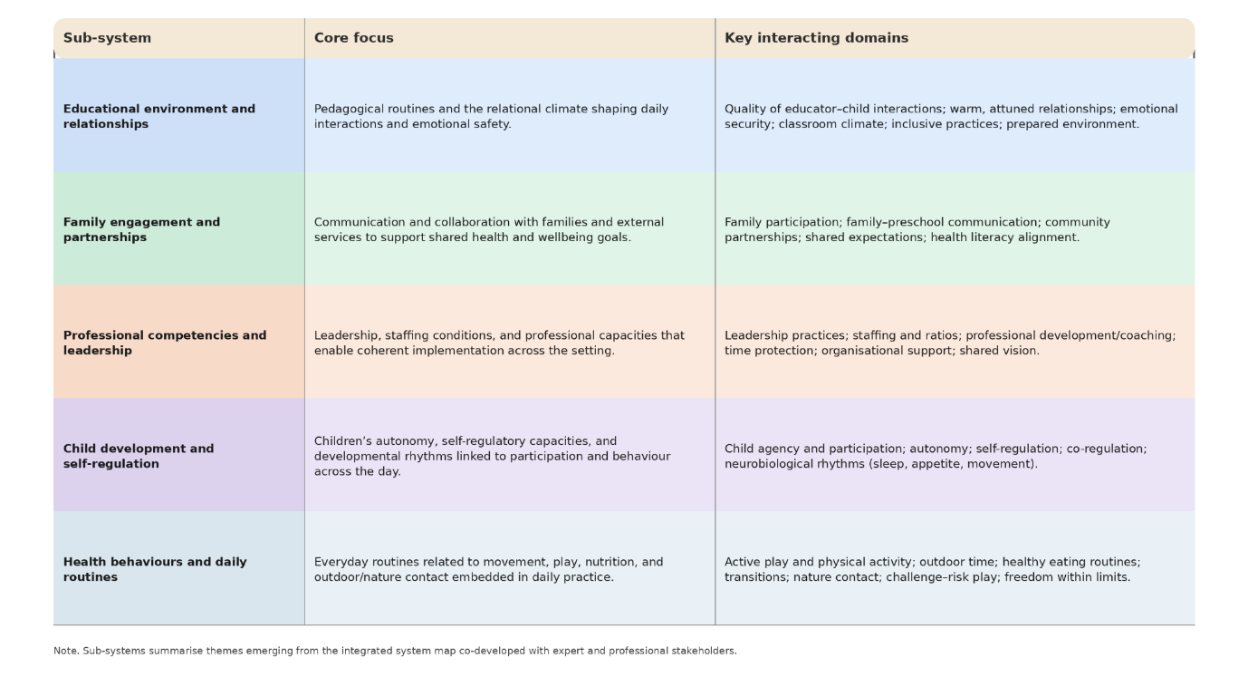
Table 2. Interrelated sub-systems of preschool health promotion
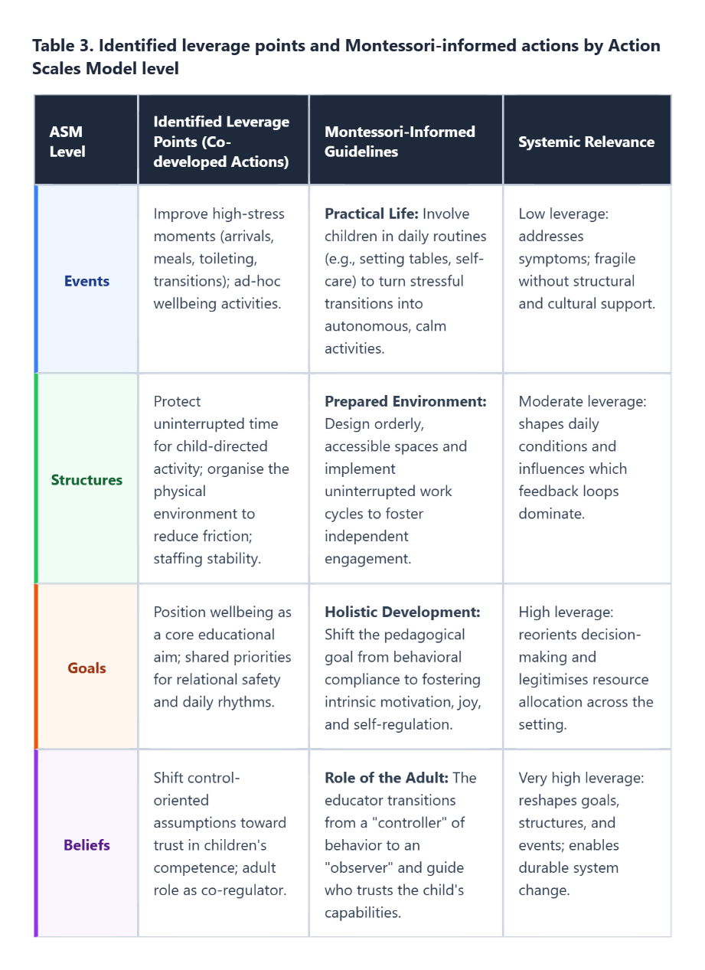
Table 3. Identified leverage points and Montessori-informed actions by Action Scales Model level

