APPENDIX

Supplemental Table 1. Variables selected for analysis from the NLSY97 survey
Category | Original Variable Name |  | Explanation | Survey Year(s)
Mental Health Symptoms Components (outcome) | CV_CESD_SCORE_R19_2019 | 7-item CES-D Score with a range from 0 to 21 |  | 2019-2020
 | CV_CESD_SCORE_R20_2021 | 7-item CES-D Score with a range from 0 to 21 |  | 2021-2022
 | CVC_GAD7_SCORE_3839 | Generalized Anxiety Disorder Scale scoring |  | 2019-2022 (When respondent turned 38 or 39)
Demographics | KEY_SEX_1997 | Sample Type |  | 1997-1998
 | KEY_RACE_ETHNICITY_1997 | Race/Ethnicity |  | 1997-1998
 | CVC_HIGHEST_DEGREE_EVER_XRND | Highest Education Level |  | Cross-Round
Relationship Variables | YSAQ2-707_* | Relationship Breakdowns |  | 2003–2011
 | MAR_COHABITATION_* | Total Cohabitations by 2015 |  | 2015
 | MAR_COHABITATION_* | Total Marriages by 2015 |  | 2015
 | CV_BIO_CHILD_HH_2015,  CV_BIO_CHILD_NR_2015 | Total Biological Children by 2015 |  | 2015
Income Variables | YINC-1700_* | Personal income from wages and salary |  | 2007–2022
Deceased Relatives | YHEA-2320~* | Deceased close relatives (mother/father, sibling, child, partner/souse) |  | 2002–2013

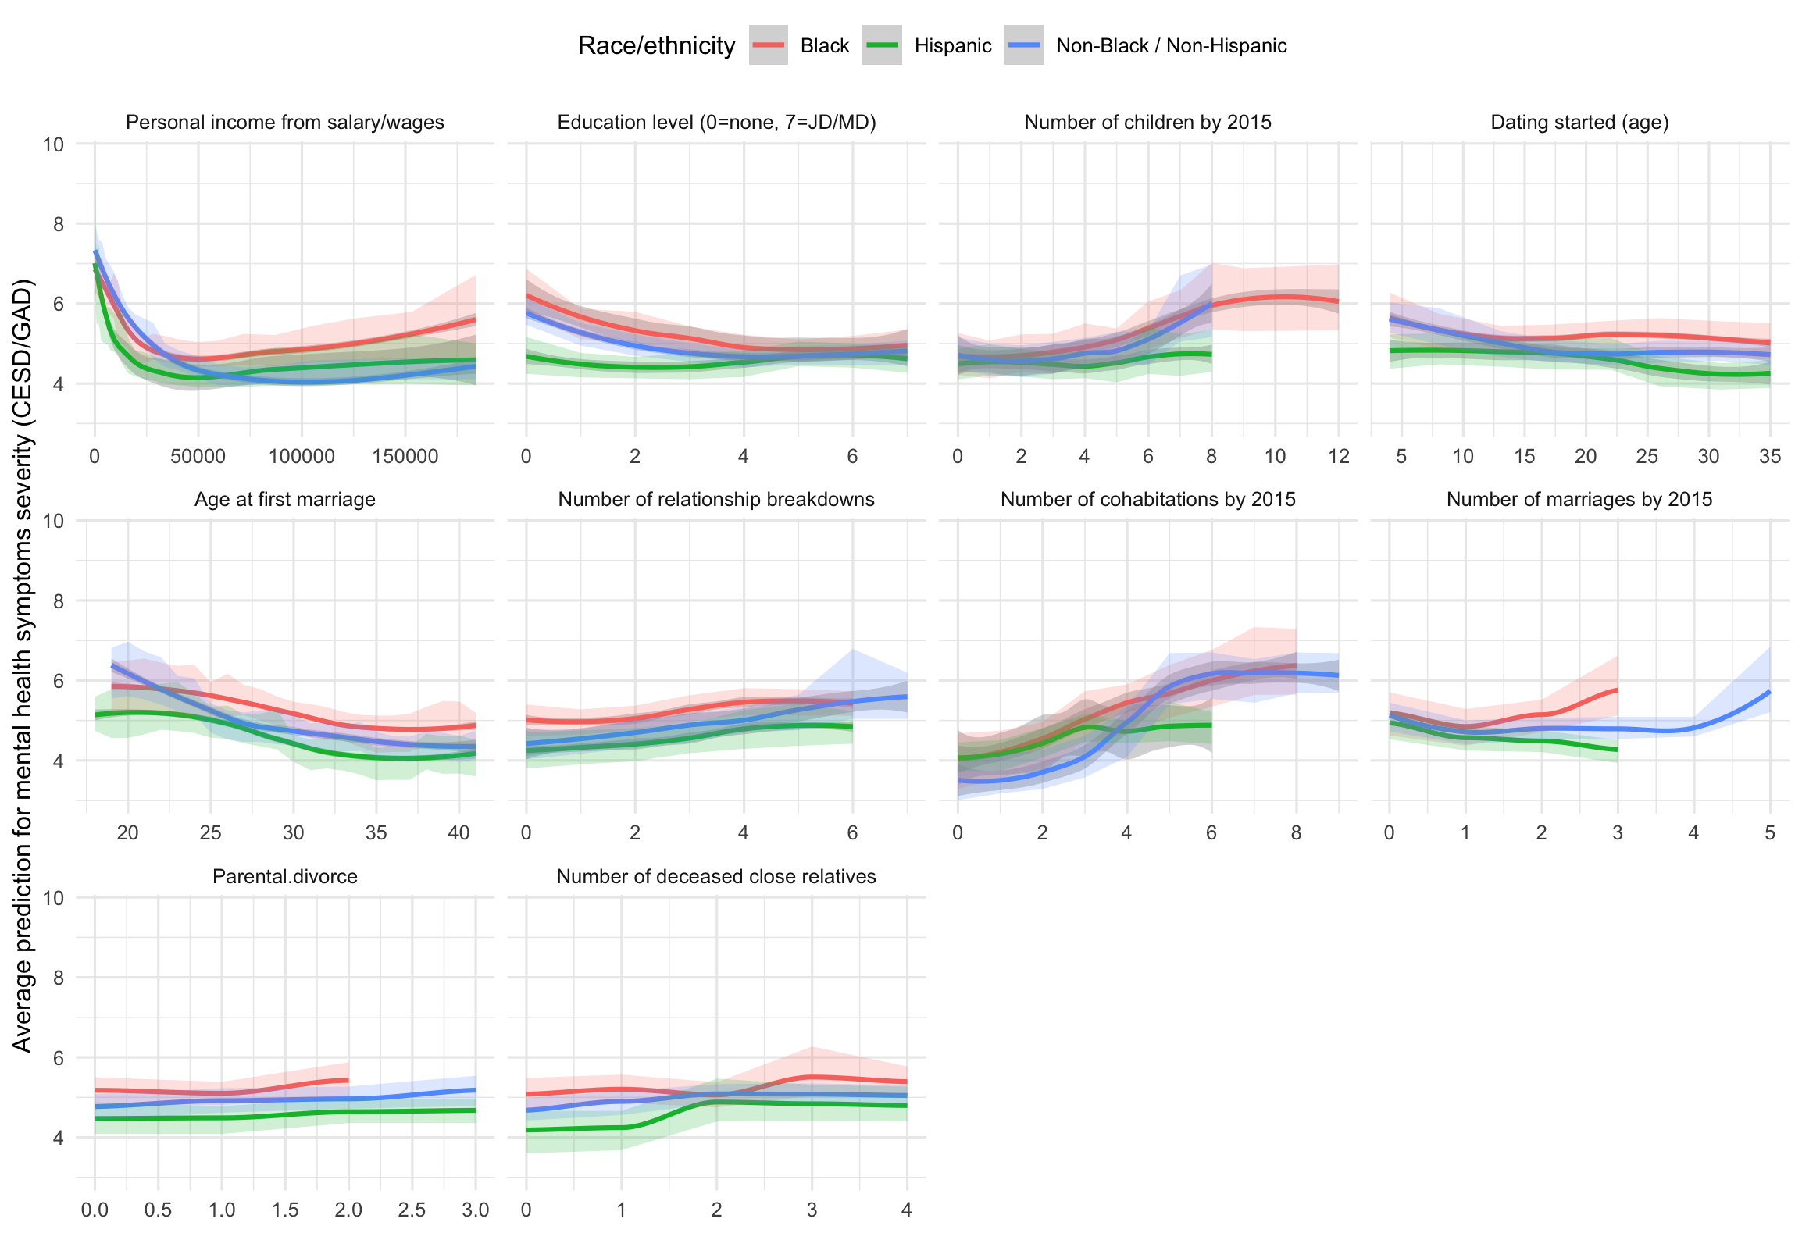
Supplemental Figure 2. Results stratified by race/ethnicity

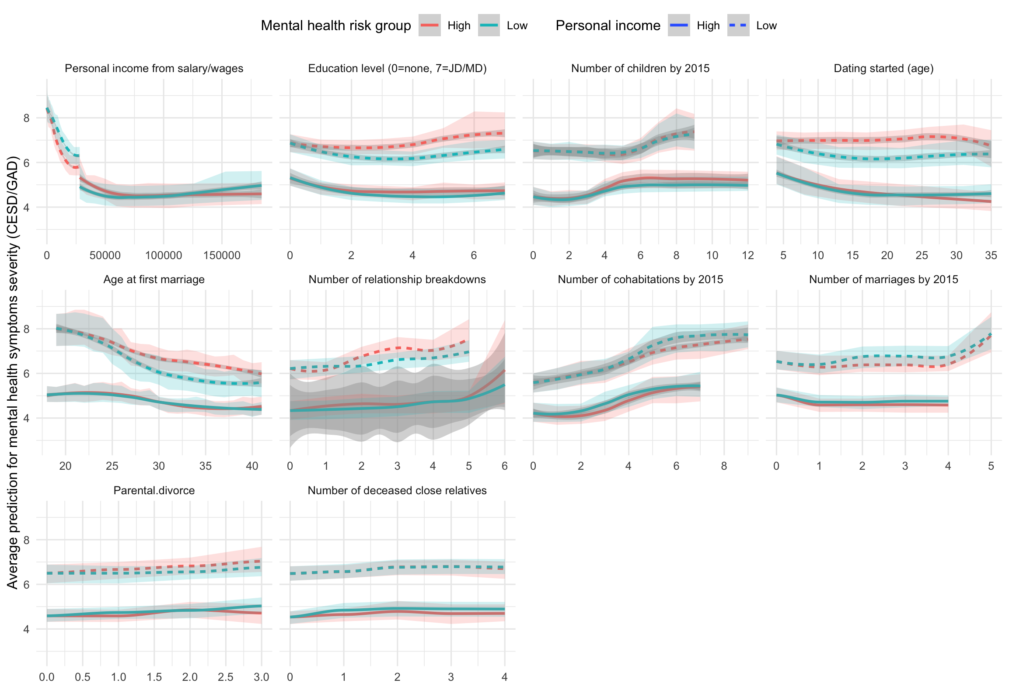
Supplemental Figure 3. Results stratified by baseline mental health risk/ethnicity

