Supplementary Data for
Beyond Water: Global Hydropower Futures Shaped by Interacting Hydrological and Socio-Technical Drivers

Gi Joo Kim¹, Thomas Wild², Ying Zhang², Matthew Binsted², Hassan Niazi², A.F.M. Kamal Chowdhury³, Mengqi Zhao⁴, Jonathan Lamontagne⁵

¹ ByWater Institute, Tulane University, New Orleans, LA, USA
² Joint Global Change Research Institute, Pacific Northwest National Laboratory, College Park, MD, USA
³ Earth System Science Interdisciplinary Center, University of Maryland, College Park, MD, USA
⁴ Pacific Northwest National Laboratory, Richland, WA, USA
⁵ Department of Civil and Environmental Engineering, Tufts University, Medford, MA, USA

Contents in this document

Supplementary Text S1
Supplementary Figures S1-S13

Text S1. Detailed Ensemble Design Process

We explain our ensemble design process in more detail. Figure S1 shows a step-by-step process of our ensemble design process, with a more detailed explanation of how we project future exploitable hydropower potential (EHP) and hydropower capacity factor (HCF) considering hydroclimatic impacts. We first fit multiple linear regression models based on historical data: annual streamflow, exploitable hydropower potential [1], and hydropower capacity factor [2] (Figure S1a). We then use the regression models to project hydropower’s future exploitable potential and capacity factor based on future streamflow [3] (Figure S1b). Finally, we generate a large ensemble of GCAM scenarios considering broader human and Earth system drivers and explore outputs across scales (Figure S1c).

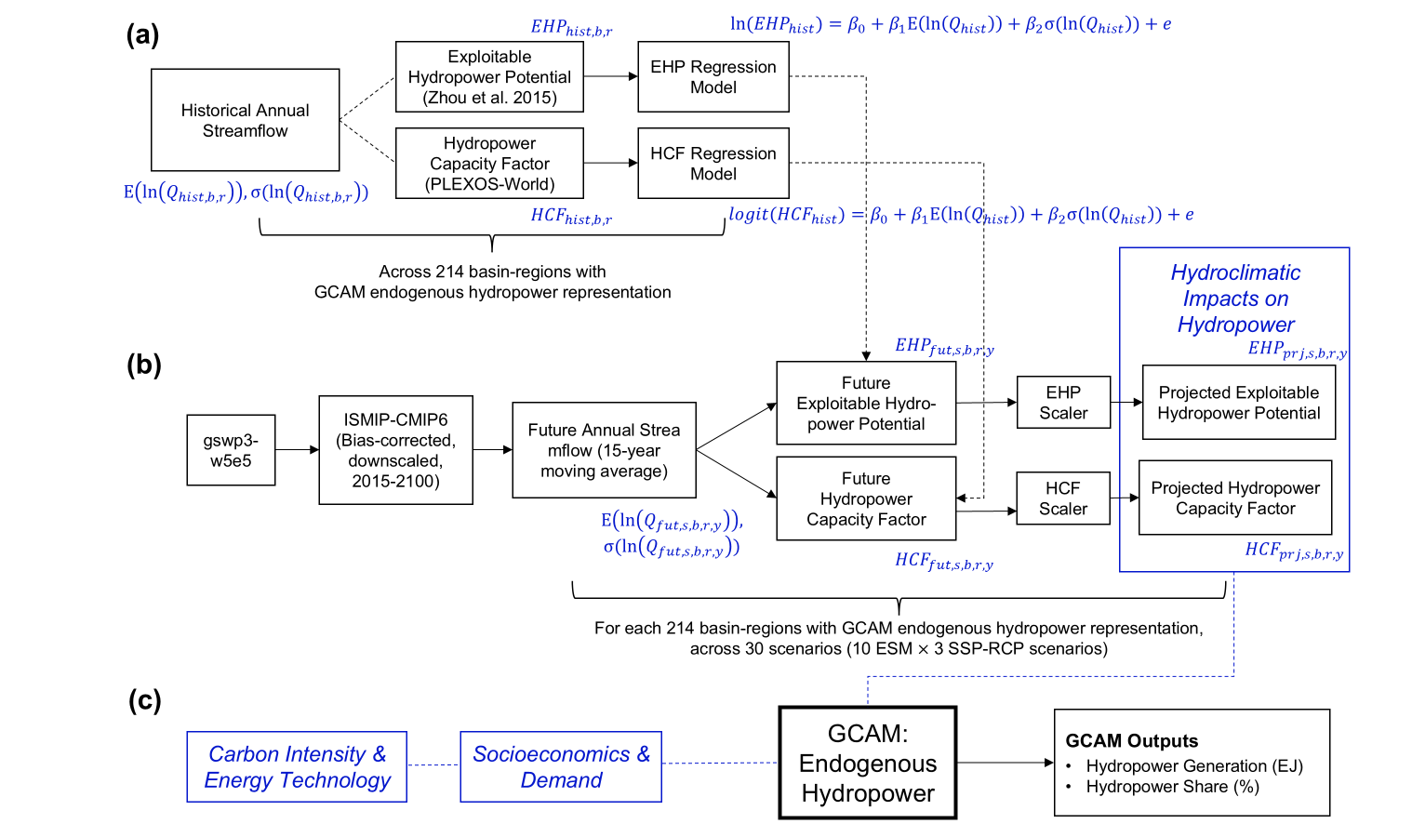

Figure S1. The overall flowchart of our ensemble design process. In (a), we fit two multiple linear regression models to derive the relationship between historical streamflow and exploitable hydropower potential (EHP) and hydropower capacity factor (HCF). In (b), we use the regression models from (a) to predict future EHP and HCF based on future streamflow projections. In (c), we widely sample from human and Earth system drivers to generate a large ensemble and explore outputs.

First, we derive two linear regression models to estimate the relationships between the statistics from historical annual streamflow ($Q_{hist}$) and two dependent variables for each basin-region: ${EHP}_{hist}$ and ${HCF}_{hist}$ (Figure S1a). Among multiple candidates for independent variables (e.g., monthly runoff, annual runoff, installed capacity, and monthly streamflow), we select the mean of log-transformed annual streamflow ($E(ln⁡(Q_{hist})$) and the standard deviation of log-transformed annual streamflow ($σ(ln⁡(Q_{hist})$) for our independent variables. Moreover, we apply log-transformation to EHP, and logit transformation to HCF before fitting regression models. The equation for the multiple linear regression model we use to derive the relationship between the statistics of $Q_{hist}$ and ${EHP}_{hist} and {HCF}_{hist}$ for each basin-region ($b,r$) is in Eq. 1:

$$\begin{aligned}y=β_{0}+β_{1}E(\ln\left(Q_{hist,b,r}\right))+β_{2}σ(\ln\left(Q_{hist,b,r}\right))+e\#\left(1\right)\end{aligned}$$

where $y$ is dependent variable (e.g., $ln({EHP}_{hist,b,r})$ or $logit({HCF}_{hist,b,r})$); $E(ln⁡(Q_{hist,b,r})$ and $σ(ln⁡(Q_{hist,b,r})$ are independent variables; $β_{0},β_{1},β_{2}$ are the coefficients of the regression model; and $e$ is the residual.

From the first step, we derive two multiple linear regression models that are statistically significant (i.e., $p-value<0.05$), each for EHP and HCF (Figure S2). The coefficients (e.g., $β_{0},β_{1},β_{2}$) and adjusted r-squared values for the two regression models are in Table S1.

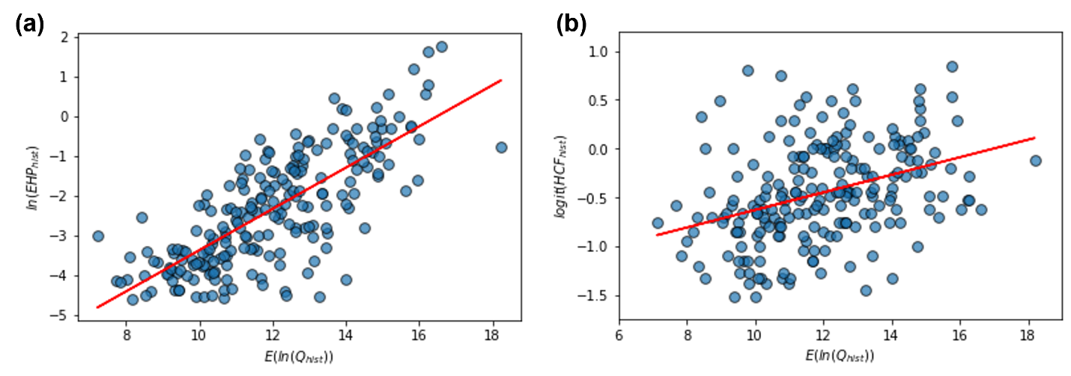
Figure S2. Multiple regression models for (a) $ln({EHP}_{hist})$ and (b) $logit({HCF}_{hist})$. Each point in the scatterplot represents each basin-region with endogenous hydropower representation in GCAM. There are 214 points in each scatterplot.

Table S1. Coefficients of regression models for $ln({EHP}_{hist,b,r})$ and $logit({HCF}_{hist,b,r})$
 | $$β_{0}$$ | $$β_{1}$$ | $$β_{2}$$ | Adjusted-$r^{2}$
Model 1 (EHP) | -8.5709 | 0.5197 | 0 | 0.574
Model 2 (HCF) | -1.1531 | 0.0698 | -0.7099 | 0.148

We then use the regression models to derive future EHP and HCF for 30 hydroclimate scenarios (Figure S1b). We neglect the effect of the residual term $e$ and only take account of the coefficients from the regression model during our predictions. In order to account for long-term changes in streamflow, we use the statistics of 15-year average streamflow in each basin-region to derive future EHP and HCF in 5-year time periods using Eq. 2-3:

$$\begin{aligned}ln({EHP}_{fut,s,b,r,y}))=β_{0,EHP}+β_{1,EHP}E(\ln\left(Q_{fut,s,b,r,y}\right))\#\left(2\right)\end{aligned}$$
$$\begin{aligned}logit({HCF}_{fut,s,b,r,y}))=β_{0,HCF}+β_{1,HCF}E(\ln\left(Q_{fut,s,b,r,y}\right))+β_{2,HCF}σ(\ln\left(Q_{fut,s,b,r,y}\right))\#\left(3\right)\end{aligned}$$

We then back-transform the future EHP and HCF using exponential and expit transformation, respectively. Finally, we compute EHP and HCF ‘scalers’ using future EHP and HCF in 2015. This process enables us to minimize the effects from extreme streamflow changes on EHP/HCF. EHP and HCF scalers are computed by Eq. 4-5:
$$\begin{aligned}{EHP Scaler}_{s,b,r,y}=\frac{{EHP}_{fut,s,b,r,y}}{{EHP}_{fut,b,r,2015}}\#\left(4\right)\end{aligned}$$
$$\begin{aligned}{HCF Scaler}_{s,b,r,y}=\frac{{HCF}_{fut,s,b,r,y}}{{HCF}_{fut,b,r,2015}}\#\left(5\right)\end{aligned}$$

Finally, we multiply the EHP and HCF scalers to historical EHP and HCF in each basin-region, to compute projected EHP and HCF for each climate scenario ($s$), basin-region ($b,r$), and 5-year time step ($y$), as shown in Eq. 6-7. We demonstrate the effect of our scaler approach by comparing the percent change of ${EHP}_{fut,s,b,r,y}$ (before applying the scaler) and ${EHP}_{prj,s,b,r,y}$ (after applying the scaler) from ${EHP}_{hist,b,r}$ in two selected scenarios (Figure S3).

$$\begin{aligned}{{EHP}_{prj,s,b,r,y}=EHP Scaler}_{s,b,r,y}×{EHP}_{hist,b,r}\#\left(6\right)\end{aligned}$$
$$\begin{aligned}{{HCF}_{prj,s,b,r,y}=HCF Scaler}_{s,b,r,y}×{HCF}_{hist,b,r}\#\left(7\right)\end{aligned}$$

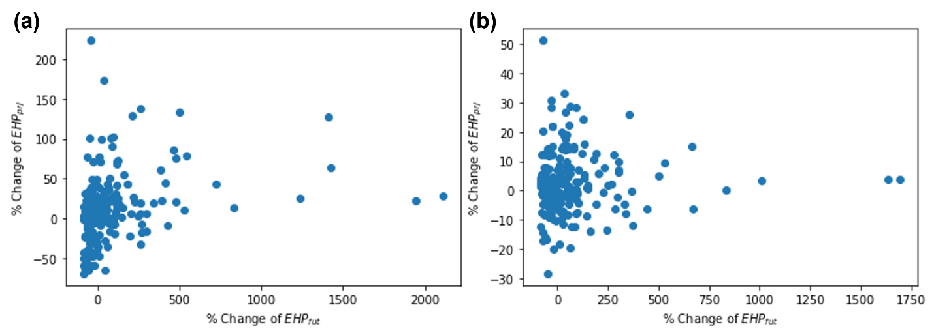
Figure S3. Percent change from ${EHP}_{hist,b,r}$ to ${EHP}_{fut,s,b,r,y}$ (x-axis, before applying the scaler) and ${EHP}_{prj,s,b,r,y}$ (y-axis, after applying the scaler) across 214 basin-regions in 2100 under two selected scenarios: (a) canesm5_ssp585 and (b) gfdl-esm4_ssp126.

Finally, we generate a large ensemble of future hydropower scenarios by sampling from wide human and Earth system drivers (Figure S1c).

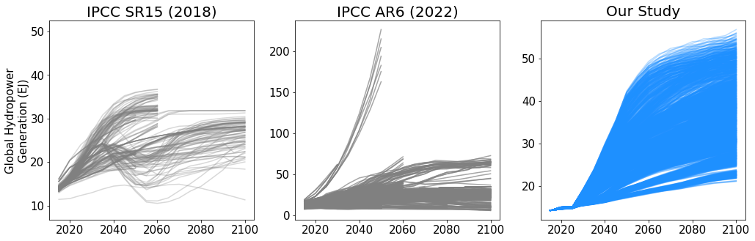

Figure S4. Comparison of global hydropower projections from 2020 to 2100: IPCC SR15 [4], IPCC AR6 [5], and our study.

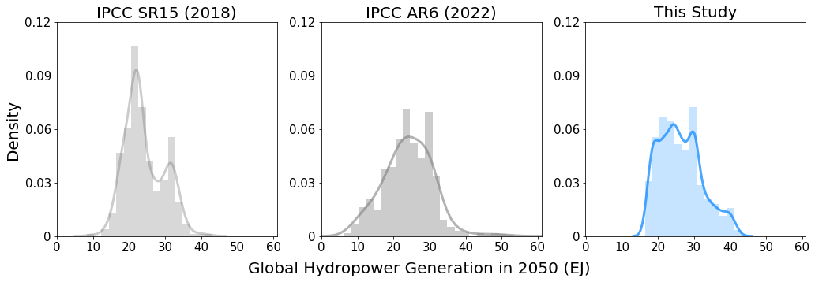
Figure S5. Comparison of global hydropower projections in 2050: IPCC SR15 [4], IPCC AR6 [5], and our study.

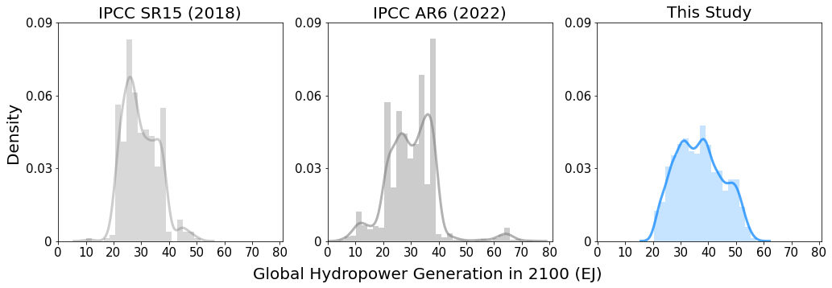
Figure S6. Comparison of global hydropower projections in 2100: IPCC SR15 [4], IPCC AR6 [5], and our study.

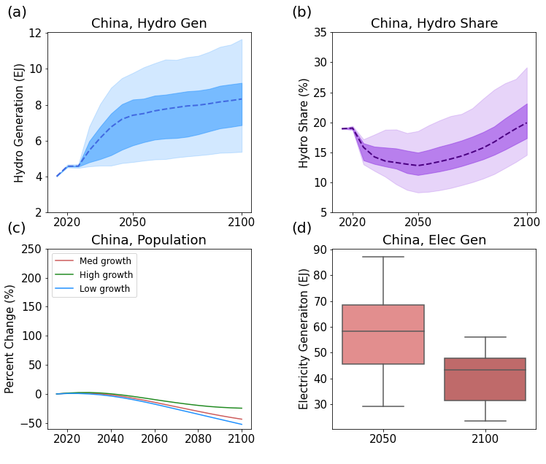
Figure S7. Projections of (a) regional hydropower generation, (b) regional hydropower share, (c) population growth, and (d) total electricity generation in China. In panels (a) and (b), shaded bands represent the interquartile range (dark shading) and the full ensemble range (light shading) with the dashed line indicating the median projection.

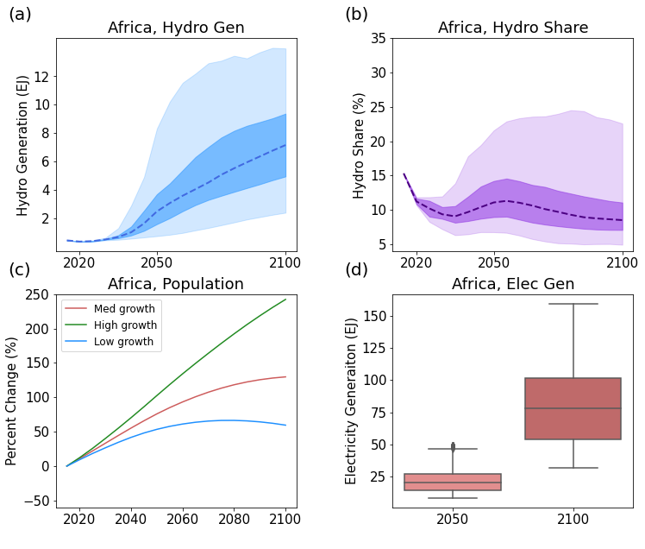 Figure S8. Projections of (a) regional hydropower generation, (b) regional hydropower share, (c) population growth, and (d) total electricity generation in Africa. In panels (a) and (b), shaded bands represent the interquartile range (dark shading) and the full ensemble range (light shading) with the dashed line indicating the median projection.

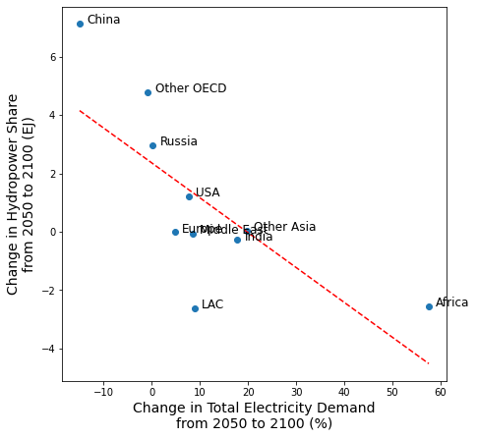
Figure S9. Scatterplot showing the relationship between median change in regional electricity demand (x-axis) and median change in regional hydropower share (y-axis) from 2050 to 2100 for 10 aggregated GCAM regions.
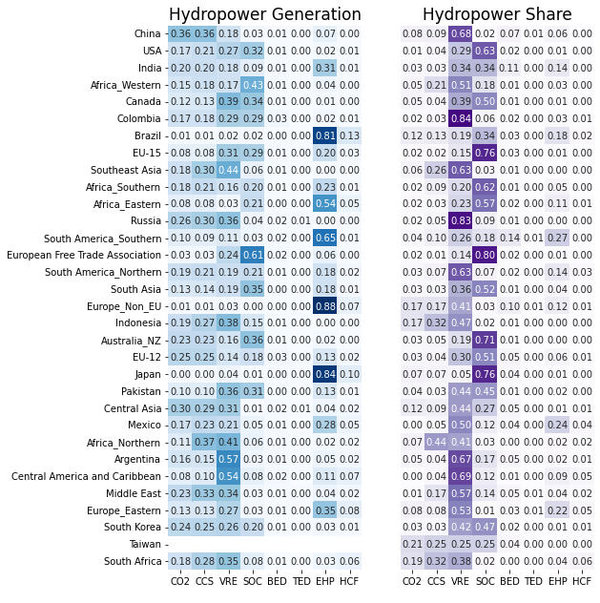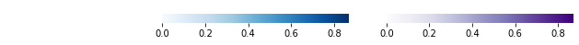
Figure S10. Annotated heatmap of relative feature importance scores of regional hydropower generation and regional hydropower share in 2100 across all 32 GCAM regions.

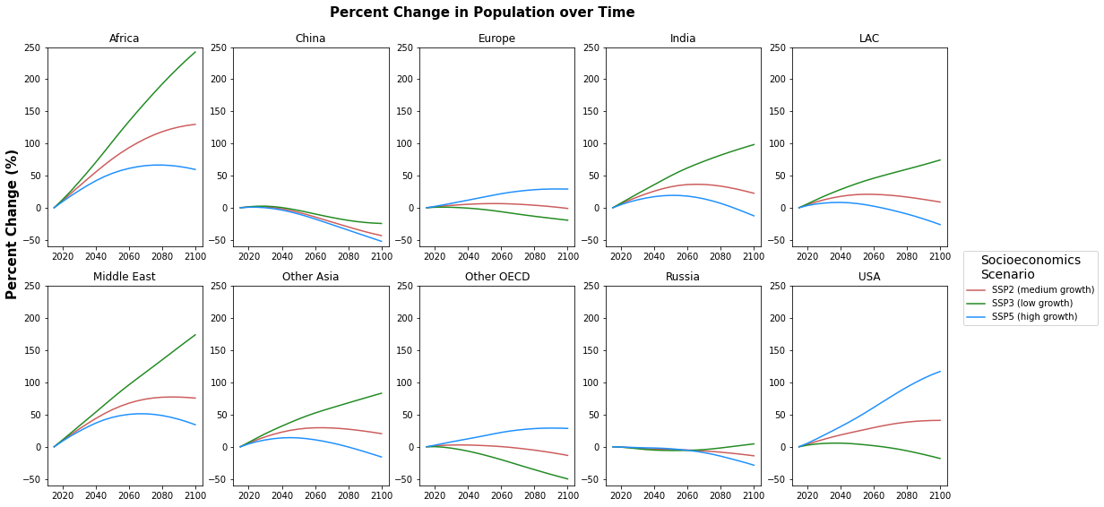
Figure S11. Percent change in population over time across 10 aggregated GCAM regions in three socioeconomics scenarios modeled in this study.

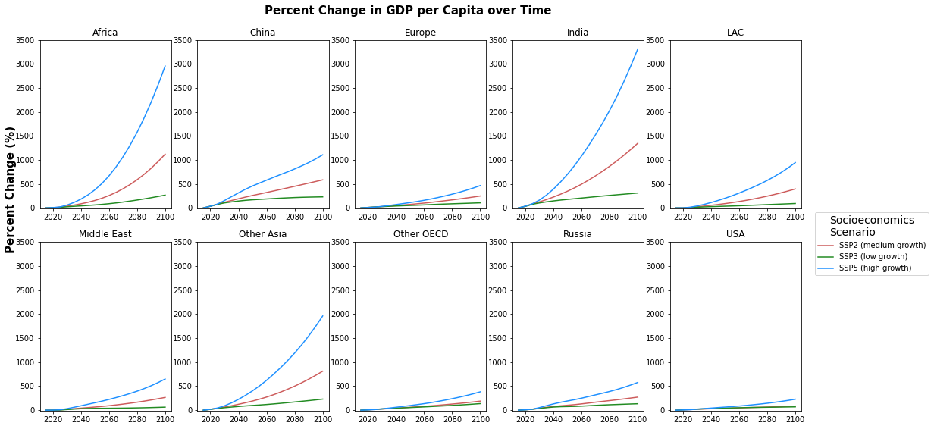
Figure S12. Percent change in GDP per capita over time across 10 aggregated GCAM regions in three socioeconomics scenarios modeled in this study.

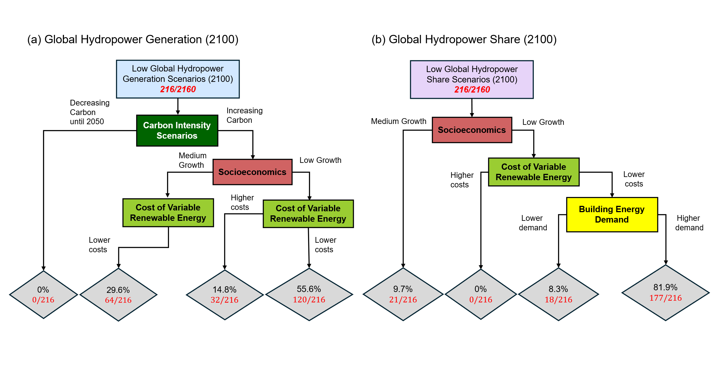
Figure S13. Simplified classification trees for scenarios leading to (a) low global hydropower generation scenarios and (b) low global hydropower share scenarios by 2100 (i.e., scenarios below the 10th percentile global generation or share)

References
[1] Zhou Y, Hejazi M, Smith S, Edmonds J, Li H, Clarke L, et al. A comprehensive view of global potential for hydro-generated electricity. Energy Environ Sci 2015;8:2622–33. https://doi.org/10.1039/C5EE00888C.
[2] Brinkerink M, Deane P. PLEXOS-World 2015 2020. https://doi.org/10.7910/DVN/CBYXBY.
[3] Zhao M, Wild T, Vernon C. Xanthos Output Dataset Under ISIMIP3b Selected CMIP6 Scenarios: 1850 - 2100 2023. https://doi.org/10.57931/2280839.
[4] Huppmann D, Kriegler E, Krey V, Riahi K, Rogelj J, Rose S, et al. IAMC 1.5°C Scenario Explorer and Data hosted by IIASA 2018. https://doi.org/10.22022/SR15/08-2018.15429.
[5] Byers E, Krey V, Kriegler E, Riahi K, Schaeffer R, Kikstra J, et al. AR6 Scenarios Database 2022. https://doi.org/10.5281/ZENODO.5886911.

