Supplementary Table 1. Participant characteristics in the tidal FA EBC SARS-CoV-2 viral load study conducted in Greece.
Characteristics | Total n=30
Age (years, ± SD) | 47.2 ± 17.1
Age groups, years (n, %)
<18 | 0 (0%)
18-69 | 23 (77%)
70-80 | 7 (23%)
Sex (n, %)
Male | 15 (50%)
Female | 15 (50%)
Height (cm, ± SD) | 171 ± 6.75
Weight (kg, ± SD) | 73.5 ± 21.8
BMI | 25.2 ± 8.12
<18.5 | 2 (7%)
18.5-24 | 14 (40%)
≥24 | 16 (46%)
Armspan (cm, ± SD) | 172 ± 7.82
Nasopharyngeal viral load (Ct, ± SD) | 21.2 ± 5.43
Days after symptom onset (n, ± SD) | 3.17 ± 1.09
Symptoms (n, %)
Fatigue | 20 (67%)
Dyspnoea | 5 (17%)
Diarrhoea | 2 (7%)
Cough | 10 (33%)
Rhinorrhoea | 1 (3%)
Headache | 7 (23%)
Muscle pain | 11 (37%)
Joint pain | 1 (3%)
Dysgeusia/Ageusia | 4 (13%)
Dysosmia/Anosmia | 6 (20%)
Fever (n, %) | 22 (73%)
Mild (<38 ºC; n, %) | 17 (77%)
Moderate (38 – 40 ºC; n, %) | 5 (23%)
Severe (>40 ºC; n, %) | 0 (0%)
Other lung disease
Asthma (n, %) | 1 (3%)
Chronic bronchitis (n, %) | 0 (0%)
Emphysema (n, %) | 1 (3%)
COPD (n, %) | 1 (3%)
Tuberculosis (n, %) | 0 (0%)
Lung cancer (n, %) | 0 (0%)
Lung fibrosis (n, %) | 1 (3%)
Comorbidities (n, %) | 7 (23%)
Lung Surgery (n, %) | 0 (0%)
Inpatient (n, %) | 19 (63%)

Supplementary Table 2. Individual Ct values from three technical replicates for each breath condensate specimen analysed for SARS-CoV-2 nucleocapsid (N) gene targets (N1 and N2) and human 18S rRNA.
Specimen ID/Replicate# | TiEBC |  |  |  |  |  |  |  |  | SiEBC
Specimen ID/Replicate# | N1 |  |  | N2 |  |  | 18S |  |  | N1 |  |  | N2 |  |  | 18S
Specimen ID/Replicate# | 1 | 2 | 3 | 1 | 2 | 3 | 1 | 2 | 3 | 1 | 2 | 3 | 1 | 2 | 3 | 1 | 2 | 3
COVEX01 | NEG | NEG | NEG | NEG | NEG | NEG | 33.84 | 33.99 | 33.62 | 31.24 | 31.32 | 31.60 | 29.26 | 30.36 | 30.24 | 27.59 | 28.13 | 27.90
COVEX02 | NEG | NEG | NEG | 39.40 | NEG | NEG | 34.48 | 34.37 | 34.34 | NEG | NEG | NEG | NEG | 35.80 | NEG | 30.41 | 29.91 | 29.95
COVEX04 | NEG | NEG | NEG | NEG | 37.76 | NEG | 36.28 | 34.79 | 35.02 | 31.08 | 30.65 | 31.22 | 31.23 | 31.46 | 31.81 | 25.96 | 26.41 | 26.25
COVEX05 | NEG | NEG | 37.57 | 37.90 | NEG | NEG | 34.10 | 33.42 | 34.76 | 32.98 | 33.61 | 33.16 | 33.82 | 33.98 | 32.89 | 28.59 | 28.82 | 28.71
COVEX06 | NEG | NEG | NEG | NEG | NEG | NEG | 37.50 | 39.14 | NEG | 29.62 | 29.57 | 29.32 | 29.85 | 29.62 | 29.52 | 26.02 | 25.97 | 25.76
COVEX07 | 37.76 | NEG | 37.58 | NEG | 37.02 | 35.55 | 33.71 | 34.18 | 33.65 | NEG | NEG | NEG | 35.58 | 34.67 | NEG | 28.19 | 28.75 | 28.40
COVEX08 | NEG | NEG | NEG | NEG | 37.49 | NEG | 33.77 | 33.80 | 34.55 | 27.66 | 27.99 | 27.64 | 27.99 | 28.32 | 28.30 | 27.41 | 27.33 | 27.35
COVEX09 | NEG | NEG | NEG | NEG | NEG | 37.49 | 34.59 | 35.02 | 35.41 | 25.47 | 26.16 | 25.74 | 26.22 | 26.59 | 26.36 | 23.35 | 23.35 | 23.20
COVEX10 | 36.61 | NEG | 37.45 | 37.24 | NEG | 37.38 | 33.61 | 33.62 | 34.21 | 27.67 | 27.82 | 27.57 | 28.04 | 28.45 | 27.88 | 26.75 | 26.75 | 26.80
COVEX11 | NEG | NEG | NEG | 37.40 | NEG | NEG | 32.68 | 32.84 | 32.90 | 33.31 | 32.62 | 31.99 | 35.30 | 33.13 | 32.96 | 28.96 | 28.99 | 29.27
COVEX12 | NEG | NEG | 36.38 | NEG | 37.24 | NEG | 35.59 | 36.00 | 34.89 | NEG | 32.56 | 34.10 | 35.69 | 35.37 | 35.43 | 28.72 | 28.74 | 28.80
COVEX13 | NEG | NEG | NEG | NEG | NEG | NEG | 34.48 | 34.03 | 34.21 | 27.91 | 27.94 | 27.82 | 28.29 | 28.03 | 28.14 | 27.93 | 27.82 | 28.17
COVEX14 | 38.11 | NEG | 37.12 | NEG | 37.74 | 35.9 | 31.81 | 31.91 | 32.14 | 30.51 | 30.41 | 30.49 | 31.17 | 30.93 | 31.16 | 25.85 | 26.10 | 26.07
COVEX16 | NEG | NEG | NEG | 37.09 | NEG | NEG | 31.46 | 31.68 | 31.57 | 34.31 | 35.10 | 34.27 | 34.68 | 33.86 | 35.50 | 28.25 | 27.82 | 27.88
COVEX17 | 37.68 | NEG | NEG | NEG | NEG | NEG | 33.02 | 32.82 | 32.78 | 34.02 | 35.25 | 34.02 | 34.22 | 35.50 | 35.51 | 27.98 | 27.85 | 28.05
COVEX18 | NEG | 36.44 | 36.4 | 37.54 | 37.42 | 37.26 | 34.28 | 34.34 | 34.42 | 25.42 | 25.53 | 25.65 | 25.76 | 26.08 | 26.08 | 26.58 | 26.50 | 26.56
COVEX19 | NEG | 34.3 | NEG | 37.47 | 36.70 | NEG | 34.38 | 34.57 | 33.96 | 33.37 | NEG | 33.96 | 34.34 | NEG | 33.95 | 27.66 | 27.59 | 27.80
COVEX20 | NEG | NEG | NEG | 35.74 | 36.55 | NEG | 36.79 | 36.44 | 33.97 | 33.53 | 33.19 | 35.16 | 33.13 | 34.03 | 33.49 | 26.04 | 25.86 | 25.77
COVEX21 | NEG | NEG | 36.66 | NEG | NEG | NEG | 32.97 | 33.46 | 32.84 | NEG | 35.17 | NEG | NEG | NEG | NEG | 24.77 | 24.97 | 25.05
COVEX22 | NEG | NEG | 37.5 | NEG | NEG | NEG | 38.87 | 35.30 | 36.91 | 35.07 | 34.06 | 34.06 | 34.13 | 34.62 | 34.69 | 30.07 | 30.54 | 30.80
COVEX23 | NEG | 38.29 | NEG | NEG | 39.18 | NEG | 33.99 | 34.41 | 34.42 | 34.18 | 33.62 | 34.13 | 34.68 | NEG | NEG | 30.15 | 29.99 | 30.03
COVEX24 | NEG | NEG | NEG | 37.85 | NEG | 38.8 | 35.58 | 36.67 | 36.05 | 26.36 | 26.51 | 26.42 | 26.55 | 26.62 | 26.66 | 27.64 | 27.78 | 28.00
COVEX25 | 37.54 | NEG | 37.24 | 37.21 | 36.74 | NEG | 34.60 | 34.46 | 35.25 | 35.53 | 34.93 | NEG | 35.59 | 34.93 | NEG | 31.10 | 31.13 | 32.39
COVEX26 | NEG | 37.6 | NEG | NEG | NEG | NEG | 31.15 | 31.52 | 31.43 | 29.95 | 30.30 | 30.33 | 30.92 | 30.71 | 30.39 | 29.57 | 29.48 | 29.77
NEG = Negative or not detected, where Ct > 40. TiEBC = Exhaled breath condensate collected via tidal breathing. SiEBC = Exhaled breath condensate collected via a singing maneuver.

Supplementary Table 3. Individual Ct values from three technical replicates for each nasopharyngeal swab and saliva specimen analysed for SARS-CoV-2 nucleocapsid (N) gene targets (N1 and N2) and human 18S rRNA.
Specimen ID/Replicate# | NP swab |  |  |  |  |  |  |  |  | Saliva
Specimen ID/Replicate# | N1 |  |  | N2 |  |  | 18S |  |  | N1 |  |  | N2 |  |  | 18S
Specimen ID/Replicate# | 1 | 2 | 3 | 1 | 2 | 3 | 1 | 2 | 3 | 1 | 2 | 3 | 1 | 2 | 3 | 1 | 2 | 3
COVEX01 | 24.47 | 27.33 | 27.75 | 26.39 | 26.01 | 26.40 | 22.32 | 22.25 | 22.37 | 27.23 | 27.74 | 27.80 | 25.19 | 25.34 | 25.45 | 18.05 | 18.16 | 18.25
COVEX02 | 22.33 | 22.57 | 22.59 | 21.03 | 21.06 | 21.31 | 22.74 | 22.86 | 22.89 | 23.69 | 24.08 | 23.66 | 22.49 | 22.54 | 22.221 | 19.11 | 18.10 | 18.16
COVEX04 | 17.74 | 17.68 | 17.85 | 17.29 | 17.21 | 17.44 | 14.43 | 14.51 | 14.48 | 27.31 | 27.37 | 27.35 | 27.09 | 27.11 | 27.10 | 20.03 | 20.08 | 20.29
COVEX05 | 25.91 | 26.10 | 26.03 | 25.45 | 25.62 | 25.74 | 22.00 | 21.99 | 22.20 | 29.29 | 29.19 | 29.06 | 29.12 | 29.01 | 28.80 | 18.62 | 18.65 | 18.65
COVEX06 | 21.77 | 21.85 | 21.84 | 21.25 | 21.31 | 21.62 | 20.37 | 20.34 | 20.40 | 32.14 | 31.59 | 32.08 | 31.81 | 31.35 | 31.66 | 19.97 | 20.26 | 20.17
COVEX07 | 32.94 | 32.77 | 33.92 | 33.91 | 33.82 | 33.52 | 26.84 | 26.93 | 26.89 | 29.35 | 29.50 | 29.37 | 28.84 | 28.92 | 28.93 | 22.67 | 22.62 | 22.73
COVEX08 | 30.96 | 30.74 | 30.70 | 30.35 | 30.44 | 30.22 | 23.68 | 23.69 | 23.75 | 22.32 | 22.51 | 22.48 | 22.02 | 22.14 | 22.18 | 16.17 | 16.37 | 16.34
COVEX09 | 22.88 | 23.20 | 22.96 | 22.38 | 22.67 | 22.45 | 25.41 | 25.38 | 25.26 | 21.61 | 21.61 | 21.65 | 21.34 | 21.38 | 21.35 | 18.98 | 19.13 | 19.17
COVEX10 | 24.11 | 24.12 | 24.14 | 23.72 | 23.81 | 23.78 | 19.90 | 19.39 | 19.27 | 24.19 | 24.15 | 24.13 | 23.85 | 23.85 | 23.81 | 19.02 | 19.26 | 19.28
COVEX11 | 22.62 | 22.53 | 22.34 | 21.85 | 22.05 | 21.86 | 20.47 | 20.61 | 20.49 | 30.07 | 30.23 | 30.30 | 30.00 | 29.90 | 30.13 | 17.80 | 17.97 | 17.65
COVEX12 | 24.98 | 24.99 | 24.85 | 24.42 | 24.67 | 24.35 | 23.86 | 23.86 | 23.81 | 31.45 | 31.47 | 31.44 | 31.36 | 31.53 | 31.42 | 18.50 | 18.29 | 18.29
COVEX13 | 20.14 | 20.15 | 20.32 | 19.65 | 19.54 | 19.80 | 23.82 | 23.83 | 23.89 | 26.91 | 26.85 | 26.95 | 26.54 | 26.56 | 26.68 | 20.36 | 20.28 | 20.35
COVEX14 | 25.73 | 25.68 | 25.70 | 25.25 | 25.22 | 25.34 | 22.26 | 22.49 | 22.43 | 27.99 | 27.94 | 28.04 | 27.71 | 27.64 | 27.65 | 19.56 | 19.52 | 19.72
COVEX16 | 24.96 | 25.22 | 25.12 | 24.60 | 24.87 | 24.67 | 23.55 | 23.63 | 23.52 | 30.37 | 30.47 | 30.12 | 30.15 | 30.22 | 30.03 | 20.00 | 19.86 | 19.92
COVEX17 | 27.04 | 26.97 | 27.05 | 26.66 | 26.63 | 26.66 | 22.27 | 22.31 | 22.27 | NEG | NEG | NEG | NEG | NEG | NEG | 18.68 | 18.80 | 18.71
COVEX18 | 20.51 | 20.40 | 20.54 | 19.95 | 20.00 | 20.15 | 19.92 | 19.83 | 19.99 | 19.73 | 19.94 | 19.66 | 19.36 | 19.51 | 19.31 | 18.96 | 18.79 | 18.81
COVEX19 | 27.79 | 27.91 | 27.89 | 27.31 | 27.56 | 27.49 | 22.04 | 22.08 | 22.00 | NEG | 36.57 | 37.48 | NEG | 36.67 | 36.64 | 20.33 | 20.33 | 20.25
COVEX20 | 25.01 | 25.15 | 25.19 | 24.55 | 24.65 | 24.92 | 24.75 | 24.69 | 24.71 | 28.60 | 28.38 | 28.43 | 28.29 | 28.13 | 28.18 | 18.49 | 18.52 | 18.49
COVEX21 | 30.98 | 31.19 | 31.52 | 30.40 | 30.97 | 31.04 | 20.33 | 20.38 | 20.33 | 35.31 | 35.60 | 34.31 | 34.9 | 35.32 | 34.81 | 21.77 | 22.52 | 21.85
COVEX22 | 24.36 | 24.76 | 24.56 | 23.99 | 24.41 | 24.17 | 16.92 | 17.00 | 16.77 | 28.39 | 28.26 | 28.23 | 28.04 | 28.07 | 28.03 | 20.85 | 21.06 | 21.17
COVEX23 | 22.28 | 22.24 | 22.31 | 21.63 | 21.59 | 21.42 | 22.30 | 22.44 | 22.34 | 26.09 | 26.18 | 26.19 | 25.86 | 26.03 | 26.08 | 20.24 | 20.21 | 20.31
COVEX24 | 20.60 | 20.90 | 20.88 | 19.99 | 20.18 | 20.17 | 22.30 | 22.04 | 22.37 | 23.03 | 23.14 | 23.11 | 22.80 | 22.80 | 22.93 | 21.21 | 21.25 | 21.11
COVEX25 | 20.47 | 20.28 | 20.71 | 20.16 | 20.41 | 20.18 | 20.13 | 19.98 | 20.00 | 28.00 | 28.12 | 28.34 | 27.72 | 27.79 | 28.1 | 20.09 | 20.11 | 20.16
COVEX26 | 23.61 | 23.48 | 23.47 | 22.90 | 22.96 | 22.91 | 22.42 | 22.51 | 22.41 | 21.84 | 21.88 | 22.11 | 21.48 | 21.46 | 21.76 | 19.33 | 19.50 | 19.52
NEG = Negative or not detected, where Ct > 40. NP = nasopharyngeal.
Supplementary Table 4. Individual Ct values from three technical replicates of large droplet specimens recovered from the PBM-Hale™ saliva trap following EBC collection, analysed by RT-PCR for SARS-CoV-2 nucleocapsid (N) gene targets (N1 and N2) and human 18S rRNA.
Specimen ID/Replicate# | TiLD |  |  |  |  |  |  |  |  |  | SiLD
Specimen ID/Replicate# | N1 |  |  | N2 |  |  | 18S |  |  |  | N1 |  |  |  | N2 |  |  |  | 18S
Specimen ID/Replicate# | 1 | 2 | 3 | 1 | 2 | 3 | 1 | 2 | 3 | 1 |  | 2 | 3 | 1 |  | 2 | 3 | 1 |  | 2 | 3
COVEX01 | NEG | NEG | NEG | NEG | NEG | NEG | 33.67 | 34.14 | 35.30 | 35.13 |  | 37.89 | 33.67 | 34.68 |  | 35.27 | NEG | 29.80 |  | 29.67 | 29.38
COVEX02 | NEG | NEG | NEG | 36.89 | NEG | NEG | 35.32 | 35.33 | 35.16 | NEG |  | NEG | NEG | NEG |  | NEG | 35.85 | 31.73 |  | 31.22 | 29.35
COVEX04 | 37.96 | NEG | NEG | NEG | NEG | NEG | 22.70 | 22.68 | 22.98 | 35.14 |  | NEG | 34.18 | 33.93 |  | NEG | 35.41 | 30.41 |  | 30.01 | 29.32
COVEX05 | NEG | NEG | NEG | NEG | NEG | NEG | 33.58 | 33.93 | 33.90 | NEG |  | NEG | NEG | NEG |  | 33.19 | 34.48 | 30.96 |  | 30.64 | 31.05
COVEX06 | NEG | NEG | NEG | NEG | NEG | NEG | 35.05 | 36.05 | 31.90 | 34.66 |  | 31.91 | 33.48 | 35.06 |  | 32.31 | 33.90 | 28.80 |  | 28.98 | 27.37
COVEX07 | NEG | NEG | NEG | NEG | NEG | NEG | 35.58 | 35.91 | 35.71 | NEG |  | NEG | 34.95 | NEG |  | 36.19 | 37.47 | 26.71 |  | 30.83 | 30.17
COVEX08 | NEG | NEG | NEG | NEG | 37.34 | NEG | 35.93 | 36.67 | 34.17 | 33.60 |  | 33.42 | 32.57 | 33.83 |  | 32.81 | 33.50 | 29.74 |  | 30.73 | 30.56
COVEX09 | NEG | NEG | NEG | NEG | NEG | NEG | 34.81 | 35.10 | 35.06 | 29.59 |  | 29.75 | 29.64 | 30.03 |  | 30.16 | 29.97 | 25.76 |  | 25.51 | 25.76
COVEX10 | NEG | 37.98 | NEG | NEG | NEG | NEG | 21.28 | 21.50 | 21.48 | 31.23 |  | 31.61 | 31.04 | 31.30 |  | 31.41 | 31.25 | 26.94 |  | 29.63 | 29.44
COVEX11 | NEG | NEG | NEG | NEG | 38.89 | NEG | 33.47 | 33.17 | 33.58 | NEG |  | NEG | 37.70 | 34.80 |  | 36.23 | 36.20 | 28.03 |  | 27.90 | 28.04
COVEX12 | 37.65 | NEG | NEG | NEG | NEG | NEG | 36.44 | 34.79 | 34.59 | NEG |  | 33.51 | NEG | 39.22 |  | NEG | NEG | 30.96 |  | 30.73 | 31.32
COVEX13 | NEG | 37.10 | NEG | NEG | NEG | NEG | 33.36 | 33.38 | 33.49 | NEG |  | 35.16 | 34.12 | NEG |  | 38.36 | NEG | 30.97 |  | 29.87 | 31.01
COVEX14 | NEG | NEG | NEG | NEG | NEG | NEG | 35.54 | 33.83 | 35.49 | 34.08 |  | 35.12 | 33.60 | 34.56 |  | 34.57 | 34.56 | 29.28 |  | 29.64 | 28.11
COVEX16 | NEG | 37.45 | NEG | NEG | NEG | NEG | 35.62 | 36.57 | 34.22 | 35.11 |  | 34.13 | 33.94 | NEG |  | NEG | NEG | 29.37 |  | 29.19 | 29.21
COVEX17 | NEG | NEG | NEG | NEG | NEG | NEG | 36.73 | 36.55 | 35.13 | NEG |  | NEG | NEG | 35.30 |  | NEG | 35.85 | 30.03 |  | 29.84 | 30.29
COVEX18 | 34.07 | 34.93 | 33.54 | 35.40 | 34.61 | 36.24 | 35.72 | 34.74 | 35.06 | 30.45 |  | 31.01 | 31.78 | 30.87 |  | 31.06 | 31.47 | 30.33 |  | 30.08 | 30.45
COVEX19 | NEG | NEG | 37.09 | NEG | NEG | NEG | 35.07 | 34.56 | 34.32 | 34.52 |  | 35.73 | NEG | NEG |  | 36.83 | 35.49 | 30.02 |  | 30.77 | 31.08
COVEX20 | NEG | NEG | NEG | 35.62 | NEG | NEG | 36.71 | 34.89 | 39.00 | NEG |  | NEG | 36.85 | 37.45 |  | NEG | NEG | 30.21 |  | 31.09 | 29.72
COVEX21 | NEG | NEG | NEG | NEG | NEG | NEG | 32.21 | 32.49 | 32.41 | 34.02 |  | NEG | NEG | 35.59 |  | NEG | 35.64 | 28.48 |  | 28.20 | 28.12
COVEX22 | NEG | 37.47 | NEG | NEG | NEG | NEG | 33.86 | 34.22 | 34.03 | 34.11 |  | 34.91 | NEG | 32.97 |  | 35.89 | 33.58 | 29.91 |  | 29.75 | 30.31
COVEX23 | NEG | NEG | NEG | 37.51 | NEG | NEG | 35.51 | 36.12 | 35.13 | 34.99 |  | NEG | 35.03 | 34.44 |  | 36.06 | NEG | 29.69 |  | 29.70 | 29.89
COVEX24 | NEG | NEG | NEG | NEG | NEG | NEG | 35.33 | 36.04 | 34.80 | 29.94 |  | 30.18 | 30.63 | 30.51 |  | 30.79 | 30.67 | 29.73 |  | 29.83 | 30.06
COVEX25 | NEG | NEG | 38.00 | NEG | NEG | NEG | 31.37 | 31.27 | 31.10 | 34.36 |  | 34.74 | 34.19 | 35.23 |  | NEG | NEG | 29.44 |  | 30.94 | 30.23
COVEX26 | 31.57 | 31.39 | 31.55 | 31.38 | 31.18 | 31.08 | 21.04 | 21.20 | 21.17 | 33.92 |  | 32.54 | 33.16 | 32.90 |  | 32.94 | 33.04 | 30.51 |  | 30.34 | 30.92
NEG = Negative or not detected, where Ct > 40. TiLD = Larde droplets recovered from the saliva trap after exhaled breath condensate collection using a tidal breathing maneuver. SiEBC = Larde droplets recovered from the saliva trap after exhaled breath condensate collection via a singing maneuver.

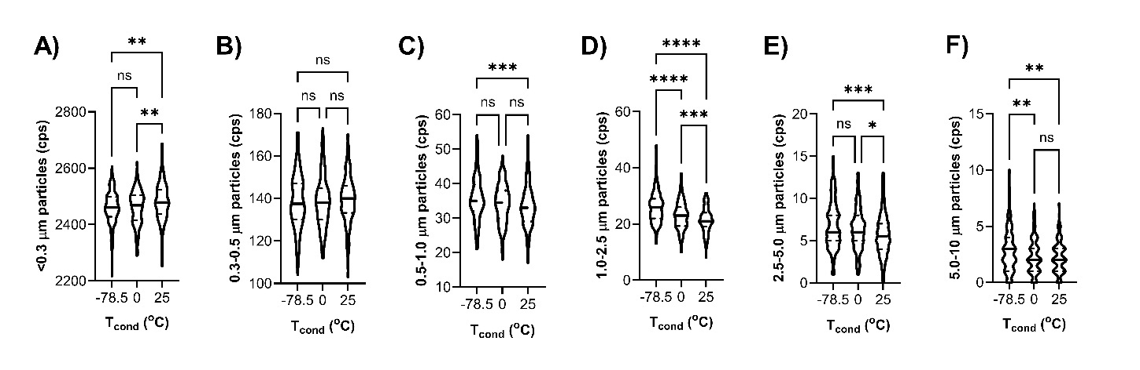
Supplementary Figure 1. Aerosol particles count at the PBM-HaleTM exhaust during 3 minutes of tidal breathing (n=3/group), with condensation temperature (Tcond) at -78.5 ºC (dry ice), 0 ºC (wet ice) or 25 ºC (room temperature) showing temperature-dependent depletion of ultrafine particles (<0.3 µm) and enrichment of larger particle sizes. Increased counts (counts per second; cps) of 0.5-10 µm particles (dry ice) and 1-5 µm particles (wet ice) consistent with aerosol swelling and enhanced capture at lower temperatures (optimum with dry ice). Counts presented in interval bins of (A) <0.3 µm, (B) 0.3-0.5 µm, (C) 0.5-1 µm, (S) 1.0-2.5 µm, (E) 2.5-5 µm, and (F) 5-10 µm, with violin plots showing medians and quartiles; *p<0.05; **p<0.01; ***p<0.001; ****p<0.0001; ns: not significant.
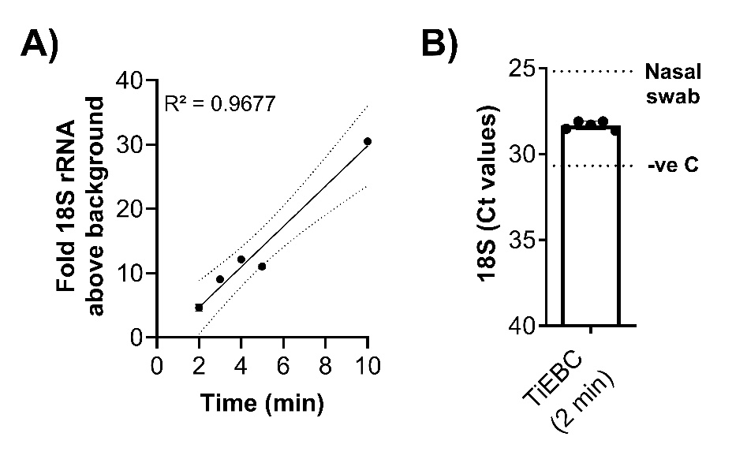
Supplementary Figure 2. Reproducible and collection-time dependent detection of 18S rRNA in PBM-HaleTM breath condensates. 18S rRNA levels were determined by pan-eukaryotic Taqman® assay in extracted RNA from FA EBC samples captured at -78.5 ºC from an adult male healthy volunteer for (A) 2-10 minutes vial tidal breathing or (B) over 2 minutes, 5 independent times. Each point in the graph represents the mean of duplicate RT-PCR technical replicates. In (B), Ct values for a nasal swab sample obtained from an adult healthy male volunteer and RNase free water were used as positive and negative control, respectively.
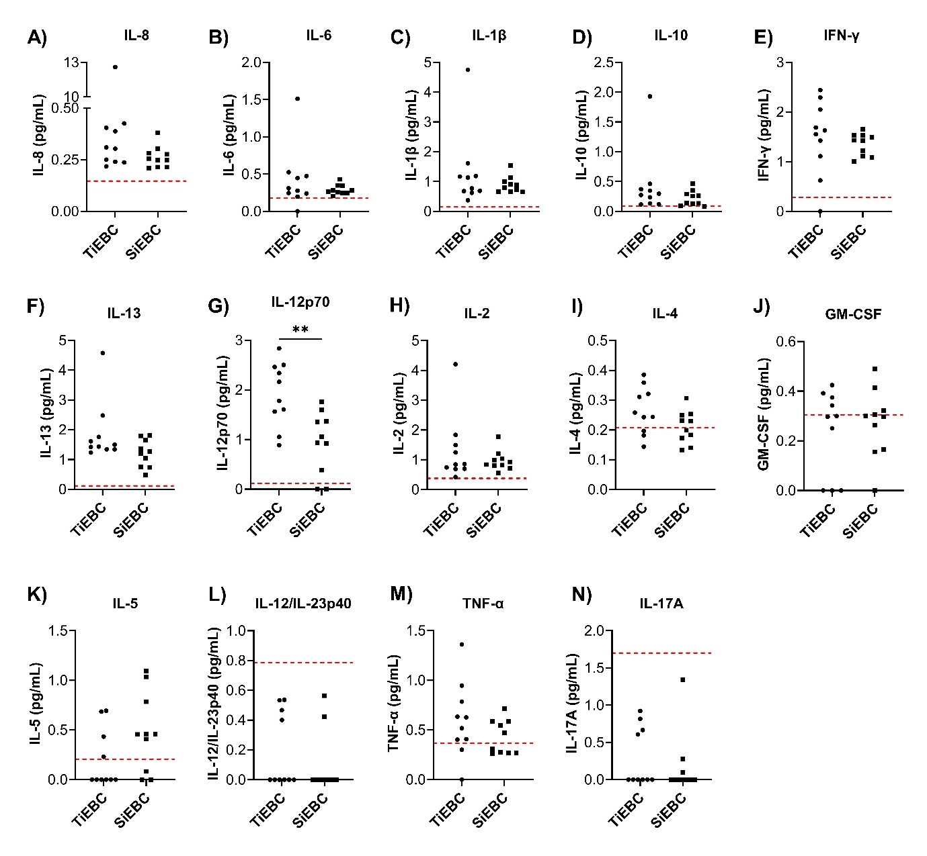
Supplementary Figure 3. Inflammatory markers in PBM-Hale™ breath condensates collected using dry ice. Inflammatory markers were quantified in the distal FA collected via tidal breathing (TiEBC) or singing (SiEBC) for 15 and 30 minutes, respectively; n=10 healthy volunteers. A 14-plex panel (Mesoscale Discovery V-plex) was used to determine levels of each marker. Dashed red lines represent the LLQ each marker. TiEBC vs SEBC *: p<0.05, statistically different as analysed by paired T test. All other markers are not significantly different by paired t test or Wilcoxon matched-pairs signed rank test.
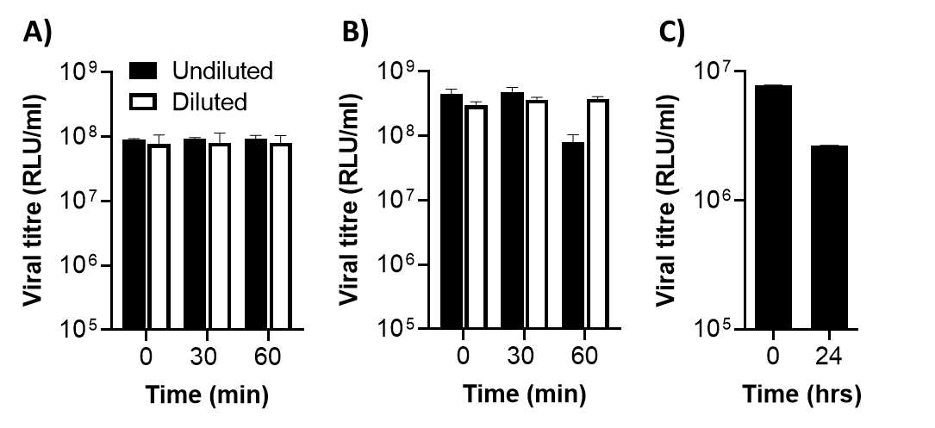
Supplementary Figure 4. Viral solution dilution (reflecting condensation-driven dilution of breath condensate specimens) does not affect viral infectivity. (A-B) Two pseudotyped lentiviruses, a GFP-reporter D614G SARS-CoV-2 spike-pseudotyped lentivirus (A) or rabies glycoprotein-pseudotyped lentivirus (B) were incubated for 0, 30, or 60min after 1:14 dilution in 18 megaOhm water, and were subsequently seeded onto HEK293T cells for 72h to assess impact on infectivity. (C) GFP-reporter Beta variant SARS-CoV-2 spike-pseudotyped lentivirus was incubated at room temperature for 24h and impact on HEK293T cell infectivity was compared to 4 ºC storage. Virus titres were calculated as the mean relative light units/min (n=3, average ± standard deviation; data representative of 3 independent experiments.
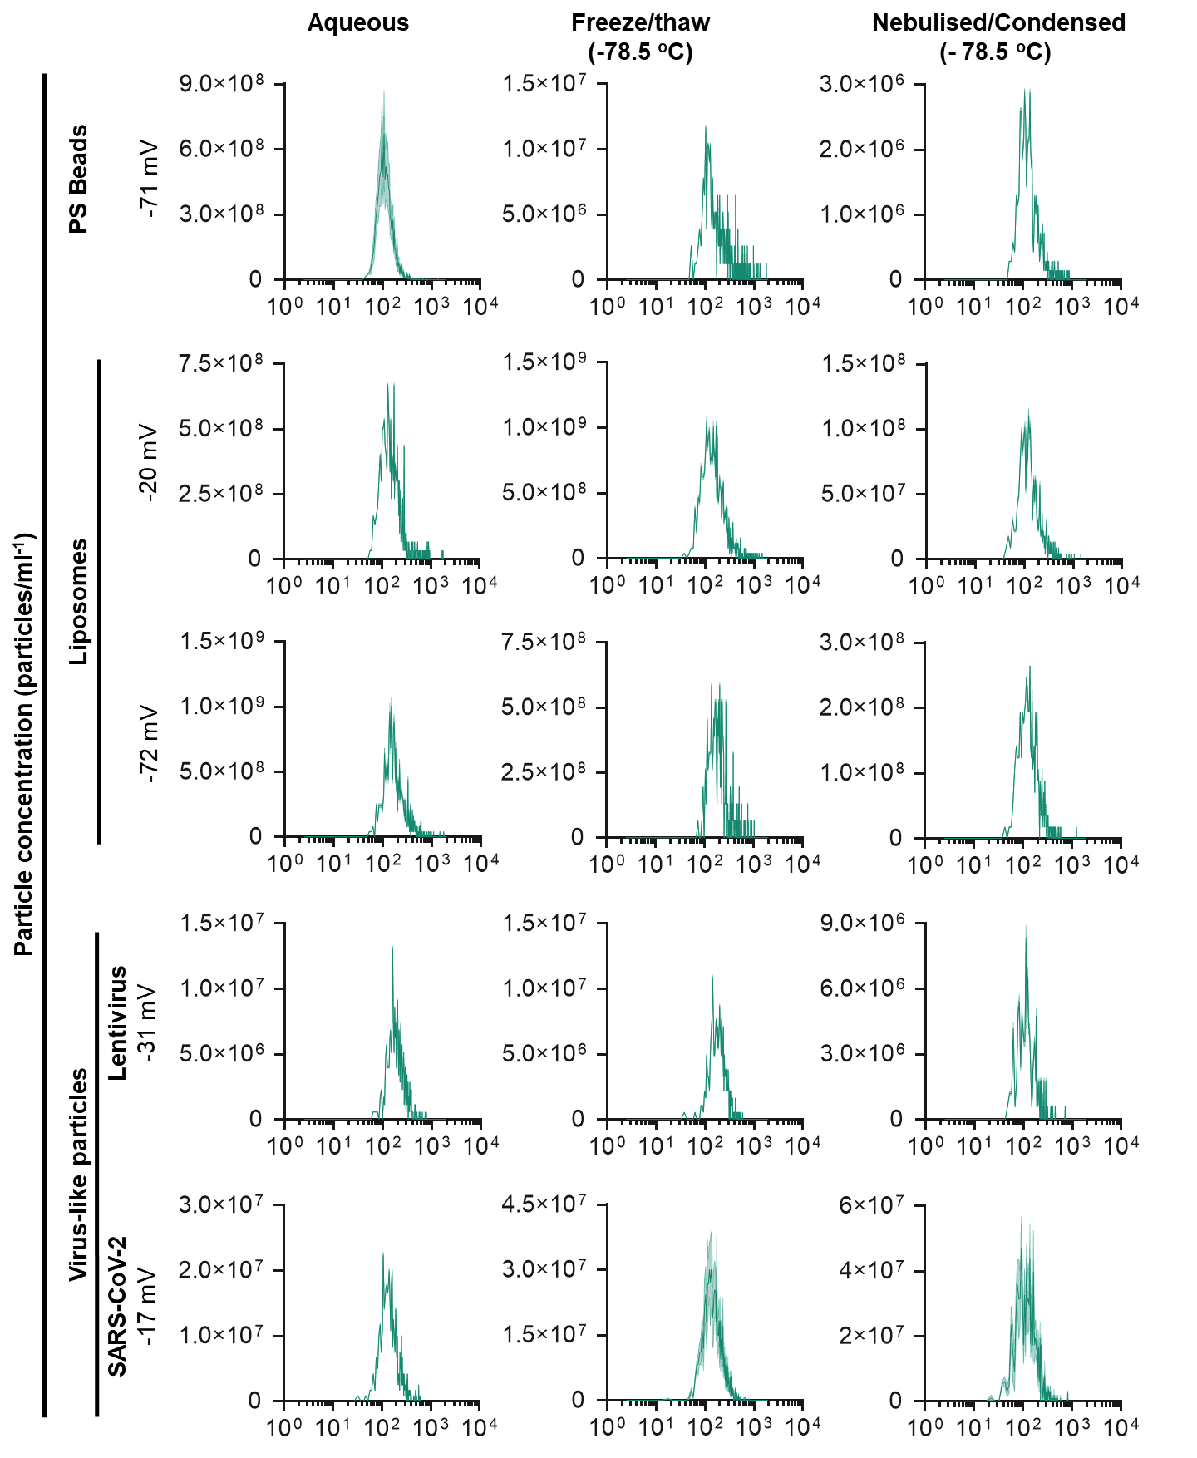
Supplementary Figure 5. Impact of condensation temperature on mechanically nebulized infectious pseudoviruses and synthetic nanoparticles. (A) A clinical grade nebulizer (PARI) was attached to PBM-HaleTM using a 3D printed adapter to passively route suspensions of nanoparticles into the condenser. (B) Titration of VSV-GFP lentivirus for the determination of 50% Tissue Culture Infectious Dose (TCID50) identifies a 2.5 log stock dilution as the appropriate concentration for the above-background detection of GFP positive cells by fCM (average ± standard deviation of 3 independent replicates). (C) Effect of flash-freezing or mechanical aerosolization/condensation capture of polysterene (PS) beads, liposomes, lentiviral virus-like particles, or SARS-CoV-2 virus-like particles on particle concentration as a function of particle diameter, as measured by nanoparticle tracking analysis (average ± standard error of the mean of 3 independent replicates is depicted in the green-shaded area). The charge (zeta potential) of each particle type is shown.

