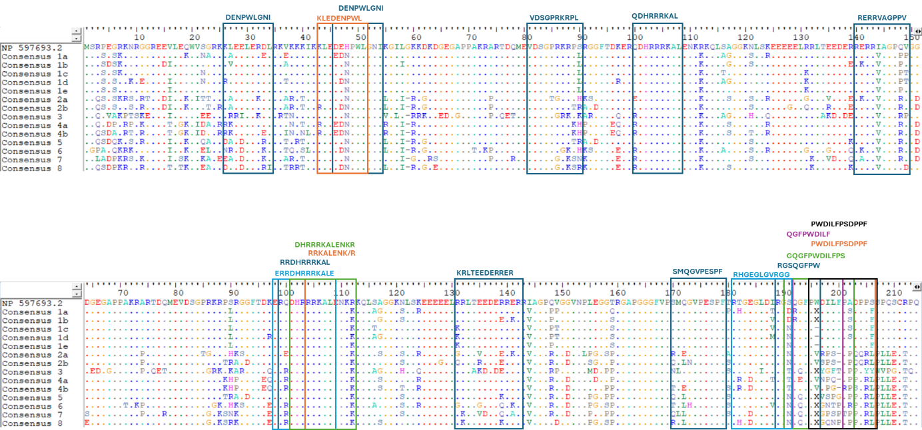
Figure S1. The genetic conservation of 18 CTL epitopes of the consensus sequences with respect to the reference protein sequence of L-HDAg.

